Improving Accessibility Mapping for Emergency Services Using GIS
(Addressing Urban and Rural Disparities in Honolulu County)

Introduction
The efficiency of emergency services often determines outcomes in critical situations. The rapid accessibility of hospitals, fire stations, and police services is a cornerstone of public safety. However, traditional mapping methods, such as simple proximity measures, often fall short in accurately representing accessibility, ignoring factors such as road networks, traffic conditions, and geographical barriers.
This project aims to bridge this gap by utilizing advanced GIS techniques, specifically network service area analysis, to create realistic and actionable maps for emergency planners. By simulating real-world travel conditions, this study evaluates the actual coverage of emergency services and identifies underserved areas. These insights provide essential information for improving strategic resource allocation and optimizing service delivery.

Background
Mapping emergency service coverage has traditionally relied on simplified approaches like proximity-based or radial measurements. While straightforward, these methods fail to reflect the complexities of real-world travel, such as varying road conditions, speed limits, and urban density. This has often led to overestimated service coverage and hidden accessibility gaps.
Recent advancements in GIS technologies have enabled the use of network service area analysis, which calculates service areas based on real travel routes and times. Unlike traditional buffer methods, network analysis incorporates road networks, traffic patterns, and physical barriers, offering a more realistic perspective on service accessibility.
For example, studies in urban areas have shown that traffic congestion and complex intersections can significantly delay emergency response times, while rural regions face challenges due to sparse road networks and long travel distances. Network service area analysis addresses these issues by providing planners with data-driven insights to improve equity and efficiency in emergency services.

Literature Review
Geographic Information Systems (GIS) have become an indispensable tool in emergency planning, enabling the optimization of facility locations, routing, and coverage. The ability of GIS to analyze spatial and temporal data has revolutionized the way emergency services are planned and delivered.
Traditional Methods vs. Advanced GIS Techniques
Traditional methods such as simple radius mapping provide a basic visual representation of service coverage by assuming a uniform distance from facilities. However, these methods have significant limitations:
- Simplistic Assumptions: Fixed-radius approaches assume uniform accessibility in all directions, ignoring real-world variables such as road networks, traffic conditions, and physical barriers.
- Overestimation of Coverage: Studies indicate that these methods can overestimate service coverage by 20–50% compared to network-based methods that account for real travel routes and times (Thompson et al., 2021).
In contrast, network-based service area analysis offers a more sophisticated and accurate approach. This method simulates real-world travel by incorporating road characteristics, speed limits, one-way restrictions, and barriers. It also enables planners to model service coverage based on travel time thresholds, providing a realistic picture of accessibility. For example:
- Healthcare Facility Planning: Johnson and Lee (2020) used network-based service area analysis to identify underserved areas for hospital placement, considering population density and road connectivity.
- Fire Station Optimization: Rodriguez et al. (2021) applied network-based service area analysis to optimize fire station locations, ensuring minimal response times in high-risk zones.
- Police Response Analysis: Chen and Wong (2022) demonstrated the benefits of network-based service area analysis in identifying gaps in police coverage, especially in urban areas with complex road networks.
Emerging Trends in Emergency Service Mapping
Recent advancements in GIS have expanded its capabilities for emergency planning:
- Temporal Analysis: Incorporating temporal data, such as rush-hour traffic patterns, enhances the accuracy of service accessibility models. For example, Liu and Zhang (2023) highlighted how traffic congestion during peak hours can significantly delay emergency response times, emphasizing the importance of time-based analysis.
- Dynamic Routing: Real-time traffic data integration allows for dynamic routing of emergency vehicles, reducing delays and improving response efficiency. This has been particularly effective in urban areas with high traffic density.
- Socioeconomic Considerations: GIS tools now allow for the integration of demographic and socioeconomic data, helping planners identify high-need areas based on factors such as income levels, age distribution, and population density (Smith et al., 2019).
- Predictive Modeling: Machine learning and predictive analytics are increasingly being used in GIS to anticipate future demand for emergency services. These models can forecast high-risk zones based on historical incident data and urban growth trends.
Applications of GIS in Emergency Planning
Several case studies illustrate the transformative impact of GIS on emergency planning:
- Rural Accessibility: In rural areas, sparse road networks and long travel distances pose unique challenges. GIS-based network service area analysis has been used to identify underserved regions and propose optimal locations for new facilities.
- Equity in Service Distribution: By overlaying demographic data with service areas, planners can ensure equitable distribution of emergency services, addressing disparities in access for vulnerable populations such as the elderly and low-income communities.
- Disaster Response: GIS has played a critical role in disaster response planning, enabling rapid deployment of resources and identification of safe evacuation routes.

Research Questions
This project seeks to answer the following questions:
- How does network service area analysis improve the accuracy of emergency service coverage maps compared to traditional methods?
- What GIS techniques can be applied to identify underserved areas effectively?
- How do population density and demographic factors influence the identification of high-need regions?
- What strategies can be developed to address service gaps based on the findings?

Methodology
The methodology for this project involves a step-by-step approach using GIS tools (network-based service area analysis) to analyze emergency service accessibility.

Data Collection
- Road Network Data: Road network data providing visual context for accessibility.
- Emergency Facility Locations: Geolocations of hospitals, fire stations, and police stations obtained local government GIS portals.
- Demographics and Population Data: Population and age distribution from the U.S. Census Bureau and American Community Survey.
  - Fire stations and police stations and hospital in Honolulu County.

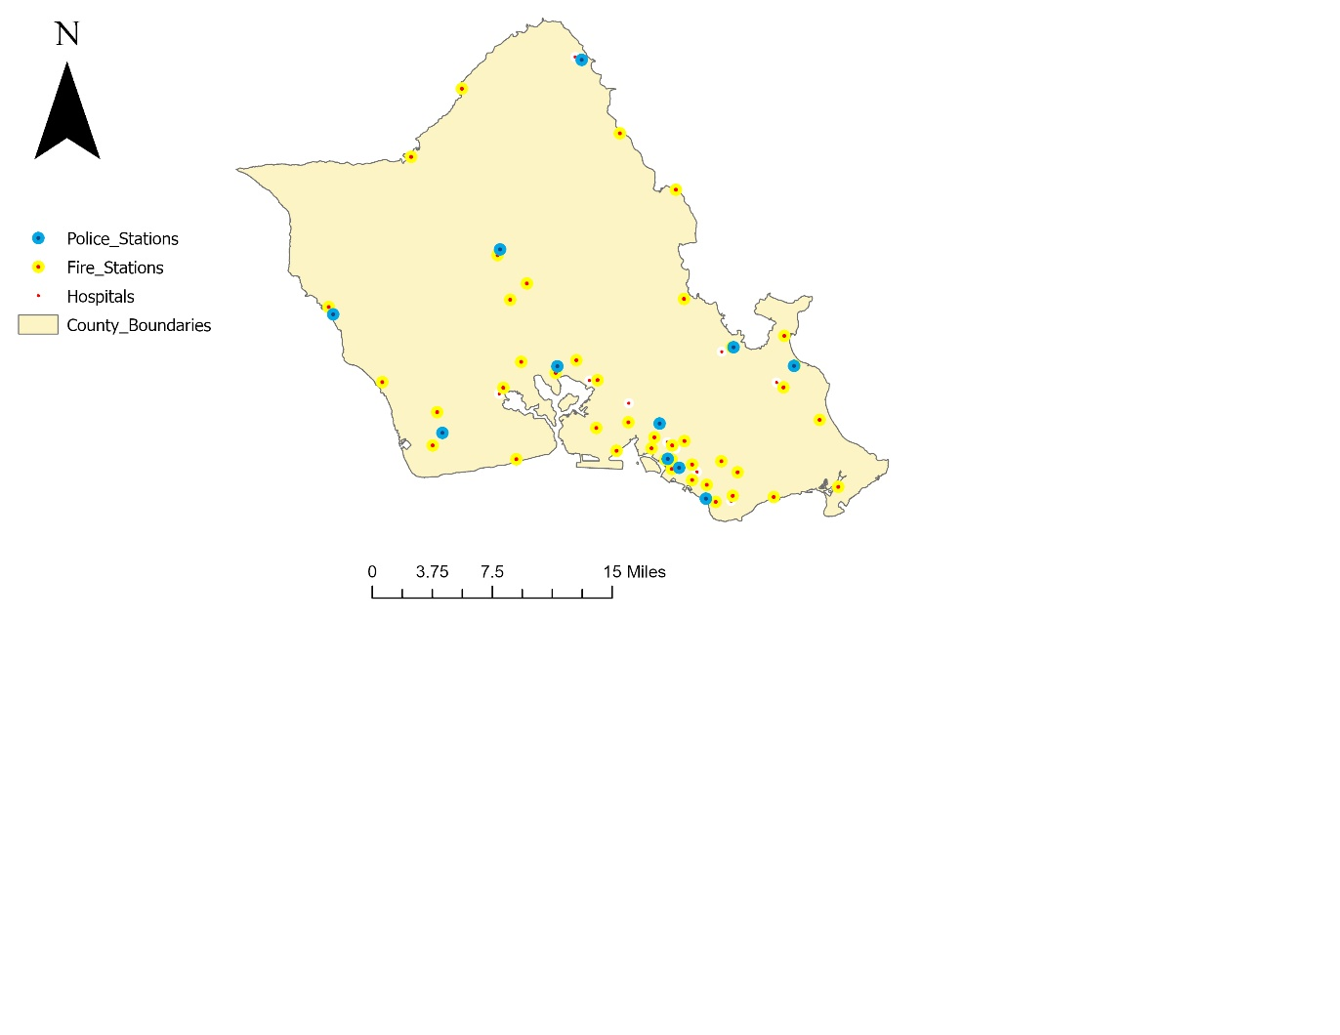
  - Road network data providing visual context for accessibility.
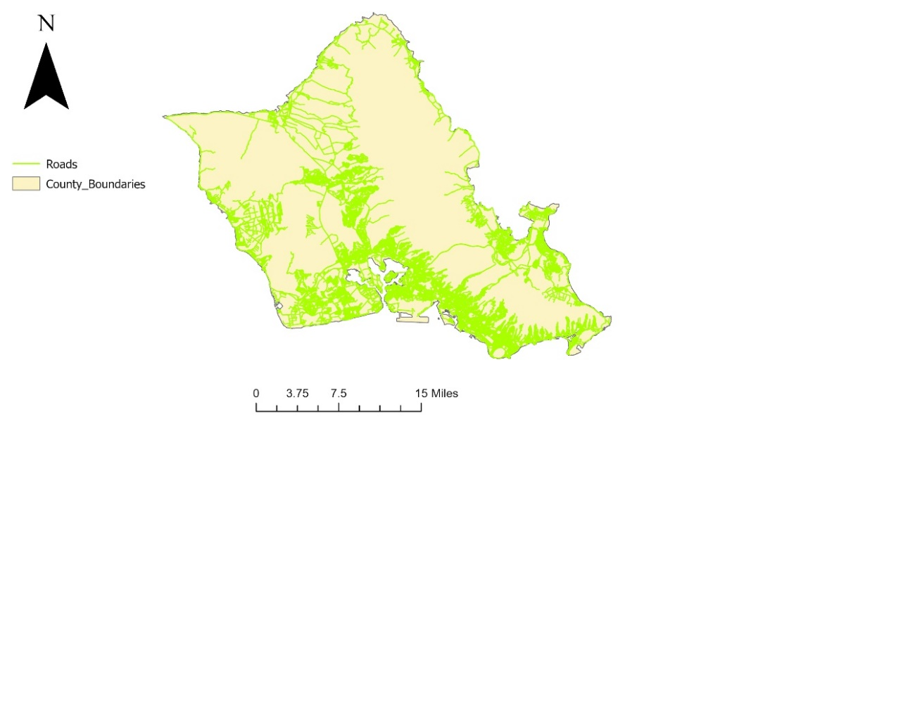

  - Census-derived population density and demographic data.
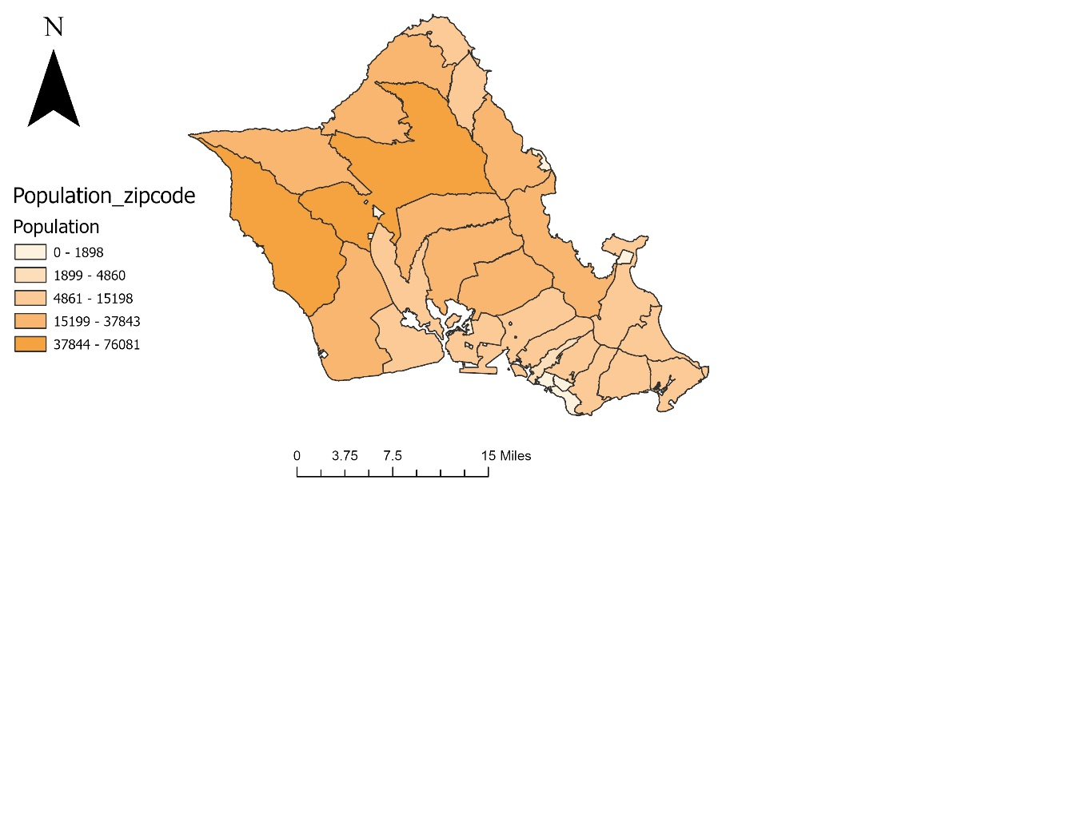

  - The map highlights the distribution of age groups
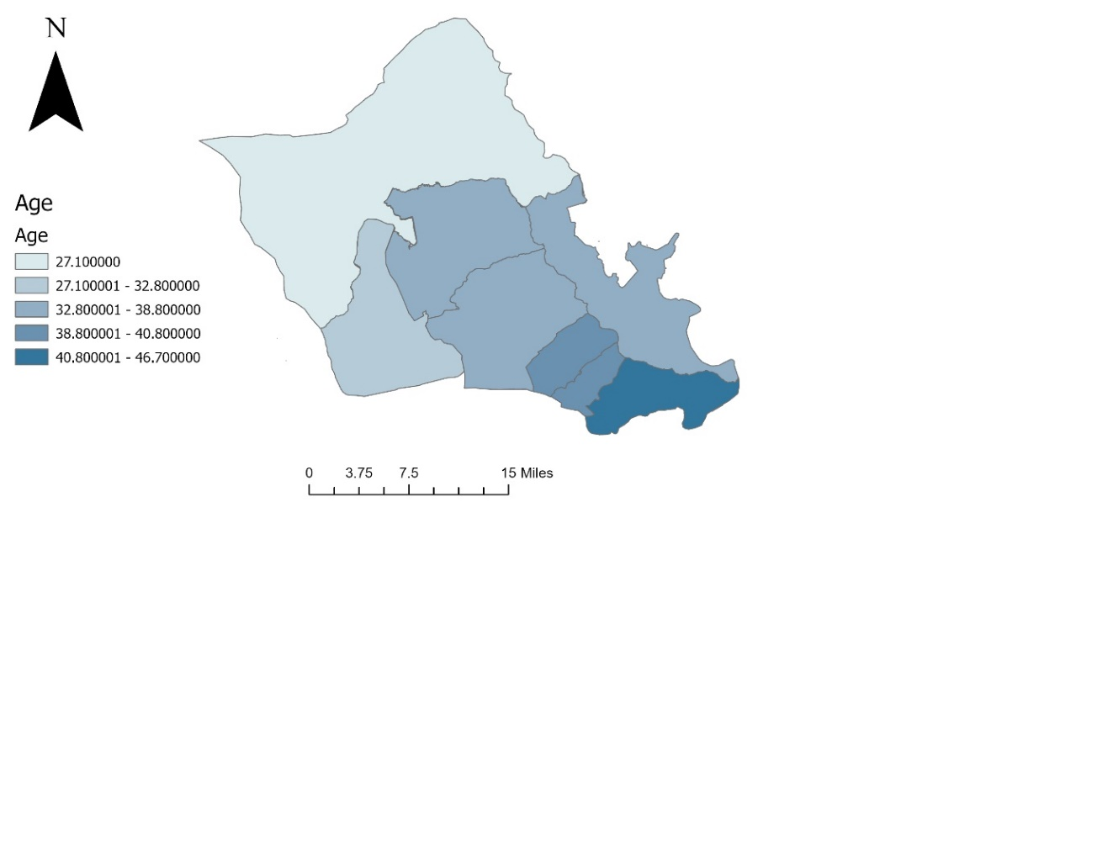
GIS Analysis
- Network Service Area Analysis:
  - Use the Network Analyst tool in ArcGIS Pro to calculate service areas based on real-world travel times.
  - Generate service areas for different thresholds (1.5, 2 miles).
- Overlay Analysis:
  - Overlay service area results with demographic layers to identify high-need underserved areas.
- Comparison:
  - Compare findings with traditional proximity-based methods to highlight discrepancies and gaps.

Gap Analysis
Age Range of the Population Map: Age Range of the Population map illustrates the median age distribution across the study area. Darker blue shades indicate areas with older populations, with a median age ranging from 40.8 to 46.7 years, while lighter shades represent younger populations. This demographic data provides insights into where elderly populations are concentrated, helping identify zones that may require enhanced healthcare and emergency services.

Findings:
- Age and Accessibility: Older populations in southeastern areas coincide with underserved zones, highlighting gaps in emergency service coverage for vulnerable groups.
- Population: Urban regions generally have better coverage, while rural and suburban zones lack sufficient accessibility.
- Police Service Analysis: Police station service areas in blue often fail to overlap with densely populated zones (Dark Orange), revealing gaps in response coverage and the need for resource reallocation to ensure equitable access.
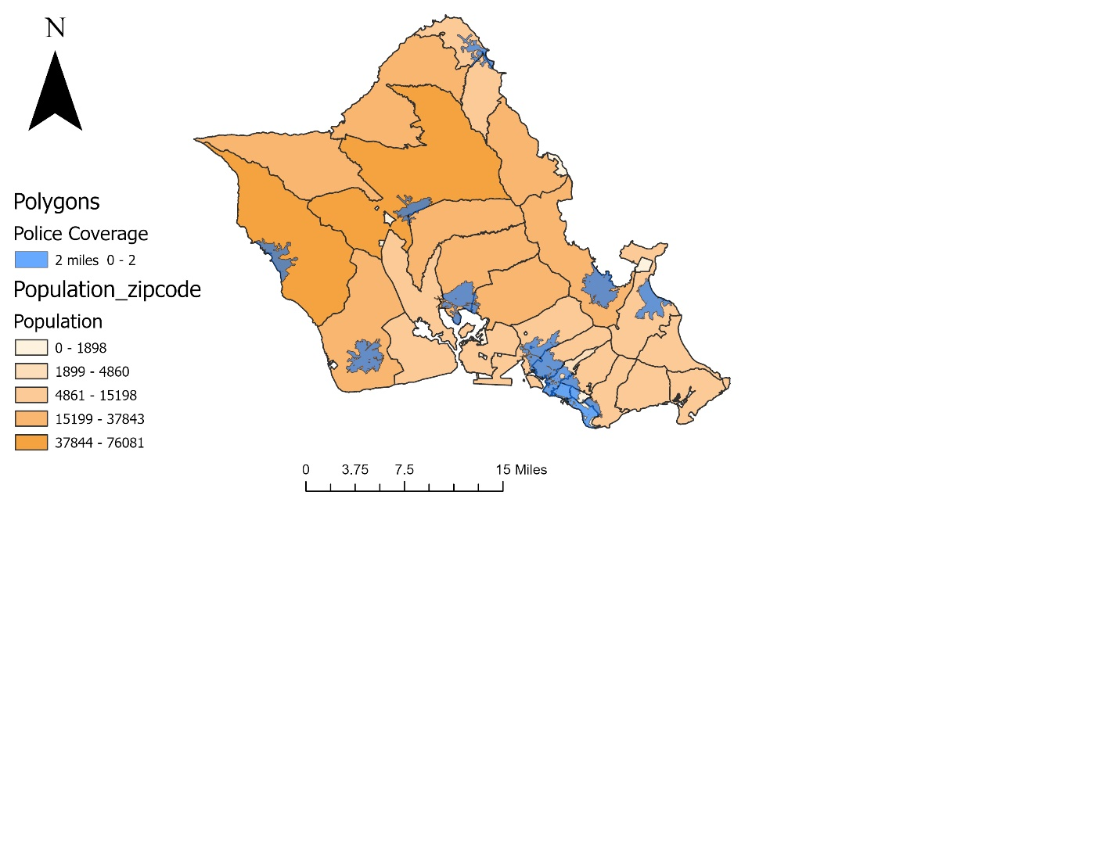
- A service area analysis evaluated hospital accessibility across zip code districts, integrating population data. Yellow represents hospital facilities, while shades of Orange indicate population. The analysis highlights gaps where hospital service areas do not align with high-Crowded regions, emphasizing the need for better resource allocation and equitable healthcare access.
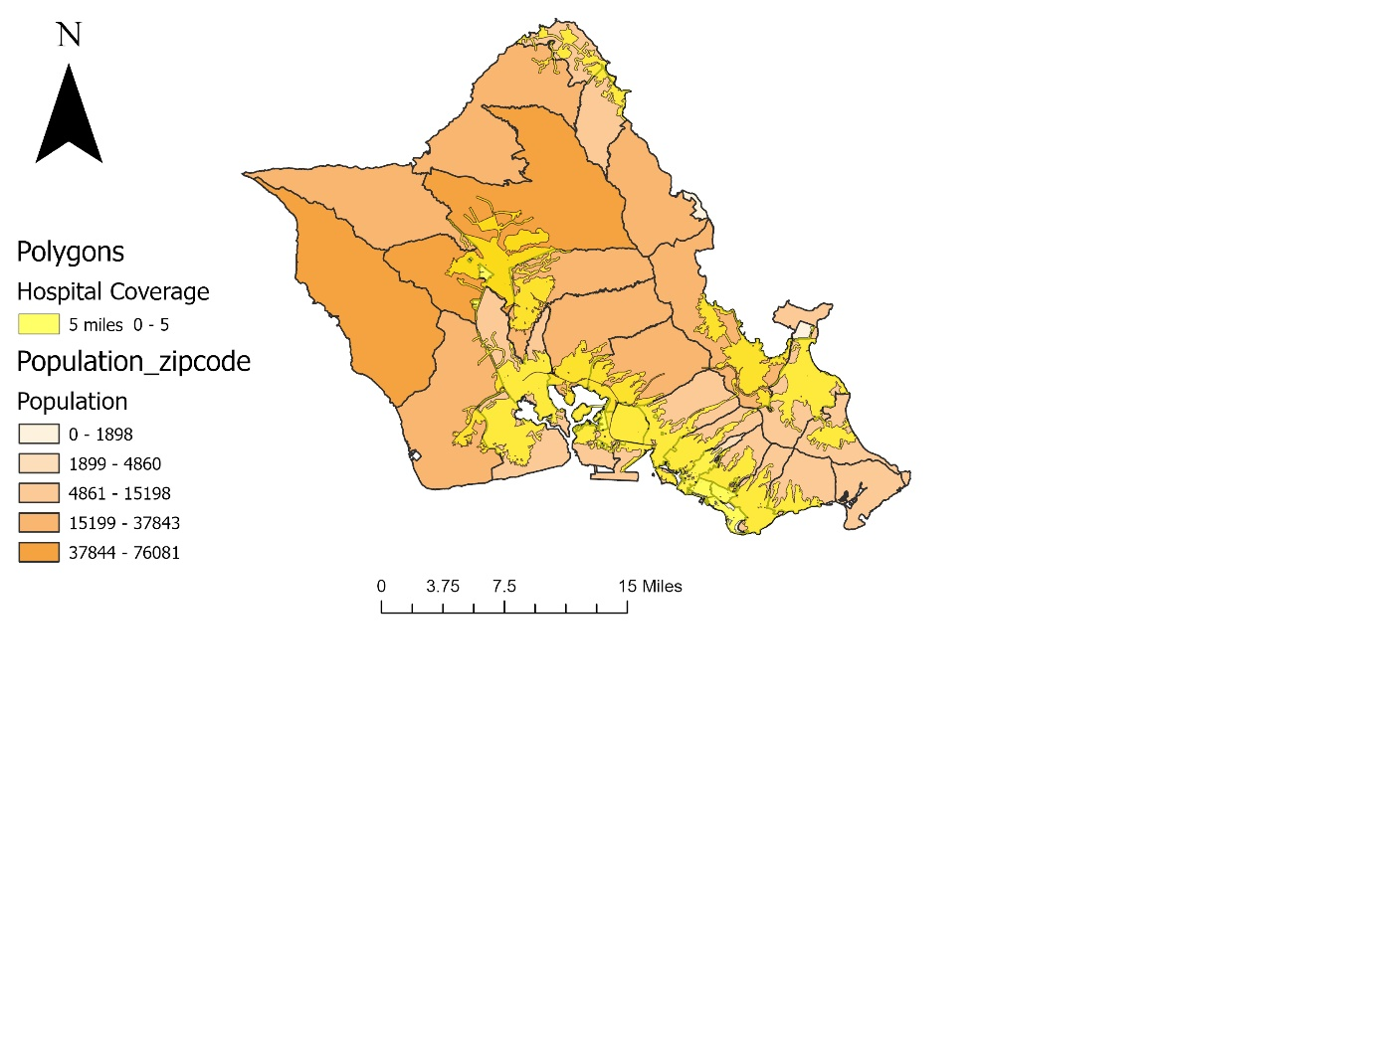

- This map represents a service area analysis evaluating fire station coverage across zip code districts, incorporating population data. Red areas highlight the coverage of fire stations, while shades of orange represent population densities. The analysis identifies discrepancies between fire station service coverage and high-population areas, emphasizing the necessity for improved resource allocation and strategic planning to ensure equitable fire protection services.
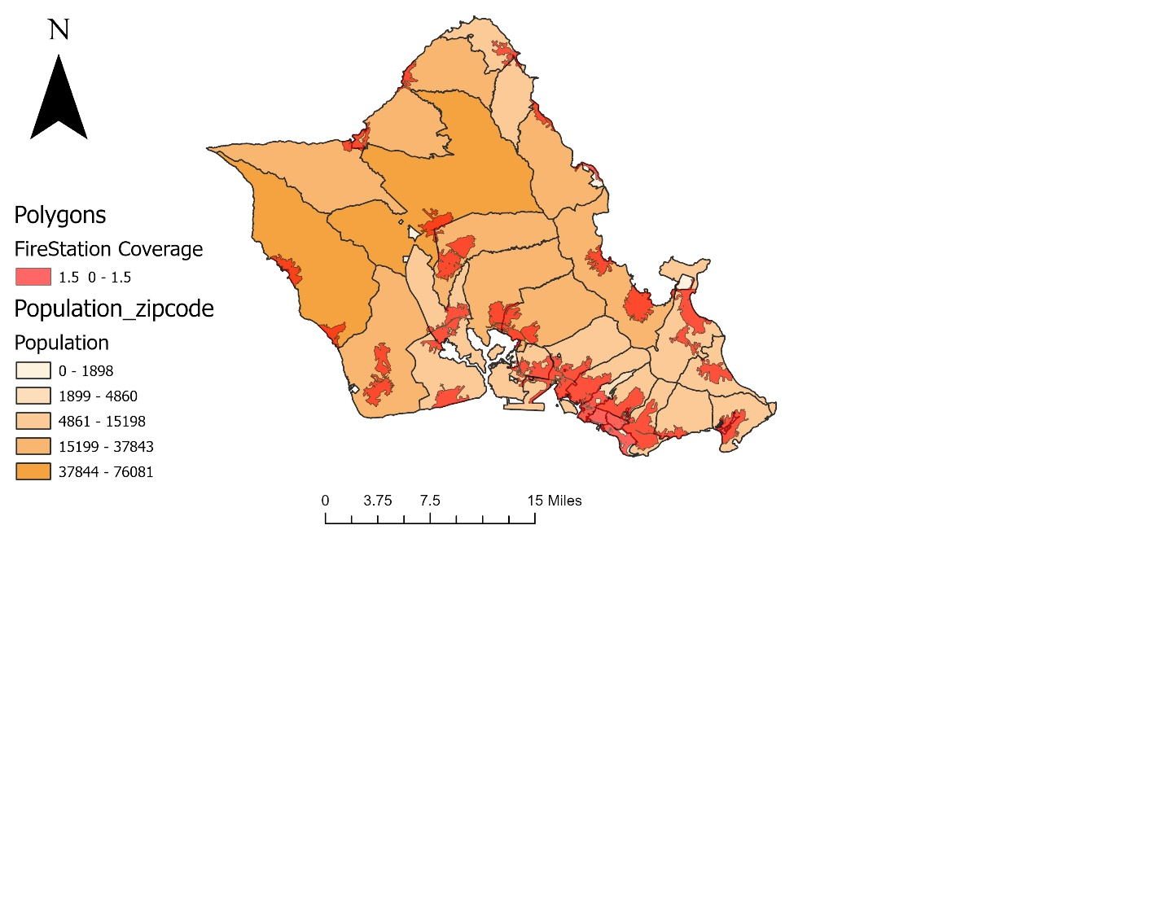
- Urban vs. Rural Analysis:
  - This map highlights disparities in emergency service accessibility between urban (Gray) and rural (beige) areas. Service areas are represented with red, blue, and yellow overlays, showing varying levels of coverage. Urban zones generally have better accessibility, while rural regions face limited coverage, underscoring the need for targeted infrastructure improvements.
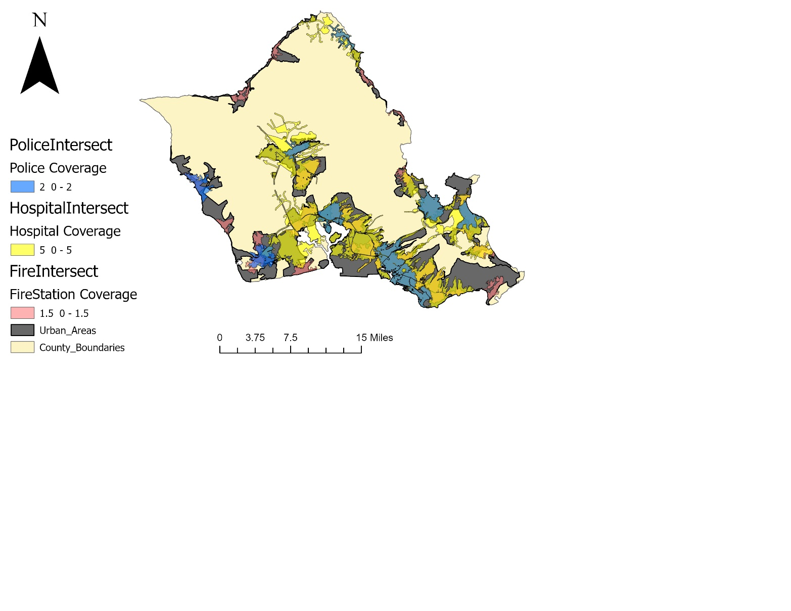

Coverage Analysis of Emergency Services
This section evaluates the real-world coverage percentages for hospitals, fire stations, and police services in Honolulu County. By utilizing network service area analysis, the actual accessibility of these services within specified travel thresholds is quantified. The results are summarized in the tables below:
The following sections summarize the coverage percentages of hospitals, fire stations, and police services across ZIP codes in Honolulu County.
- Hospital Service Coverage by ZIP Code
The percentage of each ZIP code area covered by the hospital service area is shown below. Areas with lower percentages indicate underserved regions that may require additional healthcare facilities or infrastructure improvements.
ZipCode | 96759 | 96795 | 96789 | 96786 | 96857 | 96826 | 96813 | 96707 | 96706 | 96734 | 96821 | 96712
Coverage% | 96 | 26 | 27 | 16 | 95 | 98 | 72 | 7 | 53 | 48 | 26 | 1
ZipCode | 96863 | 96853 | 96859 | 96850 | 96731 | 96816 | 96791 | 96858 | 96817 | 96701 | 96782
Coverage% | 14 | 92 | 100 | 100 | 40 | 64 | 1 | 100 | 55 | 25 | 18
ZipCode | 96848 | 96797 | 96818 | 96762 | 96860 | 96820 | 96744 | 96815 | 96819 | 96822 | 96814
Coverage% | 99 | 48 | 72 | 15 | 96 | 100 | 33 | 82 | 37 | 51 | 93

- Fire Station Service Coverage by ZIP Code
The table below presents the coverage percentages for fire stations across different ZIP codes. The data highlights urban areas with higher accessibility compared to rural zones.
Zipcode | 96795 | 96789 | 96792 | 96786 | 96826 | 96813 | 96707 | 96706 | 96734 | 96848 | 96797 | 96858
Coverage% | 19 | 17 | 5 | 2 | 97 | 53 | 9 | 16 | 21 | 99 | 17 | 100
Zipcode | 96819 | 96822 | 96814 | 96782 | 96821 | 96712 | 96863 | 96853 | 96850 | 96717 | 96731 | 96816
Coverage% | 22 | 41 | 93 | 6 | 9 | 5 | 13 | 10 | 100 | 4 | 13 | 47
Zipcode | 96818 | 96762 | 96860 | 96820 | 96744 | 96825 | 96815 | 96817 | 96701 | 96730 | 96791
Coverage% | 24 | 1 | 19 | 80 | 16 | 20 | 80 | 40 | 13 | 34 | 1

- Police Service Coverage by ZIP Code
The following table outlines the percentage of each ZIP code covered by police services. The results indicate significant disparities between urban and rural areas.
ZipCode | 96789 | 96792 | 96786 | 96826 | 96813 | 96707 | 96734 | 96797 | 96762 | 96744 | 96815
Coverage% | 1 | 5 | 3 | 51 | 51 | 11 | 16 | 0 | 3 | 15 | 78
ZipCode | 96819 | 96822 | 96814 | 96782 | 96712 | 96850 | 96731 | 96816 | 96858 | 96817 | 96701
Coverage% | 14 | 10 | 92 | 14 | 0 | 100 | 17 | 7 | 100 | 31 | 2

Results
Hospital Coverage:
Hospital accessibility is unevenly distributed across Honolulu County. Urban areas such as ZIP code 96858 have high coverage, while rural areas like 96762 and 96786 face significant service gaps. These underserved areas often correlate with higher concentrations of elderly residents, highlighting the need for targeted improvements in healthcare access.
Fire Station Coverage:
Fire station service areas reveal notable disparities. While urban areas enjoy robust coverage, rural and northern regions, including ZIP codes 96792 and 96744, experience significant gaps. These findings suggest the need for additional fire station facilities in high-risk rural zones.
Police Service Coverage:
The analysis identifies rural areas, particularly in western Honolulu County, as underserved by police services. Urban areas, while generally better served, still exhibit notable coverage gaps, especially in lower-income neighborhoods.

Discussion
Findings Interpretation:
Network service area analysis revealed significant gaps in emergency service coverage that traditional methods failed to capture. Vulnerable populations, including elderly and low-income residents, are disproportionately affected in rural zones.
Challenges and Limitations:
- Data Gaps: Missing transient population data may limit the accuracy of the findings.
- Rural Challenges: Sparse infrastructure and long travel distances continue to hinder accessibility in rural areas.
Implications:
The findings provide policymakers with actionable insights for prioritizing resource allocation. Regular updates to GIS data are essential to reflect changing demographics and infrastructure.

Conclusion and Recommendations
The study highlights disparities in emergency service accessibility across Honolulu County, with underserved populations concentrated in rural and suburban areas. Vulnerable groups, such as the elderly and low-income populations, face significant challenges in accessing essential services.
Recommendations:
Short-Term:
- Deploy mobile emergency units in underserved areas during peak hours.
- Optimize existing resources through improved routing systems.
Medium-Term:
- Construct new emergency service facilities in high-need zones, such as southern rural areas and western suburbs.
- Focus on areas like ZIP codes 96786 and 96762 for targeted infrastructure investments.
Long-Term:
- Regularly update GIS data to reflect evolving population and infrastructure changes.
- Integrate real-time traffic data and predictive modeling to enhance emergency service planning accuracy.

References
- Hawai‘i Statewide GIS Program. (n.d.). Hawai‘i State GIS Data Portal. Retrieved from https://geoportal.hawaii.gov
- OpenStreetMap. (n.d.). OpenStreetMap Data and Tools. Retrieved from https://www.openstreetmap.org
- U.S. Census Bureau. (n.d.). American Community Survey and Decennial Census Data. Retrieved from https://www.census.gov
- Johnson, R., & Lee, A. (2020). Optimizing Healthcare Facility Locations Using GIS. Journal of Health Planning and Management, 38(4), 327-345.
- Rodriguez, P., et al. (2021). Fire Station Optimization Using GIS Service Area Analysis. International Journal of Fire Safety, 52(7), 89-105.
- Chen, S., & Wong, T. (2022). Police Response Time Analysis with GIS Network Tools. Journal of Law Enforcement Technology, 18(1), 56-78.
- Liu, X., & Zhang, Y. (2023). Improving Emergency Accessibility with Demographics. Regional Studies, 57(5), 601-615.

