身高 体重

决定

领围 袖长 肩宽 胸围 中腰 裤长 袖肥

裤腰 臀围 大腿围 衣长 直档 袖口

不考虑 “站 胸 腹 肩“后的数据，去重后还剩742行，使用升高和体重拟合个指标结果如下:

x(身高)，y(体重)，z(领围)

Linear model Poly11:

f(x,y) = p00 + p10\*x + p01\*y

Coefficients (with 95% confidence bounds):

p00 = 34.55 (34.39, 34.72)

p10 = -0.03432 (-0.03525, -0.03338)

p01 = 0.1514 (0.1513, 0.1515)

Goodness of fit:

SSE: 0.6177

R-square: 1

Adjusted R-square: 1

RMSE: 0.02891

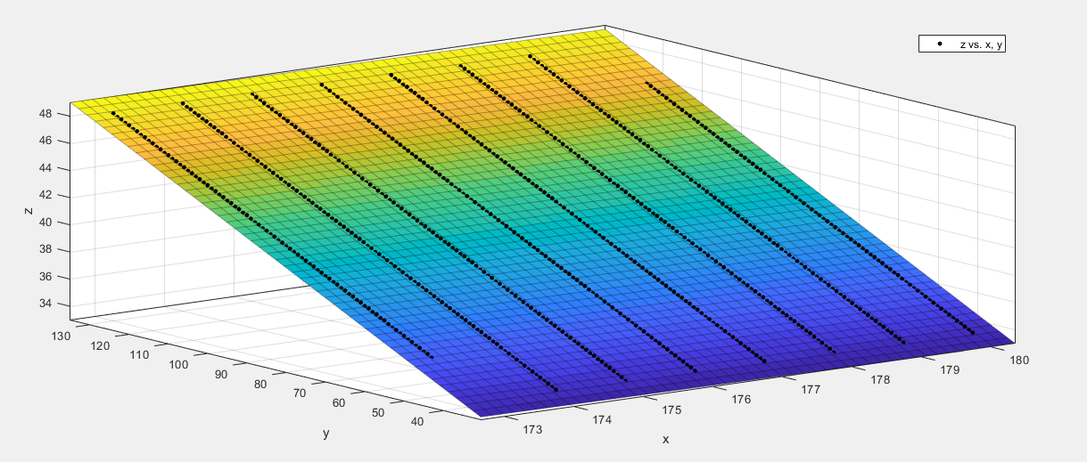

x(身高)，y(体重)，z(袖长)

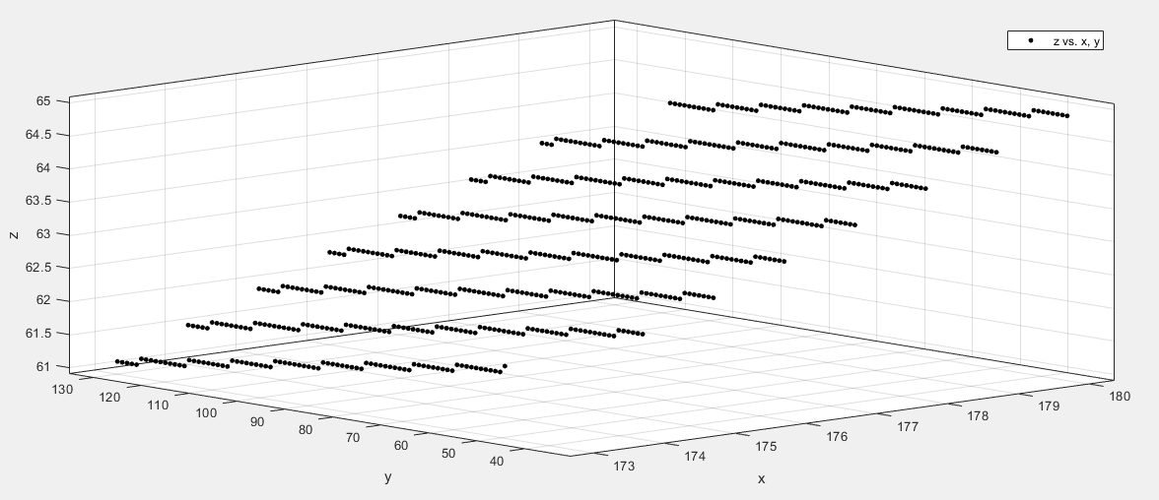

Linear model Poly11:

f(x,y) = p00 + p10\*x + p01\*y

Coefficients (with 95% confidence bounds):

p00 = -7.367 (-7.532, -7.202)

p10 = 0.4037 (0.4028, 0.4047)

p01 = -0.01063 (-0.01071, -0.01056)

Goodness of fit:

SSE: 0.6132

R-square: 0.9991

Adjusted R-square: 0.9991

RMSE: 0.02881

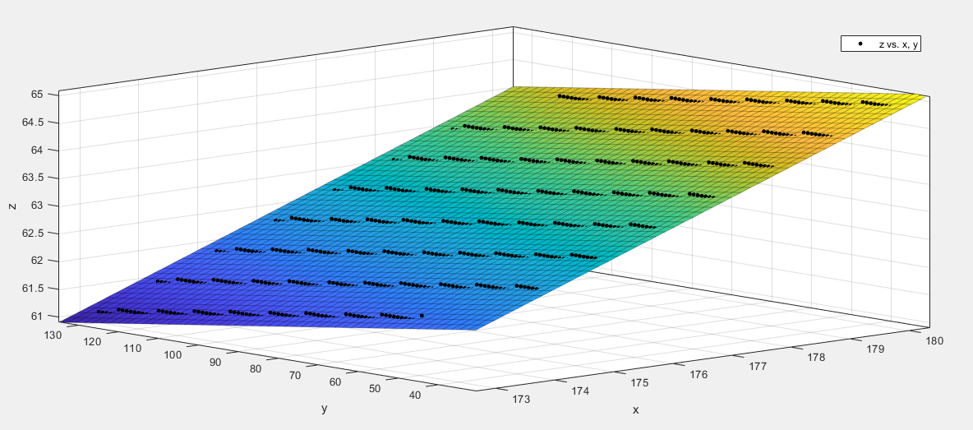

x(身高)，y(体重)，z(肩宽)

Linear model Poly11:

f(x,y) = p00 + p10\*x + p01\*y

Coefficients (with 95% confidence bounds):

p00 = 23.88 (23.72, 24.05)

p10 = 0.05949 (0.05855, 0.06042)

p01 = 0.1781 (0.1781, 0.1782)

Goodness of fit:

SSE: 0.6183

R-square: 1

Adjusted R-square: 1

RMSE: 0.02893

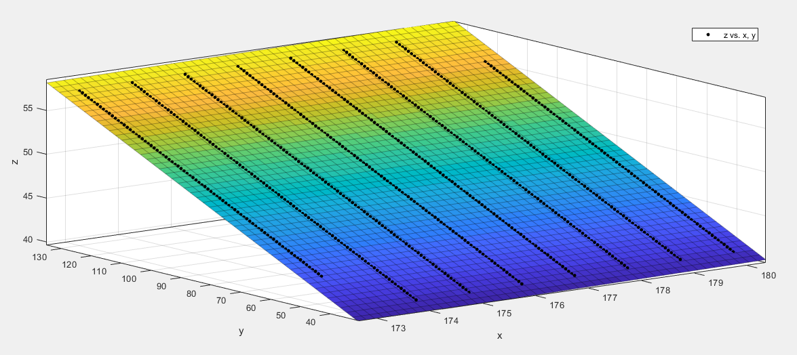

x(身高)，y(体重)，z(胸围)

Linear model Poly11:

f(x,y) = p00 + p10\*x + p01\*y

Coefficients (with 95% confidence bounds):

p00 = 86.32 (86.15, 86.48)

p10 = -0.1884 (-0.1893, -0.1874)

p01 = 0.6359 (0.6358, 0.6359)

Goodness of fit:

SSE: 0.6199

R-square: 1

Adjusted R-square: 1

RMSE: 0.02896

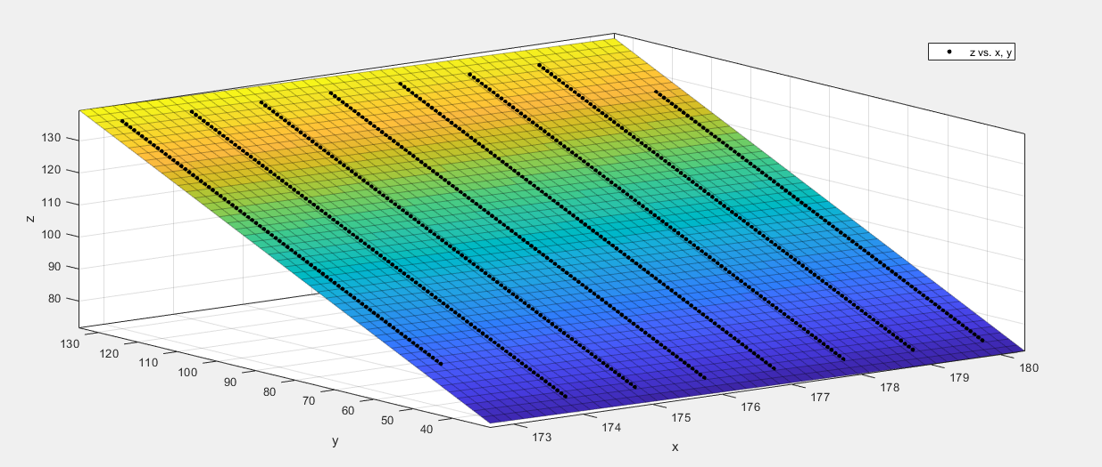

x(身高)，y(体重)，z(中腰)

Linear model Poly11:

f(x,y) = p00 + p10\*x + p01\*y

Coefficients (with 95% confidence bounds):

p00 = 93.68 (93.51, 93.85)

p10 = -0.3404 (-0.3414, -0.3395)

p01 = 0.7632 (0.7631, 0.7632)

Goodness of fit:

SSE: 0.6235

R-square: 1

Adjusted R-square: 1

RMSE: 0.02905

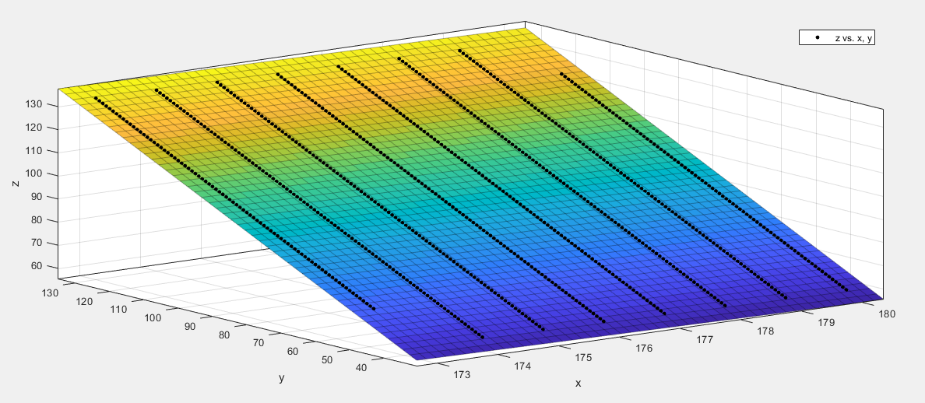

x(身高)，y(体重)，z(裤长)

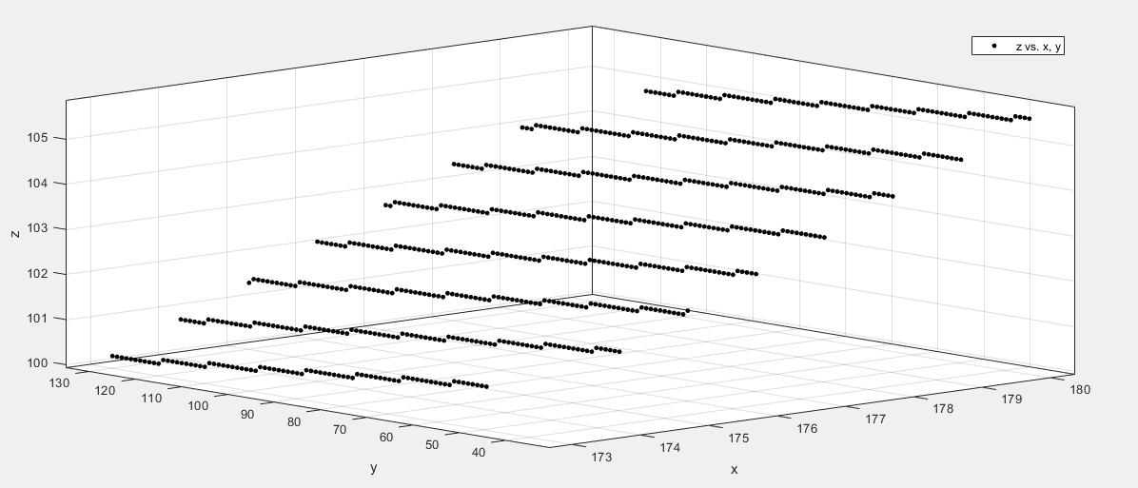

Linear model Poly11:

f(x,y) = p00 + p10\*x + p01\*y

Coefficients (with 95% confidence bounds):

p00 = -10.35 (-10.51, -10.18)

p10 = 0.6459 (0.645, 0.6468)

p01 = -0.009525 (-0.009602, -0.009448)

Goodness of fit:

SSE: 0.6171

R-square: 0.9996

Adjusted R-square: 0.9996

RMSE: 0.0289

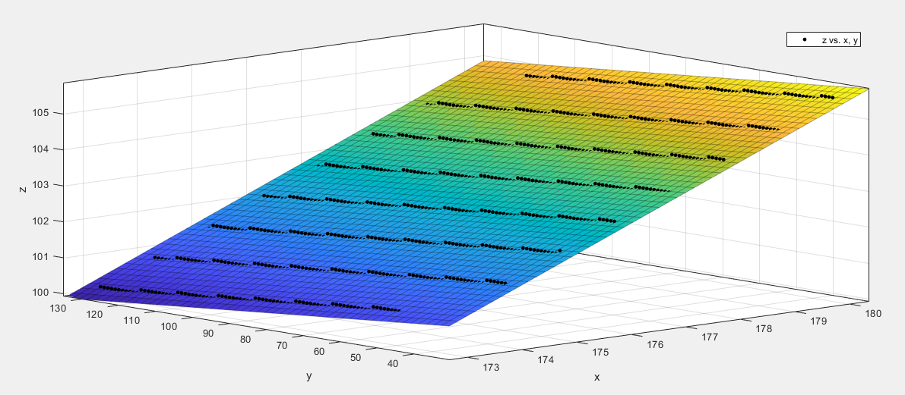

x(身高)，y(体重)，z(袖肥)

Linear model Poly11:

f(x,y) = p00 + p10\*x + p01\*y

Coefficients (with 95% confidence bounds):

p00 = 36.41 (36.25, 36.58)

p10 = -0.1188 (-0.1197, -0.1179)

p01 = 0.2322 (0.2321, 0.2322)

Goodness of fit:

SSE: 0.6191

R-square: 1

Adjusted R-square: 1

RMSE: 0.02894

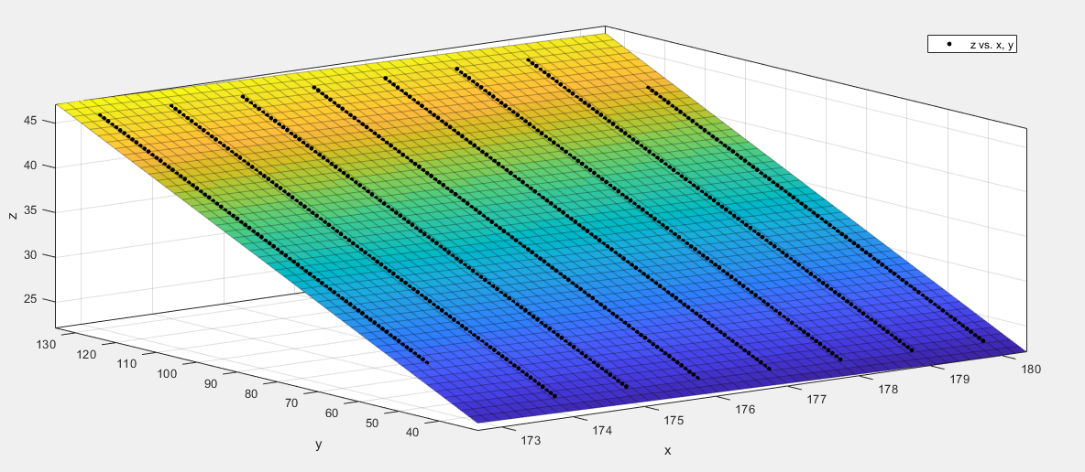

x(身高)，y(体重)，z(裤腰)

Linear model Poly11:

f(x,y) = p00 + p10\*x + p01\*y

Coefficients (with 95% confidence bounds):

p00 = 77.94 (77.77, 78.11)

p10 = -0.1703 (-0.1713, -0.1694)

p01 = 0.5741 (0.574, 0.5742)

Goodness of fit:

SSE: 0.6208

R-square: 1

Adjusted R-square: 1

RMSE: 0.02898

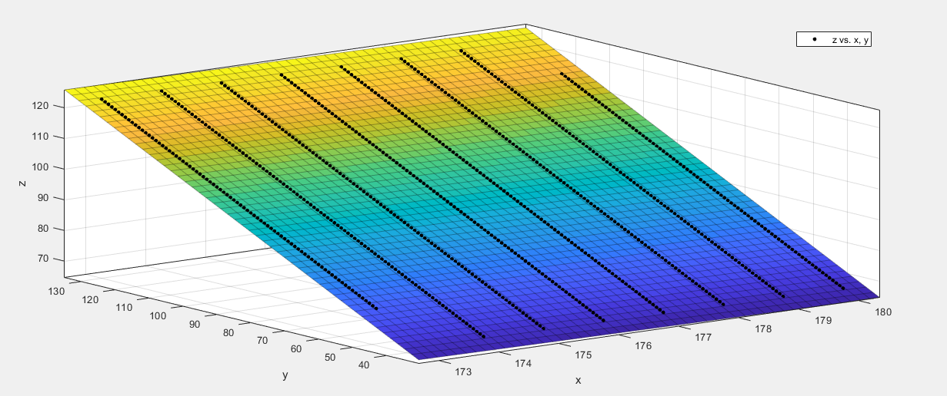

x(身高)，y(体重)，z(臀围)

Linear model Poly11:

f(x,y) = p00 + p10\*x + p01\*y

Coefficients (with 95% confidence bounds):

p00 = 93.4 (93.24, 93.57)

p10 = -0.2096 (-0.2106, -0.2087)

p01 = 0.581 (0.5809, 0.5811)

Goodness of fit:

SSE: 0.623

R-square: 1

Adjusted R-square: 1

RMSE: 0.02903

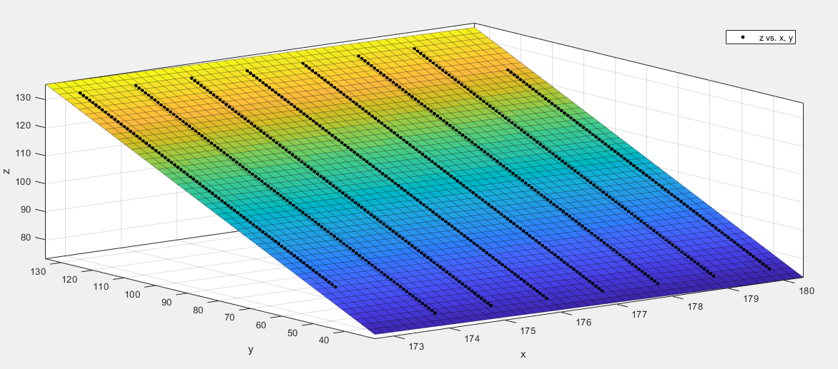

x(身高)，y(体重)，z(大腿围)

Linear model Poly11:

f(x,y) = p00 + p10\*x + p01\*y

Coefficients (with 95% confidence bounds):

p00 = 58.7 (58.53, 58.86)

p10 = -0.1753 (-0.1762, -0.1744)

p01 = 0.3861 (0.386, 0.3862)

Goodness of fit:

SSE: 0.6171

R-square: 1

Adjusted R-square: 1

RMSE: 0.0289

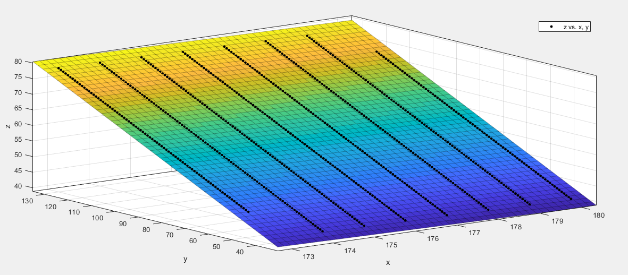

x(身高)，y(体重)，z(衣长)

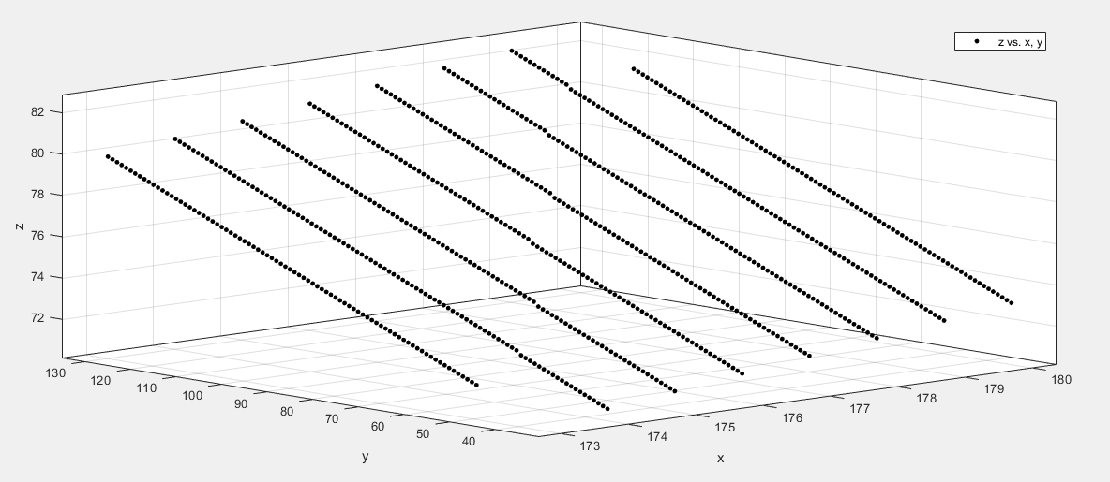

Linear model Poly11:

f(x,y) = p00 + p10\*x + p01\*y

Coefficients (with 95% confidence bounds):

p00 = -0.1645 (-0.3259, -0.003073)

p10 = 0.3871 (0.3862, 0.388)

p01 = 0.101 (0.1009, 0.1011)

Goodness of fit:

SSE: 0.5864

R-square: 0.9999

Adjusted R-square: 0.9999

RMSE: 0.02817

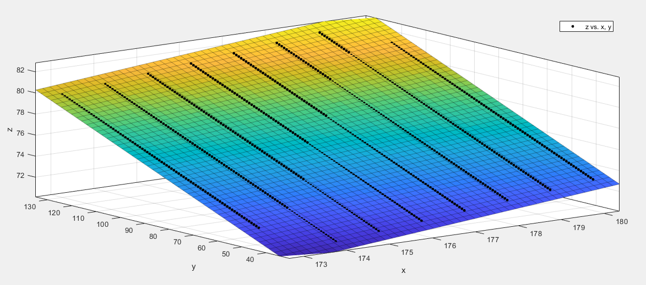

x(身高)，y(体重)，z(直档)

Linear model Poly11:

f(x,y) = p00 + p10\*x + p01\*y

Coefficients (with 95% confidence bounds):

p00 = 53 (52.84, 53.17)

p10 = -0.03379 (-0.03473, -0.03286)

p01 = 0.2493 (0.2492, 0.2494)

Goodness of fit:

SSE: 0.6192

R-square: 1

Adjusted R-square: 1

RMSE: 0.02895

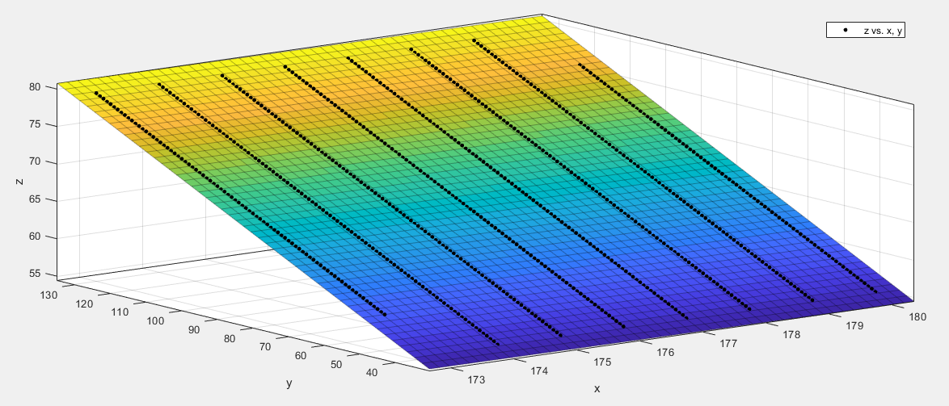

x(身高)，y(体重)，z(袖口

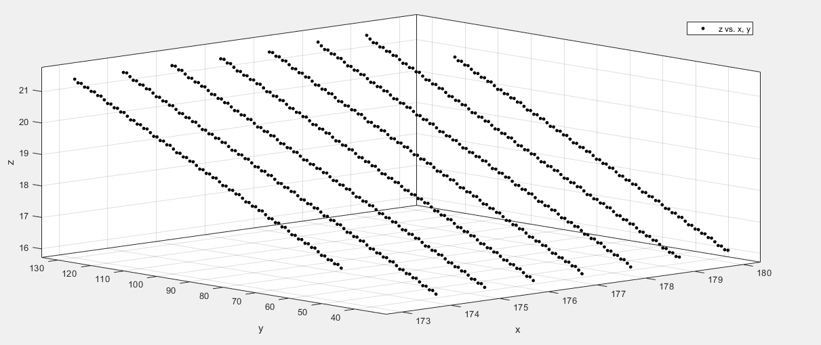

Linear model Poly11:

f(x,y) = p00 + p10\*x + p01\*y

Coefficients (with 95% confidence bounds):

p00 = 12.38 (12.21, 12.54)

p10 = 0.009432 (0.008496, 0.01037)

p01 = 0.0569 (0.05682, 0.05698)

Goodness of fit:

SSE: 0.6204

R-square: 0.9996

Adjusted R-square: 0.9996

RMSE: 0.02898

