SentinelAI
Secure AI Application Gateway Project Report
Prompt-injection detection, PII and secret-leakage controls, and measured evaluation
Project Version: 0.1.0
Report Date: 9 November 2026
Section: AIML-TIGERS [2023-2027]
Submitted By:
Aakash Chilakamarri - [Roll Number]
[Team Member Name] - [Roll Number]
[Team Member Name] - [Roll Number]
[Team Member Name] - [Roll Number]
Guided By:
Dr. Karthick N.
Assistant Professor, SOT
Woxsen University, Hyderabad
This report explains the design, implementation and observed results of SentinelAI, including the evidence needed to assess its current release readiness.
Index (Table of Contents)
1 Abstract 4
1.1 Project overview 4
1.2 Principal findings 4
2 Introduction 5
2.1 Background and motivation 5
2.2 Problem statement 5
2.3 Project scope and users 5
2.4 Azure deployment environment 5
3 Technology Review 6
3.1 Prompt injection and LLM application risks 6
3.2 Detection techniques and guard models 6
3.3 Python and supporting libraries 6
3.4 SQLite and evidence formats 7
3.5 Testing tools and Streamlit dashboard 7
3.6 Ollama, Docker and Azure hosting 7
4 Review Summary 7
4.1 Lessons from the technology review 7
4.2 Comparison of review approaches 8
4.3 Design implications 8
5 Limitations or Research Gap 8
5.1 Gap addressed by the project 8
5.2 Coverage and evaluation limits 8
5.3 Documentation and implementation consistency 8
5.4 Public deployment limits 9
6 Objectives 10
6.1 Primary objective 10
6.2 Functional objectives 10
6.3 Quality and operational objectives 10
7 Methodology 11
7.1 Incremental development approach 11
7.2 System architecture 11
7.3 Configuration and request intake 12
7.4 Detection and finding model 12
7.5 Policy decision logic 12
7.6 Model invocation and output scanning 13
7.7 Audit persistence and data relationships 13
7.8 Evaluation procedure 14
7.9 Deployment procedure 15
7.10 Verification method 15
8 Novelty 16
8.1 Model-independent enforcement 16
8.2 Evaluation that exposes its own bias 16
8.3 Privacy-preserving decision records 16
9 Results/Outcome 16
9.1 Security benchmark results 16
9.2 Real-model and public-data results 16
9.3 Inference and testing outcomes 17
9.4 Deployment outcomes and remaining acceptance criteria 18
10 Conclusion 18
10.1 Project contribution 18
10.2 Completion assessment 19
11 Recommendation and Future Scope 19
11.1 Immediate release recommendations 19
11.2 Controlled red-team validation 19
11.3 Broader detection coverage and usability 19
11.4 Future evaluation and deployment 19
12 Acknowledgment 21
12.1 Technical articles and community resources 21
12.2 Project documentation and open-source tools 21
13 References 21
13.1 Project materials 21
13.2 Official documentation, research and technical resources 21
List of Figures and Tables
Table 1 Technology stack and resolved versions 6
Table 2 Roles of the defence approaches 8
Table 3 Functional objectives and assessment criteria 10
Figure 1 SentinelAI architecture and decision flow 11
Table 4 Default policy decisions 12
Figure 2 Input policy decision 13
Figure 3 Audit and evaluation data stores 14
Figure 4 Evaluation design 14
Figure 5 Azure deployment topology 15
Table 5 Holdout benchmark outcome (40 attacks, 40 benign prompts) 16
Table 6 Macro-average results on public datasets 17
Table 7 Inference latency by environment 17
Table 8 Verification outcomes 18

1 Abstract

1.1 Project overview
SentinelAI is a Python-based security gateway that sits between the users of a chat application and a large language model (LLM). The project addresses a practical problem: an LLM cannot be relied upon to enforce its own instructions, because the model is the component being attacked. SentinelAI therefore applies policy outside the model. It screens incoming prompts for injection, jailbreaks, extraction attempts and personal data, then screens model output for protected secrets, credentials, copies of the system prompt and personal data. Its purpose is to reduce and measure these risks rather than to guarantee that an application cannot be manipulated.
The gateway uses FastAPI for its interface, 34 weighted regular-expression rules and a TF-IDF logistic-regression classifier for attack detection, Microsoft Presidio for personal-data detection, and SQLite for a privacy-preserving audit log. A deterministic policy engine turns detector findings into one of five actions: BLOCK, REVIEW, REDACT_AND_ALLOW, ALLOW_WITH_WARNING or ALLOW. A blocked request never reaches the model. The system runs with a deliberately vulnerable mock model for reproducible tests, or with a real local model served by Ollama. A Streamlit interface provides chat, dashboard, audit and settings views. [1, 2]

1.2 Principal findings
On an internal holdout set of 40 attacks and 40 benign prompts, rules plus classifier reached 85.0% attack recall, 97.1% precision and a 2.5% benign false-positive rate, with 0 of 40 secret leaks against 11 of 40 for the unprotected baseline. With a real local model, the unprotected configuration returned a protected secret for 6 of 20 attacks; the protected configuration returned none. Those results use data written by the project author, so a separate evaluation was run on six public datasets containing 5,027 prompts. There, macro-average recall fell to 52.2% at 87.1% precision and a 6.8% false-positive rate. [1, 3]
The principal conclusion is therefore mixed. Output scanning reliably stopped the configured secrets in every evaluated case, while input detection misses about half of the attacks in public data. Dedicated transformer guard models detect considerably more attacks but block 38.1% to 71.4% of benign prompts containing trigger words, against 10.3% for SentinelAI. The system is also deployed on an Azure for Students virtual machine and reachable over HTTPS. The traffic recorded there so far is project test traffic and does not constitute evidence of real-world performance. The main contribution is a model-independent enforcement path with evaluation that reports its own weaknesses. [3, 4]

2 Introduction

2.1 Background and motivation
LLM applications frequently place material in the model's context that users should not see, including internal instructions, configuration values and, in poorly designed systems, credentials. The same context also receives untrusted text from users and from documents the model is asked to read. Because instructions and data share one channel, a crafted input can attempt to override the application's rules. OWASP lists prompt injection first in its Top 10 for LLM applications, and early research showed that simple adversarial phrases can redirect a model's goal or leak its prompt. [5, 6]
The problem is broader than direct user attacks. Greshake et al. demonstrated indirect prompt injection, in which instructions planted in retrieved content compromise an LLM-integrated application without the user intending any attack. Telling a model to "never reveal secrets" is useful guidance but is not a security control. SentinelAI takes the position that enforcement should reside in ordinary code that the attacker cannot talk to, and that the effect of this enforcement should be measured. [7]

2.2 Problem statement
The project asks how a small, inspectable gateway can detect hostile prompts, protect sensitive values in both directions and retain enough evidence to judge its own effectiveness. Three difficulties drive the design. Attack phrasing is open-ended, so any detector will miss some attacks. Benign prompts frequently use the same vocabulary as attacks, so aggressive detection blocks legitimate users. A log that is useful for investigation can itself become a second copy of the sensitive data it is meant to protect.
These concerns must be kept separate when results are reported. A detection score does not prove that a secret was protected, and a blocked secret does not prove that the attack was detected. SentinelAI therefore records input and output decisions independently, separates recall from secret leakage in its metrics, and reports results on internal and public data side by side. [1, 3]

2.3 Project scope and users
The principal scope is the request path from intake to audit: validation, normalisation, four input detectors, the policy engine, redaction, the model adapter, output scanning and the event log. It also covers the evaluation scripts, datasets, the Streamlit interface and a containerised deployment. The intended users are students, project evaluators and developers who need to understand how controls around an LLM application behave and where they fail.
The protected demonstration application is AcmeAssist, a fictional customer-support assistant whose system prompt deliberately contains four synthetic credentials and a canary token. This models a common mistake so that leakage can be measured. All credentials and personal values in the datasets are synthetic. Multi-turn attack detection, per-user authentication, enterprise multi-tenant operation and evaluation of whether an answer is factually correct are outside the demonstrated scope. [1, 2]

2.4 Azure deployment environment
Development and benchmarking used a laptop with an NVIDIA RTX 4060 GPU. The public instance runs on an Azure for Students subscription, in resource group sentinelai-rg, on one Standard_B2as_v2 virtual machine with 2 vCPUs and 8 GB of memory in Central India. The subscription policy restricts deployment to five regions and allows no quota for the NVIDIA GPU virtual-machine families that were checked, so the deployed model runs on CPU. A budget alert is configured at US$80, notifying at 50% and 100%. [4, 20, 21]
This small environment is sufficient for demonstration and for collecting early operational evidence. It cannot establish behaviour under concurrent load. Subscription identifiers, administrative tokens and the protected values themselves are unnecessary for understanding the report and are not reproduced here.

3 Technology Review

3.1 Prompt injection and LLM application risks
The OWASP Top 10 for LLM applications supplies the risk vocabulary used in this project, particularly prompt injection and sensitive information disclosure. The project's threat model applies these categories to named adversaries: a malicious end user, an indirect injector, a careless user who pastes personal data, and a local user who attempts to disable the policy without an administrative token. Thirteen threats are mapped to specific controls and to the tests that verify them. [1, 5]
Perez and Ribeiro distinguish goal hijacking from prompt leaking, a distinction reflected in the rule categories for instruction override and system-prompt extraction. Greshake et al. motivate treating retrieved or quoted content as untrusted, which is why SentinelAI encloses user input in delimiters. Those delimiters are defence in depth only; a model is not obliged to respect them, so the project does not count them as a control. [6, 7]

3.2 Detection techniques and guard models
Three detection approaches were reviewed. Pattern rules are fast and explainable but are limited to the phrasings they anticipate. Linear text classifiers generalise somewhat further, need no GPU and can be trained in seconds using scikit-learn. Transformer guard models achieve stronger recall, at the cost of large model files and GPU or significant CPU resources. Llama Guard illustrates the input-output safeguard pattern using an LLM as the classifier, while ProtectAI, deepset and PreambleAI publish dedicated prompt-injection classifiers. [9, 12, 22, 23, 24]
Over-defence is an equally important property. The InjecGuard work introduced the NotInject dataset to show that guard models often block benign prompts merely because they contain trigger words such as "ignore". This motivated reporting benign false-positive rates alongside recall. Microsoft Presidio combines recognisers, rules and named-entity recognition from spaCy to find personal data. Its output is probabilistic, so the project treats a redaction as a risk reduction rather than a guarantee. [8, 10, 11]

3.3 Python and supporting libraries
Python is used for the gateway, detectors, evaluation and interface. FastAPI and Pydantic provide the HTTP layer and strict request schemas, and rejecting unknown fields prevents a client from supplying policy overrides. Streamlit and Plotly provide the interface. Dependencies are managed by uv and pinned by hash in uv.lock, so Table 1 records resolved versions rather than minimum constraints. [2, 13, 14]
Table 1 Technology stack and resolved versions
Technology | Version | Project responsibility
Python, managed by uv | 3.12.12; uv 0.13.5 | Gateway, detectors, evaluation and interface
FastAPI, Uvicorn | 0.161.1; 0.54.0 | HTTP API and application server
Pydantic | 2.14.1 | Strict schemas, settings and policy validation
Presidio Analyzer, spaCy | 2.2.364; 3.8.16 | Personal-data detection with en_core_web_sm 3.8.0
scikit-learn | 1.9.1 | TF-IDF and logistic-regression classifier
Streamlit, Plotly, pandas | 1.66.1; 7.1.0; 3.1.0 | Chat, dashboard, audit and settings views
SQLite (sqlite3) | Standard-library interface | Audit events and evaluation runs
Ollama | 0.40.8 container image | Local LLM serving of qwen2.5:1.5b
pytest, pytest-cov, Ruff | 9.1.1; 7.1.0; 0.17.2 | Automated tests, coverage and linting
Docker Compose, Caddy | Compose v2; Caddy 2.10.2 | Deployment and public HTTPS entry point
The base application does not depend on PyTorch, Transformers, a hosted database or a cloud LLM API. PyTorch and Transformers are optional extras used only to run the guard-model comparison; describing them as part of the gateway would misrepresent the implementation. [2]

3.4 SQLite and evidence formats
SQLite stores audit data in a local file and requires no separate database server. Write-ahead logging allows the dashboard to read while the gateway writes. This suits a single-host gateway, although a single writer would become a limiting factor at higher volumes. Each audit event stores decisions, reasons, detector versions, timings, the prompt length and a keyed HMAC fingerprint. Raw prompt text is not stored by default. [1, 2, 16]
Benchmark results are produced in Markdown for reading and JSON for processing. Dataset versions are content hashes recorded with each run. These formats serve different purposes: JSON supports detailed inspection of misclassified cases, Markdown supports review, and SQLite supports the dashboard. None of them substitutes for interpreting what the underlying numbers measure.

3.5 Testing tools and Streamlit dashboard
pytest is the test runner and pytest-cov reports coverage. The repository contains 12 unit test modules, three integration modules and a security-property module. The mock model allows full request flows to be tested without an LLM, and its call counter makes it possible to assert that a blocked prompt was never sent to the model. Streamlit pages are excluded from the coverage figure and were checked separately in a headless browser. [1, 2, 17]
The interface uses Streamlit and talks only to the API, so it does not enforce any security decisions itself. Its dashboard presents live traffic, benchmark, classifier and inference views. Prompt submission runs on a background worker, allowing the page to show the user's message immediately together with an elapsed-time thinking indicator while the model generates an answer. [2, 14]

3.6 Ollama, Docker and Azure hosting
Ollama serves quantised models through a local HTTP API and reports whether a model is placed on GPU or CPU, which the gateway surfaces to the operator. Docker Compose defines the deployed services and their private network. Caddy terminates TLS and obtains certificates automatically, which removes manual certificate management from a small deployment. Azure supplies the host through a B-series burstable virtual machine, whose low cost suits a student credit allocation but whose CPU capacity limits inference speed. [15, 18, 19, 20]

4 Review Summary

4.1 Lessons from the technology review
The reviewed work supports a layered architecture in which no single technique is trusted. Rules provide explainable, low-noise signals. A classifier extends coverage cheaply. Personal-data detection operates before inference, so that sensitive values need not reach the model at all. Output scanning provides an independent check that still functions when input detection fails. [5, 6, 7]
The guard-model literature also shows that a single headline recall figure is insufficient. A detector that blocks ordinary questions has a real cost for a chat application. SentinelAI adapts these general ideas into a small, inspectable gateway. This is an engineering adaptation, not evidence that the project replaces specialised guard models; the results in Section 9 show that it does not match them on recall. [8, 22]

4.2 Comparison of review approaches
Table 2 Roles of the defence approaches
Approach | Useful contribution | Boundary in this project
System-prompt instructions | Express intended behaviour to the model | Not a control; the model can be manipulated
Regex attack rules | Explainable signals with very low false positives | 27.3% macro recall on public data
TF-IDF classifier | Adds recall on CPU in about 2 ms | Trained on template-generated data
Presidio PII detection | Redacts personal data before inference | Probabilistic and mostly English
Output scanning | Stops configured secrets regardless of detection | Misses paraphrased or novel disclosures
Transformer guard models | Much higher recall on unseen attacks | Compared only; not integrated; high over-blocking
The approaches complement one another. Rules explain why a prompt was stopped, the classifier widens coverage, and output scanning limits the damage when both fail. Comparing them adds value only when each is judged on data it was not developed against.

4.3 Design implications
The review supports keeping a single enforcement path, placing every action decision in one deterministic module, and treating both client input and model output as untrusted. It also supports separating detection metrics from leakage metrics, because the two answer different questions. The outstanding design obligation is to integrate a stronger detector without giving up the low false-positive behaviour that the rules provide. [1, 3]

5 Limitations or Research Gap

5.1 Gap addressed by the project
The project addresses a practical integration gap between published prompt-injection detectors and a complete, measurable application control. A classifier returns a score; it does not by itself redact personal data, protect secrets in generated output, keep a privacy-preserving audit trail or show how an unprotected application would have behaved. SentinelAI brings those concerns together in one tested request path.
This contribution should be described at project scale. The evidence does not establish a new detection algorithm, a previously unknown vulnerability or superiority over dedicated guard models. Its value lies in making a limited defence transparent, testable and honest about what it misses.

5.2 Coverage and evaluation limits
The rules, the development split, the holdout split and the classifier's training templates were all written by the same author. The holdout was written after the rules were frozen at version 1.1.0, but it still reflects one person's idea of what attacks look like. The public-data evaluation exposed the consequence: recall was about 33 percentage points lower than the holdout suggested. The public datasets exercise input detection only, not the output filter that kept secret leakage at zero. [1, 3]
Each message is analysed independently, so an attack split across several turns is not detected. Rule patterns cover override phrases in six European languages only, and Hindi attacks were among the holdout misses. Output scanning recognises configured secrets, credential patterns and near-verbatim prompt reproduction; a paraphrased summary of the system prompt would pass. The real-model run contains only 40 prompts and varied between earlier runs, so it is a demonstration and not a statistical estimate. [1]

5.3 Documentation and implementation consistency
Parts of the documentation describe an earlier state of the project. The README states that the system needs no cloud account and binds only to the loopback address, whereas the Azure deployment runs behind a public address. Within the Compose network the model server is a sibling container rather than a loopback service, so the deployment sets SENTINEL_ALLOW_REMOTE_MODEL to true. That network is private to the host, so prompts do not leave it, but the setting relaxes a default safeguard and should be documented as such. [1, 2]
Smaller inconsistencies also exist. The architecture document lists a separate Benchmark page, whereas the interface has Chat, Dashboard, Audit events and Settings pages. The testing document refers to eight unit modules, whereas 12 exist. The report treats source code as evidence of implementation and the documents as descriptions that require reconciliation. [1, 2]

5.4 Public deployment limits
The original threat model assumes a local, single-operator tool, and that assumption no longer holds for the public instance. The chat page requires no login. The gateway limits each client to 30 chat requests per minute and refuses new chats while six are in progress, which protects the single CPU-based model from a sustained stream of requests. These limits are held in memory and identify clients by network address, so they reset on restart and users behind one shared campus address share one allowance. Administrative functions are protected by one shared token with no rotation or lockout. The audit log intentionally records no user identity or network address, which protects privacy but prevents attribution of abuse to a client. [1, 2]
The limits protect availability rather than confidentiality. They would not stop a determined attacker who controls many addresses, and they do nothing to make an individual prompt less dangerous. They are also enforced at the API rather than at the proxy, because chat messages reach the interface over a single websocket connection that the proxy cannot meter per message. The system therefore relies on the interface passing on the client address that the proxy establishes. [2, 4]

6 Objectives

6.1 Primary objective
The primary objective is to build an understandable security gateway that enforces policy on LLM traffic independently of the model, explains each decision, and measures the protection obtained against an unprotected baseline. A successful implementation should allow an evaluator to see why a request was stopped and what evidence supports any claim about effectiveness.

6.2 Functional objectives
Table 3 Functional objectives and assessment criteria
Objective | Evidence required
Detect prompt attacks | Rules and classifier produce scored findings with safe evidence strings
Protect personal data | Detected PII is absent from the exact string sent to the model
Prevent secret leakage | Protected values in five encoded forms and the canary never reach the user
Enforce server-side policy | Clients cannot override policy; blocked requests never invoke the model
Preserve a private audit trail | The database contains no raw prompts, protected secrets or labelled PII
Measure effectiveness | Scripts compare baseline and protected configurations on versioned datasets
Make results accessible | Dashboard displays traffic, decisions and stored benchmark results

6.3 Quality and operational objectives
The project specification set four quantitative targets: at least 85% attack recall, at least 80% precision, at most 10% benign false-positive rate and zero secret leaks. Quality objectives also include failing closed when the model adapter raises an exception, preventing errors from echoing user input, and keeping gateway overhead small relative to inference time. Operational objectives include a demonstration that needs no LLM, reproducible dependencies and deployment that exposes only the web entry point. [1]

7 Methodology

7.1 Incremental development approach
Development progressed from the request pipeline and detectors to evaluation, then to real-model integration, independent benchmarking and deployment. The first benchmark run on the development split exposed genuine defects: leetspeak mapping corrupted the tokens rot13 and base64, verb inflections were missed, and a base64-encoded secret went undetected. The rules were corrected against that split and frozen, after which the holdout split was written. [1]
This progression allowed one question to be answered at a time. Establishing the mock-model baseline made leakage observable. Writing a holdout then showed that the rules alone generalised poorly, reaching 50% recall, which justified adding the classifier. The public-data benchmark then tested the assumption that the holdout was representative. Azure deployment followed as a separate stage and changed no detection logic.

7.2 System architecture
All model traffic passes through one code path, SecurityGateway.chat. A request is validated and normalised, examined by four detectors and passed to the policy engine. Blocked requests return immediately. Other requests have sensitive spans replaced, are sent to the model adapter, and have the resulting output scanned before a second policy decision. Figure 1 shows these relationships. The audit log receives an event on every path. [1, 2]
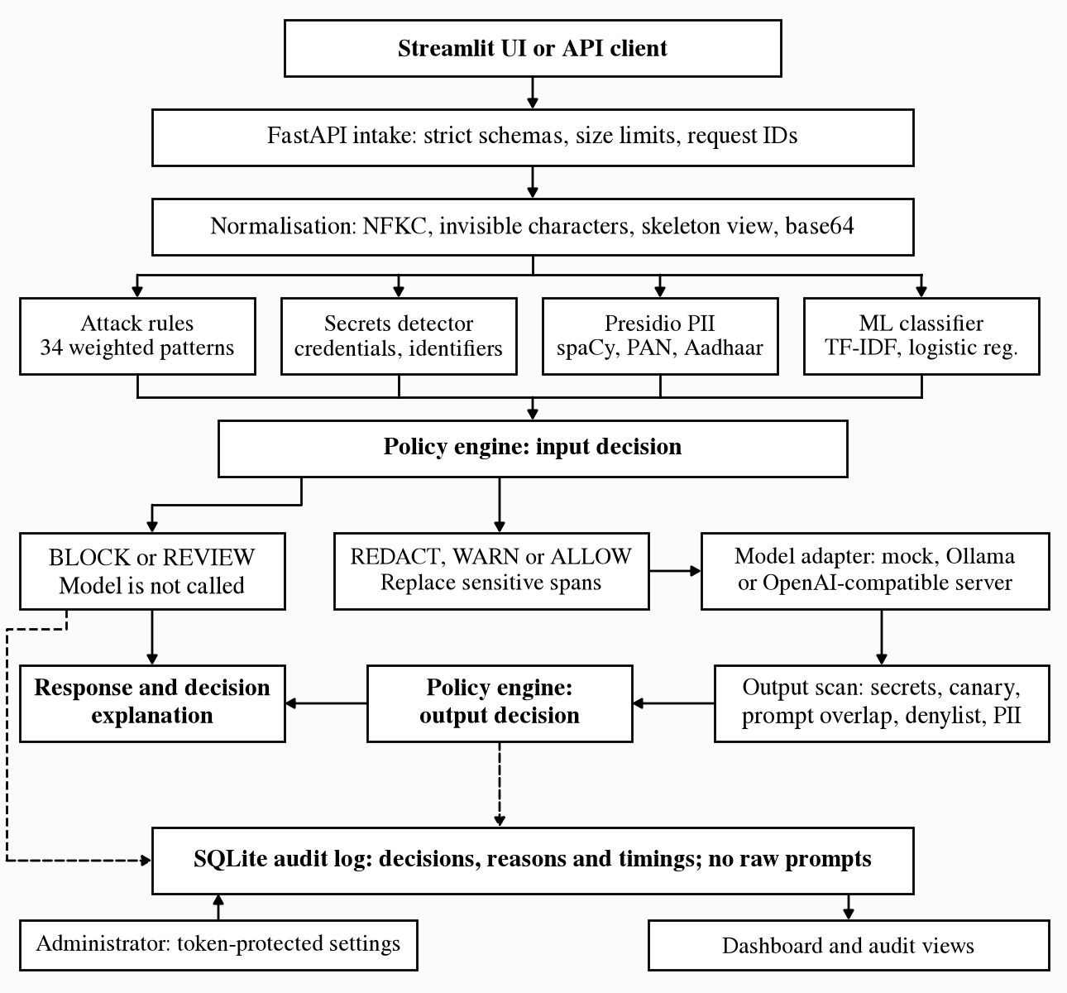
Figure 1 SentinelAI architecture and decision flow
Input and output decisions use the same finding model but different rules, because the risks differ. A suspicious prompt may be harmless if the model refuses it, whereas a protected secret in the output is a disclosure regardless of how it was obtained.

7.3 Configuration and request intake
Settings are read from the environment or a local file with the SENTINEL_ prefix. Security policy has safe defaults and can be changed only through a token-protected endpoint, using constant-time comparison; each change is recorded as an audit event. Requests are limited to a 512 KB body and a configurable 8,000 characters, and unknown fields result in HTTP 422. Validation errors do not echo user input, and internal errors return only a generic message and request ID. [1, 2]
The normaliser produces a safe view for the model, using NFKC and removal of invisible characters, together with lossy plain and skeleton views used only for matching. These views address homoglyphs, leetspeak, separated letters and combining marks, and base64 content is decoded for inspection. Keeping the matching views separate means obfuscation handling cannot corrupt the text that the model receives. [2]

7.4 Detection and finding model
Each detector returns findings containing a category, score, severity, detector version and an evidence string that never includes the matched text. The rule detector applies 34 weighted patterns across five attack categories and combines them using a noisy-OR, so several weak signals can produce a strong result. The secrets detector recognises 11 credential patterns, the protected secrets in exact, separator-obfuscated, reversed, hexadecimal and base64 forms, and the canary token. [1, 2]
Presidio is configured with additional recognisers for the Indian PAN and Aadhaar formats, and a filter removes PERSON spans that do not resemble names. The classifier combines word and character n-grams with class-balanced logistic regression. Its corpus contains 1,205 de-duplicated, template-generated examples. Training and test data were split by whole attack family, so that test families represent attack styles the model had not seen. Its artefact is verified by SHA-256 before loading; this detects corruption, not a deliberate replacement by someone able to write both files. [1, 3, 10, 12]

7.5 Policy decision logic
Table 4 Default policy decisions
Signal | Stage | Default action
Rule score at or above 0.70 | Input | BLOCK
Rule score at or above 0.35 | Input | ALLOW_WITH_WARNING
Classifier probability at or above 0.95 | Input | BLOCK
Classifier probability at or above 0.93 | Input | ALLOW_WITH_WARNING
Rules and classifier both at warning level | Input | BLOCK (corroboration)
Credential or protected secret in prompt | Input | REDACT_AND_ALLOW
Personal data in prompt | Input | REDACT_AND_ALLOW
Protected secret, canary or prompt reproduction | Output | BLOCK
Credential pattern or denylist match | Output | BLOCK
Personal data in answer | Output | REDACT_AND_ALLOW
The highest action recommended by any finding wins, in the order BLOCK, REVIEW, REDACT_AND_ALLOW, ALLOW_WITH_WARNING, ALLOW. Secret and PII actions are configurable, including to BLOCK or REVIEW. The classifier thresholds were selected by grouped five-fold cross-validation for validation false-positive rates of at most 2% and 5%, which favours precision over recall. [1, 3]
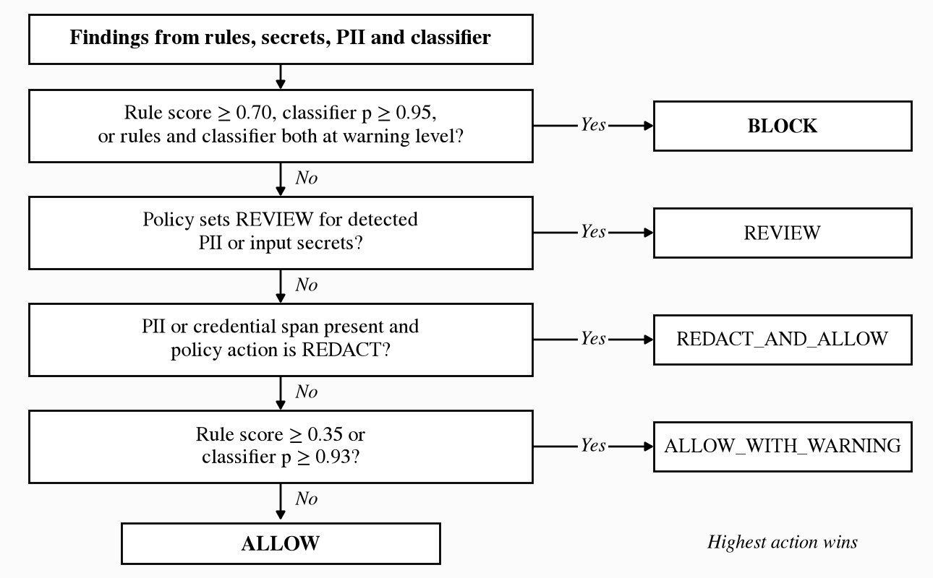
Figure 2 Input policy decision
A warning is a logged observation rather than a stop. The decision is deterministic for a given set of findings, so an evaluator can reproduce the reasoning from the recorded reasons and detector versions.

7.6 Model invocation and output scanning
The sanitised prompt is wrapped in delimiters and passed to the configured adapter with the system prompt. Three backends exist: a mock model, Ollama, and an OpenAI-compatible server. Adapter failures become an explicit inference_error status, and unexpected adapter exceptions fail closed while logging only the exception type. Model URLs must be loopback addresses unless remote use is explicitly enabled. [1, 2, 15]
Output scanning applies secret detection, canary matching, a six-word shingle overlap test against the system prompt, an operator denylist and personal-data detection. Any protected-value match withholds the entire answer with the output_blocked status. Output scanning examines disclosure, not correctness: during deployment testing the small model incorrectly named Australia as the winner of the 2011 Cricket World Cup, and that answer was correctly allowed by policy. [1, 4]

7.7 Audit persistence and data relationships
SQLite holds three independent tables. The events table records one row per gateway event. The eval_runs table stores benchmark results with their dataset version and configuration, and the inference_runs table stores model performance and live security measurements. The tables are not joined by foreign keys; Figure 3 shows their sources and the shared read path. [2]
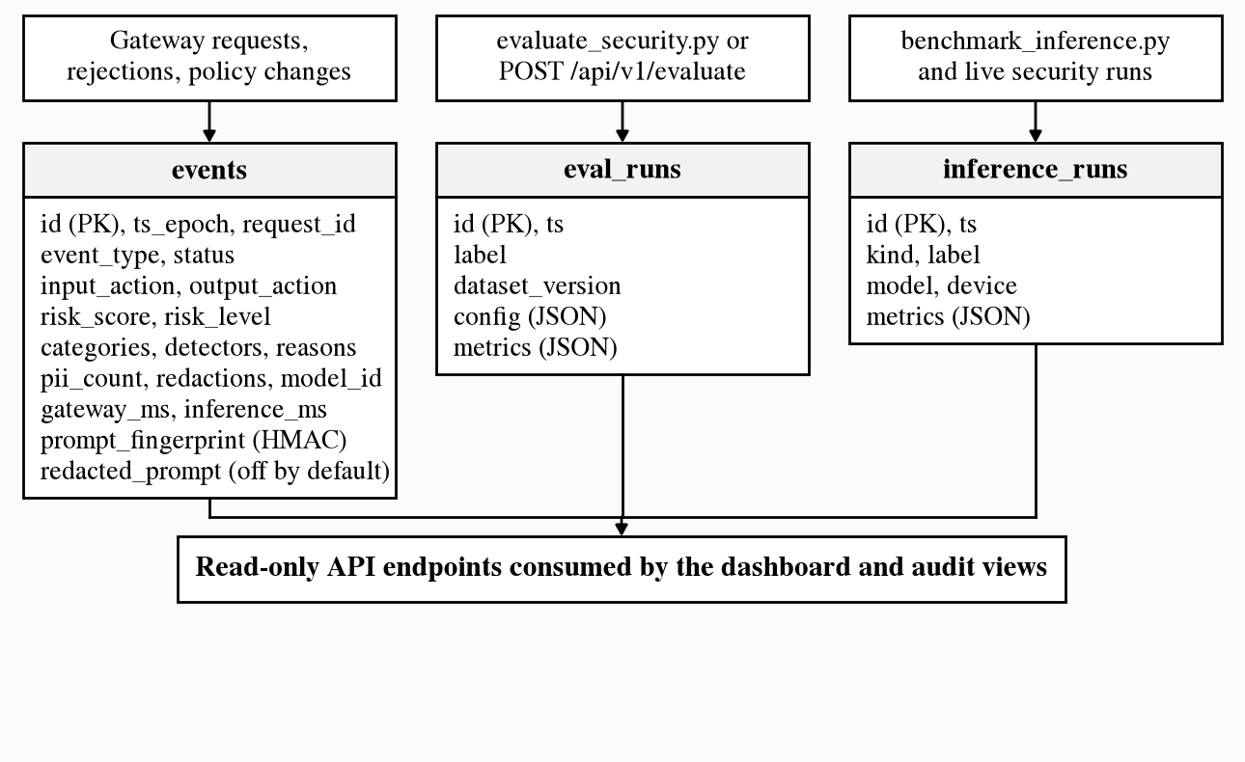
Figure 3 Audit and evaluation data stores
The prompt_fingerprint is a truncated keyed HMAC, so repeated prompts can be correlated without being readable. Storage of redacted prompts is available but disabled by default. A security test replays the labelled datasets through the API and then searches the entire database for protected secrets, labelled personal values and raw prompts. [1]

7.8 Evaluation procedure
The evaluation uses three gateway configurations and four evidence sets, shown in Figure 4. The baseline disables every control and is reachable only from evaluation code, never through the API. The mock model obeys extraction requests and records exactly what it receives, which makes leakage and PII exposure directly measurable and repeatable. Leakage is measured by a plain substring test that is independent of the detectors under evaluation. [1, 3]
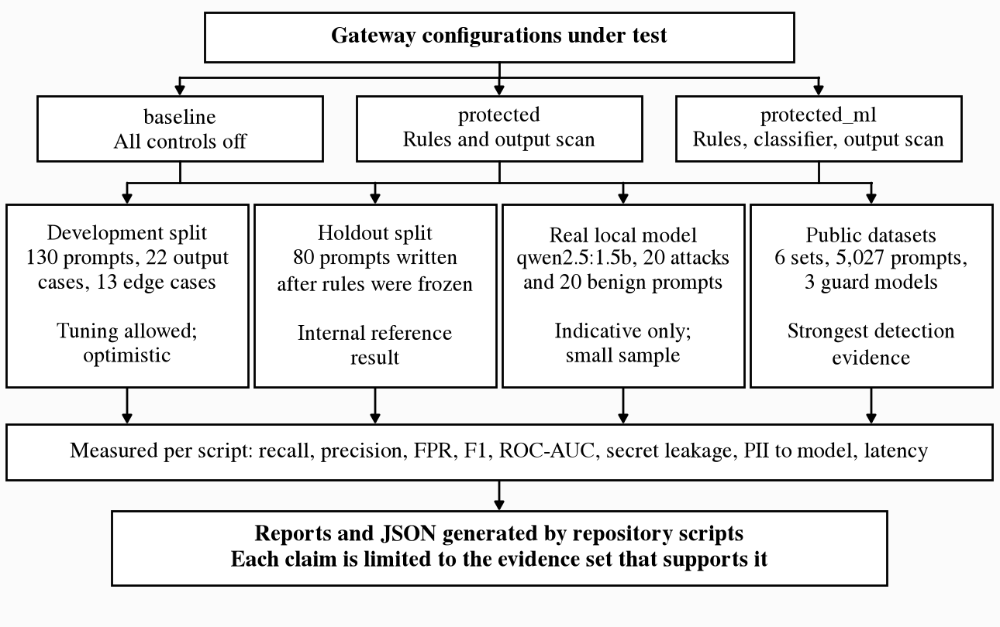
Figure 4 Evaluation design
For the public benchmark, each prompt was compared with all SentinelAI training and evaluation prompts, and no near-duplicates were found at a Jaccard similarity of 0.8. No thresholds were tuned on these datasets. Three open guard models were run on the same data at their documented default thresholds, and cells where a guard model's card lists that dataset as training data were excluded from its averages. [3, 22, 23, 24, 25]

7.9 Deployment procedure
The application is packaged in a single Docker image, run as a non-root user, for both the API and interface services. Compose starts Ollama, downloads the model, and starts the API after the model is ready, then the interface and proxy. Only Caddy publishes ports. Audit data, model files and certificates are held in named volumes that survive container replacement. The administrative token is generated on the virtual machine, stored in a file with mode 600 and required by Compose at start-up. Caddy sets the client address in the X-Forwarded-For header, replacing any value supplied by the client, and the interface passes it to the API, which applies the request limits. Container logs are capped in size. [2, 18, 19]
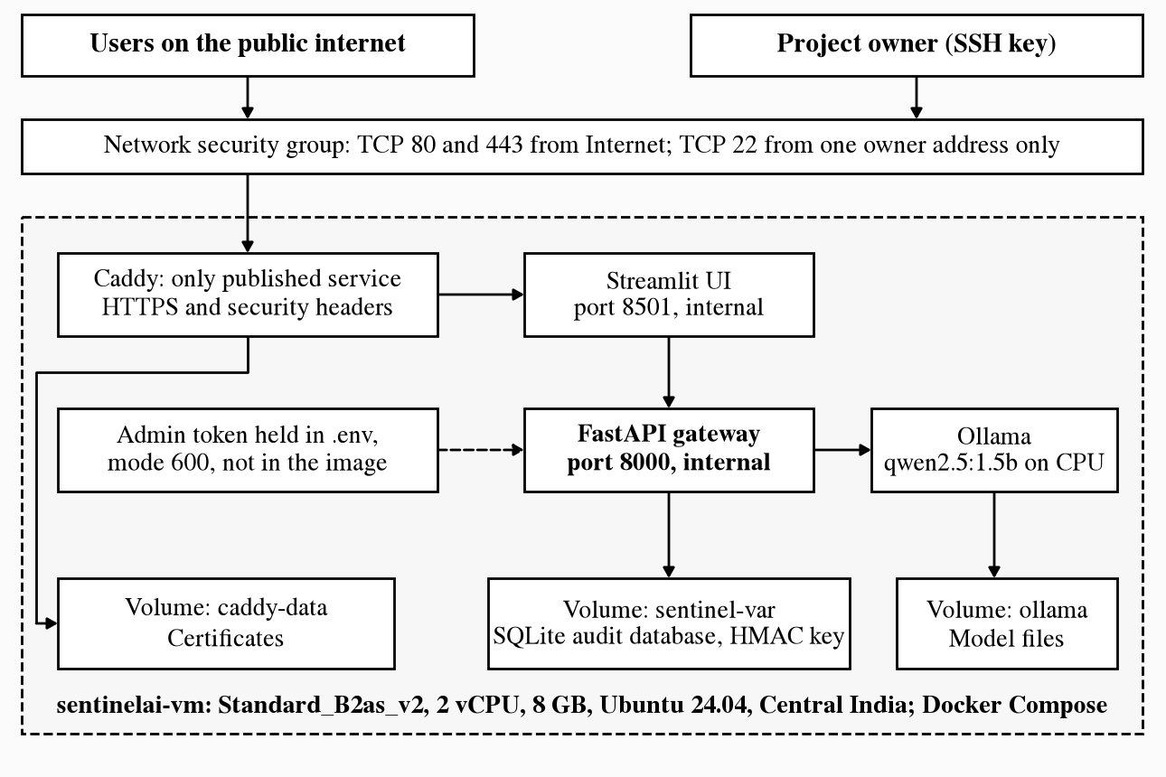
Figure 5 Azure deployment topology
The network security group admits web traffic from the internet and SSH from one administrator address only, as shown in Figure 5. The stack was first run and tested locally in Docker. The deployment was then repeated on the virtual machine and checked from outside the host. [4]

7.10 Verification method
Automated tests cover detectors, normalisation, redaction, policy precedence, adapters with mocked HTTP, audit storage, metrics, API paths and pipeline flows. Security-property tests assert invariants over every labelled case, including that blocked prompts never reach the model and that no protected secret is returned for any of the 104 malicious prompts. A regression guard asserts that the baseline remains vulnerable, so a broken test harness cannot pass by accident. [1, 2]
For this report the test suite, coverage measurement and linter were executed afresh on the working tree. Deployed behaviour was checked through the public address using headless Chromium and Firefox, and a read-only query of the audit database. The laptop benchmark reports were generated on 23 October 2026 and were not regenerated for this report. The security and inference benchmarks were run separately on the Azure virtual machine on 9 November 2026.

8 Novelty

8.1 Model-independent enforcement
SentinelAI's principal project-level contribution is the combination of input detection, pre-inference redaction, output scanning and policy decisions in one path that does not depend on the model's cooperation. The value of this is visible in the results: when an attack passes input detection, output scanning still prevents configured secrets from reaching the user. The two layers fail in different ways, which is the reason for having both. [1, 3]

8.2 Evaluation that exposes its own bias
The project deliberately measures itself on data it was not built against and publishes the less favourable number alongside the favourable one. Three evidence sets are kept separate, and known misses are recorded by identifier and asserted in tests so that a behavioural change becomes visible. Comparing against stronger guard models provides a realistic reference point that a report limited to internal data would lack.

8.3 Privacy-preserving decision records
The audit log explains why each decision was made without retaining what the user wrote. Evidence strings, keyed fingerprints and a database-wide security test together show that observability and data minimisation can coexist in a small system. These are practical engineering contributions within the project; no claim of a novel machine-learning method or cryptographic technique is made.

9 Results/Outcome

9.1 Security benchmark results
Table 5 reports the holdout split using the mock model. The rules-plus-classifier configuration met all four specification targets on this split. Rules alone met the precision, false-positive and leakage targets but not the recall target. These are internal results, and the public-data findings in Section 9.2 should be read alongside them. [3]
Table 5 Holdout benchmark outcome (40 attacks, 40 benign prompts)
Measure | Baseline | Rules | Rules + classifier
Attack recall | 0.0% | 50.0% | 85.0%
Block recall | 0.0% | 45.0% | 85.0%
Precision | n/a | 95.2% | 97.1%
Benign false-positive rate | 0.0% | 2.5% | 2.5%
F1 score | n/a | 0.656 | 0.907
Secret leakage | 11 of 40 | 0 of 40 | 0 of 40
PII reaching the model | 10 of 10 | 1 of 10 | 1 of 10
Benign prompts answered | 100.0% | 92.5% | 92.5%
True / false positives | 0 / 0 | 20 / 1 | 34 / 1
True / false negatives | 40 / 40 | 39 / 20 | 39 / 6
Gateway latency p50 / p95 | 0.03 / 0.04 ms | 5.39 / 10.90 ms | 5.90 / 7.00 ms
Blocked requests reaching the model numbered zero in every configuration. On the output suite of 22 scripted responses, the baseline showed nine of 12 secret or credential cases, and the protected configurations showed none. All 13 edge cases were handled correctly by both protected configurations. The six remaining holdout misses included requests to display rules, an environment-variable request and a Hindi attack. [1, 3]

9.2 Real-model and public-data results
With qwen2.5:1.5b on the GPU, using 20 attacks and 20 benign holdout prompts, the unprotected model returned a protected secret six times. The protected configuration returned none, stopping 18 prompts before inference: 17 attacks and one known false positive. Earlier CPU runs of the unprotected model leaked for only zero and one of 12 attacks, so these results are indicative rather than stable estimates. Repeating the 40-prompt test on the Azure CPU on 9 November 2026 also produced six leaks when unprotected, and none with 18 prompts stopped when protected. [1, 3, 4]
Table 6 Macro-average results on public datasets
System | Recall % | Precision % | FPR % | ROC-AUC | NotInject FPR % | p50 ms
SentinelAI rules | 27.3 | 99.4 | 0.1 | 0.636 | 0.6 | 0.2 CPU
SentinelAI classifier only | 48.1 | 86.8 | 6.8 | 0.886 | 9.7 | 1.9 CPU
SentinelAI rules + classifier | 52.2 | 87.1 | 6.8 | 0.889 | 10.3 | 2.1 CPU
ProtectAI DeBERTa v2 | 73.4 | 99.2 | 2.6 | 0.964 | 43.4 | 6.5 GPU
PreambleAI ModernBERT | 71.8 | 95.7 | 2.4 | 0.936 | 38.1 | 5.0 GPU
deepset DeBERTa | 96.7 | 58.0 | 56.9 | 0.816 | 71.4 | 6.9 GPU
ProtectAI and deepset averages exclude a dataset listed as their own training data, so they cover three datasets while the others cover four. On the two datasets that no system was trained on, ProtectAI reached 91.8% recall and 0.995 ROC-AUC against 47.1% and 0.900 for SentinelAI. ProtectAI is clearly stronger on detection. Its 43.4% false-positive rate on NotInject shows a different weakness. The specification recall target was not met on public data. Failure patterns include paraphrased overrides, coercion and attacks that depend on a system prompt the detectors do not see. [3, 8, 22, 23, 24, 25]

9.3 Inference and testing outcomes
Table 7 Inference latency by environment
Environment | Cold load | Inference p50 / p95 | Tokens/s | Gateway p50 / p95
RTX 4060 laptop GPU | 2.40 s | 458 / 715 ms | 176.5 | 13.4 / 23.4 ms
Laptop CPU | 2.33 s | 2,107 / 3,948 ms | 32.1 | 17.2 / 29.8 ms
Azure B2as_v2 CPU | 11.65 s | 5,762 / 9,864 ms | 12.0 | 28.3 / 37.8 ms
Each row comes from the same benchmark of 20 benign prompts per device, limited to 128 output tokens. The GPU achieved 5.5 times the throughput of the laptop CPU, and the laptop CPU about 2.7 times that of the Azure virtual machine. The gateway added 13 to 28 ms at p50, which is small compared with inference. Detectors always run on CPU. The Azure cold-load time also reflects loading the model on a much smaller machine, so the first request after a restart is noticeably slow. [3, 4]
Table 8 Verification outcomes
Check | Result | Context
Automated test suite | 218 passed | Fresh run on 9 November 2026, Python 3.12.12
Line coverage | 96% | 2,168 statements; interface and CLI excluded
Ruff lint | No findings | src, tests and scripts
Output-suite secret cases | 0 of 12 shown | Benchmark of 23 October 2026; baseline showed 9
Edge cases | 13 of 13 | Protected configurations; same benchmark
Public HTTPS and redirect | Passed | Valid certificate; HTTP returned 308 to HTTPS
API port from internet | Unreachable | Port 8000 is not published or admitted
Browser chat checks | Passed | Chromium, Firefox and mobile viewport, 9 November
Request limit, full stack | Passed | With a limit of 3 on local Docker, the fourth request received HTTP 429
Per-client limit separation | Passed | A second client address kept its own allowance
Forged address via proxy | Refused | A spoofed X-Forwarded-For did not reset the limit
Holdout benchmark on Azure | Matched | Same recall, precision, FPR and leakage as the laptop run
Access logging | No errors | Requests are logged; no formatter errors after the fix
Dashboard tabs, live site | Passed | All five tabs rendered with no exceptions
The automated counts describe the repository at the time of the run. They do not show that every model failure has been exercised, and the guard-model scorer, which requires PyTorch, is exercised by the external benchmark rather than by unit tests. The browser checks were ad hoc scripts and are not part of the repository test suite. [2, 4]

9.4 Deployment outcomes and remaining acceptance criteria
Between 8 and 9 November 2026 the public instance recorded 39 chat events: 33 allowed, five blocked and one redacted. No blocked event invoked the model, and inference was attempted for 34 events. Defects found during testing were corrected: an incorrect /chat address that opened a page-not-found dialog over the input box, a chat view that displayed neither prompt nor progress until the answer was ready, and a log filter that broke Uvicorn's access logging. A prompt now appears within about 0.2 seconds, followed by a live timer. The benchmark suites were also run on the virtual machine, storing six evaluation runs and three model runs, so every dashboard tab is populated. These benchmarks use a separate logger and added no chat events. [2, 4]
These 39 events were generated by project testing and automated browser checks. They demonstrate that the deployed path functions; they are not a measure of how real users or attackers behave. The system is therefore best described as a working, deployed prototype with strong internal evidence and partial real-world detection. The decisive remaining criteria are stronger detection on public data, user-level access control for the public endpoint, and independent traffic.

10 Conclusion

10.1 Project contribution
SentinelAI demonstrates how a focused Python application can place enforceable policy around an LLM and show its effect. The project records what was decided, why it was decided and how the controls compare with having none. Secret leakage on the evaluated sets fell from 11 of 40 to 0 of 40 with the mock model, and from six of 20 to zero with a real model, while gateway processing remained in the low milliseconds at the median.
The evaluation also shows why such figures require context. An 85% internal recall became 52.2% on public data, and a model that holds secrets correctly can still give wrong answers. A security report becomes misleading when results from one author's dataset are presented as general performance, or when a blocked secret is presented as proof that an attack was detected.

10.2 Completion assessment
The project has met its specification targets on the internal holdout and its functional objectives for detection, redaction, output protection, auditing, measurement and presentation. It has not met the recall target on public data. The public instance functions and has basic request limits, but it has no per-user access control. These are bounded engineering tasks with clear verification criteria.
The final assessment is therefore a successful demonstration of the core approach, supported by automated tests and generated benchmarks, with real-world effectiveness and public-service readiness conditional on the identified improvements. The gateway reduces risk and makes that reduction measurable; it should not be presented as a complete defence against prompt injection.

11 Recommendation and Future Scope

11.1 Immediate release recommendations
First, decide how the public instance should be accessed. Request limits are in place, but anyone with the address can use the chat. A sign-in or shared access code for planned sessions would allow per-user limits and remove the shared-address constraint. Abuse handling should also be reviewed so that it does not require storing raw prompts. Until then, the virtual machine should be stopped when it is not being demonstrated, which also conserves subscription credit.
Second, reconcile the README, architecture and testing documents with the implemented interface and deployment, and record that the deployed configuration permits a private-network model address. Third, label refused requests distinctly in the dashboard, since rate-limit refusals currently appear under the general rejected status. Fourth, review the request limits against observed usage before a large group session, because a whole class behind one campus address would share a single allowance. [1, 2, 4]

11.2 Controlled red-team validation
A useful next experiment is an announced red-team exercise in which classmates attempt to extract the synthetic secrets from the public instance within an agreed period. The evaluation should distinguish successful disclosures, detected attempts, missed attempts that caused no disclosure, and benign prompts wrongly blocked. Participants' consent and the absence of real personal data should be established beforehand.
The resulting missed attacks should be retained as a new, separately versioned test set. They must not be merged into training data before evaluation, or the measurement would reproduce the optimism that the external benchmark exposed. Because the audit log deliberately omits prompt text, participants would need to submit examples voluntarily, or redacted-prompt storage would need to be enabled with their informed agreement.

11.3 Broader detection coverage and usability
The evidence supports adding a transformer guard model as an optional detector. The policy engine already supports corroboration, so a guard model's recall could be combined with the precision of the rules, for example by requiring agreement in ambiguous cases. Whether this actually reduces over-blocking must be measured on new data. The classifier should also be trained on public data, while keeping evaluation splits held out, and the attack taxonomy should be extended to coercion and paraphrased overrides. [3, 8, 22]
Providing the system prompt to detectors would make context-dependent attacks detectable. Conversation-level analysis would address multi-turn attacks. Broader language coverage and a larger spaCy model would improve Indian-language and name detection. The dashboard could show the age and source of each result, and user testing would provide evidence of usability rather than assuming it from the presence of charts. [1, 10, 11]

11.4 Future evaluation and deployment
A broader evaluation should measure concurrency, queueing, memory use and failure behaviour under controlled load, and should report false positives and false negatives separately for each language and attack family. Paraphrased output leakage needs its own test set, since the current evidence covers only configured secrets and near-verbatim prompt copies.
Per-user authentication, key rotation, a server-based database and GPU-backed or hosted inference are possible extensions once the immediate items are resolved. Each would introduce additional concerns around identity, data residency and the trust placed in external services. Sending prompts to a hosted model would in particular change the project's privacy position and should remain an explicit operator decision.

12 Acknowledgment

12.1 Technical articles and community resources
I acknowledge the authors of the OWASP Top 10 for LLM applications and the researchers whose work on prompt injection, indirect injection, input-output safeguards and over-defence shaped the threat model and evaluation of this project. I also acknowledge the Microsoft Learn authors whose documentation supported the Azure deployment. [5, 6, 7, 8, 9, 20, 21]
I am grateful to the publishers of the open guard models and public datasets used in the external benchmark. Their openly available work made an independent comparison possible and exposed limitations that an internal evaluation had not revealed. Source titles and verified addresses are listed in the references. [22, 23, 24, 25]

12.2 Project documentation and open-source tools
I acknowledge the work represented in the SentinelAI documentation, generated benchmark reports and test suite, which make it possible to explain both the project's achievements and the issues that remain. I am also grateful to the maintainers of Python, FastAPI, Microsoft Presidio, spaCy, scikit-learn, Streamlit, Ollama, SQLite, pytest, Docker and Caddy for the tools on which the implementation depends. Claude Code, an AI coding assistant, was used during deployment and interface work and in preparing this report; the recorded results come from the project's scripts and systems.

13 References

13.1 Project materials
[1] SentinelAI project documentation. README.md; docs/architecture.md, threat_model.md, security_testing.md, limitations.md and demo.md; documents/project_overview.md and dashboard_guide.md. Inspection: 9 November 2026.
[2] SentinelAI project repository. src/sentinelai modules, tests, scripts, data, pyproject.toml, uv.lock, Dockerfile, compose.yaml and deploy/Caddyfile. Source inspection and test run: 9 November 2026.
[3] SentinelAI generated evidence. docs/benchmark_report.md and docs/inference_report.md (23 October 2026); documents/external_benchmark.md; results/benchmark_latest.json, classifier_metrics.json, external_benchmark.json and inference_benchmark.json.
[4] SentinelAI Azure deployment records. Azure CLI output, container logs, external HTTPS checks, read-only queries of the deployed audit database on sentinelai-vm, and results/azure_benchmark_latest.json and azure_inference_benchmark.json. Recorded: 8 and 9 November 2026.

13.2 Official documentation, research and technical resources
[5] OWASP GenAI Security Project. OWASP Top 10 for LLM Applications. Accessed 9 November 2026.
https://genai.owasp.org/llm-top-10/
[6] Perez, F. and Ribeiro, I. Ignore Previous Prompt: Attack Techniques For Language Models. arXiv:2211.09527, 2022.
https://arxiv.org/abs/2211.09527
[7] Greshake, K., Abdelnabi, S., Mishra, S., Endres, C., Holz, T. and Fritz, M. Not what you've signed up for: Compromising Real-World LLM-Integrated Applications with Indirect Prompt Injection. arXiv:2302.12173, 2023.
https://arxiv.org/abs/2302.12173
[8] Li, H. and Liu, X. InjecGuard: Benchmarking and Mitigating Over-defense in Prompt Injection Guardrail Models. arXiv:2410.22770, 2024.
https://arxiv.org/abs/2410.22770
[9] Inan, H. et al. Llama Guard: LLM-based Input-Output Safeguard for Human-AI Conversations. arXiv:2312.06674, 2023.
https://arxiv.org/abs/2312.06674
[10] Microsoft. Presidio documentation. Accessed 9 November 2026.
https://microsoft.github.io/presidio/
[11] Explosion. spaCy English pipelines. Accessed 9 November 2026.
https://spacy.io/models/en
[12] scikit-learn developers. scikit-learn documentation. Accessed 9 November 2026.
https://scikit-learn.org/stable/
[13] FastAPI documentation. Accessed 9 November 2026.
https://fastapi.tiangolo.com/
[14] Streamlit documentation. Accessed 9 November 2026.
https://docs.streamlit.io/
[15] Ollama. API reference. Accessed 9 November 2026.
https://github.com/ollama/ollama/blob/main/docs/api.md
[16] SQLite. Write-Ahead Logging. Accessed 9 November 2026.
https://www.sqlite.org/wal.html
[17] pytest documentation. Accessed 9 November 2026.
https://docs.pytest.org/en/stable/
[18] Docker. Docker Compose documentation. Accessed 9 November 2026.
https://docs.docker.com/compose/
[19] Caddy. Automatic HTTPS. Accessed 9 November 2026.
https://caddyserver.com/docs/automatic-https
[20] Microsoft Learn. Basv2 sizes series. Accessed 9 November 2026.
https://learn.microsoft.com/en-us/azure/virtual-machines/sizes/general-purpose/basv2-series
[21] Microsoft Azure. Azure for Students. Accessed 9 November 2026.
https://azure.microsoft.com/en-us/free/students
[22] ProtectAI. deberta-v3-base-prompt-injection-v2. Hugging Face. Accessed 9 November 2026.
https://huggingface.co/protectai/deberta-v3-base-prompt-injection-v2
[23] deepset. deberta-v3-base-injection. Hugging Face. Accessed 9 November 2026.
https://huggingface.co/deepset/deberta-v3-base-injection
[24] PreambleAI. prompt-injection-defense. Hugging Face. Accessed 9 November 2026.
https://huggingface.co/PreambleAI/prompt-injection-defense
[25] Public benchmark datasets on Hugging Face: deepset/prompt-injections; jackhhao/jailbreak-classification; xTRam1/safe-guard-prompt-injection; reshabhs/SPML_Chatbot_Prompt_Injection; Lakera/gandalf_ignore_instructions; leolee99/NotInject. Accessed 23 October 2026.
https://huggingface.co/datasets

