3.

STEPS:

1. install

sudo apt-get install john

2. combine files

unshadow /etc/passwd /etc/shadow > test_passwd

3. use dictionary cract password

john --wordlist=/mnt/d/Code/ComputerSecurityRepo/HW2/dictionary.txt test_passwd

4. wait for the results

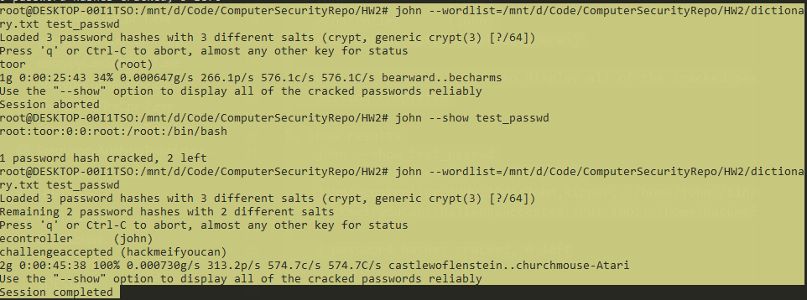

Loaded 3 password hashes with 3 different salts (crypt, generic crypt(3) [?/64])

Press 'q' or Ctrl-C to abort, almost any other key for status

toor (root)

econtroller (john)

challengeaccepted (hackmeifyoucan)

Use the "--show" option to display all of the cracked passwords reliably

Session completed

5. show results

