AIMMS-MOPTA 2026 Project Readme

Welcome to the AIMMS MOPTA Starter Project (2026)
This project is intended as a starting point for AIMMS-MOPTA competition students who are building an optimization models using AIMMS.
The project already includes:
- A basic project structure
- Examples of reading input data using pyaimms and aimmspy
- Core AIMMS identifiers (sets, parameters)
- Simple UI components for interacting with the model
You are expected to extend and modify this project for your own MOPTA assignment or experiments.
Purpose of This Project
This starter project is designed to help you:
- Get familiar with the AIMMS modeling language
- Understand how data flows can into an AIMMS model
- See how optimization models connect to a simple user interface
- Focus on modeling and optimization logic, rather than project setup
You do not need prior AIMMS experience to get started, but basic knowledge of optimization concepts is assumed.

Project structure
Refer to the screenshot below, the model tree contains:
- Raw Input Data a section used to store data from the provided .xlsx file. This section demonstrates how a data model can be structured and read into AIMMS using the pyaimms and aimmspy libraries. Note: not all data has been read in for you.
- UI Basic user interface components to help get you started, e.g., a workflow containing three pages: Data, Control Panel, Results. This mimics the flow of many operational optimization applications. The UI section also contains a page action for the Data page.
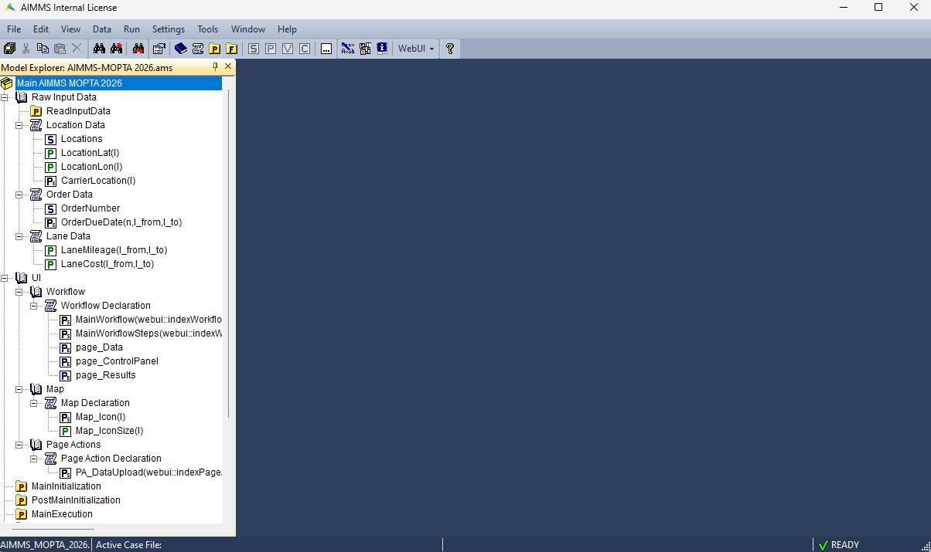
The procedure ReadInputData calls a python script that lives in the project, read_input_data.py. This python file can be adjusted to read all data into the AIMMS model from the appropriate Excel file (defined in line 6), but must be run from AIMMS:
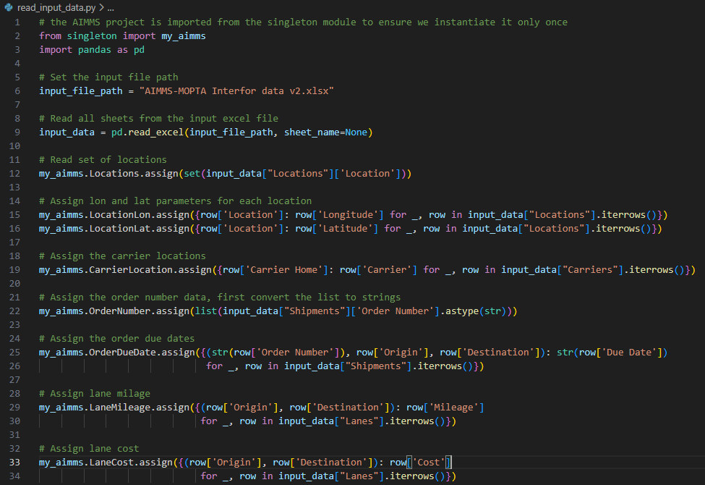

To run the ReadInputData procedure, you can right click on the procedure in the Model Tree and click “Run Procedure”, or, click on in the toolbar, and navigate to the Data page and click on the page action that will automatically run the procedure:
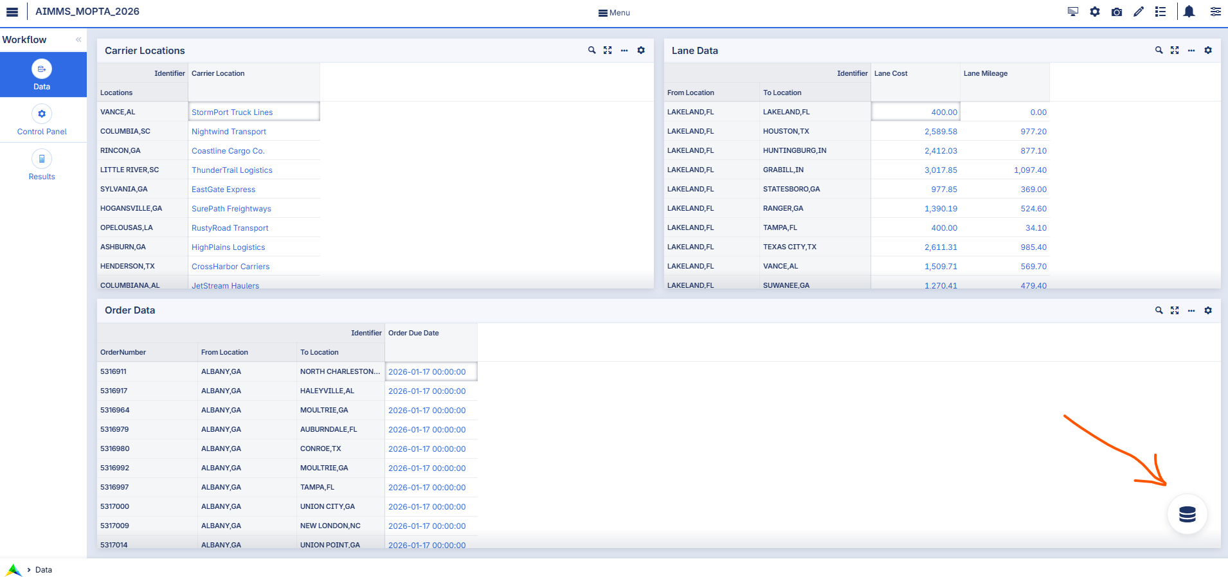

This project is intended purely as a starting point to help you get up and running with AIMMS quickly. It is not a complete solution, nor does it prescribe how your final model should look. You are expected to explore, adapt, and extend the project as needed for your own work. For a deeper understanding of AIMMS modeling concepts and best practices, we strongly recommend the AIMMS eLearning courses Modeling with AIMMS I, II, and III:
https://elearning.aimms.com/course/modeling-with-aimms-i
https://elearning.aimms.com/course/modeling-with-aimms-ii
https://elearning.aimms.com/course/modeling-with-aimms-iii

