**Documentation**

To

WalkingPeopleDetect.cpp

Made by Eszter Tóth

Note: You can try out every functions in the code if you remove comment (//) from the imshow. I have left imshows after every main function so you can try it out to see what they are do.

You can stop the program running with ESC.

Before you run it, write your video name to main function (now it is adasvideo.mp4, because I saved you video to my computer in this name).

1. Proceed video and copy every frame to Mat temp (so the original video won’t be injured, if I modify things with opencv.

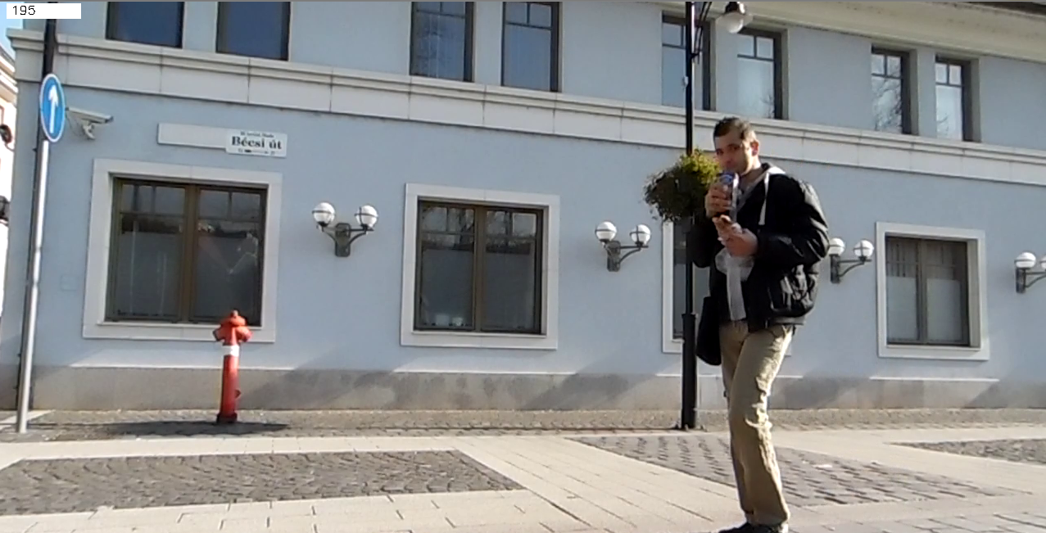

1. With BackgroundSubtractorMOG2 function I have cropped all of the background and shadows, I have made the settings to cut all of the background pixels, but in this case the function cuts some black part of the people.

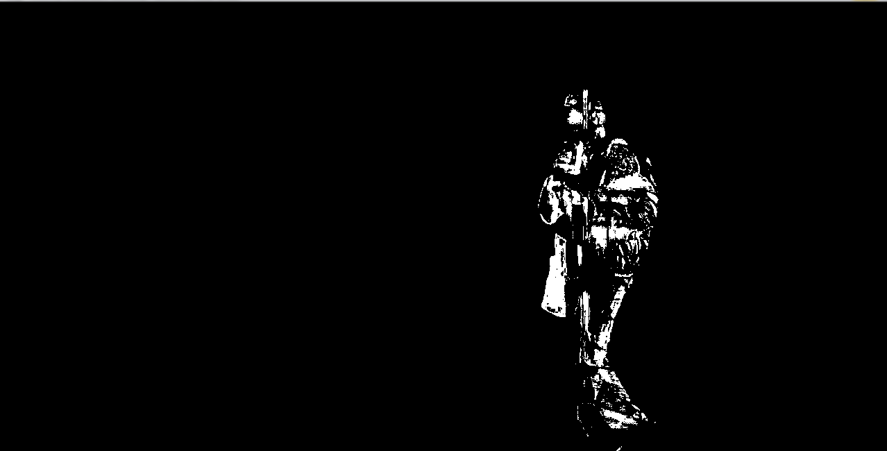

1. In this part I made some transformation with man-sized shape with no shadow, I grow pixels with dilate and blur the image so the holes are filled, but it has no more man shape, but something similar, and it is always move with people. I will use it as a mask.

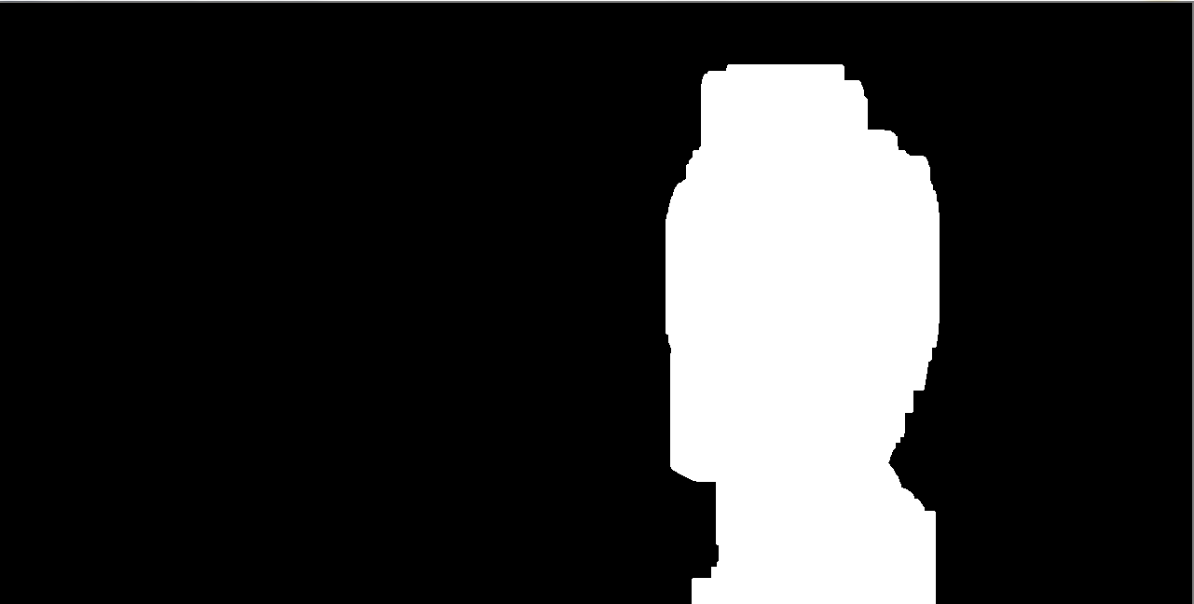

1. I have created another background subtraction with BackgroundSubtractorMOG2 , but this time I made more permissive settings, so the function has not cut anything (or very little) from the shape of the walking man, but this way the shadow not disappeared and there were a little noise in the background.

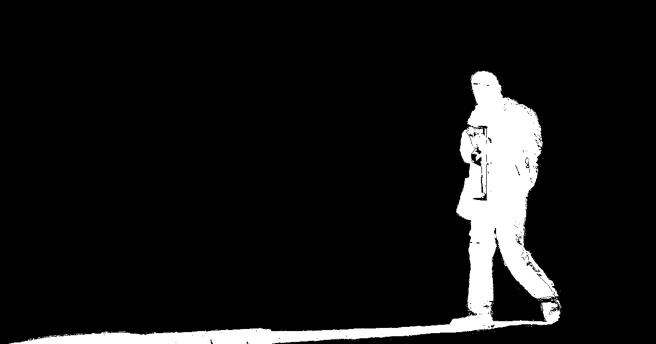

1. I have multiplied the result of 3. and 4., so I get a picture where everything is black except that points which were white in both pictures. With this step I ignored shadows, background noise and also holes in the shape of the man.

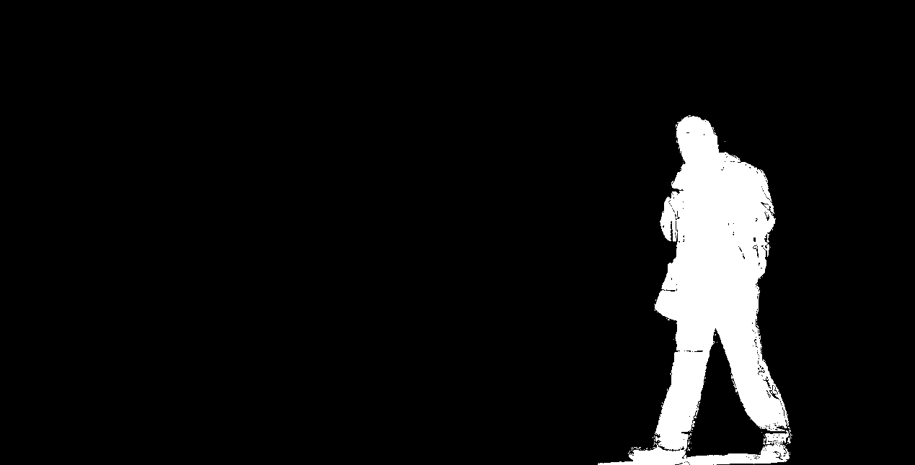

1. I have masked with this frames the original video, so I get the walking man with the black background.

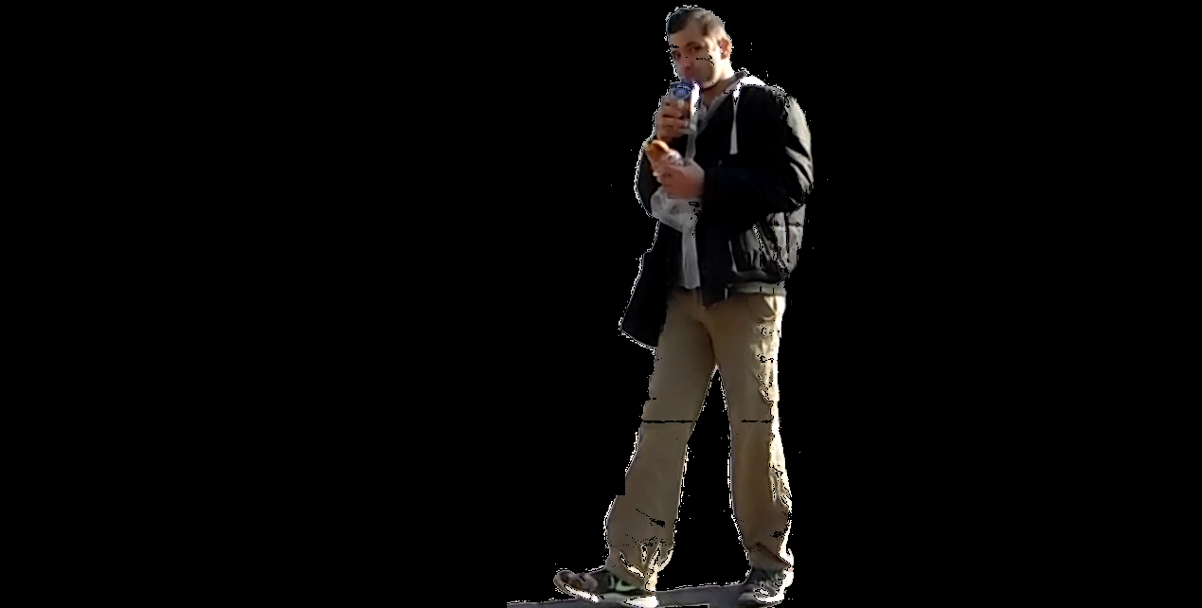

1. I set the bounding box on this picture, because it is easier to find only the walking man, if the background is black. So I set the bounding box and then write the ROI inside the bounding box to png file. Now it save images to the project folder as cropped.png.

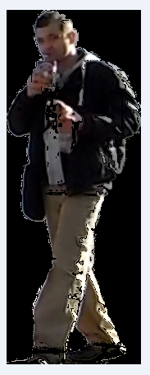

1. I have created transparent png image, and a mask of the ROI (cut the bounding box documentation part5 result image) and then I masked the previously get ROI with MaskROI, and copied the result (only the man shape without the background) to the transparent png image.

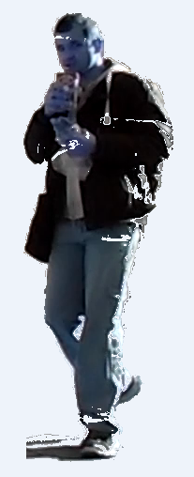

FOR DEVELOPMENT

* It is not perfect in every case. The program need more configuration (trying the function settings with different values) to get better result
* Maybe it needs trackbars which help better configurations.
* The transparent image changes the original colours, it has to be found out, why.
* This program saves png file to the same png, it rewrites the previous image, if there is the next frame. This is because I have to avoid chrashing my computer because of several saved images, but if you need many picture it can be easily solved with a simple for cycle
* There is no input(w,h) size set yet, because there was also a request to find the best bounding box, so I have choosen to find the best bounding box not the predefined (w,h) box. Decision has to be made which is more important: the best matching bounding box or a predefined size, because they exclude each other.