|  |
| --- |
| FORSBERGS SKOLA |
| WORK SAMPLE DOCUMENTATION |
| Option 1 : Tutorial follow-up |

|  |
| --- |
| Sara SABER  8-20-2021 |

Summary:

1. INTRO
2. THE PROCESS / STEPS TO MAKE THE SAMPLE
3. PART 1+PART 2 SUMMARY
4. PART 1+PART 2 DIAGRAMS
5. PART 3: FEATURES ADDED
6. KILLED PROJECT IDEAS
7. LINKS
8. RESOURCES
9. CONCLUSION
10. **INTRO**

This is report of my short work sample, I choose the Option 1 (which is to follow the tutorial and improve on it), as a first option due to the lack of time and the close deadline (I am a full time worker developer).

In this report/documentation you will find a fast track of the work I did with the links and resources that I may use to complete the sample.

I am a former self-taught game developer, with a background of software engineering, although my aspiring career has a lot of breaches that I cannot fill unless with a correct education like in Forsberg Skola curriculum.

*Note: This is not following by line any protocol or writing norm for official report or documentation, it is used as inspired from those norm as the fastest way to explain in an organized way what I did and underline some important steps and personal explanation on the process etc.*

*Note 2: This project sample was recorded in a big part, please find the Time lapse/Video in the “links” section*

*Note 3: I was thinking to add 2 extras projects that I get to cancel due to the deadline, if you want more examples, please let me know, see the “killed project ideas” section to get an overview of those ideas projects. You can also check my website portfolio (*[*www.sarasaber.com*](http://www.sarasaber.com)*) for more work samples.*

*Note 4: Please note that some sections might get shortened/resumed and escape details due to time constraints*

*Note 5: This document is also made to help judge my documentation score, writing and English proficiency (as per the main language of the program study is English)*

1. **THE PROCESS / STEPS TO MAKE THE SAMPLE**

I am using some of my previous experience on development/IT/Software projects to create the project following a certain process, that is resumed bellow in the bullet list below:

1. Create a GitHub repository
   1. Create the empty repo
   2. Add the ReadMe
   3. Clone into PC (GitHub Desktop)
2. Create an empty Unity project (Version 2021.1.9f)
   1. Create an empty Unity URP template
   2. Move the files inside the project
3. Organize the project
   1. Use the Bash file to generate a structure of folders inside of assets for organization
   2. Organize the Hierarchy game scene in the GameScene.unity and clone it as a template scene
   3. Push the changes to GitHub
   4. Use a personal C# template script instead of the default Unity C# template script
4. Follow tutorial Part 1
   1. Code and test following the tutorial
   2. Each time push to GitHub
5. Follow tutorial Part 2 and push to GitHub
   1. Code and test following the tutorial
   2. Each time push to GitHub
6. Draw a fast diagram for the project
7. Write documentation/Report (this file)
8. Follow the Part 3: Add features
   1. Think about features
   2. List the features to add (see in details in the section “part 3: features added”
      1. UI (from free assets)
      2. Arts (if there is time, free assets and modeled in Blender)
      3. Sounds (from free assets)
      4. Gameplay functionalities (example mentioned: restart etc.)
      5. New controls (if there is time, on Mobile)
      6. AR version (if there is time, with Vuforia or AR Fondation)
9. Record the links and the resources
10. Build the game
11. Final push to GitHub, zip the sample work documents
12. Send the sample work to the given email
13. **PART 1+PART2 SUMMARY**

In those 2 parts I was mostly following the tutorial, learning the logic behind, which was very interesting, I reorganized the project in my way though (in the Unity side, not in code)

1. **HIERARCHY DIAGRAM**

Even as a professional, I have a weakness finding the project best design methods, which is one of the reasons I would love to re learn again in professional way, I was sure that the work sample you gave has some good practice, so I tried to understand it,

Diagram module for part 1 and part 2 of the game Tutorial:

1. **PART 3: FEATURES ADDED**

As for the lack of time, I could not try many additions to the game, nor try those additions on other projects, but I managed to get out some sample features:

1. Restart the game

It was mentioned in the suggestions for game improvement

We can either:  
-Reload the scene (scene Management)  
Or  
-Use the functions already in the projects and modify them (RestartGame(),OnPlayerDeath())

Then, add the UI button in the Editor

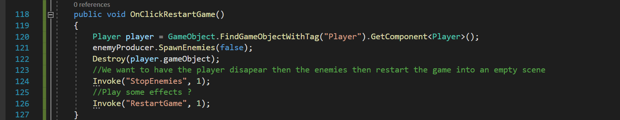

*GameController.cs*

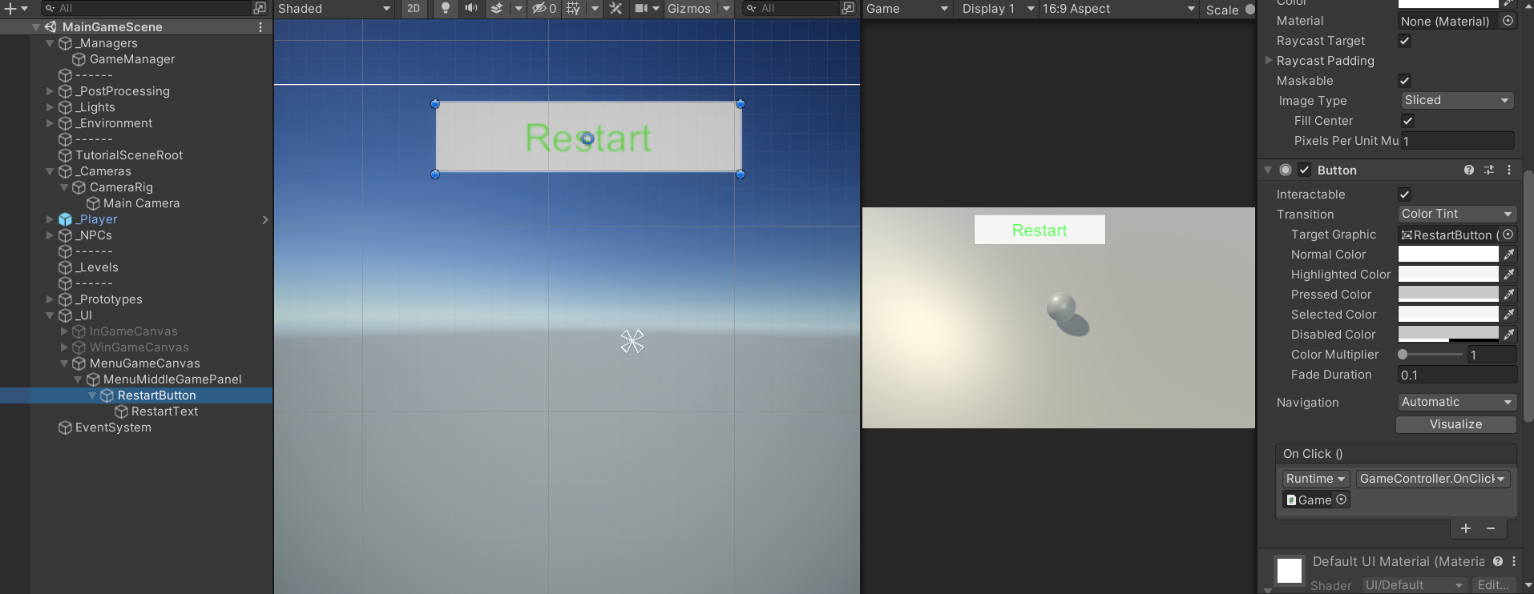

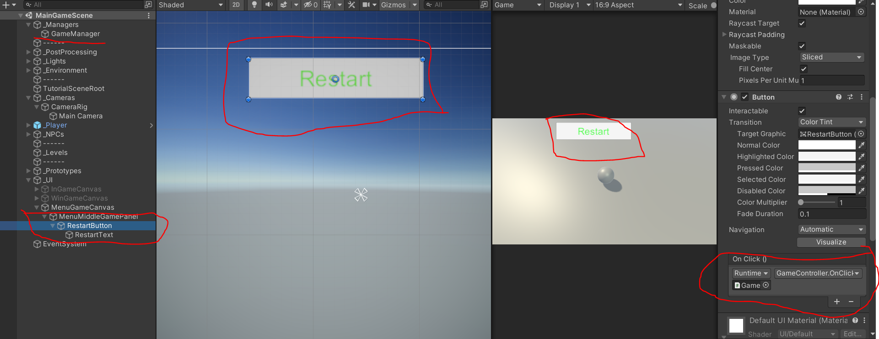

1. Lose Panel

To get the keep the logic, loose game text appears in the seconds after the player die before the gameRsetart() is invoked, in OnPlayerDeath

Added Initialize UI and set UI method

1. UI Panels

Get some fancy UI and themes to the game

Modified Initialize UI and set UI methods

1. Title for the game and a menu

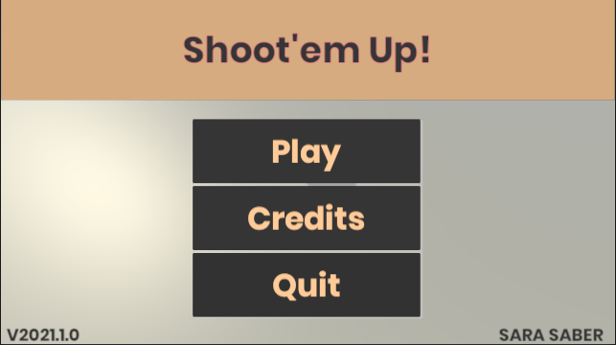 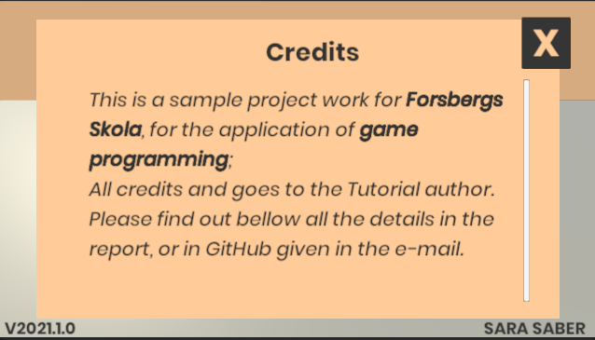

1. Music for the game
   1. Sound Manager

SoundManager.cs and Sounds.cs scripts are old scripts that I developed and worked with on many small projects in professional side, they are easy to attach and to implement

* 1. Get the music sounds

1. Colorful playground (no time)
2. Tutorial (no time)
3. Game Theme with assets (no time)
4. Touch controls and mobile (using control freaks 2)(no time)
5. AR version (Vuforia or ARFondation)
   1. Markerbase version
   2. Make the marker
   3. Virtual buttons (no time)
6. **KILLED PROJECTS IDEAD (FOR THE LACK OF TIME)**

I have had the ambition to test out some extra projects and go for the option 2, after the tutorial option, thus to finish having the tutorial game and the idea games, like mentioned above this idea was dropped.

Please feel free if you find one of them interesting for you and you would want me to do it as a solidification of University application.

Here are the project ideas that were killed:

AR/CLASSICAL VERSION GAMES

1. **Puzzle jigsaw :**

Main concept: Player scan the target image which is the same as the puzzle image/or different a normal QR code, there is a 3D puzzle jigsaw pieces thrown around the target, the player assembles on AR target, once it is finished, the 3D model shows up with animation and sound etc.

2 themes :

1-Educational themes

2-Monuments/Cultural themes

2 ways of play :

The game can get toggled between: AR Jigsaw mode, or normal gameplay mode, or paper mode with AR result shown(in this case the AR mode work if the paper jigsaw image is assembled)

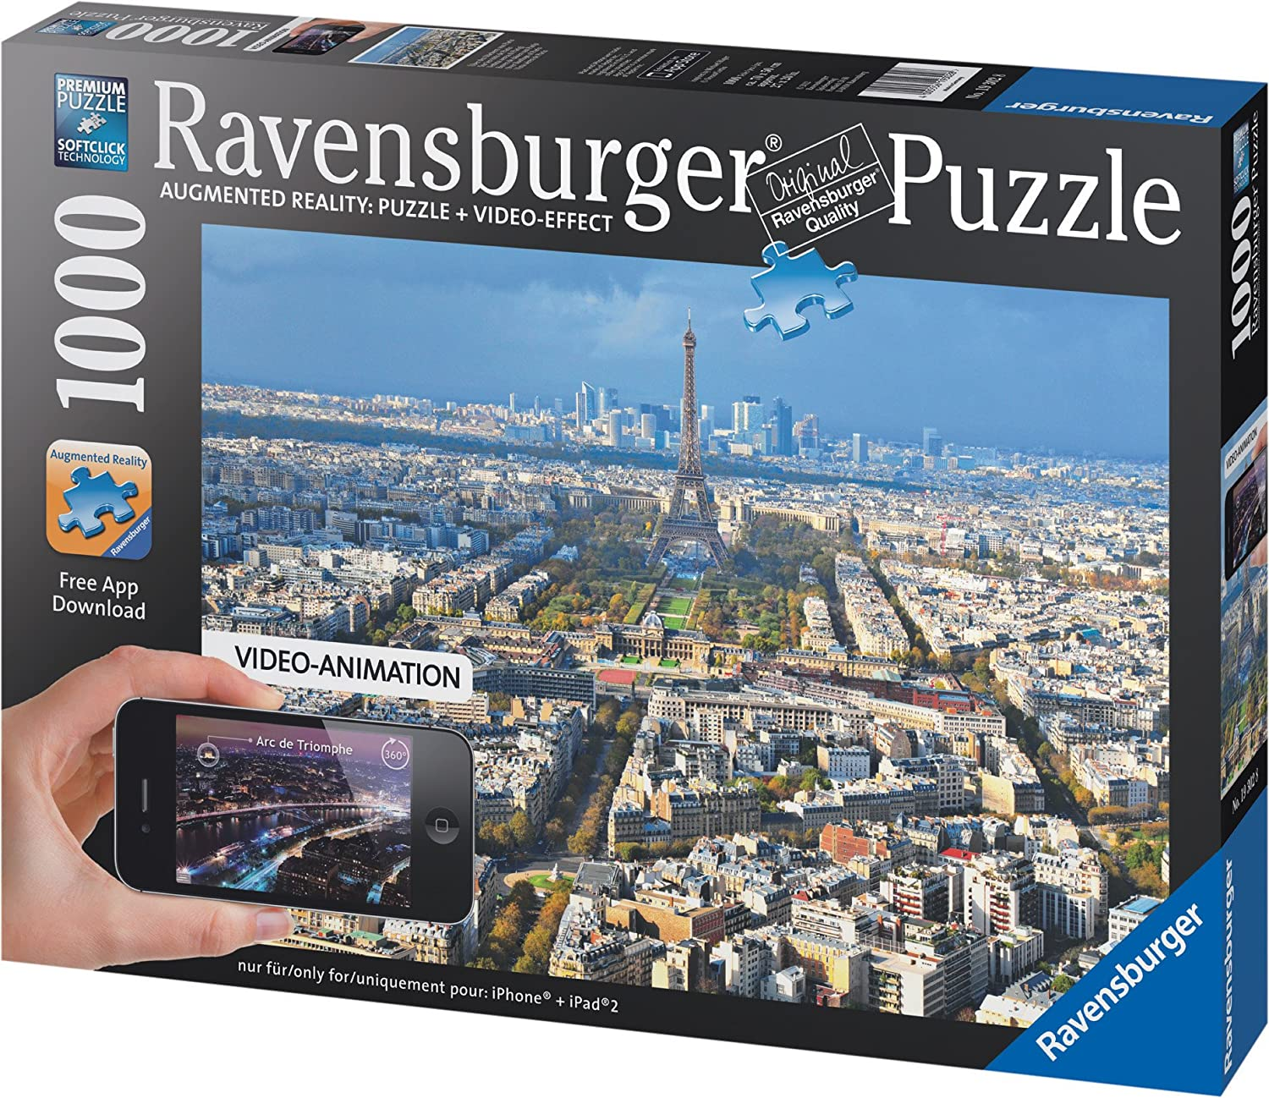

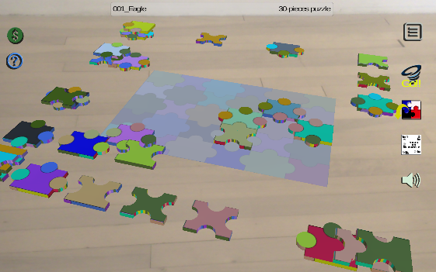 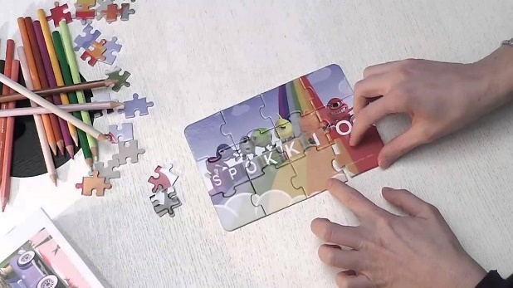

1. **AR Escape Room:**

This game is inspired by the escape classical room games,   
but instead you are looking in a little 3d room shown on a target image, the room show a character/or not and you are using the natural zoom in of the AR to check out where the hidden riddles are to open the door, or your character does it in a dollhouse mode where you interact with a click to move for the player (like RTS but with AR zooms etc)  
This game can also get player in VR  
This game can also get player in classical 3D version or 2D version on devices etc.

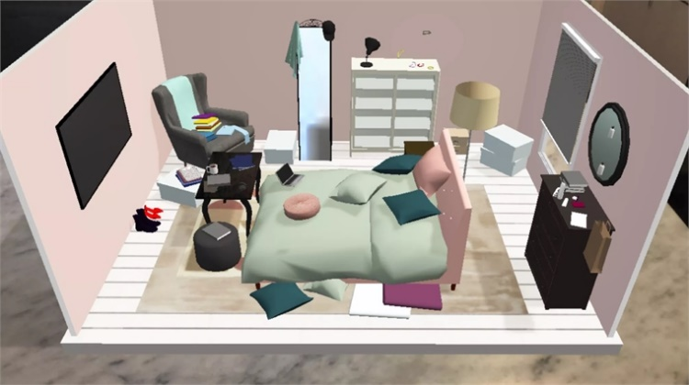 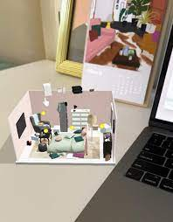 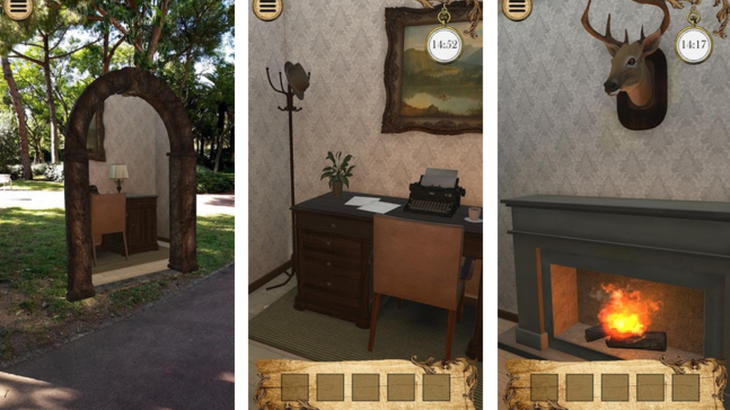

1. **Memory room:**

What is more wonderful that having your memories pictures, videos and favorite music in a 3d house like a showcase, gifted from yourself or from someone, what if it can get always on your desk via an AR card that launches these memory gifts: D

This 3D app is getting the user/player to select the pictures/videos of someone/groups he likes and send it to the app, he choose the predefined 3D house/museum he/she wants to use for showcasing his memory  
The app put them as pictures in the walls and frames in the 3D building

The player can choose the music that plays in the background

This app can get them send it as a link gifts, it targets classical devices and also it is very special to showcase on an AR tracker gifted to self or to someone or groups.  
This app can also get a VR version, a webGL version etc.

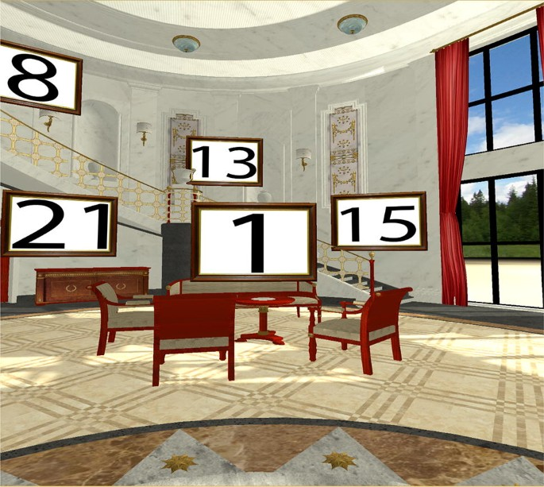 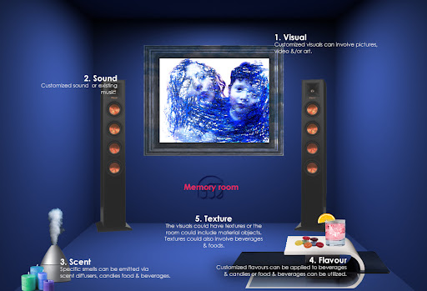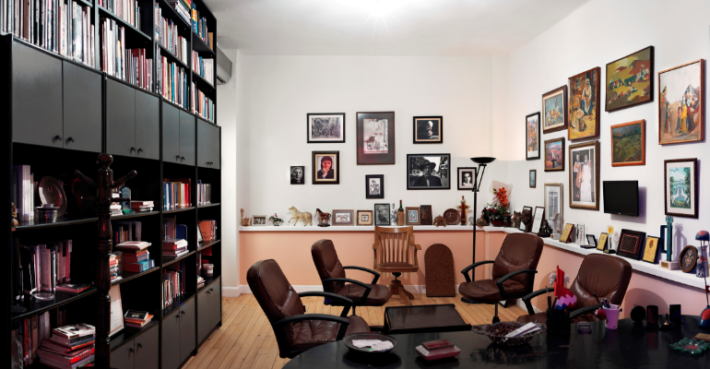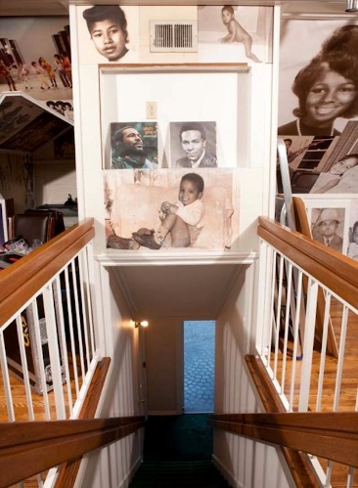

1. **LINKS**

Those are the links for the project and sample work :  
  
a. GitHub : https://github.com/SaberSara/WorkSample1_SuperShooter

b. WeTransfer: link in the e-mail sent

1. **RESOURCES**

This is a list of links of the resources that have been used on the tutorial work sample:

*All the assets are royalty free or permitted to use for non-commercial use.*

-Tutorial : <https://www.raywenderlich.com/980-introduction-to-unity-scripting>

-Music: Free Music Tracks for games, free sounds that I have from PC and used befores etc.

-Art: CartoonFX FreePack,Customizale Skybox, Sample Button Set

-Scripts packages: DotWeen(HotWeen 2) Free version

1. **CONCLUSIONS**

This part concludes this sample work report/documentation; Please feel free to ask me or check out:

My website: [www.sarasaber.com](http://www.sarasaber.com)

My LinkedIn: <https://www.linkedin.com/in/sara-saber-6b0804b6/>

This project allows me to check out so many missed points in my self-learning journey in video games and get me more hyped to join you as soon as possible and keep unique and professional, thank you again for giving me the opportunity to apply to Forsberg Skola.