10/19/2018

MyCore Technologies

Practical 3

TCP vs UDP

Gerhard van Wyk, 21091137

Dawid Joubert, 27479943

Jacques Vosloo, 27236285

Tyran Deale, 27625400

Table of Contents

List of Figures i

List of Tables ii

List of Context ii

List of Terms ii

Introduction 1

Transport Protocols 1

What is TCP? 2

What is UDP? 2

Why do they exist? 3

TCP vs UDP 3

UDP 3

TCP 4

Practical 5

UDP 5

TCP 6

Conclusion 8

References 9

# List of Figures

Figure 1 - TCP/IP and OSI network models [1] 1

Figure 2 - TCP and UDP Transmission [2] 2

Figure 3 - TCP vs UDP [3] 3

Figure 4 - UDP-TEST-3.jpg 5

Figure 5 - UDP-TEST-2.jpg 5

Figure 6 - UDP-TEST-1.jpg 5

Figure 7 - UDP Graph 6

Figure 8 - TCP-TEST-1 6

Figure 9- TCP-TEST-3 6

Figure 10- TCP-TEST-2 6

Figure 11 - TCP Graph 7

# List of Tables

Table 1 - UDP Findings 5

Table 2 - TCP Findings 6

# List of Context

**OSI** - Open Systems Interconnection model

**TCP/IP** - Transmission Control Protocol / Internet Protocol

**UDP** - User Datagram Protocol

**TCP** - Transmission Control Protocol

# List of Terms

**Three-way handshake** – Is used by TCP to set up a connection.

# Introduction

When you download a file, stream a movie or even playing an online game you are constantly receiving information over a network in the world. This information can be sent to you in many ways, but we are going to look at the two most popular transport protocols, how they work, how they differ, why they exist and lastly use them to send a picture over the network and show the findings.

# Transport Protocols

Transport Protocols works on the Transport Layer of the OSI network model as well as the TCP/IP model.

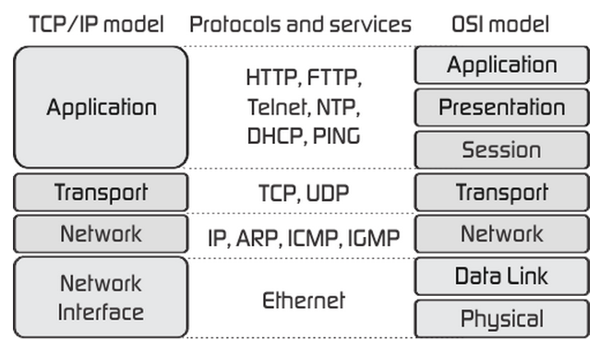

Figure 1 - TCP/IP and OSI network models [1]

The transport layer creates hundreds of ports on a network and thus each application can reserve ports to send and receive messages on.

The two most popular transport protocols is TCP and UDP and they differ in almost every way.

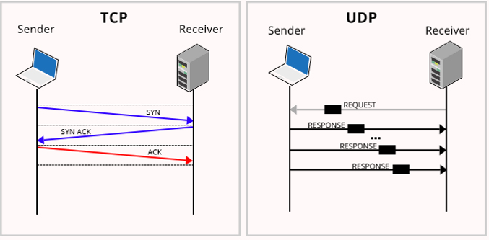

Figure 2 - TCP and UDP Transmission [2]

## What is TCP?

TCP is a connection-based transport protocol, which need to set up a connection using the three-way handshake before the files are transferred.

If a connection has been made and a file is received the receiver will send acknowledgements to the sender letting them know what frames have been received and, in this way, ensures the data reaches its destination.

The frames are sent and received in the correct order and no data will be lost since when a frame is lost the receiver will let the sender know to resend the last frame before it will continue.

Mainly used for:

* Web browsers
* E-mail
* File transfers

## What is UDP?

UDP is a transport protocol that does not wait for a connection it just keeps sending the files and does not care if the files reach its location, no acknowledgements are used, and the establishment of a connection is needed it will just keep sending until it is done.

Mainly used for:

* Domain Name System (DNS).
* Video streaming
* Voice over IP (VOIP)

## Why do they exist?

Transport layers are needed to allow multiple applications on multiple devices to use one network simultaneously. Without them only one application at a time will be able to use the network. But now every application can use a different port number on the network to communicate at the same time.

## TCP vs UDP

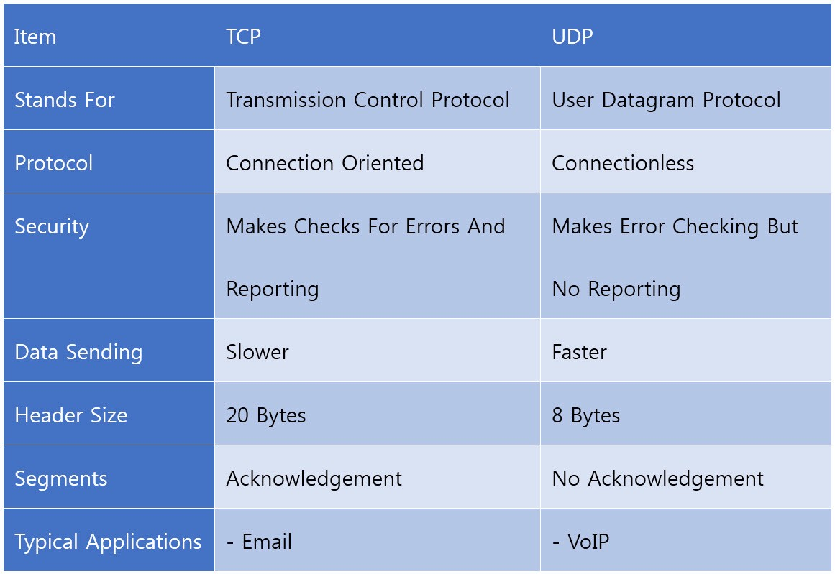

Figure 3 - TCP vs UDP [3]

UDP

UDP also uses the following:

* Uses smaller packet sizes.
* Does not need to create or maintain a connection.
* Have more control over when data will be sent
* Does not guaranteed the order in which the file will be received by the
* Smaller headers

### TCP

TCP also uses the following:

* Is more reliable
* Uses acknowledgements.
* Congestion control to ease the strain on the network.
* Uses checksum error detection.
* Bigger headers.

# Practical

We are going to send several files with different file sizes with the TCP and UDP transport protocols and check the time it takes to send and to receive the files as well as look at the conditions of the files when received.

## UDP

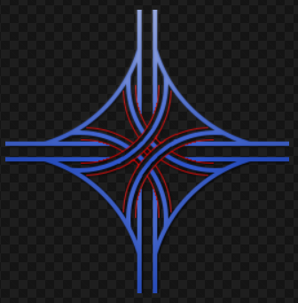Files to be sent:

Figure 4 - UDP-TEST-3.jpg

Figure 5 - UDP-TEST-2.jpg

Figure 6 - UDP-TEST-1.jpg

After sending the files shown above 5 times each we found and recorded the following data.

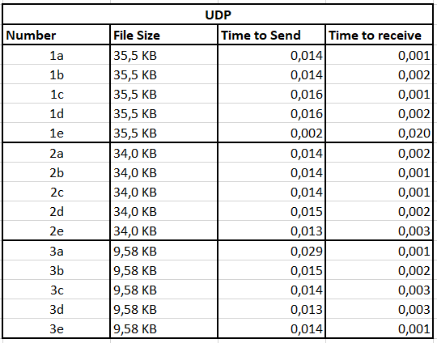

Table 1 - UDP Findings

We can now see just how fast UDP is when sending and receiving files, when we create the graph we can see its consistent for the small file sizes with only one or two abnormalities.

NOTE: The time to send and the time to receive is in seconds.

Figure 7 - UDP Graph

The files were sent multiple times and only once or twice did the file get corrupted on the way.

## TCP

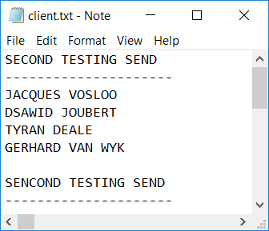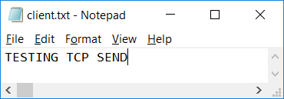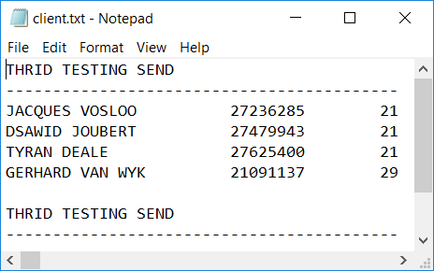Files to be sent.

Figure 8 - TCP-TEST-1

Figure 9- TCP-TEST-3

Figure 10- TCP-TEST-2

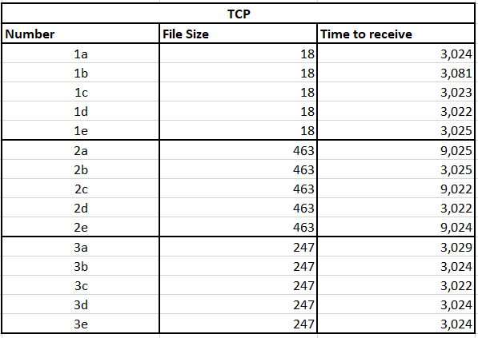After sending the text files shown above five times each we found and recorded the following data:

Table 2 - TCP Findings

And when we create the graph we can see its consistent for the small file sizes with minimal abnormalities.

NOTE: The time to receive is in seconds.

Figure 11 - TCP Graph

# Conclusion

If you look at what we found we can see that UDP transport protocol was sent and received much faster than the TCP transfer protocol, and you now know that its because the UDP does not set up a connection or wait for acknowledgements.

This report should have given you an overview of the two most important transport protocols and how they differ from each other and a look at how they work and why they are needed on the transport layer.

# References

|  |  |
| --- | --- |
| [1] | clinetworking, “Command Line Networking,” 9 June 2018. [Online]. Available: https://clinetworking.wordpress.com/2018/06/09/1-1-compare-and-contrast-osi-and-tcp-ip-models/. [Accessed 17 October 2018]. |
| [2] | Oodles Technologies, “Why UDP is preferred for Live Streaming,” 11 July 2016 . [Online]. Available: https://www.oodlestechnologies.com/blogs/Why-UDP-is-preferred-for-Live-Streaming. [Accessed 17 October 2018]. |
| [3] | Meela, “TCP VS. UDP,” 20 September 2017. [Online]. Available: https://medium.com/@Meela349588204/tcp-vs-udp-8aba3c4efb72. [Accessed 17 October 2018]. |
| [4] | CodeJava, “Java Socket Server Examples (TCP/IP),” 13 November 2017 . [Online]. Available: https://www.codejava.net/java-se/networking/java-socket-server-examples-tcp-ip. [Accessed 18 October 2018]. |
| [5] | K. Hong, “TCP Sockets Server/Client - 2018,” 2018. [Online]. Available: https://www.bogotobogo.com/Java/tutorials/tcp_socket_server_client.php. [Accessed 18 October 2018]. |
| [6] | H. Sparrow, “Node.js UDP Server and Client Example,” 9 May 2016. [Online]. Available: https://www.hacksparrow.com/node-js-udp-server-and-client-example.html. [Accessed 18 October 2018]. |
| [7] | Nodejs, “Node.js v10.12.0 Documentation,” [Online]. Available: https://nodejs.org/api/dgram.html. [Accessed 18 October 2018]. |