|  |  |
| --- | --- |
| **EXP.NO:** | **PROPERTY MANAGEMENT E-MALL** |
| **DATE:** |

# AIM:

To develop a webpage for property management E-Mall.

# TOOLS AND VERSIONS:

* HTML - v5
* CSS - v3
* JavaScript - ES14
* XAMPP ( PHP , MySQL) - v8.2.12

# ABSTRACT:

The provided SQL script initializes a database named `e_mall` and creates three tables: `dress_admin`, `dress_billing`, and `dress_sales`. It inserts data into these tables, including administrator, customer billing, and sales representative information. Indexes are established for primary keys, and auto-increment values are configured for certain fields. Additionally, the script includes SQL mode settings, transactions, and character set configurations.The SQL script begins by setting the SQL mode to “NO_AUTO_VALUE_ON_ZERO” and the time zone to “+00:00”. It then starts a transaction and sets character set configurations.After inserting data into these tables, indexes are added for the primary keys of each table. Auto-increment values are set for the primary key fields (`id` for `dress_admin` and `dress_sales`, `customer_id` for

`dress_billing`). Finally, the script concludes by restoring the character set configurations to their previous values.Overall, the script sets up a basic database structure for an e-commerce application, including administrators, customer billing details, and sales representatives.

The database access rights are delineated as follows: the Salesperson is endowed solely with the capability to append customer details to the database, devoid of any authorization to alter or manipulate existing data. Conversely, the Manager is vested with comprehensive access privileges, encompassing both the viewing and modification of the database, including the removal of customer records.

# PROGRAM:

SET SQL_MODE = "NO_AUTO_VALUE_ON_ZERO"; START TRANSACTION;

SET time_zone = "+00:00";

## --Database: `e_mall`

--**Table structure for table `dress_admin`**

CREATE TABLE `dress_admin` (

`id` int(11) NOT NULL,

`username` varchar(100) NOT NULL,

`email` varchar(100) NOT NULL,

`password` varchar(100) NOT NULL

) ENGINE=InnoDB DEFAULT CHARSET=latin1 COLLATE=latin1_swedish_ci;

## --Dumping data for table `dress_admin`

INSERT INTO `dress_admin` (`id`, `username`, `email`, `password`) VALUES (1, 'xyz', ['xyz@gmail.com',](mailto:%27xyz@gmail.com) '000'),

(2, 'asd', ['asd@gmail.com',](mailto:%27asd@gmail.com) '111'),

(3, 'fgh', ['fgh@gmail.com',](mailto:%27fgh@gmail.com) '222');

CREATE TABLE `dress_billing` (

`customer_id` int(11) NOT NULL,

`customer_name` varchar(100) DEFAULT NULL,

`mobile_number` bigint(100) DEFAULT NULL,

`item_purchased` varchar(100) DEFAULT NULL,

`MRP` int(100) DEFAULT NULL,

`quantity` int(100) DEFAULT NULL,

`total_price` decimal(10,2) DEFAULT NULL

)ENGINE=InnoDBDEFAULTCHARSET=utf8mb4

COLLATE=utf8mb4_general_ci;

INSERT INTO `dress_billing` (`customer_id`, `customer_name`, `mobile_number`,

`item_purchased`, `MRP`, `quantity`, `total_price`) VALUES (1, 'john', 56879876, 'T-Shirt', 250, 3, 750.00),

(2, 'lisa', 3456789, 'Coat', 750, 4, 3000.00),

(3, 'bennet', 9876543, 'T-shirt', 250, 8, 2000.00),

(4, 'lumine', 987654, 'Formal-pant', 550, 6, 3300.00),

(5, 'aether', 234567890, 'Formal-shirt', 600, 7, 4200.00),

(6, 'ramesh', 9876543, 'Jean', 350, 5, 1750.00),

(7, 'suresh', 9876543, 'T-shirt', 250, 33, 8250.00),

(8, 'knave', 987654, 'Coat', 750, 1, 750.00),

(10, 'sudha mam', 876543567, 'Coat', 750, 5, 3750.00);

CREATE TABLE `dress_sales` (

`id` int(11) NOT NULL,

`username` varchar(100) NOT NULL,

`email` varchar(100) NOT NULL,

`password` varchar(100) NOT NULL

) ENGINE=InnoDB DEFAULT CHARSET=latin1 COLLATE=latin1_swedish_ci;

INSERT INTO `dress_sales` (`id`, `username`, `email`, `password`) VALUES (1, 'qwer', ['qwer@gmail.com',](mailto:%27qwer@gmail.com) '1234'),

(2, 'jkl', ['jkl@gmail.com',](mailto:%27jkl@gmail.com) '12345'),

(3, 'tyu', ['tyu@gmail.com',](mailto:%27tyu@gmail.com) '567'),

(4, 'bnm', ['bnm@gmail.com',](mailto:%27bnm@gmail.com) '890'),

(5, 'abc', ['abc@gmail.com',](mailto:%27abc@gmail.com) '123');

ALTER TABLE `dress_admin` ADD PRIMARY KEY (`id`);

ALTER TABLE `dress_billing`

ADD PRIMARY KEY (`customer_id`);

ALTER TABLE `dress_sales` ADD PRIMARY KEY (`id`);

ALTER TABLE `dress_admin`

MODIFY `id` int(11) NOT NULL AUTO_INCREMENT, AUTO_INCREMENT=4;

AUTO_INCREMENT for table `dress_billing`

ALTER TABLE `dress_billing`

MODIFY `customer_id` int(11) NOT NULL AUTO_INCREMENT, AUTO_INCREMENT=11;

AUTO_INCREMENT for table `dress_sales` ALTER TABLE `dress_sales`

MODIFY `id` int(11) NOT NULL AUTO_INCREMENT, AUTO_INCREMENT=6;

# DATABASE DESIGN:

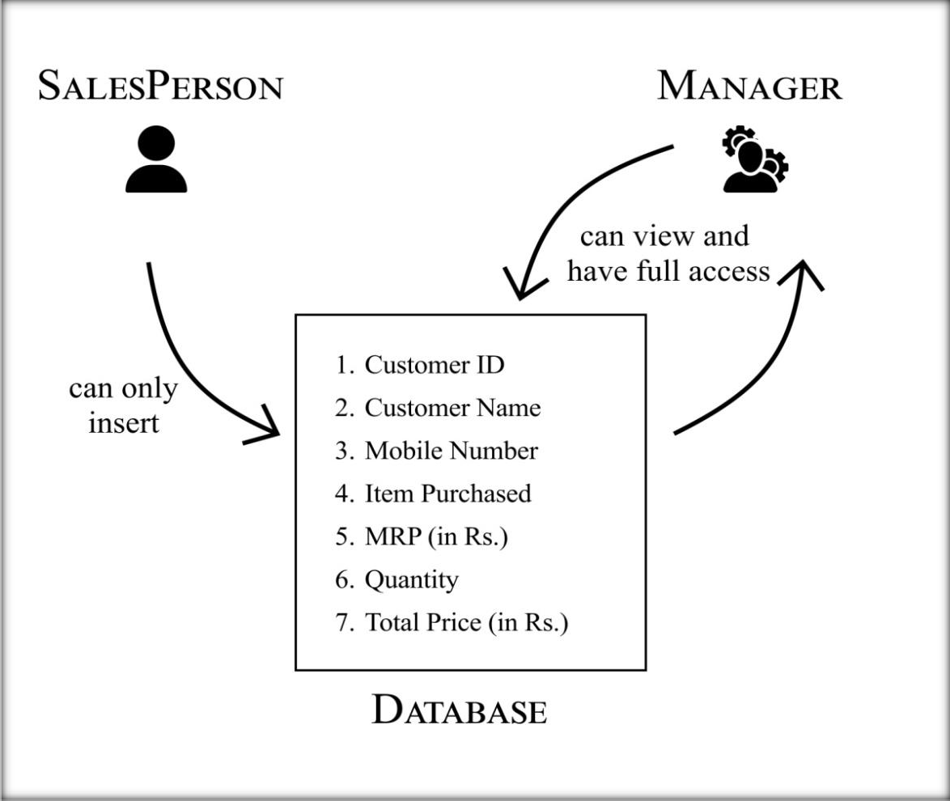

**Fig 1.**

# OUTPUT:



**Fig 2. Home page**

**Fig 2.1 Login page**

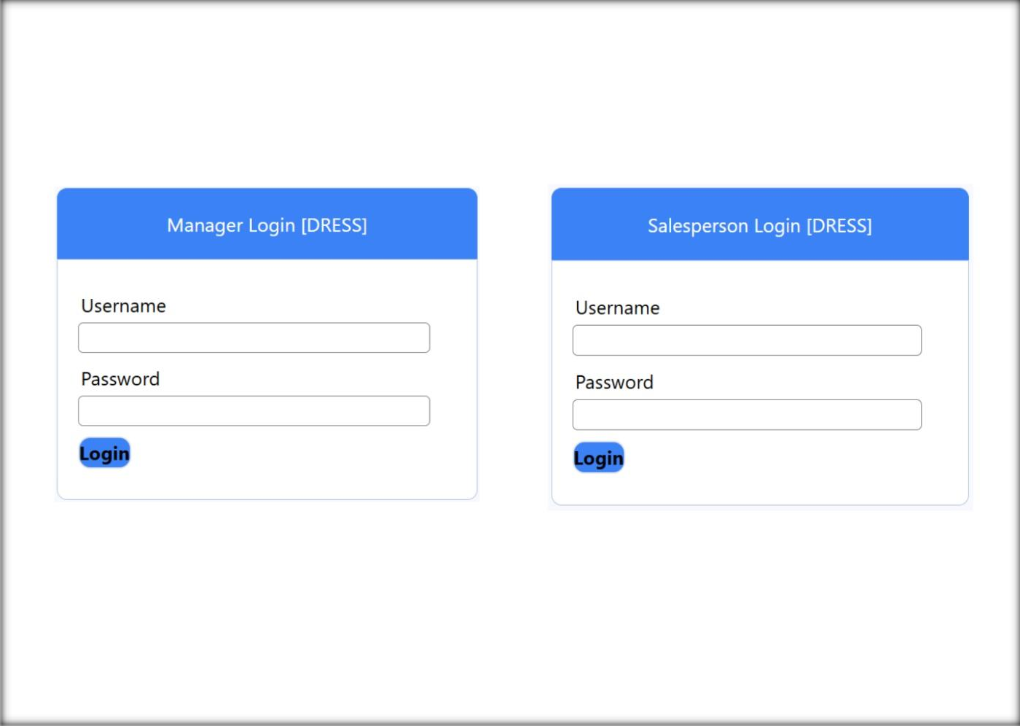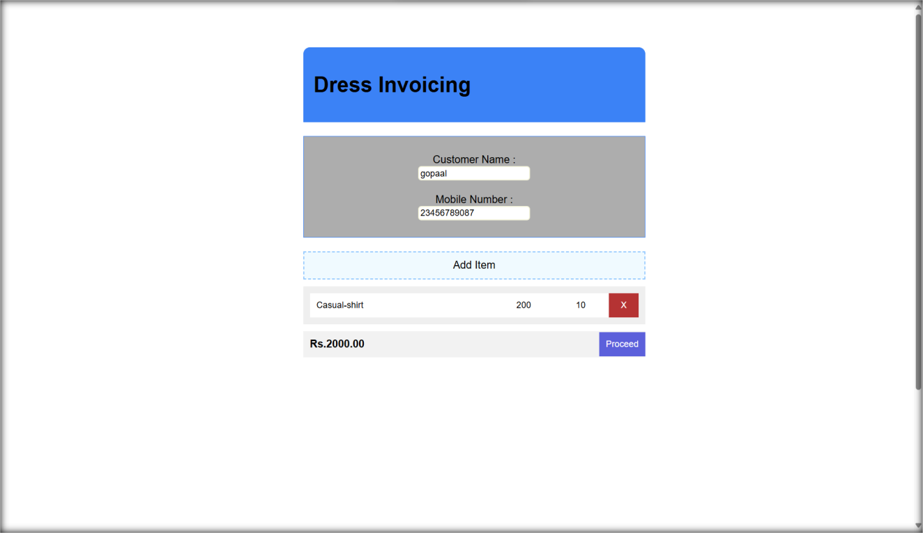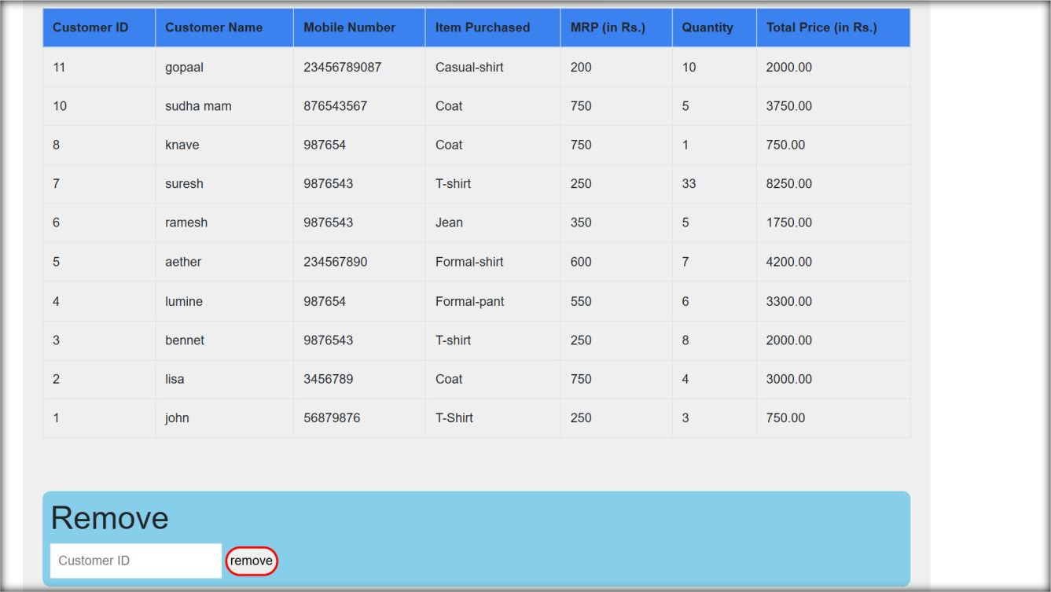

**Fig 2.2 Salesperson access**

**Fig 2.3 Manager access**

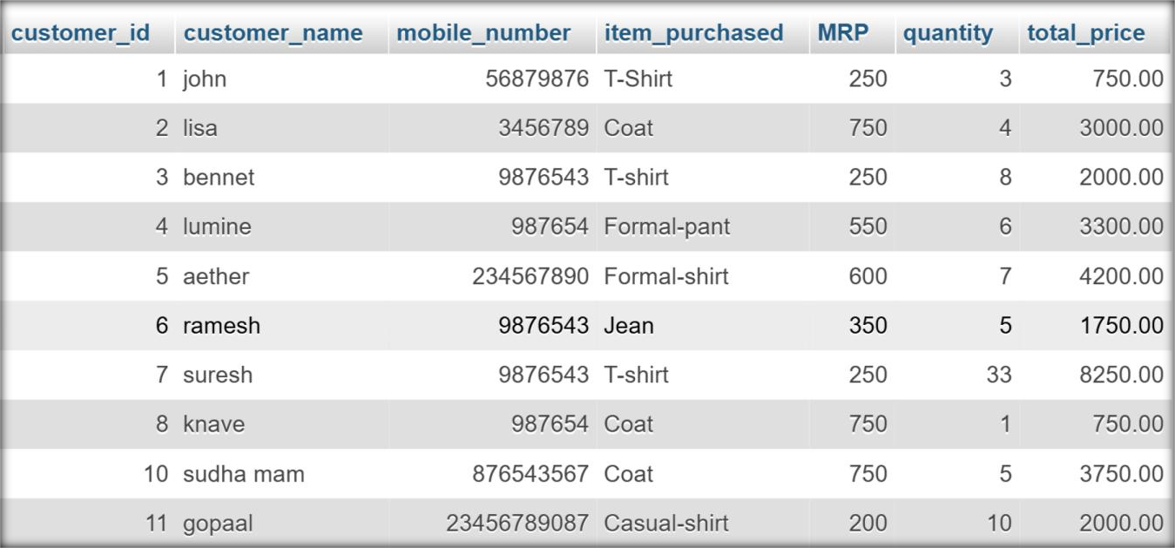

**Fig 2.4 Database**

# Result:

Thus, the webpage for property management E-Mall was created.