National Research University Higher School of Economics
Faculty of Computer Science
HSE and University of London Double Degree Programme in
‘Data Science and Business Analytics’
BACHELOR'S THESIS
(Research Project)

Компьютерное зрение для автоматизированного выявления дорожных происшествий и инфраструктурных аномалий на видеопотоках транспортных магистралей

Студент: [ФИО студента]
Группа: [номер группы]
Научный руководитель: [ФИО научного руководителя]

Москва, 2026

Annotation
This work explores computer vision methods for automated detection of road accidents and assessment of their severity in highway traffic video streams from fixed cameras. The study was carried out in the research project format: its result is not only a trained model, but also a well-founded problem statement, a reproducible data preparation procedure, an analysis of domain risks and a comparison of several types of visual representations of a road event.
The proposed approach considers the road monitoring system as a cascade pipeline. At the first stage, the input video stream is split into short clips. The binary accident detector then determines if the clip contains a traffic accident. If an incident is detected, a separate severity classifier assigns it to one of three severity levels: minor, moderate, or major. Infrastructural anomalies - foreign objects on the road, pavement damage, lane obstacles - are considered as the next stage of system development using the same infrastructure of preprocessing, metadata, evaluation and visual error analysis.
Special attention is paid to the issue of dataset-source bias. At an early stage, positive and negative examples were formed from different datasets: AI City was used as a source of normal traffic, and BAVD as a source of accident videos. This approach proved to be methodologically risky, since the model could study the differences between sources rather than the signs of an emergency event. Therefore, a harmonization procedure was introduced and then a grouped-window formulation was developed, where accident and no_accident windows are formed within the same visual domain.
The final accident-detection result was obtained with the D02 ConvNeXt-based grouped-window road-crop model, which achieved a test balanced accuracy of 0.8049, an F1-score of 0.7576, a precision of 1.0000, and zero false positives on the held-out test set. For severity classification, the strongest documented result was achieved by the S13 R3D-18 model, which reached a test accuracy of 0.6222 and a macro-F1 score of 0.6169.
Key words:
Сomputer vision, fixed-camera traffic surveillance, traffic video analytics, accident detection, severity classification, ConvNeXt, R3D-18, domain bias, grouped windows, traffic anomaly detection.

List of contents
Annotation 2
Key words: 2
1 Introduction 4
1.1 The goal of the thesis 4
1.2 Objectives of the thesis 5
1.3 Research questions and hypotheses 5
1.4 Scientific and practical novelty 5
1.5 Formal task decomposition 6
1.6 Structure of the report 7
2 Review of the subject area and existing methods 8
2.1 Traffic video analytics as a family of tasks 8
2.2 Fixed-camera CCTV and the event-related nature of road accidents 9
2.3 Mathematical representations of video signals and families of models 9
2.4 Datasets, benchmark mismatch, and dataset bias 11
2.5 Pitfalls of Evaluating Surveillance Systems 13
2.6 Infrastructure anomaly detection 13
2.7 Chapter Conclusions and Research Gap 14
3 Search, selection and preparation of data 15
3.1 Why one dataset was not enough 16
3.2 AI City as a curated source no_accident 16
3.3 BAVD as an accident source and severity 17
3.4 Metadata-first and manifest-first approach 18
3.5 Harmonization and Domain Reduction 18
3.6 Central Difficulty: Source-Domain Leakage 19
3.7 Grouped-window reformulation 20
3.8 Severity Splits Formation Policy 21
4 Methodology and implemented system 23
4.1 General organization of the pipeline 23
4.2 ConvNeXt as a clip-based baseline 23
4.3 R3D-18 as honest video baseline 24
4.4 YOLO-guided hybrid as the next logical branch 24
4.5 Reproducibility and code organization of the project 24
5 Experimental design and evaluation protocol 26
5.1 Formal criteria for accident detection 26
5.2 Formal criteria for severity classification 27
5.3 Hypotheses and testable consequences 28
5.4 Metrics accident detection 28
5.5 Metrics severity classification 28
5.6 Why is threshold analysis necessary? 29
5.7 Rules for selecting official results 29
5.8 Summary Map of Artifacts 30
6 Results and Analysis 31
6.1 Accident detection: от доменной ловушки к защищаемому baseline 31
6.2 Severity classification: the advantage of temporal modeling 34
6.3 Summary of two branches 37
7 Discussion and limitations 38
8 Transition to infrastructure anomalies 39
9 Conclusion 40
10 Github Link 40
List of sources 40
Приложение А. Рекомендуемые иллюстрации и артефакты для включения в финальную версию 43
Приложение Б. Какие фрагменты кода и команд лучше показать 43
Приложение В. Практические замечания по оформлению 44

1 Introduction
Modern road infrastructure increasingly relies on video surveillance. Cameras are used at standard intersections, highways, tunnels, bridges, and areas with high accident rates. However, simply increasing the number of cameras does not solve the safety problem. Video streams, for example, require constant analysis, and manual monitoring does not scale well: an operator cannot closely monitor dozens or hundreds of screens, especially when dangerous events are rare and visually ambiguous.
According to the World Health Organization, road accidents claim approximately 1.19 million lives each year, and road traffic injuries remain the leading cause of death among people aged 5 to 29 years. [1, 2].
Road accidents are low-frequency events with a high error cost. A missed accident can lead to delayed emergency response, secondary collisions, and increased congestion. At the same time, an excessive number of false alarms renders an automated system virtually unusable: the operator loses confidence in the signals, and the dispatch system becomes overloaded. Therefore, accident detection cannot be assessed solely by accuracy. For real-world monitoring, recall, precision, false alarms per hour, latency, stability on new cameras, and resistance to domain shift are all important.
It is also important that this study does not examine arbitrary videos related to transportation, but rather video streams from fixed traffic cameras. This significantly changes the task. Unlike dashcam videos, fixed-camera video has a stable camera angle, a static background, and high scene repetitiveness, but also increases the risk that the model will memorize the features of a specific camera rather than the event itself.
A problem we encountered even before choosing the architecture was the lack of a single, open, and methodologically convenient dataset covering the entire project lifecycle. For our topic, there's no ready-made dataset that would simultaneously contain a fixed CCTV viewpoint, a guaranteed clean normal traffic class, crash clips with reliable severity labels, and a foundation for the subsequent infrastructure anomaly detection branch. As a result, we had to not simply "take data from an open source" but conduct a full-scale process of selecting, comparing, and rethinking several datasets with different roles within a single pipeline. [3–5, 19, 20]

1.1 The goal of the thesis
The goal of the work is to develop and investigate a methodology for automated detection of road accidents and assessment of their severity using video streams from fixed road cameras, taking into account the limitations of real data, domain shift, and practical requirements for the monitoring system.

1.2 Objectives of the thesis
- Analyze the subject area and existing approaches to detecting road accidents and related anomalies in video.
- Select and validate a dataset suitable for solving accident detection and severity classification problems.
- Prepare data for experiments and develop a reproducible sample processing scheme.
- Build and evaluate a baseline model for binary detection of road accidents.
- Build and compare models using different types of visual representation of events, including clip-based and video-based approaches.
- Explore the problem of accident severity classification and determine the most reliable model for this area.
- Select metrics and an evaluation procedure that allow for analyzing the quality of models not only from research but also from a practical perspective.
- Outline directions for further development of the system, including an object-centric approach and a transition to the problem of detecting infrastructure anomalies.

1.3 Research questions and hypotheses
- Which visual representation is most effective for analyzing video streams from fixed traffic cameras: global clip-level features, explicit temporal modeling, or an object-centric approach?
- Does moving to a more complex video architecture yield consistent gains in the accident detection task under different sampling schemes?
- Can a model be considered practically useful if, despite high final metrics, it retains a high number of false alarms on long video streams?
- How do accident detection and severity classification tasks differ in terms of data requirements, architecture, and evaluation procedures?

1.4 Scientific and practical novelty
The scientific novelty of this work lies not in proposing a completely new architecture, but in identifying and formalizing a methodological problem that had distorted previous findings. It was shown that when mixing crash clips from one source and negative examples from another domain, the model quickly begins to learn from visual differences between the sources. This leads to an important methodological conclusion: for surveillance tasks, the correctness of the data protocol and split discipline may be more important than switching from one standard neural network architecture to another.
The practical contribution lies in the construction of a manifest-first pipeline, in which data, experiments, and post-evaluation do not depend on manual folder labeling or one-off notebook scripts. All key results were linked to configurations, manifest files, saved checkpoint artifacts, and individual post-evaluation reports.
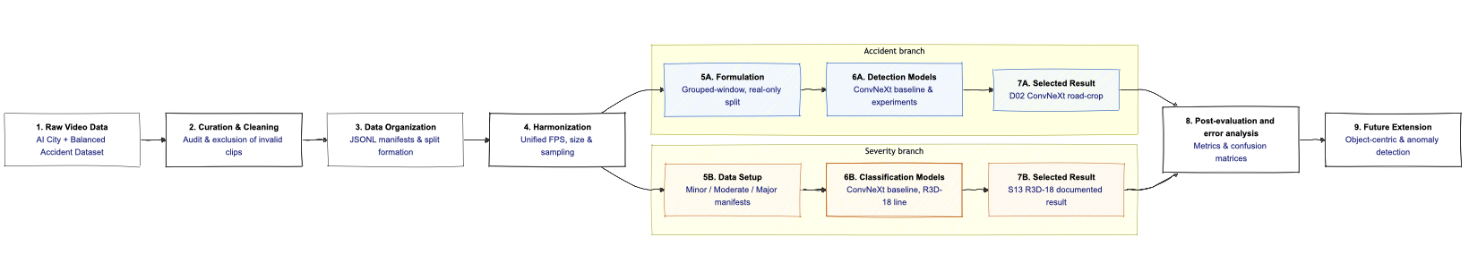
Figure 1.1 – Overall project workflow: from raw video data and manifest-based preparation through harmonization and corrected accident formulation to the accident detection branch, severity classification branch, and future extension toward infrastructure anomaly detection.
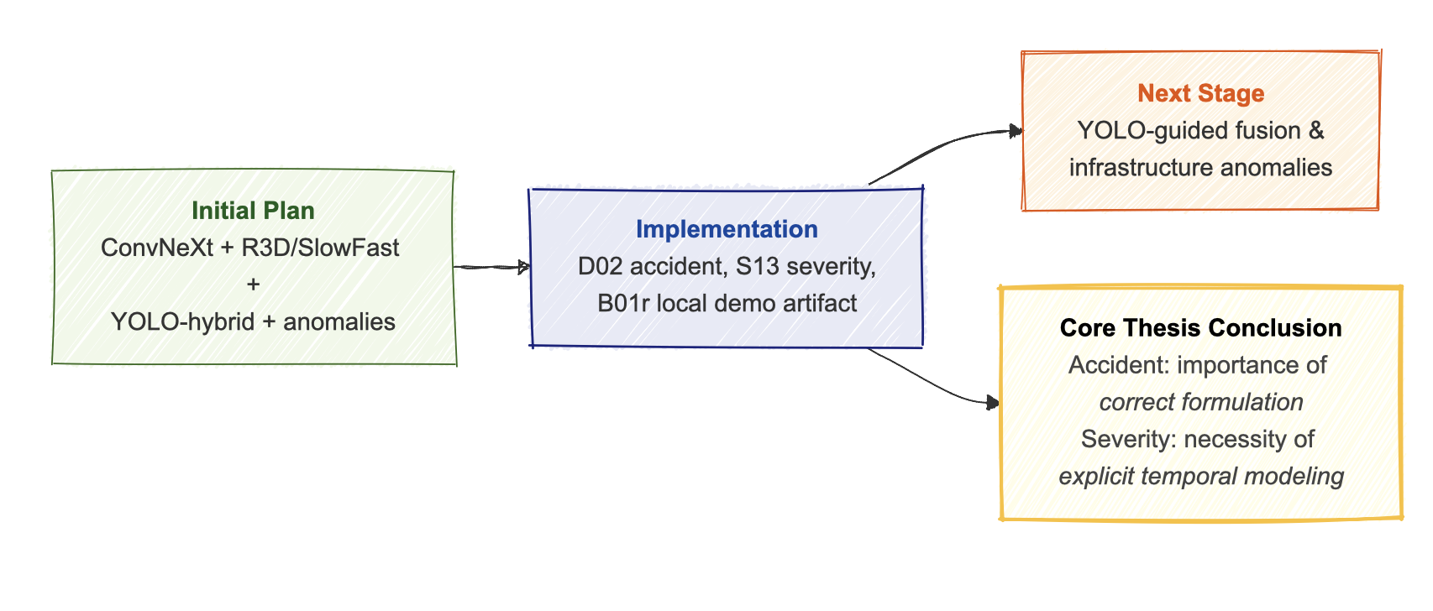
Figure 1.2 – The relationship between the original project concept, the actual implemented and formally estimated volume of work, and future directions of development.

1.5 Formal task decomposition
The current work considers the road-video analysis system as a cascade of two implemented branches and one future extension. The first branch answers whether a video clip contains a road accident. The second branch, activated only after a positive decision, estimates accident severity. The third branch, related to infrastructure anomalies, is not part of the defended empirical comparison but follows naturally from the pipeline already developed in the project.
Formally, the first stage solves a binary classification problem with target labels accident and no_accident. The second stage solves a three-class classification problem with labels minor, moderate, and major. This decomposition reflects a realistic monitoring scenario: the system first separates incidents from normal traffic and only then estimates their severity. It also matches the current research scope and the available data configuration.
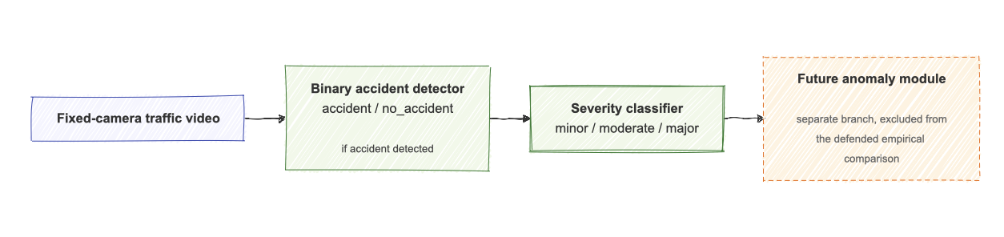
Figure 1.3 – Formal task decomposition: binary accident detection followed by severity classification, with the future anomaly module treated as a separate branch outside the defended empirical comparison.

1.6 Structure of the report
The remainder of this paper is structured from the problem statement to the data, models, experiments, and final conclusions. Chapter 2 examines the subject area, key areas of literature, and limitations of existing approaches and available datasets. Chapter 3 is devoted to the data: it describes the search and selection of sources, the harmonization procedure, and the methodological problem of source-domain leakage, which significantly influenced early results. Chapter 4 presents the architectural solutions and the general logic of the implemented pipeline. Chapter 5 describes the experimental design, metrics, and rules for selecting official results. Chapter 6 presents the main quantitative results and their interpretation. Chapter 7 discusses the limitations of the work and the applicability of the findings. Chapter 8 shows how the current approach can be extended to detect infrastructure anomalies. The conclusion (Chapter 9) summarizes the main findings of the study and outlines directions for its further development. Chapter 10 is Github link.

2 Review of the subject area and existing methods
A literature review on this topic is not limited to a list of works; it requires distinguishing several closely related approaches: traffic video analytics as a broad family of problems, binary accident detection as a key research objective, severity classification as the second stage of the cascade, and infrastructure anomaly detection as a future direction. For fixed-camera surveillance, these approaches differ in terms of labeling, error types, and data requirements, so they cannot be considered interchangeable.
Two pillars are essential for this work. Traffic accidents in CCTV are considered spatio-temporal events, not static objects. The quality of solutions is determined by architecture, but not least by the data protocol, split discipline, and evaluation regime. This logic underlies the review.

2.1 Traffic video analytics as a family of tasks
The umbrella term "traffic video analytics" typically encompasses flow recording and description (vehicle counting, tracking, flow estimation), rare event detection (accident detection, traffic anomaly detection, incident localization), and infrastructure disruption detection (road obstacle detection, anomaly segmentation, road damage detection). These approaches overlap in terms of data and engineering pipelines, but diverge in terms of metrics and research findings.
The thesis examines two tasks within this family: binary accident detection and severity classification. The former determines whether a clip contains an incident; the latter is activated after the first block responds positively and assigns a class of minor, moderate, or major to the clip. This cascading division corresponds to both the structure of available data and the applied monitoring logic.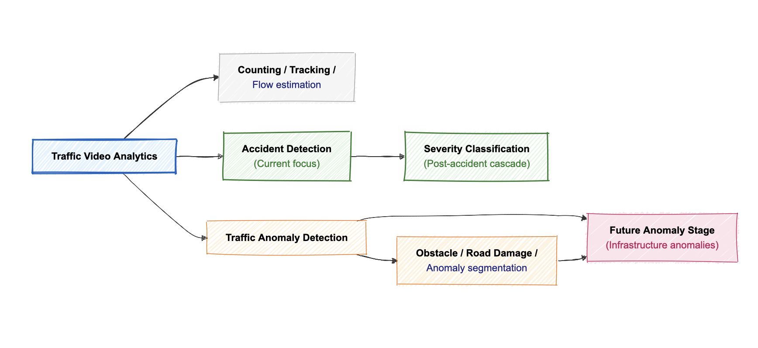
Figure 2.1 – The position of this study within the family of traffic video analytics tasks

2.2 Fixed-camera CCTV and the event-related nature of road accidents
It is crucial to distinguish between dashcam/ego-view and fixed-camera CCTV. In dashcam, the camera moves with the vehicle, so the useful signal is mixed with ego-motion and a rapidly changing background. In fixed-camera surveillance, the camera angle is stable, the background barely changes, and the main variability comes from the movement of participants, weather, light, and scene geometry.
In terms of practical application, fixed-camera mode is closest to city monitoring centers and dispatch services. Scene stability is also a methodological risk: the model can rely on a constant background, lane markings, intersection perspective, or codec characteristics as shortcut features. Therefore, for CCTV applications, the issue of generalization between cameras and scenes is not secondary, but primary.
In this mode, accident detection is the recognition of an event that has already occurred or is clearly unfolding. The useful signal is spread out over time: a brief collision, sudden braking, post-impact motion, lane closure, and secondary flow reaction. Severity classification is closely related, but more complex: the boundaries between minor, moderate, and major are determined not only by the moment of impact but also by the scale of the consequences.
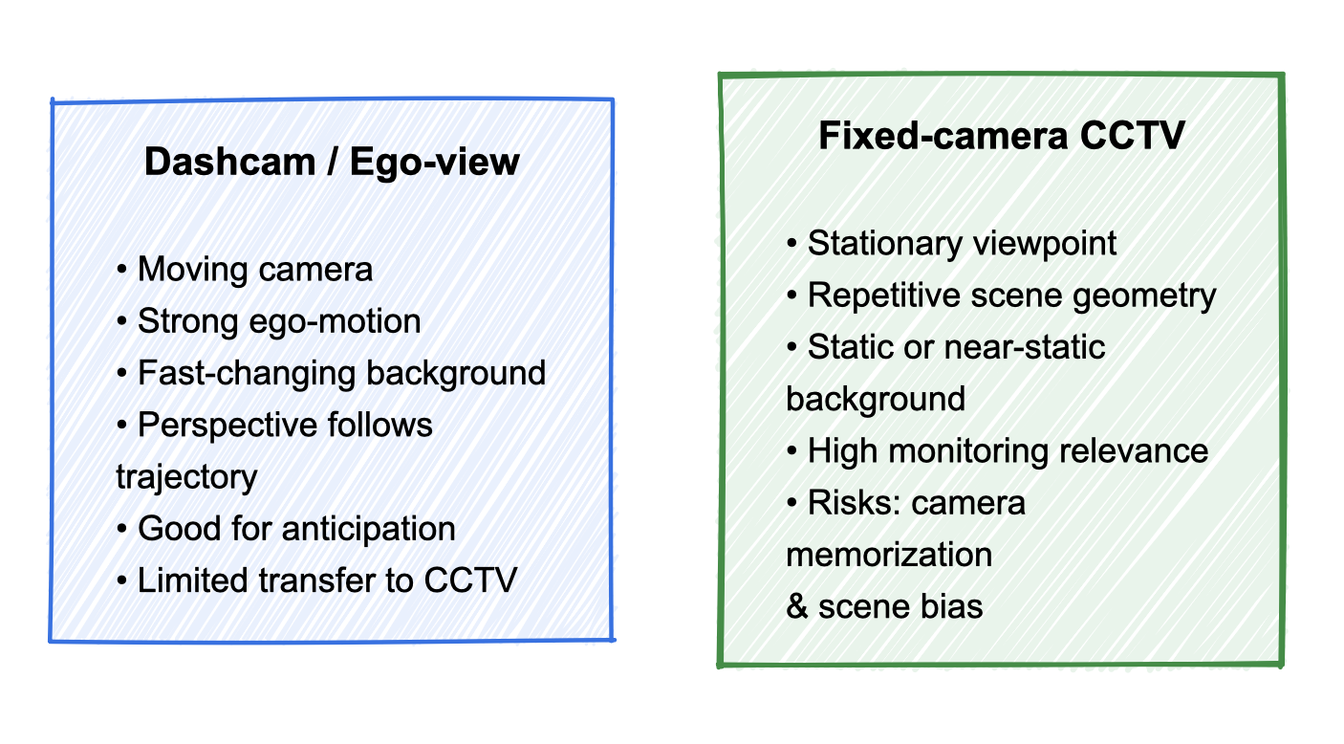
Figure 2.2 – Comparison of dashcam and fixed camera setups

2.3 Mathematical representations of video signals and families of models
For a road video clip, three families of representations are natural in the literature and in the project plan: clip-based, spatio-temporal, and object-centric. Clip-based aggregates frame-level features, spatio-temporal applies a video-native operator to the entire volume, and object-centric combines the global context of the scene with local object-oriented features.
In a clip-based baseline, each frame x_t is encoded by a function f_θ, after which the features are aggregated into a temporal representation of the clip. For fixed-camera scenes, this model already yields a strong and easily interpretable baseline if the event is visible in individual frames:
$h=\left(1/T\right)Σ_{t=1}^{T}f_{θ}\left(x_{t}\right)$ (2.1)

Video-native models work directly with time. In its most general form, 3D convolution operates on both temporal and spatial axes simultaneously, making it a natural candidate for event recognition.:
$y_{c}\left(t,i,j\right)=\sum{\left(c^{'}\right)\sum_{τ}{\sum_{u}{\sum_{v}{w_{\left(c,c^{'}\right)}\left(τ,u,v\right)x_{\left(c^{'}\right)}\left(t+τ,i+u,j+v\right)}}}}$ (2.2)

SlowFast architectures use dual-rate temporal reasoning: one stream is sparse temporal sampling, global scene semantics; the second is high-frequency, fast motion cues.:
$X^{\left(slow\right)}=\{x_{1},x_{\left(1+α\right)},x_{\left(1+2α\right)},…\}, X^{\left(fast\right)}=\{x_{1},x_{2},x_{3},…\}$ (2.3)

The object-centric branch complements the global scene representation with local evidence regions-vehicles, potential collision regions, and obstacles in the lane. In general, the fused representation is written as follows:
$z=\left[g_{\left(global\right)}\left(x_{\left(1:T\right)}\right);g_{\left(local\right)}\left(r_{\left(1:T\right)}^{\left(1\right)},…,r_{\left(1:T\right)}^{\left(K\right)}\right)\right]$ (2.4)

In the thesis, these families correspond to three project lines: ConvNeXt serves as a strong clip-based baseline, R3D-18 as a reliable video baseline, and YOLO-guided hybrid as a substantively motivated but empirically incomplete object-oriented approach.

Table 2.1 – Model families, their representation type, and expected role in the thesis tasks
Model family | Representation type | Main strength | Key limitation
ConvNeXt clip baseline | aggregated frame embeddings | strong and interpretable baseline for clip classification | limited explicit temporal modeling
R3D / R(2+1)D | spatio-temporal volume | directly captures temporal cues | sensitive to dataset size and overfitting
SlowFast | dual-rate temporal representation | separates slow semantic context from fast motion dynamics | higher computational complexity
YOLO-guided hybrid | global + local object-centric features | potentially better interpretability and localization of evidence regions | this branch is not yet empirically completed in the project

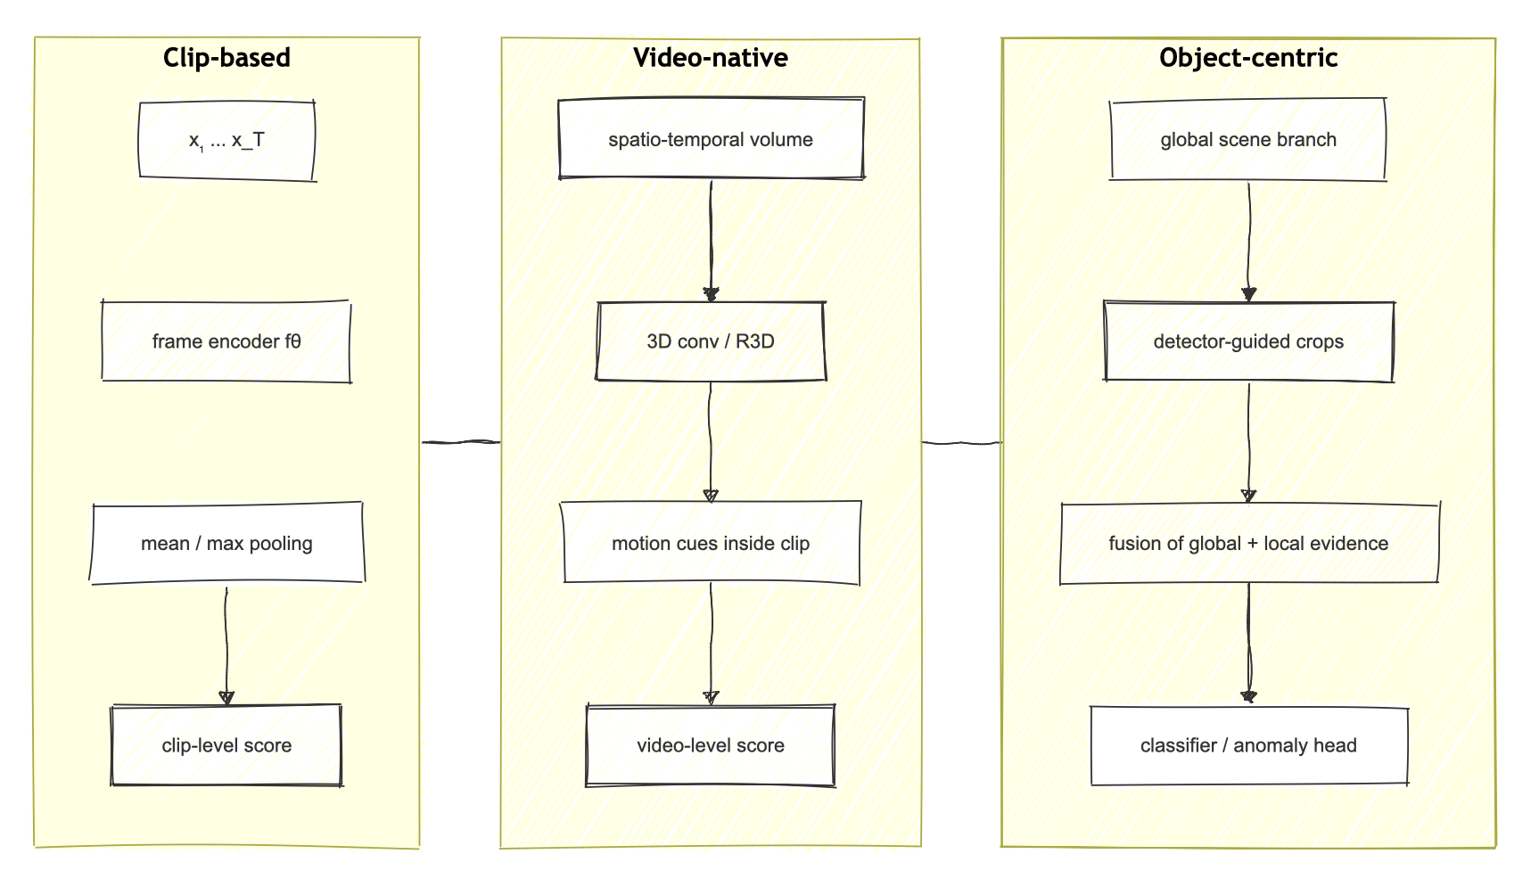Figure 2.3 – Comparison of clip-based, spatio-temporal and object-centric representations of a video signal

2.4 Datasets, benchmark mismatch, and dataset bias
In this field, dataset selection isn't just an engineering detail, but rather a key methodological issue. AI City 2021 Track 1 was designed as a benchmark for multi-class, multi-movement vehicle counting using traffic cameras. In the project, it is reinterpreted as a normal traffic source for fixed-camera surveillance. This reinterpretation is acceptable with a caveat: AI City is not an officially labeled zero-accident corpus, so its no_accident subset needs to be curated, and a split needs to be built camera-aware.
CADP is important as one of the early CCTV-oriented datasets for accident analysis and forecasting. It demonstrates that CCTV accident research requires a different approach than dashcam analysis and has long suffered from a lack of representative data. The BAVD is convenient as a source of accident and severity labels, but does not provide a pure normal CCTV baseline. Therefore, the project adopted a modular two-dataset design: AI City is a curated normal source, and BAVD is an accident/severity source.
New CCTV-oriented benchmarks don't solve the problem. They expand coverage, but typically address broader challenges (event localization, richer taxonomies, mixed real/synthetic modes) and are not a direct replacement for clip-level binary accident setup. This leads to benchmark mismatches: differences in camera type, granularity labels, the role of normal class, and evaluation mode make headline metrics from different studies only partially comparable.
For fixed-camera surveillance, this is especially painful, because positive and negative examples often come from different visual domains. In this setting, the model can learn to distinguish not the event itself, but the file origin, codec features, or a specific camera. Comparing architectures without controlling source alignment and split discipline then becomes meaningless.

Table 2.2 – Public datasets and corpora most relevant to this study
Source | Camera setting | Primary task | Relevance to the thesis | Key limitation
AI City 2021 Track 1 | fixed roadside / CCTV | vehicle counting | source of normal traffic and surveillance framing | no accident or severity labels
CADP | CCTV | accident analysis / forecasting | example of an open CCTV accident corpus | focused on forecasting and does not match the current binary setup
BAVD | accident clips, mixed real-world video | severity-labeled accidents | main source of accident and severity data in the project | does not provide a clean no-accident CCTV baseline
UCF-Crime | surveillance, mixed scenes | weakly supervised anomaly detection | highlights the importance of long untrimmed evaluation | too broad and not traffic-specific
Street Scene | single-scene fixed camera | video anomaly detection | important as a reference for a realistic evaluation protocol | not an accident-specific benchmark
ACCIDENT benchmark (2026) | traffic surveillance / CCTV | event-level accident understanding | indicates the development of stricter CCTV benchmarks | broader than the current clip-level formulation
RoadObstacle21 / SegmentMeIfYouCan | ego-view road scenes | obstacle segmentation | relevant to the future anomaly branch | not fixed-camera CCTV
RDD2022 | road images | road damage detection | relevant to the road-surface damage branch | an image benchmark rather than a fixed-camera video benchmark

2.5 Pitfalls of Evaluating Surveillance Systems
For surveillance systems, quality cannot be reduced to a single metric. For rare events, high accuracy coexists with an unacceptable number of false alarms; with a poorly defined positive class, a model may look good on short clips but fail in long-stream mode. Therefore, threshold analysis, event-level localization, long-stream evaluation, and camera-level error analysis are increasingly discussed in the literature.
From an operational perspective, one natural metric is the number of false alarms per hour:
$FAH=\frac{N_{\left(FP\right)}}{H}$ (2.5)
Here, N_FP is the number of false positives in a long video stream, and H is its duration in hours. This value is directly tied to the practical utility of the system. For the severity branch, in turn, metrics that don't mask failure in one class at the expense of another are important; primarily, these are macro-F1 and balanced accuracy.
The methodological conclusion is simple: published accident detection results cannot be directly compared without specifying the dataset mode, the role of the normal class, the split discipline, and the type of errors being evaluated. In some studies, this applies to curated binary clips and headline accuracy, in others, it's anomaly detection on long videos, and in still others, it's CCTV forecasting. Comparing a "large number" with a "smaller number" without taking the evaluation mode into account is meaningless.
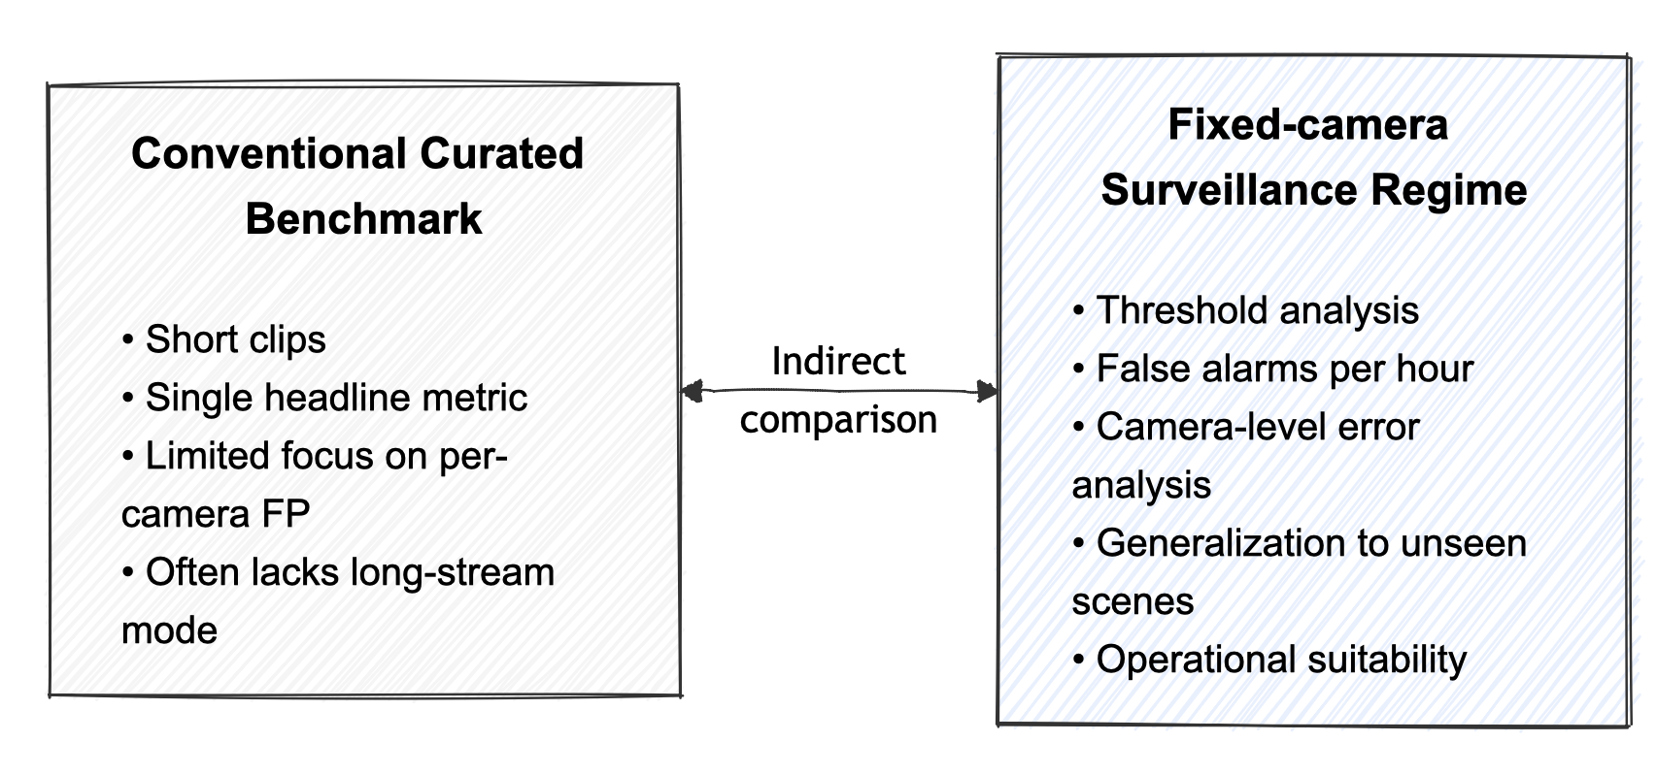
Figure 2.4 – Why headline metrics from different papers cannot be compared directly

2.6 Infrastructure anomaly detection
This topic covers not only accidents but also infrastructure anomalies: debris, fallen objects, lane obstacles, and pavement damage. Mixing these tasks with accident detection in a single empirical comparison is incorrect. The markup is different, the visual granularity is different, and a different model is often needed - object detection or anomaly segmentation instead of clip-level classification.
RoadObstacle21 and Lost and Found are useful as benchmarks for obstacle logic, while RDD2022 is useful for road damage branching. All these corpora address related, rather than identical, problems. Therefore, in the current study, infrastructure anomalies are treated as a logical extension of the constructed pipeline, rather than as part of the final accident/severity comparison.

2.7 Chapter Conclusions and Research Gap
The review yields three conclusions. First, accident detection and severity classification in fixed-camera CCTV mode constitute a separate subproblem that cannot be mixed with dashcam analysis, anomaly segmentation, or accident anticipation without reservation.
Second, the literature confirms the value of both strong clip-based baselines and explicit temporal modeling, but does not provide a universal answer regarding which architecture is inherently superior. For surveillance settings, model selection is closely tied to split discipline, source alignment, and problem formulation.
Third, there is no publicly available clean corpus that would immediately provide fixed-camera normal traffic, accident severity labels, and data for the infrastructure anomaly stage. This explains the research gap: for fixed-camera road surveillance, not only the architecture is underdeveloped, but also a proper data protocol that allows for fair comparison of models and separation of event understanding from dataset-specific shortcuts.

3 Search, selection and preparation of data
In a CV project, carelessly selected data devalues ​​everything that follows - from the choice of architecture to beautiful graphs. In our work, finding and structuring datasets turned out to be one of the most meaningful and challenging stages. We initially formulated not just a couple of corpora names, but a target profile of what the data should be for the task at hand.
The ideal corpus had to immediately satisfy several conditions: it had to provide a feed from a fixed traffic camera or roadside view, depict the real road environment, contain a sufficient number of normal and accident clips, and ideally, severity tagging. The infrastructure anomalies branch additionally requires anomaly classes that cannot be reduced to people and vehicles: trash, fallen objects, debris, pavement damage, and objects blocking lanes. The entire corpus had to be available from a verifiable open source.
Even at this stage, it became clear that such a unified corpus was not openly available. Data retrieval became a separate research task: the goal wasn't to select a dataset, but to assemble a compatible source architecture, each with its own role. This resulted in a modular two-dataset design: AI City serves as a curated source of normal fixed traffic, while BAVD serves as a source of severity-labeled emergency clips.
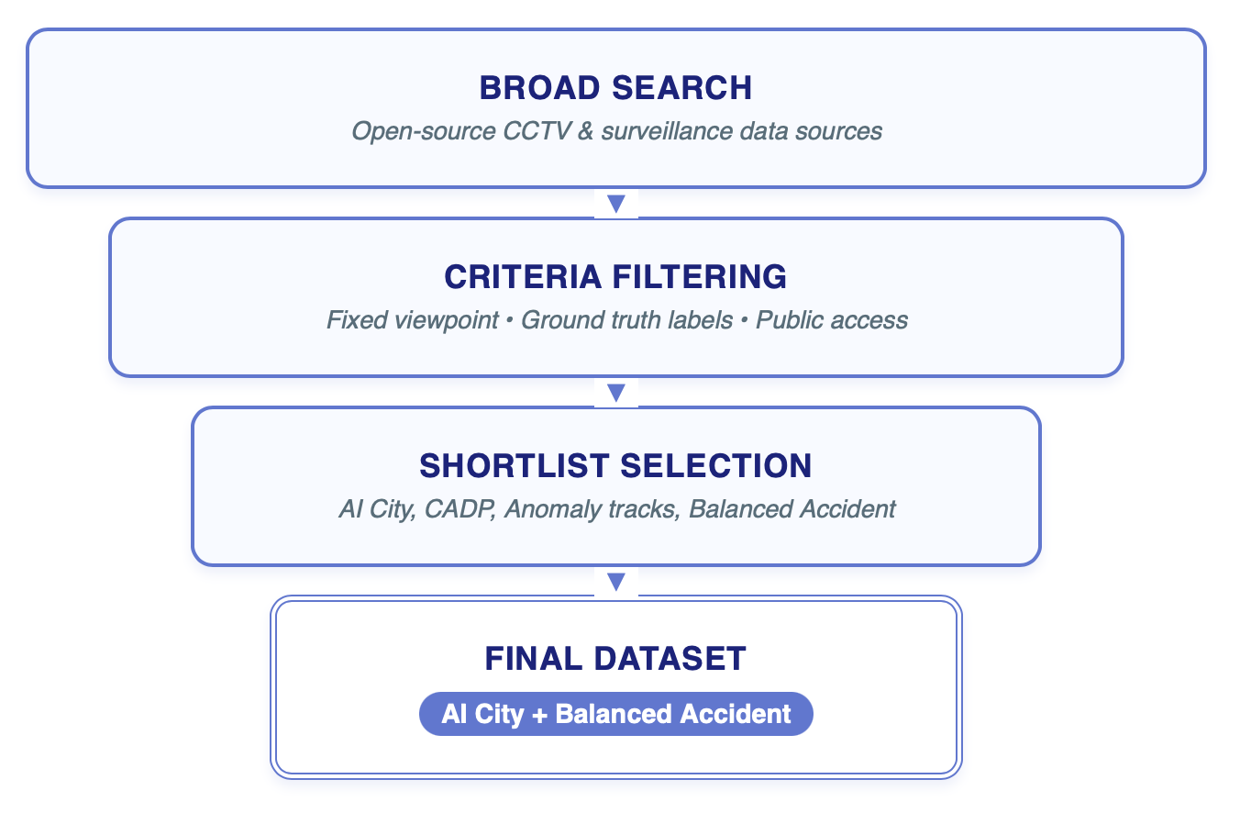
Figure 3.1 – Data source selection flow chart: from general target corpus specification to shortlist and final two-corpus design.

3.1 Why one dataset was not enough
AI City 2021 Track 1 is well suited as a fixed-camera normal traffic source: these are road cameras, closely related to urban monitoring and transport analytics. However, the corpus was developed for counting tasks, not accident detection or severity classification. It does not contain ready-made accident tagging, formally "zero accidents" are not guaranteed, and before using it as a source of the no_accident class, the corpus requires careful manual or semi-automated filtering.
BAVD, on the other hand, contains ready-made accident clips, divided into three severity categories: minor, moderate, and major. This makes it convenient for the severity branch and allows all accident classes to be merged into a common accident class for the binary branch. The corpus does not solve the inverse problem—it itself does not contain a reliable and visually comparable source of normal CCTV traffic.
CADP and AI City anomaly track, as measured by literature and open surveillance benchmarks, confirm the same picture: each public source covers only a portion of the required space. One describes emergency segments, another describes freeway scene anomalies, and a third describes stable, normal traffic. Therefore, the important thing in a thesis isn't choosing the "best dataset," but rather justifying why a working composition had to be assembled from multiple corpora and how this influenced the experimental design.

Table 3.1 – Data requirements matrix and the role of selected corpora.
Criterion | AI City 2021 Track 1 | BAVD | Final role
Fixed CCTV / roadside viewpoint | Yes | partial / mixed accident clips | AI City serves as the main normal source
Clean normal class | requires curation | No | obtained from AI City after filtering
Accident labels | No | Yes | obtained from the BAVD
Severity labels | No | Yes | obtained from the BAVD
Potential for an anomaly branch | limited | low | requires separate extension
Open and reproducible access | Yes | Yes | both sources are used in the modular pipeline

3.2 AI City as a curated source no_accident
In the local project, AI City was reimagined not as a counting benchmark, but as a source of normal road traffic. The logic aligns with the thesis topic: fixed-camera surveillance scenes are much closer to the final use case than random dashcam videos. Since the corpus is not formally "zero" in terms of accidents, it had to be treated with caution: automatically labeling the entire dataset as no_accident and closing the issue was impossible.
This necessitated a camera-based split discipline and manual verification of suspicious fragments. If the same camera is included in both train and test, the model is highly likely to memorize the background, lane pattern, and object positions, rather than absorbing the general features of normal traffic. Therefore, at the local corpus structure level, the subset was organized by camera and train/val/test roles.
According to the formal dataset procedure report, the local AI City subset after selection consists of 31 videos, totaling approximately 4.98 hours and 5.346 GB. In the original raw form, these materials were not used: everything passed through a harmonized pipeline, which is necessary to reduce the differences between sources and codecs.

3.3 BAVD as an accident source and severity
BAVD became key for the accident branch. The folder hierarchy already reflects severity classes, so a single source is used in two ways: for the binary branch, all severity folders are merged into the accident class, while for the severity branch, the split into minor, moderate, and major remains.
According to the dataset procedure report, the local corpus contained 1,500 clips, totaling approximately 4.31 hours and 13.673 GB. The default split was 1,050 train / 225 val / 225 test, with severity classes distributed completely balanced—500 clips each. This is convenient for comparing model families, but does not solve the problem of visual heterogeneity relative to the normal CCTV source. This is where the main methodological problem of the entire study arose.
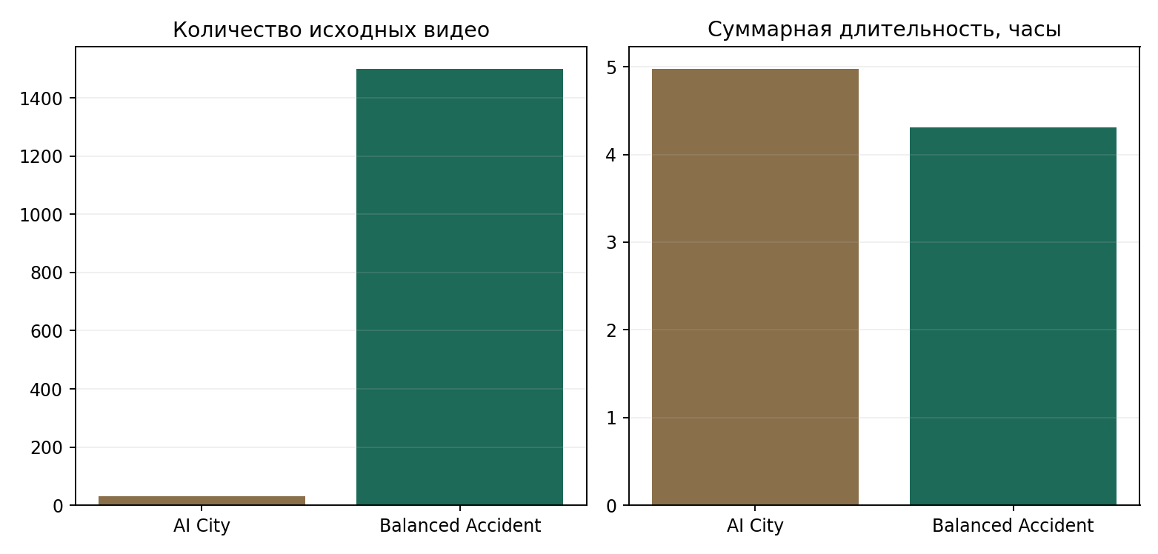
Figure 3.2 – Overview of source corpora and their role in the formal report bundle project: normal traffic source, emergency clips, split structure and data volume.

Table 3.2 – Key indicators of the original corpora according to the formal dataset procedure report.
Source | Number of videos/clips | Size | Total duration | Comment
AI City local subset | 31 videos | 5.346 GB | 17914.6 s (~4.98 h) | used as a curated normal traffic source
BAVD | 1500 clips | 13.673 GB | 15514.14 s (~4.31 h) | used as the accident and severity source

3.4 Metadata-first and manifest-first approach
The project's experiments rely not on a random folder structure, but on individual clip manifest descriptions. This disciplines the entire pipeline: a clip becomes not a file, but a record with fields such as split, source dataset, binary label, severity label, camera ID, frame rate, and additional tags.
For a research project, this binding is especially important. When a result matches a specific manifest file, it's possible to reconstruct the sample composition, check the class distribution, track whether augmented examples have been excluded, and repeat the same post-evaluation. Without a manifest-first approach, comparing run-time artifacts quickly devolves into comparing opaque folders whose contents can change unnoticeably over time.

Table 3.3 – Example of ClipRecord recording scheme in the manifest-first pipeline.
Field | Meaning
clip_id | unique clip identifier
video_path | path to the harmonized video file
dataset | data source
split | train / val / test
task | binary or severity
binary_label | accident / no_accident
severity_label | minor / moderate / major / none
camera_id | camera identifier, if applicable
fps, duration_sec | technical characteristics of the clip
tags | additional tags, such as augmented, roadcrop, etc.

3.5 Harmonization and Domain Reduction
Different video data sources almost always differ in frame rate, resolution, codec, compression, and overall visual profile. Without control, a neural network is highly likely to learn the technical features of the file rather than the event. Therefore, the project included a separate harmonization stage, which brought all clips to a single profile.
The main harmonization profile according to the formal report bundle is bridge_v1_8fps_160: target_fps = 8, 160×160, libx264 transcoding, yuv420p pixel format, veryfast preset, crf 28. In practice, this means that AI City's normal clips and Balanced Accident's emergency clips pass through the same technical "throttle," and the likelihood of learning from codec-level cues is significantly lower.
The data processing report records that FPS was adjusted on 1,529 files, resized on 1,531, and the same number of files were re-encoded. The scale of this operation shows that harmonization was not cosmetic, but a real part of the research design.
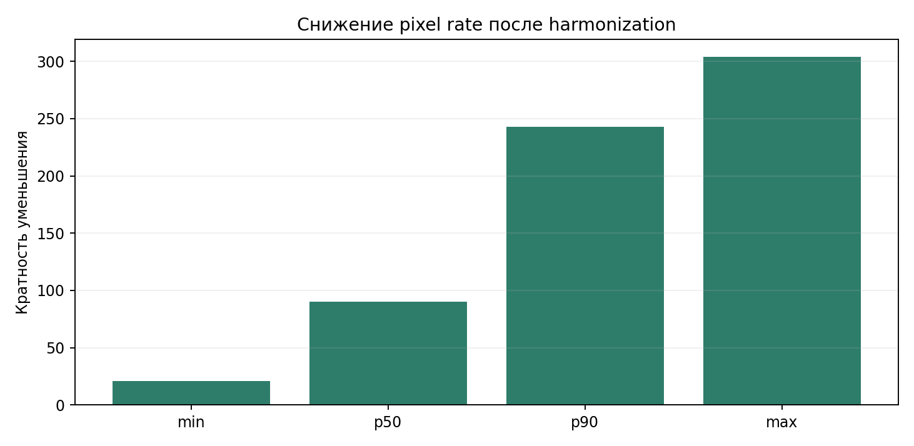
Figure 3.3 – Illustration of harmonization: bringing clips to a common technical profile reduces the influence of source-specific features and makes the comparison more fair.

3.6 Central Difficulty: Source-Domain Leakage
The main problem with early accident experiments was that positive and negative examples came from different visual domains. Positive clips were taken from the accident building, negative ones from AI City. Formally, the setup is logical: one source generates an accident, the other normal traffic. It generates a dangerous shortcut. A model can learn to distinguish data sources by video quality, resolution, color rendition, scene composition, or even specific cameras, but still fail to recognize accidents.
This happened in the early baseline A01b. At the headline level, it looked acceptable, but the formal defense report showed a failure for unseen cameras: on cameras cam_8, cam_13, and cam_15, the model almost always generated false alarms. This was a manifestation of the camera-domain trap: high recall for the accident class was accompanied by a huge number of false positives, and the practical value of this solution was low.
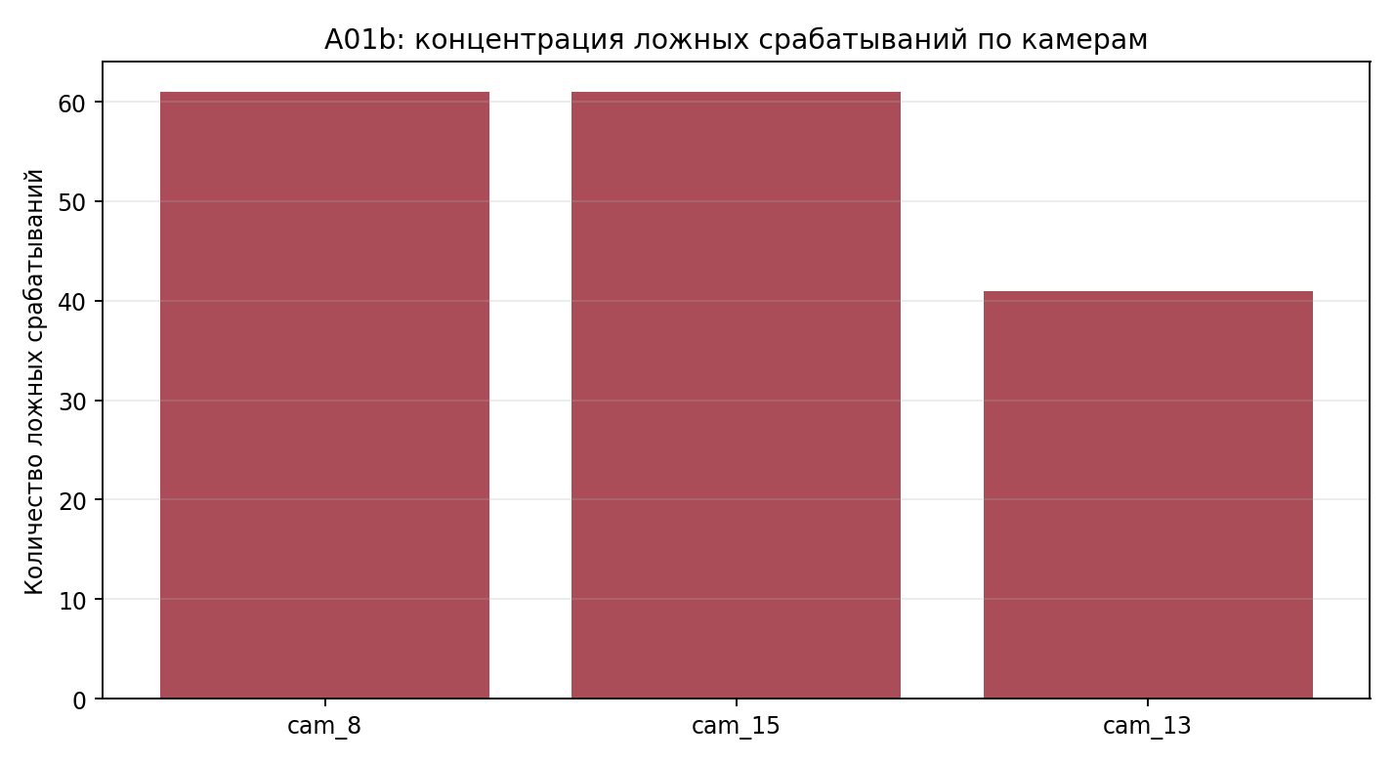
Figure 3.4 – Concentration of false alarms baseline A01b on unseen cameras: the model captured the difference between sources and specific cameras, and not the fact of an accident itself.

3.7 Grouped-window reformulation
The solution was not to increase the number of negative clips, but to reconsider the problem statement itself. Instead of mixed-source negatives, we introduced grouped-window reformulation: no_accident examples were extracted as calm head windows from the same visual domain as accident recordings. This transition aligns codec and scene statistics, makes splitting more disciplined, and removes a key shortcut - the ability to predict class based on file origin.
Furthermore, augmented recordings were excluded from the official selected line. This is significant: when artificially corrupted or transformed clips are introduced into train or test, the model can learn augmentation artifacts instead of the useful signal. In the accident branch D02, this risk was removed, and the split became balanced and real-only. Therefore, grouped-window reformulation in this regard is not a technical detail, but a fundamental scientific step in the work.
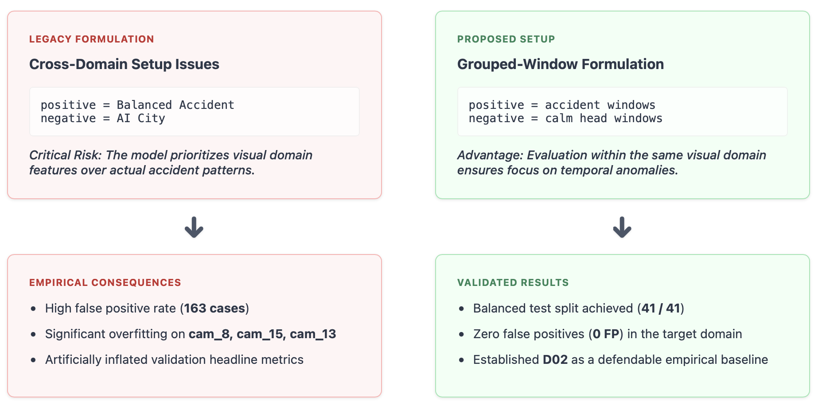
Figure 3.5 – Schematic of the transition from the erroneous mixed-source formulation to the grouped-window reformulation, in which the negative windows are taken from the same visual domain as the crash clips.
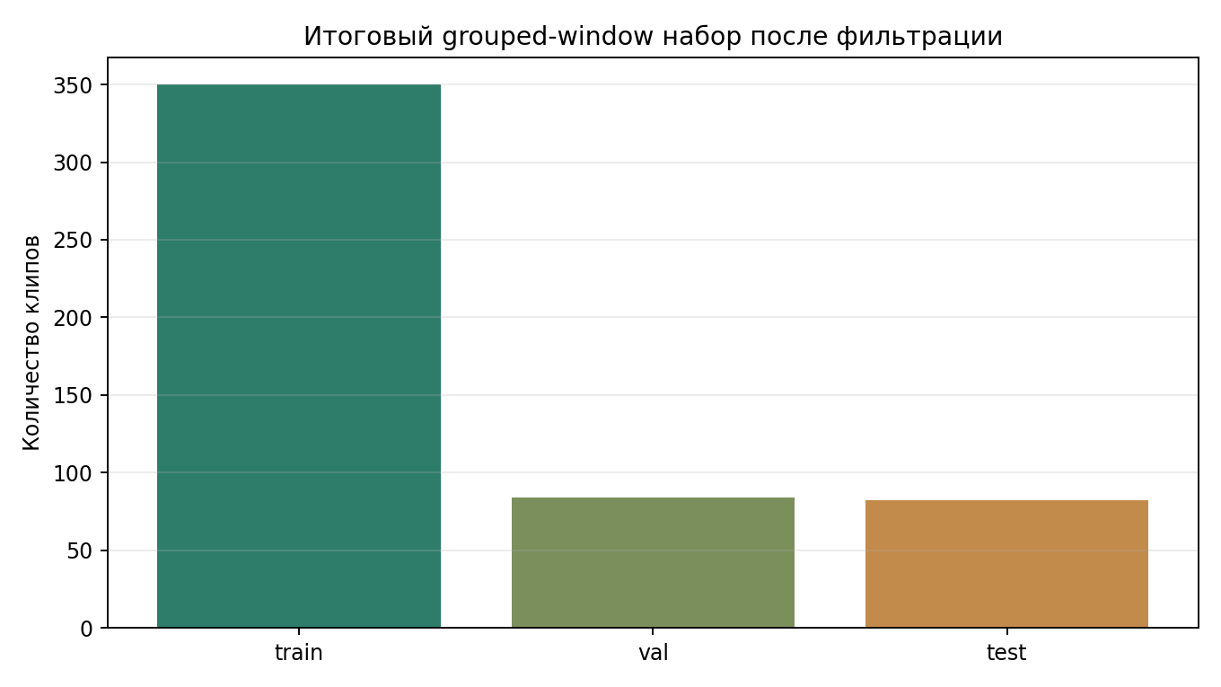
Figure 3.6 – The final composition of the grouped-window split for the selected accident line: balanced train/val/test after filtering out invalid and augmented examples.
Table 3.4 – Dimensions of the official grouped-window split for the selected accident line D02.
Split | Total clips | Accident | No accident
train | 350 | 175 | 175
val | 84 | 42 | 42
test | 82 | 41 | 41

3.8 Severity Splits Formation Policy
The severity branch is built separately from accident/no_accident and uses only the accident source with the minor, moderate, and major classes. AI City plays no role here: normal traffic is not needed for severity. The issue of augmented clips was addressed separately: the formal report bundle included both mixed splits and cleaner real-only summaries. Ultimately, the choice was made not based on the most attractive validation headline, but on the behavior in the held-out test - hence, the selected run is S13, not S15.
The data chapter leads to the main methodological conclusion: data selection in this project cannot be considered an auxiliary stage before the "real" model training. It was precisely data analysis, harmonization, and correction of negative examples that determined the quality and integrity of the final output for the accident branch.

4 Methodology and implemented system
By the time the project moved to the architectural part, it had ceased to be a "collection of several models." The data had been consolidated, manifests had become the key unit of sample description, and official results were separated from exploratory runs via saved-run post-evaluation. Against this background, model selection cannot be discussed in isolation from the pipeline, but only as part of the system.
Architecturally, the project was initially conceived as a comparison of three pipelines: a ConvNeXt clip baseline, a pure video-based pipeline based on R3D-18/SlowFast, and a hybrid object-aware pipeline based on YOLO and ConvNeXt. The first two pipelines were ultimately developed to a defensible state, and a formal comparison was conducted for accident and severity. The YOLO-guided pipeline remained at the stage of substantiated future development, and this is how it should be described in the thesis.
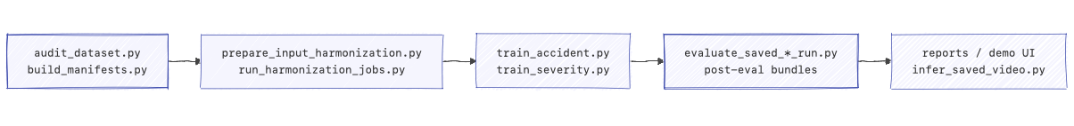
Figure 4.1 – Project repository workflow: preparation of manifests, harmonization, training, preservation of checkpoint artifacts and a separate post-evaluation stage for formally protected results.

4.1 General organization of the pipeline
The system is modular. A video stream or a pre-selected clip is input. Next, it's converted to the required format and frame-sampled. A binary accident detector returns an incident detection rating. If an incident is detected, the clip is fed to a severity classifier, which distinguishes between minor, moderate, and major. The cascaded approach makes sense from both an engineering and research perspective: the model doesn't solve everything at once, and the accident and severity branches can be independently optimized for different signals and metrics.

4.2 ConvNeXt as a clip-based baseline
The ConvNeXt branch accepts a clip as a sequence of frames: the image backbone extracts the embedding from each frame, after which frame-level features are aggregated into a temporal representation of the clip. The inspected codebase at least implements mean/max pooling on top of frame embeddings - the model works as a strong baseline for clip classification without an explicit 3D temporal block.
The strength of this approach is its interpretability. If it performs well, then static or quasi-static features averaged over several frames are sufficient for the task. If the clip-based baseline is inferior to the video model, then information about the temporal development of the event is truly necessary. The comparison of these two situations became one of the central conclusions of the thesis.
$h=\left(1/T\right)Σ_{t=1}^{T}f_{θ}\left(x_{t}\right)$ (4.1)
Here x_t is the t-th frame of the clip, f_θ is the frame encoder, and h is the clip-level embedding after mean aggregation over T frames.

4.3 R3D-18 as honest video baseline
R3D-18 works directly with spatiotemporal volumes. Unlike a clip-based baseline, it doesn't reduce a clip to a set of nearly independent images, but applies 3D convolutions to a block of frames. This approach better captures events with pronounced dynamics: trajectory changes, collisions, skidding, and subsequent flow disruptions.
The presence of temporal inductive bias alone does not guarantee success. This is clearly evident in the accident branch: A06, built as an R3D baseline, quickly overfitted. In early epochs, the val metric reached a local maximum, then training accuracy continued to increase, while validation quality degraded. A video-based model may prove too powerful or too unstable for the chosen formulation and data volume. R3D is not "automatically better" here, but serves as a fair test of the hypothesis about the usefulness of temporal modeling.

4.4 YOLO-guided hybrid as the next logical branch
The idea behind the hybrid line is to combine global scene context with local object-oriented features. A detector (e.g., one from the YOLO family) first identifies vehicles or potentially hazardous areas, after which the classification part receives both the entire frame and the cropped regions of the interaction. This scheme is interesting when one wants to improve the recall of accident models without returning to the previous level of false alarms.
The limitation is that the current repository does not contain a completed empirical comparison of this line with D02 and S13. In the thesis, the hybrid line should be described as a designed next step, not as a final result. This does not weaken the work: the project has an internal development logic and has already laid the foundation for it - manifests, harmonization, pipeline scripts, and an evaluation discipline.

4.5 Reproducibility and code organization of the project
The project's repository discipline is a distinct asset. The codebase separates the domain, data, models, training, evaluation, inference, and pipeline layers. This means that an experiment can be reconstructed not only from the schedule, but also from the configuration, manifest file, saved history/metrics JSON, checkpoint metadata, and post-evaluation artifacts.
This is important for a thesis for two reasons. The work is truly a research project, not a software prototype: it includes a comparison of approaches, a methodological conclusion, and a separate stage of formal saved-run evaluation. Furthermore, the presence of a reproducibility layer protects against the typical problem of "we once saw a good result, but can't reconstruct the dataset and preprocessing used." In the inspected repository and outputs bundles, this problem is solved by manifests, config-driven scripts, and separate evaluators for accident and severity.

Table 4.1 – Main experimental lines of the project and their status in the diploma.
Run | Task | Model family | Status | Role in the thesis
A01b | accident | ConvNeXt | historical baseline | illustrates the domain trap
A03r | accident | ConvNeXt | repaired baseline | comparison prior to D02 and threshold analysis
A04 | accident | ConvNeXt | exploratory dense-negative run | negative result
A06 | accident | R3D | exploratory overfit run | illustrates the limitation of the video line
D02 | accident | ConvNeXt | selected defendable run | official final result for the accident branch
B01 | severity | ConvNeXt | historical baseline | reference point
B01r | severity | ConvNeXt | bundled local demo | not the final research result
S13 | severity | R3D-18 | selected defendable run | official final result for the severity branch
S15 | severity | R3D-18 | validation leader | counterexample against selecting by validation headline only
YOLO hybrid | accident / anomaly | YOLO + ConvNeXt | planned future work | promising future direction

5 Experimental design and evaluation protocol
One notable methodological result is that the final figures weren't simply extracted from history files of the best epochs, but cross-checked through a separate saved-run post-evaluation pipeline. This is significant for the accident branch: formal reports explicitly state that early headline results were partially inflated due to mismatches in train/eval preprocessing and other technical factors. Therefore, not just any figures from run artifacts are considered official in the thesis, but only those confirmed by a proper post-evaluation stage [21–23].
The separation of the exploratory headline and formal defendable metric may seem redundant, but it is precisely this that ensures the reliability of the conclusions. Otherwise, the thesis turns into a collection of attractive but poorly comparable results obtained with slightly different evaluation rules. This risk is deliberately mitigated in this paper.
A brief explanation of why the protocol in this paper is stricter than in some published accident detection studies. The literature often features headline figures like 95–98% accuracy obtained with a curated clip-level setup, where positive and negative examples are taken from different sources or where thresholding and preprocessing are adjusted for the test. In such setups, high accuracy does not guarantee performance on a real-world workload. Therefore, the defended portion of the results relies on four rules: balanced accuracy as the primary metric instead of standard accuracy, to ensure that the bias between FP and FN is not hidden; threshold sweep instead of a fixed τ = 0.5, to ensure that the operating point is chosen reasonably; camera-level error analysis on unseen cameras, to separately test robustness to new visual domains; saved-run post-evaluation instead of headline metrics from a history file, to ensure that train/eval preprocessing are consistent. With such a protocol, direct comparison with the published "pretty" figures is meaningless - numbers from different evaluation modes are not comparable.

5.1 Formal criteria for accident detection
Let p(x) be the estimated probability of an accident for clip x, and τ be the operating threshold. The binary classifier's decision is determined by the threshold exceedance indicator. This notation links the model's output to operational tuning: the same network behaves differently for different τ, which is especially important for false alarm analysis.
$ŷ = 1[p(x) ≥ τ]$ (5.1)
Here ŷ is the predicted binary class, p(x) is the probability of the accident class, τ is the decision threshold.
Binary cross-entropy is used to train the binary model. In this setup, it penalizes both missed accidents and false alarms in normal traffic.
$L_{B}CE=-\left(y log p+\left(1-y\right) log\left(1-p\right)\right)$ (5.2)

Here, y ∈ {0,1} is the true clip label, and p is the predicted accident probability.

Accuracy alone is not enough for accident detection. With a large number of false alarms, the operator loses confidence in the system; with a small number of false alarms but a high proportion of missed accidents, the system loses its usefulness as a screening tool. Therefore, the main metrics used in this work include balanced accuracy, precision, recall, F1-score, ROC-AUC, PR-AUC, and the number of false positives. Precision and recall are determined by TP, FP, and FN.

$Precision = TP / (TP + FP), Recall = TP / (TP + FN)$ (5.3)

TP is the number of true positive responses, FP is the number of false positive responses, FN is the number of false negative responses.

$F1 = 2 · Precision · Recall / (Precision + Recall)$ (5.4)

The F1-score specifies the harmonic mean of precision and recall and is useful when there is an unbalanced focus on error types.

$BalancedAccuracy = (TPR + TNR) / 2$ (5.5)

TPR is the sensitivity for the accident class, TNR is the specificity for the no_accident class.

5.2 Formal criteria for severity classification
The Severity model produces a probability distribution across three classes, so the loss function is a multiclass cross-entropy loss. The final choice of severity model is made not based on training loss or even validation accuracy alone, but on performance in the holdout test, with an emphasis on macro-F1 and balanced accuracy. This is methodologically significant: in the actual results, the best validation headline and the best held-out test run turned out to be different.

$L_{C}E=-Σ_{c=1}^{3}y_{c}logp_{c}$ (5.6)
Here y_c is a one-hot representation of the true class severity, p_c is the predicted probability of class c.
$MacroF1=\left(1/3\right)Σ_{c=1}^{3}F1_{c}$ (5.7)
Macro-F1 averages F1 across minor, moderate, and major classes, and therefore does not hide a failure in one class at the expense of another.

5.3 Hypotheses and testable consequences

Table 5.1 – Main hypotheses and the method of their testing within the project.
Hypothesis | Expected implication | Verification through artifacts
H1: temporal modeling helps severity more than accident detection | R3D should outperform ConvNeXt in the severity branch | Comparison of B01/B01r with S13 and S15
H2: grouped-window formulation improves the validity of accident detection | D02 should clearly outperform A01b/A03r/A04 in false positives and balanced accuracy | Accident defense report and post-evaluation
H3: the best validation headline does not always produce the best final run | S15 does not necessarily have to be the final selection | Comparison of S13 and S15 on the test set
H4: the object-aware branch is theoretically justified but not yet completed | the YOLO hybrid should be presented as future work | Project plan and current repository state

5.4 Metrics accident detection
The accident branch uses balanced accuracy, precision, recall, F1-score, ROC-AUC, PR-AUC, and confusion matrix as its primary metrics. The number of false alarms and their concentration by camera are analyzed separately, as well as the model's behavior at different decision thresholds. The latter is essential: the same model can be acceptable or unacceptable depending on the chosen τ, so the threshold sweep is not a decorative graph but a means of selecting the operating point.
Based accuracy plays a special role. When an operator scenario is sensitive to both FP and FN, standard accuracy easily conceals a bias toward one side or the other. Recall measures the ability to avoid missing real accidents, while precision reflects the cost of one alarm trigger. PR-AUC is more sensitive to the positive class, which is important if the system will be used in long-stream screening, where real accidents are rare.

5.5 Metrics severity classification
The main severity branch metrics are accuracy, macro-F1, and balanced accuracy. Unlike a binary problem, one class cannot be allowed to mask the weakness of another. If a model recognizes major well but regularly confuses minor and moderate, standard accuracy may look decent, while macro-F1 will immediately reveal uneven performance across classes.
In practice, the held-out test macro-F1 has become one of the key criteria when choosing between S13 and S15. This is a prime example of a disciplined approach to selection: the validation headline remains a guideline, but not the only one.

5.6 Why is threshold analysis necessary?
Comparing accident-branch models at a single point, τ = 0.5, is insufficient. Some baselines (e.g., A03r) slightly improve operational behavior when threshold tuning, but they don't address the underlying source bias issue. For D02, it's important to demonstrate that zero false positives isn't a fluke at a single point; threshold sweeping provides a trade-off between recall and precision and confirms that the selected operating point is consistent with the overall model behavior.

5.7 Rules for selecting official results
The thesis uses two categories of numbers. The first is the official headline numbers, which are included in the abstract, main results, and conclusion. For the accident branch, this is D02, confirmed by post-evaluation; for the severity branch, this is S13, which demonstrated the best reliability in the held-out test. The second category is comparison-only numbers: historical baselines, exploratory lines, and local demo artifacts, useful for analysis but not constituting the main empirical result.
This helps avoid the typical mistake of lumping all metrics ever obtained together. In a research project, different numbers play different roles: some demonstrate progress, others address a flawed hypothesis, and still others explain the limitations of local integration. It is important to clearly indicate which of these are considered defensible final results.
Table 5.2 – Rules for interpreting numbers in the diploma text.
Category | Examples | How to use
Official headline numbers | D02, S13 | abstract, results, conclusion, defense
Comparison-only numbers | A01b, A03r, A04, A06, B01, S15 | analytical comparison
Bundled demo / integration artifacts | B01r | to describe the engineering state, but not as a final scientific conclusion

5.8 Summary Map of Artifacts
Artifact summary map. D02 on ConvNeXt with grouped-window road-crop formulation is considered the official accident-run. S13 on R3D-18 is the official severity-run. Local severity artifact B01r is considered a demo/local artifact, not a final research result; its role in the thesis text is limited to demonstrating the checkpoint format. Line S15 is present as a comparison-only run and accompanies the selection argumentation, but is not the final choice. YOLO-guided hybrid is described as planned future work - an architectural line, substantively prepared by data and code organization, but not brought to a formal final comparison. A single set of roles is maintained across all chapters; there should be no discrepancies between the description of the data, methodology, experiments, and conclusion.

6 Results and Analysis
Компактная сводка официальных результатов. Accident detection: selected run D02, ConvNeXt grouped-window road-crop, test balanced accuracy 0.8049, F1 0.7576, precision 1.0000, recall 0.6098, ноль ложных срабатываний на held-out test; роль в дипломе — official accident result. Severity classification: selected run S13, R3D-18 с clip_num_frames = 8 и stride = 8, test accuracy 0.6222, macro-F1 0.6169, balanced accuracy 0.6222, ROC-AUC OvR 0.8076; роль в дипломе — official severity result. Сравнительные линии (A01b, A03r, A04, A06 по accident; B01, B01r, S15 по severity) разбираются ниже отдельно и выступают как comparison-only evidence, а не как headline numbers.
Accident и severity ветки в этой главе рассматриваются раздельно, и это сделано намеренно. Несмотря на тематическую близость, эмпирическая логика двух задач разная. Для accident detection главный скачок качества связан с пересмотром data protocol и устранением source-domain leakage. Для severity classification решающим фактором стало явное temporal modeling. Эти выводы нельзя сводить к формуле «нужна лучшая архитектура» — реальный результат работы содержательнее.

6.1 Accident detection: от доменной ловушки к защищаемому baseline
At first glance, the historical baseline A01b looked good: high recall and acceptable overall metrics. The formal accident defense report ruined the picture. On unseen cameras (primarily cam_8, cam_13, and cam_15), the baseline almost always returned false alarms. The error concentration was so high that it was impossible to attribute it to noise. This is a classic camera-domain trap [21].
The corrected baseline A03r better reflected the useful signal, but did not primarily solve the problem. Balanced accuracy increased compared to A01b, but the false alarm rate remained very high. An attempt to correct the situation with the dense-negative variant A04 also failed to produce the desired effect. This is an important scientific conclusion: simply adding more negative examples is insufficient if the negative examples themselves still represent an incorrect problem statement.
Against this background, the grouped-window run D02 turned out to be a qualitative turnaround. After switching to a more honest formulation and a real-only split, the model retained its ability to distinguish faulty clips but eliminated false positives in the test. This isn't just the best run in the table—it's evidence that a properly formulated data protocol changed the nature of the error.

Table 6.1 – Main results of the accident branch.
Run | Balanced accuracy | F1 | Precision | False positives | Interpretation
A01b | 0.6378 | 0.7341 | 0.5799 | 163 | camera-domain trap
A03r | 0.6711 | 0.7517 | 0.6038 | 147 | repaired baseline, but still too many false positives
A04 | 0.6356 | 0.7320 | 0.5788 | 163 | adding more negatives did not solve the problem
A06 | — | — | — | — | severe overfitting of the video model
D02 | 0.8049 | 0.7576 | 1.0000 | 0 | official final accident run

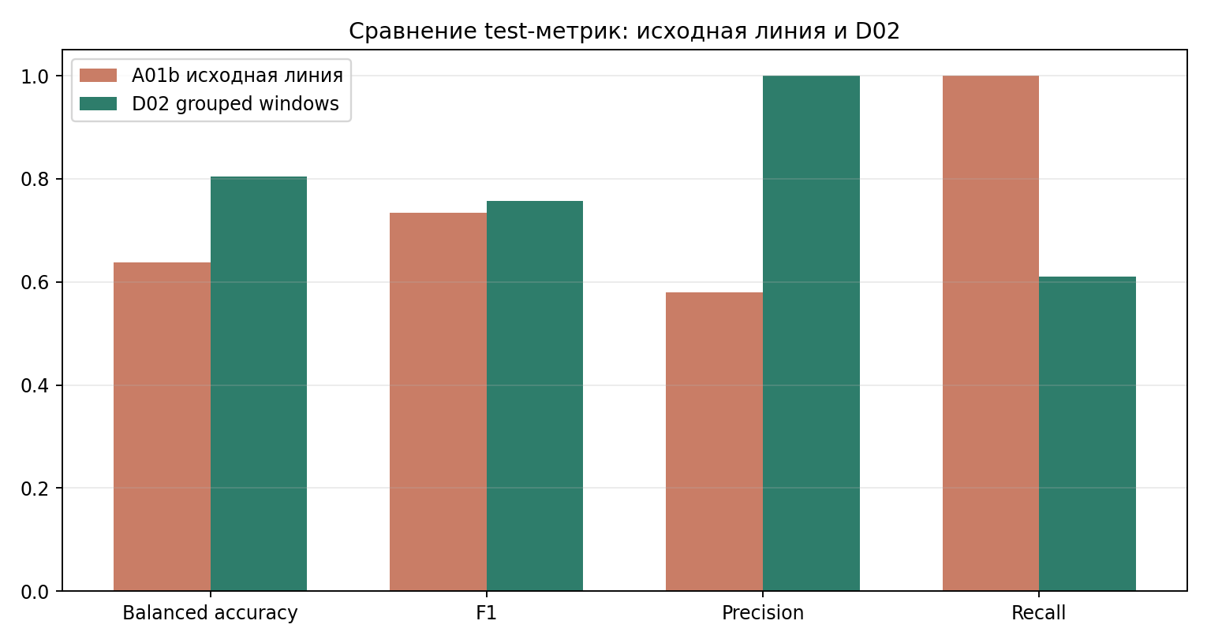
Figure 6.1 – Comparison of key accident-run metrics. For D02, the gain is associated not only with the architecture, but primarily with a change in the problem statement.
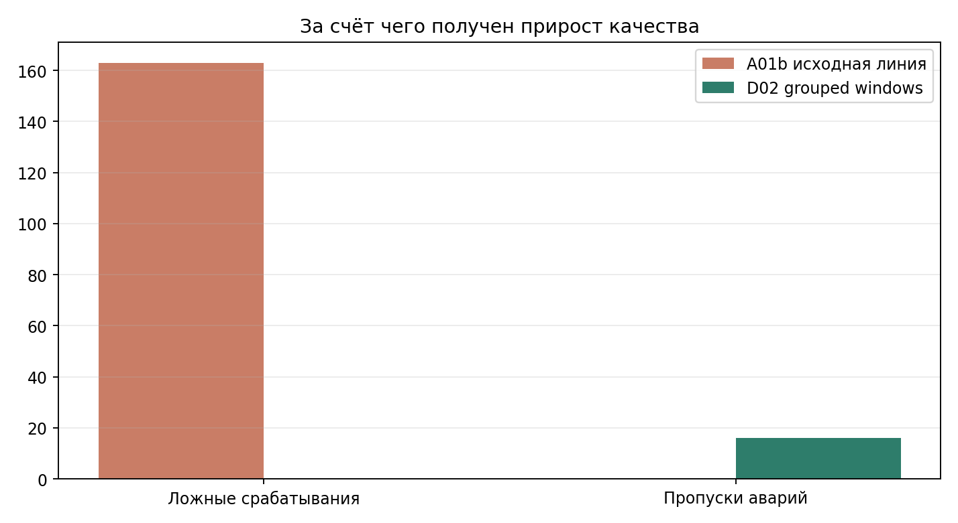
Figure 6.2 – Comparison of false alarm responses in the baseline accident reports. It is most clearly seen that the operational gap between the early baseline and D02 reports is due specifically to false alarm suppression.
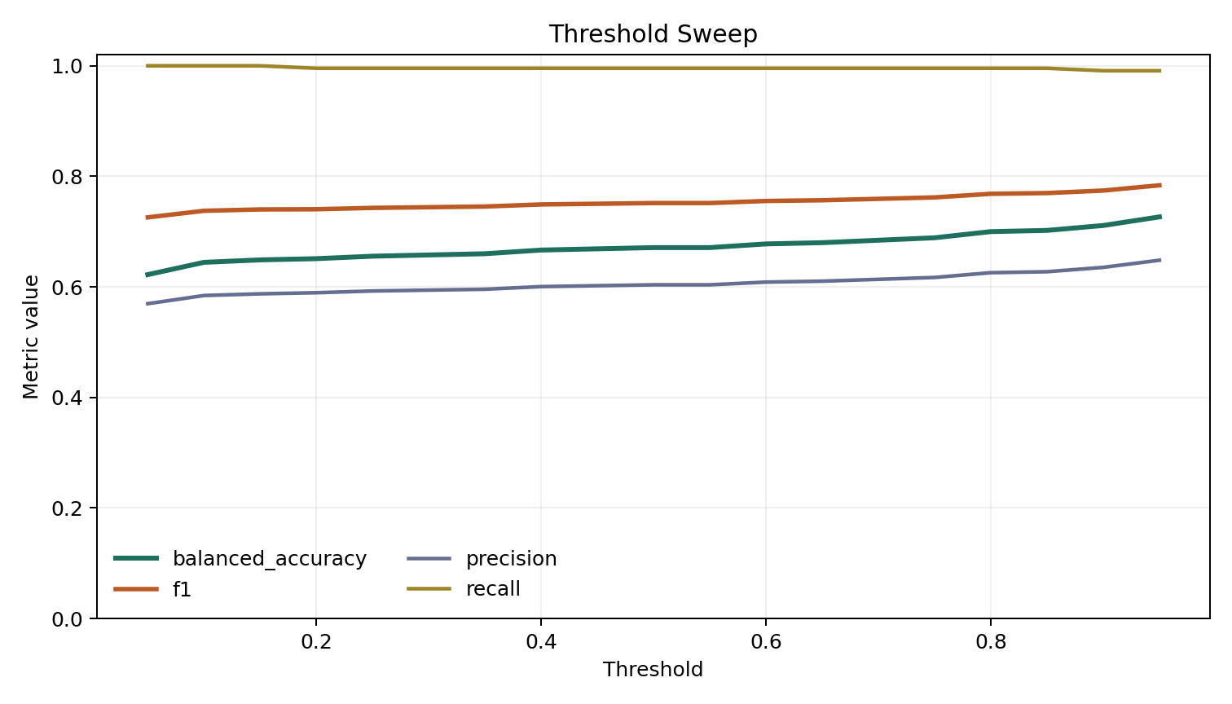
Figure 6.3 – Threshold sweep for A03r. Threshold tuning can slightly improve the model's behavior, but does not eliminate the fundamental problem of source-domain leakage.
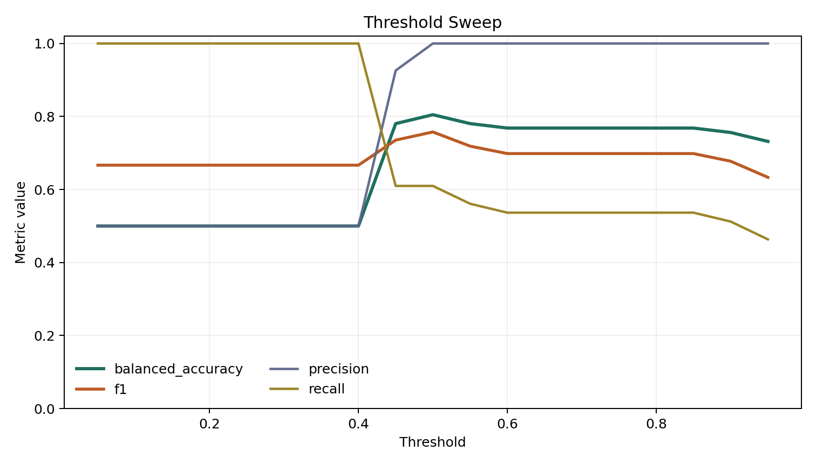
Figure 6.4 – Threshold sweep for D02. The model remains well-controlled within a reasonable range of thresholds and does not lose its behavioral discipline at the selected operating point.
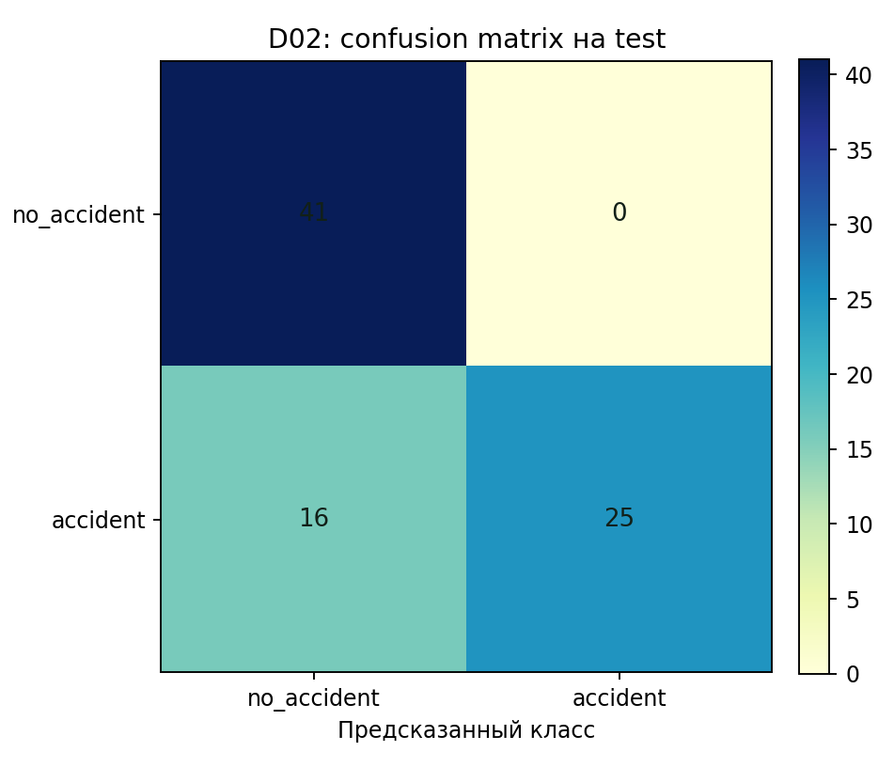
Figure 6.5 – Confusion matrix for selected accident-run D02. The test shows no false positives, but some missed accident clips remain.

6.2 Severity classification: the advantage of temporal modeling
The severity branch yields a different conclusion. The historical ConvNeXt baseline B01 yields best validation macro-F1 = 0.4271, a working starting point but not a strong result. The local bundled artifact B01r is even weaker and serves only as a demonstration checkpoint artifact. This is no longer sufficient for assessing crash severity using the clip-level CNN baseline.
R3D baselines S13 and S15 significantly improved the situation. Moreover, not only the improvement itself is significant, but also the method used to make the final decision. S15 has a more attractive validation headline: best val macro-F1 = 0.6322. In the held-out test, it still lost to S13, with a macro-F1 of 0.5925 versus 0.6169. The final choice for the severity branch is based not on the most attractive validation figure, but on the more reliable test generalization [22].
This makes the severity branch conclusion particularly valuable. Temporal modeling is indeed important, but the video model should be chosen based on honest held-out behavior, not on local lift on the validation split.

Table 6.2 – Main results of the severity branch.
Run | Val macro-F1 | Test accuracy | Test macro-F1 | Balanced accuracy | Interpretation
B01 | 0.4271 | — | — | — | historical ConvNeXt baseline
B01r | 0.1667 | — | — | 0.3333 (val) | local demo artifact
S13 | 0.5326 | 0.6222 | 0.6169 | 0.6222 | selected defendable severity run
S15 | 0.6322 | 0.6044 | 0.5925 | 0.6044 | validation leader, but not the best test run

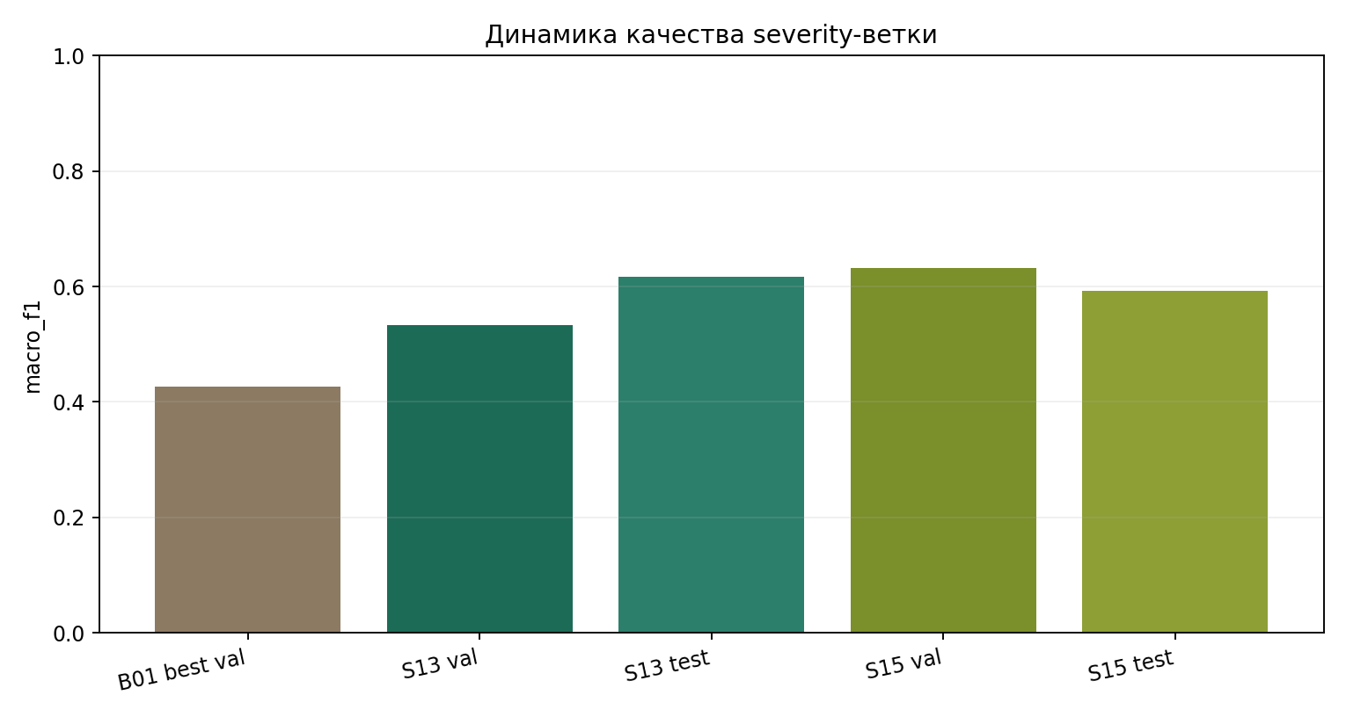
Figure 6.6 – Quality progress in the severity branch: the transition from the ConvNeXt baseline to the R3D line gave a meaningful increase in macro-F1 and overall stability.
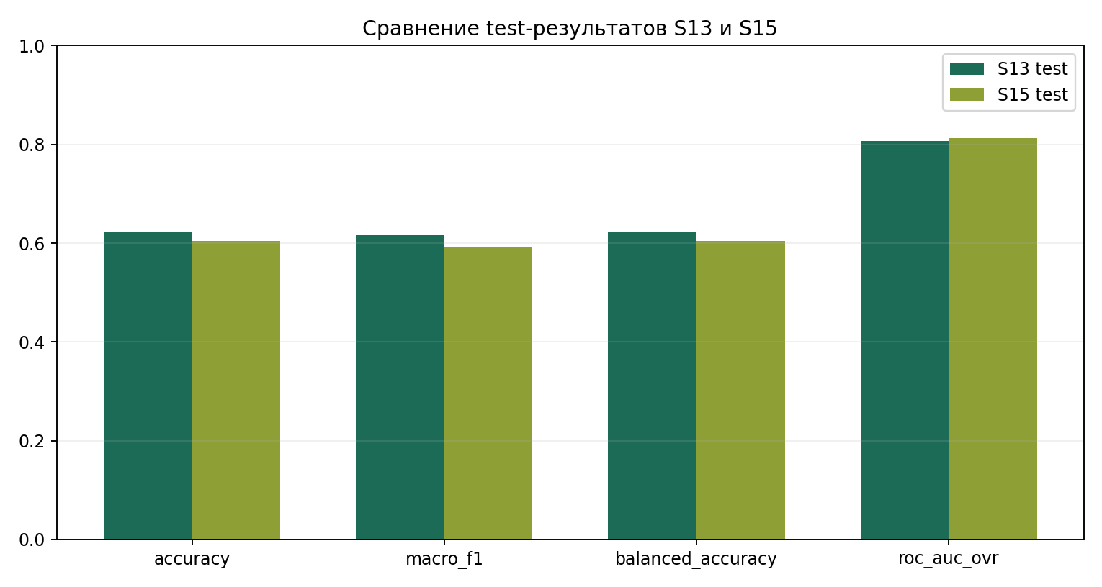
Figure 6.7 – Direct held-out test comparison for S13 and S15. Despite the stronger validation headline for S15, the final choice in favor of S13 is justified by better generalization.
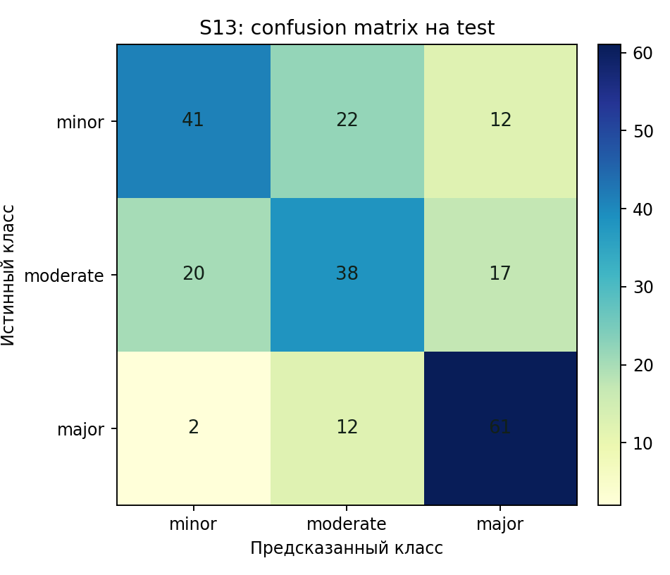
Figure 6.8 – Confusion matrix for S13. The model confidently recognizes some major examples, but retains noticeable confusions between adjacent severity classes.
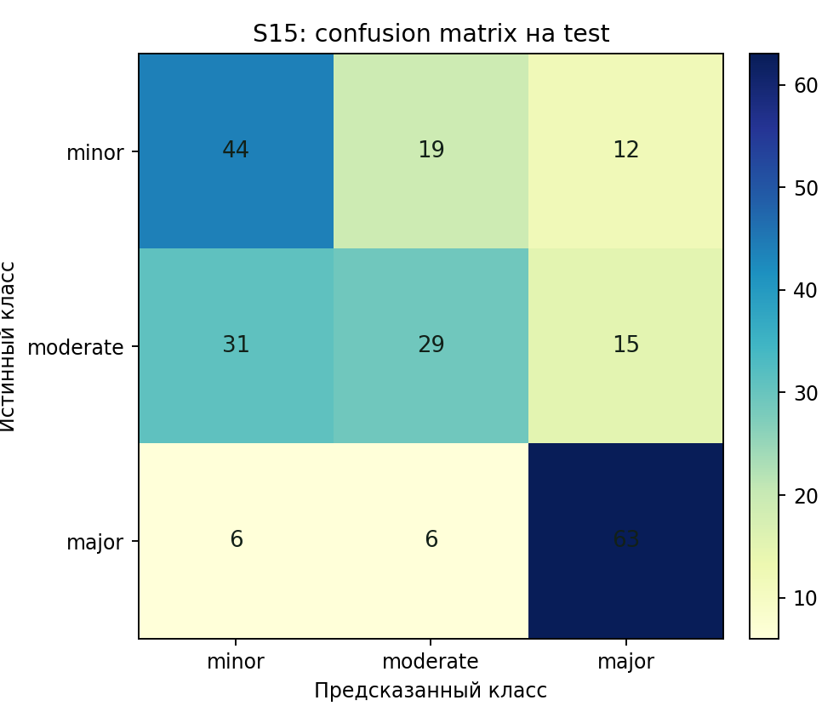
Figure 6.8 – Confusion matrix for S15. The model confidently recognizes some major examples, but retains noticeable confusions between adjacent severity classes.

6.3 Summary of two branches
The accident and severity branches lead to different but consistent conclusions. Accident detection improved through adjustments to the problem formulation and data: D02 is strong not because "ConvNeXt is generally better," but because the grouped-window reformulation made the problem fair. Severity classification improved due to the transition to a temporal architecture: here, R3D-18 is truly useful, while the clip-based baseline remains only a starting point.
This dual picture is the main result of this work. In a real-world CV study, it's impossible to assume that gains come only from a more complex neural network. Sometimes the architecture is the source of progress, and sometimes, correcting the problem formulation and data structure first requires.

7 Discussion and limitations
An honest research paper doesn't hide limitations, but rather embeds them in its argumentation. In the paper, they aren't reduced to the formula "there wasn't enough time." On the contrary, limitations reveal what was achieved and where the next bottleneck lies.
The first and most fundamental limitation is the data. There was no openly available, ideal corpus that would immediately cover normal fixed-camera traffic, accident severity labels, and future infrastructure anomalies. This forced us to build a modular data design. While the solution was justified, it also created the risk of source-domain leakage, which had to be specifically addressed.
The second limitation concerns AI City as a source of normal traffic. The corpus is well suited for the fixed-camera approach, but it is not officially "completely accident-free." Its use requires curation and care when generating negative clips.
The third limitation concerns the accident branch itself. D02 significantly improved the picture of false positives and yielded a better, fair test result, but it didn't fully address the problem. The confusion matrix shows that some accidents are missed at the selected threshold. The detector has become disciplined, but its recall ceiling remains significant.
The fourth limitation concerns video-based accident runs. A06 was significantly overfitted, so the success of R3D in the severity branch doesn't automatically imply that any temporal model will be equally successful in binary accident detection. Most likely, the combination of data volume, the problem formulation itself, and the distinguishability of the temporal signal plays a role.
The fifth limitation concerns the severity branch as an engineering system. S13 was chosen as the best documented research result, but the locally packaged severity artifact in the repository doesn't match this run and doesn't represent a mature deployment-level inference path. For severity, we have a reliable research conclusion, but a less mature end-to-end delivery than in the accident branch.
The sixth limitation concerns the hybrid line. The YOLO-guided object-aware approach is logically justified, but the current implementation hasn't been formally compared. This can't be omitted from the thesis. However, it's worth emphasizing that the logic for transitioning to such a branch is already prepared: manifests, harmonization, road fixed-camera setup, and an already-built false alarm analysis create a good foundation for it.

8 Transition to infrastructure anomalies
The thesis topic is initially broader than accident detection and severity estimation. It also includes infrastructure measurement: detection of obstacles on the roadway, debris, fallen objects, pavement damage, and other anomalies that don't always constitute accidents but can be no less dangerous. In the current version of the project, this branch is not included in the defended empirical comparison, but its inclusion in the topic is not a formality: the accident/severity pipeline has created the foundation upon which the next anomaly branch can be built.
The entire preparatory part is preserved and carried over unchanged: fixed-camera surveillance framing, manifests, harmonization, split discipline, saved-run evaluation procedure, and false alarm analysis. The architectural foundation is also preserved: the future object-aware line with detector-guided crops is naturally transferred to the tasks of searching for foreign objects on the roadway. Both the literature review and dataset analysis have already established the requirements for such data: a fixed camera, a real road environment, localizable anomalies that are not limited to people and vehicles.
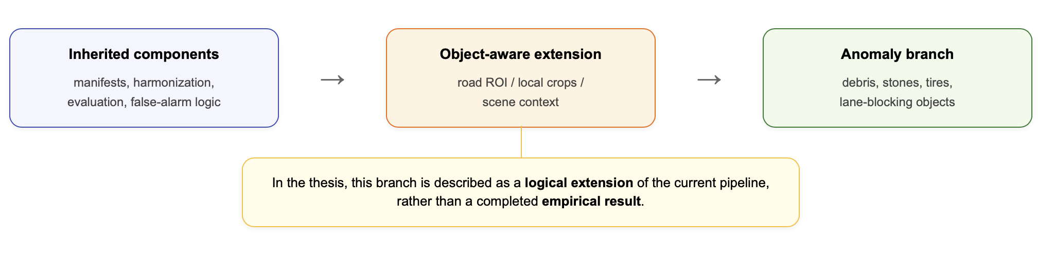
Figure 8.1 – Logic for extending the current pipeline to infrastructure anomalies: already built components are reused, and the empirical branch is supplemented with dataset-specific object localization and anomaly labels.

Table 8.1 – Target classes and requirements for the future anomaly branch.
Direction | Examples | What is already available in the project | What is still needed
Road objects / obstacles | debris, tire, stone, fallen object | fixed-camera pipeline, manifests, evaluation discipline | a suitable CCTV dataset with localization labels
Pavement damage | potholes, damaged surface | harmonization, future object-aware branch | specialized annotations
Lane-blocking anomalies | stalled vehicle, lane blockage | experience with accident/anomaly framing | long-stream scenarios and an event-level protocol

9 Conclusion
The study demonstrated that building a CV system for analyzing video streams from fixed traffic cameras is more than just selecting a successful neural network architecture. In practice, the main research challenges lay in the formulation of the problem, the selection of negative examples, and the discipline of the evaluation procedure. Therefore, the main scientific contribution of the study consists of two parts: the construction of a reproducible manifest-first pipeline and the demonstration that a correct data protocol can radically change the conclusions about the model's effectiveness.
The most defensible solution for accident detection is the D02 line on ConvNeXt with a grouped-window road-crop formulation. Balanced accuracy was 0.8049, F1 = 0.7576, precision = 1.0000, and zero false positives in the test. This result is interpreted not as an "absolute victory for ConvNeXt," but as a consequence of a more honest formulation of the problem after eliminating source-domain leakage. The best documented solution for severity classification was line S13 on R3D-18: test accuracy 0.6222 and macro-F1 0.6169. Here, in contrast, temporal modeling was the primary driver of progress. The work leads to an asymmetric but meaningful conclusion: accident screening benefits from a correct data protocol, and severity estimation from adequately accounting for the temporal structure of events.
The project retains its internal development potential. The YOLO-guided object-aware line and infrastructure anomalies branch have not yet been finalized for empirical comparison, but their inclusion in the next version of the system is motivated and supported by the current data architecture, code organization, and set of formal report artifacts. Thus, this thesis not only addresses the current problem but also sets the direction for the next research phase.

10 Github Link

List of sources
[1] World Health Organization. Road Traffic Injuries. URL: https://www.who.int/news-room/fact-sheets/detail/road-traffic-injuries (дата обращения: 23.04.2026).
[2] World Health Organization. Global Status Report on Road Safety 2023. URL: https://www.who.int/teams/social-determinants-of-health/safety-and-mobility/global-status-report-on-road-safety-2023 (дата обращения: 23.04.2026).
[3] Naphade M., Wang S., Anastasiu D. et al. The 5th AI City Challenge. Proceedings of CVPR Workshops. 2021.
[4] AI City Challenge. 2020 Data and Evaluation. URL: https://www.aicitychallenge.org/2020-data-and-evaluation/ (дата обращения: 23.04.2026).
[5] Shah A., Lamare J.-B., Nguyen-Anh T., Hauptmann A. CADP: A Novel Dataset for CCTV Traffic Camera based Accident Analysis. IEEE CVPR Workshops. 2020.
[6] Liu Z., Mao H., Wu C.-Y. et al. A ConvNet for the 2020s. CVPR. 2022.
[7] Tran D., Wang H., Torresani L. et al. A Closer Look at Spatiotemporal Convolutions for Action Recognition. CVPR. 2018.
[8] Feichtenhofer C., Fan H., Malik J., He K. SlowFast Networks for Video Recognition. ICCV. 2019.
[9] Doshi K., Yilmaz Y. Rethinking Video Anomaly Detection — A Continual Learning Approach for Traffic Surveillance. IEEE/CVF Winter Conference on Applications of Computer Vision Workshops. 2022.
[10] Khan S., Yairi T. A Review on the Application of Deep Learning in System Health Management. Mechanical Systems and Signal Processing. 2018.
[11] Ramachandra B., Jones M. A Survey of Single-Scene Video Anomaly Detection. IEEE Transactions on Pattern Analysis and Machine Intelligence. 2023.
[12] Yao Y., Yuan H., Liu X. et al. Anomaly Detection in Road Traffic Using Visual Surveillance: A Survey. IEEE Transactions on Intelligent Transportation Systems. 2021.
[13] Robles-Serrano M., García-Díaz V., Menéndez H.D., Villagrá V.A. Automatic Road Accident Detection in CCTV Video Using Deep Learning. Applied Sciences. 2021.
[14] Ghahremannezhad R., Li Y. Real-Time Automatic Accident Detection in Traffic Surveillance Using Vision Transformers and CNNs. arXiv preprint. 2023.
[15] Aboah K., Obeng P., Ofori-Atta K. Traffic Anomaly Detection with Deep Learning and Decision Trees in Surveillance Video. Sensors. 2022.
[16] Ultralytics. YOLO11 Documentation. URL: https://docs.ultralytics.com/models/yolo11/ (дата обращения: 23.04.2026).
[17] Torchvision Documentation. Video Classification Models. URL: https://pytorch.org/vision/stable/models.html#video-classification (дата обращения: 23.04.2026).
[18] AI City Challenge 2021 Track 1: Multi-Class Multi-Movement Vehicle Counting. Challenge materials and benchmark description. URL: https://www.aicitychallenge.org/ (дата обращения: 23.04.2026).
[19] Project document: 01 Project Idea and Datasets. Internal project material supplied with the repository.
[20] Project document: 02 Research Plan and Code Ideas. Internal project material supplied with the repository.
[21] Project report bundle: Accident Defense Report, 2026-04-21. Internal project artifact.
[22] Project report bundle: Severity Defense Report, 2026-04-21. Internal project artifact.
[23] Project report bundle: Dataset Procedure Results Report, 2026-04-21. Internal project artifact.
[24] Gregory Antonovsky. Personalized Product Recommendations in E-Commerce. Bachelor Thesis. HSE, 2023. Example of structure and results presentation.
[25] HSE Faculty of Computer Science. Guidelines for Writing, Evaluating, Defending, and Publishing Term Papers and Theses. DSBA Programme. 2022.

Приложение А. Рекомендуемые иллюстрации и артефакты для включения в финальную версию
Сильный основной текст всё равно выигрывает от аккуратного выбора иллюстраций, именно тех, что подтверждают тезисы глав. Для работы в основной текст стоит включить уже существующие figure assets из outputs bundles и несколько специально нарисованных схем, прямо объясняющих логику проекта.
В обязательный набор входят: общая схема pipeline; схема dataset search funnel; схема перехода от mixed-source постановки к grouped-window reformulation; график сравнения основных accident-runs; heatmap или bar chart концентрации ложных срабатываний baseline A01b по unseen cameras; threshold sweeps для A03r и D02; график прогресса severity-ветки; confusion matrices для S13 и S15. Эти визуализации прямо поддерживают центральную narrative line диплома и не являются декоративным материалом.
• Из имеющихся assets вставить в основной текст: accident_metric_comparison.png, accident_error_counts.png, a01b_camera_trap.png, a03r_test_threshold_sweep.png, d02_test_threshold_sweep.png, severity_metric_progress.png, severity_test_comparison.png, s13_confusion_matrix.png, s15_confusion_matrix.png, raw_corpora_overview.png.
• Дорисовать специально для диплома: diagram_overall_pipeline.png, diagram_research_logic.png, diagram_dataset_funnel.png, diagram_grouped_window_fix.png, diagram_repo_workflow.png, diagram_anomaly_extension.png.
• В приложение вынести: дополнительные confusion matrices, history curves, long-form manifest summaries, а также скриншоты demo UI и live-status artifacts, если они не перегружают основной текст.

Приложение Б. Какие фрагменты кода и команд лучше показать
В research project по ML/CV основной текст не стоит перегружать длинными листингами. Полезнее короткие содержательные фрагменты, показывающие reproducibility и архитектурную логику пайплайна. В проекте уместны: пример ClipRecord/manifest-структуры; фрагмент конфигурации harmonization profile; команда запуска build_manifests; команда запуска train_accident; команда evaluate_saved_accident_run и аналогичная для severity post-eval.
Если один короткий листинг в основной части всё-таки нужен, лучший кандидат — manifest-пример. Он показывает, что эксперименты строятся вокруг описанных записей клипов, а не вокруг неформальной папочной структуры. Остальные команды и конфиги удобнее вынести в приложение.
python scripts/prepare_input_harmonization.py --profile bridge_v1_8fps_160
python scripts/build_manifests.py --task accident_binary --profile bridge_v1_8fps_160
python scripts/train_accident.py --config configs/accident/d02_grouped_windows_roadcrop.yaml
python scripts/evaluate_saved_accident_run.py --run_dir outputs/D02_accident_convnext_balanced_grouped_windows_gap96_real_roadcrop_rtx3080_10gb
python scripts/evaluate_saved_severity_run.py --run_dir outputs/.../S13

Приложение В. Практические замечания по оформлению
• В основном тексте оставить только те таблицы и графики, которые непосредственно поддерживают тезис главы; вспомогательные history plots и расширенные варианты confusion matrices перенести в приложения.
• При вставке фигур обязательно проверить подписи осей, легенды и читаемость текста без масштабирования; если элемент трудно прочитать в DOCX, он не должен оставаться в финальной версии.
• В тексте отчёта не смешивать planned scope, implemented scope и future work; эта развязка должна оставаться прозрачной в каждой главе.
• Локальный severity checkpoint B01r следует описывать как bundled demonstration artifact, а не как лучший итоговый результат severity-ветки.
• При устной защите основной narrative line должна звучать коротко: accident improved through data protocol correction; severity improved through temporal modeling.

