Sabina Sasu – 260803977

**Assignment 4, Cartpole LQR**

To balance the cartpole, I decided to use LQR since the code was already mostly written with some values missing, meaning the A and B matrices, some tuning on Q and R and finally the control calculation using the resulting K matrix.

1. *Getting A and B*: This was the most tedious part as I was convinced my math was wrong as explained in the next step. The partial derivation steps are omitted as they wouldn’t fit in the one-page report limit. I verified the derivations using online calculators like Symbolab.

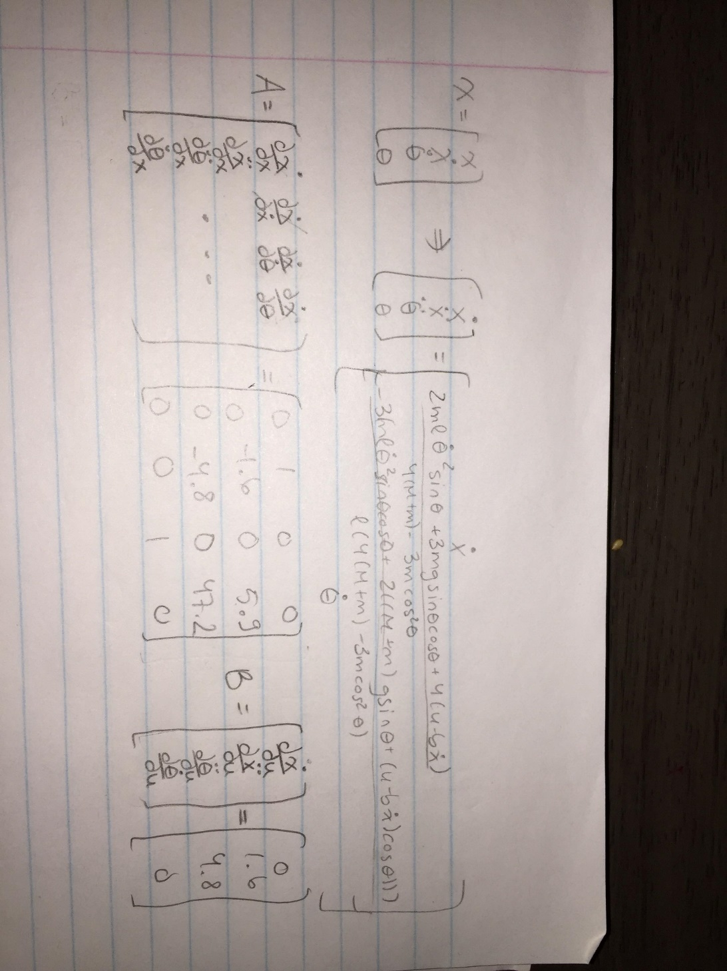

1. *Computing the control*:
   1. I used the equation from the instructions but ended negating K: 𝑢=-𝐾(𝑥−𝑔). With positive K, the cart would bug out and spaz everywhere. With negated K, the cartpole balanced perfectly.
   2. To compute the control in the code, I loop through K, x and goal matrix and arrays, applying the equation to each iteration and summing them in the control variable, which is returned. I spent a lot of time redoing my math from the previous step because I initially thought g was the gravity constant :(
2. *Tuning*: I ended up not needing to tune much since it was balancing almost perfectly from the first run. I did end up changing one of the Q values to 100 and R to 1, as recommended by one of the online resources I found, although it didn’t change much from the default values.
3. *Conclusion*: The cartpole can instantly balance without much tuning and once it is balanced, it completely stops moving. I am not sure that’s normal as I was expecting the cart to move back and forth but the math seems fine. I spent a few hours doing the explained steps above, including doing some reading.