ASSIGNMENT _5.1
Huzaifa Ali(2303.KHI.DEG.016)
Sheikh Muhammad Sabih (2303.KHI.DEG.023)
Muhammad Safi(2303.KHI.DEG.023)

1)import necessary library and joining data frames
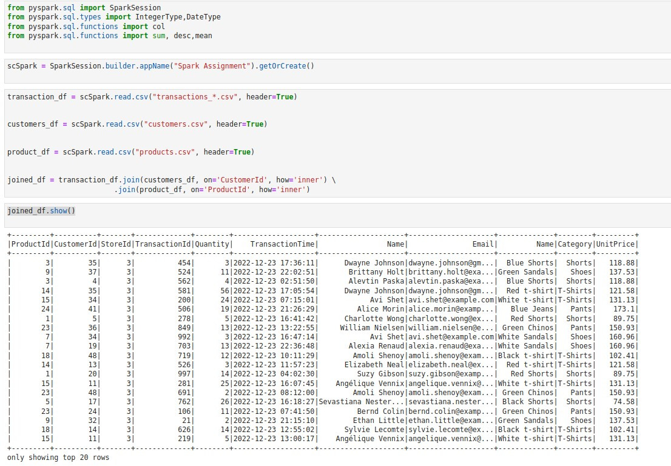
- Casting datatype
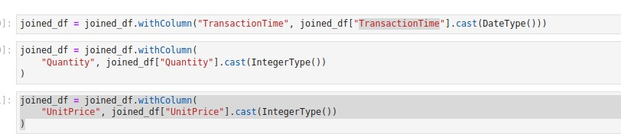

- The daily total sales for the store with id 1
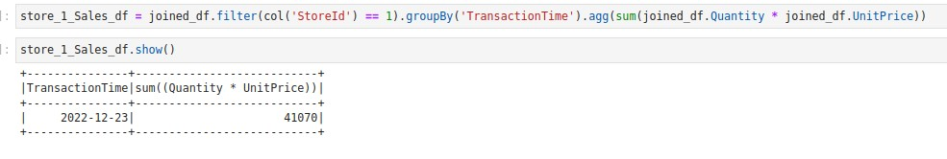
- The mean sales for the store with id 2
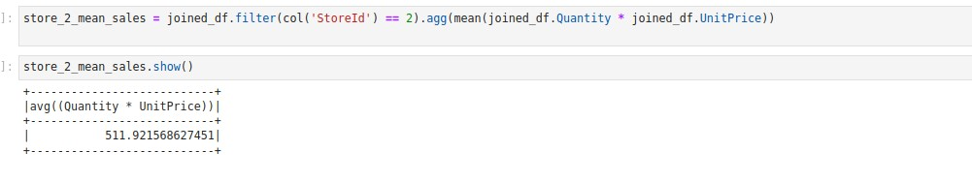
- the email of the client who spent the most when summing up purchases from all of the stores
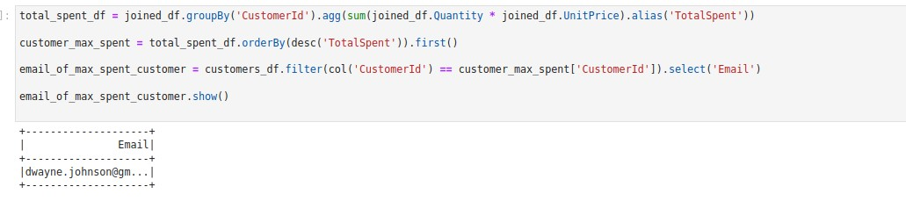
- 5 products are most frequently bought across all stores
