Assignment (Build a matrix)

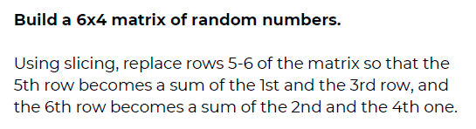

Solution

- Import numpy.

- Generate a random matrix of 6*4.
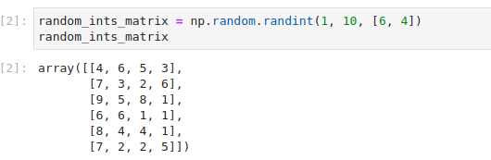
- Slice the random_ints_matrix and replace the R5 by the sum of R1 and R3 and R6 by the sum of R2 and R4.

- And the updated matrix is.
