SQL

Store Analysis

Schema:

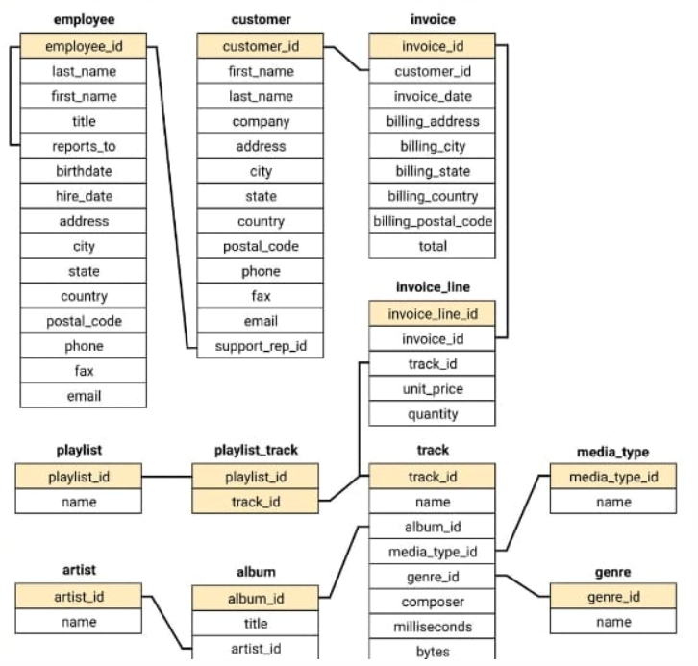

Question 1:

Query -

Output -

Question 2:

Query -

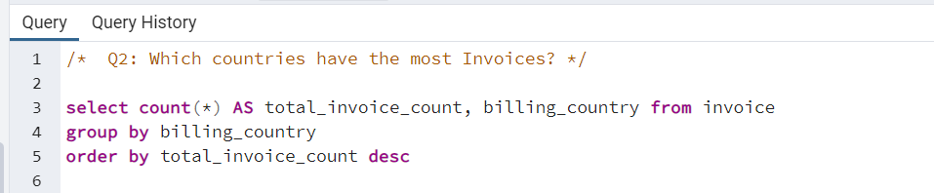

Output -

Question 3:

Query -

Output -

Question 4:

Query -

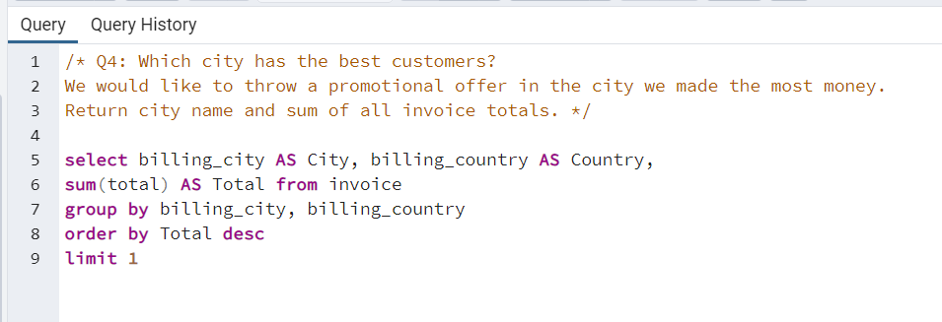

Output -

Question 5:

Query -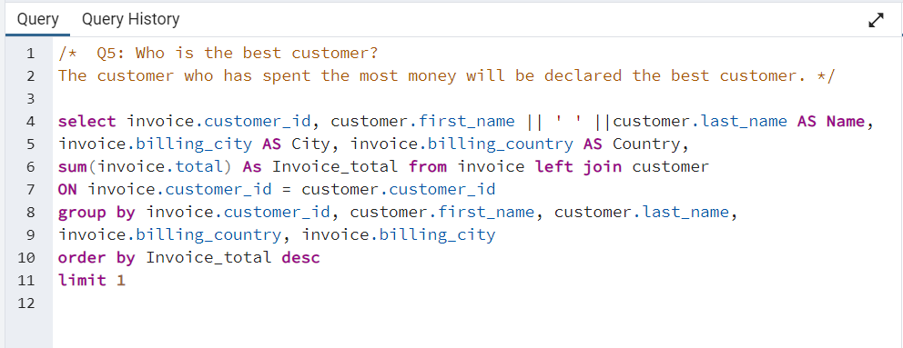

Output -

Question 6:

Output -

Question 7:

Query -

Question 8:

Query -

Output - 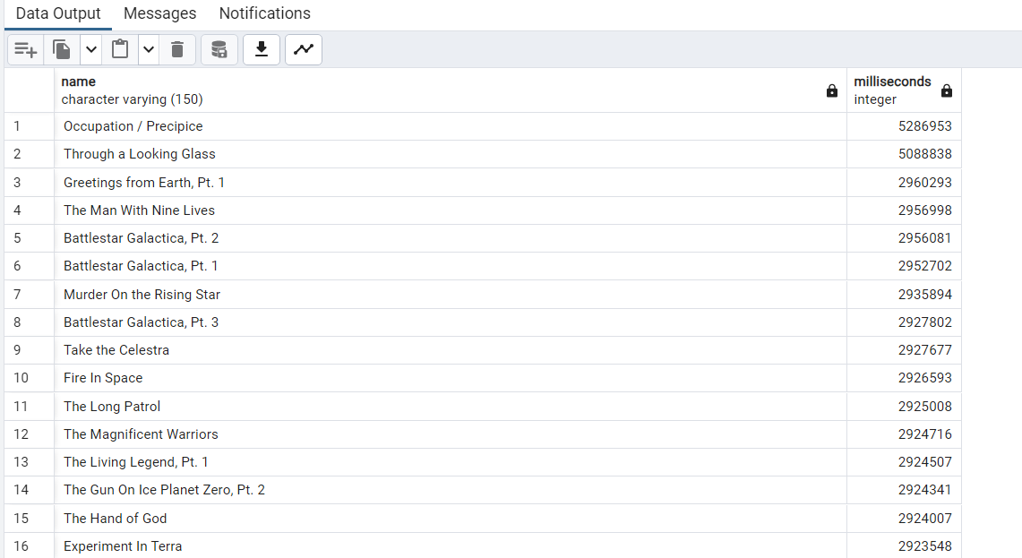

Question 9:

Question 10:

Output -

Question 11:

Output -

