SARATHI-SERVE ARXIV STUDY — MODEL REFERENCE
Divergent Attention
The five checkpoints behind this study share the same skeleton — 4096-wide hidden state, 32 layers, 32 query heads of 128 dimensions. What separates them is what backs those query heads, and what each layer does with the result. This is a reference for exactly where and why.
01 FIVE CHECKPOINTS, SIDE BY SIDE
All figures are read from each checkpoint's published config.json — not estimated, not carried over from an earlier run.
Model | FFN class | Q | KV | Q:KV | Head | Layers | Hidden | Intermediate | Vocab | KV$/tok | Notable quirk
Model  meta-llama/Llama-2-7b-hf | Dense SwiGLU | 32 | 32 | 1:1 | 128 | 32 | 4096 | 11,008 | 32,000 | 512 KiB | Reference multi-head baseline — every query head owns a private key/value head.
Mistral-7B  mistralai/Mistral-7B-Instruct-v0.2 | Dense SwiGLU | 32 | 8 | 4:1 | 128 | 32 | 4096 | 14,336 | 32,000 | 128 KiB | 32k context via GQA and RoPE θ=1e6 — v0.2 drops the sliding window used in v0.1.
Mixtral-8x7B  mistralai/Mixtral-8x7B-Instruct-v0.1 | MoE SwiGLU · top-2 of 8 | 32 | 8 | 4:1 | 128 | 32 | 4096 | 14,336 / expert | 32,000 | 128 KiB | Attention block is identical to Mistral-7B. 46.7B total params, ~12.9B active per token.
Qwen-7B  Qwen/Qwen-7B | Dense SwiGLU | 32 | 32 | 1:1 | 128 | 32 | 4096 | 22,016 | 151,936 | 512 KiB | Only one of the five with a bias term on its fused QKV projection; adds dynamic-NTK RoPE and logN attention scaling.
Yi-6B  01-ai/Yi-6B | Dense SwiGLU | 32 | 4 | 8:1 | 128 | 32 | 4096 | 11,008 | 64,000 | 64 KiB | Most aggressive KV compression of the five; ships as LlamaForCausalLM — reuses Llama's code verbatim.
kv$/token = 2 (k,v) × kv_heads × head_dim × 2 bytes (bf16/fp16) × layers, tensor_parallel_size=1. qwen has no explicit kv-head field in its config — sarathi's loader falls back to num_attention_heads, and kv_channels=128 (=head_dim) confirms it: k/v are not compressed.
02 ATTENTION — DEDICATED OR SHARED KEY/VALUE HEADS
All five split hidden state into 32 query heads of 128 dimensions — identical geometry, up to that point. Where they diverge is what backs each query head at inference time: a dedicated key/value pair, or a key/value pair shared across a group of queries.
Llama-2-7B and Qwen-7B keep the original design — 32 separate key/value heads, one per query head. Every query reads its own private slice of the cache. Mistral-7B and Mixtral-8x7B group four query heads onto each of 8 shared key/value heads — grouped-query attention (GQA), built to cut KV memory traffic without retraining the query side. Yi-6B goes further: 8 query heads share a single key/value head, the most aggressive compression here.
The KV cache is what actually occupies GPU memory through a serving session, and it scales with kv_heads, not query heads. Halving the KV head count roughly halves the bytes held per token — the entire reason grouped attention exists: it buys room to hold more concurrent sequences in the memory a full multi-head model would spend on one.
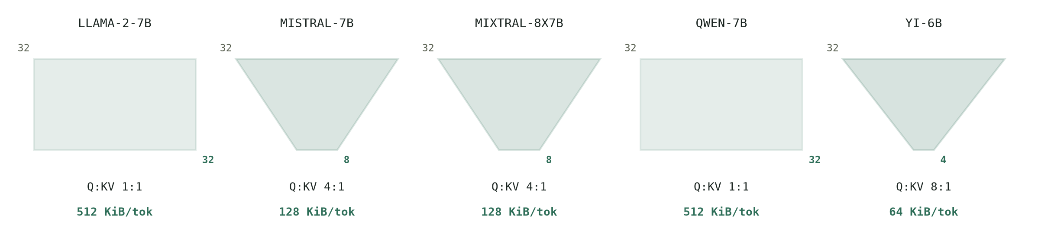
Bus width tapers from 32 query heads (top) to that model's key/value head count (bottom) — width is drawn proportional to head count, so the taper itself is the compression ratio. Llama-2 and Qwen carry the full width straight through; Yi narrows the most.
03 FEED-FORWARD — ONE PATH OR EIGHT
Four of the five run every token through one feed-forward block per layer — fixed compute, fixed weights, whatever the token. Mixtral-8x7B replaces that block with eight, and a small router that picks two of them per token, per layer, weighting their outputs and summing them.
The eight experts aren't eight small models glued together — each is a full-size SwiGLU MLP, the same size as Mistral-7B's single FFN. That's why Mixtral's parameter count (46.7B total) dwarfs its active compute footprint (~12.9B touched per token): most of the network sits idle for any given token, woken only when the router selects it.
Attention is untouched by any of this. Mixtral's Q/KV head layout is identical to Mistral-7B's, so its KV cache costs exactly the same per token — even though it's by far the largest checkpoint on disk.
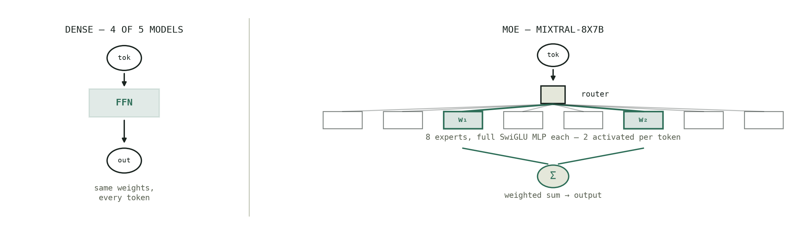
A dense block spends the same weights on every token. Mixtral's router activates two of eight full-size experts per token and sums their weighted outputs — the other six sit idle for that token.
04 WHY IT MATTERS AT SERVING TIME
KV head count is the number that actually predicts how many concurrent requests a replica can hold before it runs out of cache blocks — not parameter count, not layer depth. Yi-6B's 4 KV heads give it a cache footprint per token that's a fraction of Llama-2-7B's or Qwen-7B's, at identical hidden size and layer depth. Mixtral inherits Mistral's compact attention, so despite being the largest checkpoint of the five on disk, its KV cache behaves like a 7B dense model's — the extra 40B parameters live in expert weights that never touch the cache at all. Any comparison of block utilization or achievable batch size across these five models has to control for this before concluding anything about the scheduler itself.
Figures drawn from published config.json for meta-llama/Llama-2-7b-hf, mistralai/Mistral-7B-Instruct-v0.2, mistralai/Mixtral-8x7B-Instruct-v0.1, Qwen/Qwen-7B, 01-ai/Yi-6B, and sarathi-serve's kv-head resolution logic in sarathi/config.py and sarathi/model_executor/models/qwen.py.

