Challenge1:
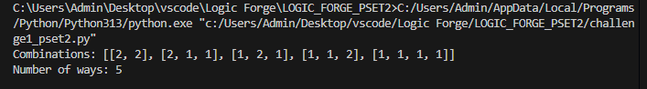

Challenge 2: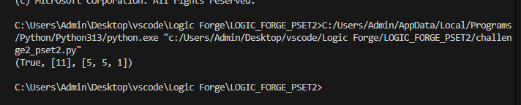

Challenge 3: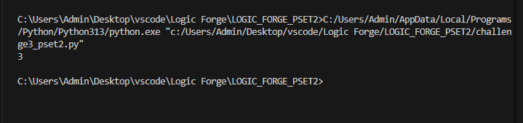

Challenge 4: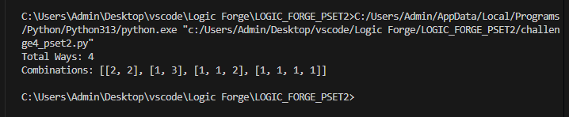

Challenge 5: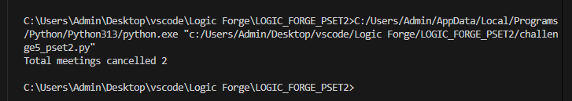
Challenge 6: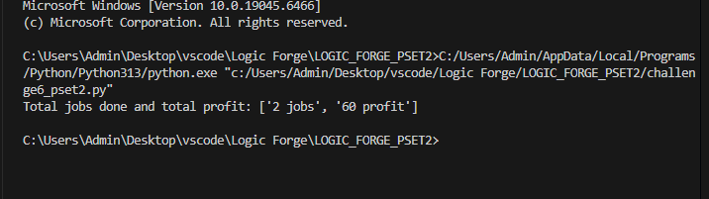
Challenge 7: