Challenge 1:
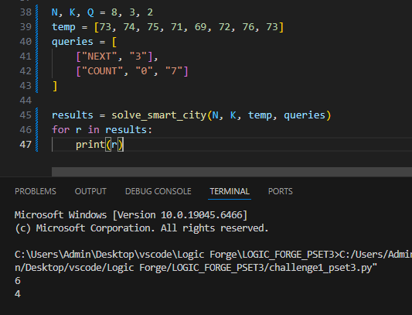
Challenge 2:
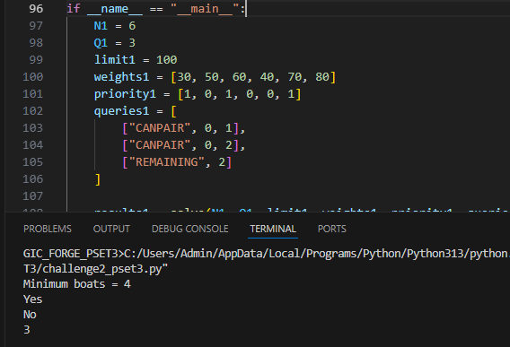

Challenge 3:
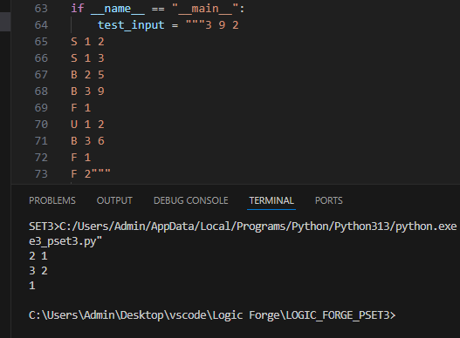
Challenge 4: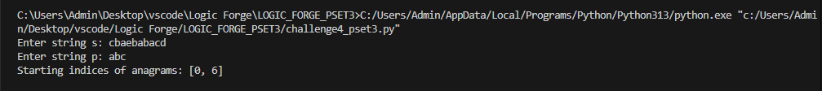
Challenge 5:
Challenge 6:
