Contents

Customer Service Chabot Implementation 1

Executive Summary 1

System Overview 1

Technical Implementation 1

Performance Analysis 2

Sample Interactions 2

Recommendations for Improvement 3

Conclusion 3

# Customer Service Chabot Implementation

## Executive Summary

This report evaluates the implementation of a customer service chatbot using semantic search and retrieval-based techniques. The system leverages state-of-the-art natural language processing models to provide accurate responses to customer inquiries in a customer support context.

## System Overview

The chatbot system consists of three core components:  
1. Semantic Search Engine: Uses sentence embeddings and FAISS for efficient similarity search  
2. Knowledge Base: Built from a customer support dataset with 27,000 responses  
3. Response Generation: Combines retrieved responses with optional GPT-2 augmentation

## Technical Implementation

1. Core Technologies  
- Embedding Model: `all-MiniLM-L6-v2` from Sentence Transformers  
 - Lightweight model (384-dimensional embeddings)  
 - Optimized for semantic similarity tasks  
 - Processes 840 queries in batches with progress tracking  
- Vector Database: FAISS (Facebook AI Similarity Search)  
 - IndexFlatL2 index for exact L2 distance calculations  
 - Efficient nearest neighbor search at scale  
- Optional Generation: GPT-2 model  
 - Available for response enhancement  
 - Currently not activated in production flow  
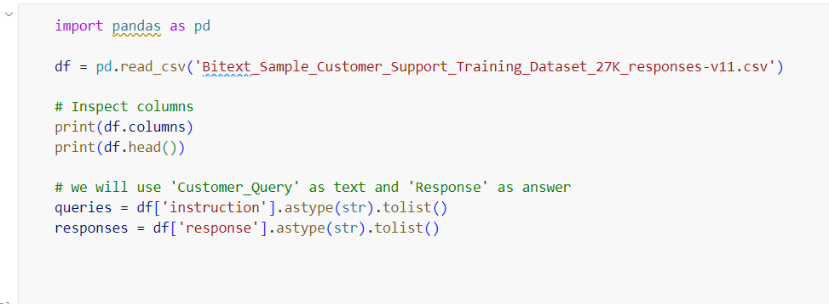

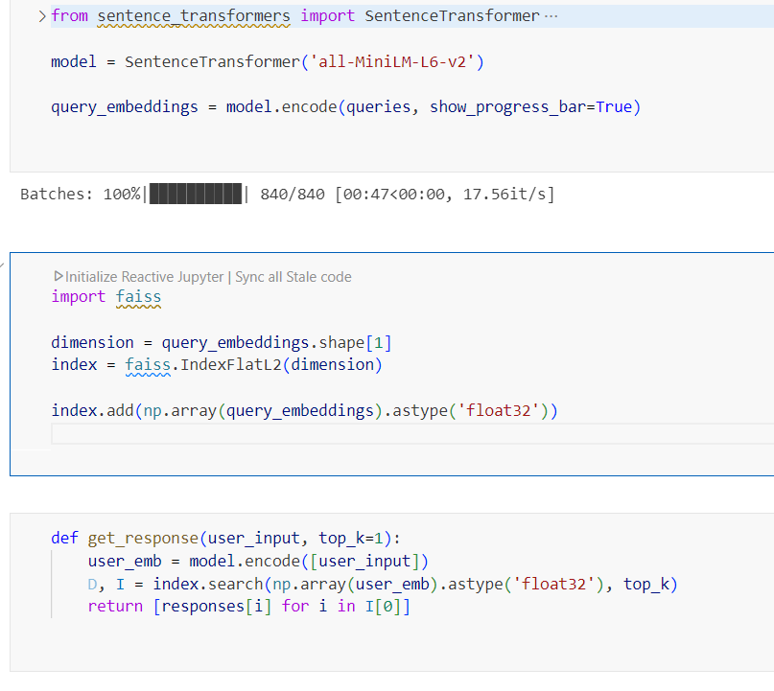  
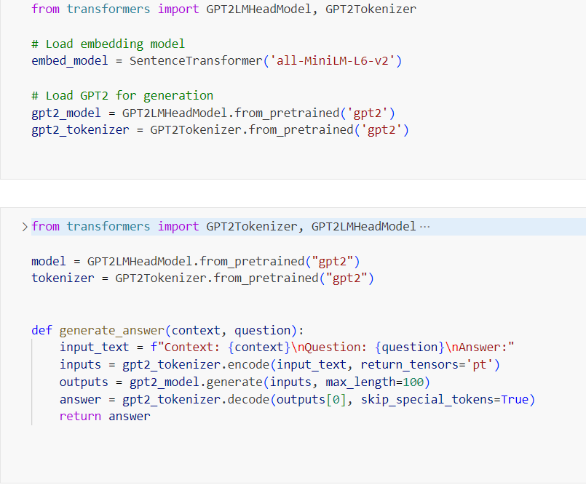

## Frontend

To facilitate interaction between users and the Chabot, a lightweight Flask-based frontend was developed. Flask provides a simple and flexible framework ideal for building web applications with minimal overhead. The frontend serves a chat interface where users can type queries and receive real-time responses from the Chabot. It communicates with the backend via RESTful API calls, enabling seamless exchange of user inputs and retrieved responses. The interface is designed with usability in mind, supporting asynchronous message flow, styled message bubbles, and input handling to mimic a real-time customer service experience. This architecture allows rapid prototyping and integration while maintaining a clean separation between the presentation layer and backend logic.

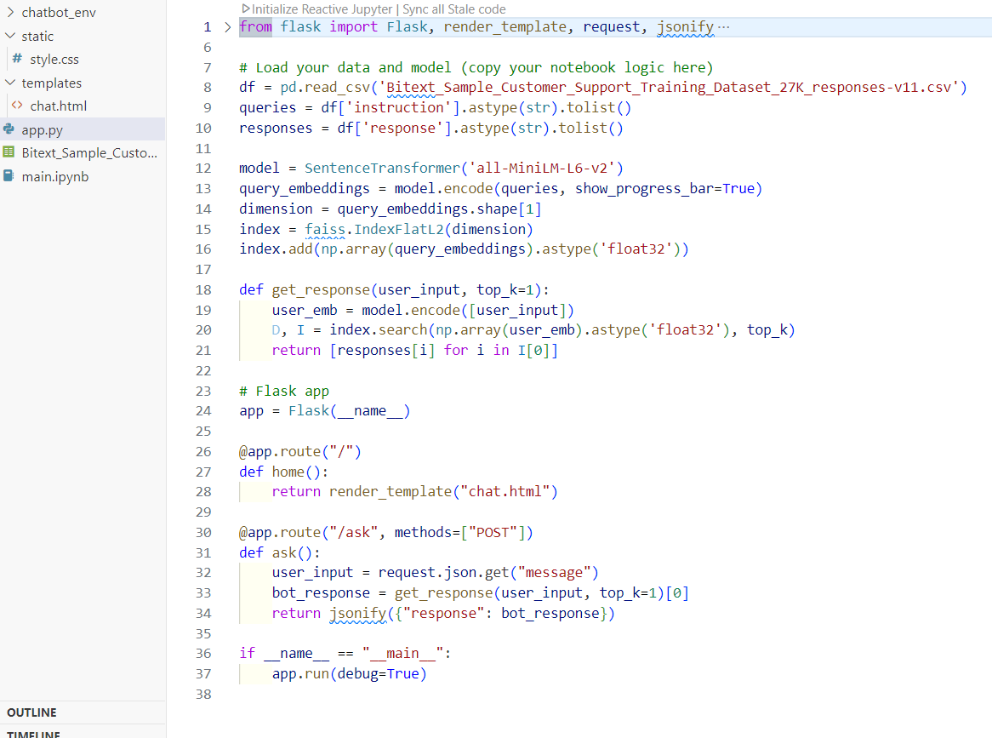

## Performance Analysis

Strengths  
1. Accuracy: Semantic search provides highly relevant responses by matching intent rather than just keywords  
2. Speed: FAISS enables sub-linear search times even with 27,000+ entries  
3. Consistency: Retrieval-based approach ensures responses stay within approved guidelines  
4. Maintainability: Clear separation between knowledge base and search logic

Limitations  
1. Static Responses: Currently uses canned responses without dynamic adaptation  
2. Context Window: Lacks conversation history tracking  
3. Template Handling: Doesn't yet dynamically fill template variables (e.g., {{Order Number}})

## Sample Interactions

User: I need to cancel my order  
Bot: I've realized that you're seeking assistance in canceling an order...

User: Where is my package?  
Bot: We appreciate your message! It's clear to me that you would like to know...

User: I want to speak to a human  
Bot: Always good to connect! I'm attuned to the fact that you're looking for someone...

## Recommendations for Improvement

1. Dynamic Variables: Implement template filling for order numbers, dates, etc.  
2. Conversation State: Add dialogue management to handle multi-turn conversations  
3. Hybrid Approach: Combine retrieval with generation for more natural responses  
4. Confidence Thresholds: Add score-based fallback to human agents  
5. Performance Monitoring: Track response quality metrics and user satisfaction

## Output

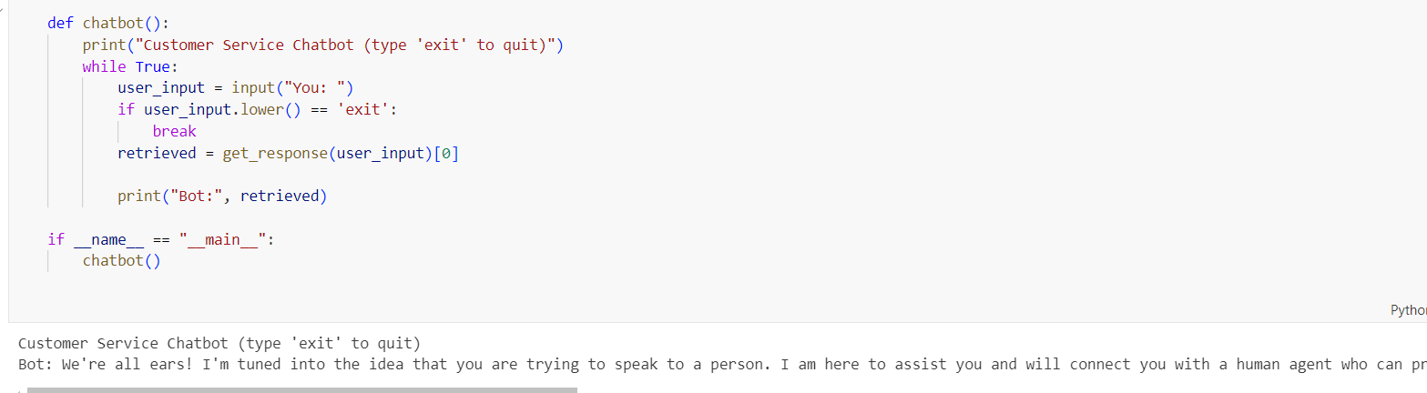

After implementation of flask based frontend Visual Representation

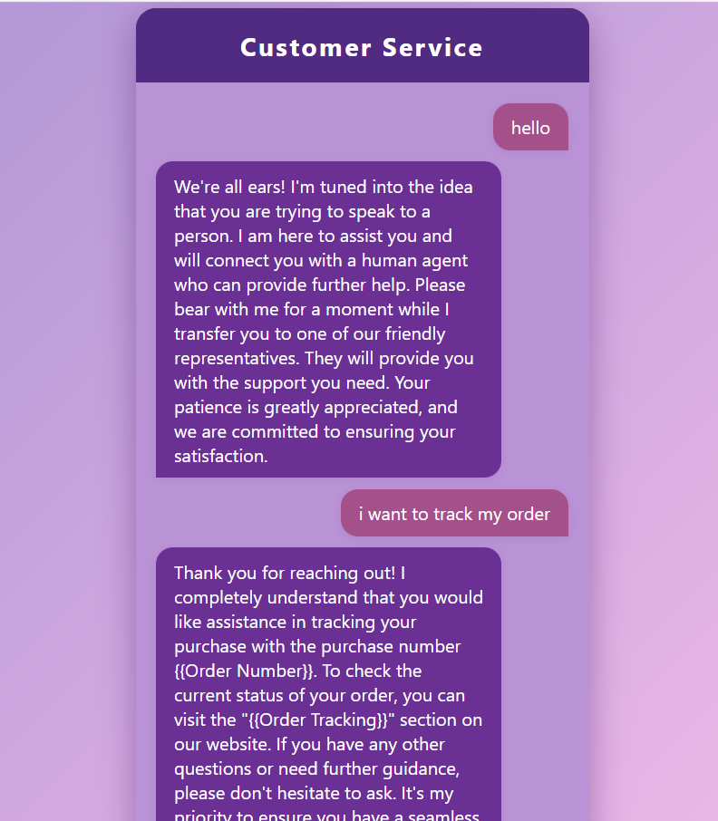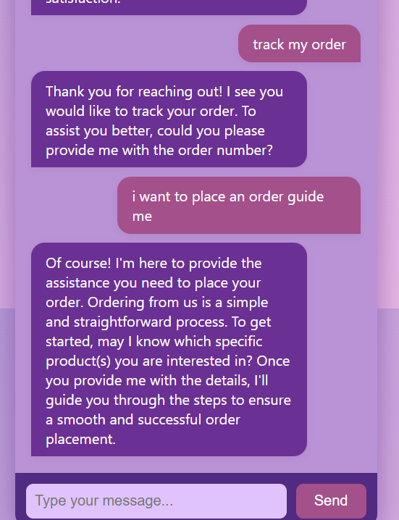

## Conclusion

The implemented chatbot provides a solid foundation for customer service automation, demonstrating effective use of modern NLP techniques. With the recommended enhancements, the system has potential to handle increasingly complex customer interactions while maintaining response quality and brand voice consistency.

Next Steps:  
- A/B testing between retrieval and hybrid approaches  
- Implementation of template variable resolution  
- Integration with live customer service systems