

**NAME: SABIKA ZAHRA**

**ROLL NUMBER: 074**

**CLASS: BSAI**

**SECTION: ALPHA**

**SEMESTER: 4**

**SUBMITTED TO: SIR MUNEEB SALEEM**

**DATE: 2,20,2025**

**1. Import Libraries**

The first step is to import the necessary libraries for data manipulation, preprocessing, and modeling.

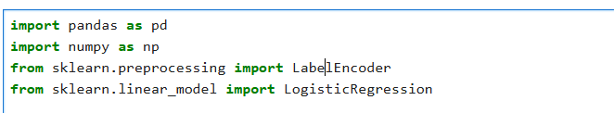

### ****2. Load Data****

Load the training and testing datasets.



**3. Combine Data**

Combine the training and testing datasets for preprocessing. This ensures that any transformations applied are consistent across both datasets.



### ****4. Drop Unnecessary Columns****

Drop columns that are not needed for modeling. In this case, the SalePrice column is dropped from the combined dataset.



### ****5. Handle Missing Values****

Identify columns with a large number of missing values and drop them. Then, fill missing values in the remaining columns.

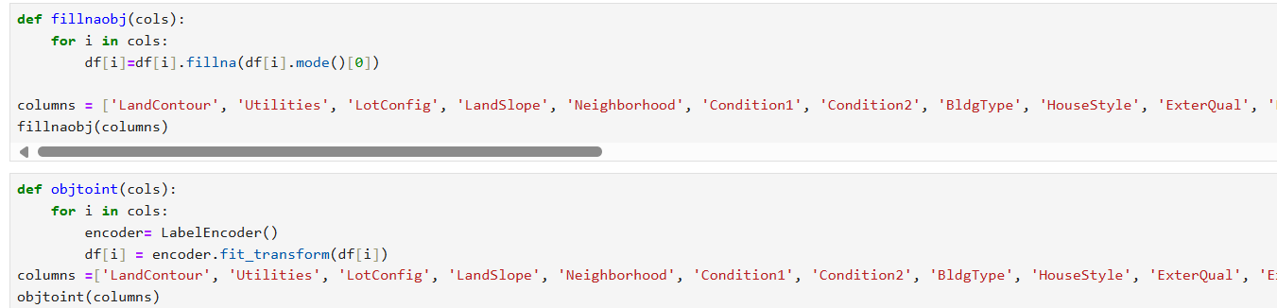

### ****6. Convert Data Types****

Convert numerical columns with float data types to integers.

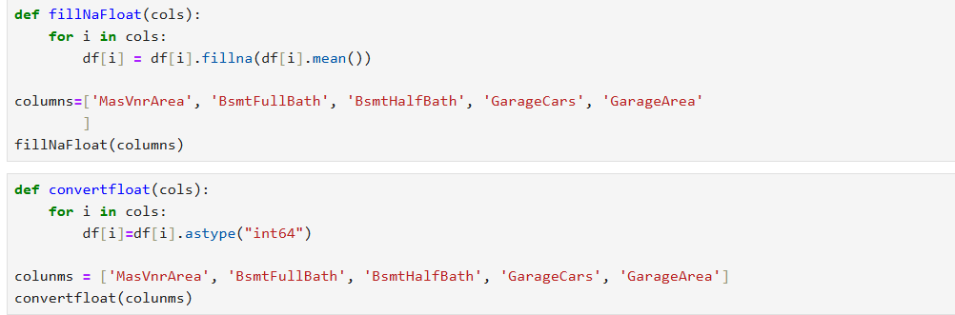

### ****7. Split Data Back into Train and Test Sets****

Split the combined dataset back into training and testing sets.

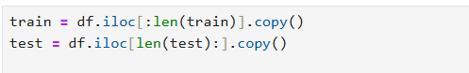

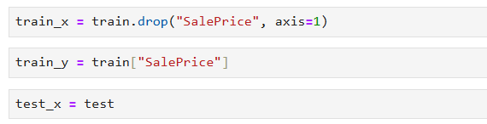

### ****8. Train the Model****

Train a logistic regression model on the training data.

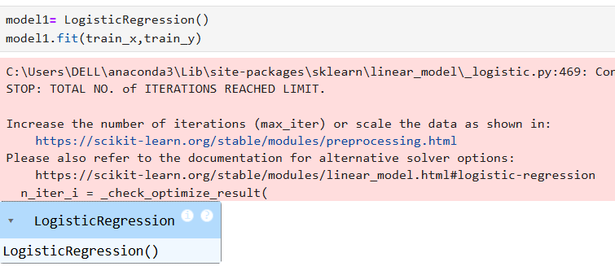

### ****9. Make Predictions****

Use the trained model to make predictions on the test data.

### ****10. Create Submission File****

Create a submission file with the predicted SalePrice values.

