

**NAME: SABIKA ZAHRA**

**ROLL NUMBER: 074**

**CLASS: BSAI**

**SECTION: ALPHA**

**SEMESTER: 4**

**SUBMITTED TO: SIR RASIKH**

**DATE: 2,27,2025**

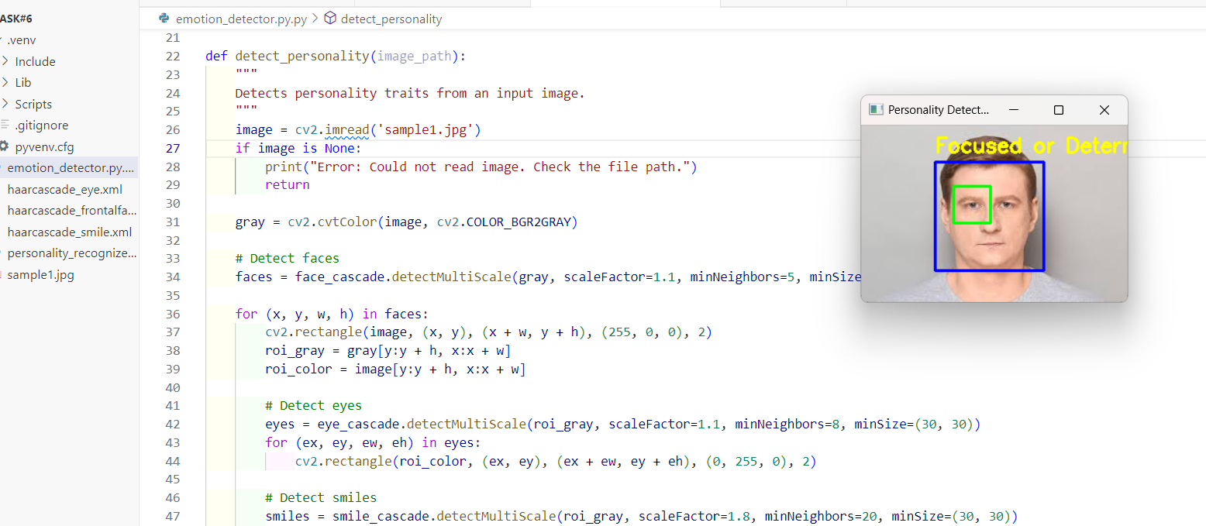

**Face-Based Personality Detection System Report**

**Introduction**

The Face-Based Personality Detection System is an implementation of facial feature detection using OpenCV's Haar Cascade classifiers. This system attempts to infer basic personality traits based on detected facial features such as eyes and smiles. By analyzing the presence and count of these features, the system determines whether a person appears **friendly, curious, focused, or reserved**.

**Technology Stack**

* **Programming Language:** Python
* **Libraries Used:** OpenCV, NumPy
* **Model Used:** Haar Cascade Classifiers (Pre-trained XML files from OpenCV)

**Working Mechanism**

**1. Loading Haar Cascade Models**

The system utilizes OpenCV’s pre-trained Haar Cascade models for:

* Face Detection (haarcascade_frontalface_default.xml)
* Eye Detection (haarcascade_eye.xml)
* Smile Detection (haarcascade_smile.xml)
* The input image is loaded and converted to grayscale.
* Grayscale conversion helps improve processing speed and detection accuracy.

**3. Face Detection**

* The system scans the grayscale image to detect faces using Haar cascade classifiers.
* If a face is detected, a bounding box is drawn around it.

**4. Feature Detection (Eyes & Smiles)**

* For each detected face, the system detects eyes and smiles using corresponding Haar cascade classifiers.
* Rectangles are drawn around detected eyes and smiles.

**5. Personality Analysis**

* **Smiling Face:** Friendly and Approachable 😀
* **More than one eye detected:** Curious and Alert 🤔
* **One eye detected:** Focused or Determined 😐
* **No eyes or smiles detected:** Calm and Reserved 😶
* The inferred personality trait is displayed on the image using OpenCV’s putText() function.

**Example Execution**

**Input:**

* Image of a person with visible facial features.

**Output:**

* Image with detected faces, eyes, and smiles marked.
* Personality trait displayed as a label near the face.

**Conclusion**

The Face-Based Personality Detection System showcases an exciting application of computer vision in analyzing human expressions. While it provides basic personality insights, integrating deep learning techniques in future versions could significantly enhance its accuracy and real-world applicability.