

**CSE347: Information Systems Analysis & Design**

**[Summer 2021]**

**Project SRS**

**Section: 01**

**Submitted by:**

|  |  |
| --- | --- |
| **Student ID** | **Student Name** |
| **2019-1-60-256** | **Md. Sabik Alam Rahat** |
| **2019-1-60-243** | **Humaira Tabassum** |
| **2018-3-60-058** | **Kawshik Das** |

**Project File:** [**https://github.com/Sabikrahat/techhelper**](https://github.com/Sabikrahat/techhelper)

**Tech Helper**

**Introduction:**

Tech Helper is a web-based application where a developer can easily find the solution to his problem and help other developers to find their problem’s solution. A user will get some points if his answer is effective to the person who has asked for that question. On the other hand, a user needs to have some point in his account to ask for a question.

We will specify every question with a subject-wise common tag and each user can update his profile’s specialism by these tags. If a user faces a problem and asks for help in this system, an automatic notification will send to those users whose specialism is matched to the tag of that question. If the specialist answers his question, the person who asked for that question will get a notification and if he marked the answer as helpful then the specialist who has answered that question will get some points. At the same time, some points will reduce from the account of the user who has asked for the question as he is getting benefits from the system. To reduce server extra storage each question will be reviewed by an admin and the admin can accept the question or reject based on the repetition.

As the whole system is running on points, so it is normal that a user can suffer from a lack of points. At that moment, a user can purchase points from that system to use as he wants. Moreover, there will be a ranking system that will be measured by the user’s points. It will help a company to hire a developer from the system. If a developer got hired from that system, he or she has to pay 20% payment of his salary only from the first month.

The main purpose of this system is to relieve the developers who have been stuck in a problem for a long term. Moreover, we want to create a friendly community among developers from all over the world with the motive of helping each other.

**System Models:**

**Functional Requirement:**

* This system will provide question & answer sessions among developers which is an educational service.
* Each user must log in with this personal login credential.
* Each user will get a unique username whenever he created his account in the system.
* Users can find their problem’s solution from the timeline or can ask for a question, or he can answer someone’s question.
* Each question will be reviewed by the admin to reduce the question’s repetition.
* For both asking or answering questions, there will be a matter of points.
* Based on these points there will be a rank list.
* Users can also purchase points if needed.
* There will be a section of the job vacancy or paid internship.

**Non-functional Requirement:**

* We must ensure the security of the whole system first that a non-authenticate user couldn’t access the system.
* A user can’t change his email and username for the whole lifetime. He or she can only change the password and the password will store in the database as encrypted.
* If a user provides the wrong password more than three times his account will be disabled, and he must enable his account by a link that will automatically send to his email account.
* We must also ensure that a question must be reviewed first then will appear in the timeline.

**Technologies:**

We will use **Python (Django)** to develop this system because python is a very secure language and easy to use. For designing, we will use **HTML, CSS, Bootstrap.** We will use **Xampp Control Panel** as a server because it is a locally created virtual server in which we can easily **Apache** **MySQL** server for our project. Moreover, Xampp is free of cost and easy to use.

**UML Use Case Diagram**

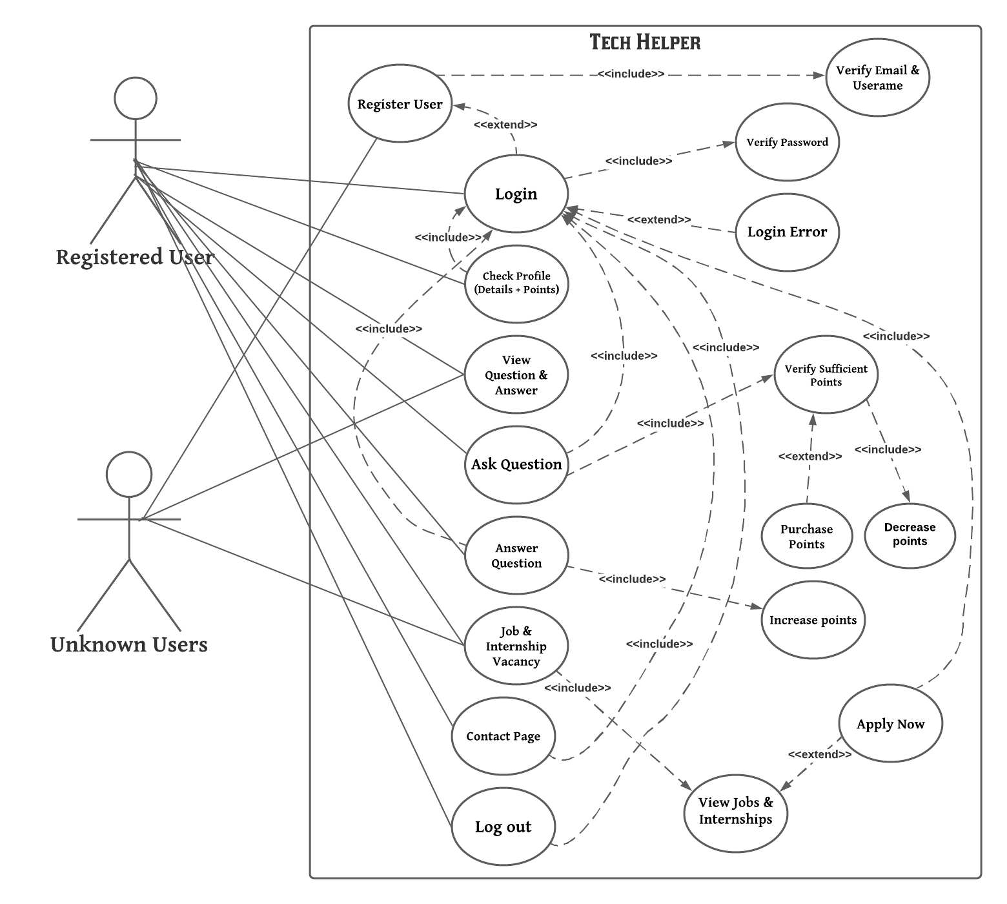

**UML Class Diagram**

