OFFICE MANAGEMENT SYSTEM

by
Md. Sohag Hossain
ID: CSE1502005023

Abul Hasan Mia
ID: CSE1502005027

Akram Ullah
ID: CSE1502005040

Farzana Jannath
ID: CSE1502005045

Supervised by
Bulbul Ahamed

Submitted in partial fulfillment of the requirements for the degree of
Bachelor of Science in Computer Science and Engineering



DEPARTMENT OF COMPUTER SCIENCE AND ENGINEERING
SONARGAON UNIVERSITY (SU)

February 2020

APPROVAL

The thesis and project titled “Office Management System” submitted by Md. Sohag Hossain (CSE1502005023), Abul Hasan Mia (CSE1502005027), Akram Ullah (CSE1502005040) and Farzana Jannath (CSE1502005045) to the Department of Computer Science and Engineering, Sonargaon University (SU), has been accepted as satisfactory for the partial fulfillment of the requirements for the degree of Bachelor of Science in Computer Science and Engineering and approved as to its style and contents.

Board of Examiners

----------------------------------------  Bulbul Ahamed  Associate Professor & Head,  Department of Computer Science and Engineering  Sonargaon University (SU) | Supervisor
----------------------------------------  (Examiner Name & Signature)  Department of Computer Science and Engineering  Sonargaon University (SU) | Examiner 1
----------------------------------------  (Examiner Name & Signature)  Department of Computer Science and Engineering  Sonargaon University (SU) | Examiner 2
----------------------------------------  (Examiner Name & Signature)  Department of Computer Science and Engineering  Sonargaon University (SU) | Examiner 3

ABSTRACT

The modern world almost wholly depends on advanced technology. Consequently, our life is fully influenced by modern technology-based devices like mobile phones, laptops, tablets, computers and so on. However, we cannot think a single day without technology. Nowadays, office management is replacing the prevailing norm of traditional office management systems. It’s not new, as the latter part of the twentieth century saw its inception.
The extraordinary rush of the internet made the world much easier, and the corporate world coped with it in every aspect. People around the globe are now adapting to the ongoing trend of virtual office management.
The most efficient small- and medium-size businesses don’t rely on outdated paper filing systems to manage their business documents. Go online and let our office management software process the drudgery for you. Less work = more play, and if there’s less to organize, there’s less to worry about.
All attendance, applications, management, leave apply are happening online. Online office management become essential for storing records of all employees.

TABLE OF CONTENTS
Title |  |  |  |  |  | Page No.
DECLARATION …………………………………………………………..…….. |  |  |  |  |  | iii
ABSTRACT ……………………...………………………………………………. |  |  |  |  |  | iv
ACKNOWLEDGEMENT ………………………………………….…………… |  |  |  |  |  | v
LIST OF ABBREVIATION ………….…………………………………………. |  |  |  |  |  | vi
CHAPTER 1 |  |  |  |  |  | 1 – 5
INTRODUCTION TO THE SOFTWARE
 | 1.1 | Project Overview………………………………..…………………..... |  |  |  | 1
 | 1.2 | Project Purpose……………………………………………………….
 | 1.3 | Objectives……………………………...…………………………...... |  |  |  | 2
 | 1.4 | Feature Extraction ……..……………………………………………. |  |  |  | 2
 | 1.5 | Why office management system? ……………….………………....... |  |  |  | 3
CHAPTER 2 |  |  |  |  |  | 6 – 7
OFFICE MANAGEMENT SYSTEM
 | 2.1 | Introduction ………………….……………………………….…......... |  |  |  | 6
 | 2.2 | Importance…………………… ……………………………….……… |  |  |  | 6
 | 2.3 | Stakeholder……………………………………………………………. |  |  |  | 7
 | 2.4 | Scope………………………………………………………………….. |  |  |  | 7
 | 2.5 | Limitations……………………………………………………………. |  |  |  | 8
CHAPTER 3 |  |  |  |  |  | 8 – 17
DIFFERENT TYPES OF MODELS
 | 3.1 | SDLC………………… …………………………………………...... |  |  |  | 8 – 10
 |  | 3.1.1 |  | Introduction ………………………….……………….…... |  | 8
 |  | 3.1.2 |  | Requirements gathering and analysis……………………..
 | 3.2 | Database Diagram………………………………….……………… |  |  |  | 13 – 16
 |  | 3.2.1 |  | Introduction …………………………………….….……... |  | 13
 |  | 3.2.2 |  | DB Diagram Architecture …………………….….………... |  | 13
CHAPTER 4 |  |  |  |  |  | 18 – 27
SYSTEM ANALYSIS
 | 4.1 | Introduction ………………………………….……………………… |  |  |  | 18
 | 4.2 | Use Case Diagram ………………....………………………………..
 |  | 4.2.1 |  | Admin ……………………………………..……………….. |  | 19
 |  | 4.2.2 |  | Employee ……..……………………………………………. |  | 20
 | 4.3 | Gant Chart…………………………………………………………… |  |  |  | 21
 | 4.4 | Functional Requirement……………………………………………... |  |  |  | 22
 | 4.5 | Non-Functional Requirement………………………………………… |  |  |  | 23
 | 4.6 | Performance Requirements……………………………………………
 |  | 4.6.1 |  |  | Speed and Latency Requirements…………………………... | 24
 |  | 4.6.2 |  |  | Precisions or Accuracy Requirements………………………. | 24
 |  | 4.6.3 |  |  | Capacity Requirements……………………………………… | 24
 | 4.7 | Dependability Requirements…………………………………………. |  |  |  | 25
 |  | 4.7.1 |  |  | Maintenance Requirements…………………………………. | 25
 |  | 4.7.2 |  |  | Supportability Requirements……………………………….. | 25
 |  | 4.7.3 |  |  | Adaptability Requirements…………………………………. | 25
 |  | 4.7.4 |  |  | Scalability or Extensibility Requirements………………….. | 26
 | 4.8 | Security Requirements……………………………………………….. |  |  |  | 27
 |  | 4.8.1 |  |  | Access Requirements……………………………………….. | 27
 |  | 4.8.2 |  |  | Integrity Requirements……………………………………… | 28
 |  | 4.8.3 |  |  | Privacy Requirements………………………………………. | 28
CHAPTER 5
EXPERIENCE AND ACHIEVEMENTS
 | 5.1 | Technical Enhancement .………………………….……………...…. |  |  |  | 29
 | 5.2 | Non-Technical Enhancement …………..…………………………… |  |  |  | 29
 | 5.3 | Achievements ………………………………………….……………. |  |  |  | 29
 | 5.4 | Development Tools and Technology………..……………………….. |  |  |  | 30
 | 5.5 | Technologies…………………………………………………………. |  |  |  | 30
 | 5.6 | Tools………………………………………………………………….. |  |  |  | 30
 | 5.7 | Database………………………………………………………………. |  |  |  | 30
CHAPTER 6
CONCLUSION AND FUTURE WORKS
 | 6.1 | Conclusion ………………………………………………………..…. |  |  |  | 29
 | 6.2 | Challenges…………………………………………………………… |  |  |  | 30
 | 6.3 | Future Works …………………………………………….………….. |  |  |  | 30
APPENDIX……………………………………………………….………………. |  |  |  |  |  | 31-34
DEVELOPMENT CODES…………………………………………….………… |  |  |  |  |  | 35-40
REFERENCES ……………………………………………………….………….. |  |  |  |  |  | 40

CHAPTER 1: INTRODUCTION TO OFFICE MANAGEMENT SYSTEM

Project Overview

Initially, Office Management was a manual system of maintaining hard copy paper records of Information and documents. But with time, this conventional method got replaced with a software system that maintains a library for all office-related documents and helps in paperless and convenient office management. This software is known as an Office Management System.

Office management is the technique of planning, organizing, coordinating and controlling office activities with a view to achieve business objectives and is concerned with efficient and effective performance of the office work. The success of a business depends upon the efficiency of its office. The volume of paper work in offices has increased manifold in these days due to industrialization, population explosion, government control and application of various tax and labour laws to any business enterprise. Efficiency and effectiveness which are key words in management are achieved only through proper planning and control of activities, reduction of office costs and coordination of all activities of business.

Office record is very important for managing office smoothly and it has many benefits also. Benefits of Records Management include more effective management of your current records (both paper and electronic); a reduced / eliminated level of record-keeping redundancies; reduced costs for records storage equipment and supplies; and increased usable office space through the elimination of unnecessary file storage. In addition, Records Management provides institutional accountability and timely access to information.

Project Purpose

Office management helps in increasing office efficiency, smooth flow of work, maintaining public relations, minimisation of cost, managing change and accepting the new challenges which help in achievement of goals of the organisation. It helps to achieving organisation goals, achieving individual goals, creating a dynamic environment, developing society, and improving efficiency.

Objectives

Office management helps to maintain a close relationship between the different departments and people. It regularly supplies order, command, and instruction to different people. It performs various functions like planning, organizing, controlling, staffing, supervising, motivating and effective leadership.
The main aim is to streamline the various functions of an office manager, such as planning, organizing, coordinating, controlling, staffing, and supervising. Ensuring effective office operations is essential for achieving your overall business goals.

The purpose of this online management system is to manage all the records, employee profile, leaves, attendance, notifications, notice boards, events, travel requests and loan requests. Administration can track all the records and information in a glance.
User also can use the

Feature Extraction

Office Management is the vital part of an organization which means to get things done through others. Management is creative and innovative force which aims to attain maximum results through the available resources like money, men and material. The word management has been defined differently by different authors. .Features of this online management system:
- Maintain and control company profile.
- Notice management create/edit/update/delete.
- Event management create/edit/update/delete.
- Ticket management create/edit/update/delete and assign the tickets problems.
- Leave management system with approval and rejection.
- Notification management system
- Managing user controls and management.
- Attendance management system.
- Profile management with edit and updates.
- Travel and transport management system

Why office management system?

The success of a business depends upon the efficiency of its office. The volume of paper work in offices has increased due to industrialization, population explosion, government control and application of various tax and labor laws. Efficiency and effectiveness, which are keywords in management are achieved only through proper planning and control of activities, reduction of office costs and coordination of all activities of business.

An office without organization is unthinkable. Office management is needed in all organizations. It manages support services of various departments in the organization. No organization can run effectively without efficient office management. Office management is needed at all levels of management.

CHAPTER 2: OFFICE MANAGEMENT SYSTEM

2.1 Introduction:
Office management is managing and improving the logistics within an office in order to support all the employees within that organization. It also can be call Business Management System. As an Admin, it can be expected to do more than most in the office. You’re the scheduler, financial advisor, overseer, office shopper, and so much more. Business Management System.

In simple words, office management can be defined as “a distinct process of planning, organizing, staffing, directing, coordinating and controlling office in order to facilitate achievement of objectives of any business enterprise’ the definition shows managerial functions of an administrative manager. Following diagram indicates various elements or functions in the process of office management.

Admin can track all the information and updates of stuffs. Admin can manage records of attendance, leave, notifications, travel request, employee benefits etc. On the other hand, employee can use the system for any kind of approvement and applications.

Importance:

The success of a business depends upon the efficiency of its office. The volume of paper work in offices has increased due to industrialization, population explosion, government control and application of various tax and labor laws. Efficiency and effectiveness, which are keywords in management are achieved only through proper planning and control of activities, reduction of office costs and coordination of all activities of business.

Office management is the art of guiding the personnel of the office in the use of means appropriate to its environment in order to achieve its specific purpose. Office management is that branch of management which is concerned with efficient performance of office work. An office is set up with certain aims and well defined objective. The office activities are directed for the attainment of this objective. The primary objective of an office is to provide service through clerical operation.

A software for Office management is needed in all organizations. It manages support services of various departments in the organization. No organization can run effectively without efficient office management. Office management is needed at all levels of management.

Stakeholder:

The international standard providing guidance on social responsibility, called ISO 26000, defines a stakeholder as an individual or group that has an interest in any decision or activity of an organization.

A stakeholder is a party that has an interest in a company and can either affect or be affected by the business. The primary stakeholders in a typical corporation are its investors, employees, customers and suppliers. However, the modern theory of the idea goes beyond this original notion to include additional stakeholders such as a community, government or trade association.
Stakeholders can be internal or external. Internal stakeholders are people whose interest in a company comes through a direct relationship, such as employment, ownership or investment. External stakeholders are those people who do not directly work with a company but are affected in some way by the actions and outcomes of said business. Suppliers, creditors and public groups are all considered external stakeholders. There are two types of stakeholders in nearly all projects:

Internal stakeholders: An internal stakeholder is a person or group linked directly to the company conducting the project.

External stakeholders. An external stakeholder is an entity that is not directly associated with the company involved in the project but is still impacted in some way by its outcome.

Our managements project holders are:
- Project manager.
- Team members.
- Managers.
- Resource managers.
- Executives.
- Senior management.
- Company owners.
- Investors.

Scope:
Office management is an integral part of general management. It refers to the process of planning, organizing, guiding, communicating, directing, coordinating and controlling the activities of a group of people who are working to achieve business objectives efficiently and economically.
Office management helps in increasing office efficiency, smooth flow of work, maintaining public relations, minimization of cost, managing change and accepting the new challenges which help in achievement of goals of the organization.
There are three processes of Project Scope Management:
- Planning. The planning process is when an attempt is made to capture and define the work that needs to be done.
- Controlling.
- Closing.
This software have all this scopes and development.

Limitations:

A technical limitation of a software usually refers to what the defined system is unable to do as of its present state. The technical limitation of software usually serve as recommendations for improvements on upcoming systems.
Some of the limitations are its complexity, costs, learning process, and secured control. Project managers will need to become familiar with the program's main functions and make sure that their team members are trained on the features that are pertinent to the jobs they must complete.
Office management have some limitation. We have lacking of cost management, experienced developer, some short of knowledges in some sector. But we can overcome it by time.

CHAPTER 3: Software Development Life Cycle

3.1 SDLC
3.1.1: Introduction:
The Software Development Life Cycle (SDLC) is a structured process that enables the production of high-quality, low-cost software, in the shortest possible production time. The goal of the SDLC is to produce superior software that meets and exceeds all customer expectations and demands. There are 6 phase in Software Development Life Cycle. They are given below:
- Requirements gathering and Analysis
- Design
- Implementation
- Testing
- Deployment
- Maintenance

3.1.2 Requirements gathering and analysis:

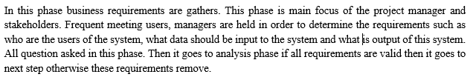

Design:

Implementation:

Testing:
When complete implement code then it comes to testing. In this phase all functional and nonfunctional requirements are tested as like as integration testing, system testing, acceptance testing is done.

Deployment:
When successfully complete the testing phase then software prepare for shipping, Then its use for customers. If any problem to use this software then they contact them.

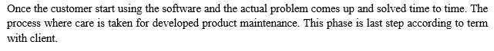
Maintenance:

3.2 Database Diagram:

3.2.1 Introduction:
Database diagrams graphically show the structure of the database. Using database diagrams you can create and modify tables, columns, relationships, and keys. Additionally, you can modify indexes and constraints. To create relations between database objects, consider using primary and foreign keys.

3.2.2 DB Diagram Architecture

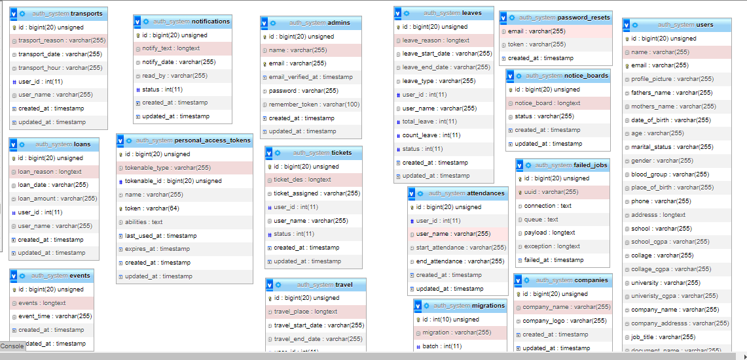
Fig: 3.2.2 Database Diagram

Chapter 4: SYSTEM ANALYSIS

4.1 Introduction:

System analysis is a procedure or approach that serves to determine the system's performance for a given (known) structure of this system. An example may be a typical student project with a given input data which should be made for a defined system structure. The resulting calculation data characterize system outputs.
System analysis is used in every field where something is developed. Analysis can also be a series of components that perform organic functions together, such as system engineering. System engineering is an interdisciplinary field of engineering that focuses on how complex engineering projects should be designed and managed

4.2 USE CASE

4.2.1 ADMIN USE CASE

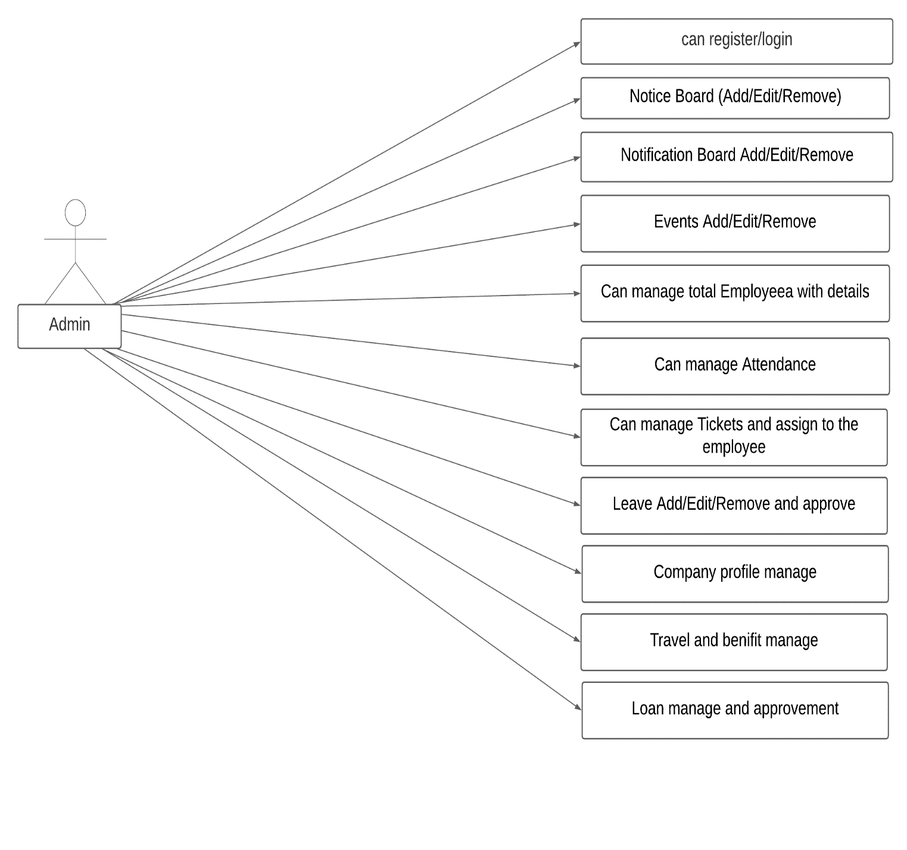
Fig: 4.2.1 Admin Use case

4.2.2 EMPLOYEE USE CASE

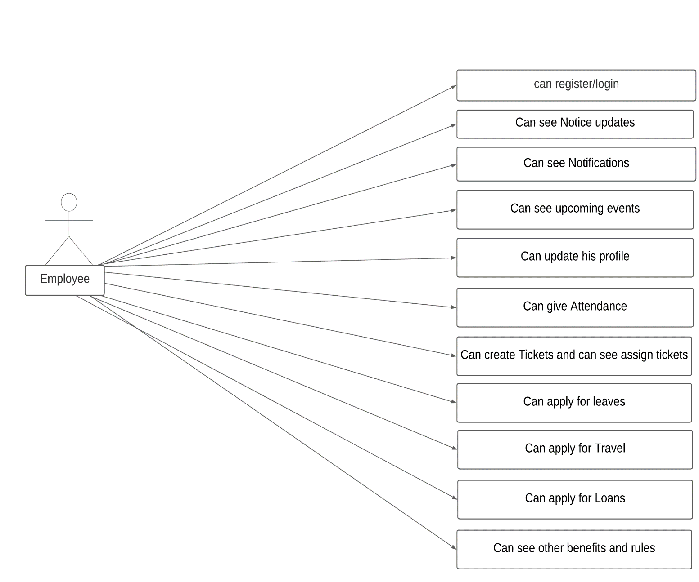

Fig: 4.2.2 Employee Use case

4.3 Gant chart

Gantt charts are most commonly used for tracking project schedules. For this it is useful to be able to show additional information about the various tasks or phases of the project, for example how the tasks relate to each other, how far each task has progressed, what resources are being used for each task and so on.
Originally Gantt charts were prepared laboriously by hand; each time a project changed it was necessary to amend or redraw the chart and this limited their usefulness, continual change being a feature of most projects. Nowadays, however, with the advent of computers and project management software, Gantt charts can be created, updated and printed easily.
This is describing the time duration to develop this project.

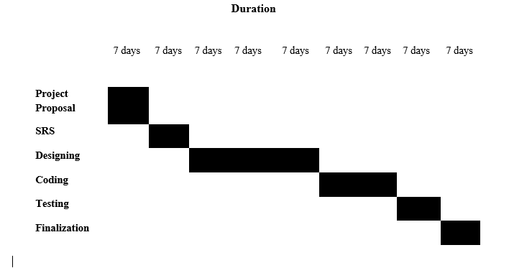

4.4 Functional Requirement:

Functional requirements are product features or functions that developers must implement to enable users to accomplish their tasks. So, it's important to make them clear both for the development team and the stakeholders. Generally, functional requirements describe system behavior under specific conditions. The functional requirement of this project are:

ID | Name | Description | Functional / Non  functional | Priority
FRQ-01 | Request access for  password | User can request for pass  with fill-up your email-id | Functional | High
FRQ-02 | Login | User can login with their  valid email id and pass. | Functional | High
FRQ-03 | Assign Tickets | Admin can  assign tickets to employees. | Functional | High
FRQ-04 | Verify leaves | After leave application admin have to approve or rejects the leaves | Functional | High

4.5 Non-Functional Requirement:

Nonfunctional Requirements (NFRs) define system attributes such as security, reliability, performance, maintainability, scalability, and usability. They serve as constraints or restrictions on the design of the system across the different backlogs.
Nonfunctional requirements describe the general properties of a system. In systems engineering and requirements engineering, a non-functional requirement (NFR) is a requirement that specifies criteria that can be used to judge the operation of a system, rather than specific behaviors. They are contrasted with functional requirements that define specific behavior or functions. The plan for implementing functional requirements is detailed in the system design.

ID | Name | Description | Functional / Non  functional | Priority
NFR-01 | Security | Using token-based  authentication, session,  validation 2FA it will be  secure from unauthorized  access. | Non-Functiona | High
NFR-02 | Availability | The system should work  24/7 as user can get access  and service. | Non-Functional | High
NFR-03 | Accuracy | Data or process requirement  concerned with defining the  precision which the solution  will record or produce data. | Non-Functional | High
NFR-04 | Maintenance | It’s way how easy to  support, change and  enhance the system. | Non-Functional | High

4.6 Performance Requirements:

4.6.1 Speed and Latency Requirements
- Dataset would be inserted in MySQL Databases using php artisan Make
(Command).
- UI design-build on the user fulfills table data set and show. The Database we have to use php artisan migrate this command.

4.6.2 Precisions or Accuracy Requirements
- All user capable to show accurates page where he or she can show detail of
proposal, proposal status. And Project thesis committee can check all student
list and teacher list.
- Project thesis committee can update student proposal.
- Admin can update student information.

4.6.3 Capacity Requirements
- At time multiple users can use this system.
- Admin can add supervisor at a time one supervisor for one student.

4.7 Dependability Requirements:

4.7.1 Maintenance Requirements
- Web application did not modify or change.
- If we need to data need to recover or update then need to using command line.
- We are need to maintainecs all security and others works.

4.7.2 Supportability Requirements
- When the system did not work perfectly then need to check database and others
- work.
- Update security patch and others system.

4.7.3 Adaptability Requirements
- This is very important software.
- This web application can help to all student and faculty member then they can
- get all services easily.

4.7.4 Scalability or Extensibility Requirements
- This project proposal web application is very good supported software application
- Web application is good for help.
- Every student can easily check his or her all proposal status.

4.8 Security Requirements

4.8.1 Access Requirements
- Only for registered user can access this system.
- Guest cannot allow this system.
- Any student can submit his or her proposal then need to activate his or her portal account

4.8.2 Integrity Requirements
- This web application cannot access another user like guest user.

4.8.3 Privacy Requirements
- Here we are using activate account system.
- All teacher account portal can activate admin (Project/thesis committee)

Chapter 4: EXPERIENCE AND ACHIEVEMENTS

5.1 Technical Enhancement

Software Enhancements means modifications or improvements made to the Software relating to Products which improve performance, capabilities or capacity of the Software revision level with which it is associated or which provide additional functions to the Software.
Technological enhancement and sustainability can be defined as ‘improving the results of higher education through the use of information and communication technologies in a sustainable way’.

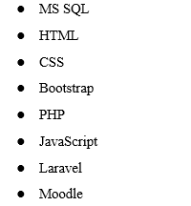

5.2 Non-Technical Enhancement

Non-technical skills are skills you have that do not relate to your specific job. Also called soft skills, these skills relate more to your personal qualities and habits than your technical abilities. These skills affect how you interact with others and how you complete your work. Non-technical skills may help you be more productive and foster a positive, well-functioning work environment.

- Internal Communication
- Responsibilities
- Team Work
- Self Confidence
- Take Challenges

5.3 Achievements

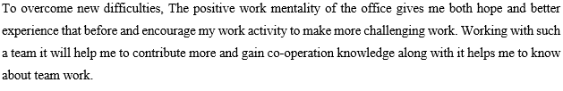
There have been major software engineering contributions in many application domains, from airtraffic control systems to genomic research, from automobile systems to healthcare. These achievements required that various deep software engineering issues were addressed and implemented. We are interested in identifying the core and enduring technical problems overcome, and in illustrations of their utility.

5.4 Development Tools and Technology

There are certain factors to be considered while selecting the corresponding development tool, based on the type of the project. A few common examples of strategic planning tools include: SWOT (Strengths, Weaknesses, Opportunities, Threats) analysis. OKR (Objectives and Key Results) PEST (political, economic, socio-cultural, and technological) analysis. . We uses many advance technology & tools & frameworks, that’s are:

5.5 Technologies:

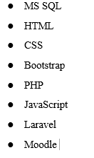

5.6 Tools:

- Visual Studio Code
- Git Bash

Mobile Application Platform:
- Android
- IOS
Database:
- phpmyadmin
- MYSQL

CHAPTER 6: CONCLUSION & FUTURE SCOPE

6.1 Conclusion

Having proper management is necessary for all divisions of the business. In this regard, office management is one of those elements that one cannot pass up. We hope in this piece; you got a fair idea of how you can get the best results in this management concept. Working here we have figured out how to function in an expert programming organization, how to act officially, how different engineers fill in collectively and how to propel myself more to get familiar with each day. With the experience that we had over the most recent half-year, we figure it will assist for us.

Management is creative problem solving. This creative problem solving is accomplished through four functions of management: planning, organizing, leading and controlling. But when it can be managed smoothly with a digital platform, managing become so easier. The intended result is the use of an organization’s resources in a way that accomplishes its mission and objectives.

6.2 Challenges

The most important single aspect of software development is to be clear about what you are trying to build. Understanding the fundamental obstacles in software development is critical, as is devising a methodical strategy to address each challenge. Time Management. One of the biggest challenges while working on a software project is time management.

Every technology advancement is a blessing for the IT industry. But at the same time, technology evolving at a phenomenal rate leads to an added pressure for software development professionals to leverage these upcoming technology trends in software product development to gain a cutting edge over competitors and stand out in the market.

6.3 Future Scope

Modern office management is a crucial element in managing day-to-day activities like financial planning, maintenance of employee and company records. The management of the modern office is responsible for obtaining and administrative accomplishments with strategy. The office management functions are concerned with designing, evaluating, implementing the work processes carried out in offices and the traditional office environments. It is a part of the business management function because office management is crucial towards activities like planning, control and organization. Its efficiency is quite crucial for the success of business management activities. This software will be helpful for both administration and employees.

Appendix

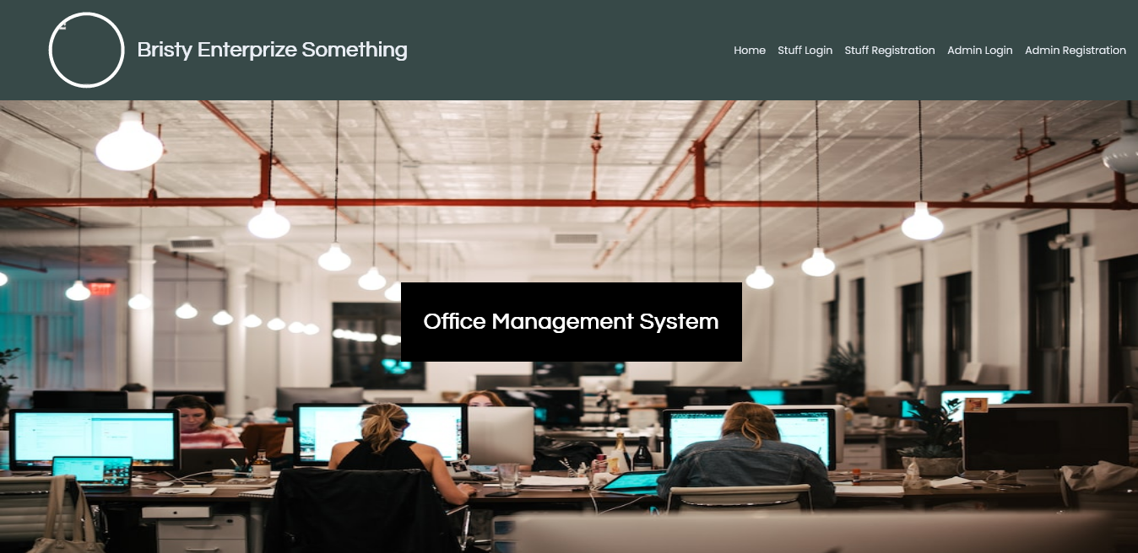

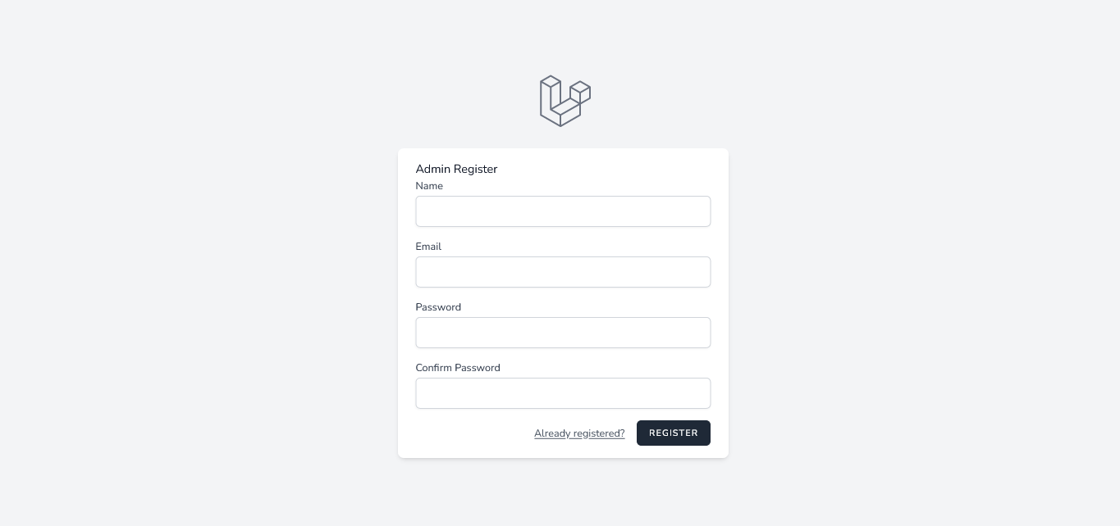
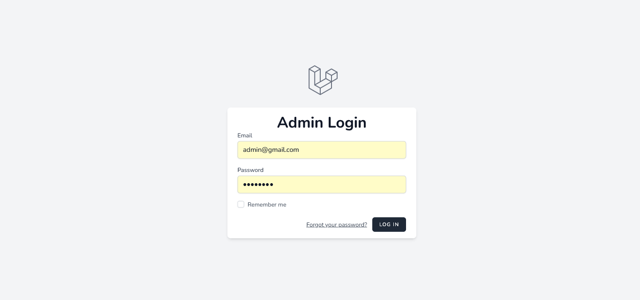

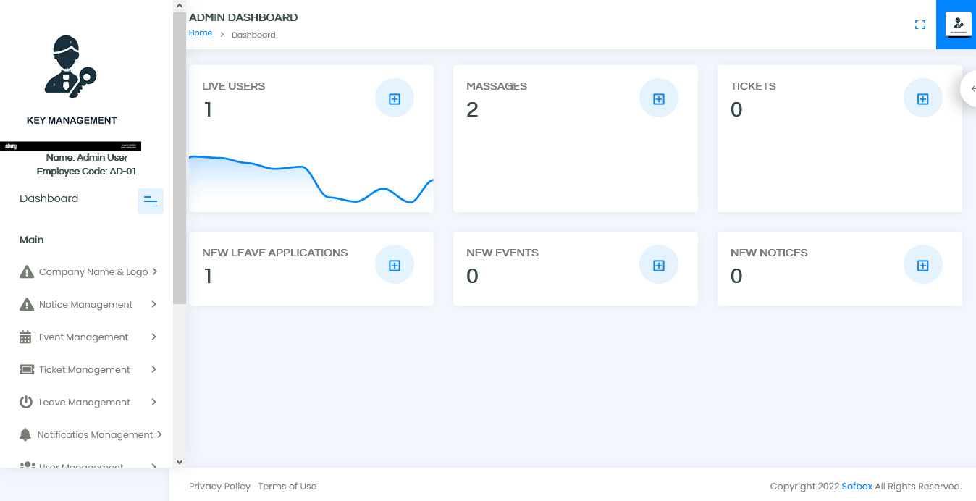

Development Codes:

<?php

namespace App\Http\Controllers\Admin;

use App\Http\Controllers\Controller;
use App\Http\Requests\Adminauth\LoginRequest;
use App\Providers\RouteServiceProvider;
use Illuminate\Http\Request;
use Illuminate\Support\Facades\Auth;

class AuthenticatedSessionController extends Controller
{
/**
* Display the login view.
*
* @return \Illuminate\View\View
*/
public function create()
{
return view('admin.auth.login');
}

/**
* Handle an incoming authentication request.
*
* @param \App\Http\Requests\Auth\LoginRequest $request
* @return \Illuminate\Http\RedirectResponse
*/
public function store(LoginRequest $request)
{
$request->authenticate();

$request->session()->regenerate();

return redirect()->intended(RouteServiceProvider::Admin_HOME);
}

/**
* Destroy an authenticated session.
*
* @param \Illuminate\Http\Request $request
* @return \Illuminate\Http\RedirectResponse
*/
public function destroy(Request $request)
{
Auth::guard('admin')->logout();

$request->session()->invalidate();

$request->session()->regenerateToken();

return redirect('/');
}
}

<?php

namespace App\Http\Controllers\Admin;

use App\Http\Controllers\Controller;
use App\Models\Company;
use Illuminate\Http\Request;
use Carbon\Carbon;
use Intervention\Image\Facades\Image;

class CompanyController extends Controller
{
public function __construct()
{
$this->middleware('auth:admin');
}
//index
public function index(){

$create = Company::orderBy('id','ASC')->paginate(10);

return view('admin.company.index',compact('create'));
}
/// Store
public function store(Request $request){

$request->validate([
'company_name' =>'required',
'company_logo' =>'required',
]);

$img =$request->file('company_logo');
$img_gen = hexdec(uniqid()).'.'.$img->getClientOriginalExtension();
Image::make($img)->save('admin/images/company'.$img_gen);
$save_url='admin/images/company'.$img_gen;

Company::insert([
'company_name'=>$request->company_name,
'company_logo'=>$save_url,
'created_at' =>Carbon::now(),
]);
$notification=array(
'message'=>'Created Success',
'alert-type'=>'success'
);
return redirect()->back()->with($notification);
}

// Edit
public function edit($id){
$edit =Company::findOrFail($id);

return view('admin.company.edit',compact('edit'));
}

// Update
public function update(Request $request){

$id= $request->id;
$request->validate([
'company_name' =>'required',
'company_logo' =>'required',
]);

$old_img = $request->old_img;

unlink($old_img);
$image= $request->file('company_logo');
$img_gen = hexdec(uniqid()).'.'.$image->getClientOriginalExtension();
Image::make($image)->save('admin/images/company'.$img_gen);
$img_url = 'admin/images/company'.$img_gen;

Company::findOrFail($id)->update([
'company_name'=>$request->company_name,
'company_logo'=>$img_url,
'created_at' =>Carbon::now(),
]);
$notification=array(
'message'=>'update Success',
'alert-type'=>'success'
);
return redirect()->route('company_create')->with($notification);
}
// Destroy
public function destroy($id){
Company::findOrFail($id)->delete();

$notification=array(
'message'=>'Delete Success',
'alert-type'=>'success'
);
return redirect()->back()->with($notification);
}

}

<?php

namespace App\Http\Controllers\Admin;

use App\Http\Controllers\Controller;
use App\Models\User;
use App\Models\Loan;
use Carbon\Carbon;
use Illuminate\Http\Request;

class UserManagementController extends Controller
{
public function __construct()
{
$this->middleware('auth:admin');
}
public function user_create()
{
return view('admin.manage_users.index');
}
public function view_users(Request $request)
{
return view('admin.manage_users.all_users');
}
public function user_loans(Request $request)
{
return view('admin.manage_users.loan_view');
}

public function travel_view(Request $request)
{
return view('admin.manage_users.travel_view');
}
public function transport_view(Request $request)
{
return view('admin.manage_users.transport_view');
}
public function attendance_view(Request $request)
{
return view('admin.manage_users.attendance_view');
}
}

<?php

namespace App\Http\Controllers;

use App\Models\Attendance;
use App\Http\Controllers\Controller;
use Carbon\Carbon;
use Illuminate\Http\Request;
use Illuminate\Support\Facades\Auth;

class attendanceController extends Controller
{
//Approval
public function start_attendance(){
Attendance::insert([
'user_id' =>Auth::user()->id,
'user_name' =>Auth::user()->name,
'start_attendance' =>Carbon::now(),
'created_at' =>Carbon::now(),

]);
$notification=array(
'message'=>'Attendance Store Successfully',
'alert-type'=>'success'
);
return redirect()->back()->with($notification);
}

//end attendance
public function ends_attendance($id){
// $data= Attendance::latest($id);
$data= Attendance::findOrFail($id);
$data -> end_attendance= Carbon::now();
$data-> save();
return redirect()-> back();

$notification=array(
'message'=>'Attendance Store Successfully',
'alert-type'=>'success'
);
return redirect()->back()->with($notification);
}

// // Update
// public function ends_attendance(Request $request){

// $id= $request->id;
// Attendance::findOrFail($id)->update([
// 'end_attendance' =>Carbon::now(),
// 'created_at' =>Carbon::now(),
// ]);
// $notification=array(
// 'message'=>'update Success',
// 'alert-type'=>'success'
// );
// return redirect()->route('admin_create_leaves')->with($notification);
// }

}

<?php

namespace App\Http\Controllers;

use App\Models\Ticket;
use Carbon\Carbon;
use Illuminate\Http\Request;
use Illuminate\Support\Facades\Auth;

class ticketControlle extends Controller
{
public function __construct()
{
$this->middleware('auth');
}
//index
public function index(){

$ticket = Ticket::orderBy('id','ASC')->paginate(10);

return view('auth.tickets.index',compact('ticket'));
}
/// Store
public function store(Request $request){

$request->validate([
'ticket_des' =>'required',
]);

Ticket::insert([
'ticket_des'=>$request->ticket_des,
'user_id' =>Auth::user()->id,
'user_name' =>Auth::user()->name,
'created_at' =>Carbon::now(),
]);
$notification=array(
'message'=>'Created Success',
'alert-type'=>'success'
);
return redirect()->back()->with($notification);
}
// Edit
public function edit($id){
$edit =Ticket::findOrFail($id);

return view('auth.tickets.edit',compact('edit'));
}

// Update
public function update(Request $request){

$id= $request->id;
$request->validate([
'ticket_des' =>'required',
]);
Ticket::findOrFail($id)->update([
'ticket_des'=>$request->ticket_des,
'created_at' =>Carbon::now(),
]);
$notification=array(
'message'=>'update Success',
'alert-type'=>'success'
);
return redirect()->route('ticket_view')->with($notification);
}
// view
public function ticket_view(){
$ticket = Ticket::orderBy('id','ASC')->paginate(10);

return view('auth.tickets.view',compact('ticket'));
}
// view
public function ticket_assigned(){
$ticket = Ticket::orderBy('id','ASC')->paginate(10);

return view('auth.tickets.ticket_assigned',compact('ticket'));
}

}

<?php

namespace App\Http\Controllers;

use App\Models\Transport;
use Illuminate\Http\Request;
use App\Models\User;
use Carbon\Carbon;
use Illuminate\Support\Facades\Auth;

class transportController extends Controller
{
public function __construct()
{
$this->middleware('auth');
}
//create/index
public function index(){

$transport = Transport::orderBy('id','ASC')->paginate(10);

return view('auth.transport.index',compact('transport'));
}
/// Store
public function store(Request $request){

$request->validate([
'trasport_reason' =>'required',
'transport_date' =>'required',
'transport_hour' =>'required',
]);

Transport::insert([
'trasport_reason'=>$request->trasport_reason,
'transport_date'=>$request->transport_date,
'transport_hour'=>$request->transport_hour,
'user_id' =>Auth::user()->id,
'user_name' =>Auth::user()->name,
'created_at' =>Carbon::now(),
]);
$notification=array(
'message'=>'Created Success',
'alert-type'=>'success'
);
return redirect()->back()->with($notification);
}
// Edit
public function edit($id){

$edit =Transport::findOrFail($id);

return view('auth.transport.edit',compact('edit'));
}
// Update
public function update(Request $request){

$id= $request->id;
$request->validate([
'trasport_reason' =>'required',

]);
Transport::findOrFail($id)->update([
'trasport_reason'=>$request->trasport_reason,
'transport_date'=>$request->transport_date,
'transport_hour'=>$request->transport_hour,
'updated_at' =>Carbon::now(),
]);
$notification=array(
'message'=>'update Success',
'alert-type'=>'success'
);
return redirect()->route('trasport_view')->with($notification);
}
//view
public function view(){

$transport = Transport::orderBy('id','ASC')->paginate(10);

return view('auth.transport.view',compact('transport'));
}

}

<?php

namespace App\Http\Controllers;

use App\Models\Travel;
use Illuminate\Http\Request;
use App\Models\User;
use Carbon\Carbon;
use Illuminate\Support\Facades\Auth;

class travelController extends Controller
{
public function __construct()
{
$this->middleware('auth');
}
//create/index
public function index(){

$travel = Travel::orderBy('id','ASC')->paginate(10);

return view('auth.travel.index',compact('travel'));
}
/// Store
public function store(Request $request){

$request->validate([
'travel_place' =>'required',
'travel_start_date' =>'required',
'travel_end_date' =>'required',
]);

Travel::insert([
'travel_place'=>$request->travel_place,
'travel_start_date'=>$request->travel_start_date,
'travel_end_date'=>$request->travel_end_date,
'user_id' =>Auth::user()->id,
'user_name' =>Auth::user()->name,
'created_at' =>Carbon::now(),
]);
$notification=array(
'message'=>'Created Success',
'alert-type'=>'success'
);
return redirect()->back()->with($notification);
}
// Edit
public function edit($id){

$edit =Travel::findOrFail($id);

return view('auth.travel.edit',compact('edit'));
}
// Update
public function update(Request $request){

$id= $request->id;
$request->validate([
'travel_place' =>'required',

]);
Travel::findOrFail($id)->update([
'travel_place'=>$request->travel_place,
'travel_start_date'=>$request->travel_start_date,
'travel_end_date'=>$request->travel_end_date,
'updated_at' =>Carbon::now(),
]);
$notification=array(
'message'=>'update Success',
'alert-type'=>'success'
);
return redirect()->route('travel_view')->with($notification);
}
//view
public function view(){

$travel = Travel::orderBy('id','ASC')->paginate(10);

return view('auth.travel.view',compact('travel'));
}
}

<?php

namespace App\Http\Controllers;

use App\Models\Ticket;
use Carbon\Carbon;
use Illuminate\Http\Request;
use Illuminate\Support\Facades\Auth;

class ticketControlle extends Controller
{
public function __construct()
{
$this->middleware('auth');
}
//index
public function index(){

$ticket = Ticket::orderBy('id','ASC')->paginate(10);

return view('auth.tickets.index',compact('ticket'));
}
/// Store
public function store(Request $request){

$request->validate([
'ticket_des' =>'required',
]);

Ticket::insert([
'ticket_des'=>$request->ticket_des,
'user_id' =>Auth::user()->id,
'user_name' =>Auth::user()->name,
'created_at' =>Carbon::now(),
]);
$notification=array(
'message'=>'Created Success',
'alert-type'=>'success'
);
return redirect()->back()->with($notification);
}
// Edit
public function edit($id){
$edit =Ticket::findOrFail($id);

return view('auth.tickets.edit',compact('edit'));
}

// Update
public function update(Request $request){

$id= $request->id;
$request->validate([
'ticket_des' =>'required',
]);
Ticket::findOrFail($id)->update([
'ticket_des'=>$request->ticket_des,
'created_at' =>Carbon::now(),
]);
$notification=array(
'message'=>'update Success',
'alert-type'=>'success'
);
return redirect()->route('ticket_view')->with($notification);
}
// view
public function ticket_view(){
$ticket = Ticket::orderBy('id','ASC')->paginate(10);

return view('auth.tickets.view',compact('ticket'));
}
// view
public function ticket_assigned(){
$ticket = Ticket::orderBy('id','ASC')->paginate(10);

return view('auth.tickets.ticket_assigned',compact('ticket'));
}

}

use Illuminate\Support\Facades\Route;
use App\Http\Controllers\Admin\ProfileController;
use App\Http\Controllers\Admin\NoticeBoardController;
use App\Http\Controllers\Admin\UserManagementController;
use App\Http\Controllers\Admin\EventController;
use App\Http\Controllers\dashboardUserController;

use App\Http\Controllers\Admin\adminTicketControlle;
use App\Http\Controllers\Admin\adminLeaveController;
use App\Http\Controllers\Admin\notificationController;
use App\Http\Controllers\Admin\CompanyController;
use App\Http\Controllers\attendanceController;
use App\Http\Controllers\UserInfoController;
use App\Http\Controllers\leaveController;
use App\Http\Controllers\ticketControlle;
use App\Http\Controllers\loanController;
use App\Http\Controllers\travelController;
use App\Http\Controllers\transportController;

/*
|--------------------------------------------------------------------------
| Web Routes
|--------------------------------------------------------------------------
|
| Here is where you can register web routes for your application. These
| routes are loaded by the RouteServiceProvider within a group which
| contains the "web" middleware group. Now create something great!
|
*/

Route::get('/', function () {
return view('welcome');
});

Route::get('/dashboard', function () {
return view('auth.notifications.index');
})->middleware(['auth', 'verified'])->name('layouts.user_master');

require __DIR__.'/auth.php';

//Admin auth
Route::get('/admin/dashboard', function () {
return view('admin.home');
})->middleware(['auth:admin', 'verified'])->name('admin.home');

require __DIR__.'/adminauth.php';

// Route::get('slider',[SliderController::class,'index'])->name('sliders');

// Main
Route::group(['prefix'=>'admin'], function(){
// Route::get('navbar',[NavbarController::class,'navbar'])->name('main_navbar');

// /// Admin Profile Settings
Route::get('my-profile',[ProfileController::class,'index'])->name('admin_profile');
Route::get('profile-settings',[ProfileController::class,'profileSettings'])->name('profile_settings');
Route::post('profile-update',[ProfileController::class,'profileUpdate'])->name('update_profile');
Route::post('profile-password',[ProfileController::class,'profilePasswordUpdate'])->name('profile_password_update');

// // User Create
Route::get('/create_users', [UserManagementController::class, 'user_create'])->name('create_users');
Route::get('/all_users', [UserManagementController::class, 'view_users'])->name('all_users');
Route::get('/user_loans', [UserManagementController::class, 'user_loans'])->name('user_loans');
Route::get('/travel_view', [UserManagementController::class, 'travel_view'])->name('admin_travel_view');
Route::get('/user_loans', [UserManagementController::class, 'user_loans'])->name('user_loans');
Route::get('/transport_view', [UserManagementController::class, 'transport_view'])->name('admin_transport_view');
Route::get('/attendance', [UserManagementController::class, 'attendance_view'])->name('admin_attendance_view');

/// Notice Board
Route::get('notice-board',[NoticeBoardController::class,'index'])->name('notice_board');
Route::post('notice-board/store',[NoticeBoardController::class,'store'])->name('notice_board_store');
Route::get('notice-board/edit/{id}',[NoticeBoardController::class,'edit']);
Route::post('notice-board/update',[NoticeBoardController::class,'update'])->name('notice_board_update');
Route::get('notice-board/delete/{id}',[NoticeBoardController::class,'destroy']);
Route::get('notice-board/view',[NoticeBoardController::class,'view'])->name('admin_notice_view');

/// Events
Route::get('events',[EventController::class,'index'])->name('event_create');
Route::post('events/store',[EventController::class,'store'])->name('event_store');
Route::get('events/edit/{id}',[EventController::class,'edit']);
Route::post('events/update',[EventController::class,'update'])->name('event_update');
Route::get('events/delete/{id}',[EventController::class,'destroy']);
Route::get('events/view',[EventController::class,'view'])->name('admin_event_view');

/// Tickets
Route::get('tickets/controller',[adminTicketControlle::class,'index'])->name('admin_ticket');
Route::post('tickets/controller/store',[adminTicketControlle::class,'store'])->name('admin_ticket_store');
Route::get('tickets/controller/edit/{id}',[adminTicketControlle::class,'edit']);
Route::post('tickets/controller/update',[adminTicketControlle::class,'update'])->name('admin_ticket_update');
Route::get('tickets/delete/{id}',[adminTicketControlle::class,'destroy']);
Route::get('tickets/view',[adminTicketControlle::class,'view'])->name('admin_view_tickets');

/// leaves
Route::get('leaves/controller',[adminLeaveController::class,'index'])->name('admin_create_leaves');
Route::post('leaves/controller/store',[adminLeaveController::class,'store'])->name('admin_leave_store');
Route::get('leaves/controller/edit/{id}',[adminLeaveController::class,'edit']);
Route::post('leaves/controller/update',[adminLeaveController::class,'update'])->name('admin_leave_update');
Route::get('leaves/controller/delete/{id}',[adminLeaveController::class,'destroy']);
Route::get('approved/{id}',[adminLeaveController::class,'approve']);
Route::get('leaves/view',[adminLeaveController::class,'view'])->name('admin_view_leaves');

//Notification
Route::get('notification',[notificationController::class,'index'])->name('notify');
Route::post('notification/store',[notificationController::class,'store'])->name('notify_store');
// Route::get('notification/edit/{id}',[notificationController::class,'edit']);
// Route::post('notification/update',[notificationController::class,'update'])->name('notify_update');
Route::get('notification/delete/{id}',[notificationController::class,'destroy']);
Route::get('notification/view',[notificationController::class,'view'])->name('admin_view_notify');

/// company
Route::get('company',[CompanyController::class,'index'])->name('company_create');
Route::post('company/store',[CompanyController::class,'store'])->name('company_store');
Route::get('company/edit/{id}',[CompanyController::class,'edit']);
Route::post('company/update',[CompanyController::class,'update'])->name('company_update');
Route::get('company/delete/{id}',[CompanyController::class,'destroy']);

});

//*******************************user controlls****************************

//common views
Route::get('all_notices',[dashboardUserController::class,'view_notices'])->name('all_notices');
Route::get('all_events',[dashboardUserController::class,'view_events'])->name('all_events');
Route::get('all_notifications',[dashboardUserController::class,'view_notifications'])->name('all_notify');
Route::get('markasdone/{id}',[dashboardUserController::class,'notification_read']);
Route::get('notice/rules',[dashboardUserController::class,'notice_rules'])->name('notice_rules');
Route::get('ticket/assesment',[dashboardUserController::class,'ticket_rules'])->name('ticket_rules');

/

// leaves
Route::get('leaves',[leaveController::class,'index'])->name('create_leaves');
Route::post('leaves/store',[leaveController::class,'store'])->name('leave_store');
Route::get('leaves/edit/{id}',[leaveController::class,'edit']);
Route::post('leaves/update',[leaveController::class,'update'])->name('leave_update');
Route::get('leaves/view',[leaveController::class,'leave_view'])->name('leave_view');

//Tickets
Route::get('tickets',[ticketControlle::class,'index'])->name('create_tickets');
Route::post('tickets/store',[ticketControlle::class,'store'])->name('ticket_store');
Route::get('tickets/edit/{id}',[ticketControlle::class,'edit']);
Route::post('tickets/update',[ticketControlle::class,'update'])->name('ticket_update');
Route::get('tickets/view',[ticketControlle::class,'ticket_view'])->name('ticket_view');
Route::get('tickets/assigned',[ticketControlle::class,'ticket_assigned'])->name('user_ticket_assigned');

/// loans
Route::get('loan',[loanController::class,'index'])->name('create_loan');
Route::post('loan/store',[loanController::class,'store'])->name('loan_store');
Route::get('loan/edit/{id}',[loanController::class,'edit']);
Route::post('loan/update',[loanController::class,'update'])->name('loan_update');
Route::get('loan/view',[loanController::class,'view'])->name('loan_view');

/// travel
Route::get('travel',[travelController::class,'index'])->name('create_travel');
Route::post('travel/store',[travelController::class,'store'])->name('travel_store');
Route::get('travel/edit/{id}',[travelController::class,'edit']);
Route::post('travel/update',[travelController::class,'update'])->name('travel_update');
Route::get('travel/view',[travelController::class,'view'])->name('travel_view');

/// trasport
Route::get('trasport',[transportController::class,'index'])->name('trasport_travel');
Route::post('trasport/store',[transportController::class,'store'])->name('trasport_store');
Route::get('trasport/edit/{id}',[transportController::class,'edit']);
Route::post('trasport/update',[transportController::class,'update'])->name('trasport_update');
Route::get('trasport/view',[transportController::class,'view'])->name('trasport_view');

//Attendance
Route::get('start-attendance/',[attendanceController::class,'start_attendance']);
Route::get('end-attendance/{id}',[attendanceController::class,'ends_attendance']);

//User infon system
Route::get('info',[UserInfoController::class,'index'])->name('user_info');
Route::get('info/edit/{id}',[UserInfoController::class,'edit']);
Route::post('info/update',[UserInfoController::class,'update'])->name('user_info_update');

REFERENCES
- https://www.w3schools.com/php/
- https://www.quora.com/Is-there-any-scope-after-the-completion-of-an-office-management-course
- https://en.wikipedia.org/wiki/Non-functional_requirement

