Accesories

**Teapots**

1.Glass Teapots

Description: Elegant and modern, glass teapots allow you to enjoy the visual beauty

of your tea as it brews.

Made from heat-resistant borosilicate glass, these teapots are durable and designed

to handle hot water without cracking. They often come with built-in infusers for loose

leaf tea, ensuring a perfect brew every time.

Price: $29.99

Quote: "Experience the art of tea brewing with our elegant glass teapots.”

2.Ceramic Teapots

Description: Classic and timeless, ceramic teapots are known for their excellent heat

retention properties. Available in various designs and colors, they add a touch of tradition

to your tea brewing experience. Ceramic teapots are ideal for brewing a variety of teas, and

many are handcrafted, adding a unique aesthetic to your tea time.

Price: $34.99

Quote: "Add a touch of tradition to your tea time with our classic ceramic teapots.”

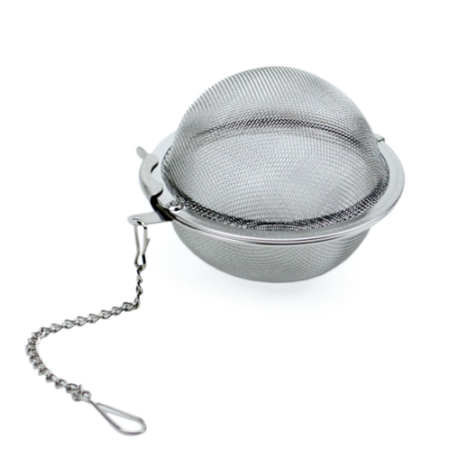

**Tea Infusers and Strainers**

1.Mesh Tea Balls

Description: Simple and effective, mesh tea balls are perfect for brewing a single

cup of loose leaf tea. Made from stainless steel, they are easy to use and clean. J

ust fill the ball with your favorite tea leaves, close it, and steep it in hot water.

The fine mesh prevents leaves from escaping, ensuring a smooth cup of tea.

Price: $6.99

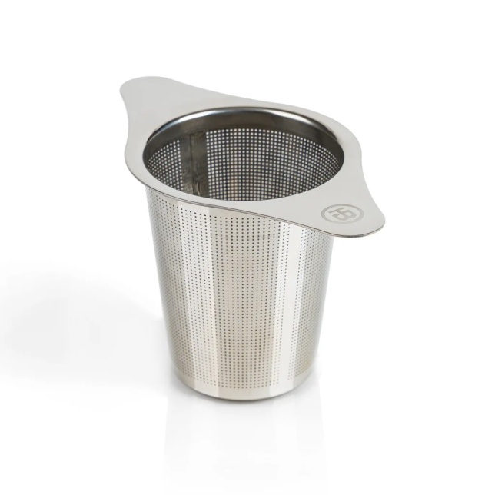

*Quote*: "Simplicity meets functionality with our stainless steel mesh tea balls.”

2.Tea Infuser Baskets

Description: Versatile and convenient, tea infuser baskets fit into most mugs and

teapots. They allow ample room for tea leaves to expand, providing a better

flavor extraction. Typically made from stainless steel or silicone, these baskets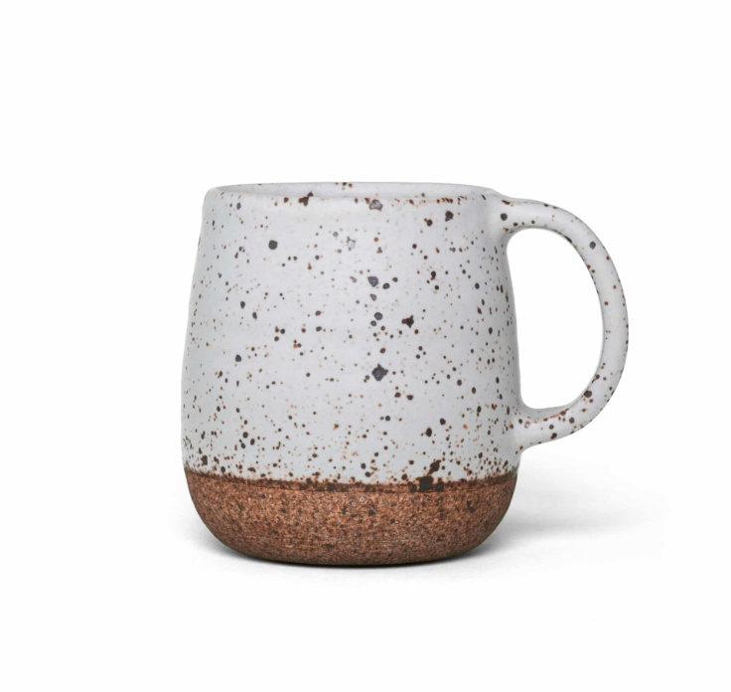

are durable and easy to clean. They are perfect for brewing both single

cups and larger quantities of tea.

Price: $9.99

*Quote*: "Versatile and convenient, our tea infuser baskets are perfect for any cup or teapot.”

**Tea Cups and Mugs**

1.Porcelain Tea Cups

Description: Porcelain tea cups are a staple in any tea lover's collection.

Known for their delicate appearance and high-quality finish, they provide an elegan

t way to enjoy your tea. Porcelain cups retain heat well, ensuring that your tea

stays warm for longer. Available in various designs, from simple to intricate, they suit any occasion.

Price: $12.99 (per set of 2)

*Quote:* "Enjoy elegance and quality with our beautiful porcelain tea cups.”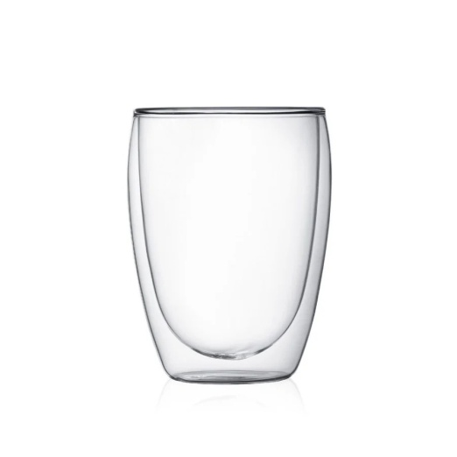

2.Double-Walled Glass Cups

Description: Innovative and stylish, double-walled glass cups offer both aesthetic

appeal and functionality. The double-wall design provides insulation, keeping your

tea hot while the outer surface remains cool to the touch. These cups are perfect

for showcasing the color of your tea and are ideal for both hot and cold beverages.

Price: $14.99 (per set of 2)

Quote: "Showcase your tea's true color with our stylish double-walled glass cups.”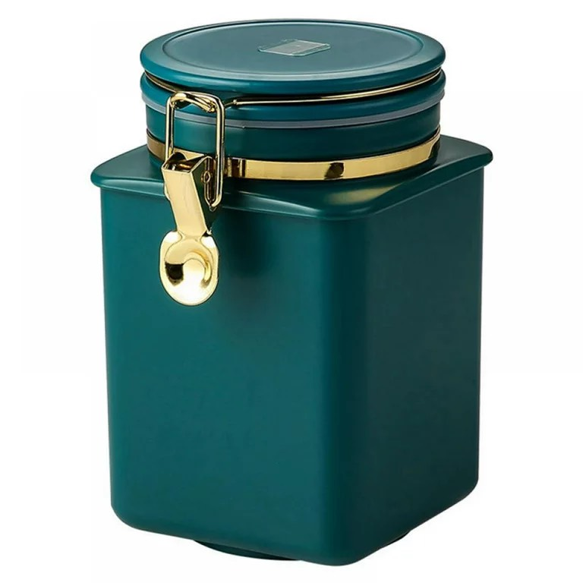

**Tea Canisters and Caddies**

1.Airtight Containers

Description: Preserve the freshness and flavor of your tea with airtight containers.

Designed to keep out moisture and light, these containers are essential for storing

loose leaf tea. They come in various materials, including stainless steel, glass, and

ceramic, and are available in multiple sizes to suit your storage needs.

Price: $19.99

*Quote*: "Keep your tea fresh and flavorful with our airtight containers.”

**Matcha Accessories**

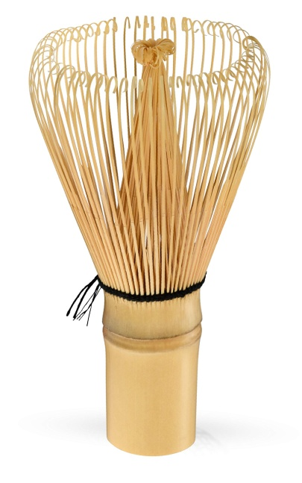

1.Matcha Bowls (Chawan)

Description: Traditional and authentic, matcha bowls, or chawans, are used for

preparing matcha tea. These bowls are crafted to the perfect size and shape for

whisking matcha powder with water. Made from ceramic, they often feature unique

glazes and designs, making each bowl a work of art.

Price: $24.99

Quote: "Experience authentic matcha preparation with our handcrafted matcha bowls.”

2.Bamboo Whisks (Chasen)

Description: Essential for making matcha, bamboo whisks, or chasens, are hand-crafted

tools designed to blend matcha powder smoothly with water. The multiple tines

of the whisk create a creamy, frothy texture. Bamboo whisks are delicate yet durable,

offering an authentic matcha preparation experience.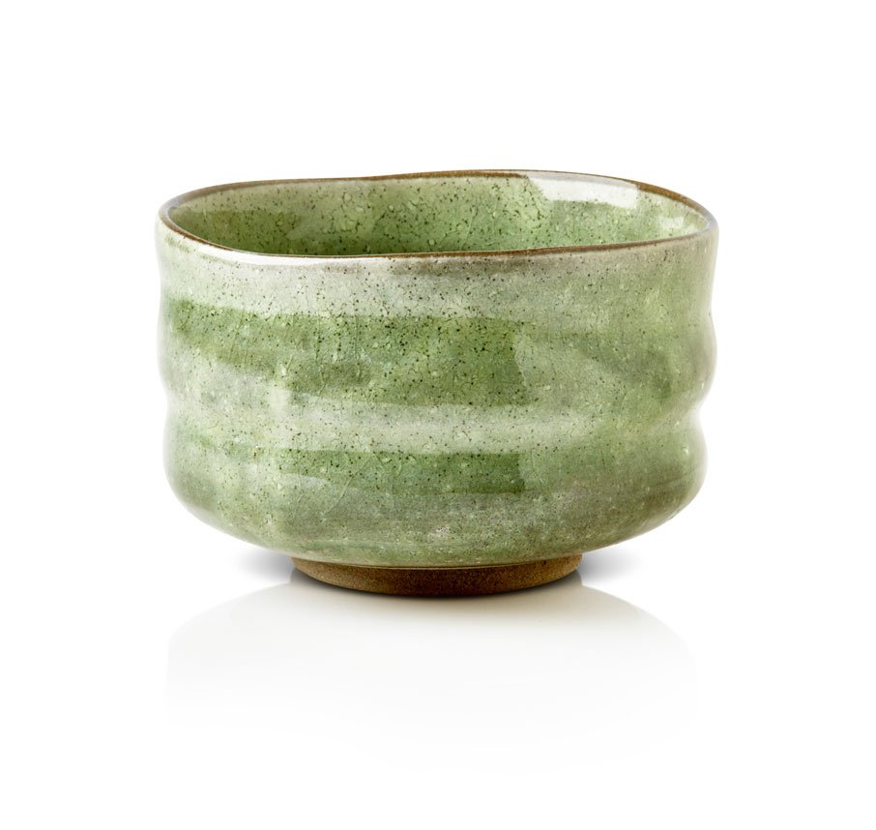

Price: $14.99

*Quote*: "Create the perfect froth for your matcha with our traditional bamboo whisks.”

**Tea Spoons and Scoops**

Wooden Tea Scoops

Description: Beautiful and functional, wooden tea scoops are perfect for

measuring the right amount of tea leaves. Made from various types of wood,

these scoops are often hand-carved and polished to a smooth finish. They add

a rustic charm to your tea preparation routine and are gentle on delicate tea leaves.

Price: $7.99

*Quote:*"Measure your tea with precision and style using our wooden tea scoops.”

**Milk Frothers**

1.Handheld Frothers

Description: Create creamy and frothy milk for your tea lattes with handheld frothers.

These battery-operated devices are easy to use and perfect for frothing milk quickly.

Whether you prefer dairy or plant-based milk, handheld frothers help you achieve the

perfect consistency for your tea

beverages. Compact and portable, they are a convenient addition to any kitchen.

Price: $15.99

Quote: "Achieve barista-quality froth at home with our handheld milk frothers."

: