Assortments by Tea type

BLACK :

**English Breakfast:** A robust blend, perfect for starting your day.

product_name: English Breakfast Tea

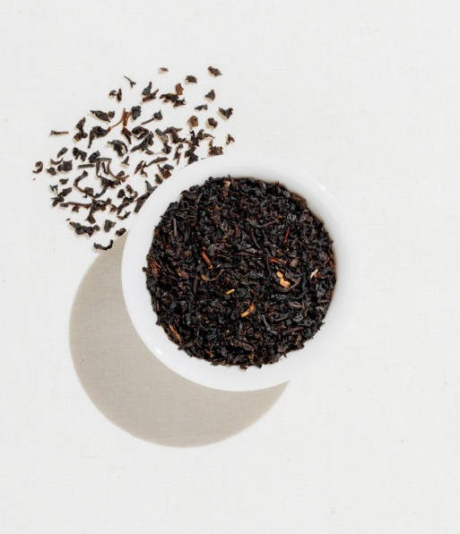description: A robust blend, perfect for starting your day.

quantity: 100g

id_category_1: 1 (Black Tea)

id_category_2: NULL

picture: [Link to English Breakfast Tea Image]

product_link: /products/english-breakfast-tea

is_active: Yes

price: $9.99

.

**Earl Grey:** Fragrant black tea infused with bergamot oil for a citrusy aroma.

product_name: Earl Grey Tea

description: Fragrant black tea infused with bergamot oil for a citrusy aroma.

quantity: 50g

id_category_1: 1 (Black Tea)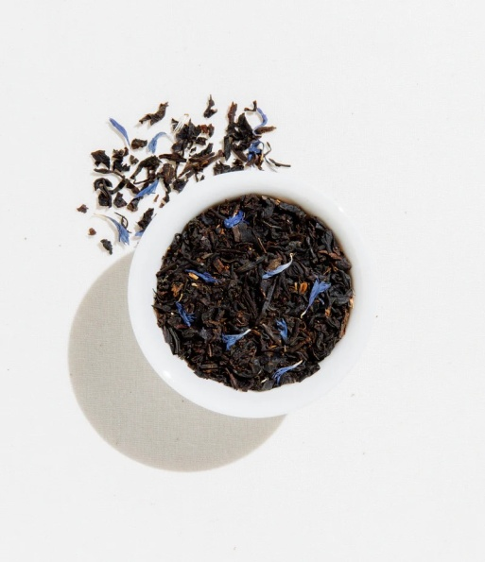

id_category_2: NULL

picture: [Link to Earl Grey Tea Image]

product_link: /products/earl-grey-tea

is_active: Yes

price: $8.99

.

**Assam:** Known for its bold flavor and malty notes, ideal for mornings.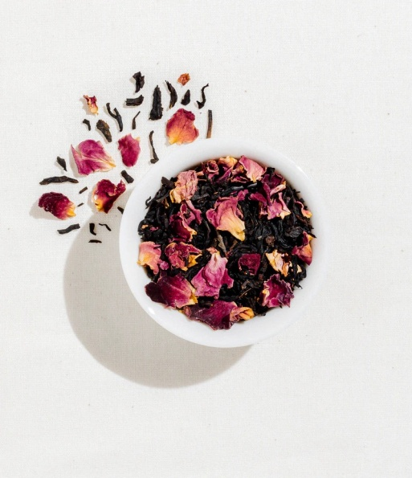

product_name: Assam Black Tea

description: Known for its bold flavor and malty notes, ideal for mornings.

quantity: 50g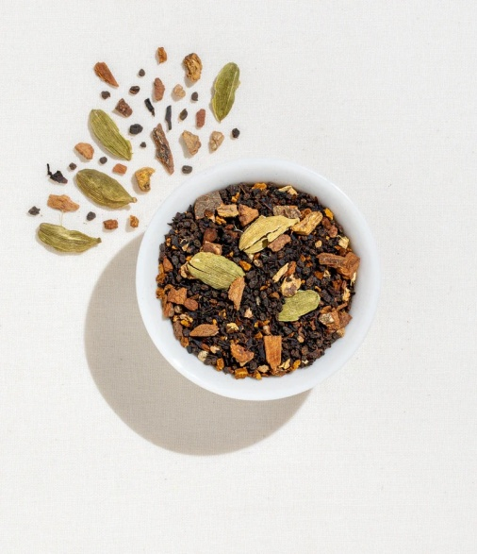

id_category_1: 1 (Black Tea)

id_category_2: NULL

picture: [Link to Assam Black Tea Image]

product_link: /products/assam-black-tea

is_active: Yes

price: $7.99

.

**Vanilla Black Tea:** Smooth black tea with hints of creamy vanila.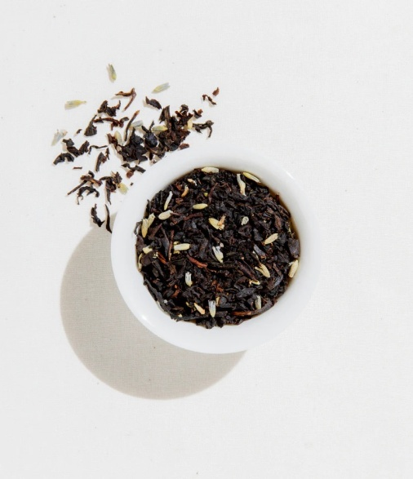

product_name: Vanilla Black Tea

description: Smooth black tea with hints of creamy vanilla.

quantity: 50g

id_category_1: 1 (Black Tea)

id_category_2: NULL

picture: [Link to Vanilla Black Tea Image]

product_link: /products/vanilla-black-tea

is_active: Yes

price: $10.99

.

**Chai**: Spiced black tea with cinnamon, cardamom, cloves, and ginger .

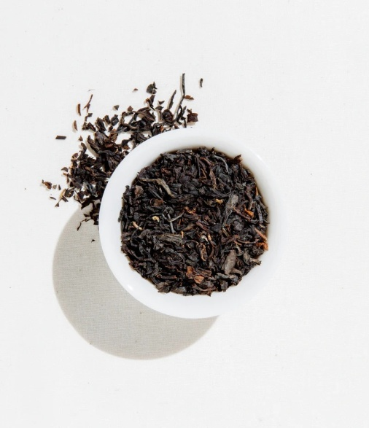

product_name: Chai Black Tea

description: Spiced black tea with cinnamon, cardamom, cloves, and ginger.

quantity: 50g

id_category_1: 1 (Black Tea)

id_category_2: NULL

picture: [Link to Chai Black Tea Image]

product_link: /products/chai-black-tea

is_active: Yes

price: $8.99

.

**Ceylon**: Bright and brisk tea from Sri Lanka, offering a refreshing taste .

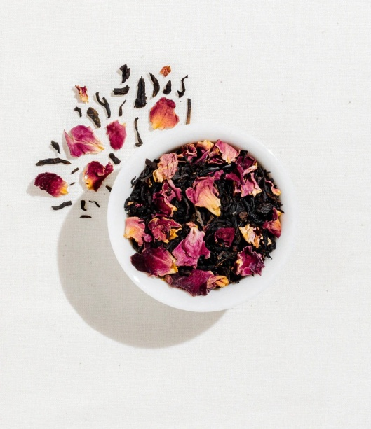

product_name: Ceylon Black Tea

description: Bright and brisk tea from Sri Lanka, offering a refreshing taste.

quantity: 50g

id_category_1: 1 (Black Tea)

id_category_2: NULL

picture: [Link to Ceylon Black Tea Image]

product_link: /products/ceylon-black-tea

is_active: Yes

price: $6.99

.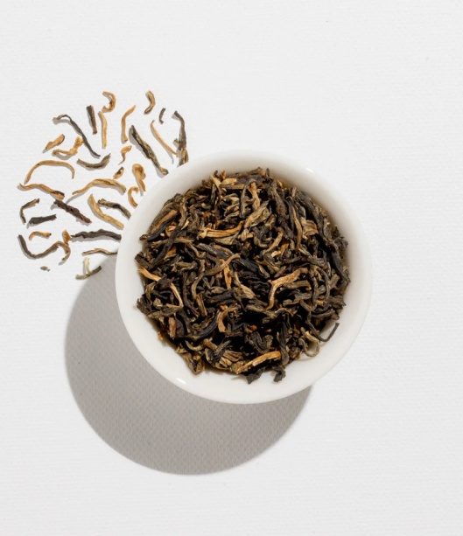

GREEN :

**Sencha:** Traditional Japanese green tea with a refreshing grassy flavor.

product_name: Sencha Green Tea

description: Traditional Japanese green tea with a refreshing grassy flavor.

quantity: 50g

id_category_1: 1 (Green Tea)

id_category_2: NULL

picture: [Link to Sencha Green Tea Image]

product_link: /products/sencha-green-tea

is_active: Yes

price: $9.99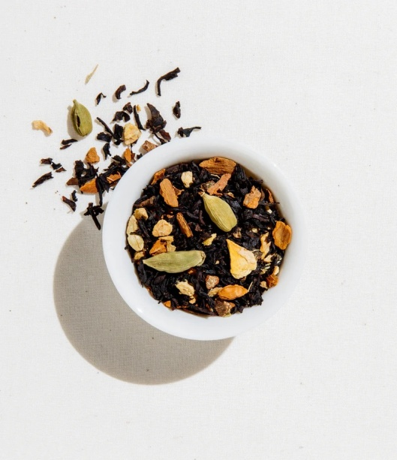

.

**Dragon Well** (Longjing): Famous Chinese green tea known for its smooth taste and chestnut-like

aroma.

product_name: Dragon Well Green Tea (Longjing)

description: Famous Chinese green tea known for its smooth taste and chestnut-like aroma.

quantity: 100g

id_category_1: 1 (Green Tea)

id_category_2: NULL

picture: [Link to Dragon Well Green Tea Image]

product_link: /products/dragon-well-green-tea

is_active: Yes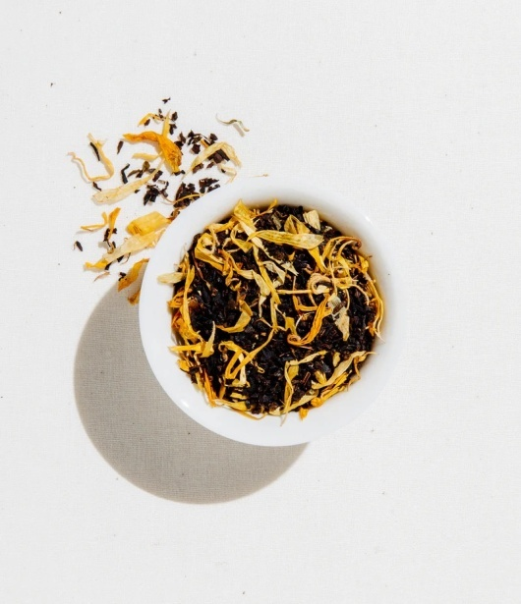

price: $12.99

.

**Matcha:** Finely ground Japanese green tea powder with a vibrant green color and rich umami

flavor.

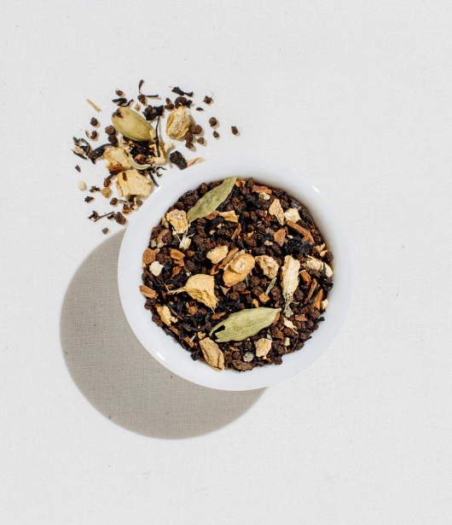

poduct_name: Matcha Green Tea Powder

description: Finely ground Japanese green tea powder with a vibrant green color and rich umami

flavor.

quantity: 30g

id_category_1: 1 (Green Tea)

id_category_2: NULL

picture: [Link to Matcha Green Tea Powder Image]

product_link: /products/matcha-green-tea-powder

is_active: Yes

price: $14.99

.

**Gunpowder**: Rolled Chinese green tea leaves that unfurl during steeping, offering a bold and

smoky taste .

product_name: Gunpowder Green Tea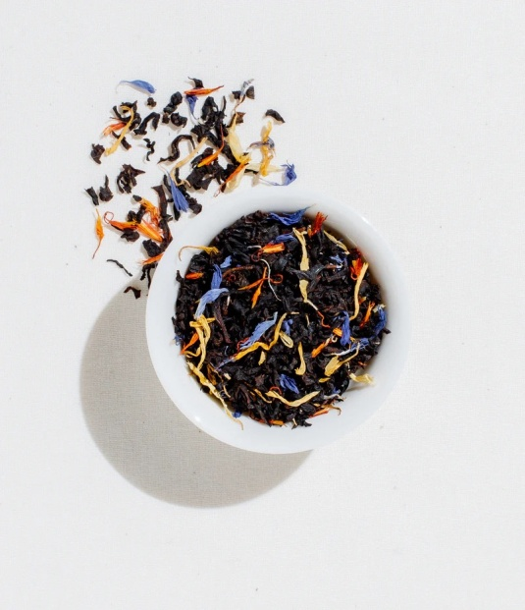

description: Rolled Chinese green tea leaves that unfurl during steeping, offering a bold and

smoky taste.

quantity: 50g

id_category_1: 1 (Green Tea)

id_category_2: NULL

picture: [Link to Gunpowder Green Tea Image]

product_link: /products/gunpowder-green-tea

is_active: Yes

price: $8.99

.

**Genmaicha**: Japanese green tea combined with roasted brown rice for a nutty and toasty flavor

profile.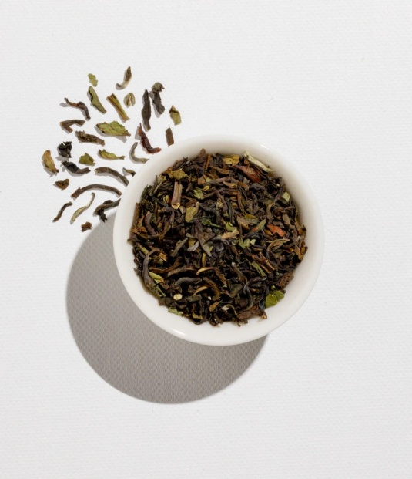

product_name: Genmaicha Green Tea

description: Japanese green tea combined with roasted brown rice for a nutty and toasty flavor

profile.

quantity: 50g

id_category_1: 1 (Green Tea)

id_category_2: NULL

picture: [Link to Genmaicha Green Tea Image]

product_link: /products/genmaicha-green-tea

is_active: Yes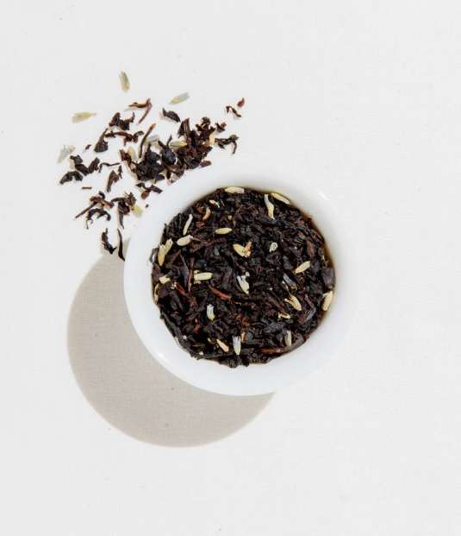

price: $10.99

.

**Jasmine Pearl:** Fragrant green tea scented with jasmine flowers, resulting in a delicate and

floral infusion

product_name: Jasmine Pearl Green Tea

description: Fragrant green tea scented with jasmine flowers, resulting in a delicate and floral

infusion.

quantity: 50g

id_category_1: 1 (Green Tea)

id_category_2: NULL

picture: [Link to Jasmine Pearl Green Tea Image]

product_link: /products/jasmine-pearl-green-tea

is_active: Yes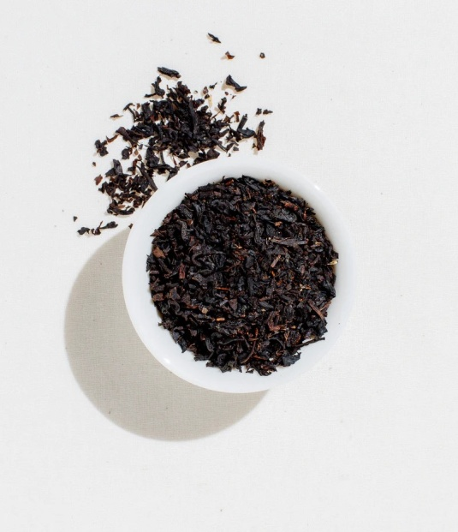

price: $11.99

.

HERBAL:

**Peppermint:** Refreshing herbal tea with a cool minty flavor, known for its digestive benefits

product_name: Peppermint Herbal Tea

description: Refreshing herbal tea with a cool minty flavor, known for its digestive benefits.

quantity: 25 tea bags

id_category_1: 2 (Herbal Tea)

id_category_2: NULL

picture: [Link to Peppermint Herbal Tea Image]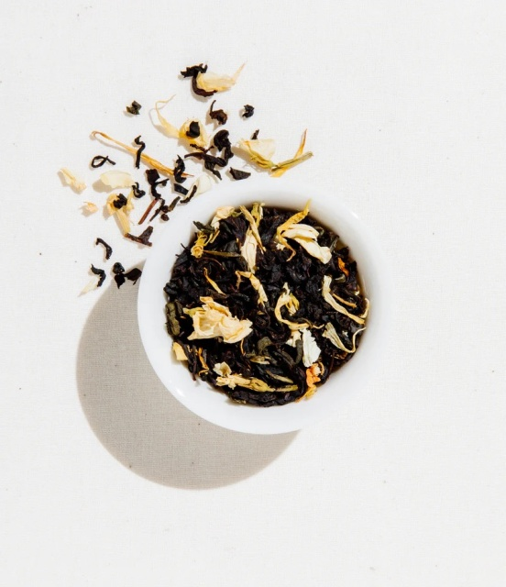

product_link: /products/peppermint-herbal-tea

is_active: Yes

price: $7.99

.

**Chamomile:** Calming herbal tea with a mild floral taste, often enjoyed for its relaxation properties .

product_name: Chamomile Herbal Tea

description: Calming herbal tea with a mild floral taste, often enjoyed for its relaxation properties.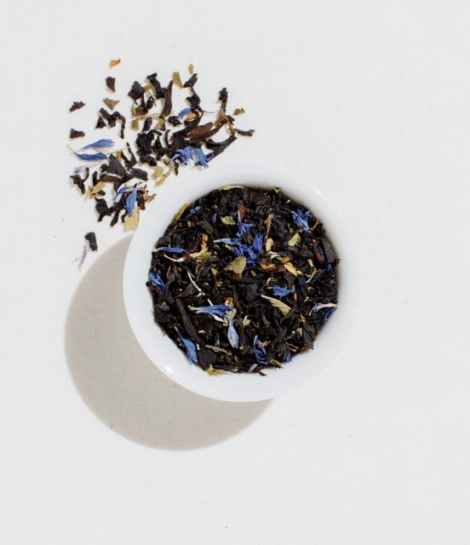

quantity: 30 tea bags

id_category_1: 2 (Herbal Tea)

id_category_2: NULL

picture: [Link to Chamomile Herbal Tea Image]

product_link: /products/chamomile-herbal-tea

is_active: Yes

price: $6.99

.

**Lavender:** Aromatic herbal tea with soothing properties and a floral aroma .

product_name: Lavender Herbal Tea

description: Aromatic herbal tea with soothing properties and a floral aroma.

quantity: 50g

id_category_1: 2 (Herbal Tea)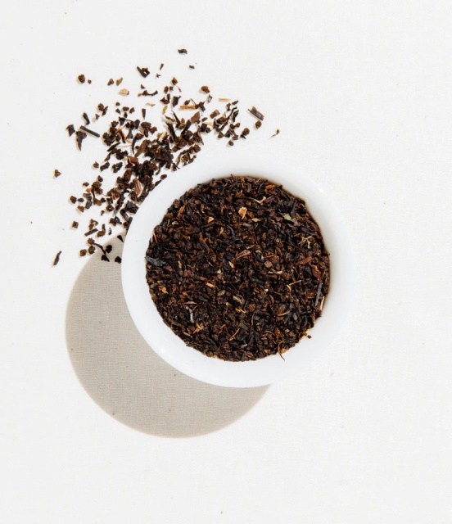

id_category_2: NULL

picture: [Link to Lavender Herbal Tea Image]

product_link: /products/lavender-herbal-tea

is_active: Yes

price: $9.99

.

**Ginger Turmeric:** Spicy and warming herbal blend with anti-inflammatory properties

product_name: Ginger Turmeric Herbal Tea

description: Spicy and warming herbal blend with anti-inflammatory properties.

quantity: 20 tea bags

id_category_1: 2 (Herbal Tea)

id_category_2: NULL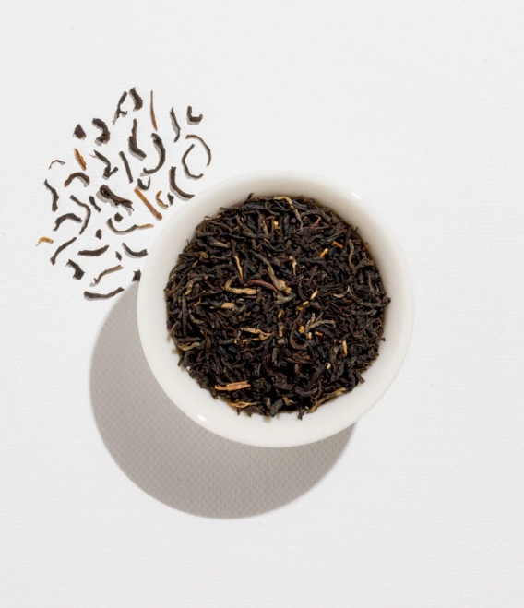

picture: [Link to Ginger Turmeric Herbal Tea Image]

product_link: /products/ginger-turmeric-herbal-tea

is_active: Yes

price: $8.99

**Hibiscus:** Tart and tangy herbal tea with a deep red color, rich in antioxidants.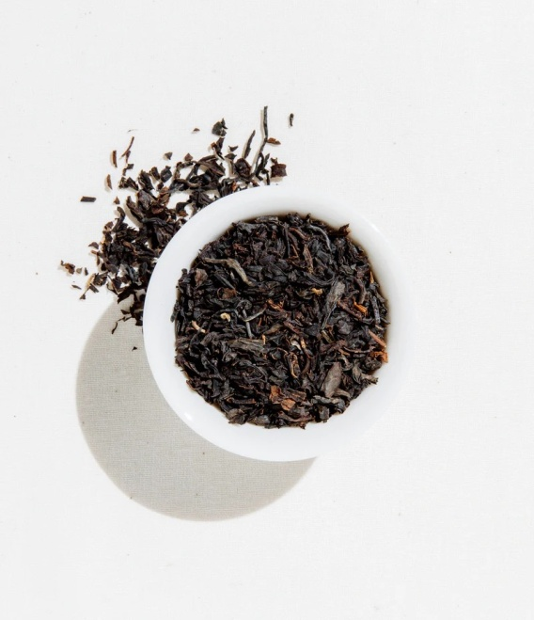

product_name: Hibiscus Herbal Tea

description: Tart and tangy herbal tea with a deep red color, rich in antioxidants.

quantity: 100g

id_category_1: 2 (Herbal Tea)

id_category_2: NULL

picture: [Link to Hibiscus Herbal Tea Image]

product_link: /products/hibiscus-herbal-tea

is_active: Yes

price: $11.99

.

**Lemon Balm**: Citrusy herbal tea with a subtle lemon flavor, reputed for its calming effects on

the mind.

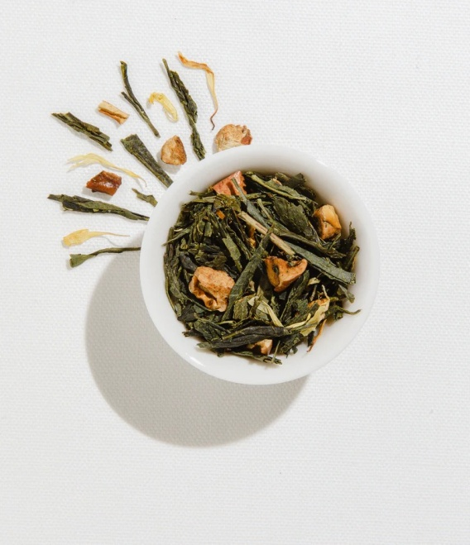

product_name: Lemon Balm Herbal Tea

description: Citrusy herbal tea with a subtle lemon flavor, reputed for its calming effects on the

mind.

quantity: 50g

id_category_1: 2 (Herbal Tea)

id_category_2: NULL

picture: [Link to Lemon Balm Herbal Tea Image]

product_link: /products/lemon-balm-herbal-tea

is_active: Yes

price: $10.99

.

OOLONG:

**Tie Guan Yin** (Iron Goddess): Fragrant and floral oolong tea with a smooth and creamy texture.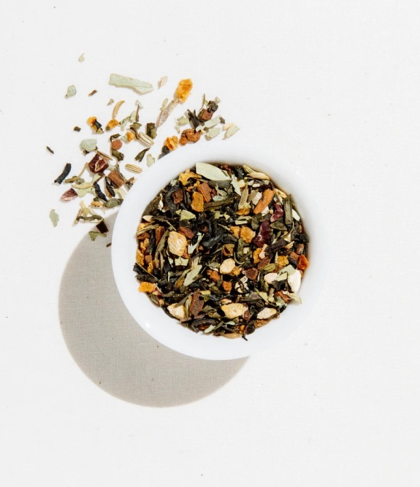

product_name: Tie Guan Yin Oolong Tea

description: Fragrant and floral oolong tea with a smooth and creamy texture.

quantity: 50g

id_category_1: 4 (Oolong Tea)

id_category_2: NULL

picture: [Link to Tie Guan Yin Oolong Tea Image]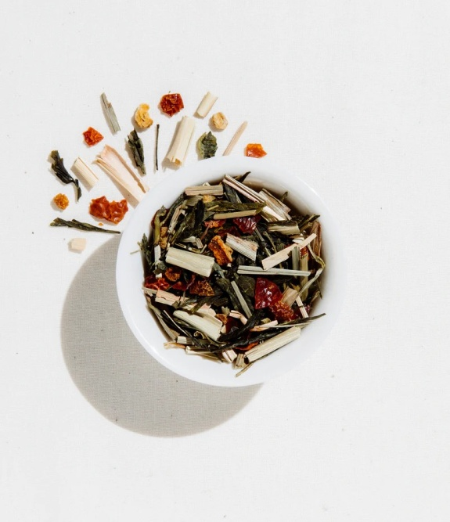

product_link: /products/tie-guan-yin-oolong-tea

is_active: Yes

price: $13.99

.

**Da Hong Pao** (Big Red Robe): Famous Chinese oolong with a complex flavor profile and hints

of roasted nuts.

product_name: Da Hong Pao Oolong Tea

description: Famous Chinese oolong with a complex flavor profile and hints of roasted nuts.

quantity: 100g

id_category_1: 4 (Oolong Tea)

id_category_2: NULL

picture: [Link to Da Hong Pao Oolong Tea Image]

product_link: /products/da-hong-pao-oolong-tea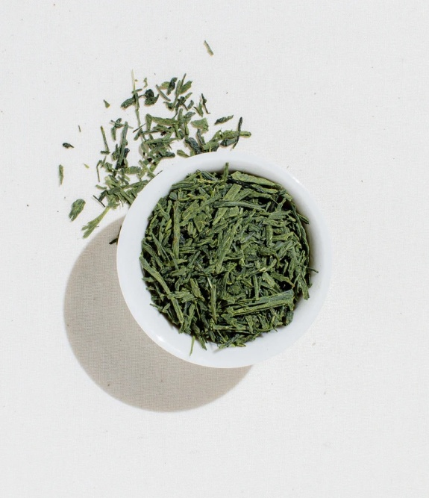

is_active: Yes

price: $19.99

.

**Dong Ding:** Taiwanese oolong tea with a balanced taste and lingering sweetness .

product_name: Dong Ding Oolong Tea

description: Taiwanese oolong tea with a balanced taste and lingering sweetness.

quantity: 50g

id_category_1: 4 (Oolong Tea)

id_category_2: NULL

picture: [Link to Dong Ding Oolong Tea Image]

product_link: /products/dong-ding-oolong-tea

is_active: Yes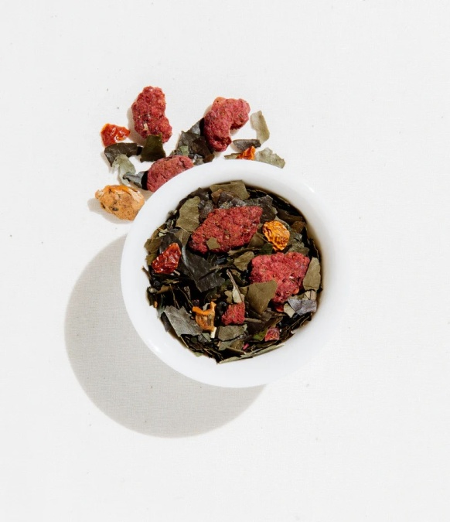

price: $11.99

.

**Formosa Oolong**: Lightly oxidized oolong from Taiwan, offering a floral and fruity aroma.

product_name: Formosa Oolong Tea

description: Lightly oxidized oolong from Taiwan, offering a floral and fruity aroma.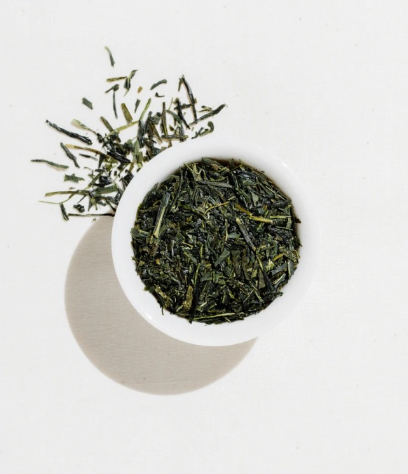

quantity: 50g

id_category_1: 4 (Oolong Tea)

id_category_2: NULL

picture: [Link to Formosa Oolong Tea Image]

product_link: /products/formosa-oolong-tea

is_active: Yes

price: $14.99

.

**Phoenix Dan Cong**: Single-origin oolong with diverse flavor profiles ranging from fruity to floral

notes.

product_name: Phoenix Dan Cong Oolong Tea

description: Single-origin oolong with diverse flavor profiles ranging from fruity to floral notes.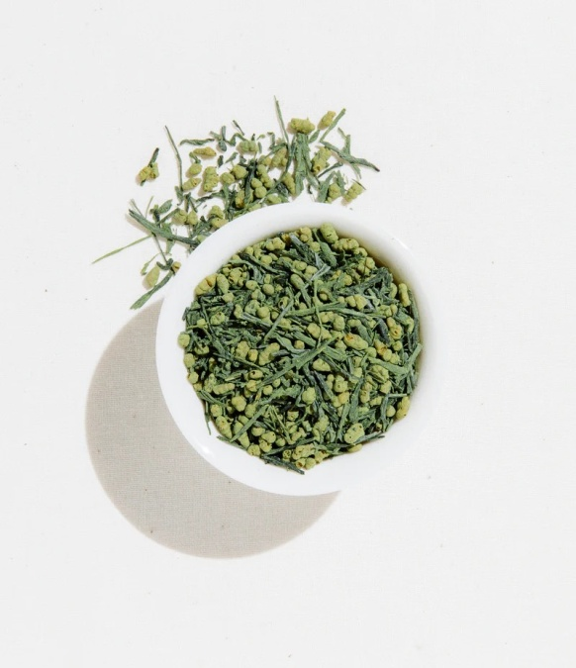

quantity: 50g

id_category_1: 4 (Oolong Tea)

id_category_2: NULL

picture: [Link to Phoenix Dan Cong Oolong Tea Image]

product_link: /products/phoenix-dan-cong-oolong-tea

is_active: Yes

price: $16.99

.

WHITE:

**Silver Needle:** Premium white tea made from young tea buds, known for its delicate f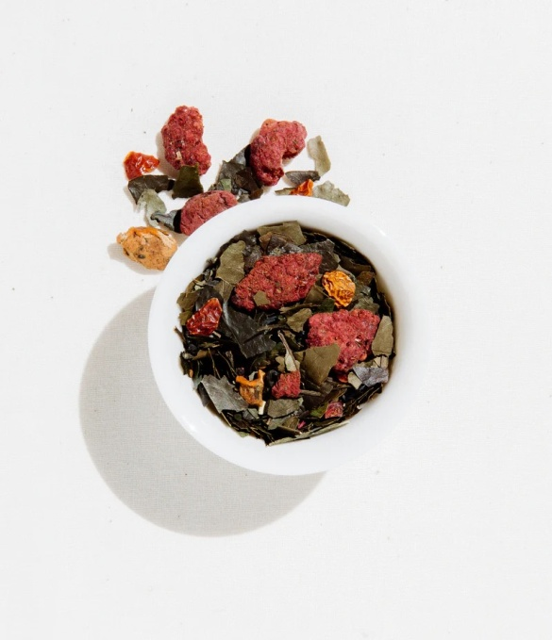

lavor and silvery appearance

product_name: English Breakfast Tea

description: A robust blend, perfect for starting your day.

quantity: 100g

id_category_1: 1 (Black Tea)

id_category_2: NULL

picture: [Link to English Breakfast Tea Image]

product_link: /products/english-breakfast-tea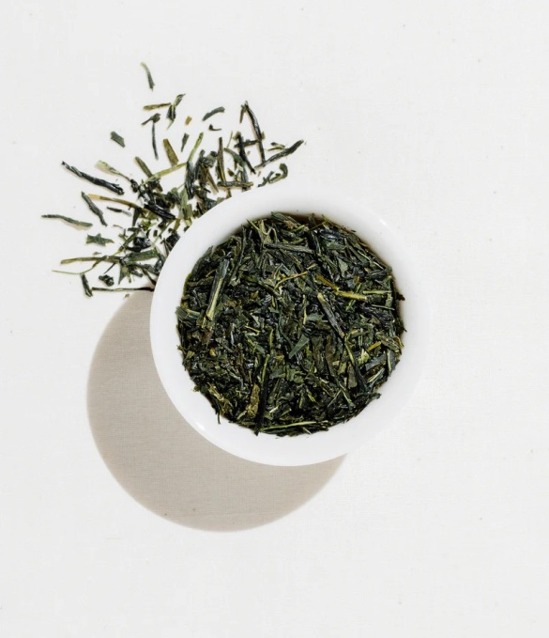

is_active: Yes

price: $9.99

.

**White Peony (Bai Mudan):** Classic white tea with a mix of young buds and leaves, offering a

mellow

and slightly sweet taste .

product_name: White Peony (Bai Mudan) White Tea

description: Classic white tea with a mix of young buds and leaves, offering a mellow and

slightly

sweet taste.

quantity: 50g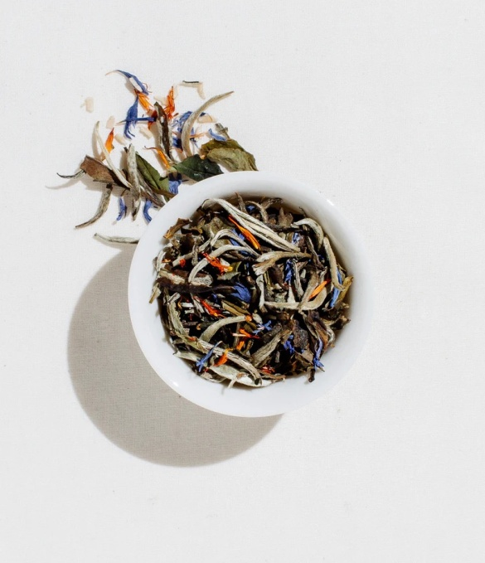

id_category_1: 6 (White Tea)

id_category_2: NULL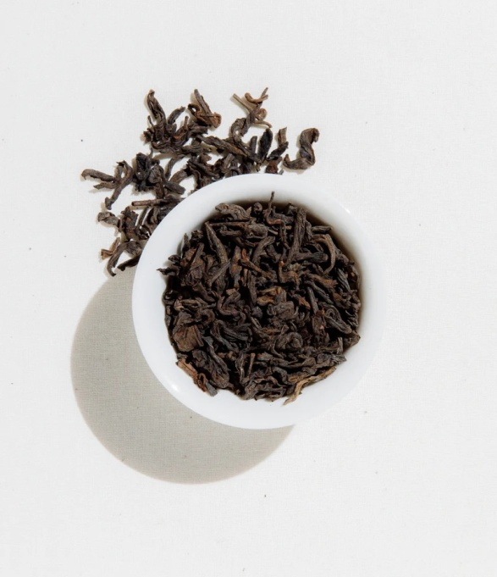

picture: [Link to White Peony White Tea Image]

product_link: /products/white-peony-white-tea

is_active: Yes

price: $16.99

.

**Darjeeling White:** Rare white tea from the Darjeeling region, characterized by floral and fruity

notes.

product_name: Darjeeling White Tea

description: Rare white tea from the Darjeeling region, characterized by floral and fruity notes.

quantity: 50g

id_category_1: 6 (White Tea)

id_category_2: NULL

picture: [Link to Darjeeling White Tea Image]

product_link: /products/darjeeling-white-tea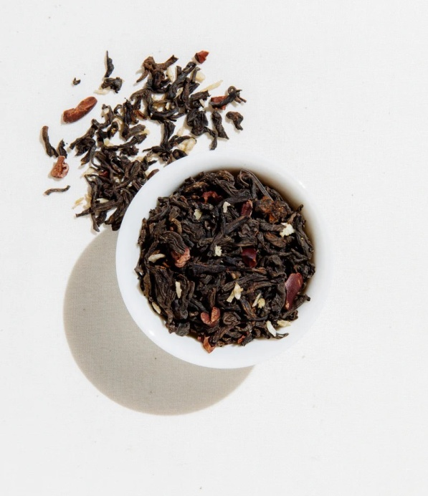

is_active: Yes

price: $22.99

.

**Pai Mu Tan (White Peony)**: Traditional Chinese white tea with a subtle flavor and light golden l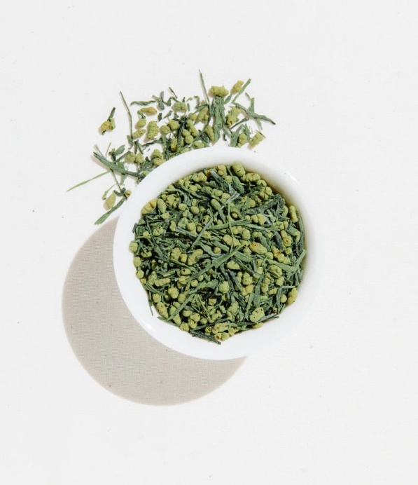

iquor

.product_name: Pai Mu Tan (White Peony) White Tea

description: Traditional Chinese white tea with a subtle flavor and light golden liquor.

quantity: 50g

id_category_1: 6 (White Tea)

id_category_2: NULL

picture: [Link to Pai Mu Tan White Tea Image]

product_link: /products/pai-mu-tan-white-tea

is_active: Yes

price: $14.99

.

**Shou Mei:** Mild and earthy white tea made from more mature leaves, providing a smooth and

woody taste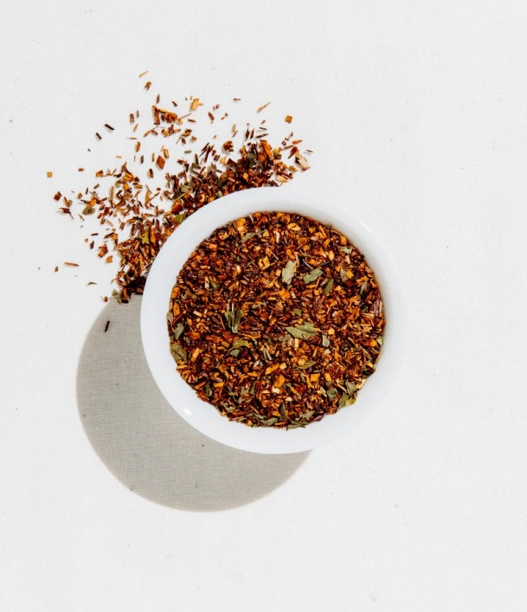

.product_name: Shou Mei White Tea

description: Mild and earthy white tea made from more mature leaves, providing a smooth and

woody taste.

quantity: 50g

id_category_1: 6 (White Tea)

id_category_2: NULL

picture: [Link to Shou Mei White Tea Image]

product_link: /products/shou-mei-white-tea

is_active: Yes

price: $12.99

.

**Ceylon White:** Sri Lankan white tea with a delicate flavor and light body, perfect for gentle

sipping .

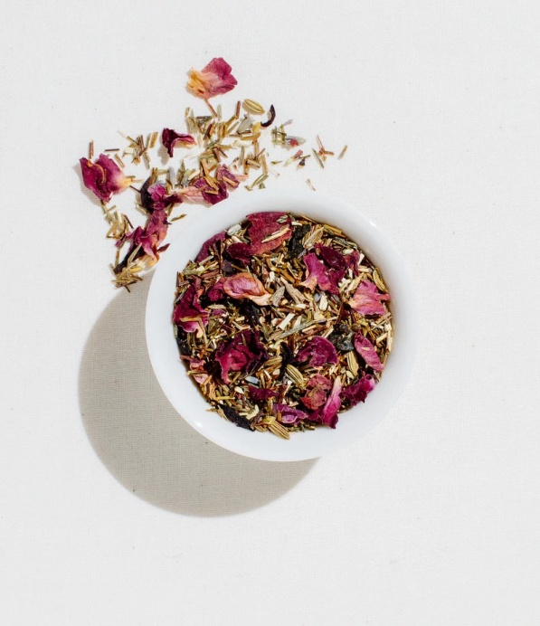

product_name: Ceylon White Tea

description: Sri Lankan white tea with a delicate flavor and light body, perfect for gentle

sipping.

quantity: 50g

id_category_1: 6 (White Tea)

id_category_2: NULL

picture: [Link to Ceylon White Tea Image]

product_link: /products/ceylon-white-tea

is_active: Yes

price: $17.99

.

.