API table

*Introductory instructions to application presenting data from JSON, contained in self-made table. The table is based on technologies such as JavaScript, HTML5, CSS3*

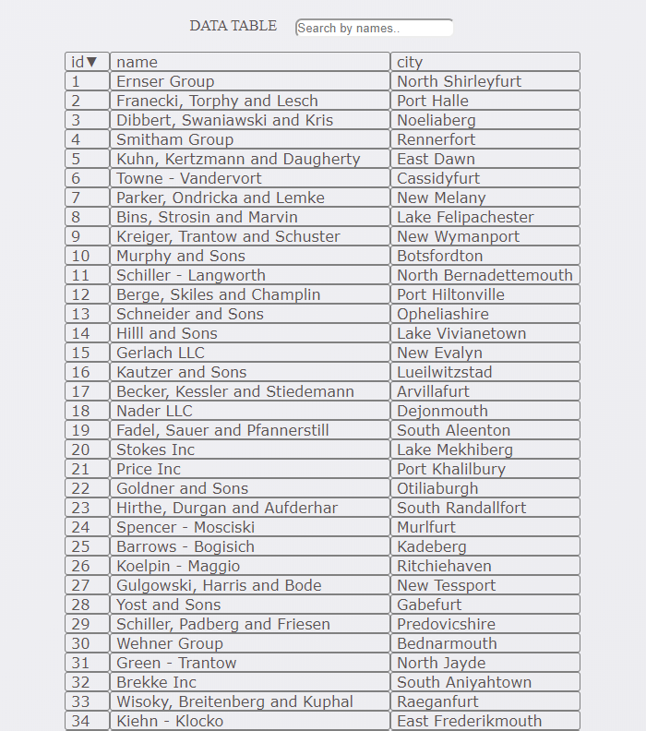

Table of Contents

Introduction**1**

Description of functionality **4**

Search function **4**

Sort function **4**

Summary **4**

# Introduction

The API table was created to carry out the recruitment task.

It contains columns with id, name and city. The sorting algorithm was implemented based on comparing numerical or text values. Search by name was used also.

The application is based on technologies such as:

- HTML

- CSS,

- JavaScript.

Visual effects in CSS have been supported by Flexbox.

# Description of functionality

The API consists of a search field as well as a table presenting data from the JSON form.

# Search function

The search algorithm works only with the "name" column. In the search box, just type a part of the name you are looking for, to filter the results.



# Sort function

Each column is sorted by pressing the column title. First, increasing sorting is performed. Then, after the secondary click, descending sorting is performed. The arrow next to the title indicates the sorting direction.

• Sorting numbers

Uses an algorithm that compares numeric values.

    Sorting Numbers: function (a, b) {// function for sorting numbers

        return parseInt (a)> parseInt (b);

    },

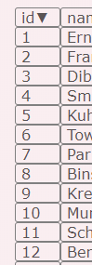 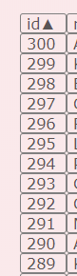 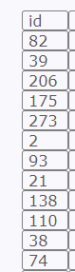

• Text sorting

The algorithm consists in comparing text values ​​based on the ASCI table.

SortTextASCI: function (a, b) {// text sort function

return a> b;

}

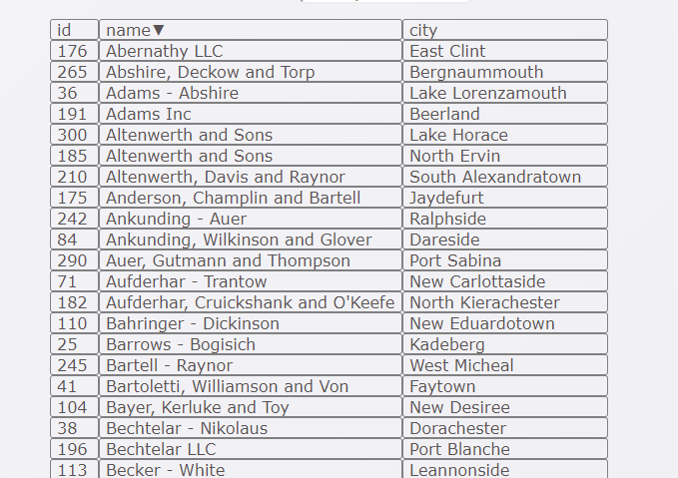

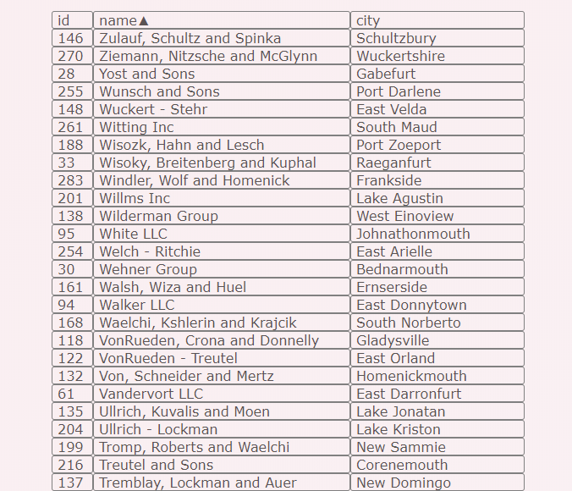

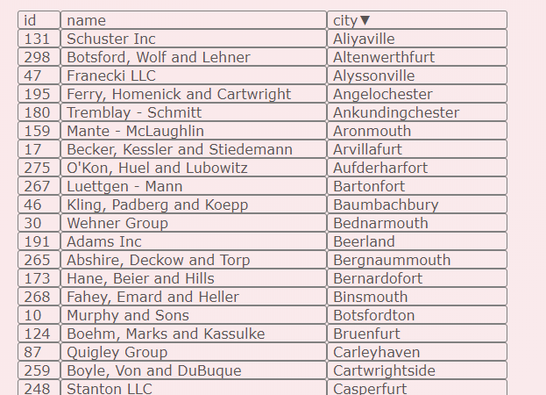

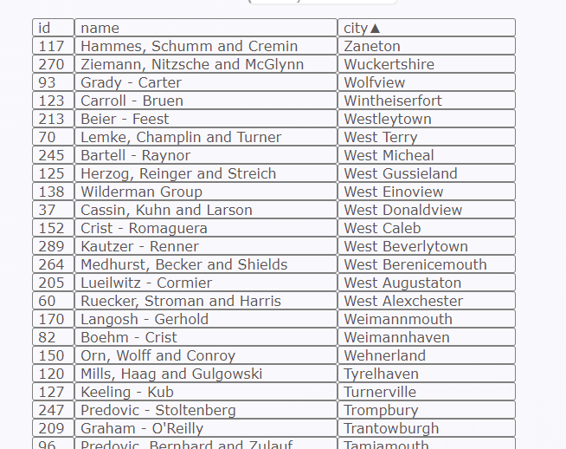

# Summary

The table retrieves data from the „<https://recruitment.hal.skygate.io/companies>” page in JSON format.