CSE373 Assignment-3
Determination of longest common subsequence (LCS) problem

// Algorithm of LCS
// LCS
Let the input sequences be s1[0..m-1] and s2[0..n-1] of lengths m and n respectively. And let lcsTable(s1[0..m-1], s2[0..n-1]) be the length of LCS of the two sequences s1 and s2. Following is the recursive definition of lcsTable (s1[0..m-1], s2[0..n-1]).
If last characters of both sequences match (or s1[m-1] == s2[n-1]) then
lcsTable (s1[0..m-1], s2[0..n-1]) = 1 + lcsTable (s1[0..m-1], s2[0..n-1])
If last characters of both sequences do not match (or X[m-1] != Y[n-1]) then
lcsTable (s1[0..m-1], s2[0..n-1]) = maxValue( lcsTable (s1[0..m-2], s2[0..n-1]), lcsTable(s1[0..m-1], s2[0..n-2]) )
// Print LCS and Length
Following is detailed algorithm to print the LCS. It uses the same 2D table L[][].
1) Construct lcsTable [m+1][n+1] using the steps discussed in previous steps.
2) The value lcsTable[m][n] contains length of LCS. Create a character array lcsStr[] of length equal to the length of lcsIndex plus 1 and (one extra to store \0).
2) Traverse the 2D array starting from L[m][n]. Do following for every cell lcsTable[p][q]
- If characters (in s1 and s2) corresponding to lcsTable[p][q] are same (Or s1[i-1] == s2[j-1]), then include this character as part of LCS.
- Else compare values of lcsTable[p-1][q] and lcsTable[p][q-1] and go in direction of greater value.

// Code of LCS
// CSE373 Assignment-3
// Longest Common Subsequence algorithm

#include <stdio.h>
#include <stdlib.h>
#include <string.h>

int maxValue(int n1, int n2){
int result;
result = (n1 > n2) ? n1 : n2;

return result;
}

void lcs(char *s1, char *s2, int m, int n){
// define lcs table
int lcsTable[m + 1][n + 1];

/*
// define tracer table;
char tracerTable[m + 1][n + 1];
*/

// index variable to traverse row and column of lcs table
int i, j;

/*
// base case - if one of the subsequence element is 0
// then set the value of that element 0
for(i = 0; i <= m; i++) {
lcsTable[i][0] = 0;
}
for(j = 0; j <= n; j++) {
lcsTable[0][0] = 0;
}
*/

// fill the lcs table
// c means cross, l means left, u means upper
// elements in lcs table
for(i = 0; i <= m; i++){
for(j = 0; j <= n; j++){
if(i == 0 || j == 0){
lcsTable[i][j] = 0;
}
else if(s1[i - 1] == s2[j - 1]){
lcsTable[i][j] = lcsTable[i - 1][j - 1] + 1;
//tracerTable[i][j] = 'c';
}
/*
else if(lcsTable[i - 1][j] >= lcsTable[i][j - 1]){
lcsTable[i][j] = lcsTable[i - 1][j];
tracerTable[i][j] = 'u';
}
else if(lcsTable[i - 1][j] <= lcsTable[i][j - 1]){
lcsTable[i][j] = lcsTable[i][j - 1];
tracerTable[i][j] = 'l';
}
*/
else{
lcsTable[i][j] = maxValue(lcsTable[i - 1][j], lcsTable[i][j - 1]);
}
}
}

// Index of LCS length
int lcsIndex = lcsTable[m][n];

// create a char array to store lcs string
char lcsStr[lcsIndex + 1];
lcsStr[lcsIndex] = '\0';

// here, p = i, q = j
int p = m, q = n;
while(p > 0 && q > 0){
if(s1[p - 1] == s2[q - 1]){
lcsStr[lcsIndex - 1] = s1[p - 1];
p--;
q--;
lcsIndex--;
}
else if(lcsTable[p - 1][j] > lcsTable[i][q - 1]){
p--;
}
else{
q--;
}
}

// store the lcs length to print
int lcsLength = strlen(lcsStr);
//printf("\nLCS Length: %d\n", lcsLength);

// print LCS
printf("\nLCS = %s, length = %d\n", lcsStr, lcsLength);

}

int main()
{
printf("LCS Algorithm\n");

// define variables for string sequence input
char str1[15], str2[15];

// take 2 string sequence input
printf("\nEnter first string sequence: ");
scanf("%s", str1);
printf("\nEnter Second string sequence: ");
scanf("%s", str2);

// find the length of str1 and str2
int str1Length, str2Length;

str1Length = strlen(str1);
str2Length = strlen(str2);

// pass the str1 and str2 into lsc() function
// to find out the Longest Common Subsequence
lcs(str1, str2, str1Length, str2Length);

return 0;
}

// Screenshot of Code
// ss1
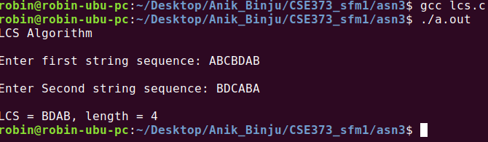

// ss2
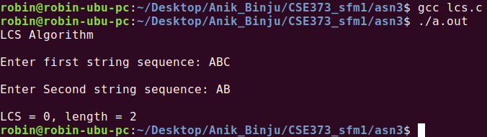

// ss3
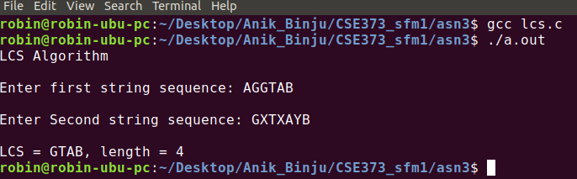

// Time complexity
Time Complexity of the above implementation is O(mn) .

