**User Interface design (MOC)**

When we run the application, the following window will appear

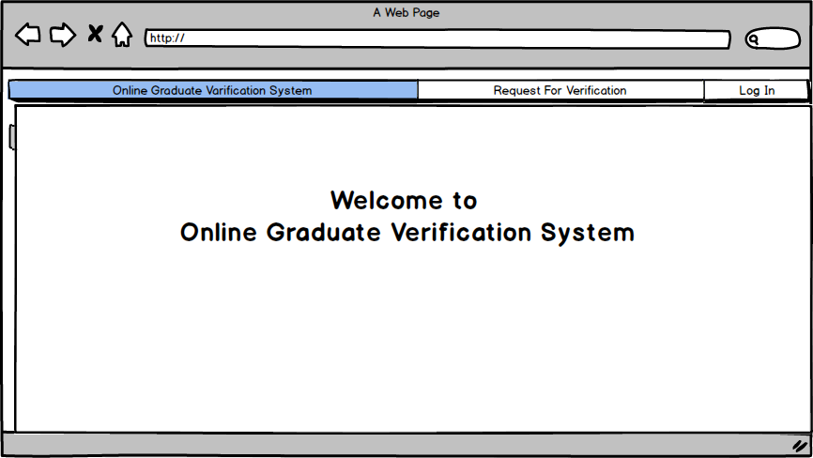

Fig: Start window

After Clicking Log In button the log in window will appear,

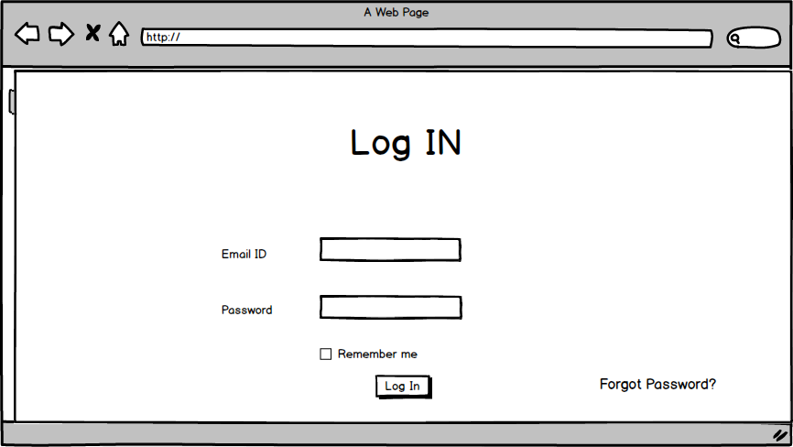

Fig: Log In window

When there is need to request verification for any student the user click the “Request for Verification” button and then will show this

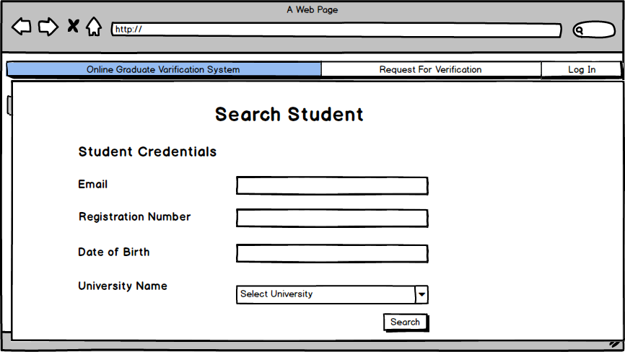

Fig: Search Student window

After successful log in as System Admin the following window will appear

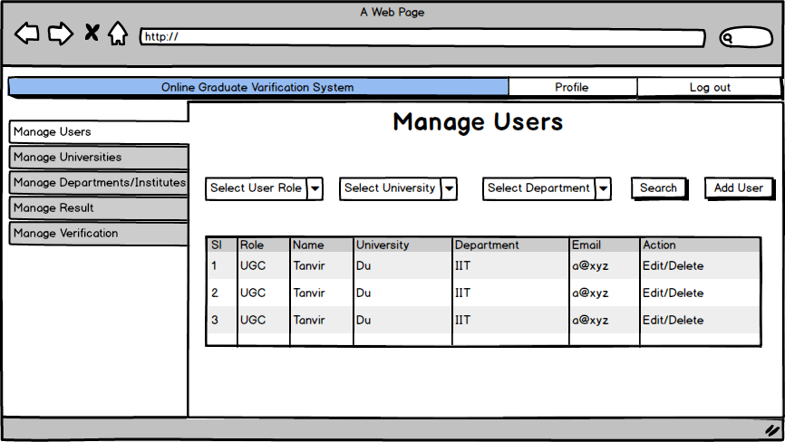

Fig: System Admin dashboard window

By clicking the “Add User” system admin can add users which is like below

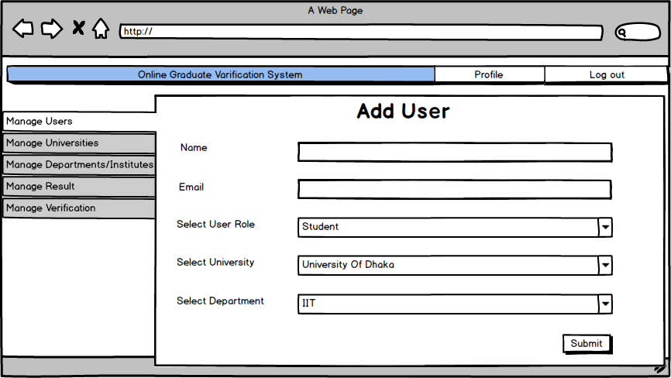

Fig: Add User window

After log in as UGC Staff the dashboard will be like below

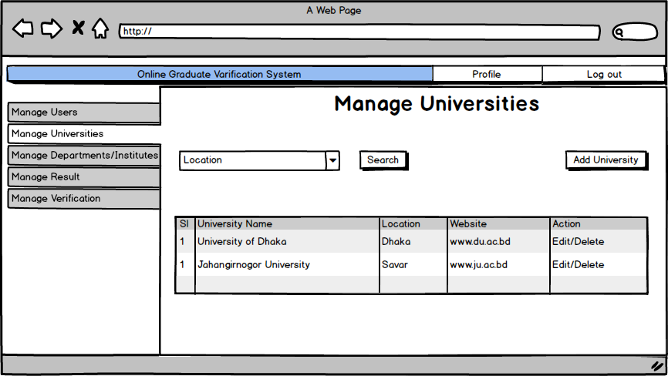

Fig: UGC Staff dashboard

UGC Staff can add universities by clicking “Add University” button

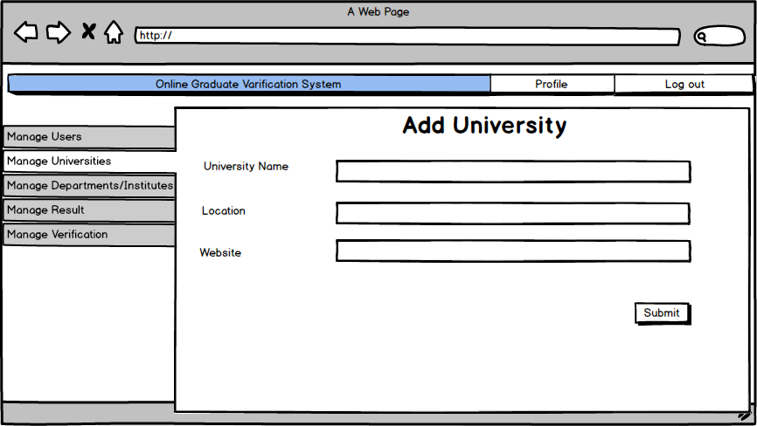

Fig: Add University window

After Log In as University Register, the register can manage, add courses

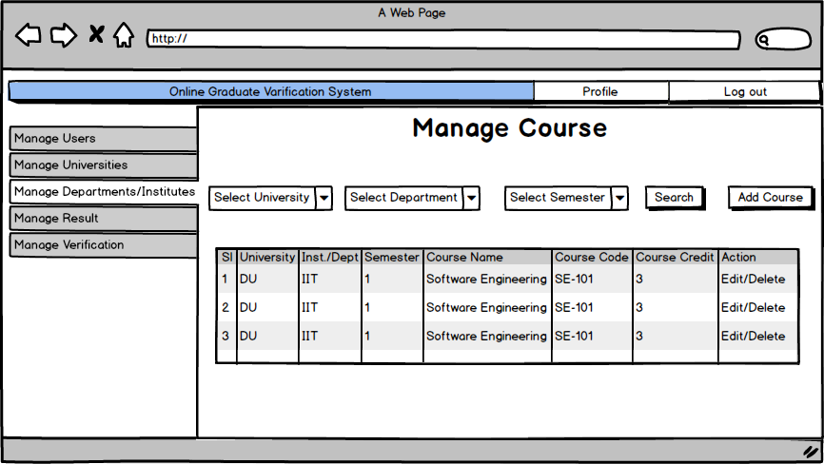

Fig: University Register dashboard

He/She can add courses buy clicking “Add Course” button

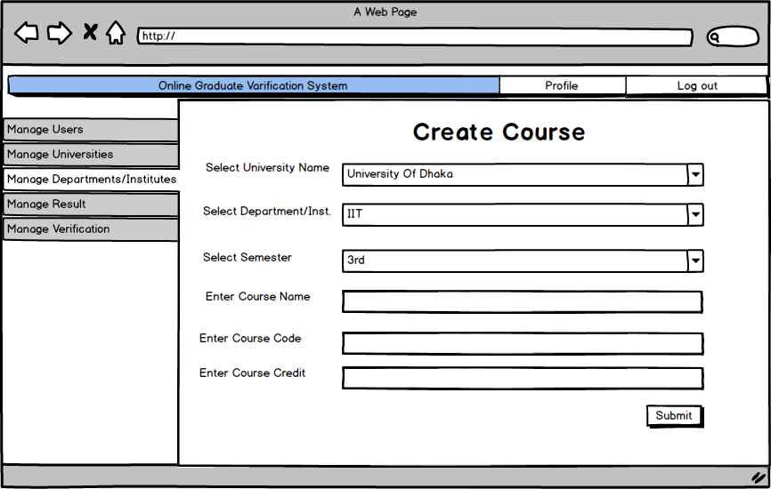

Fig: Add Course window

Register can also verify the request for any graduate student information and generate the report

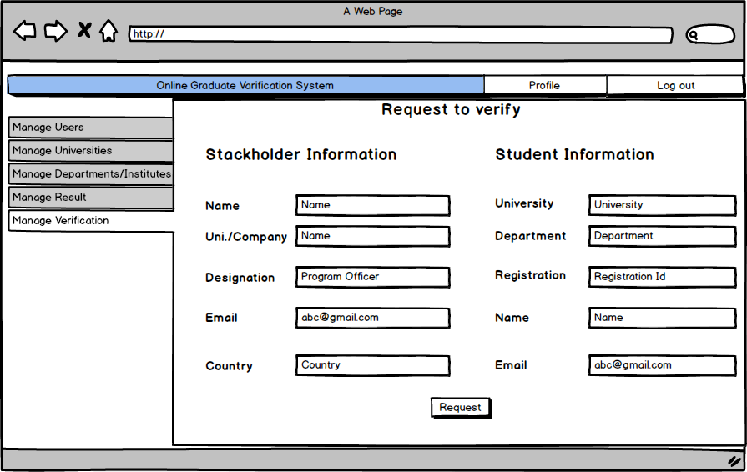

Fig: Verification window

After log in as program officer, he/she can add the result

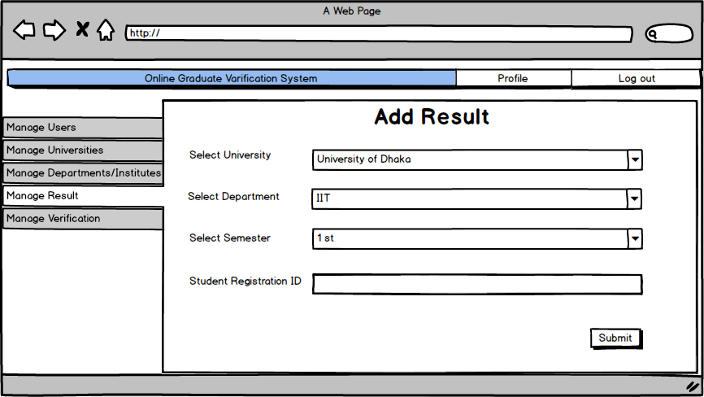

Fig: Add Result window

After successful log in as a student he/she can view in his/her dashboard with the options of view notifications and online payment

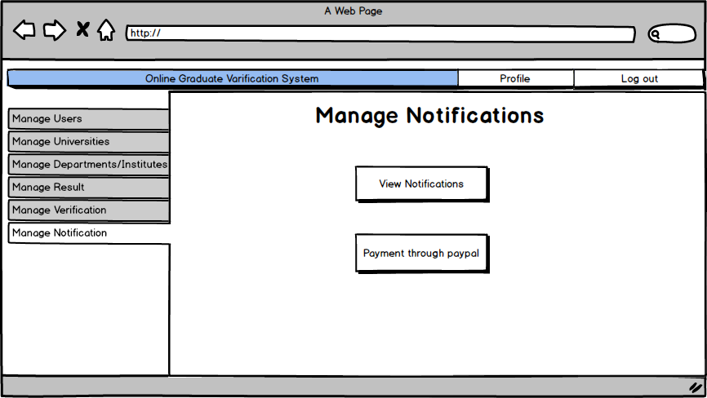

Fig: Student dashboard