Student ID: 00623376
Design Patterns
29/04/25
CRN – 52789

Contents
Introduction 2
Software Design 2
Model 2
View 2
Controller 2
Command Pattern 2
Factory Pattern 3
Application of Design Patterns and Key Code Elements 3
Class Design and UML 4
Reflection 5

Introduction
This report shows the design, structure and evaluation of the Solar System Application. Explanation will be given to each design pattern used and key designs to them. At the end is an evaluation of the system.

Software Design
The solar system application follows a Model-View-Controller (MVC) structure while implementing a command and factory design pattern. The command and factory patterns were also used to support scalability and encapsulation

Model
The model has the core data for each object and is the base for the controller and view to use. This includes planet, rocket and SolarSystemModel. Both the planet and rocket file include all the attributes of each object like name, colour, position and movement. The SolarSystemModel file uses the planet models made from the planet factory and combines them together to be used later.

View
The view handles the UI and visuals of the system. In this file is the SolarSystemView, SpeedLabel and ScoreLabel. The SolarSystemView was used to display all the graphics used like the planet, rocket and sun. The 2 labels were made to display the speed and score to the user. This was separate to the View file was for improved readability and reusability.

Controller
The controller manages all the functions for the models and manages all the interactions between the model and the view. This section only has SolarSystemController. This file handled all the animations, collision detection from the rocket and planets and allowed the users buttons commands to be read.

Command Pattern
The command pattern was used to have each user action as separate classes. This was done by creating a main command interface with a execute method and having the pause, resume, speed up and slow down classes implement. This allowed for easy addition of commands in the future and clear separation that can be seen in the UI. This makes the system and code cleaner.

Factory Pattern
The factory pattern was used to create all the different planet objects without repeated code. This PlanetFactory class implements the PlanetFactoryIF interface to create planets that could be named. If new alien planets were to be created it can be done without affecting the creations of these familiar ones. The factory pattern implements encapsulation and cleans up the code of the system.

Application of Design Patterns and Key Code Elements
Model - SolarSystemController
planets.add(factory.createPlanet(name));
Adds a planet object to the model list

View- SolarSystemView
Scene scene = new Scene(root, 800, 600, Color.BLACK);
Makes the background of application

Controller – SolarSystemController
rocket.update();
rocket.render(gc);

Uses the rocket model to track its movement and be rendered

Command Pattern- Command
public interface Command {
void execute();
}

Main command class each command implements

Command and Button Link- SolarSystemController
view.getPauseButton().setOnAction(e -> new PauseCommand(controller).execute());
When button pressed pauseCommand called

Implementation- pauseCommand
controller.pause();
Calls controller to pause game

Factory Pattern- planetFactory
public Planet createPlanet(String name)
Creates the planets

Class Design and UML
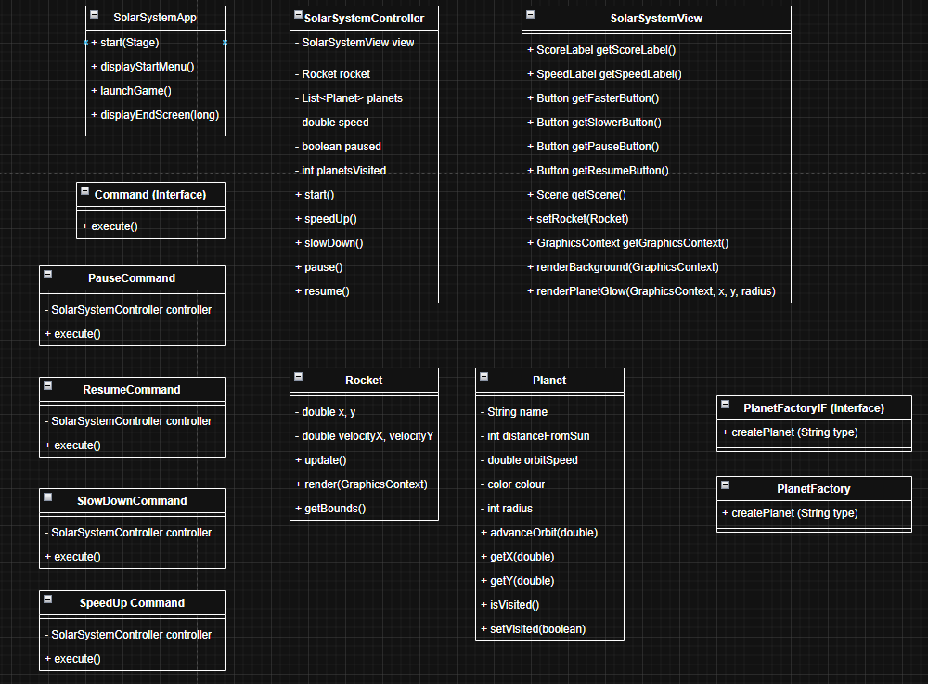
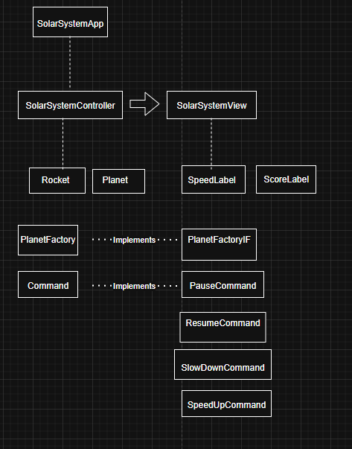

Reflection
Overall, I think the system applies the chosen patterns relatively well. The MVC structure separates the code of the system into model, view and controller well. In some places I could improve on it and dissect classes even further.
I found the command patterns to be useful in this project as it was necessary to include separate buttons in the application. Therefore, having command patterns made it easy to add new buttons as I saw fit. The factory pattern was also necessary in having clean code when creating all the planet instances. If I needed to add new planet types I could do with the addition of the planetfactoryIF class.
To improve the code more design patterns could’ve have been implemented. This would have made the code cleaner and more enhanced the modularity. For example, having observer and strategy patterns could have allowed for more sophisticated code. I didn’t do this as I struggled with coding it and didn’t have enough time.
In conclusion, whilst using the workshops and lectures, I think this code develops the patterns into a relatively well-done application. In future, I aim to expand the pattern usage and add more modularisation.

