PID Tunning using Artificial Bee Colony

# Model

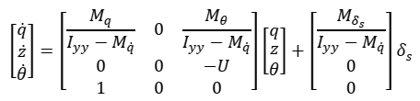

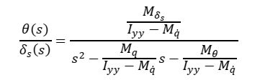

Where,

* I_yy=3.45
* M_q_dot=-4.88
* M_q=-6.87
* M_th=-6.87
* M_s=-3.46
* U=1

# Description

Here I have used the food source of 10 agents and the population size is half of the food source that is 5. As we know the dimensions of the problem is 3. Lowe and Upper bound for the PID controls are -100 and 100 respectively. I have se the maximum iteration level 100. Limit for the Scout bee phase is population size * dimensions thus it is 150.

The cost of the fitness function of the algorithm is Sum Squared Error (ISE) of the output response of the close loop system, and the objective function is to minimize this cost. Here I have used the simply PID model that is given in the paper also.

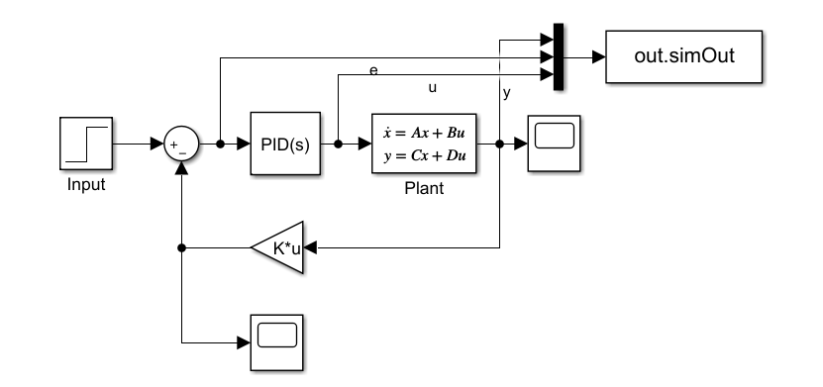

Results are different every time roughly it gives good results with respect to overshoot, rise time, steady state time and steady state error than that of classical PID tunning approaches. Here are the results for ABC algorithm.

# Results







