**Objective: -**

Modeling of Buck converter, Boast converter and Buck-boast converter.

Design a physical model.

Design a plotter software.

**Apparatus: -**

Diode

MOSFET

Capacitor

Resistor

Inductor

Arduino

**Buck converter**

* **Introduction: -**

A buck converter (step-down converter) is a DC-to-DC power converter which steps down voltage (while drawing less average current) from its input (supply) to its output (load).

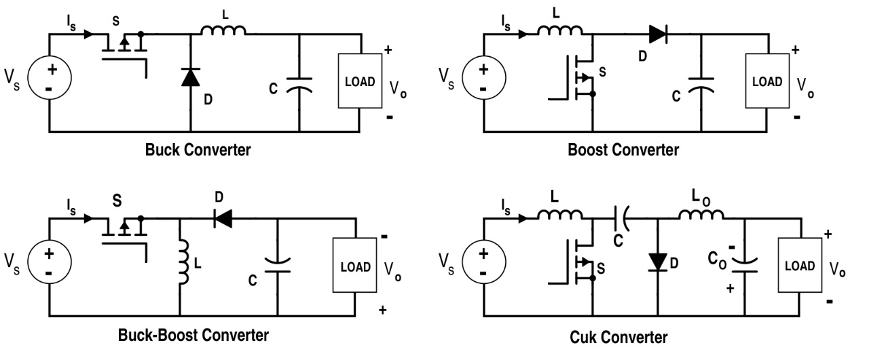

Figure 1: Circuit Diagram of Buck Converter

* **Explanation: -**

It is a class of [switched-mode power supply](https://en.wikipedia.org/wiki/Switched-mode_power_supply) (SMPS) typically containing at least two semiconductors and at least one energy storage element, a [capacitor](https://en.wikipedia.org/wiki/Capacitor), [inductor](https://en.wikipedia.org/wiki/Inductor), or the two in combination. To reduce voltage ripple, filters made of capacitors (sometimes in combination with inductors) are normally added to such a converter's output (load-side filter) and input (supply-side filter).

Switching converters (such as buck converters) provide much greater [power efficiency](https://en.wikipedia.org/wiki/Power_efficiency) as DC-to-DC converters than [linear regulators](https://en.wikipedia.org/wiki/Linear_regulator), which are simpler circuits that lower voltages by dissipating power as heat, but do not step up output current. The efficiency of buck converters can be very high, often over 90%, making them useful for tasks such as converting a computer's main [supply](https://en.wikipedia.org/wiki/Power_supply_unit_(computer)) voltage, which is usually 12 V.

* **Operation theory: -**

The basic operation of the buck converter has the current in an [inductor](https://en.wikipedia.org/wiki/Inductor) controlled by two switches (usually a [transistor](https://en.wikipedia.org/wiki/Transistor) and a [diode](https://en.wikipedia.org/wiki/Diode)). In the idealized converter, all the components are considered to be perfect. Specifically, the switch and the diode have zero voltage drop when on and zero current flow when off, and the inductor has zero series resistance. Further, it is assumed that the input and output voltages do not change over the course of a cycle, which would imply the output capacitance as being [infinite](https://en.wikipedia.org/wiki/Infinity)

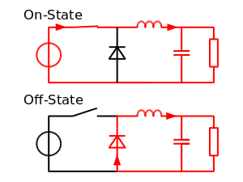

Figure 2: On and Off state Simplified Circuit for Buck Converter

**Boost Converter**

* **Introduction: -**

A boost converter (step-up converter) is a DC-to-DC power converter that steps up voltage (while stepping down current) from its input (supply) to its output (load). In other words, boost converters are used in electronics to generate a DC output voltage that is greater than the DC input, therefore boosting up the supply voltage. Boost converters are often used in power supplies for white LEDs, battery packs for electric automobiles, and many other applications.



Figure 3: Circuit Diagram for Boost Converter

* **Explanation: -**

The key principle that drives the boost converter is the tendency of an [inductor](https://en.wikipedia.org/wiki/Inductor) to resist changes in current by either increasing or decreasing the energy stored in the inductor magnetic field. In a boost converter, the output voltage is always higher than the input voltage. A schematic of a boost power stage is shown in Figure 1.

When the switch is closed (on-state), current flows through the inductor in the clockwise direction and the inductor stores some energy by generating a magnetic field. Polarity of the left side of the inductor is positive.

When the switch is opened (off-state), current will be reduced as the impedance is higher. The magnetic field previously created will be reduced in energy to maintain the current towards the load. Thus the polarity will be reversed (meaning the left side of the inductor will become negative). As a result, two sources will be in series causing a higher voltage to charge the capacitor through the diode *D.*

If the switch is cycled fast enough, the inductor will not discharge fully in between charging stages, and the load will always see a voltage greater than that of the input source alone when the switch is opened. Also while the switch is opened, the capacitor in parallel with the load is charged to this combined voltage. When the switch is then closed and the right hand side is shorted out from the left hand side, the capacitor is therefore able to provide the voltage and energy to the load. During this time, the blocking diode prevents the capacitor from discharging through the switch. The switch must of course be opened again fast enough to prevent the capacitor from discharging too much.

* **Operation theory: -**

In the on-state, the switch S is closed, resulting in an increase in the inductor current. In the off-state, the switch is open and the only path offered to inductor current is through the [flyback diode](https://en.wikipedia.org/wiki/Flyback_diode) *D,* the capacitor *C* and the load *R*. This results in transferring the energy accumulated during the on-state into the capacitor.

The input current is the same as the inductor current. So it is not discontinuous as in the [buck converter](https://en.wikipedia.org/wiki/Buck_converter) and the requirements on the input filter are relaxed compared to a buck converter.

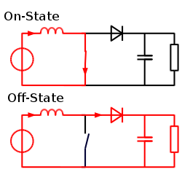

Figure 4: On and Off state Simplified Circuit for Boost Converter

**Buck-Boost Converter**

* **Introduction: -**

A buck-boost converter produces a DC output voltage that can be either bigger or smaller in magnitude than its DC input voltage. As its name suggests, it combines the functions of a buck converter (used for DC voltage step-down) and a boost converter (used for DC voltage step-up).



Figure 5: Circuit Diagram for Buck-Boost Converter

* **Working principle: -**

A Buck-Boost converter transforms a positive DC voltage at the input to a negative DC voltage at the output. The circuit operation depends on the conduction state of the MOSFET.

On-state: The current through the inductor increases and the diode is in blocking state.

Off-state: Since the current through the inductor cannot abruptly change the diode must carry the current so it commutates and begins conducting. Energy is transferred from the inductor to the capacitor resulting in a decreasing inductor current and a voltage across the resistor with the opposite polarity compared to Vin.

During steady state the circuit is said to operate in discontinuous conduction mode if the inductor current reaches zero and in continuous conduction mode if the inductor current never reaches zero. The circuit has two limits of operation. For a PWM duty cycle D ➝ 0 the output voltage equals zero, and for D ➝ 1 the output voltage grows toward negative infinity. In between those limits the output voltage in continuous conduction mode is given by: Vout = -D/(1-D) · Vin.

**Simulation Results**

* **Buck: -**

Parameters: -

* R = 4 ohms
* L = 100 µH
* C = 100 µF
* d = 0.4
* Vin = 12V

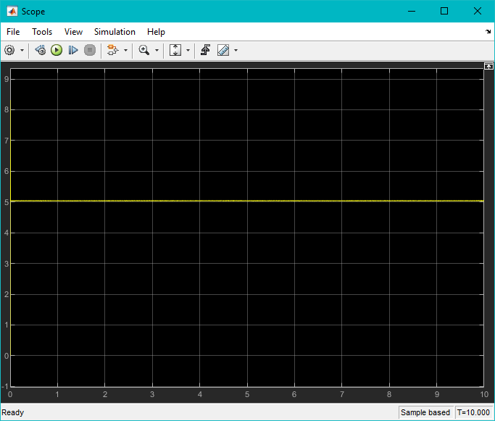

Figure 6: Output of Buck Converter in Simulink

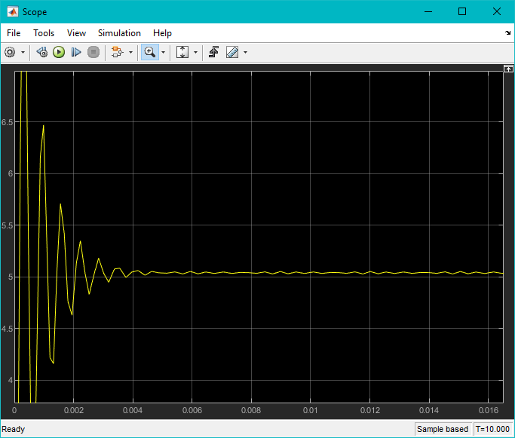

Figure 7: Voltage Ripple and Settling Time for Buck Converter

* **Boost: -**

Parameters: -

* R = 4 ohms
* L = 100 µH
* C = 100 µF
* d = 0.4
* Vin = 12V

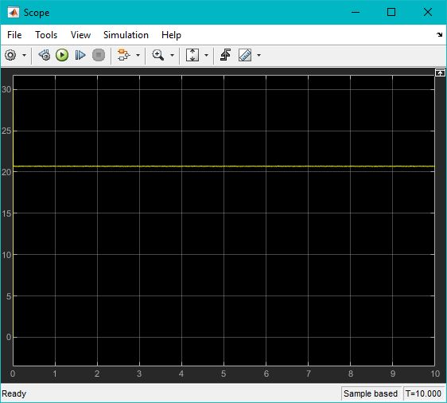

Figure 8: Output of Boost Converter on Simulink

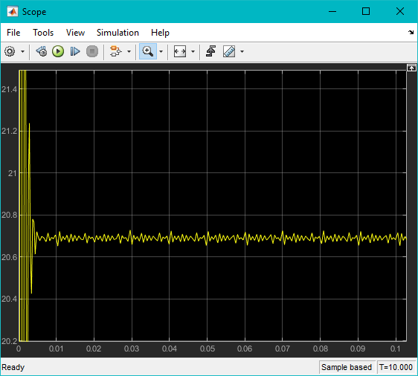

Figure 9: Voltage Ripple and Settling Time for Boost Converter

* **Buck-Boost: -**

Parameters: -

* R = 4 ohms
* L = 100 µH
* C = 100 µF
* d = 0.4
* Vin = 12V

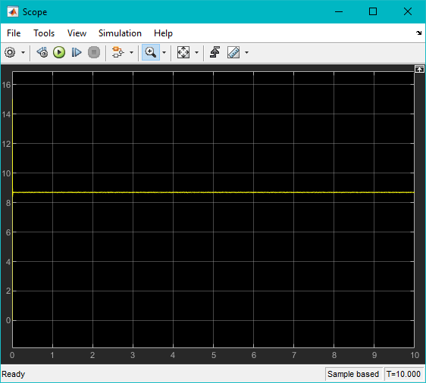

Figure 10: Output of Buck-Boost Converter on Simulink

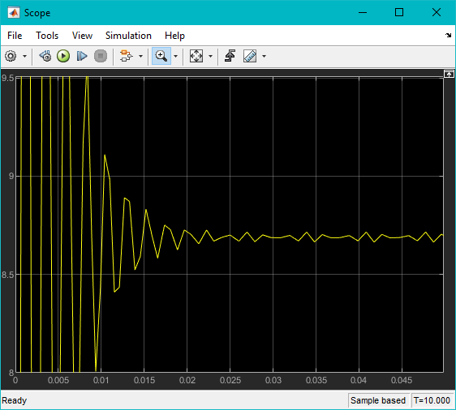

Figure 11: Voltage Ripple and Settling Time for Buck-Boost-Boost Converter