**Author: -**

Sabir Husnain

**Department of Mechatronics & Control Engineering**

Project Report

Camera Gimble

**Level Sensor Using a Combination of**

**Gyroscope & Accelerometer**

**Abstract: -**

In robotics and control engineering sensors are very important and are integral parts of a control system. An automatic control process can never be achieved without sensors. They can measure pressure, temperature, displacement, velocity and many more. but here our focus is on angular displacement transducer which is a gyroscope. A gyroscope can be used to measure angular displacement, velocity and acceleration. Gyroscopes are widely used in control systems and robotics to measure the angle of the joints in a robot or position of motors. But there is a drawback in using a gyro only to measure the angle. So, this project is based in measurement of angle using gyroscope and accelerometer as a single unit. The data will be compiled and processed by microcontroller and one will very receive accurate angles or it’s better to say angular displacement.

Here level sensor is used to make a self-balancing platform or gamble. Gyro and accelerometer-based sensor is used to measure the roll, yaw and pitch angles and then these angles are used to set the angles of motors so that the platform can balance itself.

**Objective: -**

Objective is to make an Arduino gamble using level sensor and servos. It is a self-stabilizing platform which can use the data from of the level sensor and use it to drive servos so that the platform remains horizontal, vertical or whatever specified. Thus, it is a close loop control system and following figure can completely describe the system.

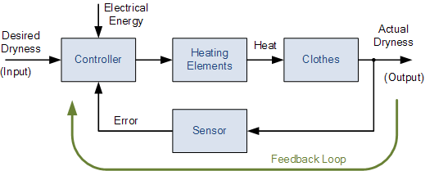

**Figure 1: Close Loop representation of Control**

Here the sensor data will generate an error if the platform is disturbed from its specified position thus controller will send a signal to servos to move and stops when the error generated is zero. The error will be zero when platform becomes horizontal.

**Apparatus: -**

* Arduino
* Gyro Scope
* Accelerometer
* Servo motors
* Servo motor brackets

**Angle Measurement using Gyro: -**

Here MPU6050 sensor is being used which contains gyro, accelerometer and temperature sensor in a single unit. But we only use two of them. It is three axis gyro scope and three axis accelerometers so is also called 6 axis sensors. it measures the angular velocity and linear acceleration. It is 8-bit sensor so return data in 8-bits with its 8-bits registers used for its configurations, data reading and many more.

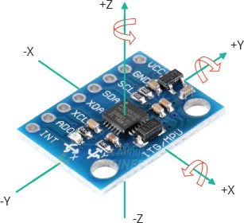

**Figure 2: MPU6050 Gyro + Accelerometer**

One can measure 3 angular velocities with the sensor, now how to measure angle with the angular velocity. So, the solution lies in the definition of velocity. It is stated as “the rate of change of distance with respect to time.” So, if there is a constant angular velocity in certain time “t” one can measure angular displacement easily by dividing velocity by time. Hence, here in this project data is being read by microcontroller in a certain fixed time and then dividing the value of velocity by the time it is added to the previous angle for a certain axis. It can clearly be seen in the below flowchart diagram.



So for every axis we can measure angle easily using gyro by reading the specific axis data and dividing it by loop time. Loop time will be found by microcontroller itself hence it is very easy to measure the angle using gyro. But there is problem I angle measurement with gyro only which is drifting of angle. angle of gyro drifts automatically after some time when it remains stationary on a stationary platform. This drifting of angle is due to the vibrations in the gyro these vibrations cause a minor angular velocity which is being added in the angle after division by time.

Another problem is that assume if gyro is initially at an angle in that case it will read zero because there was no angular velocity sensed by the microcontroller hence if there is no motion sensed by controller then no angle.

* **Problems: -**
* **Angle drifting**
* **No initial angle**

**Angle Measurement using Accelerometer: -**

Now accelerometer is used to measure acceleration of a body but there is a trick by which it can be used to measure the angle. The sensor we are using is a three axis accelerometer but first let a two axis accelerometer for simplicity. In below figure a box is being shown which consists of two accelerometers for measuring forces in x and y direction. When a force is applied on the accelerometer an inertial force will be produced in opposite direction of motion which can be used to measure the acceleration in the direction of motion.



**Figure 3: Accelerometer with Movement in Y-Axis**

We can see in above figure that the during motion in y-axis a motion is being applied on Y sensor and similarly it will be applied on X sensor when there is a motion in x-axis. The gravitational force is being always applied on the sensors always in every condition if it is in gravitational field of the earth. Now consider following situation and sensor is in motion in a diagonal axis then the forces will be applied on both the sensors shown below.



**Figure 4: Accelerometer with Movement in Diagonal Axis**

As shown in above figure a force will be applied on the Y sensor as well as on X sensor if sensor in under motion in diagonal axis. Hence using trigonometry, it can be observed that;

$$ma=\sqrt{{(ma_{x})}^{2}+{(ma_{y})}^{2}}$$

$$θ_{x}=\sin^{-1}\left(\frac{a_{y}}{a}\right)$$

$$θ_{y}=\sin^{-1}\left(\frac{a_{x}}{a}\right)$$

The third angle which is with the z-axis can’t be measured using accelerometer. Now the question is that why don’t we use accelerometer for the angle measurement for x and y axis then the answer is that there is a bigger problem with the accelerometer. If we shake the sensor there will be inaccurate angles measured using accelerometer because there will be other forces rather than gravitational forces. So if there are vibrations of motor or something like gamble which is going to be in human hand will have a chance of vibrations so we can’t use accelerometer at all for angle measurement.

**Solution for Angle Drifting: -**

Angle drifting can be stopped using weighted sum of data of both the sensors. It was found experimentally if we use 96.96% of gyro data and 0.04% of accelerometer data then there will not be a drift neither a vibration disturbance angle. Hence, we have employed both sensors to measure angles.

**Solution for Initial Angle Measurement: -**

Initially angles can be measured only using accelerometer. If the gyro is placed at an angle, then there will be initial angles which are accelerometer angles. When microcontroller starts an angle set flag is set to zero and loop start and there is a condition that if angle set flag is zero then only accelerometer data should have to be read otherwise weighted sum. So following flowchart will explain the logic clearly.



**Output of sensor: -**

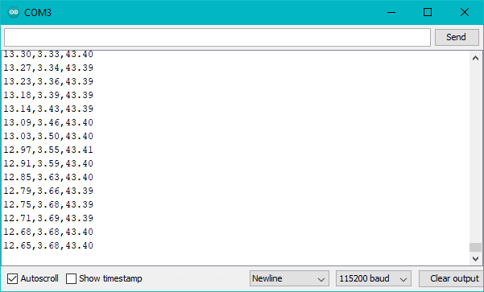

**Figure 5: Output of Sensor**

**Working of Gamble: -**

Equipped with motors and sensors, a gimbal is a device that allows your digital camera to rotate smoothly along an axis. These days, 3-axis gimbals are the most common type. They stabilize your camera while you tilt, pan and roll, and help you to film fluid, smooth footage while you’re on the move.

Now this Arduino gamble contains three motors one for each axis, each motor is a servo motor so that it can be controlled accurately and precisely. When the level sensor senses a rotation an error signal is generated which is equal to angle which motor has to be moved thus the motor moves to stabilize the platform and keep it horizontal or whatever one wants.

**Motor Controller: -**

PCA9685 PWM controller is used to control heavy servos. These servos require more current thus Arduino can’t be sued to drive them, so the driver is connected with the Arduino to control the motors. The angle which is output of the level sensor will be input of this PWM controller and it will generate PWM for the motors and set the angle precisely and accurately.

**Specification of Gamble: -**

* Degrees of Freedom = 3
* Total Load Capacity = 2.5Kg
* Voltage Range = 4.5V – 9V
* Reponses Time = 4mS
* Gyro Range = 500o/s
* Gyro Sensitivity = 65.5 LSB/ o/s
* Accelerometer Range = ±4go/s
* Accelerometer Sensitivity = 8192.0 LSB/g