**Assignment-15.1**

**CREATION OF MYSQL TABLE:**

**Query:**

create table employee (id int, name varchar(45), department varchar(45), salary int, location varchar(45));

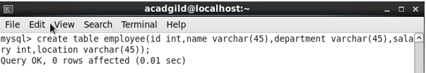

**INSERTION OF 10 RECORDS INTO THE TABLE:**

**Query:**

insert into employee (id,name,department,salary,location) values (1,'AAA','BBB',1000,'CCC'),(2,'BBB','BBB',1000,'CCC'),(3,'CCC','BBB',1000,'CCC'),(4,'DDD','BBB',1000,'CCC'),(5,'EEE','BBB',1000,'CCC'),(6,'FFF','BBB',1000,'CCC'),(7,'GGG','BBB',1000,'CCC'),(8,'HHH','BBB',1000,'CCC'),(9,'III','BBB',1000,'CCC'),(10,'JJJ','BBB',1000,'CCC');

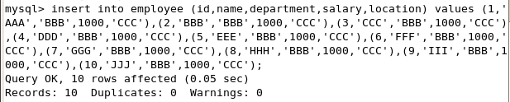

**Displaying Table:**

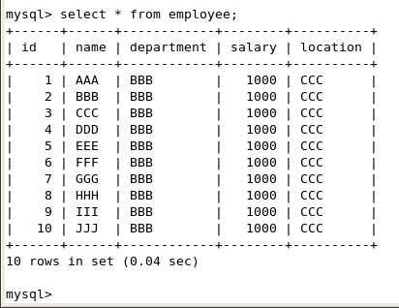

**SQOOP IMPORT INTO HDFS:**

sqoop import --connect jdbc:mysql://localhost/employee --username root --table employee --m 1 --target-dir employee

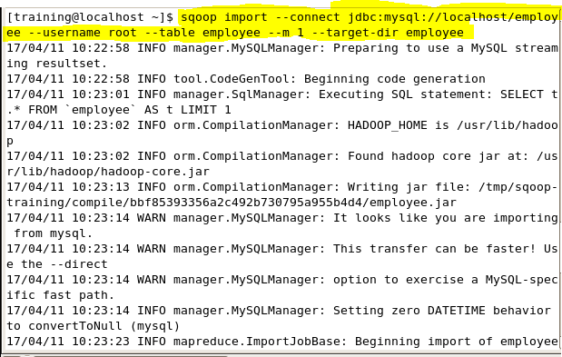

**Table in HDFS:**

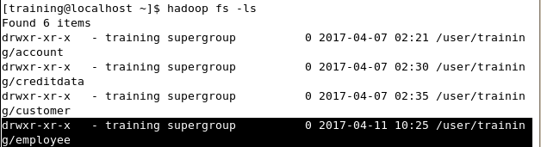

**SQOOP IMPORT INTO HIVE TABLE**

sqoop create-hive-table --hive-table employee --connect jdbc:mysql://localhost/employee --username root --table employee

load data inpath '/user/training/employee' into table employee;

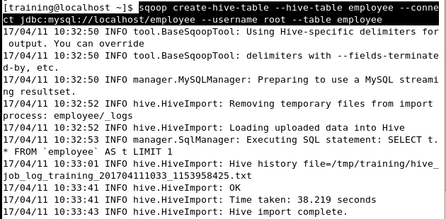

**Loading data in hive table:**

