**1.Write a pig script to find the top 20 destination people travel the most: Based on the given data**

TravelData = load '/user/acadgild/Desktop/TravelData.txt' using PigStorage('\t') as (CityPair:chararray, fromLocation:chararray, toLocation:chararray, Producttype:int, Adults:int, Seniors:int, Children:int, Youth:int, Infant:int, DateofTravel:chararray, TimeofTravel:chararray, DateofReturn:chararray, TimeofReturn:int, Price:float, Hotel:chararray);

group_destination = group TravelData by toLocation;

count_destination = foreach group_destination generate group, COUNT(TravelData.toLocation)as cnt;

orderby = order count_destination by cnt DESC;

top_destination = limit orderby 20;

dump top_destination;

**2. Write a pig script to find the top 20 locations from where people travel the most**

TravelData = load '/user/acadgild/Desktop/TravelData.txt' using PigStorage('\t') as (CityPair:chararray, fromLocation:chararray, toLocation:chararray, Producttype:int, Adults:int, Seniors:int, Children:int, Youth:int, Infant:int, DateofTravel:chararray, TimeofTravel:chararray, DateofReturn:chararray, TimeofReturn:int, Price:float, Hotel:chararray);

group_source = group TravelData by fromLocation;

count_source = foreach group_source generate group, COUNT(TravelData.fromLocation)as cnt;

orderby = order count_source by cnt DESC;

top_source = limit orderby 20;

dump top_source;

**OUTPUT:**

**TOP 20 DESTINATION:**

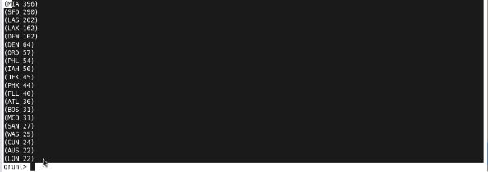

**TOP 20 LOCATIONS:**

