**ASSIGNMENT-7.4**

**Write a pig script to find the count of each Hashtag in the dataset. You can download the twitter data from the below link**

**Pig commands**

**LOGIC :GOT EVERY LINE AS A INPUT AND THEN USED TOKENIZE AND FLATTEN AND FILTER BY HASHTAGS AND MADE A COUNT**

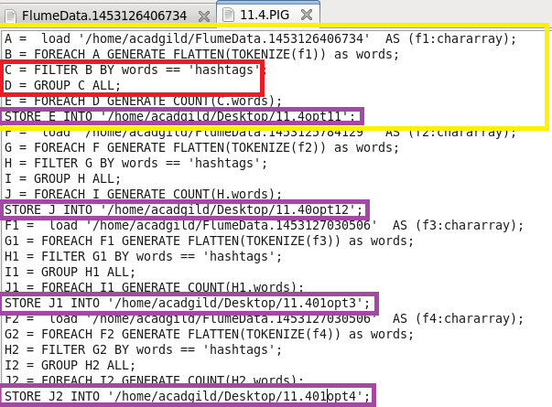

**RUNNING PIG**

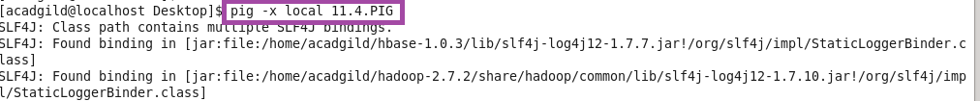

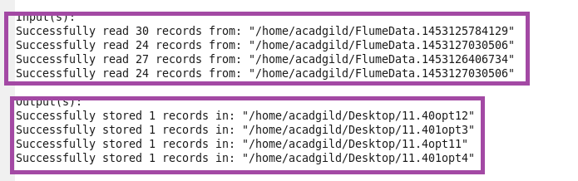

**OTPT**

