

**Course No:CSE 2100**

**Course Title:Software Development Project-I**

**Submitted to:**

**Biprodip Pal**

**Assistant Professor**

**Dept. of CSE,RUET**

**Submitted by:**

**Name:** Sabit Ahmed

**Roll:** 1503056

**Class:** 2nd year,Even semester

**Project Details:** A simple and basic website on the organizations of Ruet has been created with the help of HTML, CSS, JavaScript and PHP. Basic purpose behind this project was to learn how to deal with web development and make a step to web engineering.

**Features:** The submitted website contains these features:

>>Information on the topics related to the specific organizations

>>Upcoming events based on the related clubs or organizations

>>Registration and Login opportunity

>>A blog where both students can express their thoughts or publish their research

>> A comment box which is under development.

**Screenshots:**

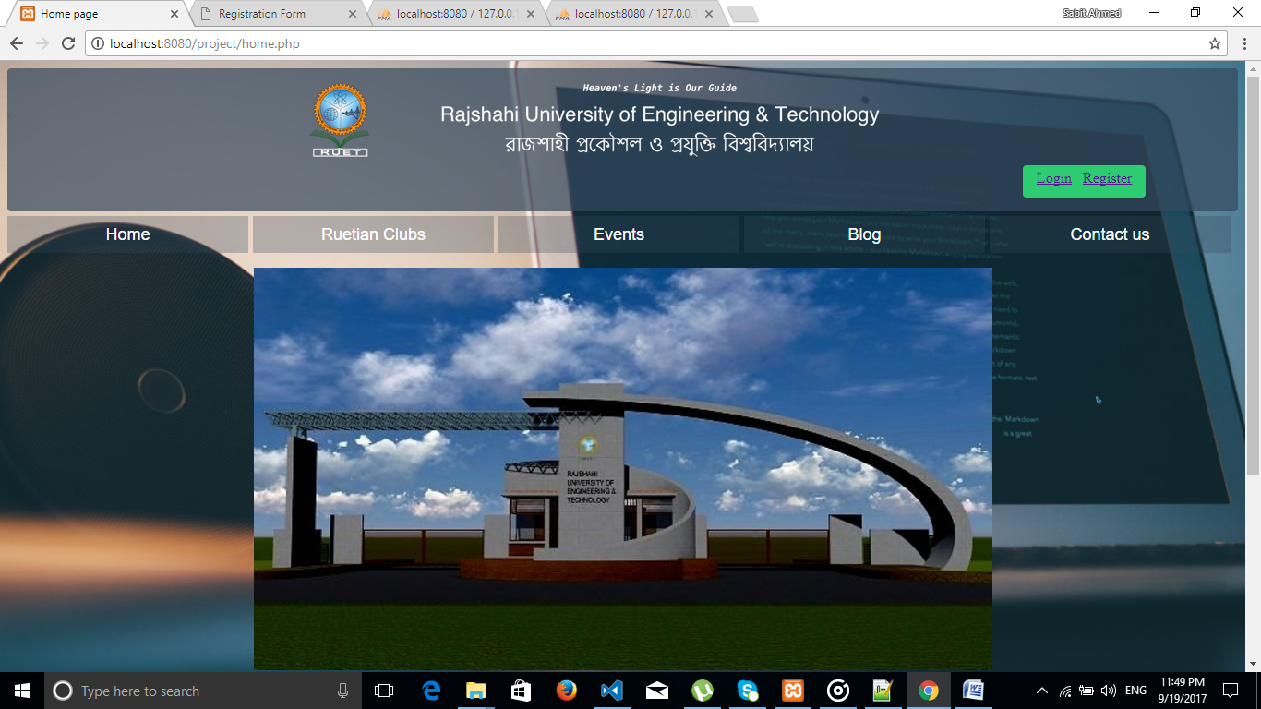

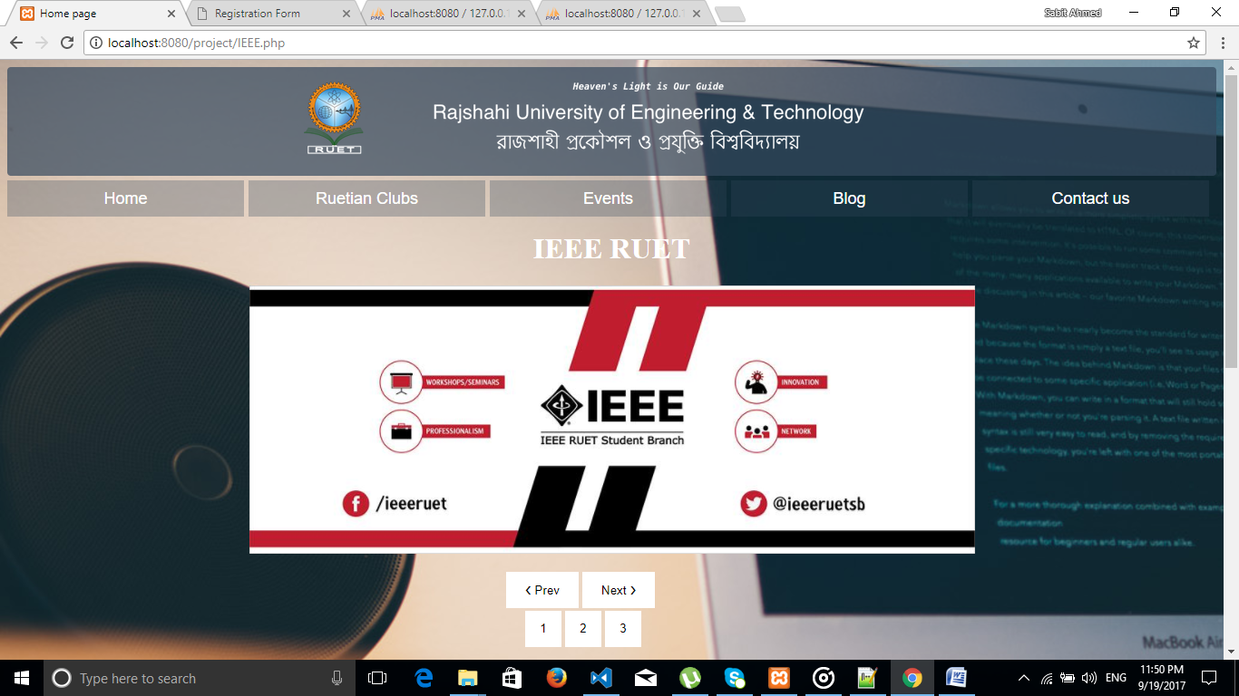

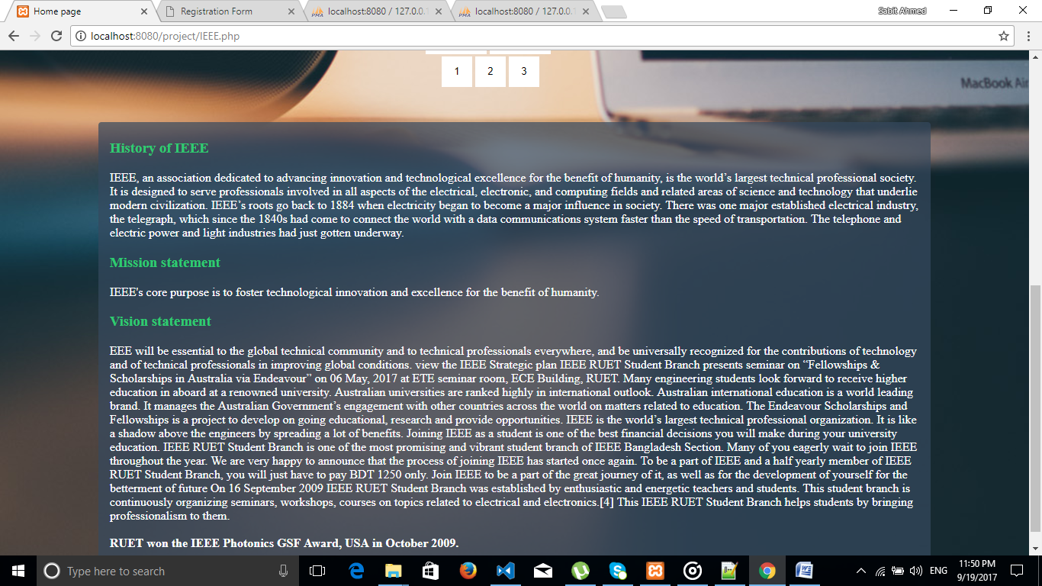

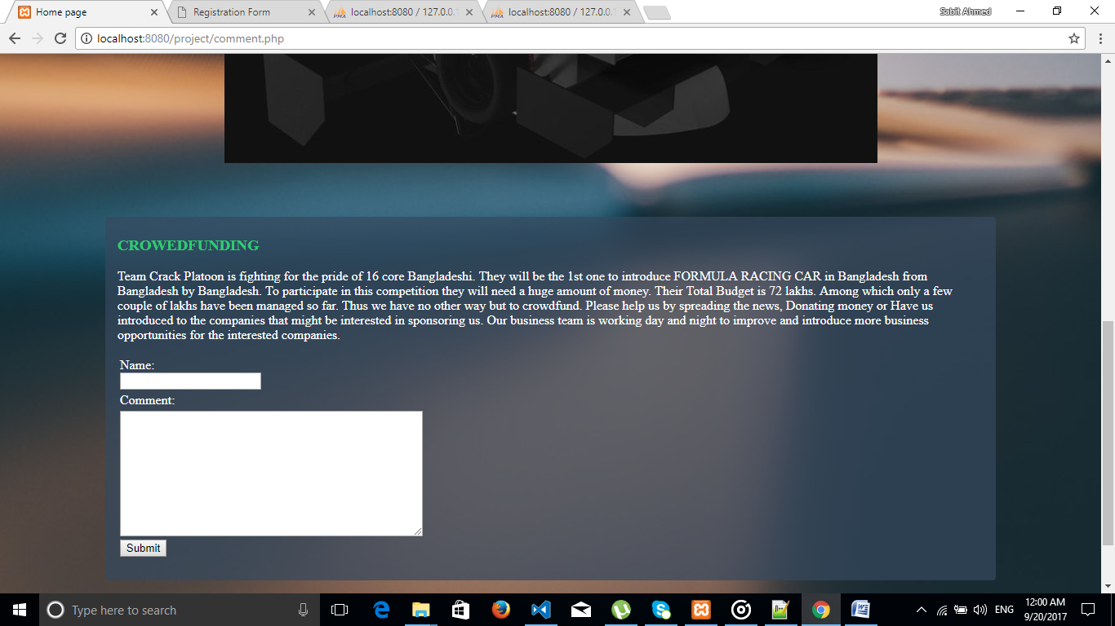

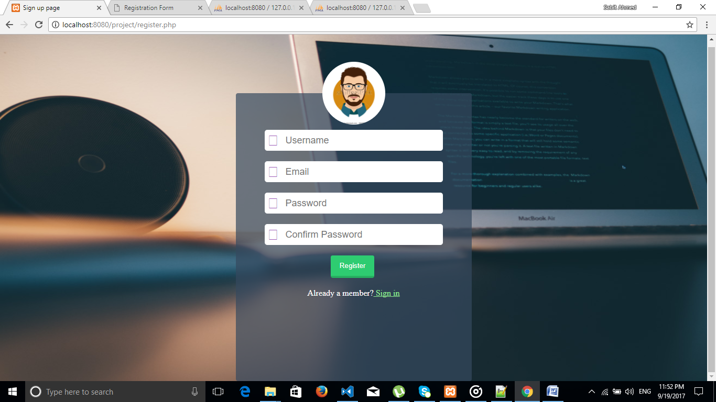

**Future Plan:** A few steps will be included in future. The website will contain:

>>A complete blog

>>An online based system for all students where they can post problems, solutions etc.

>>Admin panel and user panel with respected access issue.

>>Every student has his own id. He can get internal online facilities using this id.

>>In future, a Ruetian online product exchange system might be constructed.

>>Online recruiting in organizations or clubs.

>>Overall a communication system among students of Ruet.