EX1-BASIC QUESTIONS

1) Get the three sides of a triangle and check if it is equilateral, isosceles or scalene



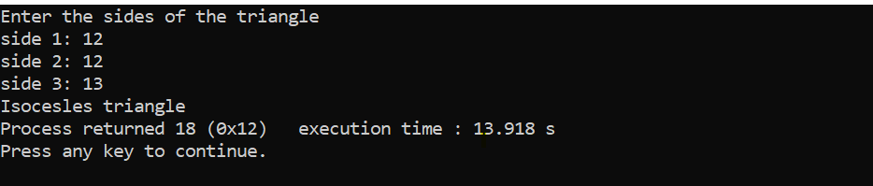

2) Get the month and year and print the number of days in that month



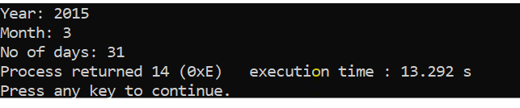

3) Reverse of a number



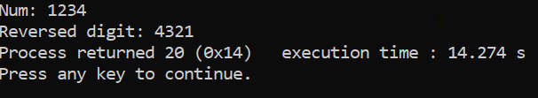

4) Series GP



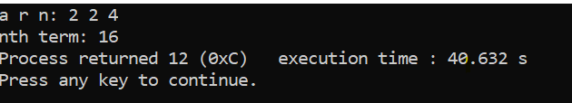

5) Reverse a string and check if it’s a palindrome



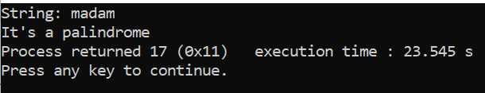

6) Find if a number is an Armstrong number:



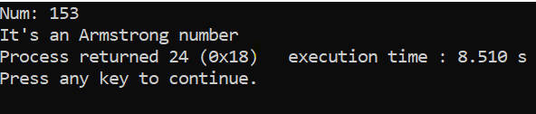

7) Search an element in an array



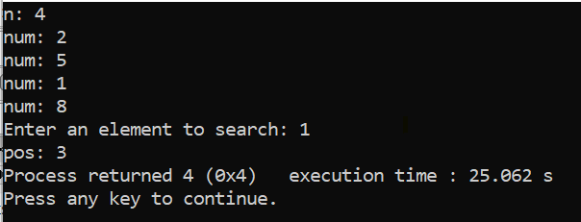

8) Print n Fibonacci terms using iteration and recursion.



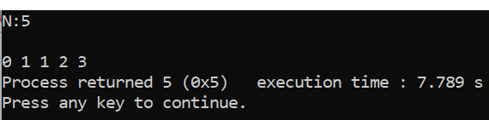

9) Given a string, count the number of alphabets in it



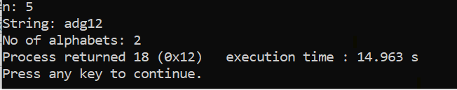

10) Check if two strings are anagrams



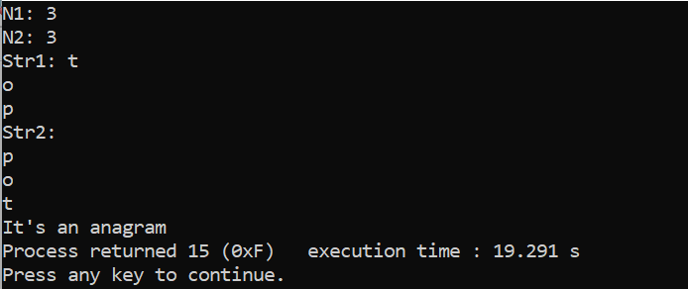

11) Reverse an array



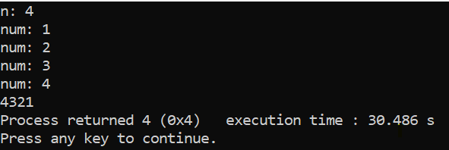

12) Given an array, find the second largest number



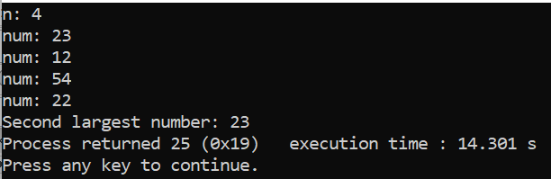

13) Single number



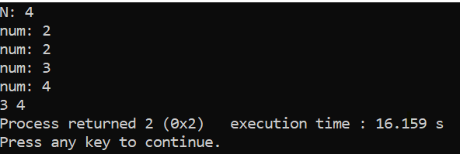

14) Maximum money



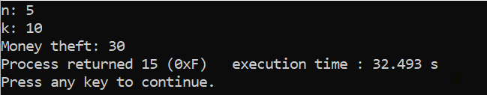

15) Check if the given elements are in the given range



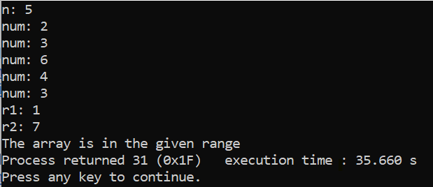

16) Total fine



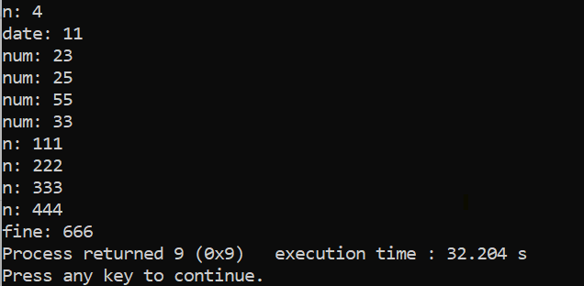

17) Given an array, find the sum of elements at odd index and elements at even index



