

**Submitted by : SYEDA SAMAR FATIMA (BSE201059)**

**SABITULLAH (BSE201013)**

**SAJJAD KHAN (BSE201030)**

**Submitted to : PROF . SHEHZAD RAFIQ**

**Subject:. Software architecture and design**

**Date:. 21th June 2022**

**Vision:**

**Collaborative delivery services:**

Supply chain management forms the spine of any business especially in post COVID era where everything is going towards automation. My software will automate the supply chain helping to maintain the demand-supply balance. The software will have 3 main components nicknamed named :

1. Warehouse.

2. Shop.

3. User.

It can accommodate more members if the chain is longer. For user and warehouse it is simple. If the shop’s stock crosses the low threshold, the system will automatically notify the warehouse and make a delivery schedule for the desired quantity of product/s before the shop’s stock runs too low. Warehouse will use larger mode of transportation(truck,van) as the large quantity of product/s has to be delivered. Similarly shop can deliver the product/s to the user on specific date and time selected by the user but on small mode of transportation (riders,van). If the user has a constant demand for a specific product/s, he can become a weekly/monthly subscriber setting required quantity and credentials that can be linked to the shop. This whole system is expandable and flexible according to the demand of the business model.

**We will make the software of this specific business idea, discussed below.**

**Grain Story:**

Wheat is easily the most important single product both as a food & source of income in Pakistan. My goal for developing this application is to interconnect different segments to create a hassle free supply chain.

Most of the people prefer crushed wheat flour (organic), they have to go to mill or atta chaki weekly or monthly and wait there for their turn and then load sacks on any vehicle to take home. This application will make the delivery Hassle free.

Consumers can set their weekly or monthly required flour quantity in the application which will be delivered to their address on their set date & time by the nearest registered wheat crusher via door step delivery service. Then comes the wheat crushers whose managers/shopkeepers will have a schedule of deliveries they have to make through the application. The application will keep the record of the stock available and will automatically send notification to the nearest wheat supplier, if the stock is below a certain level. Lastly, wheat Suppliers will get their wheat from the farms on receiving demand notification via the application. They will refill the wheat Crushers stock by their delivery vans. These deliveries will be monitored by the head office who will also have a call center for any assistance. Customer’s will mark ‘order received’ on application after receiving the order.

This application will be used by wheat suppliers, wheat crushers (Atta chakki) & flour consumers.Consumers will cover restaurants, bakeries & home kitchens.

**Work flow diagram:**

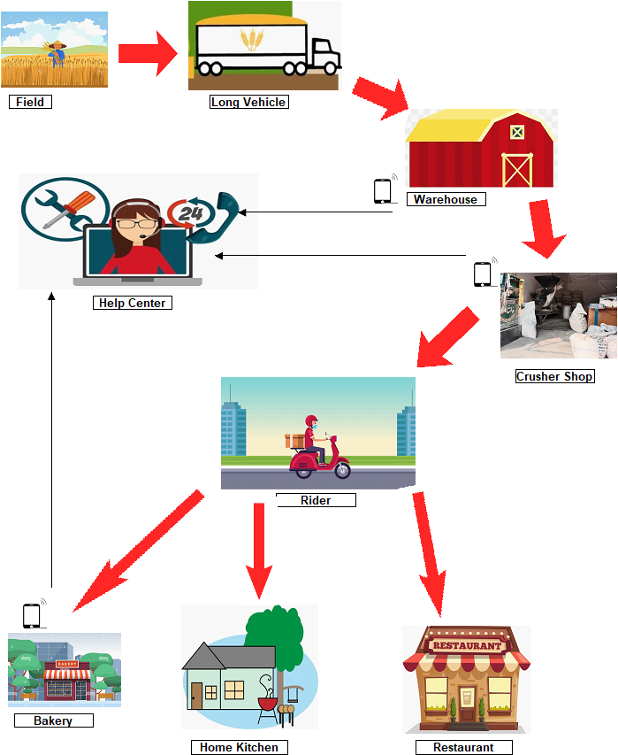

**Component Diagram:**

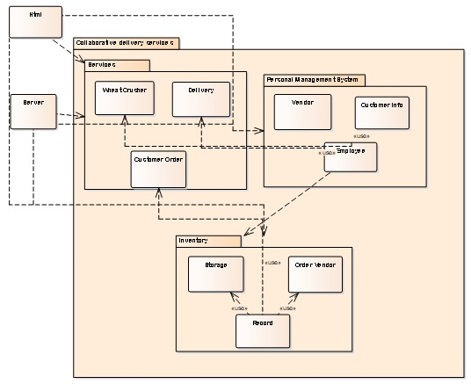**Modular diagram:**

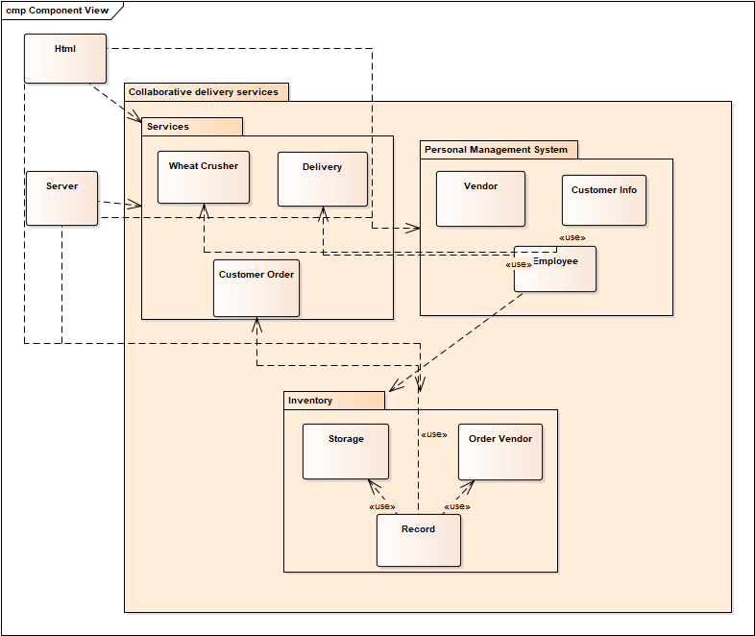

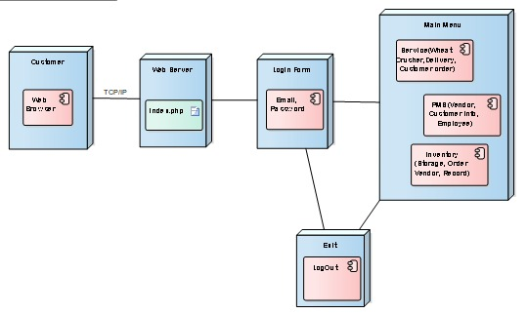**Deployment diagram:**

**Module: Inventory**

**Submitted by : SYEDA SAMAR FATIMA**

**Reg no. : BSE201059**

**Use Case diagrams:**

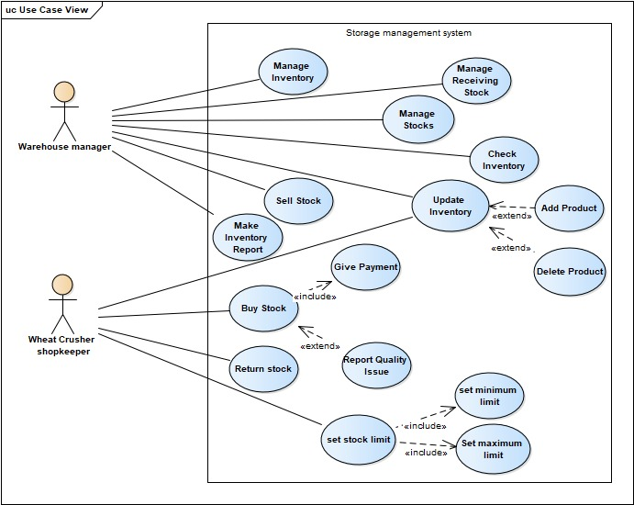**1:**

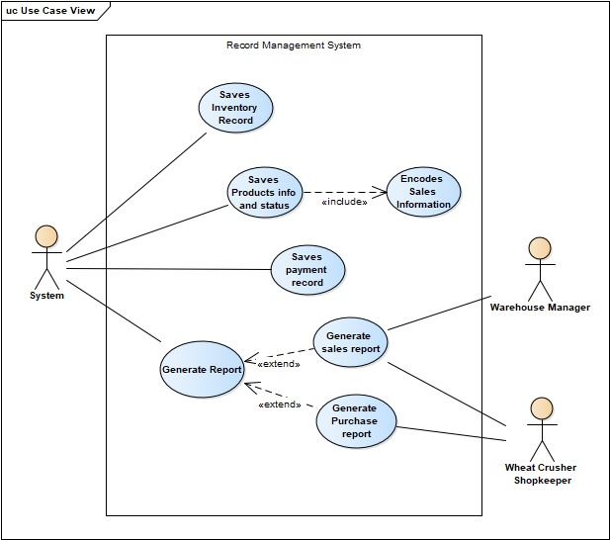**2:**

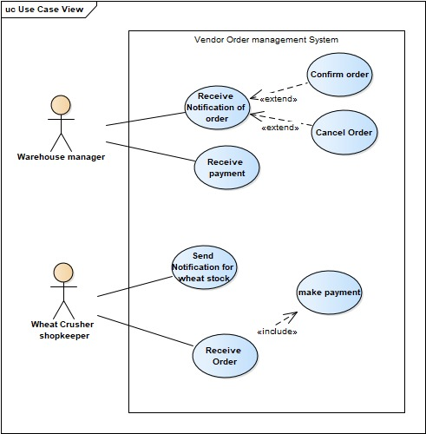

**System Sequence Diagrams:**

**1:**

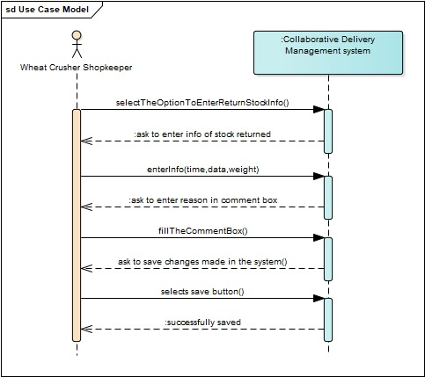

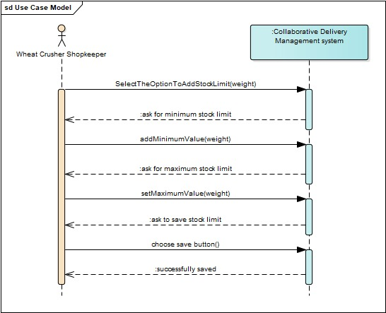**2:**

**3:**

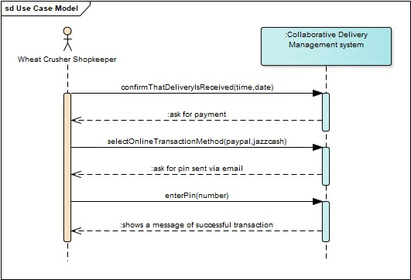

**4:**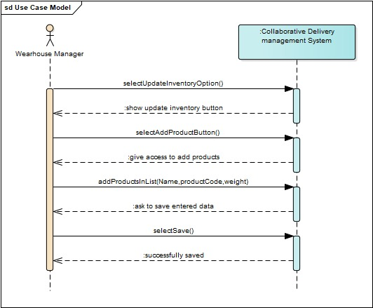

**Domain Model** 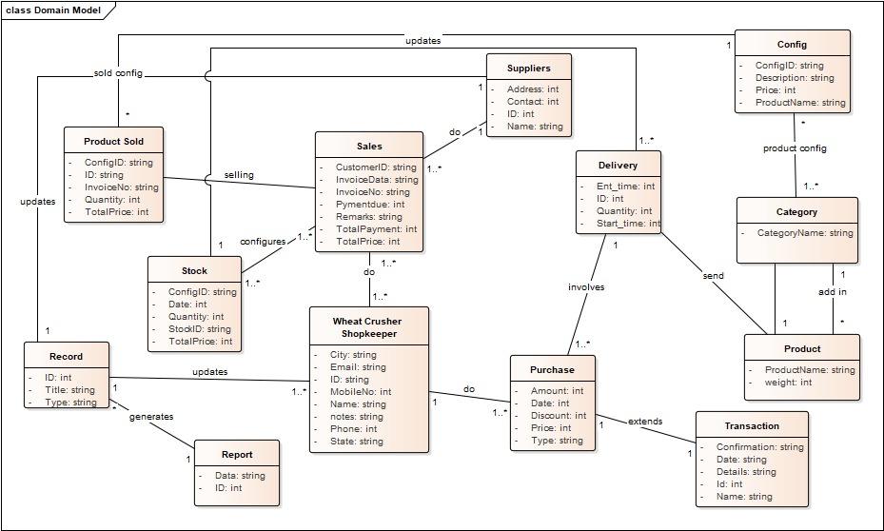

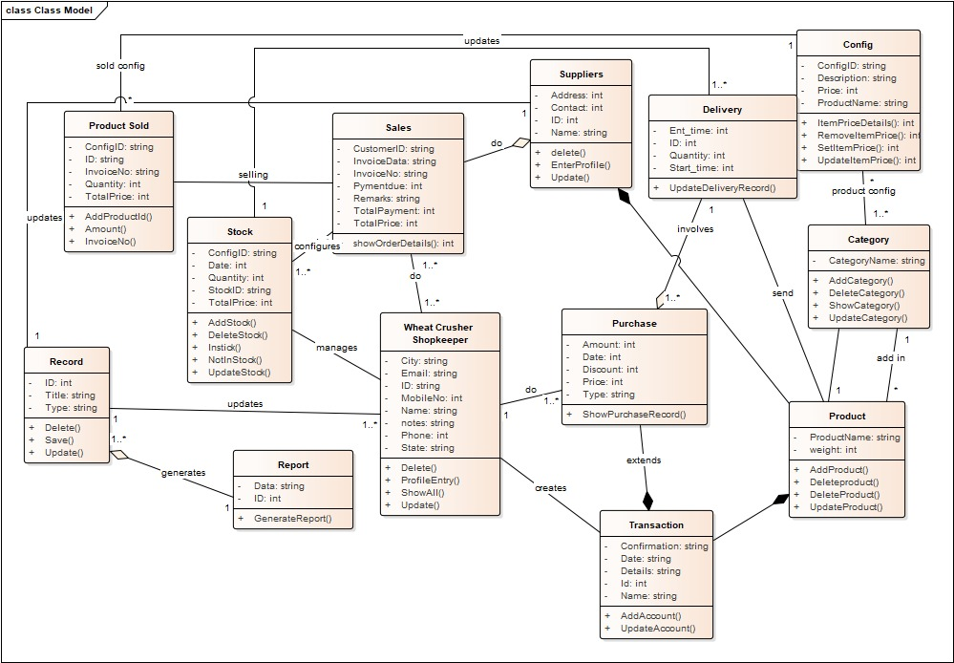**Class Diagram:**

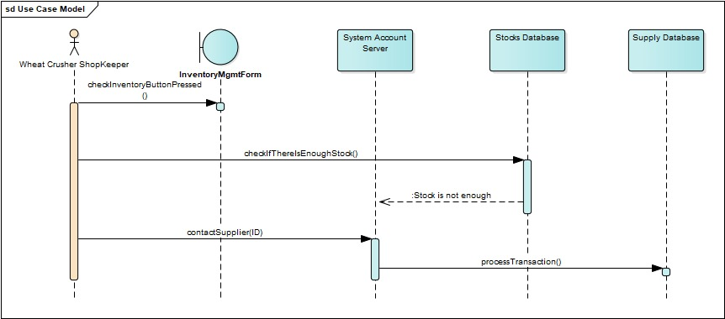**Sequence Diagram:**

**Form:**

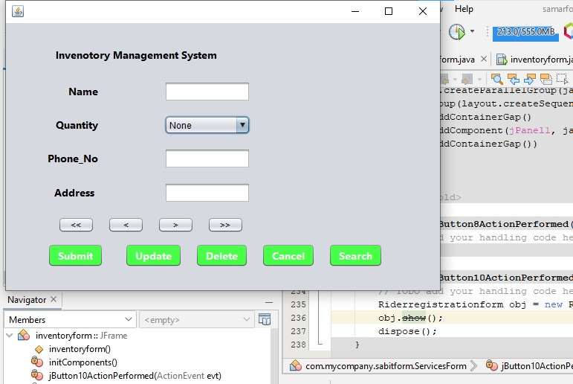

**Module: Services**

**Submitted by: Sabitullah**

**Reg no. : BSE201013**

**Use Case Diagrams:**

**1:**

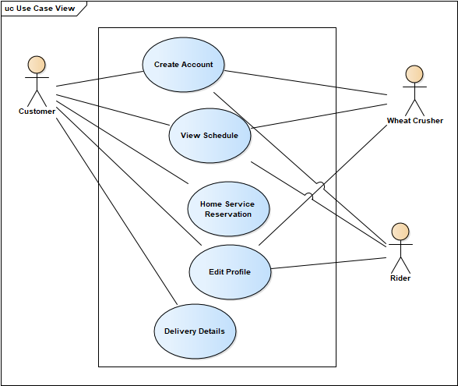

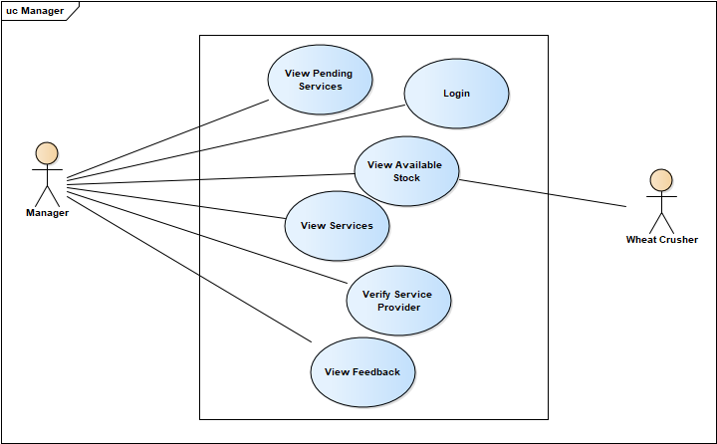

**SSD**

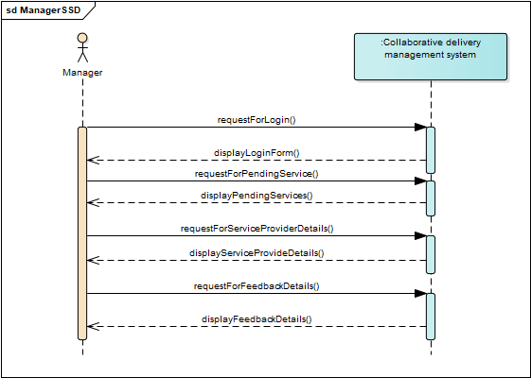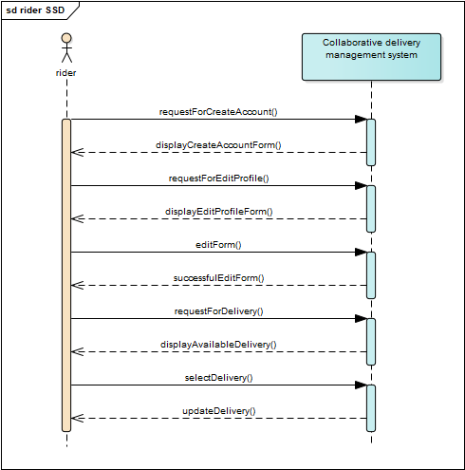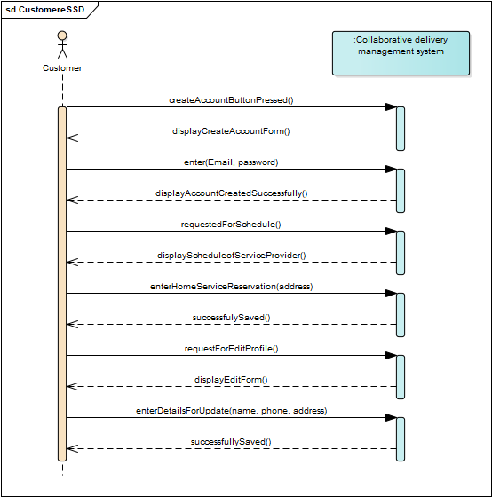

**Domain Model**

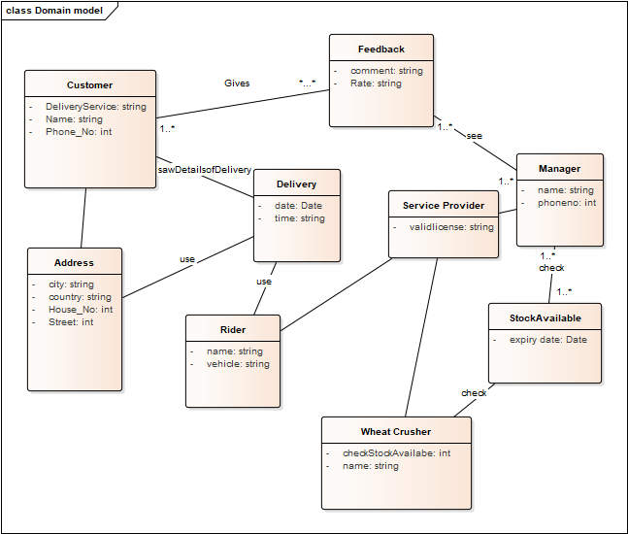

**Class Diagram**

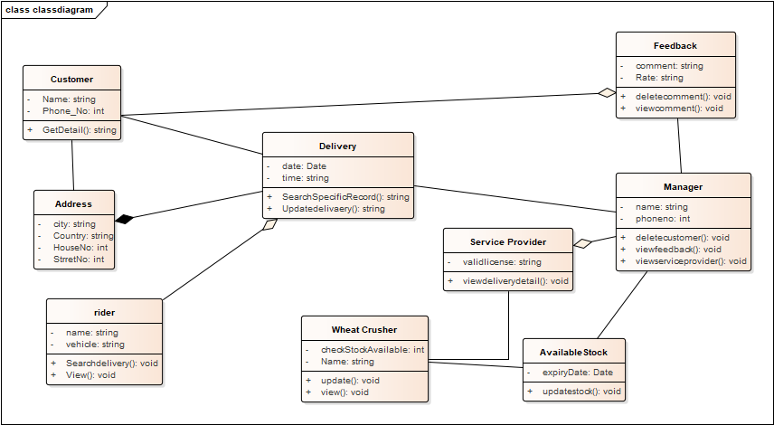

**Form**

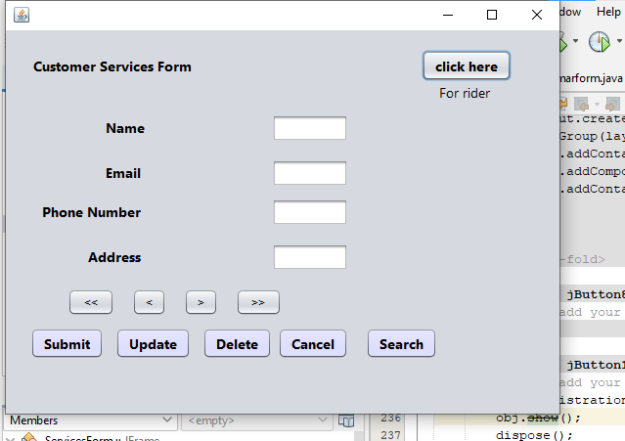

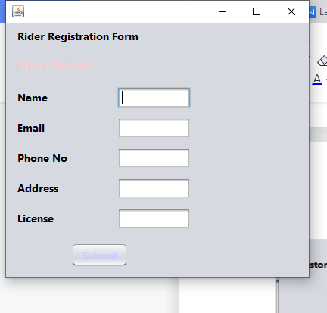

**SEQUENCE DIAGRAM**

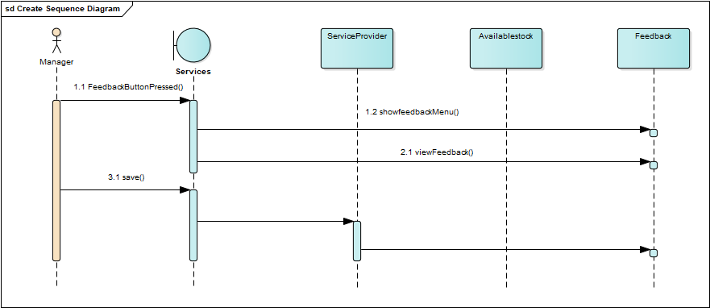

**Module: Personal Management System**

**Submitted by: Sajjad Khan**

**Reg no. : BSE201030**

**Use Case Diagram:**

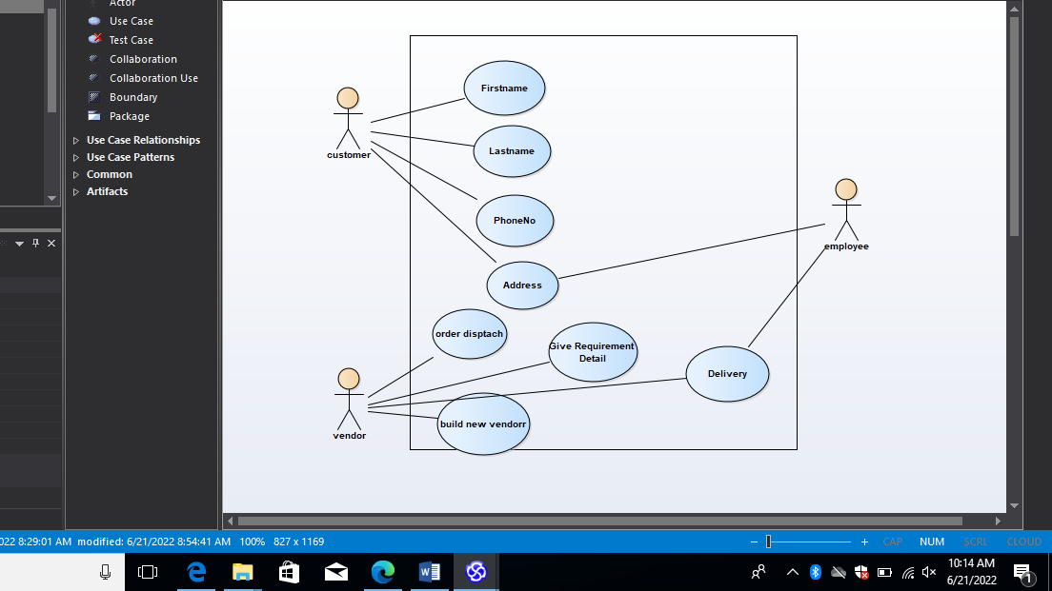

**SSD:**

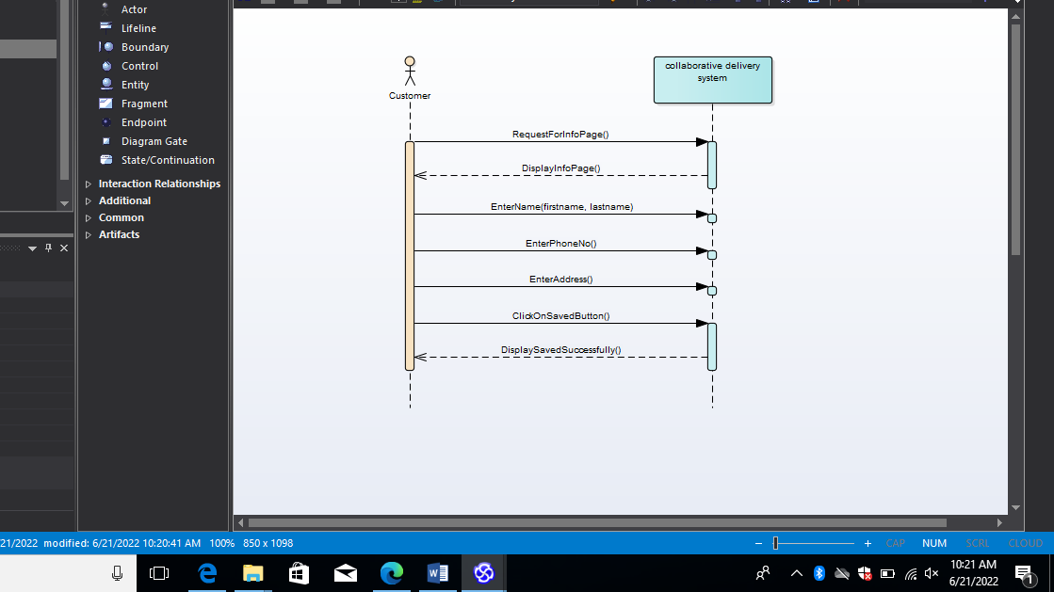

**Domain Model:**

