Nutan Maharashtra Vidya Prasarak Mandal's
NUTAN MAHARASHTRA INSTITUTE OF ENGINEERING &
TECHNOLOGY
Samarth Vidya Sankul, Vishnupuri, Talegaon Dabhade, Pune-410507.

CERTIFICATE
Department of Computer Application

This is to certify that,
Mr./Miss: Sabiya Sameer Shaikh Roll No: 40 (B) And Exam Seat No: P251J108 Of
Class: FYMCA Branch: Computer Application has completed all the Project Work
Satisfactorily in subject Advanced Web Development During Semester II For The Academic Year 2025-26

Subject In-charge Head of the Department Principal
Date: / /2026

PROJECT REPORT

ON

“ Smart Health – Symptom based Disease Analysis”

SUBMITTED TO
SAVITRIBAI PHULE PUNE UNIVERSITY

IN PARTIAL FULFILLMENT OF
MASTER OF COMPUTER APPLICATION

SUBMITTED BY
Sabiya Shaikh 40 - B
UNDER THE GUIDANCE OF
Dr. Priyanka Abhang

THROUGH
NUTAN MAHARASHTRA INSTITUTE OF ENGINEERING AND
TECHNOLOGY
Talegaon Dhabade

DECLARATION
I hereby declare that the project entitled “Smart Health – Symptom Based Disease Analysis System” submitted to Savitribai Phule Pune University, Pune in partial fulfillment of the requirements for the award of the degree of Master of Computer Application (MCA) is my original work.
This project is developed by me under the guidance of Dr. Priyanka Abhang during the academic year 2025–26.
The information and data presented in this project have been collected and implemented by me to the best of my knowledge and understanding.

Date: / /2026
Sabiya Shaikh _____________________

ACKNOWLEDGEMENT
I would like to express my sincere gratitude to my project guide Dr. P for her valuable guidance, continuous support, and encouragement throughout the development of this project entitled “Smart Health – Symptom Based Disease Analysis System”.
Her insightful suggestions, technical expertise, and constant motivation helped me to successfully complete this project within the given time frame.
I am also thankful to the Head of the Department and the institute for providing all the necessary facilities, infrastructure, and a supportive academic environment required for the successful completion of this project.
I extend my sincere thanks to all the faculty members of the Department of Computer Applications for their support and guidance during the project development.
I am also grateful to my friends and classmates for their help and cooperation during this work.
Finally, I express my deepest gratitude to my parents for their constant encouragement, patience, and support throughout my academic journey.

Date: / /2026

Place: Pune
Name of Student: Sabiya Shaikh
Roll No / Exam Seat No: PJ251J108

Department of Computer Applications

INDEX
Sr. No. | Contents 11 | Page No.
1 | List of Figures & Tables | 9
2 | Chapter 1: Introduction | 11
2.1 | 1.1 Introduction to Project | 11
2.2 | 1.2 Problem Statement | 12
2.3 | 1.3 Objectives of Project | 12
2.4 | 1.4 Scope of Project | 13
3 | Chapter 2: Requirement Analysis | 14
3.1 | 2.1 Hardware Requirements | 14
3.2 | 2.2 Software Requirements | 14
3.3 | 2.3 Functional Requirements | 15
3.4 | 2.4 Non-Functional Requirements | 16
4 | Chapter 3: System Design | 18
4.1 | 3.1 Use Case Diagram | 18
4.2 | 3.2 Class Diagram | 18
4.3 | 3.3 Data Flow Diagram (DFD) | 19
4.4 | 3.4 ER Diagram | 19
4.5 | 3.5 Activity Diagram | 20
5 | Chapter 4: Implementation | 21
5.1 | 4.1 Frontend Design | 21
5.2 | 4.2 Backend Design | 22
5.3 | 4.3 Screenshots of Website | 25
5.4 | 4.4 Test Cases | 31
6 | Chapter 5: Conclusion and Future Scope | 32
6.1 | 5.1 Conclusion | 32
6.2 | 5.2 Future Scope | 32
7 | Bibliography | 34

ABSTRACT
The Smart Health – Symptom Based Disease Analysis System is a full-stack web application designed to provide basic disease suggestions based on user-entered symptoms. The system is developed to assist users in identifying possible health conditions by analyzing symptoms through a rule-based and datasetdriven approach.
The application allows users to input symptoms through an interactive web interface. These symptoms are then processed by a backend system developed using Node.js and Express.js, which matches the input with predefined disease datasets stored in JSON format. Based on this matching, the system generates possible disease suggestions and displays them to the user in a structured format.
The system also includes user authentication features such as registration and login, along with additional modules like user history tracking and a basic water intake tracker for health awareness.
The frontend of the system is developed using HTML, CSS, and JavaScript, ensuring a simple and user-friendly interface. The backend handles routing, data processing, and logical matching of symptoms with diseases.
This project demonstrates the implementation of full-stack web development concepts, modular architecture, and rule-based decision-making systems. It is intended for educational and awareness purposes and not for actual medical diagnosis.
Keywords: Symptom Analysis, Rule-Based System, Full Stack Web Application, Node.js, Express.js, JSON Dataset, Health Guidance System

List Of Figures and Tables
Sr. No. | Figure/Table No. | Title | Page No.
1 | Table 2.1 | Hardware Requirements | 14
2 | Table 2.2 | Software Requirements | 14
3 | Table 2.3 | Functional Requirements | 15
4 | Table 2.4 | Non-Functional Requirements | 15
5 | Figure 3.1 | Use Case Diagram | 18
6 | Figure 3.2 | Class Diagram | 18
7 | Figure 3.3 | Level 0 Data Flow Diagram | 19
8 | Figure 3.5 | ER Diagram | 19
9 | Figure 3.6 | Activity Diagram | 20
10 | Table 4.3.1 | API Endpoint Table | 24
11 | Figure 4.3.1 | Home Page (Index Page) | 25
12 | Figure 4.3.2 | Login page | 26
13 | Figure 4.3.3 | Registration Page | 27
14 | Figure 4.3.4 | Symptom Analysis Page | 27
15 | Figure 4.3.5 | Disease Result Page | 28
16 | Figure 4.3.6 | Disease Confirmation Page | 29
17 | Figure 4.3.7 | User Dashboard | 29
18 | Figure 4.3.8 | User Profile | 30
19 | Table 4.3 | Test Cases | 31

Chapter 1 : Introduction

1.1 Introduction to Project
The healthcare sector plays a vital role in maintaining the well-being of individuals. However, many people face difficulties in identifying possible health conditions at an early stage due to a lack of awareness, limited medical knowledge, or delayed access to healthcare professionals. As a result, there is a growing need for digital solutions that can provide basic health guidance in a simple and accessible manner.
The Smart Health – Symptom Based Disease Analysis System is a web-based application developed to provide preliminary health guidance by analyzing symptoms entered by users. The system allows users to select or enter symptoms through an interactive interface and then processes the information using a rule-based and dataset-driven approach to identify possible diseases associated with those symptoms.
The application is designed using modern web technologies, including HTML, CSS, and JavaScript for the frontend and Node.js with Express.js for the backend. The system utilizes structured disease datasets stored in JSON format, which contain information about diseases, symptoms, and related details. Based on the symptoms provided by the user, the application compares the input against the available dataset and generates possible disease suggestions.
In addition to symptom analysis, the system incorporates features such as user registration, login authentication, symptom history management, and a water intake tracker to promote general health awareness. The modular architecture of the application ensures maintainability, scalability, and ease of future enhancements.
The primary aim of this project is to demonstrate the practical implementation of full-stack web development concepts while providing users with a simple platform for symptom-based health guidance. The system is intended for educational and awareness purposes and should not be considered a substitute for professional medical diagnosis or treatment.
Overall, the Smart Health – Symptom Based Disease Analysis System serves as an effective example of how web technologies can be utilized to develop user-friendly healthcare applications that assist individuals in understanding potential health conditions based on their symptoms.

1.2 Problem Statement
In today's fast-paced world, many individuals tend to ignore minor health symptoms or are unable to identify the possible diseases associated with them. Lack of basic medical knowledge, busy lifestyles, and limited access to healthcare professionals often result in delayed health awareness and decisionmaking. Consequently, people may overlook early warning signs of health conditions that require timely attention.
Although a large amount of health-related information is available on the internet, users often find it difficult to determine which information is relevant to their symptoms. Searching for symptoms online can lead to confusion due to the availability of unverified, inaccurate, or excessive information. Therefore, there is a need for a simple and user-friendly system that can provide preliminary health guidance based on symptoms entered by users.
The challenge is to develop a web-based application that can accept user symptoms, analyze them using predefined disease datasets, and provide possible disease suggestions in an organized and understandable manner. The system should be capable of processing symptom information efficiently while maintaining a simple and interactive user experience.
To address this issue, the Smart Health – Symptom Based Disease Analysis System is developed. The system helps users gain basic awareness about possible health conditions by analyzing symptoms through a rule-based approach and presenting the results in a structured format. This enables users to obtain preliminary health insights and encourages them to seek professional medical consultation when necessary.

1.3 Objectives of Project
The primary objective of the Smart Health – Symptom Based Disease Analysis System is to develop a web-based platform that provides basic health guidance by analyzing symptoms entered by users. The system aims to assist users in understanding possible health conditions and promote health awareness through the use of modern web technologies.
The specific objectives of the project are as follows:
- To develop a user-friendly web application that allows users to enter and manage health-related symptoms easily.
- To analyze user symptoms using a rule-based and dataset-driven approach for identifying possible diseases.
- To provide users with possible disease suggestions based on the symptoms entered into the system.
- To implement a secure user authentication mechanism that enables user registration, login, and logout functionality.
- To maintain symptom analysis history for users, allowing them to review their previous health assessments.
- To integrate structured disease datasets and disease details for efficient symptom-to-disease mapping.
- To provide a responsive and interactive user interface that enhances user experience and accessibility.
- To incorporate additional health-awareness features such as water intake tracking to encourage healthy habits.
- To demonstrate the practical implementation of full-stack web development concepts, including frontend design, backend development, API integration, and data management.
- To create a scalable system architecture that can be extended in the future with advanced features such as machine learning-based disease prediction, doctor recommendations, and realtime health monitoring.

1.4 Scope of Project
The scope of the Smart Health – Symptom Based Disease Analysis System is focused on providing a web-based platform that assists users in obtaining basic health guidance based on the symptoms they enter. The system is designed to improve health awareness by offering possible disease suggestions through a structured and user-friendly interface.
The application enables users to register and log in securely, enter symptoms, and receive disease suggestions based on predefined symptom-disease relationships stored in the system datasets. The platform also allows users to maintain a record of their symptom analysis history, making it easier to review previous assessments.
The project covers the implementation of a complete full-stack web application using modern web technologies. The frontend provides an interactive interface for user interaction, while the backend processes symptom data, manages user information, and performs disease analysis using dataset-driven logic. The system also incorporates supporting health-awareness features such as water intake tracking to encourage healthy lifestyle habits.
The scope of the project includes:
- User registration, login, and authentication management.
- Symptom collection and processing through a web interface.
- Disease suggestion based on predefined symptom datasets.
- Storage and management of user symptom history.
- Display of disease-related information in a structured format.
- Health-awareness features such as water intake tracking.
- Responsive and user-friendly web application design.
- Integration of frontend and backend components through APIs.
Although the system provides disease suggestions based on symptom analysis, it is not intended to replace professional medical diagnosis or treatment. The application serves as an educational and awareness tool that provides preliminary health guidance to users.
In the future, the scope of the project can be extended by incorporating machine learning algorithms, real-time healthcare services, doctor consultation modules, advanced medical datasets, and personalized health recommendations to improve the accuracy and effectiveness of the system.

Chapter 2: Requirement Analysis

2.1 Hardware Requirements
The following hardware specifications were used for the development and testing of the project:
Sr. No. | Hardware Component | Specification
1 | Processor | Intel Core i3 / AMD Ryzen 3 or higher
2 | RAM | Minimum 4 GB (8 GB Recommended)
3 | Storage | Minimum 20 GB Free Disk Space
4 | System Type | 64-bit Operating System
5 | Input Devices | Keyboard and Mouse
6 | Display | Monitor with minimum 1366 × 768 resolution
7 | Internet Connection | Required for package installation and updates

2.2 Software Requirements
The following software components were used during the development of the system:
Sr. No. | Software | Purpose
1 | Windows 10/11 | Operating System
2 | Visual Studio Code | Source Code Editor
3 | Node.js | Backend Runtime Environment
4 | Express.js | Web Application Framework
5 | HTML5 | Structure of Web Pages
6 | CSS3 | User Interface Design and Styling
7 | JavaScript (ES6) | Client-Side and Server-Side Logic
8 | JSON | Storage of Disease and Symptom Datasets
9 | Google Chrome / Microsoft Edge | Web Browser for Testing and Execution
10 | npm (Node Package Manager) | Dependency and Package Management

2.3 Functional Requirements
Functional requirements describe the specific functionalities and services that the Smart Health – Symptom Based Disease Analysis System must provide to users. These requirements define how the system should behave and what operations it must perform to achieve its intended objectives.
The following are the functional requirements of the system:

1. User Registration
- The system shall allow new users to create an account by providing the required information.
- The system shall validate user details before registration.
- Registered user information shall be stored securely for future access.

2. User Authentication
- The system shall provide login functionality for registered users.
- The system shall verify user credentials before granting access.
- The system shall provide logout functionality to terminate user sessions securely.

3. Symptom Input Management
- The system shall allow users to enter or select symptoms through the user interface.
- The system shall validate symptom inputs before processing.
- The system shall collect and organize symptom information for analysis.

4. Symptom Analysis
- The system shall process the symptoms entered by users.
- The system shall compare the symptoms with predefined disease datasets.
- The system shall identify possible diseases based on symptom matching logic.

5. Disease Suggestion
- The system shall generate possible disease suggestions based on the analysis results.
- The system shall display the identified disease information in a structured format. • The system shall provide relevant disease details available in the dataset.

6. History Management
- The system shall maintain records of previous symptom analyses performed by users.
- The system shall allow users to view their analysis history.
- The system shall store historical data for future reference.

7. Data Management
- The system shall retrieve disease-related information from JSON datasets.
- The system shall process disease details and follow-up question data efficiently.
- The system shall ensure proper handling of dataset information during analysis.

8. User Interface Management
- The system provide a user-friendly and responsive interface.
- The system enable smooth navigation between different pages of the application. • The system shall display results and information clearly for users.
These functional requirements ensure that the Smart Health – Symptom Based Disease Analysis System performs all necessary operations required for symptom collection, disease analysis, user management, and health-awareness support.

2.4 Non-Functional Requirements
Non-functional requirements define the quality attributes, performance characteristics, and operational standards of the Smart Health – Symptom Based Disease Analysis System. These requirements focus on how the system performs its functions rather than the specific functionalities it provides.
The following non-functional requirements are considered during the development of the system:
1. Performance • The system should process user requests efficiently and provide disease suggestions within a reasonable time.
- The system should handle multiple user interactions without significant delays.
- The response time for symptom analysis should be fast enough to provide a smooth user experience.

2. Reliability
- The system perform its intended functions consistently and accurately.
- The application should provide stable operation during normal usage.
- The system minimize failures and handle unexpected inputs appropriately.

3. Usability
- The user interface should be simple, intuitive, and easy to understand.
- Users should be able to navigate through the application without requiring technical knowledge.
- The system should provide clear instructions and meaningful messages to users.

4. Maintainability
- The system follow a modular architecture to simplify maintenance and future updates. • Source code should be organized and well-structured for easier modification.
- New features and enhancements should be integrated with minimal impact on existing functionalities.

5. Scalability
- The system support future expansion and additional functionalities.
- The architecture should allow integration of advanced healthcare modules and larger datasets. • The system should be adaptable to increasing user requirements.

6. Security
- User authentication mechanisms should be implemented to protect user accounts.
- Access to system resources should be restricted to authorized users.
- User-related information should be handled securely within the application.

7. Availability
- The system should be available whenever users need to access its services.
- The application should maintain consistent operation during normal working conditions.

8. Compatibility
- The system perform function properly on commonly used web browsers such as Google Chrome, Microsoft Edge, and Mozilla Firefox.
- The application should support different screen sizes and resolutions.
9. Portability • The system should be capable of running on various operating systems that support Node.js and modern web browsers.
• The application should be easy to deploy in different development and testing environments.

10. Data Integrity
- The system should ensure that disease datasets and user information remain accurate and consistent.
- Data should be processed correctly during symptom analysis and result generation.
The above non-functional requirements ensure that the Smart Health – Symptom Based Disease Analysis System remains efficient, reliable, secure, user-friendly, and maintainable while delivering a quality experience to users.

Chapter 3: System Design
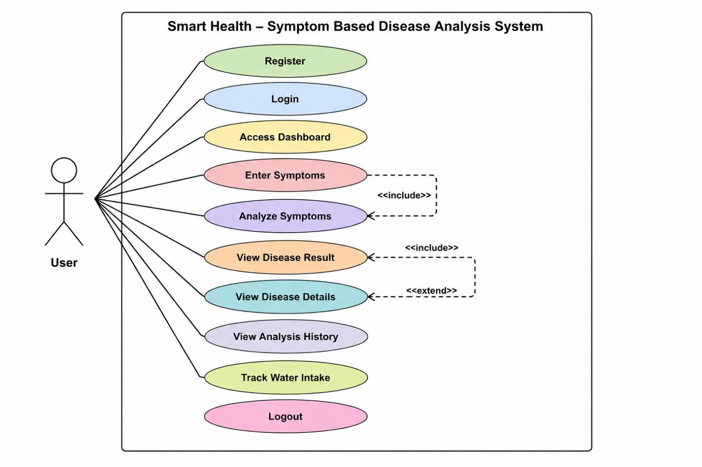
3.1
Use Case Diagram

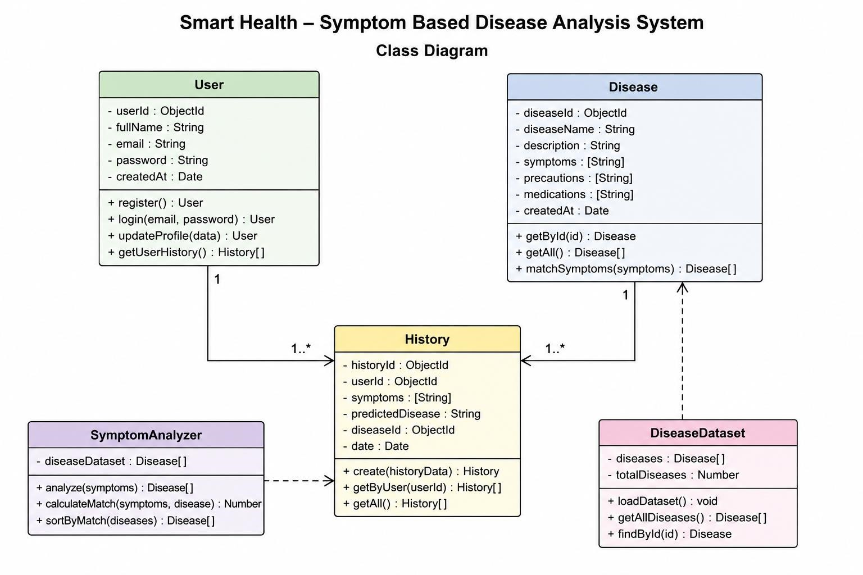
3.2
Class Diagram

3.3 Data Flow Diagram (DFD)
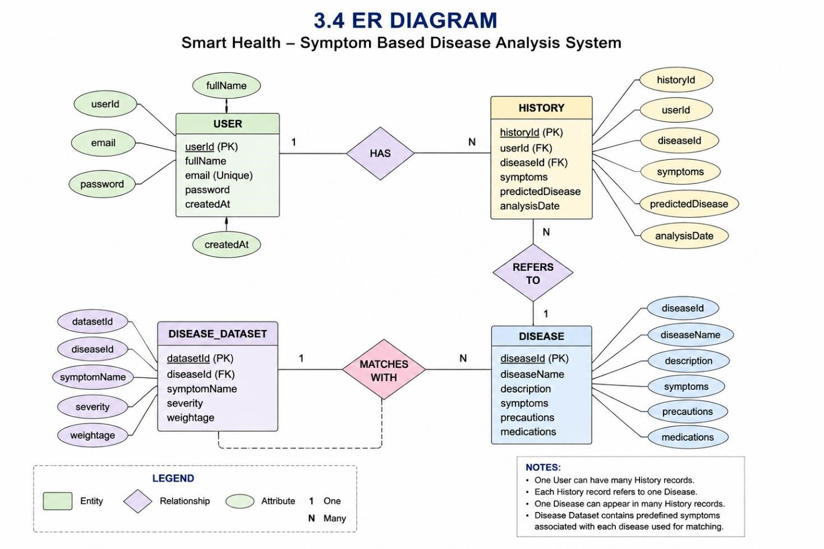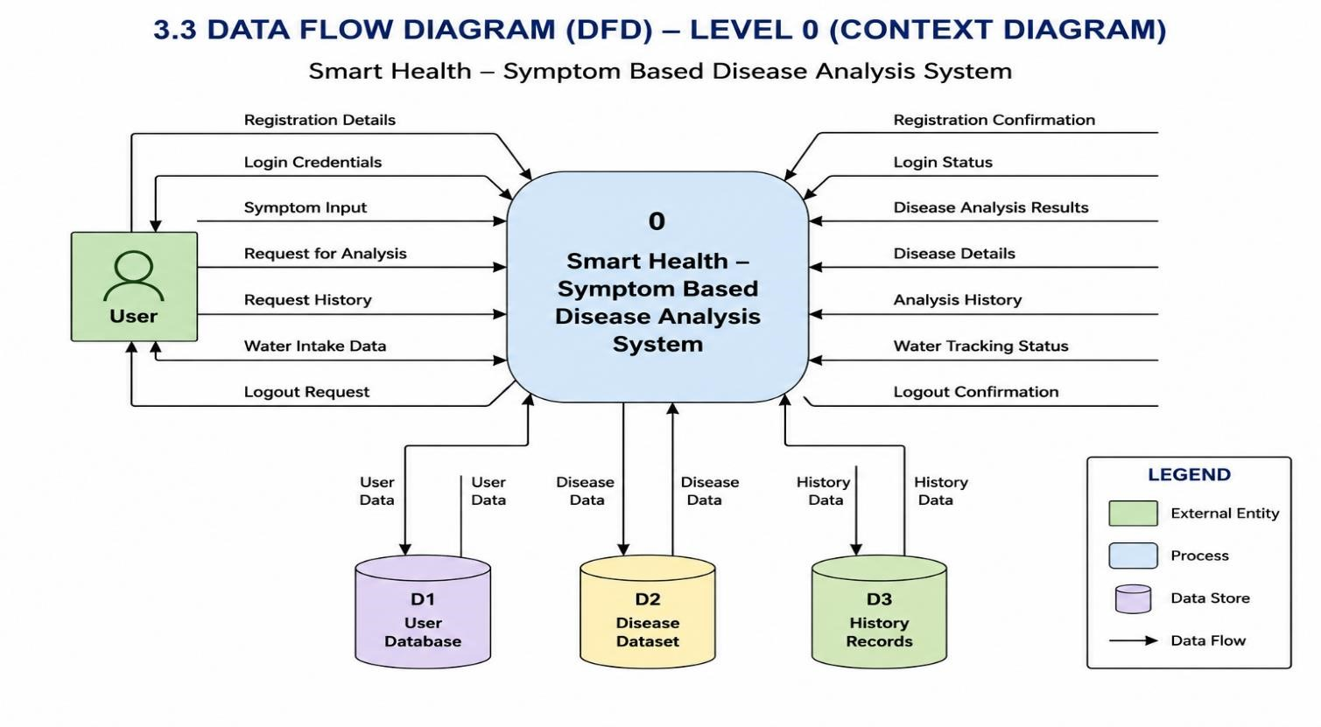
3.4
ER Diagram

3.5 Activity Diagram
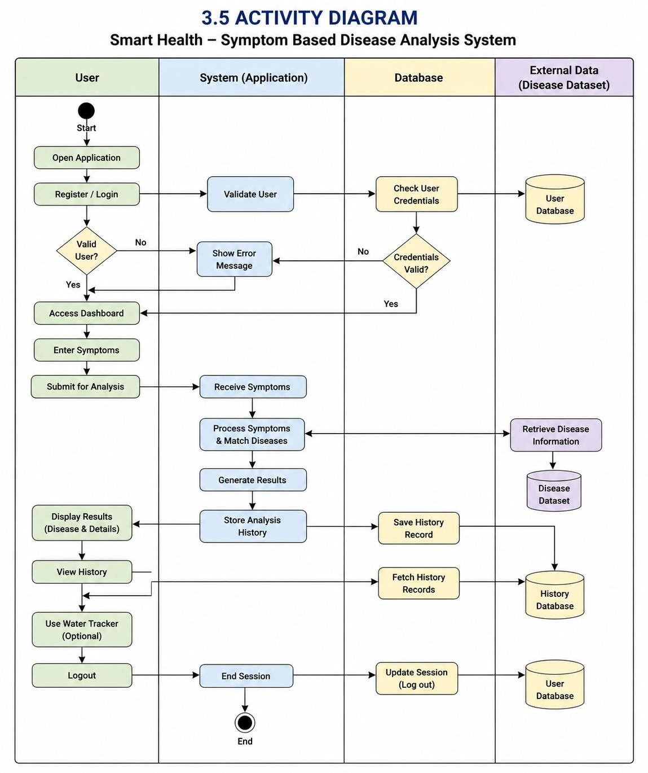

Chapter 4 : Implementation

4.1 Frontend Design

The frontend of the Smart Health – Symptom Based Disease Analysis System is designed to provide
an interactive, responsive, and user-friendly interface for users. The frontend serves as the communication layer between users and the backend system, enabling users to access various functionalities such as registration, login, symptom analysis, result viewing, history management, and health tracking.
The system consists of multiple web pages that work together to provide a complete user experience:

1. Home Page (index.html)
The Home Page serves as the entry point of the application. It introduces users to the Smart Health System and provides options for user authentication and navigation. The page is designed with an attractive layout and responsive interface.

2. User Authentication Module
The authentication module includes registration and login functionality. Users can create new accounts and securely access the system using their credentials. Authentication-related operations are handled through JavaScript and backend API integration.

3. Symptom Analysis Page (symptoms.html)
This page allows users to enter or select symptoms for disease analysis. The interface is designed to collect symptom information efficiently and submit it to the backend for processing.

4. Result Page (result.html)
After symptom analysis, the result page displays the possible disease suggestions generated by the system. Disease-related information is presented in a clear and organized format to improve user understanding.

5. Dashboard Page (dashboard.html)
The dashboard acts as the central navigation area of the application. It provides access to major functionalities such as symptom analysis, history viewing, and water tracking.

6. Confirmation Page (confirmation.html)
The confirmation page is used to display successful completion messages and user notifications for various operations performed within the system.

7. User Profile
The frontend design follows responsive web design principles to ensure compatibility across different screen sizes and devices. CSS styling is used to maintain consistency, readability, and an improved user experience.

Frontend Technologies Used

Technology | Purpose
HTML5 | Structure of web pages
CSS3 | Styling and responsive design
JavaScript | Client-side logic and interactions
DOM Manipulation | Dynamic content updates
Fetch API | Communication with backend APIs
The frontend architecture is designed to provide smooth navigation, efficient user interaction, and seamless integration with the backend services of the Smart Health – Symptom Based Disease Analysis System.

4.2 Backend Design
The backend of the Smart Health – Symptom Based Disease Analysis System is responsible for processing user requests, managing application logic, handling authentication, analyzing symptoms, retrieving disease information, and maintaining user history records. The backend acts as the core component of the system by establishing communication between the frontend interface and the data sources.
The backend is developed using Node.js and Express.js, which provide a lightweight and efficient environment for handling HTTP requests and implementing server-side functionality. The backend architecture follows a modular approach, where different functionalities are separated into models, routes, datasets, and utility components to improve maintainability and scalability.

1. Server Management
The main server is implemented using server.js, which initializes the Express application, configures middleware, and manages API routes. The server receives requests from the frontend and sends appropriate responses after processing the required operations.

2. User Authentication Module
The authentication module manages user registration and login functionality. It validates user credentials and controls access to protected features of the system.
Authentication Components:
- User Registration
- User Login
- User Validation
- Session Management
- Logout Functionality
Related Files:
- User.js
- authRoutes.js

3. Symptom Analysis Module
The symptom analysis module is the core functionality of the system. It receives symptoms entered by users and compares them with disease datasets stored in JSON files. Based on symptom matching logic, the system identifies possible diseases and generates results.
Functions Performed:
- Receive user symptoms
- Process symptom data
- Compare symptoms with disease datasets
- Generate disease suggestions
- Return analysis results to frontend

4. Disease Management Module
The disease management module retrieves disease-related information from the dataset and provides detailed disease information when required.
Functions Performed:
- Disease data retrieval
- Disease detail management
- Disease information display support

5. History Management Module
The history management module stores and retrieves previous symptom analysis records performed by users. This enables users to review their past health assessments.
Functions Performed:
- Save analysis history
- Retrieve previous records
- Display user history

6. Data Management
The system utilizes structured JSON datasets to store disease information and symptom mappings. These datasets are processed dynamically by backend APIs during symptom analysis.
Dataset Files:
- diseases.json
- diseaseDetails.json
- followUpQuestions.json
The use of JSON datasets allows easy maintenance and modification of disease-related information without changing the application logic.

7. API Routing
The backend follows a route-based architecture using Express.js. Different routes are responsible for handling specific application functionalities.
Route Module | Purpose
authRoutes.js | User authentication operations
symptomRoutes.js | Symptom analysis processing
diseaseRoutes.js | Disease information retrieval
historyRoutes.js | History management operations

8. Backend Workflow
The backend workflow operates as follows:
- The user submits a request from the frontend.
- The request is received by the Express server.
- The appropriate route processes the request.
- Required datasets or models are accessed.
- Symptom analysis or data retrieval is performed.
- The generated result is returned to the frontend.
- The frontend displays the response to the user.

8. Backend Technologies Used
Technology | Purpose
Node.js | Server-side runtime environment
Express.js | Web application framework
JavaScript | Backend programming language
JSON | Disease and symptom datasets
REST APIs | Communication between frontend and backend
The backend architecture of the Smart Health – Symptom Based Disease Analysis System is designed to provide efficient symptom analysis, secure user management, organized data processing, and seamless integration with the frontend interface. The modular structure ensures easy maintenance and future expansion of the system.

4.3 Screenshots of Website
The following screenshots illustrate the various interfaces and functionalities of the Smart Health – Symptom Based Disease Analysis System.
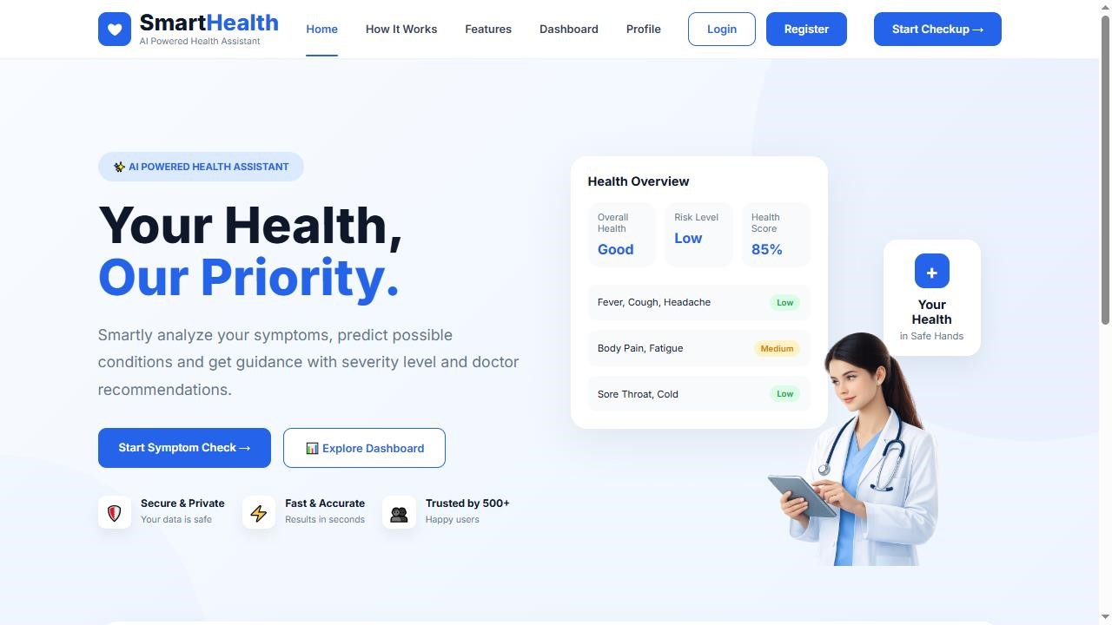
Figure 4.
3.
1
Home Page

Description:
The Home Page serves as the entry point of the application. It provides information about the Smart Health System and allows users to access registration and login functionalities. The page is designed with a responsive and user-friendly interface.
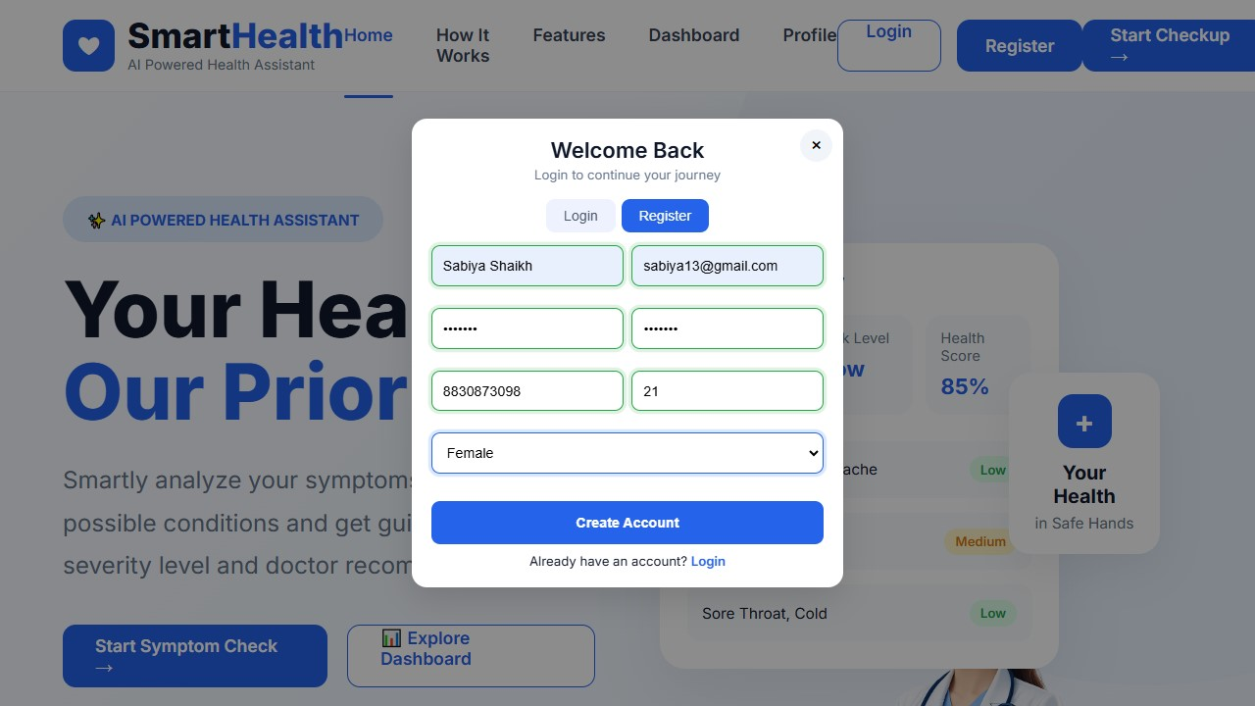
F
igure 4
.3
.2
User Registration Page

Description:
The Registration Page allows new users to create an account by providing the required details. The system validates user information before successful registration.

Figure 4.3.3 User Login Page
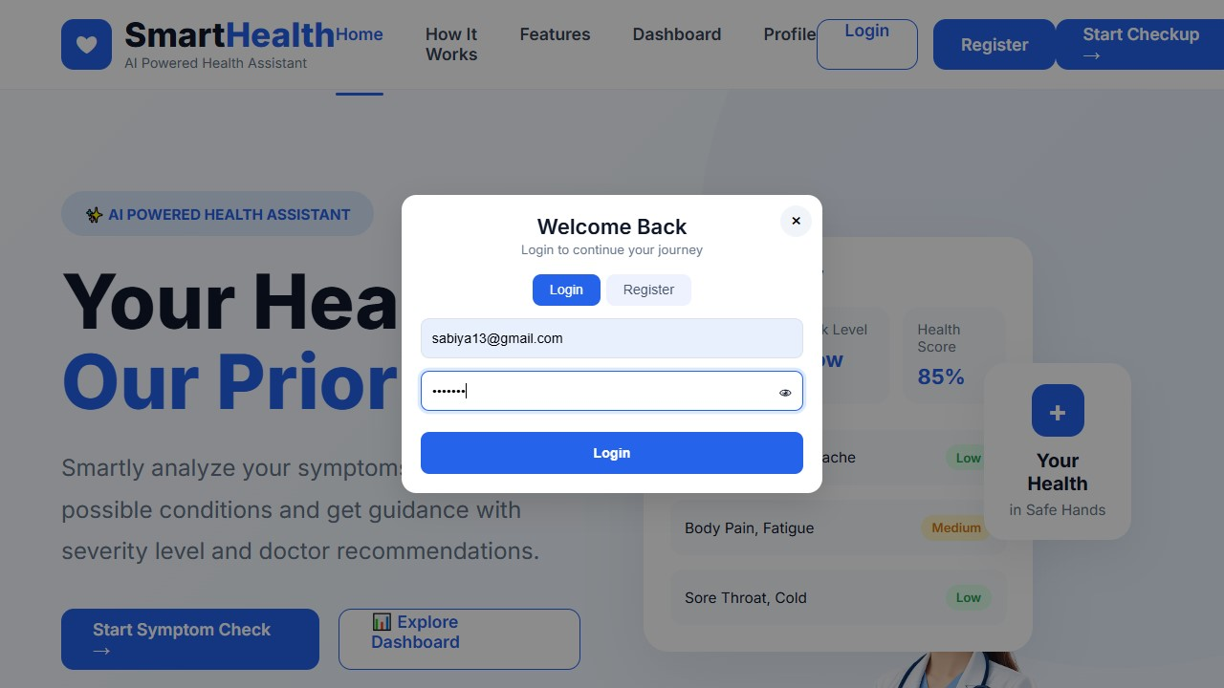
Description:
The Login Page enables registered users to access the system securely using their credentials. User authentication is performed through backend validation.
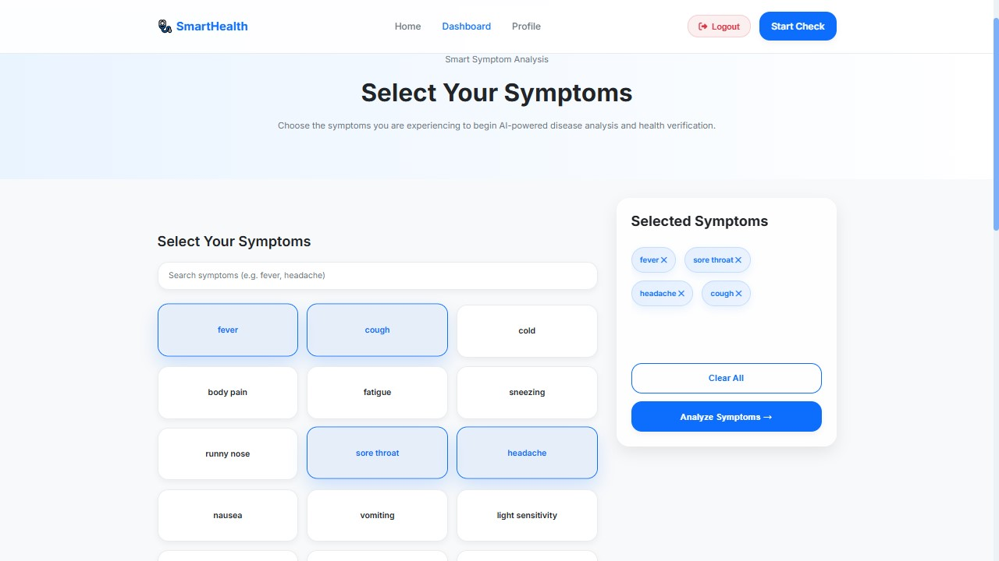
Figure 4.
3.
4

Symptom Analysis Page

Description:
The Symptom Analysis Page allows users to enter or select symptoms for disease prediction. The collected symptoms are sent to the backend for processing and analysis.
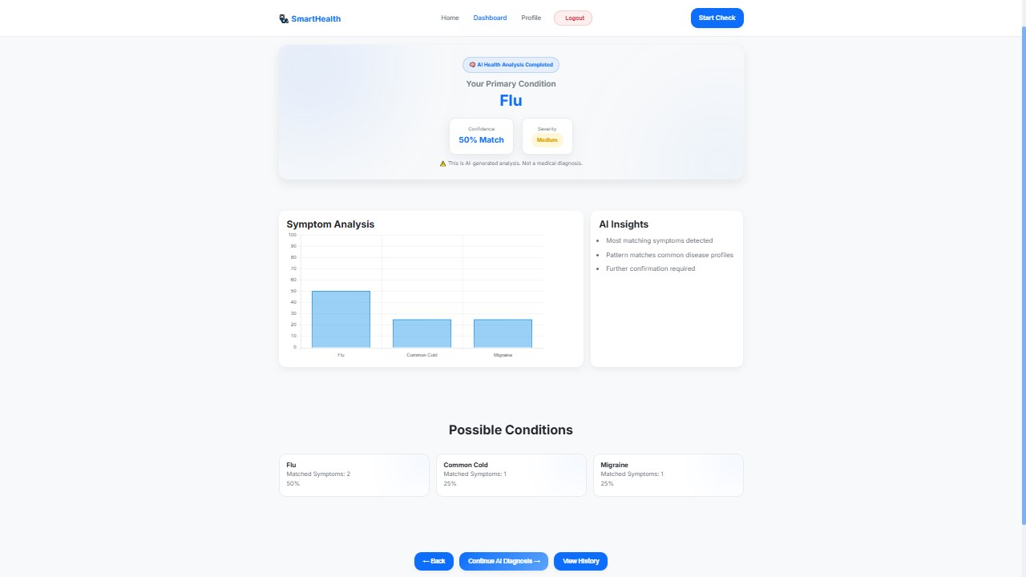
Figure 4.
3.
5

Disease Result Page

Description:
The Result Page displays possible diseases identified by the system based on the symptoms entered by the user. Relevant disease information and analysis results are presented in an organized manner.

Figure 4.3.6 Confirmation Page
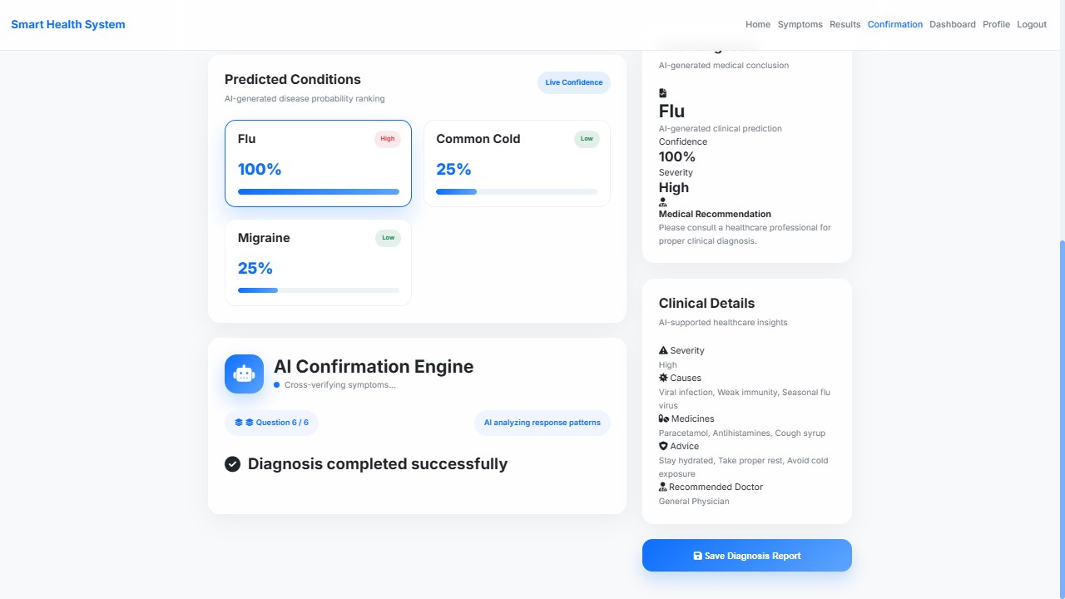

Description:
The Confirmation Page displays successful operation messages and confirms the completion of specific user actions within the application.
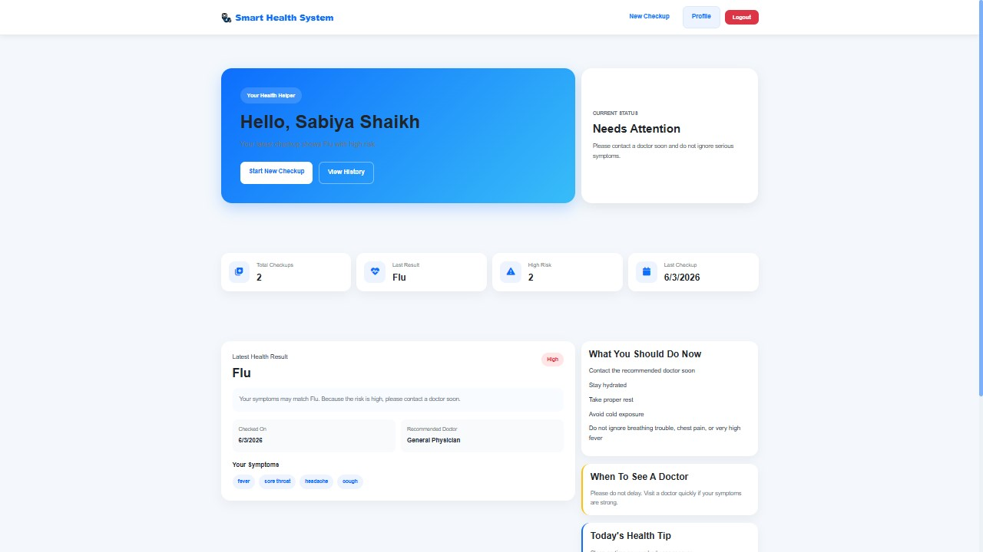
Figure 4.
3.
7

Dashboa
rd Page

Description:
The Dashboard serves as the central navigation area of the application. Users can access symptom analysis, history management, and health-tracking features from this page.

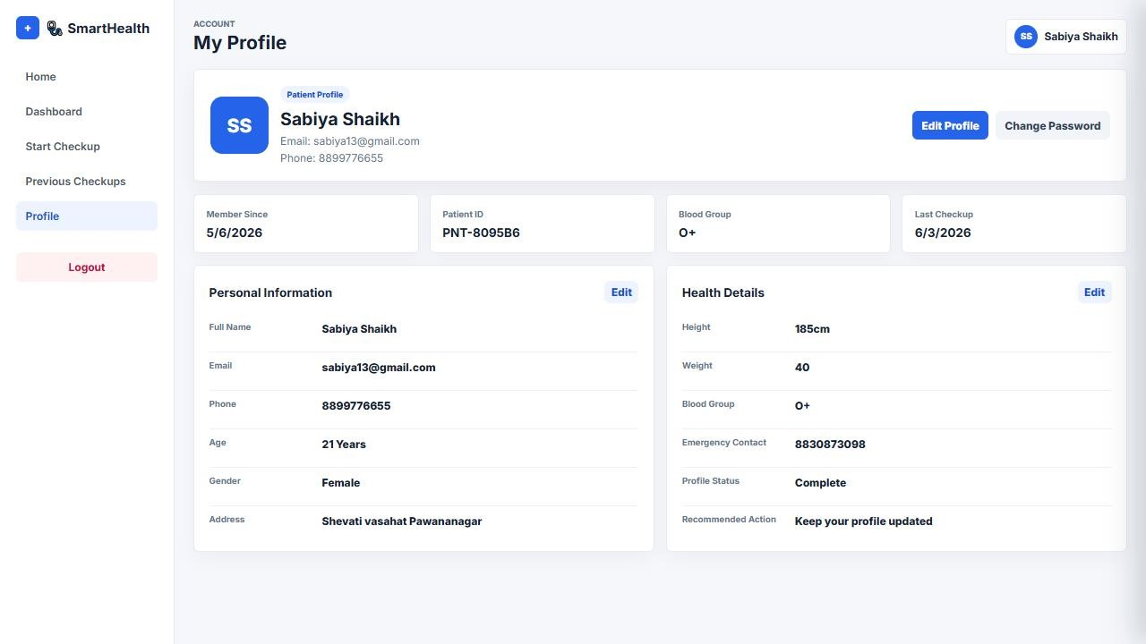
Figure 4.
3.
8

User Profile

Page

Description:
The History Page allows users to view previously performed symptom analyses. This feature helps users review their past health assessments and disease suggestions.
The screenshots presented above demonstrate the major functionalities of the Smart Health – Symptom Based Disease Analysis System and validate the successful implementation of the application's frontend and backend components.

4Test Cases
Test  Case ID | Test Scenario | Test Input | Expected Result | Actual Result | Status
TC-01 | User Registration with valid details | Valid Name, Email,  Password, Phone, Age,  Gender | User account should be created successfully | Account created successfully | Pass
TC-02 | User Registration with existing email | Existing Email ID | Registration should be rejected | Registration rejected | Pass
TC-03 | Login with valid credentials | Registered Email and Password | User should login successfully | Login successful | Pass
TC-04 | Login with invalid credentials | Incorrect Email or Password | Login should fail and display error message | Error displayed | Pass
TC-05 | Access Dashboard after login | Valid logged-in user | Dashboard should open successfully | Dashboard opened | Pass
TC-06 | Submit symptoms for analysis | Fever, Headache, Cough | System should process symptoms | Symptoms processed | Pass
TC-07 | Disease Prediction | Valid symptom combination | Possible disease should be displayed | Disease displayed | Pass
TC-08 | View Disease Details | Click disease result | Disease details should be shown | Details displayed | Pass
TC-09 | View Analysis History | Logged-in user | Previous analysis records should be displayed | History displayed | Pass
TC-10 | Save Analysis History | Complete symptom analysis | Analysis should be stored in history | History saved | Pass
TC-11 | Logout Functionality | Click Logout button | User session should end  and redirect to login/home page | Logout successful | Pass
TC-12 | Access Protected Page without Login | Open dashboard directly | System should deny access or redirect | Redirected successfully | Pass
TC-13 | Empty Symptom Submission | No symptoms selected | Validation message should appear | Validation message displayed | Pass
TC-14 | Server Response Test | Request symptom analysis API | API should return valid response | Response received | Pass

Chapter 5: Conclusion And Future Scope

5.1 Conclusion
The Smart Health – Symptom Based Disease Analysis System was successfully designed and implemented as a web-based application that provides basic health guidance based on symptoms entered by users. The project demonstrates the practical application of full-stack web development technologies by integrating frontend interfaces, backend processing, user authentication, data management, and symptom analysis functionalities into a single system.
The application enables users to register, log in, enter symptoms, receive possible disease suggestions, view previous analysis history, and monitor daily water intake. The system processes user symptoms using predefined disease datasets and generates results through a rule-based symptom matching approach. The modular architecture of the project ensures proper separation of frontend, backend, routes, models, and datasets, making the system easy to understand and maintain.
The project successfully achieved its primary objectives of developing an interactive healthcare awareness platform, implementing symptom-based disease analysis, and demonstrating real-world web application development concepts. The system provides a user-friendly interface, efficient backend processing, and organized data handling, thereby improving accessibility to basic health-related information.
Although the application is intended for educational and awareness purposes rather than professional medical diagnosis, it effectively showcases how modern web technologies can be utilized to develop practical healthcare solutions. The successful completion of this project has enhanced understanding of frontend development, backend integration, API handling, data management, and full-stack application architecture.

5.2 Future Scope
The current version of the Smart Health – Symptom Based Disease Analysis System provides symptom-based disease suggestions using predefined datasets and rule-based analysis. However, there are several opportunities for future enhancements that can improve the accuracy, functionality, and overall usefulness of the system.
The future scope of the project includes:

1. Machine Learning-Based Disease Prediction
Advanced machine learning algorithms can be integrated to improve disease prediction accuracy by learning from large medical datasets and symptom patterns.

2. Doctor Consultation Module
A doctor consultation feature can be added to allow users to connect with healthcare professionals directly through the platform.

3. Appointment Booking System
The system can be extended to support online appointment scheduling with hospitals, clinics, and medical practitioners.

4. Medicine Recommendation Support
Basic medicine information and precautionary guidance can be provided under proper medical supervision and validation.

5. Health Report Generation
Users can be provided with downloadable health assessment reports in PDF format for future reference.

6. Real-Time Health Monitoring
Integration with wearable devices and health monitoring sensors can enable real-time collection of health-related data.

7. Expanded Disease Database
The disease dataset can be expanded to include a larger number of diseases, symptoms, and medical conditions for broader coverage.
In conclusion, the Smart Health – Symptom Based Disease Analysis System provides a strong foundation for future healthcare-related applications and can be enhanced further using modern technologies such as Artificial Intelligence, Machine Learning, Cloud Computing, and Mobile Development.

Bibliography
The following books, online resources, documentation, and learning materials were referred to during the analysis, design, development, and implementation of the Smart Health – Symptom Based Disease Analysis System.

Books
- Kogent Learning Solutions Inc., HTML 5 Black Book, Dreamtech Press, New Delhi.
- Steven Holzner, JavaScript Programming: The Complete Reference, McGraw-Hill Education

Online Documentation and References
- Node.js Official Documentation
- Express.js Official Documentation
- MDN Web Docs (HTML, CSS, JavaScript)
- W3Schools Web Development Tutorials
- Visual Studio Code Documentation
- npm Documentation

Datasets and Project Resources
- Disease and symptom datasets created and maintained within the project.
- Disease details dataset used for symptom-to-disease mapping.
- Follow-up question dataset used for improving disease analysis accuracy.
- Project source code, JSON datasets, frontend resources, and backend modules developed as part of the Smart Health – Symptom Based Disease Analysis System.

Software Tools Used
- Visual Studio Code
- Node.js Runtime Environment
- Express.js Framework
- HTML5
- CSS3
- JavaScript (ES6)
- JSON Data Format
- Google Chrome Browser

