App Store Submission Document
Project: Submit an iOS App to the Udacity App Store

Enter the information for each field in the table below

App Store Submission Required Information | Your Answers
This is the information required about your App | In this column, enter your answers and insert screenshots and images where needed.
Platforms | iOS (iPhone and iPad). Minimum deployment target: iOS 17.0.
App Name | OtterlyFit
Primary Language | English (U.S.)
Bundle ID | com.otterlyfit.workout
SKU | otterlyfit-ios-001
User Access | Full Access
iOS App Previews and Screenshots 1  iPhone 6.7” display  Screenshots must be in the JPG or PNG format, and in the RGB color space. | [PRIMARY · Physical iPhone] docs/screenshots/01-home.png (= device-01-home.png) — Home / OtterlyFit branding. Prefer over sim-01-home.png for App Store Connect.
iOS App Previews and Screenshots 2  iPhone 6.7” display  Screenshots must be in the JPG or PNG format, and in the RGB color space. | [PRIMARY · Physical iPhone] docs/screenshots/02-exercises.png (= device-02-exercises.png) — Exercise Library. Prefer over sim-02-exercises.png for App Store Connect.
iOS App Previews and Screenshots 3  iPhone 6.5” display  Screenshots must be in the JPG or PNG format, and in the RGB color space. | [PRIMARY · Physical iPhone] docs/screenshots/04-routine-detail.png (= device-05-routine-detail.png) — Routine detail: Morning Strength (Push-Up / Squat / Plank). Prefer over sim-04-routine-detail.png (Test2).
iOS App Previews and Screenshots 4  iPhone 6.5” display  Screenshots must be in the JPG or PNG format, and in the RGB color space. | [PRIMARY · iPhone 17 Pro Simulator] docs/screenshots/05-workout-player.png (= sim-05-workout-player.png) — Workout Player (Goblet Squat). No device equivalent yet.
iOS App Previews and Screenshots 5  iPhone 5.5” display  Screenshots must be in the JPG or PNG format, and in the RGB color space. | [PRIMARY · iPhone 17 Pro Simulator] docs/screenshots/06-scan-card.png (= sim-06-scan-card.png) — Card Scanner intro. No device equivalent yet.
iOS App Previews and Screenshots 6  iPhone 5.5” display  Screenshots must be in the JPG or PNG format, and in the RGB color space. | [PRIMARY · Physical iPhone] docs/screenshots/07-history.png (= device-06-history.png) — History with Complete workouts. Prefer over sim-07-history.png (weaker/Partial test data).
Promotional Text | Scan fitness cards, build routines, and train with voice-guided workouts — all offline on your iPhone.
Description | OtterlyFit turns physical fitness cards into a personal, offline workout coach.  Scan your cards  Use the camera or photo library to capture exercise cards. On-device Vision OCR reads the card so you can confirm details and add exercises to your library.  Build your library  Browse and edit exercises with muscle groups, equipment, difficulty, and card images. A starter set of exercises is included so you can train immediately.  Create reusable routines  Compose ordered workout routines with sets, reps, weight, rest between sets, and rest between exercises.  Train with a guided player  Play routines with timers, progress feedback, and spoken voice prompts for preparation, work, rest, and completion.  Track your history  Review completed workouts and statistics over time. Everything is stored locally with SwiftData — no account required.  Key features: card scan (VisionKit), on-device OCR (Vision), exercise library, routine builder, workout player with AVSpeechSynthesizer voice coaching, workout summary and history, offline-first.
Keywords | fitness,workout,exercise,card,scan,OCR,routine,timer,voice,gym,strength,training,offline,coach,reps
Support URL | https://www.otterlyfit.example/support [PLACEHOLDER — replace before real submission]
Version | 1.0 (Build 1)
Sign in Required  (Does your app require a login and password to review all of the app functionality?) | No. OtterlyFit does not require a login or password. All core features work without an account.
Notes  (Additional information about your app that can help during the review process. Include information that may be needed to test your app, such as app-specific settings.) | Thank you for reviewing OtterlyFit.  How to test:  1) Exercises tab — starter library with card images is seeded on first launch (Release included).  2) Routines — create/open a routine, add exercises, configure sets/reps/rest, save.  3) Start a workout — Workout Player uses on-device TTS voice prompts (no microphone). Finish to see Summary, then History.  4) Scan Card — on a device, Scan with Camera or import a photo of an exercise card; confirm and save.  Permissions: Camera (scan cards), Photo Library (import images).  Not used in 1.0: accounts/backend, HealthKit (stub only), microphone/speech recognition, analytics.  Demo account: N/A
Copyright | © 2026 OtterlyFit. All rights reserved.
Data Collection | No, we do not collect data from this app.  All fitness data, card images, and OCR results stay on device (SwiftData). No accounts, analytics, advertising, or network APIs. Camera/Photos are used only for on-device exercise card import. HealthKit is not active in 1.0. Voice coaching is local TTS (AVSpeechSynthesizer), not recording.  Data used to track you: No. Data linked to you: None. Privacy evidence (not for product page): docs/screenshots/privacy-photos-picker.png (system Photos picker / limited library). See also docs/App-Store-Submission.md.
Enter all of the data that you or your third-party partners collect from this app. | N/A — no data is collected or transmitted off device. Camera/photo access is used only for on-device exercise card import. Purposes: App Functionality (local only).
App Availablity | Available in all territories supported by the developer account (primary: United States).
Price Schedule/Starting Price | Free
In-App Purchase | None
Subscriptions | None

Appendix: Captured Screenshots
Primary App Store Connect uploads prefer Physical iPhone captures where available; iPhone 17 Pro Simulator fills Workout Player and Scan Card. See also docs/App-Store-Submission.md. Re-export at native ASC sizes if Connect rejects scaled PNGs.
Screenshot 1 — Home (PRIMARY · Physical iPhone · 6.7" slot)
File: docs/screenshots/01-home.png (= device-01-home.png). Replaces sim-01-home.png for marketing.
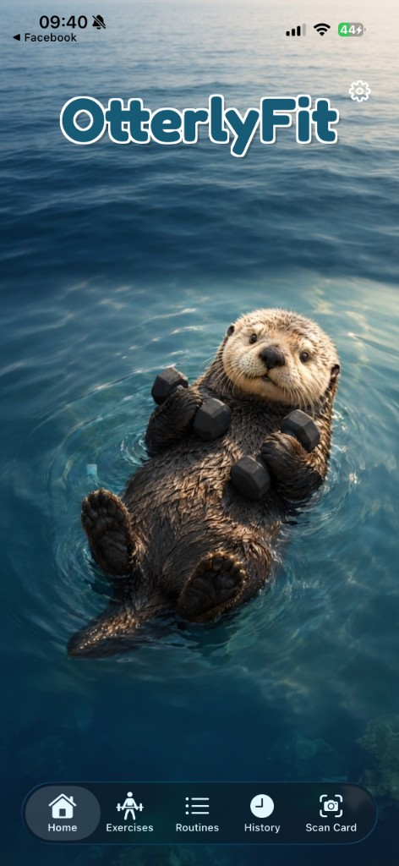
Screenshot 2 — Exercise Library (PRIMARY · Physical iPhone · 6.7" slot)
File: docs/screenshots/02-exercises.png (= device-02-exercises.png). Replaces sim-02-exercises.png for marketing.
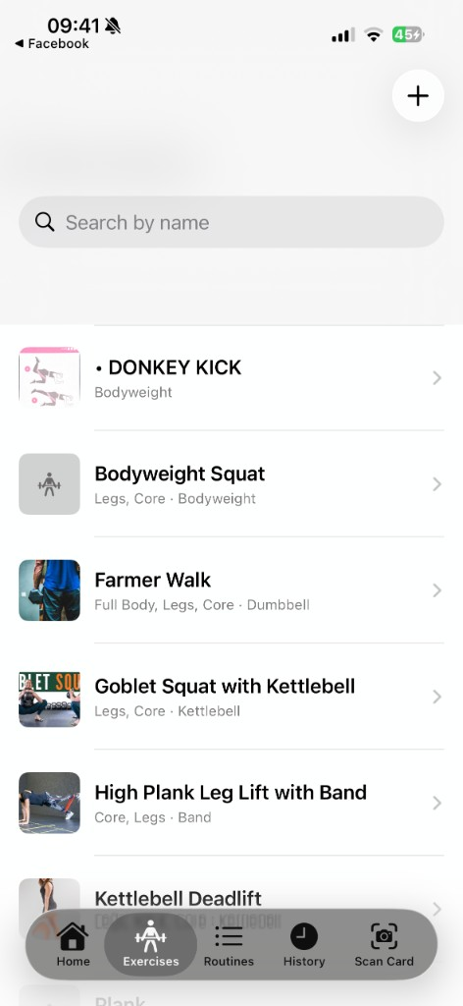
Extra — Exercise detail (Physical iPhone)
File: docs/screenshots/device-03-exercise-detail.png — High Plank Leg Lift with Band card image. Optional marketing/review extra.
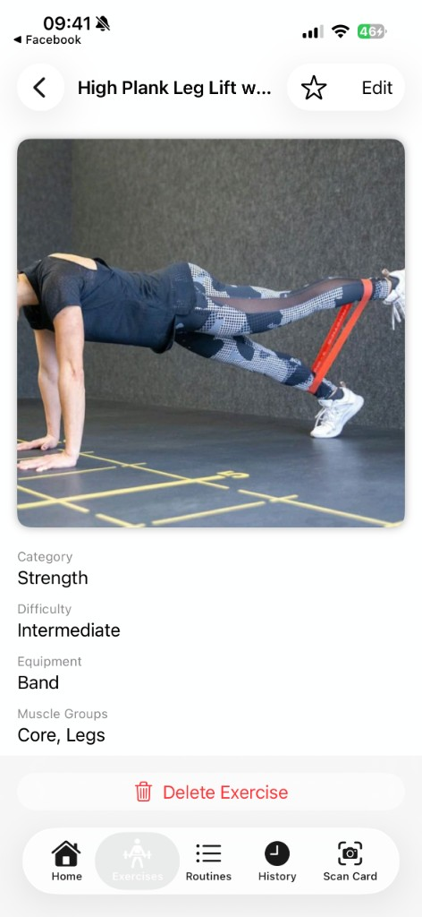
Optional — Routines list (Simulator extra)
File: docs/screenshots/03-routines.png (= sim-03-routines.png). Not a required Connect slot.
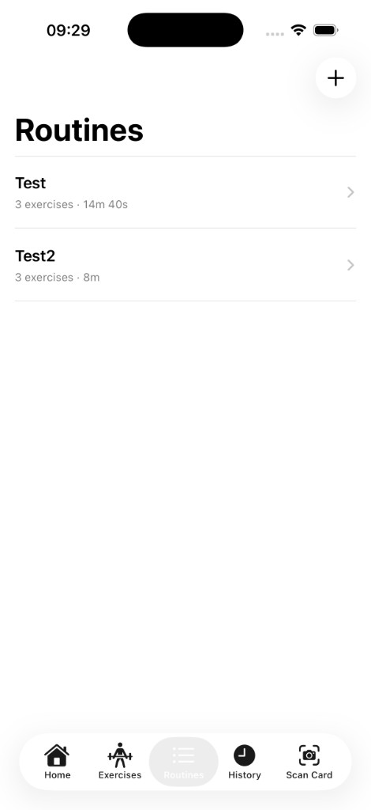
Screenshot 3 — Routine detail (PRIMARY · Physical iPhone · 6.5" slot)
File: docs/screenshots/04-routine-detail.png (= device-05-routine-detail.png) — Morning Strength. Replaces sim-04-routine-detail.png (Test2).
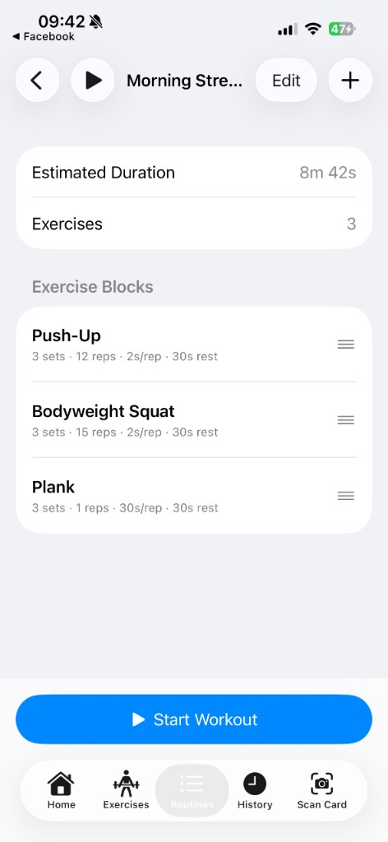
Extra — Edit Exercise (Physical iPhone · HIG / customization)
File: docs/screenshots/device-04-edit-exercise.png — Edit form for High Plank Leg Lift with Band.
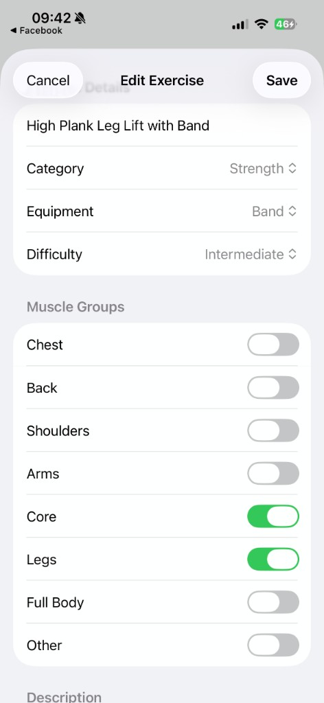
Screenshot 4 — Workout Player (PRIMARY · Simulator · 6.5" slot)
File: docs/screenshots/05-workout-player.png (= sim-05-workout-player.png). No device equivalent in this package.
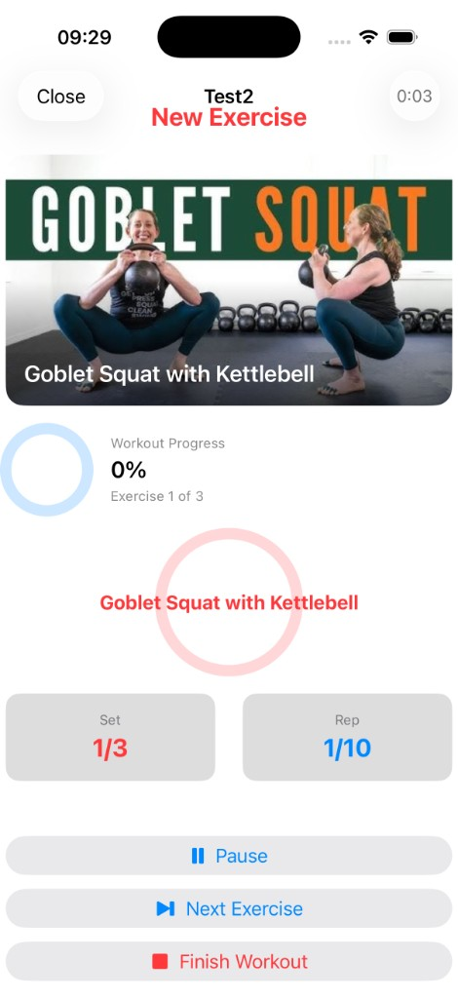
Screenshot 5 — Card Scanner (PRIMARY · Simulator · 5.5" slot)
File: docs/screenshots/06-scan-card.png (= sim-06-scan-card.png). No device equivalent in this package.
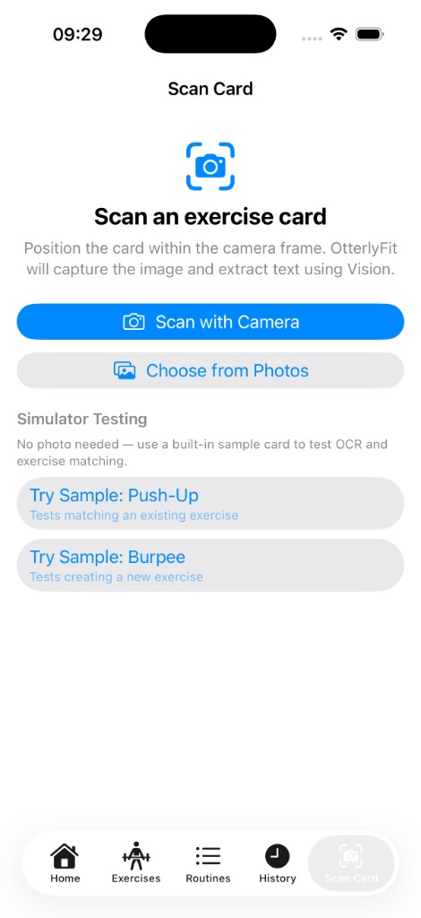
Screenshot 6 — History (PRIMARY · Physical iPhone · 5.5" slot)
File: docs/screenshots/07-history.png (= device-06-history.png) — Complete workouts. Replaces sim-07-history.png.
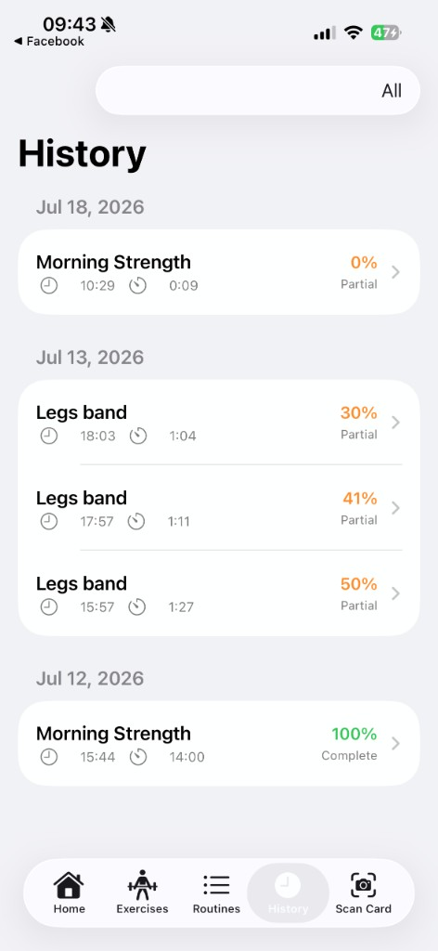
Simulator archive (superseded primaries)
Kept for comparison/fallback — do not prefer over device shots for Connect slots 1–3 and 6: sim-01-home.png, sim-02-exercises.png, sim-04-routine-detail.png, sim-07-history.png.
Archive — Home (Simulator)
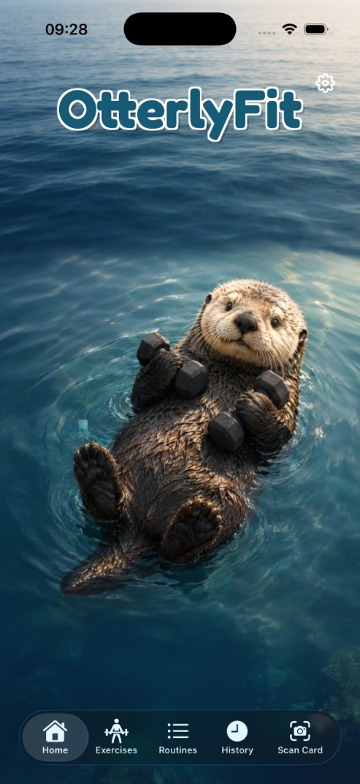
Archive — Exercises (Simulator)
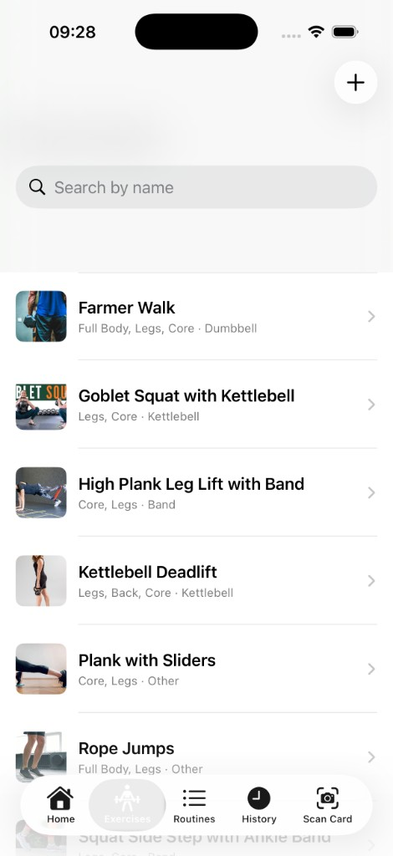
Archive — Routine detail Test2 (Simulator)
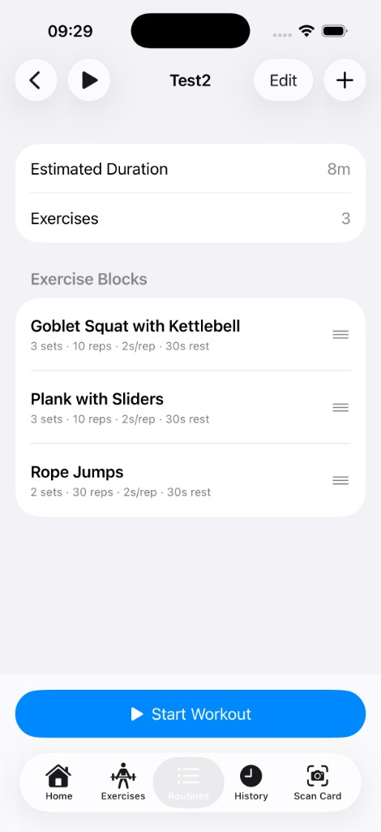
Archive — History Partial (Simulator)
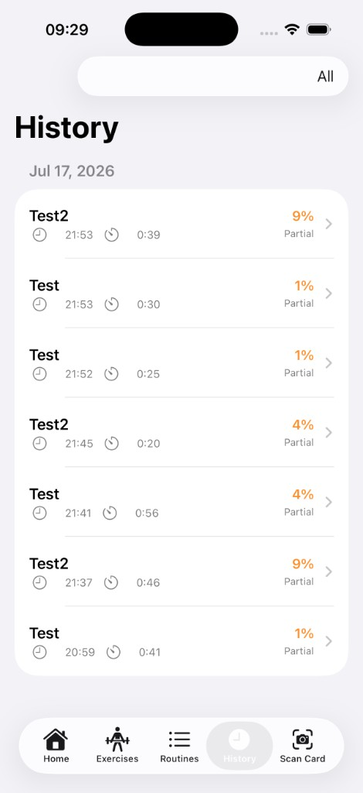
Privacy evidence (not App Store marketing)
File: docs/screenshots/privacy-photos-picker.png — system Photos picker showing limited library access.
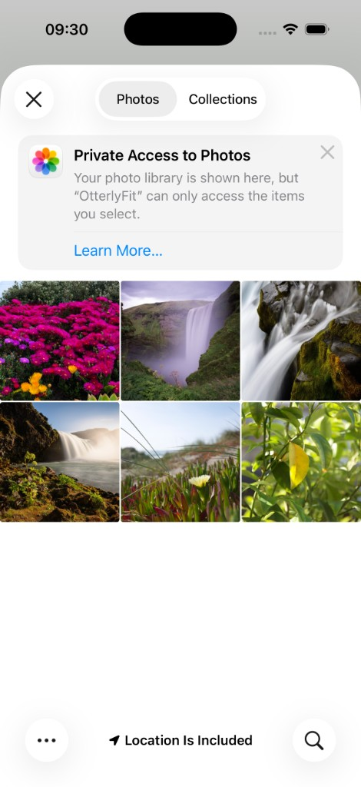
Xcode Configuration (not App Store marketing)
File: docs/screenshots/xcode-run-destination.png — Xcode run destination / scheme menu evidence for Archive readiness.
