PREDICTIVE ANALYTICS FOR HEALTHCARE:
FORECASTING PATIENT LENGTH OF STAY IN URBAN HOSPITALS
Project Report Submitted in fulfillment of the
Requirements for the Award of the Internship of
Summer Training Program by IDRA
Data Science and AI
By:
Name: Sabjot Sampla
Institute: GNDU Regional Campus Jalandhar
Institute Roll No.: 17032303328
Enrollment No.: IDRA-2026-739396
Under the Supervision of
Er. Neena Madan Davessar

Through the platform:

India Data Research Academy

DECLARATION
I hereby declare that the project report titled “Predictive Analytics for Healthcare: Utilizing Regression Models to Forecast Patient Length of Stay in Urban Hospitals” is my own work completed as part of the IDRA Summer Training Program. The analysis, data preprocessing, exploratory data analysis, machine learning implementation, model evaluation, and interpretation presented in this report were carried out by me. All external sources, datasets, references, and supporting materials used in this project have been appropriately acknowledged and cited wherever applicable. I further declare that the work presented in this report has not been submitted elsewhere for any other academic or professional qualification.

ACKNOWLEDGEMENT
I would like to sincerely express my gratitude to the India Data Research Academy (IDRA) for providing me with the opportunity to undertake this project as part of the Summer Training Program in Data Science and AI. The training and guidance provided during the program helped me strengthen my understanding of data analysis, exploratory data analysis, and machine learning techniques.
I am especially grateful to my supervisor, Er. Neena Madan Davessar for her valuable guidance, suggestions, and support throughout the project. I also thank my institute and faculty members for their encouragement and for providing the necessary academic support to complete this work.
I would also like to acknowledge the dataset/source providers whose data made this analysis possible. Finally, I am thankful to everyone who directly or indirectly supported me during the completion of this project and contributed to my learning and development.

ABSTRACT

This project develops a predictive analytics approach for estimating patient length of stay in urban hospital settings. The analysis uses the supplied LengthOfStay.csv dataset containing 61,680 observations and 28 original columns, with lengthofstay as the numerical target measured in days. The workflow includes data-quality assessment, date conversion, duplicate and target validation, outlier assessment, exploratory data analysis, statistical summaries, feature engineering, preprocessing, and regression modelling. Admission-date components were derived from vdate, rcount was converted to a numeric representation, and identifier and post-outcome information were excluded to reduce leakage risk. Three regression approaches were compared: Linear Regression, Gradient Boosting Regressor, and CatBoost Regression. On the held-out 20% test set, CatBoost achieved the lowest RMSE of 0.4007, MAE of 0.2948, MSE of 0.1606, and R² of 0.9707. The results indicate that the nonlinear CatBoost model captured the relationships in this dataset more effectively than the two comparison models. Exploratory analysis also showed substantial differences in average length of stay across hospital facilities and a strong association between the engineered record-count variable and the target. The study provides an evidence-based predictive framework for analysing patient stay duration while recognizing that the results are specific to the supplied dataset and modelling setup.
Keywords: Predictive Analytics; Healthcare Analytics; Length of Stay; Regression; CatBoost; Exploratory Data Analysis

TABLE OF CONTENTS
1. Introduction
2. Problem Statement and Motivation
3. Objectives
4. Research Questions
5. Dataset Description and Data Understanding
6. Data Cleaning
7. Data Preprocessing
8. Exploratory Data Analysis
9. Statistical Analysis
10. Feature Engineering
11. Model Development
12. Model Evaluation
13. Results and Findings
14. Discussion
15. Limitations
16. Conclusion
17. Recommendations and Future Work
18. References
Appendix A. Code
Appendix B. Additional Figures and Tables
Table of contents follows the original IDRA template structure.

1. INTRODUCTION

1.1 Background
Patient length of stay is an important operational measure in healthcare because it is linked to bed occupancy, discharge planning, staffing, resource allocation, and hospital workflow. A reliable estimate of expected stay duration can support earlier operational planning and help analysts understand which patient and facility characteristics are associated with longer stays. This project treats length of stay as a numerical prediction problem and evaluates whether patient, clinical, operational, facility, and admission-date information can be used to estimate the outcome.

1.2 Context of the Problem
The practical setting is an urban-hospital environment represented by the supplied patient dataset. Relevant stakeholders include hospital operations teams, clinical support teams, data analysts, and administrators who may use predictive information for capacity and planning decisions. The analysis focuses on patterns present in the historical dataset; it is not intended to replace clinical judgement or provide patient-specific medical advice.

1.3 Scope of the Study
The study covers data quality assessment, exploratory and statistical analysis, feature engineering, regression modelling, model comparison, and diagnostic evaluation. It does not establish causal relationships, validate the model prospectively in a hospital, or claim that the model can generalize to hospitals or populations outside the supplied dataset without additional validation.

2. PROBLEM STATEMENT AND MOTIVATION
How accurately can patient length of stay be predicted from the available patient, clinical, facility, and admission-related variables, and which patterns in the dataset are most useful for understanding variation in length of stay? The motivation is to develop a reproducible analytical workflow that combines interpretable exploratory findings with a predictive regression model.

3. OBJECTIVES
- To assess the quality, structure, and statistical characteristics of the supplied LengthOfStay.csv dataset.
- To identify important relationships, group differences, and patterns associated with patient length of stay.
- To engineer admission-date and record-count features that can be used effectively for regression modelling.
- To develop and compare Linear Regression, Gradient Boosting, and CatBoost regression models.
- To evaluate predictive performance using MAE, MSE, RMSE, and R² on an unseen test set.

4. RESEARCH QUESTIONS
- What are the major characteristics and data-quality issues in the supplied patient dataset?
- Which variables show the strongest observed associations with length of stay?
- How does average length of stay vary across hospital facilities and admission periods?
- How well do Linear Regression, Gradient Boosting, and CatBoost predict length of stay on unseen data?
- Does the selected model show evidence of substantial overfitting when training and test performance are compared?

DATASET DESCRIPTION AND DATA UNDERSTANDING

5.1 Data Source
The analysis uses LengthOfStay.csv supplied for the IDRA capstone project. The notebook does not record an external publication URL or separate licensing statement for the CSV; therefore, no external dataset attribution beyond the supplied project file is asserted here. The dataset was loaded directly into the Google Colab workflow used for this project.

5.2 Dataset Size and Structure
The raw dataset contains 61,680 rows and 28 columns. The target variable is lengthofstay, an integer-valued duration in days ranging from 1 to 17. The dataset includes patient characteristics, binary condition indicators, laboratory/vital-sign variables, facility information, admission/discharge dates, and record-count information. After feature engineering and leakage/identifier exclusions, the modelling matrix contains 29 input features and the target remains lengthofstay.

Table 1. Summary of the Dataset
Item | Value | Description | Role
Observations | 61,680 | Patient-level records | Dataset
Original columns | 28 | Variables before feature engineering | Dataset
Target | lengthofstay | Length of stay in days | Target
Model features | 29 | Final predictors after engineering/exclusions | Features
Train / test | 49,344 / 12,336 | 80% / 20% split, random_state=42 | Evaluation

5.3 Data Dictionary
The following compact dictionary highlights the variables most relevant to the project narrative. The complete 28-column structure is documented in the notebook-generated data dictionary.
Table 2. Data Dictionary

Variable | Meaning in analysis | Type | Role
lengthofstay | Patient length of stay in days | Integer | Target
rcount | Record-count category, including 5+ | Categorical | Source feature
facid | Hospital facility identifier/category A-E | Categorical | Feature
gender | Patient gender category F/M | Categorical | Feature
hematocrit | Recorded hematocrit-related measure | Numeric | Feature
neutrophils | Neutrophil-related laboratory measure | Numeric | Feature
sodium | Serum sodium measurement | Numeric | Feature
glucose | Glucose measurement | Numeric | Feature
bloodureanitro | Blood urea nitrogen-related measure | Numeric | Feature
creatinine | Creatinine measurement | Numeric | Feature
bmi | Body-mass-index measurement | Numeric | Feature
pulse | Pulse measurement | Numeric | Feature
respiration | Respiration measurement | Numeric | Feature
hemo | Hemoglobin-related indicator | Binary | Feature
secondarydiagnosisnonicd9 | Secondary-diagnosis count/category | Integer | Feature
vdate | Admission date | Date | Source / engineered
discharged | Discharge date | Date | Excluded: leakage risk
eid | Record identifier | Integer | Excluded: identifier

6. DATA CLEANING
The raw dataset was checked for missing values, duplicate records, inconsistent categorical values, date validity, target validity, and potential outliers. The executed notebook found no missing values, no duplicate rows, no non-positive target values, and no invalid dates after conversion. Categorical values were checked and normalized for gender and facility labels. The rcount variable contained six values: 0, 1, 2, 3, 4, and 5+.

6.1 Missing Values
All 28 original columns contained zero missing values (0.0%). Even though the raw dataset had no missing entries, the modelling pipelines for Linear Regression and Gradient Boosting retained training-data-fitted imputers as a defensive preprocessing step. CatBoost handled numeric values natively and categorical columns were explicitly converted to strings with a Missing fallback.

6.2 Duplicate Records
No duplicate rows were found. The dataset remained at 61,680 rows after duplicate handling, so no observations were removed for duplication.

6.3 Data Types and Inconsistent Values
The vdate and discharged columns were converted to datetime values with zero invalid/missing results after conversion. Gender and facility categories were stripped of surrounding whitespace and normalized to uppercase. The rcount categories were inspected and retained as source information before creating the numeric rcount_num representation.

6.4 Outlier Handling
For lengthofstay, Q1 = 2 days, Q3 = 6 days, and IQR = 4 days, producing IQR bounds of -4 to 12 days. Eighty-three observations were flagged as potential IQR outliers because they exceeded 12 days. These values were not removed because they were valid positive length-of-stay observations; deleting them solely because of a statistical rule could remove meaningful high-stay cases.

6.5 Before vs After Cleaning
Measure | Before cleaning | After cleaning | Change
Rows | 61,680 | 61,680 | No change
Columns | 28 | 28 | No change
Duplicate rows | 0 | 0 | No change
Total missing values | 0 | 0 | No change
Non-positive target values | 0 | 0 | No change

7. DATA PREPROCESSING
The cleaned data were separated into predictors and the target before modelling. An 80/20 random split with random_state=42 produced 49,344 training observations and 12,336 testing observations. For Linear Regression and Gradient Boosting, numerical variables were median-imputed and standardized, while categorical variables were most-frequent-imputed and one-hot encoded inside scikit-learn pipelines. CatBoost used the original categorical columns directly and handled numerical missing values natively. Feature preparation was performed using the training partition for model-fitting transformations, while the test partition remained unseen for final evaluation.

7.1 Categorical Encoding
The categorical predictors were gender and facid. For the Linear Regression and Gradient Boosting pipelines, they were processed using most-frequent imputation followed by OneHotEncoder(handle_unknown='ignore'). For CatBoost, these columns were passed as categorical features after conversion to string values.

7.2 Feature Scaling and Transformation
Linear Regression and Gradient Boosting used StandardScaler for numerical predictors because these models were evaluated through a common preprocessing pipeline. CatBoost did not require standardization and was allowed to model the numerical predictors directly.

7.3 Train-Test Split
The dataset was divided into 80% training and 20% testing data using train_test_split with random_state=42. The discharge date was excluded because it is recorded after the patient's stay and therefore can contain post-outcome information. The record identifier eid was also excluded because it is an identifier rather than a meaningful predictor. The raw admission date and original rcount representation were replaced by engineered variables.

7.4 Final Feature Set
The final feature matrix contains 29 predictors: gender, dialysisrenalendstage, asthma, irondef, pneum, substancedependence, psychologicaldisordermajor, depress, psychother, fibrosisandother, malnutrition, hemo, hematocrit, neutrophils, sodium, glucose, bloodureanitro, creatinine, bmi, pulse, respiration, secondarydiagnosisnonicd9, facid, admit_year, admit_month, admit_day, admit_dayofweek, admit_quarter, and rcount_num. The target is lengthofstay.

8. EXPLORATORY DATA ANALYSIS
The EDA was designed around the project questions: distribution of the target, facility-level differences, a clinical/operational relationship involving the hemo indicator, numerical correlation structure, and admission-month variation. The selected figures are retained because each addresses a specific analytical question.

8.1 Univariate Analysis
code

plt.figure(figsize=(9, 5))
sns.histplot(df["lengthofstay"], bins=17, kde=True)
plt.title("Distribution of Patient Length of Stay")
plt.xlabel("Length of Stay (days)")
plt.ylabel("Number of Patients")
plt.tight_layout()
plt.show()

print("Mean:", round(df["lengthofstay"].mean(), 3))
print("Median:", round(df["lengthofstay"].median(), 3))

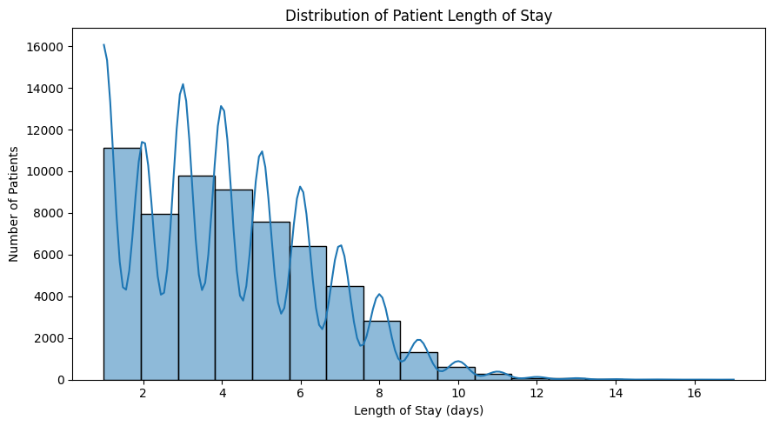
Figure 1. Distribution of Patient Length of Stay
The target distribution is centered at 4 days, with a mean of 3.999 days and a median of 4 days. Values range from 1 to 17 days. The concentration around the central values indicates that short stays are common, while a smaller number of longer stays extend the distribution to the right.

8.2 Categorical Analysis
facility_summary = (
df.groupby("facid")["lengthofstay"]
.agg(["count", "mean", "median"])
.sort_values("mean", ascending=False)
)

display(facility_summary)

plt.figure(figsize=(8, 5))
sns.boxplot(data=df, x="facid", y="lengthofstay")
plt.title("Length of Stay Across Hospital Facilities")
plt.xlabel("Facility")
plt.ylabel("Length of Stay (days)")
plt.tight_layout()
plt.show()

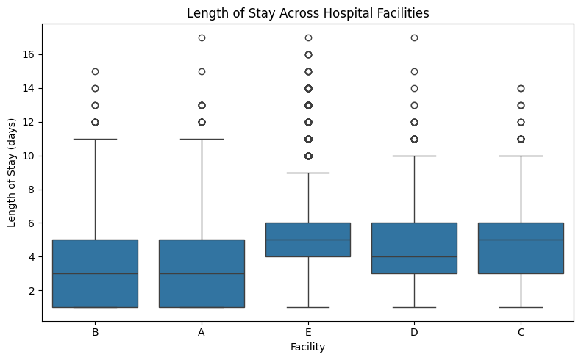
Figure 2. Length of Stay Across Hospital Facilities

Average length of stay differs materially across facilities. Facility E has the highest mean stay at 5.149 days, followed by C at 4.915 and D at 4.821 days. Facilities A and B have substantially lower means of 3.278 and 3.285 days, respectively. These are observed group differences and should not be interpreted as causal effects of the facilities.

8.3 Bivariate / Relationship Analysis
plt.figure(figsize=(9, 6))
ax = sns.boxplot(
data=df,
x="hemo",
y="lengthofstay"
)
# Add mean points
means = df.groupby("hemo")["lengthofstay"].mean()
for i, mean_value in enumerate(means):
plt.scatter(
i,mean_value,color="red",s=80,marker="D",zorder=5)
plt.title(
"Clinical/Operational Relationship: Hemo and Length of Stay",
fontsize=14,
fontweight="bold"
)
plt.xlabel("Hemo Indicator")
plt.ylabel("Length of Stay (days)")
plt.tight_layout()
plt.show()
print(
"Correlation:",
round(df["hemo"].corr(df["lengthofstay"]), 3)
)

Figure 3. Clinical/Operational Relationship — Hemo Indicator and Length of Stay

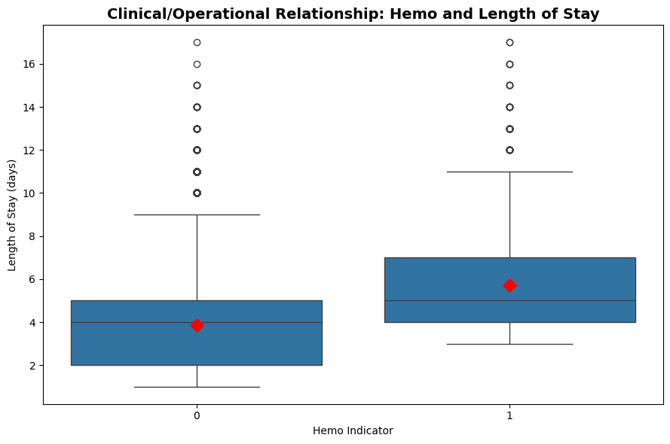

The hemo indicator has a Pearson correlation of approximately 0.218 with lengthofstay in the executed notebook, indicating a modest positive association. The box plot and mean markers provide additional information about the distribution within the indicator groups. The relationship is associative and does not establish that the hemo indicator causes longer stays.

8.4 Correlation Analysis
# Target
target = "lengthofstay"
# Select numerical columns
numeric_df = df.select_dtypes(include=np.number)
# Find 9 features most strongly correlated with target
top_features = (
numeric_df.corr(method="spearman")[target]
.drop(target)
.abs()
.sort_values(ascending=False)
.head(9)
.index
.tolist()
)
# Add target as the first variable
heatmap_columns = [target] + top_features
# Correlation matrix
corr_matrix = numeric_df[heatmap_columns].corr(method="spearman")
# Plot
plt.figure(figsize=(8, 7))
sns.heatmap(
corr_matrix,cmap="coolwarm",
vmin=-1,
vmax=1,
annot=True,
fmt=".2f",
square=True,
linewidths=0.5,
cbar=True,
annot_kws={"size": 9}
)
plt.title(
"Correlation Heatmap",
fontsize=14,
fontweight="bold"
)
plt.xticks(rotation=45, ha="right")
plt.yticks(rotation=0)
plt.tight_layout()
plt.show()

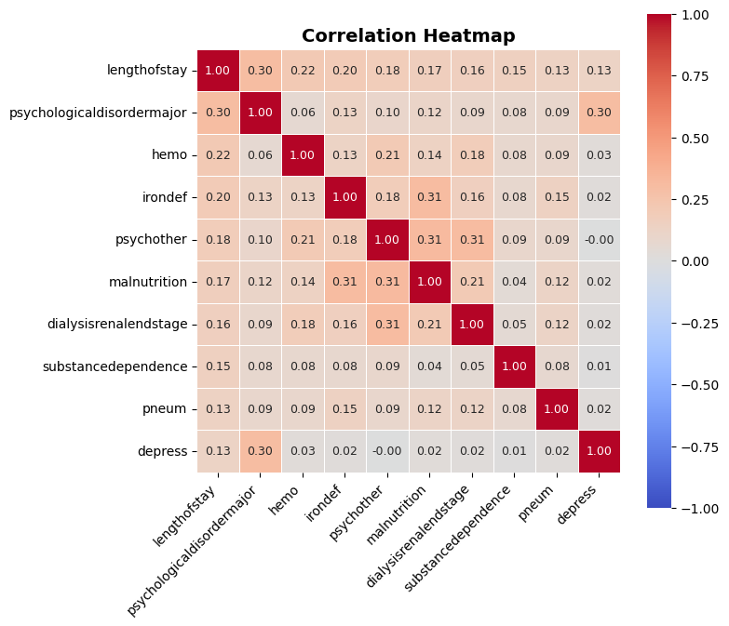
Figure 4. Spearman Correlation Heatmap of Selected Numerical Variables

The compact heatmap focuses on the target and the nine numerical variables with the strongest absolute Spearman associations with lengthofstay. The most prominent target relationship in the executed analysis is the strong positive association between the engineered record-count measure and lengthofstay. The heatmap is used to identify association patterns for modelling and EDA; it does not establish causation.

9. STATISTICAL ANALYSIS
Descriptive statistics were calculated for lengthofstay and key numerical variables. The target has mean 3.999, median 4, standard deviation 2.358, IQR 4, and range 1-17 days. Several clinical variables show substantially different scales and distributions, supporting the use of model-appropriate preprocessing and robust tree-based methods.

Table 4. Descriptive Statistics of Key Variables

Variable | Mean | Std. Dev. | Min–Max
lengthofstay | 3.999 | 2.358 | 1–17
hematocrit | 11.967 | 2.039 | 4.4–24.1
neutrophils | 10.196 | 5.271 | 0.1–245.9
sodium | 137.897 | 3.001 | 124.9–151.4
glucose | 142.053 | 29.923 | -1.0–268.6
bloodureanitro | 14.113 | 12.750 | 1.0–682.5
creatinine | 1.099 | 0.200 | 0.22–2.04
bmi | 29.804 | 2.000 | 22.0–38.9
pulse | 73.423 | 11.652 | 21–126
respiration | 6.493 | 0.573 | 0.2–10.0

The target's mean and median are almost identical, showing a central value around 4 days. Neutrophils and bloodureanitro have comparatively wide ranges relative to their central values, indicating greater dispersion. Respiration has a very narrow IQR despite a broader overall range. These differences support treating the variables according to their modelling properties rather than assuming a common scale.

FEATURE ENGINEERING

Feature engineering transformed the admission date into year, month, day, day-of-week, and quarter components so that temporal structure could be used by the models. The rcount category '5+' was converted to the numeric lower-bound representation 5 in rcount_num. The raw vdate was then excluded from the final model matrix, while discharged was excluded because it is a post-outcome field. eid was also excluded as an identifier.

Table 5. Engineered Features

Engineered feature | Logic | Purpose
admit_year | Year extracted from vdate | Capture calendar variation
admit_month | Month extracted from vdate | Capture possible seasonal patterns
admit_day | Day extracted from vdate | Capture within-month variation
admit_dayofweek | 0–6 representation of weekday | Capture weekday/weekend pattern
admit_quarter | Quarter extracted from vdate | Capture broad seasonal grouping
rcount_num | 5+ mapped to 5 | Make record-count information numeric

11. MODEL DEVELOPMENT

11.1 Problem Formulation
This is a supervised regression problem. The target variable, lengthofstay, is a numerical duration in days. The predictors combine binary clinical indicators, laboratory/vital-sign measures, facility information, and engineered admission-date and record-count variables. Regression is appropriate because the objective is to estimate a numerical stay duration rather than assign patients to discrete classes.

11.2 Model Selection
Three models were compared. Linear Regression provides an interpretable baseline. Gradient Boosting Regressor provides a nonlinear ensemble baseline. CatBoost Regression was selected as the final candidate because it can model nonlinear relationships and handle categorical predictors directly. The selection was based on the observed test RMSE among these predefined candidates.

11.3 Training the Model
The final CatBoost model used 800 iterations, depth 8, learning rate 0.05, RMSE loss, and random seed 42. The categorical columns gender and facid were passed directly to CatBoost. Linear Regression and Gradient Boosting used scikit-learn preprocessing pipelines with imputation, scaling, and one-hot encoding.
cat_model = CatBoostRegressor(
iterations=800, depth=8,
learning_rate=0.05,
loss_function="RMSE",
random_seed=42,
verbose=False
)
cat_model.fit(
X_train_cb, y_train,
cat_features=cat_feature_indices
)

12. MODEL EVALUATION
The models were evaluated on the 12,336 observations in the held-out test set. MAE measures the average absolute error in days; MSE is the average squared error; RMSE is the square root of MSE and is expressed in days; R² measures the proportion of test-set target variance explained by the model. Lower MAE/MSE/RMSE and higher R² indicate stronger predictive performance for this regression task.

12.1 Regression Evaluation

CatBoost produced the lowest test error across MAE, MSE, and RMSE and the highest R² among the three evaluated models. Its test MAE of 0.2948 days indicates an average absolute error of about 0.30 days, while its RMSE of 0.4007 days indicates a relatively small overall prediction error. The R² of 0.9707 indicates that approximately 97.07% of the variation in the test-set target is explained by the fitted model under this evaluation setup.

Model | MAE | MSE | RMSE
CatBoost | 0.2948 | 0.1606 | 0.4007
Gradient Boosting | 0.4005 | 0.2813 | 0.5303
Linear Regression | 0.8664 | 1.3046 | 1.1422
Table 6. Regression Model Performance

12.2 Classification Evaluation
Not applicable. This project is a regression problem, so confusion-matrix, accuracy, precision, recall, and F1-score are not appropriate primary evaluation metrics.
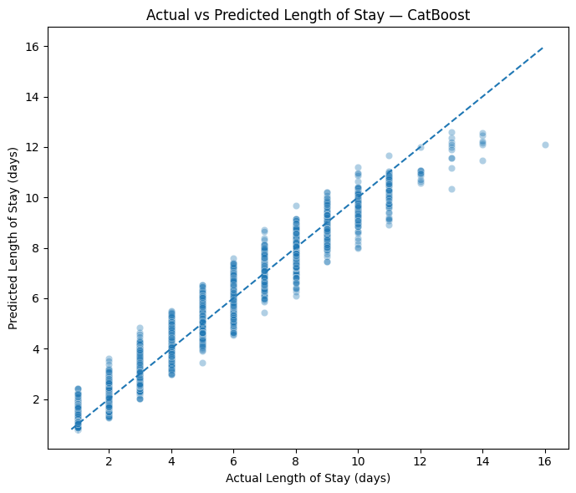

Figure 5. Actual vs Predicted Length of Stay — CatBoost

Table 7. Training vs Testing Performance

Model | Train MAE | Test MAE | Train RMSE
CatBoost | 0.2630 | 0.2948 | 0.3437
Gradient Boosting | 0.4000 | 0.4005 | 0.5254
Linear Regression | 0.8802 | 0.8664 | 1.1555

12.3 Overfitting and Underfitting
The train-test comparison does not indicate severe overfitting for CatBoost. CatBoost training performance was MAE 0.2630, RMSE 0.3437, and R² 0.9788, compared with test MAE 0.2948, RMSE 0.4007, and R² 0.9707. The R² gap is approximately 0.0081, which is relatively small. Gradient Boosting shows a similarly small train-test difference, while Linear Regression is also stable but materially less accurate. These comparisons support the interpretation that CatBoost generalizes reasonably well on this held-out split, while recognizing that a single random split is not a substitute for external validation.

RESULTS AND FINDINGS
1. The dataset contains 61,680 usable observations with no missing values, no duplicate rows, and no non-positive length-of-stay targets after the documented cleaning checks.
2. Length of stay is centered around 4 days: mean 3.999 days, median 4 days, with observed values from 1 to 17 days.
3. Hospital facilities differ substantially in observed average stay: Facility E has the highest mean at 5.149 days, while Facilities A and B are near 3.28 days.
4. CatBoost is the strongest model in the evaluated comparison, with test MAE 0.2948, RMSE 0.4007, and R² 0.9707; it outperforms Gradient Boosting and Linear Regression on the reported test metrics.
5. The fitted CatBoost model assigns the largest feature importance to rcount_num (31.96) and facid (16.42), followed by hematocrit, respiration, sodium, creatinine, BMI, glucose, pulse, and hemo. These importance values indicate model contribution within this fitted model, not causal influence.

14. DISCUSSION
The analysis suggests that patient stay duration in this dataset is strongly structured by a combination of operational and patient-level information. The especially prominent role of rcount_num and facid in CatBoost feature importance is consistent with the facility-level and record-count relationships observed during EDA. The difference between the linear baseline and the tree-based models indicates that nonlinear or interaction effects are important for this dataset. CatBoost also achieved a small train-test R² gap, supporting reasonable performance on the held-out sample. However, the observed relationships should not be interpreted as causal effects, and the model should not be treated as clinically validated without prospective and external testing.

15. LIMITATIONS
The limitations below should be considered when interpreting the reported performance:
- [1] The analysis is based on a single supplied dataset and a single random 80/20 train-test split; external or temporal validation was not performed.
- [2] The dataset may not contain all clinically relevant variables that influence length of stay, so omitted factors could limit generalization.
- [3] Facility identifiers are predictive in the fitted model, but the reasons for facility-level differences are not established and may reflect operational, population, or data-collection differences.
- [4] Some variables contain unusual ranges or potential statistical outliers; the project retained valid observations rather than deleting them, so model performance may depend on how such cases are represented.
- [5] The model estimates historical patterns and has not been deployed or evaluated prospectively in a real hospital workflow.

16. CONCLUSION
The project established a complete predictive analytics workflow for patient length of stay using the supplied LengthOfStay.csv dataset. The dataset was found to contain 61,680 observations with no missing values or duplicate rows, and valid target values from 1 to 17 days. Exploratory analysis identified meaningful facility-level differences and a strong association involving the record-count representation. Among the three evaluated regression models, CatBoost achieved the strongest held-out test performance with MAE 0.2948 days, RMSE 0.4007 days, MSE 0.1606, and R² 0.9707. The small difference between training and test performance suggests reasonable generalization within the evaluated split. Overall, the analysis demonstrates that nonlinear regression can capture useful patterns in this dataset, while further external and prospective validation would be required before operational deployment.

17. RECOMMENDATIONS AND FUTURE WORK

17.1 Recommendations
The following recommendations are derived from the observed analytical results and should be treated as data-driven operational considerations rather than clinical directives.
- Monitor facility-level variation in length of stay and investigate operational or population differences behind the higher observed averages at Facilities C, D, and E.
- Use predictive length-of-stay estimates as a supporting input for capacity and discharge-planning workflows, subject to validation in the intended hospital setting.
- Track record-count and other high-importance predictors during model monitoring because rcount_num and facid contributed strongly to the fitted CatBoost model.
- Validate the model on additional hospitals, later time periods, and prospective cases before considering production use.
- Maintain leakage controls so post-outcome variables such as discharge date are never used when generating predictions for real-time planning.

17.2 Future Work
Future work should include chronological validation, external validation on another hospital or dataset, hyperparameter tuning with cross-validation, uncertainty estimation, additional clinically relevant predictors, subgroup performance analysis, and a monitored deployment prototype. A future study should also investigate the reasons behind facility-level differences rather than treating facility as a purely predictive label.

18. REFERENCES
India Data Research Academy. (2026). IDRA Capstone Project Guide 2026. Data Science & AI.
India Data Research Academy. (2026). IDRA Capstone Project Template Sample. Data Science & AI.
Prokhorenkova, L., Gusev, G., Vorobev, A., Dorogush, A. V., & Gulin, A. (2018). CatBoost: unbiased boosting with categorical features. Advances in Neural Information Processing Systems.
Pedregosa, F., et al. (2011). Scikit-learn: Machine Learning in Python. Journal of Machine Learning Research, 12, 2825–2830.
McKinney, W. (2010). Data Structures for Statistical Computing in Python. Proceedings of the 9th Python in Science Conference.
Waskom, M. L. (2021). seaborn: statistical data visualization. Journal of Open Source Software, 6(60), 3021.

++

APPENDIX A. CODE
The following snippets summarize the main reproducibility steps. The complete code is contained in the submitted Google Colab notebook.

A.1 Data Loading and Inspection
df_raw = pd.read_csv(DATA_PATH)
print(df_raw.shape)
df = df_raw.drop_duplicates().copy()

A.2 Data Cleaning
df['vdate'] = pd.to_datetime(df['vdate'], errors='coerce')
df['discharged'] = pd.to_datetime(df['discharged'], errors='coerce')
# Validate missing values, duplicates, target and outliers

A.3 Preprocessing
df_model['admit_year'] = df_model['vdate'].dt.year
df_model['admit_month'] = df_model['vdate'].dt.month
df_model['rcount_num'] = df_model['rcount'].replace({'5+':'5'}).astype(float)

A.4 EDA and Visualization
sns.histplot(df['lengthofstay'], bins=17, kde=True)
sns.boxplot(data=df, x='facid', y='lengthofstay')
sns.heatmap(corr_matrix, annot=True, cmap='coolwarm')

A.5 Model Training and Evaluation
cat_model = CatBoostRegressor(iterations=800, depth=8, learning_rate=0.05,
loss_function='RMSE', random_seed=42, verbose=False)
cat_model.fit(X_train_cb, y_train, cat_features=cat_feature_indices)

APPENDIX B. ADDITIONAL FIGURES AND TABLES
Additional diagnostics and supporting outputs are included here so that the main report remains focused while the important modelling evidence remains available for review.
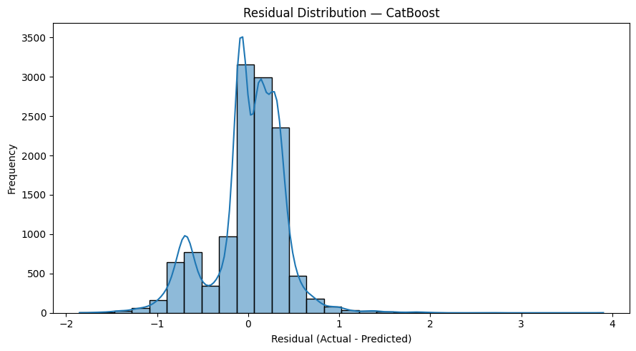
Figure 6. Residual Distribution — CatBoost

Table 8. Top CatBoost Feature Importances

Feature | Importance
rcount_num | 31.9588
facid | 16.4181
hematocrit | 6.7229
respiration | 5.3437
sodium | 4.5258

