AI-Based Algorithms Used in Smart AI-Based Food Nutrition Analysis and Their Applications

Abstract
Nutrition analysis is undergoing a transformation with the integration of Artificial Intelligence (AI), moving beyond traditional manual and subjective methods toward automated, accurate, and scalable solutions.
This review critically examines the central role of AI algorithms in advancing smart nutrition analysis systems, emphasizing their impact on improving dietary assessment and supporting personalized healthcare. By tracing the technological evolution from early machine learning techniques to state-of-the-art deep learning, this paper highlights key models used for automated food recognition, nutrient estimation, and intelligent dietary recommendations.
The strengths, limitations, and applications of these algorithms are analyzed, and current and emerging trends, such as multimodal learning, explainable AI, federated learning, and personalized nutrition systems, are discussed as pivotal directions for the field. The findings establish that AI-driven solutions are essential for the efficiency, scalability, and precision required in modern nutrition analysis, laying the foundation for intelligent healthcare and dietary management systems.

1. Introduction
1.1 Food Nutrition Analysis
Food nutrition analysis is the process of evaluating the nutritional composition of food consumed by individuals. It involves identifying food items and determining the quantity of nutrients they contain, including calories, carbohydrates, proteins, fats, vitamins, minerals, and dietary fiber. The primary objective of nutrition analysis is to assess dietary intake and determine whether an individual's nutritional requirements are being met.
Nutrition analysis has traditionally been performed using dietary surveys, food records, food frequency questionnaires, and consultations with healthcare professionals. With technological advancements, modern nutrition analysis has evolved toward automated systems capable of providing accurate and real-time dietary assessments.
1.2 Importance of Food Nutrition Analysis
Nutrition plays a critical role in maintaining overall health and well-being. Balanced dietary intake contributes to proper growth, immune function, cognitive performance, and disease prevention. In contrast, poor dietary habits are associated with numerous health conditions, including obesity, diabetes, cardiovascular diseases, hypertension, and certain types of cancer.
Accurate nutrition analysis is important for several reasons:
- Monitoring daily nutrient intake.
- Supporting disease prevention and management.
- Assisting healthcare professionals in dietary planning.
- Promoting healthy eating behaviors.
- Facilitating personalized nutrition recommendations.
- Enabling large-scale public health and epidemiological studies.
With the increasing prevalence of lifestyle-related diseases worldwide, effective nutrition assessment has become an essential component of preventive healthcare strategies.

1.3 Problems with Traditional and Manual Nutrition Assessment
Although conventional dietary assessment methods have been widely used, they suffer from several limitations that affect their reliability and practicality.
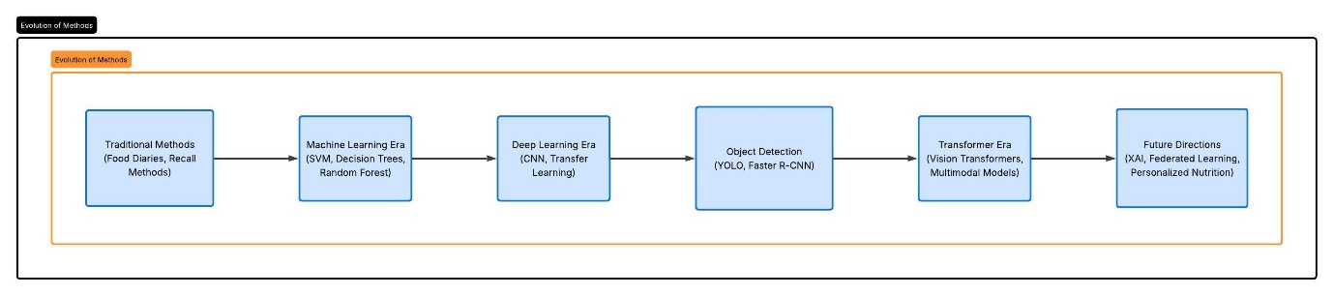
Figure 1: Evolution of Nutrition Analysis Methods

1.3.1 Food Diaries and Dietary Records
Individuals are often required to record everything they consume throughout the day. This approach is burdensome and may lead to incomplete or inaccurate records.
1.3.2 Recall Bias
Methods such as 24-hour dietary recalls depend heavily on an individual's memory. People frequently forget consumed foods or inaccurately report quantities.
1.3.3 Portion Size Estimation Errors
Estimating the exact amount of food consumed is challenging. Inaccurate portion size reporting can significantly affect nutrient calculations.
1.3.4 Time-Consuming Nature
Manual assessment requires extensive effort from both participants and nutrition professionals, making it unsuitable for large populations.
1.3.5 Subjectivity and Human Errors
Different nutritionists may interpret dietary records differently, resulting in inconsistencies in nutritional evaluation.

1.3.6 Limited Scalability
Traditional methods are difficult to implement efficiently in community-wide nutrition programs and large healthcare systems.
These limitations emphasize the necessity for intelligent and automated dietary assessment solutions.
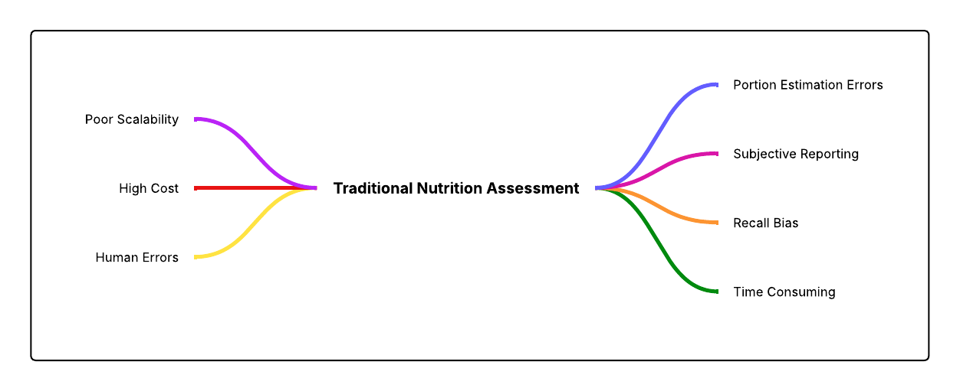
Figure 2: Limitations of Traditional Nutrition Assessment

1.4 Need for Artificial Intelligence in Nutrition Analysis
Artificial Intelligence has emerged as a transformative technology capable of addressing the shortcomings of traditional nutrition assessment methods. AI systems can automatically analyze food images, identify food categories, estimate portion sizes, calculate nutritional values, and generate dietary recommendations with minimal human intervention.
The application of AI in nutrition analysis offers several advantages:
- Automation of food identification processes.
- Reduction in manual effort and reporting burden.
- Improved accuracy and consistency of assessments.
- Real-time monitoring through mobile and wearable devices.
- Scalability for population-level applications.
- Support for personalized nutrition and precision healthcare.
Initially, AI applications relied on traditional machine learning algorithms such as Support Vector Machines (SVM), Decision Trees, and Random Forests, which required handcrafted feature extraction techniques. However, the development of deep learning significantly improved food recognition capabilities.
Convolutional Neural Networks (CNNs) enabled automatic feature learning directly from images, resulting in enhanced classification accuracy. Transfer learning approaches utilizing architectures such as ResNet, MobileNet, and EfficientNet further improved performance while reducing computational requirements. More recently, object detection algorithms such as YOLO and Transformer-based models have facilitated real-time food detection and contextual understanding of complex food scenes.
Consequently, AI has become an indispensable component in the development of smart nutrition analysis systems capable of supporting both clinical practice and everyday dietary monitoring.
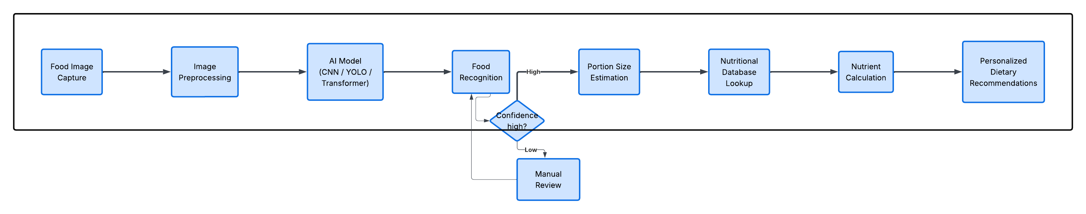
Figure 3: General Workflow of AI-Based Nutrition Analysis System
1.5 Objectives of the Review Paper
The present review paper aims to provide a comprehensive analysis of artificial intelligence techniques employed in smart nutrition analysis systems. The specific objectives are as follows:
- To explain the concept and significance of food nutrition analysis.
- To discuss the limitations associated with traditional and manual dietary assessment methods.
- To review the evolution of AI algorithms used in nutrition analysis, ranging from conventional machine learning techniques to advanced deep learning models.
- To examine the applications of algorithms such as Support Vector Machines, Random Forests, Convolutional Neural Networks, YOLO, and Vision Transformers in food recognition and nutrient estimation tasks.
- To compare the strengths and limitations of different AI approaches employed in nutrition analysis systems.
- To identify emerging trends and innovative technologies influencing the future of intelligent dietary assessment.
- To highlight current research challenges and propose future directions for improving the accuracy, efficiency, and practical deployment of AI-based nutrition analysis systems.
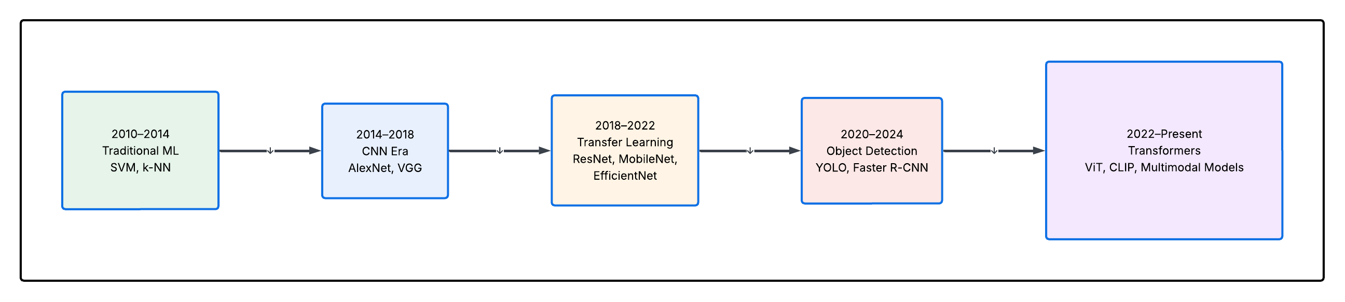
Figure 4: Timeline of AI Algorithms

By achieving these objectives, this review intends to provide researchers, healthcare professionals, and technology developers with a structured understanding of the evolution of AI techniques in nutrition analysis and their potential contributions toward intelligent healthcare and personalized nutrition management.

2. Evolution of AI in Food Nutrition Analysis
Artificial Intelligence (AI) has significantly transformed the field of food nutrition analysis over the past decade. The progression of AI techniques has been driven by the need for more accurate, automated, and scalable dietary assessment systems. Early approaches primarily relied on traditional machine learning algorithms that required handcrafted feature extraction. However, limitations associated with feature engineering and poor generalization capabilities led to the adoption of deep learning models capable of automatic feature learning. Subsequently, object detection frameworks enabled the simultaneous identification of multiple food items, while recent Transformer-based architectures have further enhanced contextual understanding and recognition performance.
The evolution of AI in food nutrition analysis can be categorized into four major eras: the Traditional Machine Learning Era, the Deep Learning Era, the Object Detection Era, and the Transformer Era.
2.1 Traditional Machine Learning Era (2010–2015)
During the early stages of automated food recognition research, traditional machine learning techniques were extensively employed. These methods relied on handcrafted features extracted from food images, such as color histograms, texture descriptors, shape characteristics, and local feature representations.
Support Vector Machines (SVM)
Support Vector Machines were among the most widely used classification algorithms in food recognition systems. SVMs classify food categories by identifying an optimal hyperplane that maximizes the separation between different classes.
Applications in Nutrition Analysis:
- Food image classification.
- Dietary assessment support systems.
- Recognition of simple food categories.

Advantages:
- Effective in high-dimensional feature spaces.
- Good performance with limited training data.
Limitations:
- Dependence on handcrafted features.
- Reduced effectiveness with large and complex datasets.

k-Nearest Neighbors (k-NN)
The k-Nearest Neighbors algorithm classifies food items based on the majority class among neighboring data samples within the feature space.
Applications in Nutrition Analysis:
- Basic food categorization tasks.
- Similarity-based food retrieval systems.
Advantages:
- Simple implementation.
- No explicit training phase.
Limitations:
- Computationally expensive during inference.
- Sensitive to irrelevant features and noise.

Random Forest
Random Forest is an ensemble learning method that combines multiple decision trees to improve classification accuracy.
Applications in Nutrition Analysis:
- Food type prediction.
- Nutritional risk classification.

Advantages:
- Reduced overfitting.
- Robustness against noisy data.
Limitations:
- Requirement for manual feature engineering.
- Limited capability in extracting complex visual representations.

Limitations of Traditional Machine Learning
Despite their contributions, traditional approaches suffered from several drawbacks:
- Dependence on handcrafted feature extraction.
- Poor adaptability to diverse food presentations.
- Inability to effectively recognize mixed dishes.
- Limited scalability for large food datasets.
These challenges motivated the transition toward deep learning methodologies.

2.2 Deep Learning Era (2015–2020)
The introduction of deep learning revolutionized food nutrition analysis by enabling automatic extraction of hierarchical features directly from images. Convolutional Neural Networks (CNNs) became the dominant approach for food recognition applications.

Convolutional Neural Networks (CNNs)
CNNs utilize convolutional layers to identify spatial patterns and visual features from food images.
Impact on Nutrition Analysis:
- Improved food classification accuracy.
- Elimination of handcrafted feature requirements.
- Enhanced robustness under varying conditions.

AlexNet
AlexNet demonstrated the effectiveness of deep CNNs in image classification tasks.
Contribution:
- Established the applicability of deep learning to food recognition problems.

VGG Network
VGG introduced deeper architectures with smaller convolution filters.
Contribution:
- Improved representation learning capabilities.

ResNet
Residual Networks employed skip connections to overcome degradation problems in deeper models.
Contribution:
- Enabled the development of very deep architectures for food classification.
DenseNet
DenseNet enhanced feature propagation through dense connectivity between layers.
Contribution:
- Improved feature reuse and computational efficiency.

EfficientNet
EfficientNet introduced compound scaling strategies to balance network depth, width, and resolution.
Contribution:
- High classification accuracy with fewer parameters.
- Suitable for mobile nutrition applications.
Improvements Achieved Through Deep Learning
Compared with traditional approaches, deep learning models offered:
- Automatic feature extraction.
- Superior classification accuracy.
- Improved generalization capability.
- Better performance on large-scale food datasets.

2.3 Object Detection Era (2018–Present)
While image classification models successfully recognized individual food items, real-world dietary scenarios frequently involve multiple foods within a single image. Object detection algorithms addressed this limitation by simultaneously identifying and localizing multiple food components.

Faster R-CNN
Faster R-CNN introduced Region Proposal Networks for efficient object localization.
Applications:
- Multi-food detection.
- Portion estimation support.
Advantages:
- High detection accuracy.

Limitations:
- Relatively slower inference speed.

Single Shot MultiBox Detector (SSD)
SSD performs object detection within a single forward pass.
Advantages:
- Faster processing speed.
- Suitable for real-time applications.

YOLOv3
YOLOv3 significantly improved detection speed while maintaining competitive accuracy.

YOLOv5
YOLOv5 introduced practical optimizations that enhanced deployment efficiency.

YOLOv7
YOLOv7 achieved state-of-the-art performance through architectural refinements.

YOLOv8
YOLOv8 provides improved accuracy, flexibility, and ease of integration.

Role of Object Detection in Nutrition Analysis
Object detection algorithms facilitate:
- Detection of multiple food items.
- Real-time dietary monitoring.
- Improved nutritional estimation accuracy.
- Mobile-based food assessment applications.
2.4 Transformer Era (2021–Present)
Transformer-based architectures have recently emerged as powerful alternatives to convolutional models in computer vision tasks.

Vision Transformer (ViT)
Vision Transformers divide images into patches and process them using self-attention mechanisms.
Advantages:
- Capture long-range dependencies.
- Strong performance on large datasets.

Swin Transformer
Swin Transformer introduces hierarchical representations through shifted window attention.
Advantages:
- Improved computational efficiency.
- Enhanced performance across multiple vision tasks.

Hybrid CNN–Transformer Models
Hybrid architectures integrate convolutional operations with attention mechanisms.
Advantages:
- Local feature extraction from CNNs.
- Global contextual understanding from Transformers.

Emerging Applications in Nutrition Analysis
Transformer-based approaches are being explored for:
- Fine-grained food recognition.
- Mixed-dish classification.
- Nutrient estimation.
- Personalized dietary recommendation systems.

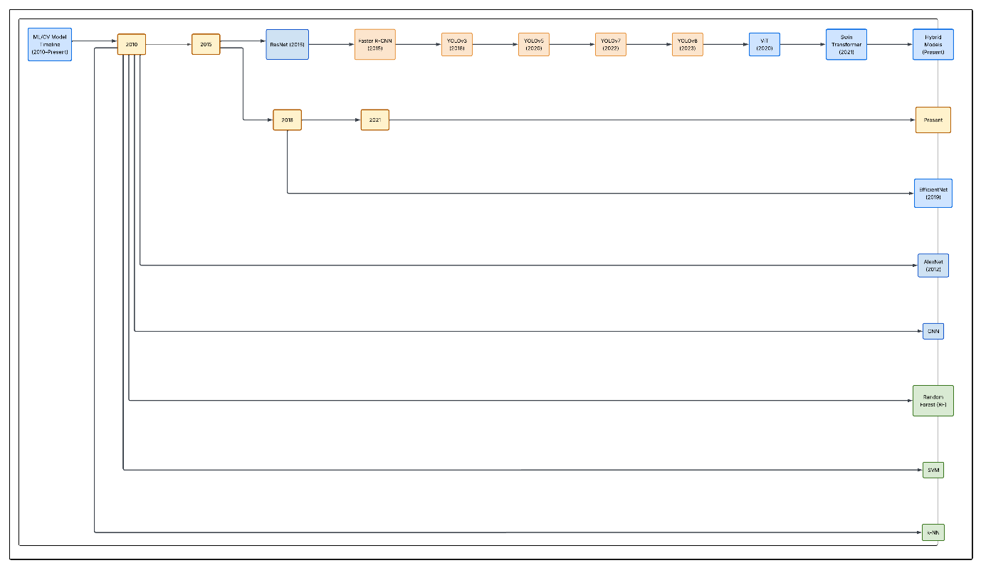
Figure 5. Timeline of AI Evolution in Food Nutrition Analysis

3. Detailed Analysis of AI Algorithms
This section provides a detailed examination of the major Artificial Intelligence algorithms employed in food nutrition analysis systems. For consistency and ease of comparison, each algorithm is discussed under the following headings:
- Working Principle
- Application in Food Nutrition Analysis
- Advantages
- Limitations
- Representative Research Studies

3.1 Support Vector Machine (SVM)
Working Principle
Support Vector Machine is a supervised machine learning algorithm used for classification tasks. It identifies an optimal hyperplane that maximizes the separation margin between different classes. Kernel functions can be employed to handle non-linear classification problems.
Application in Food Recognition
SVM was extensively used in early food recognition systems. Features such as color histograms, texture descriptors, and shape characteristics were extracted manually and used as input for classification.
Advantages
- Effective in high-dimensional spaces.
- Performs well with limited training data.
- Robust against overfitting in small datasets.
Limitations
- Requires handcrafted feature extraction.
- Limited scalability for large datasets.
- Performance declines with highly complex food images.
Representative Studies
- Kawano and Yanai (2014): Food image recognition using SVM-based classifiers.
- Matsuda et al. (2012): Food categorization using local feature descriptors and SVM.

3.2 Convolutional Neural Networks (CNN)
Architecture Overview
CNNs consist of convolutional layers, activation functions, pooling layers, and fully connected layers. These components automatically learn hierarchical visual features from input images.
Working Principle
The convolution operation extracts local patterns such as edges, textures, and shapes. Deeper layers learn increasingly complex representations that facilitate food classification.
Applications in Nutrition Analysis
- Food image classification.
- Dietary monitoring applications.
- Nutritional intake estimation.
- Mobile-based food recognition systems.
Advantages
- Automatic feature extraction.
- High classification accuracy.
- Excellent performance on large image datasets.
Limitations
- Requires substantial training data.
- Computationally intensive.
- May struggle with visually similar foods.
Representative Studies
- Bossard et al. (2014): Food-101 dataset and CNN-based recognition.
- Meyers et al. (2015): Deep learning for automated dietary assessment.
- Ciocca et al. (2017): Food recognition using transfer learning.
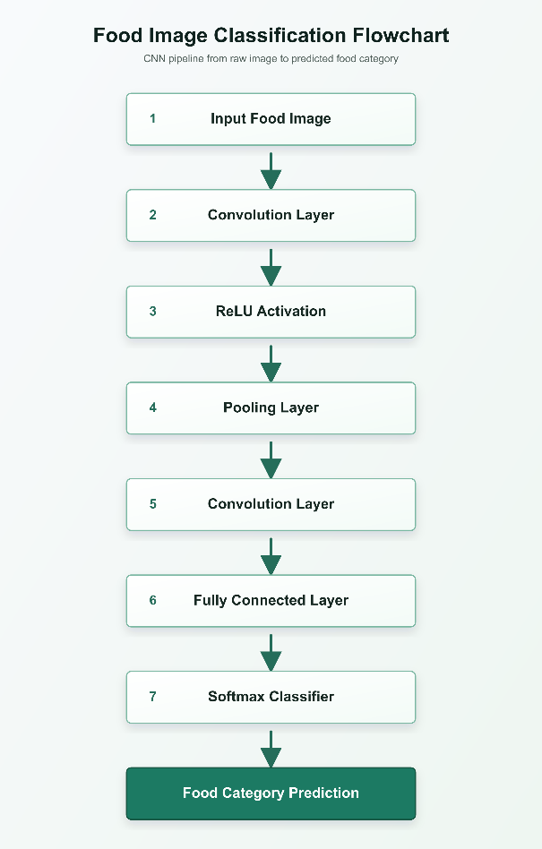
Figure 6. General architecture of a Convolutional Neural Network used for food recognition.

3.3 Residual Network (ResNet)
Architecture Overview
ResNet introduces residual learning through skip connections that enable information to bypass certain layers.
Applications in Nutrition Analysis
- Food classification.
- Transfer learning for dietary assessment.
- Fine-grained food recognition.
Advantages
- Addresses vanishing gradient problems.
- Enables deeper networks.
- Improved recognition performance.
Limitations
- Increased computational requirements.
- Larger model sizes compared with lightweight architectures.
Representative Studies
- He et al. (2016): Development of ResNet architecture.
- Various food recognition studies employing ResNet-50 and ResNet-101.

3.4 Net
Architecture Overview
EfficientNet employs compound scaling to optimize network depth, width, and image resolution simultaneously.
Applications in Nutrition Analysis
- Mobile nutrition applications.
- Food image classification.
- Resource-constrained deployment environments.
Advantages
- High accuracy with fewer parameters.
- Computational efficiency.
- Suitable for real-time systems.
Limitations
- Requires careful scaling configuration.
- Complex optimization process.
Representative Studies
- Tan and Le (2019): EfficientNet architecture.
- Recent nutrition applications utilizing EfficientNet for food classification.

3.5 YOLOv8
Architecture Overview
YOLOv8 is a one-stage object detection algorithm designed for real-time applications. It predicts object classes and bounding boxes simultaneously within a single forward pass.
Working Principle
The model processes the input image and directly outputs the locations and categories of detected food items.
Applications in Food Nutrition Analysis
- Detection of multiple food items.
- Real-time dietary monitoring.
- Automated food logging systems.
- Portion size estimation support.
Why YOLOv8 Is Popular
- High detection accuracy.
- Fast inference speed.
- Ease of implementation.
- Suitable for mobile deployment.
Advantages
- Real-time performance.
- Excellent balance between speed and accuracy.
- Effective detection of multiple food objects.
Limitations
- Performance may decrease with severe occlusion.
- Requires annotated object detection datasets.
Representative Studies
- Ultralytics YOLOv8 documentation and benchmarks.
- Recent food detection studies adopting YOLO architectures
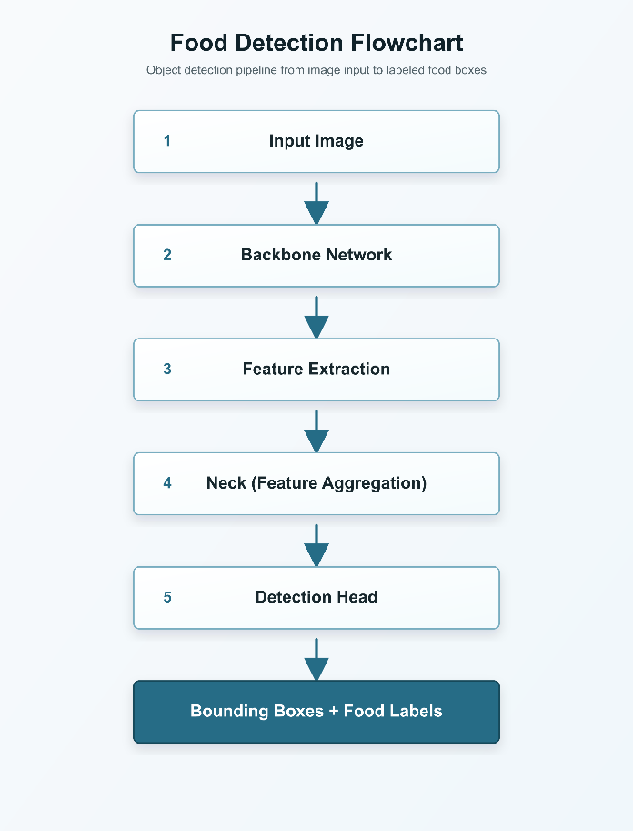
Figure 7. Simplified architecture of YOLOv8 for food item detection.

3.6 Vision Transformer (ViT)
Architecture Overview
Vision Transformers divide images into fixed-size patches and treat them as sequences processed by Transformer encoders.
Self-Attention Mechanism
Self-attention allows the model to capture relationships among image patches by assigning importance scores to different regions.
Applications in Nutrition Analysis
- Fine-grained food classification.
- Mixed-dish recognition.
- Advanced dietary assessment systems.
Advantages
- Captures global contextual information.
- Competitive performance on large datasets.
- Effective for complex recognition tasks.
Limitations
- Data-intensive training requirements.
- Higher computational demands.
- Reduced efficiency on small datasets.
Representative Studies
- Dosovitskiy et al. (2021): Vision Transformer.
- Emerging food recognition studies employing Transformer architectures.
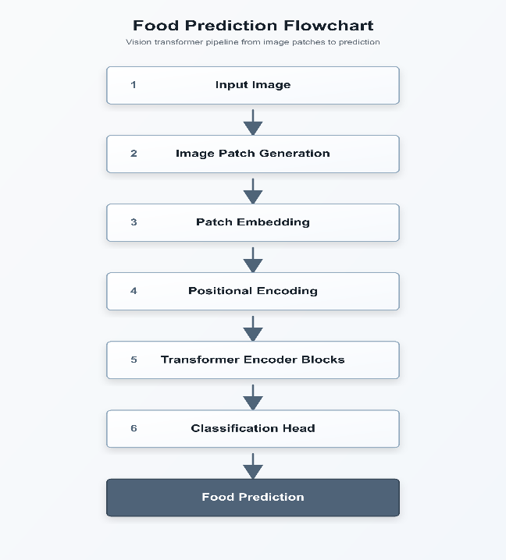
Figure 8. Vision Transformer architecture used for food image analysis.

3.7 Hybrid CNN–Transformer Models
Architecture Overview
Hybrid models integrate CNN-based local feature extraction with Transformer-based global attention mechanisms.
Applications in Nutrition Analysis
- Complex food recognition.
- Mixed-food classification.
- Improved nutrient estimation.
Advantages
- Combines strengths of CNNs and Transformers.
- Enhanced feature representation.
- Improved recognition performance.
Limitations
- Increased architectural complexity.
- Greater computational requirements.
Representative Studies
- Recent multimodal food recognition research utilizing hybrid architectures.

4. Proposed Framework for Smart AI-Based Nutrition Analysis
4.1 Overview
Based on the comprehensive review of Artificial Intelligence techniques employed in food nutrition analysis, this paper proposes an integrated framework that combines modern computer vision and recommendation technologies to improve the accuracy, efficiency, and usability of automated dietary assessment systems.
Existing approaches often focus on individual tasks such as food classification or object detection. However, practical nutrition analysis requires multiple interconnected processes, including food detection, recognition, portion estimation, nutrient computation, and recommendation generation. Therefore, the proposed framework integrates several AI components into a unified architecture capable of providing end-to-end nutrition analysis.
The proposed framework is designed to support real-world deployment through mobile applications, telehealth platforms, and personalized healthcare systems.
4.2 Proposed Framework Architecture
The proposed system begins with the acquisition of a food image captured using a smartphone or other imaging device. The image subsequently undergoes preprocessing to improve visual quality and remove noise. A state-of-the-art object detection model is then utilized to identify multiple food items present within the image. Following detection, a classification model assigns precise food labels to each detected item.
To estimate nutritional intake accurately, the framework incorporates portion size estimation techniques that approximate food volume or weight. The recognized food items and estimated quantities are matched against standardized nutritional databases to retrieve nutrient values. Finally, a recommendation engine generates personalized dietary guidance based on user-specific nutritional requirements and health objectives.

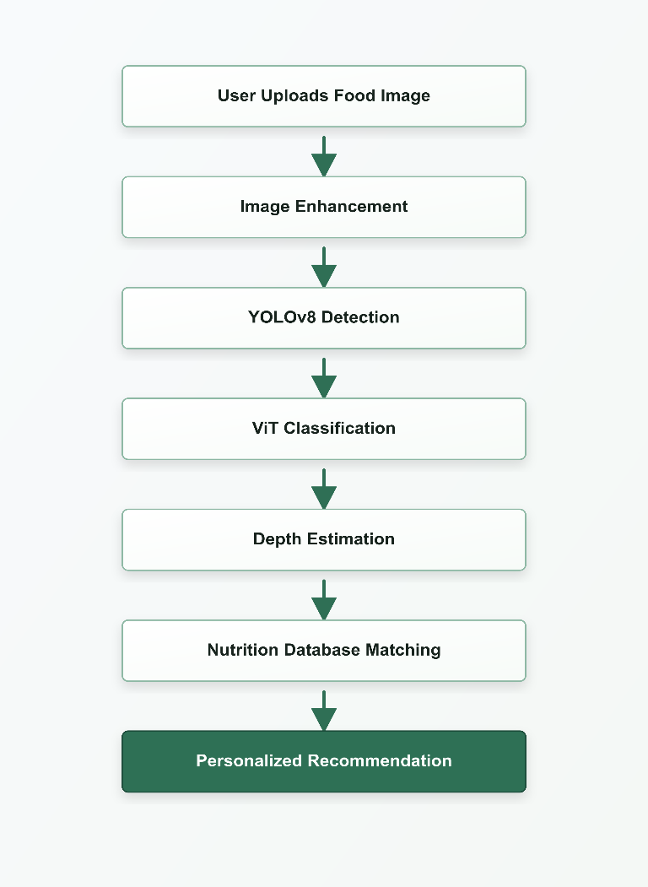
Figure 8. Proposed framework for smart AI-based food nutrition analysis integrating food detection, classification, portion estimation, nutrient computation, and personalized recommendation generation.

4.3 Components of the Proposed Framework
4.3.1 Food Image Acquisition
The user captures an image of the meal using a smartphone camera or uploads an existing photograph.
Objectives:
- Ensure convenient data collection.
- Facilitate real-time dietary monitoring.

4.3.2 Image Enhancement and Preprocessing
Preprocessing operations improve image quality before analysis.
Techniques:
- Image resizing.
- Contrast enhancement.
- Noise reduction.
- Data normalization.
Purpose:
- Improve the robustness of downstream AI models.
4.3.3 Food Detection Using YOLOv8
YOLOv8 is employed to localize multiple food items simultaneously within the input image.
Role:
- Generate bounding boxes.
- Identify the presence of different foods.
- Enable analysis of complex meal compositions.
Advantages:
- Real-time performance.
- High detection accuracy.
- Suitability for mobile applications.
4.3.4 Food Classification Using Vision Transformer
After detection, Vision Transformer-based models perform fine-grained food classification.
Role:
- Distinguish visually similar food categories.
- Capture global contextual relationships.
Advantages:
- Enhanced recognition performance.
- Improved handling of complex food patterns.
4.3.5 Portion Size and Volume Estimation
Depth estimation algorithms are incorporated to estimate the quantity of each food item.
Possible Approaches:
- Monocular depth estimation.
- Stereo vision systems.
- Reference object techniques.
Importance:
- Accurate nutrient computation depends on reliable portion estimation.
4.3.6 Nutritional Database Matching
The identified food categories and estimated quantities are linked with established nutritional databases.
Potential Databases:
- USDA FoodData Central.
- Indian Food Composition Tables.
- Regional nutritional repositories.

Outputs:
- Calorie values.
- Macronutrient composition.
- Micronutrient profiles.
4.3.7 Personalized Recommendation Engine
The final stage provides dietary recommendations tailored to individual requirements.
Factors Considered:
- Age.
- Gender.
- Health conditions.
- Dietary restrictions.
- Nutritional goals.
Outputs:
- Meal suggestions.
- Nutrient deficiency alerts.
- Calorie intake recommendations.
4.4 Advantages of the Proposed Framework
The proposed architecture offers several benefits:
- End-to-end automation of nutrition analysis.
- Capability to process meals containing multiple food items.
- Improved food recognition accuracy.
- Enhanced nutrient estimation through portion analysis.
- Support for personalized nutrition interventions.
- Potential integration with mobile healthcare applications.
4.5 Potential Challenges
Despite its advantages, several challenges remain:
- Availability of large annotated food datasets.
- Variability in food presentation styles.
- Accurate depth estimation from monocular images.
- Computational requirements of Transformer models.
- Privacy and security concerns associated with dietary data.

4.6 Future Enhancements
Future versions of the framework may incorporate:
- Explainable Artificial Intelligence techniques.
- Federated learning approaches for privacy preservation.
- Multimodal learning combining images and textual inputs.
- Integration with wearable health monitoring devices.
- Continuous dietary monitoring systems for precision nutrition.

