PREFACE
Industrial/field practical training (IPT) is an important crucial component in my studying under the program of Bachelor Engineering in Telecommunication systems. This industrial/field practical training (IPT) provides me with a unique opportunity to adopt theory with real experience in the real world. The preparation of this field practical training report marks an important stage in my academic journey as a Telecommunication Engineering student at Mbeya University of Science and Technology (MUST). Field practical training is an essential part of the curriculum because it bridges the gap between classroom theory and real-world practice. Through this exercise, I had the opportunity to gain valuable technical experience, enhance my problem-solving skills, and understand the operational environment of a professional telecommunication company.
This report provides a detailed account of my field practical training at Tanzania Telecommunications Corporation (TTCL), one of the leading providers of communication services in Tanzania. The training was conducted under the supervision of skilled technicians and engineers, who guided me in various tasks related to the design, implementation, and maintenance of telecommunication systems.
Although I was exposed to several areas during the training, I have focused this report on fiber optic splicing and customer connection because of its technical significance and its critical role in expanding internet connectivity across the country. Fiber technology forms the backbone of modern communication, and mastering the processes of splicing and customer connection gave me not only practical skills but also a better appreciation of how theory translates into practice.
The preparation of this report would not have been possible without the assistance and cooperation of many individuals. Therefore, I would like to acknowledge the support I received from the management and staff of TTCL, who were always ready to share their knowledge and provide me with guidance. Their mentorship and encouragement played a vital role in making this training a success.
I hope that this report will be a useful reference to fellow students, academicians, and anyone interested in understanding the practical aspects of fiber optic technology in telecommunication systems.

ABSTRACT
This report presents the outcomes of my field practical training undertaken at Tanzania Telecommunications Corporation (TTCL), with a focus on fiber optic splicing and customer connection. The training, conducted at TTCL Mbeya regional office, was an integral part of my academic program as a Telecommunication Engineering student at Mbeya University of Science and Technology.
The report begins by outlining the general information about TTCL, including its historical background, mission, vision, objectives, services, and organizational structure. This provides context on the role of TTCL as a key player in Tanzania’s telecommunication industry. Also, I have included the activities and photos on the activities that I have performed during my time at TTCL company.
The technical part of the report discusses in detail the processes involved in fiber optic splicing and customer connection, including preparation of fiber cables, how to use the splicing machines, termination of fibers, and testing procedures. Emphasis is placed on the tools and equipment used, the step-by-step procedure of splicing, and the significance of this activity in providing reliable and high-speed internet to customers.
Challenges encountered during the splicing and installation processes, such as cable management, environmental conditions, and alignment errors, are highlighted together with practical solutions adopted in the field area. The report concludes by reflecting on the skills acquired, the importance of teamwork, and the relevance of fiber optic technology in modern communication systems.
Overall, this report demonstrates the integration of theoretical knowledge with practical skills and emphasizes the importance of fiber optic splicing in supporting the digital transformation of Tanzania.

ACKNOWLEDGEMENT.
I would like to express my profound gratitude to GOD ALL MIGHT and Also, I would like to take this opportunity to sincerely express my heartfelt gratitude to all those who contributed to the successful completion of my field practical training and the preparation of this report. First and foremost, I thank the Almighty God for the gift of life, health, and strength that enabled me to carry out my training activities without major difficulties. Without His blessings and guidance, it would not have been possible for me to accomplish this important part of my academic journey.
My deepest appreciation goes to the management of Tanzania Telecommunications Corporation (TTCL) including Eng. Salim Kitola, department of PAC, Eng. Grayson Lubava and Eng. Joyce Mushi department of Rdio and Transmission, Eng Peter Lutumo department of switch and data ang Eng. Dudi, Eng John M, Eng Safari access and network department for granting me the chance to undertake my industrial practical training within their organization. The exposure and support I received during my stay at TTCL have been invaluable in building my technical and professional skills.
Special thanks are extended to my field supervisors, engineers, and technicians in the Access Network Department at TTCL Mbeya, who patiently guided me throughout the training. Their mentorship, technical advice, and willingness to share knowledge helped me to gain confidence in handling fiber optic splicing, customer connection, and other technical tasks. I am equally grateful to my academic supervisor at Mbeya University of Science and Technology, whose follow-up, encouragement, and guidance gave me a clear direction on how to approach the training and report writing. I cannot forget to acknowledge the support of my fellow trainees, colleagues, and friends who worked alongside me during this training. Their cooperation, teamwork, and encouragement created a friendly and productive environment that made the experience enjoyable and educational.
Lastly, I owe my deepest gratitude to my beloved parents and family members for their endless love, prayers, financial support, and moral encouragement. Their belief in my potential has always been a source of inspiration and motivation.
To all the above, I extend my sincere thanks.

DECLARATION
I BONIFACE BEN SANKWA, a student at Mbeya University of Science and Technology (MUST), pursuing a Bachelor’s Degree in Telecommunication Engineering, do hereby declare that this field practical training report is my original work. The report is based on my personal experience and activities conducted during my practical training at Tanzania Telecommunications Corporation (TTCL).
This report has not been submitted to any other institution for any academic award or recognition. Any work of other authors or sources that has been quoted, referred to, or used has been duly acknowledged and properly cited within the report.
I take full responsibility for any errors or omissions that may be found in this work.
Signature: ___________________
Name: Boniface Ben Sankwa.
Date: 19/ 09/ 2025

Table of Contents
PREFACE i
ABSTRACT ii
ACKNOWLEDGEMENT. iii
DECLARATION iv
LIST OF FIGURES vi
LIST OF ABBREVIATION vi
CHAPTER 01: GENERAL PART 1
1.1 HISTORICAL BACKGROUND OF TTCL 1
1.2 VALUES AND PRINCIPLES. 2
1.3 MISSION, VISION AND OBJECTIVES 3
1.4 SERVICES AND ACTIVITIES PERFORMED BY TTCL 4
1.5 ADMINISTRATIVE STRUCTURE. 4
1.6 ORGANIZATION STRUCTURE 5
CHAPTER 02: ACTIVITIES PERFORMED 6
2.1: Summary of Activities that I have been Carrying Out During IPT. 6
CHAPTER 03: TECHNICAL PART: 12
FIBER OPTIC SPLICING & CUSTOMER CONNECTION 12
3.1 Introduction 12
3.2 Fundamentals of Fiber Optics 12
3.3 TTCL Access Network department 16
3.4 Safety, Environmental Health & Site Discipline 17
3.5 TOOLS AND EQUIPMENT USED 17
3.6 FUSION SPLICING. 20
3.7 Customer Connection Procedure (End-to-End) 23
3.8 Testing and Acceptance Using Power Meter and OTDR 23
3.9 Common Faults and Troubleshooting 24
3.10 Risk Assessment and Mitigation 25
3.11 Bill of Materials (BoM) 25
3.12 Lessons Learned in TTCL Mbeya Context 26
CHAPTER 04: CONCLUSION AND RECOMMENDATIONS 27
4.0 Introduction 27
4.1 CHALLENGES FACED DURING FIELD PRACTICAL TRAINING 27
4.2 RECOMMENDATIONS 29
4.3 CONCLUSION 30
4.4 REFERENCES 31

LIST OF ABBREVIATION

BTS Base Transceiver Station
BWA Broadband Wireless Access
FTTH Fiber to the Home
IPT Industrial Practical Training
LOS Line Of Sight
MMF Multimode Fiber
MUST Mbeya University of Science and Technology
NICTBB National ICT Broadband Backbone
ODF Optical Distribution Frame
ODU Out Door Unit
OLT Optical Line Terminal
ONT Optical Network Terminal
OTDR Optic Time Domain Reflectometer
PON Passive Optical Networks
SMF single mode fiber
TCC Tanzania Communication Commission
TCRA Tanzania Communication Regulatory Authority
TP&TC Tanzania Posts and Telecommunications Company
TPB Tanzania Postal Bank
TPC Tanzania Posts Corporation
TPHPA Tanzania Ports and Harbours Authority
TTCL Tanzania Telecommunications Corporation
VPN Virtual Private Network

CHAPTER 01: GENERAL PART

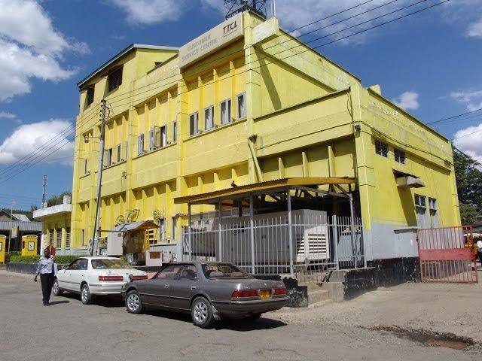
Picture 1 A picture showing the building of TTCL Mbeya region

1.1 HISTORICAL BACKGROUND OF TTCL
Tanzania Telecommunication Corporations formerly known as Tanzania Telecommunications Company Limited (TTCL) was established by An Act of the Parliament, 'The Tanzania Telecommunications Company Incorporation Act of 1993'
The Company came into operation following a split of the former parastatal organization known as Tanzania Posts and Telecommunications Company (TP&TC) and began operation on Jan 1, 1994. The split was due to the government's move to liberalize communications sector in the country, and due to this separation four parastatal entities were formed namely; The Tanzania Posts Corporation (TPC), Tanzania Telecommunications Company Limited (TTCL), Tanzania Postal Bank (TPB), and Tanzania Communication Commission (TCC) now known as Tanzania Communication Regulatory Authority (TCRA).
Subsequent to continued economic liberalization policy of the Government of Tanzania, TTCL was privatized on 23rd February 2001, where by a Consortium MSI of the Netherlands and Detecon of Germany acquired 35% shares of the company from the Government of Tanzania. However, the Government of Tanzania has effective from 23rd June 2016 fully repossessed TTCL ownership by 100%. Therefore until 1st of February 2018, TTCL was 100% owned by the Government of Tanzania.
The Tanzania Telecommunication Corporation (Act No 12 of 2017) was signed by The President of United Republic of Tanzania on 28th November 2017 and was gazetted by the Minister for Works, Transport &Communication to be effective on 1st February 2018.
Tanzania Telecommunications Corporation is taking up the duties and responsibilities of the former Tanzania Telecommunication Company Ltd -TTCL which ceased to operate on 31st January 2018.
The key functions of the Corporation are to; a) Enhance safety, security, economic and commercial viability of national telecommunications services and telecommunication infrastructure through; I. Promotion of effective management and operation of telecommunications services. ii. Development, maintenance, promotion and management of telecommunications services; and iii. Maintenance of safety and security of telecommunications infrastructure specified or determined in accordance with section 20 of Tanzania Telecommunication Corporation Act b) Plan build, operate and maintain the strategic telecommunications infrastructure proclaimed by the Government; c) Operate telecommunications services in accordance with the laws and prescribed procedures governing telecommunications services; d) Operate and maintain all types of telecommunications networks, including ICT systems and services within and outside the United Republic of Tanzania.

1.2 VALUES AND PRINCIPLES.
The TTCL’s day to day activities are guided by a set of values and principles which define a corporate culture and inform the actions of its employees by identifying what is most important in how things are done within the organization. TTCL values and principles will be understood and practiced by all employees and will be demonstrated to all stakeholders in everything the employees do.
OUR VALUES
Honesty, Integrity, and Mutual Respect. These will be at the core of all employee behavior.

PRINCIPLES
Teamwork, Open honest communications, Common Objectives; Active participation and ownership of customer solutions; Demonstrate the values and principles; and Excellence in everything we do.
- Working as a team, will allow TTCL employees achieve personal and corporate objectives and take pride in TTCL’s success and will resolve any misalignment of personal or departmental objectives.
- Open honest communications will create an atmosphere of trust and common purpose.
- TTCL employees will work toward corporate objectives. Their personal and departmental objectives will be aligned to corporate goals.
- All TTCL employees have customers, external and internal. TTCL employees will understand their customer needs and actively participate in the development of solutions to those needs. TTCL employees will not stop until their customer expectations have been met.
- TTCL employees will demonstrate the values and principles in their work environment. Their peers and their customers will recognize the value and principle driven work ethic.
- Excellence - We believe TTCL will achieve ongoing success through a concentrated effort on excellence in whatever they do.

1.3 MISSION, VISION AND OBJECTIVES
- Mission:
- To provide world-class communication services to its customers through continuous technological and customer care improvements.
- To deliver high quality telecommunication services that foster economic growth and contribute to a digitally inclusive society.
- To enhance the safety, security, economic and commercial viability of national telecommunications services and infrastructure.
- Vision: To be the leading provider of modern telecommunication services in Tanzania and the region.
- Objectives:
  - To expand fiber optic infrastructure across the country.
  - To provide affordable internet and communication services.
  - To enhance customer satisfaction through quality services.
  - To contribute to national development through digital inclusion.

1.4 SERVICES AND ACTIVITIES PERFORMED BY TTCL
TTCL provides a wide range of services including:
- Fixed-line telephone services
- Mobile voice and data services
- Fiber to the Home (FTTH) internet services
- Corporate communication solutions (leased lines, VPNs, MPLS)
- International communication services
- Cloud and data centre services

1.5 ADMINISTRATIVE STRUCTURE.
TTCL is governed by a Board of Directors and managed by a Director General. The organization is divided into departments such as:
- Network Operations
- Sales and Marketing
- Customer Service
- Finance
- Human Resources
- Regional Offices
Each regional office, including Mbeya where I was attached, is headed by a Regional Manager, who oversees departments such as Support, commercial and network departments. I as an engineering student belong to network department which includes Radio and Transmission, Switch and Data, Power and Air conditioner and Access Network Department.

1.6 ORGANIZATION STRUCTURE
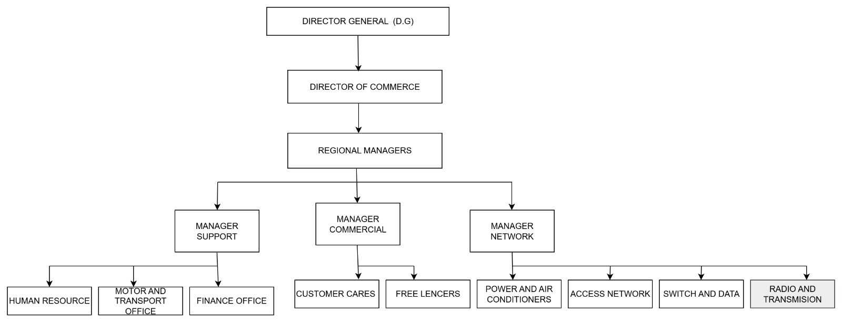
Picture 2 Administrative structure of TTCL

CHAPTER 02: ACTIVITIES PERFORMED

2.1: Summary of Activities that I have been Carrying Out During IPT.
In TTCL there are three main sections which are commercial, support and network. Commercial section deals with finance, customers and advertisements of the company. Support section deals with purchases, employee and employment. While network section has four subsections and each one has its own responsibilities. The subsections of the network section are access network, radio and transmission, switch and data together with power plants and air condition (PAC). Now let us see one subsection of the network after another.

2.1.1: ACCESS NETWORK

The subsection is led by a technical leader who is Eng. Safari for TTCL Mbeya. This technical leader is assisted by technicians and assistant technicians.

Their main job is to ensure quality and availability of the access network of both data and voice.

Responsibilities

- To perform routine and preventive maintenance according to the engineering instructions and schedules as will be directed by the technical leader.
- Implementation of the corrective maintenance activities in relation to the above, or on the advice of the technical leader.
- Implementation of the timely provision for data and voice services.
- Participate in access rehabilitation and minor expansion programs to be undertaken by the support group as may be instructed.
- To identify and timely report to the technical leader on status and requirement for cables, spare parts, consumables, tools, test gears and transport.
- Receive and promptly act on all work orders and timely feedback to the technical leader on implementation.
- To ensure prompt reporting of all Access Network faults/outages/anomalies.
- To maintain and update all appropriate documentation, including works orders and logbooks.
- To update and immediately reports on any noted changes of Access Network as built in documentation, inventory, routing and cable records.
- Ensure security and proper storage of all parts of access network.
- Adhere to processes, procedures and engineering instructions as will be provided time to time.
- To avoid any fraud related to access network.
- To perform any other duties as may be assigned by the controlling officer.

2.1.2: RADIO AND TRANSMISSION

Radio and transmission section is led by the technical leader who is Eng. Lubava for TTCL Mbeya main house. He is assisted by engineers and technicians of radio and transmission.
The main job of radio and transmission is to ensure availability and service quality of transmission/BSS systems in the region.

Responsibilities

- To perform routine/preventive maintenance activities in accordance with engineering instructions and schedules and/or as will be directed by the section technical leader.
- To analyse results and act or report/make recommendations as required.
- Monitor Transmission, BTS and BSC systems performance in the region.
- Implementation of the trouble shooting and corrective maintenance activities in the relation to the above, advice of the NMC or section Technical leader.
- To receive and act on information/advice from the Technical Leader or the NMC.
- Ensuring prompt reporting to Technical Leader/NMC of all faults/outages in accordance with guidelines.
- To participate in annual audits and major routines to be conducted by HQ Network Maintenance Group.
- To ensure clean database for all circuits/trucks/E1s configurations; timely implement accurate and reliable provisioning/cessation of new circuits, equipment and configurations as instructed by the section technical leader or NMC.
- To ensure security and cleanliness of the R&T/BSS equipment and shelter. Prohibit entrance to equipment room(s) by non-authorized personnel.
- To ensure proper storage, record and security of radio and transmission tools, test gears, spares, manuals and logbooks. Identify and report on spares, tools and test gears requirements/status.
- Detection and prevention of any possibilities of internal and external fraud related to the transmission section.
- Maintenance of all appropriate documentation, including work orders, CPAs etc.
- Provision of timely and accurate information/report/data on any activity as may be requested.
- To perform any other duty as may be assigned by the section Technical Leader.

Accountabilities:

- System availability, Transmission/BSS network performance and Quality of services.
- To adhere to company Quality Assurance requirements, in terms of processes, procedures, standards and technical/engineering instructions.

2.1.3: SWITCH AND DATA

The section is led by the Technical Leader assisted by other technicians. TTCL Mbeya has the technical leader of switch and data who is Peter Lutumo and assisted by Imma Hassan
Their main job is to ensure availability of voice and data services by providing operations and maintenance support for the Voice, IP/MPLS and Broadband Networks.

Responsibilities:

- Operation and maintenance of Voice and Data Network systems in the region to meet high quality network KPIs and service standards.
- Register, analyse and resolve incidents by performing root cause analysis and implement changes in coordination with higher level support teams including suppliers’ support lines.
- Implementation of the changes (expansions, upgrades or downgrades) on the systems/network and provision report in line change management process.
- To perform installations of the network equipment and configurations of voice and data systems.
- To perform Provisional Acceptance Tests (PAT) for newly installed systems or applications.
- Support the testing and introduction of new services.
- To monitor network and system performance and provision of solutions to improve the KPIs.
- Timely provision of incidence progress reports, monthly performance and capacity management report.
- Work orders implementation, configuration of the customers’ CPEs and Networks, commission and handover newly installed links or sites the customers, and promptly initiate billing of the services.
- Provide 24/7 service to customers.
- Perform any other duties as maybe assigned by controlling officer.

Accountabilities:

- Effective and timely management of incidences.
- Effective maintenance of the system.
- Effective service support to customers.
- Acceptance of newly installed equipment.

2.1.4: POWER PLANT AND AIR CONDITION PAC.

The section is led by the technical leader assisted by technicians. The technical leader of the section is Eng. Salim Kitola .

Their main job is to deal with all issues concerning electricity and air condition in the company.

Responsibilities:

- To ensure availability of electrical power in the telephone house.
- Making installations of electrical equipment in different areas of the company.
- Ensuring prompt reporting of all faults/outages in accordance with the guidelines.
- Ensuring security and cleanliness of power plants and air condition equipment and shelter
- Ensuring proper storage, record and security of PAC tools, test gears, spares, manuals and logbooks. Identification and report on spares, tools and test gears requirements.
- Perform any other duty as may be assigned by the technical leader.

Accountabilities:

Adhere company Quality Assurance requirements, in terms of processes, procedures, standards and technical/engineering instructions.
2.2: SAFETY REGULATIONS, GENERAL WELFARE RECRUITMENT AND TRAINING POLICIES

For maintenance of safety technicians of the company are required to wear overcoats and for those of access network are required to wear overcoats together with helmets. Also when dealing with electronics devices, technicians are required to wear anti-static strap to protect devices from static charges of human body. These protective devices, overcoats and helmets are provided freely by the company to its workers so as to ensure safety to the TTCL Corporation.

About the general welfare recruitment and training policies of TTCL Mbeya are good and the company’s staff members are well arranged to train practical training students. The staff members make their level best to train PT students so as to make them leave the company while they have gained enough knowledge. For sure I have enjoyed doing my first PT at TTCL Mbeya due to their good policies and treatment toward us as students.

2.3: BRIEF EXPLANATION ABOUT ORGANIZATIONAL STRUCTURE

The regional organizational structure of the company has been arranged well for archiving the goals of the company. Region Manager is the head of all three sections commercial, support and network. Commercial section deals with the finance, customers and advertisements of the company so as to make the company under competition with other telecommunications companies. The section is led by the Assistant Regional Manager Commercial who is the head of the section.

The support section is led by Assistant Regional Manager Support who takes the responsibilities of being accountable to the Regional Manager for the issues involving employees and purchases of the company. Support deals with employment, employees and purchases of the Corporation.

The last section is the network section which is led by the Assistant Regional Manager Network. Network section ensures that TTCL customers get high quality services as expected by the Corporation.

The combination of these three sections ensures the quality services to the customers of TTCL. Workers from all three sections work as a team toward the goal of the company of being the best company in providing telecommunications services in the country.

CHAPTER 03: TECHNICAL PART:

FIBER OPTIC SPLICING & CUSTOMER CONNECTION

TTCL ACCESS NETWORKING

INTRODUCTION:
A network is a system where two or more devices, like computers or printers, are interconnected to exchange data and share resources such as files, internet access, and peripherals.Devices or nodes can be connected via physical cables or wirelessly using radio waves .
An internetwork connects distinct networks using standard protocols like TCP/IP, enabling them to communicate, share data, and share resources across different entities. Its publicly accessible and their purpose is to facilitate communication and resource sharing between different networks, which can be owned by different entities.
An intranetwork is a private, secure network within a single organization, used for internal communication, collaboration, and knowledge sharing among employees, and is not accessible to the public.
ESSENTIAL COMPONENTS
Essential components include
- End devices(Node). Any device capable of sending, receiving, or forwarding data, including computers, servers, printers, and smartphones.
- Networking devices.Hardware that manages and controls network traffic, such as hubs, switches, routers, and firewalls.
- Transmission media, The physical or wireless medium used for data transfer, such as Ethernet cables, fiber optics, Wi-Fi, or Bluetooth.
- communication protocols (rules for data exchange). Sets of rules like TCP/IP that govern how devices communicate and exchange data within the network.
- Purpose: To enable communication, data sharing, and resource sharing between connected devices.
Tanzania Telecommunication Company limited (Ttcl) is the main provider and supplier of internet in Tanzania, buying internet outside the countries (Dubai, South Africa and India) through transmission on undersea by National ICT broadband backbone (NICTBB).

INTRODUCTION OF OPTICAL FIBER TECHNOLOGY

INTRODUCTION
Optical fiber is a flexible glass or plastic fiber that transmits information as light pulses over long distances with high speed and bandwidth. It consists of a central core where light travels, a cladding with a lower refractive index to trap the light via total internal reflection, and protective coatings. This technology has revolutionized telecommunications, enabling high-speed internet, global connectivity.
GENERAL STRUCTURE OF OPTICAL FIBER CABLE
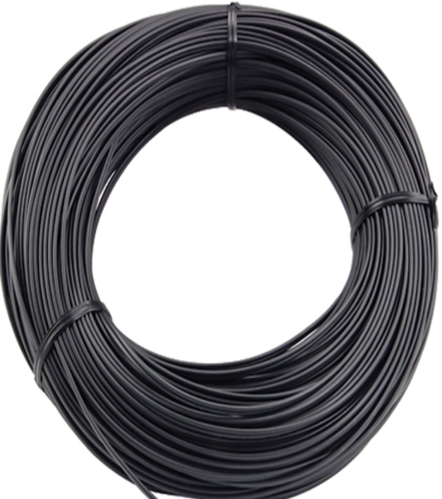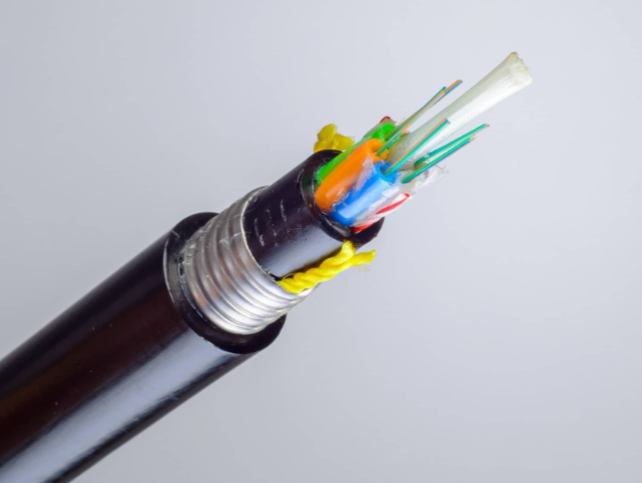

PROBLEM STATEMENT
Traditional electrical cables made of copper suffer from significant signal loss, are susceptible to electromagnetic interference (EMI), have limited bandwidth, and are physically heavier and bulkier. The introduction of optical fiber addresses these issues by providing superior performance, higher bandwidth, lower signal degradation, and immunity to electrical noise.

INSTRUMENTS AND TOOLS
- Cable Strippers: Used to remove the protective outer jackets and buffer coatings from the fiber without damaging the glass core.
- Fiber optical cable. The core medium for light transmission, consisting of a light-guiding core, a surrounding cladding, and protective coatings.
- Fusion splicer. A specialized tool used to join two fiber ends together with high precision, creating a near-lossless connection.
- Optical fiber cleaver. A tool that makes a precise, perpendicular cut on the end of the fiber, ensuring a perfect surface for splicing.
- Optical Time Domain Reflectometer (OTDR). An instrument for testing and troubleshooting fiber optic networks, capable of measuring signal loss, locating faults, and characterizing the fiber.

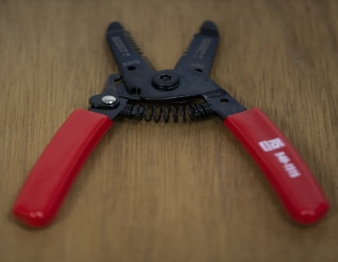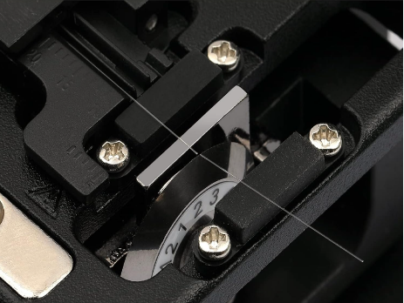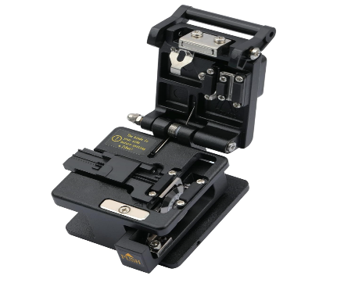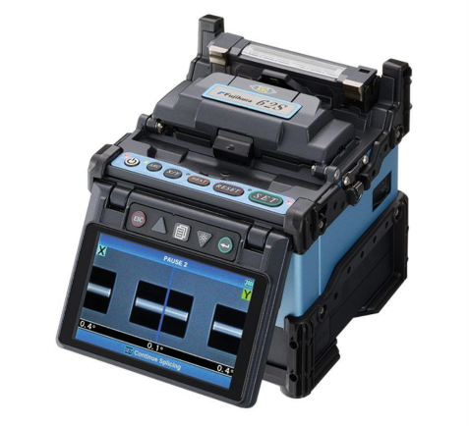

PROCEDURE FOR SPLICING

- Step 01: Prepare the Fiber. Use a fiber stripping tool to remove the outer protective coatings from the ends of the two fiber segments to be joined.
- Step 02: Cleave the Fiber. Use an optical fiber cleaver to make a precise, angled cut on the exposed glass ends of the fibers.
- Step 03: Align and Splice. Place the prepared fiber ends into the fusion splicer, which will automatically align them and then fuse them together using an electrical arc, forming a continuous, low-loss optical path.
- Step 04:Protect the Splice. After splicing, a protective sleeve is placed over the joint and often heat-shrink, providing structural integrity and safeguarding the connection.

CONCLUSION
The introduction of optical fiber has profoundly impacted telecommunications, leading to the development of ultra-fast, high-capacity networks that power the modern internet and other digital services. While the upfront cost of optical infrastructure and the need for specialized tools and skilled technicians remain significant challenges, the superior performance, reliability, and future-proofing offered by fiber optics make it an indispensable technology for current and future data communication needs.

INTRODUCTION OF NATIONAL ICT BROADBAND BACKBONE (NICTBB)
- The National ICT Broadband Backbone (NICTBB) is a strategic, government-built optical fiber network in Tanzania designed to provide nationwide, cost-effective, and reliable high-speed internet connectivity. Managed by TTCL Corporation, the NICTBB extends regional and international links, supporting e-government, e-learning, and e-commerce, with ongoing efforts to expand its reach and connect further into neighboring countries.

PURPOSE AND VISION
- Digital Inclusion. The primary goal is to enhance broadband access and penetration across Tanzania, bridging the digital divide and fostering a knowledge-based society.
- Socio-Economic Development. By improving communication infrastructure, NICTBB aims to accelerate the adoption of ICT applications, boosting the country's economic development and the efficient use of e-services.
- International Connectivity: It serves as a critical link for Tanzania to access international submarine cables, such as those landing in Dar es Salaam, providing high-quality bandwidth to the rest of Africa and the world.

KEY FEATURES AND OPERATIONS
- Network Technology. The backbone utilizes a multi-layered approach, incorporating Dense Wavelength Division Multiplexing (DWDM), Synchronous Digital Hierarchy (SDH), and Internet Protocol (IP) technologies to deliver high-capacity fiber optic connectivity.
- Management. NICTBB is managed and operated by Tanzania Telecommunications Company Ltd (TTCL) on behalf of the government, following principles of transparency and open access.
- Geographical Reach. The network connects all regions within Tanzania and provides cross-border connectivity to neighboring countries like Zambia, Malawi, Kenya, and Uganda.

IMPACT AND FUTURE EXPANSION
- Economic Benefits. The deployment of NICTBB contributed to a significant drop in internet access costs and increased the ICT sector's contribution to the Gross Domestic Product (GDP).
- Ongoing Expansion. The government continues to expand the network's reach, with plans to connect more districts and neighboring countries, including potential submarine cable connections across Lake Tanganyika to the Democratic Republic of Congo.
- Supporting Ecosystem. Beyond infrastructure, the NICTBB initiative is complemented by efforts in e-governance, e-learning, e-health, e-commerce, and efforts to develop digital skills to ensure Tanzanians can effectively use the network for daily activities and economic growth.

TTCL NETWORK ARCHITECTURE
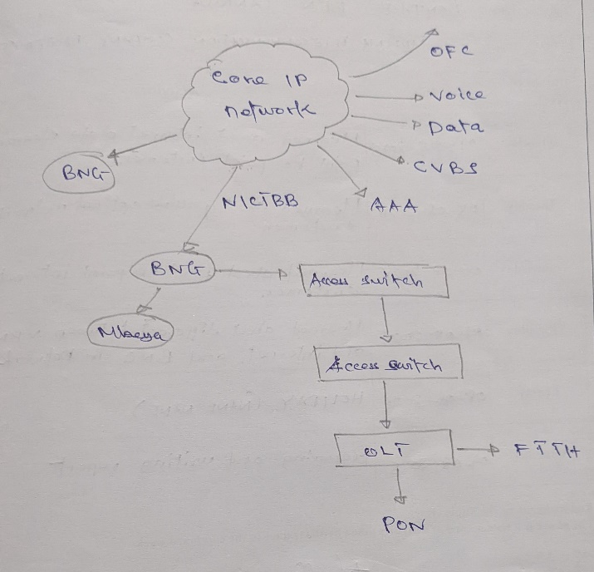

POWER MAINTANANCE FOR TTCL SERVICES.

INTRODUCTION TO POWER MAINTENANCES FOR TTCL SERVICES
Network services need energy to be provided. MDF and other network devices like DSLAM, B-RAS, MSAN cannot function without energy and these are very important devices of network.
MDF is an acronym of Main Distribution Frame. This is the termination point within local telephone exchange where the exchange equipment and termination of local loops are connected by jumper wires at the MDF. MDF is used as the termination of all coppers pair cables supplying services through user telephone lines to local exchange example repeaters and DSLAM.
B-RAS is the short time of Broadband Remote Access Server.it serve as the aggregation point for the subscriber traffic and provides session termination and subscriber management functions as authentication, authorization, accounting and IP addressing assignment.
DSLAM is the acronym of Digital Subscriber Line Access Multiplexer is an aggregate device used to handle the high speed digital data streams coming from numerous subscribers and aggregates it onto a single high capacity uplink to the ISP.DSLAM multiplexes signals from different subscribers into one signal and sends it to B-RAS. Also it DE multiplexer one signals from the B-RAS and direct the signals into different subscribers.
MSAN is the acronym of Multi-service Access Node. It is the device installed at the telephone exchange which connects customers’ telephone lines to the core network so as to provide telephone, ISDN and broadband such as DSL all from a single platform.MSAN is the modern device used instead of DSALM.
TTCL Mbeya depends on three sources of power so as to maintain its services in all of its station. The corporation has stations in every district of Mbeya and there are also different substitution in all districts. All these station need electricity all the time for the network devices to function and network to be maintained in all areas of Mbeya .There are three sources of power used by TTCL Mbeya in order to provide its telecommunications services in high efficiency. These sources are:-
1. TANESCO power sources
2. Generator power source and
3. Battery power source

BATTERY POWER INSTALLATION
INTRODUCTION
In telecommunications and many data center applications,-48V Direct Current (DC) is a standard voltage for powering network equipment like switches, routers, and base stations. This negative voltage reference where the positive terminal is grounded reduces electrochemical corrosion on outdoor wiring. The battery bank consists of 24 cells, each rated at 2V. The configuration involves two series strings of 12 batteries each, connected in parallel to achieve the required voltage and capacity.
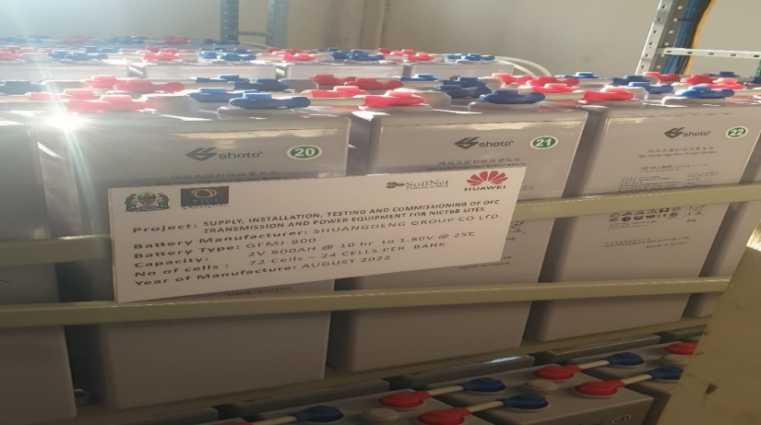
Problem Statement. A critical load requires a reliable-48V DC power source with extended backup runtime. The goal is to install a new battery bank that meets the following specifications
- System Voltage. -48V DC.
- Configuration. Utilize twenty-four (24) individual 2V lead-acid or lithium-ion cells.
- Topology. Arrange the batteries to provide both the necessary voltage (-48V) and increased amp-hour (Ah) capacity through a series-parallel connection.
- Safety. Ensure the installation is performed correctly to prevent short circuits, electrical arcs, and damage to equipment.

LIST OF TOOLS AND EQUIPMENT
- Twenty-four (24) 2V Battery Cells.
- Insulated Hand Tools such as Wrenches, Socket set, Screwdrivers.
- Personal Protective Equipment. Safety glasses, insulated gloves, protective clothing.
- Battery Interconnecting Cables.
- Cable Lugs and Bolts.
- Voltage Multimeter and
- Wire Brushes for cleaning terminals.

PROCEDURE
Step 1: Safety and Preparation
· Don all PPE (safety glasses and insulated gloves).
· Ensure the work area is clean, dry, well-ventilated, and free from sparks or flames.
· Verify that the new batteries are of the same type, voltage, and capacity.
· Install the battery racks securely and place all batteries in their designated positions.
Step 2: Building the First Series String (String A)
· Take the first set of 12 batteries.
· Connect the negative (-) terminal of Battery 1 to the positive (+) terminal of Battery 2.
· Connect the negative (-) terminal of Battery 2 to the positive (+) terminal of Battery 3.
· Continue this series connection until all 12 batteries are connected end-to-end.
· The free positive (+) terminal of Battery 1 will become the positive busbar connection for this string.
· The free negative (-) terminal of Battery 12 will now be at -24V relative to the positive end. This is the -24V output for the string.
Step 3: Building the Second Series String (String B)
· · Take the first set of 12 batteries.
· Connect the negative (-) terminal of Battery 1 to the positive (+) terminal of Battery 2.
· Connect the negative (-) terminal of Battery 2 to the positive (+) terminal of Battery 3.
· Continue this series connection until all 12 batteries are connected end-to-end.
· The free positive (+) terminal of Battery 1 will become the positive busbar connection for this string.
· The free negative (-) terminal of Battery 12 will now be at -24V relative to the positive end. This is the -24V output for the string.
· Ensure the physical layout and cable lengths are identical to those in String A to maintain balance.
Step 4: Connecting the Strings in Parallel
· Critical Check: Before making the final parallel connections, use a multimeter to verify that both strings have identical voltages (approximately -24V each).
· Connect the positive (+) output of String A to the positive (+) output of String B. This will be the connection to the system's positive busbar (which is grounded).
· Connect the negative (-) output of String A to the negative (-) output of String B. This will be the connection to the system's -48V output busbar.
· Ensure all connections are clean, secure, and tightened to the manufacturer's specified torque value.

Step 5: Final Connection and Verification
· Apply anti-corrosion gel on all terminal connections.
· Carefully connect the completed battery bank to the DC power system's load busbars.
· Use a multimeter to perform a final voltage test:
· Measure across the positive and negative busbars: it should read approximately -48V DC.
· Measure each string individually to ensure they are sharing the load equally.

CONCLUSION. The battery bank was successfully installed and configured to deliver-48V DC. The chosen topology of two series strings of 12 batteries each, connected in parallel, successfully provides the required system voltage while doubling the overall capacity (Ah), thereby extending the backup runtime for the critical load. Adherence to the safety protocol and procedure ensured a safe and reliable installation.

CHAPTER 04: CONCLUSION AND RECOMMENDATIONS
4.1 Conclusion
IPT helps us as students to use the knowledge we get from class to the field area. This is a very good thing simply because it builds competence, Ten weeks as the time allocated for IPT is sufficient to gain enough experience of work.
Generally, my practical training was very good indeed and really appreciated as I gained new knowledge and skills in Telecommunication system, also developed different skills on how to handle duties and tasks assigned to me through hard working and creativity. Also gain new attitudes of working as a team and to perform my duties likewise how to maintain the relationship with the customers in short and long terms base.
Even though the time was too limited to learn a lot of things but through the help of my on-site supervisor I managed to plan and cover what I was supposed to learn during my practical training at TTCL MBEYA. There was effective supervision from supervisors that helped me to gain spirit of hard working and management of time effectively.
On the other hand, the field training was too short in terms of time comparing to the things that I had to learn and be knowledgeable on it. Since we only had two months and two weeks of practical training and things that we have to learn need more time, efforts and continuously practices.
Therefore, conclusion can be made by saying that practical training is very essential and it should be modified through the entire recommendations given out to make program successful and hence making the better students who graduate in Telecommunication system.

4.2 Recommendation
The relationship between organization/companies and academic institutions must be extended beyond the practical training period, since the technology is evolving it would be better that seminar from industrial expertise should be encouraged to let the student aware of what is actually demanded from the industries so that they can focus and participate in the evolving technology.

4.3 REFERENCES
1. Mason, Andew G. (2002). Cisco Secure Virtual Private Network. Cisco Press .p. 7.
2. Daugherty, Herbert. ‘Automatic Transfer Switches’ p.190, 200 on site Power Generation fourth edition. Boca Raton, Florida: Electrical Generation Systems Association, 2006.
3. William, Stallings. Data and Computer Communication. New Jersey: Prentice-Hall India: 5th Edition, 1997.
4. Roger L. Freeman. Fundamental of Telecommunication. New York: John Wiley& Sons, Inc. 1999.
5. University of Chicago (2011) TELECOMMUNICATION STRUCTURED CABLING GUIDELINES AND SPECIFICATION, Chicago
www.ttcl.go.tz
www.google.co

