PREFACE
I conducted my IPT (Industrial Practical Trainings) at Mbeya University of Science and Technology(MUST) that gave me great chance to observe, learn, experience and practice the basics of Information and communication Technology in real life in short.
I had a chance of doing different tasks that I studied before in class that involved the Network, Cloud, Computing, and Ascend AI Tracks, which examine theoretical knowledge and hands-on ICT skills.

ACKNOWLEDGEMENT;
I would like to extend my grateful thanks to the almighty God for his grace, blessings, love and good health every day and during my Practical Training ,Also I would like to give a special thanks to my university telecommunication lectures and facilitators (staff) ,friends and relatives who have been supporting me during all ten weeks of my Practical Training.
I am also grateful to Mbeya University of Science and Technology and all other staff members for accepting my request of conducting the practical training at Mbeya University of Science and Technology and most importantly for orienting me with the real work environment by letting me to be part of their team for the whole period of practical training .

Much thanks also goes to the chancellor of MUST allowing me to attend my field practical training at his institution, Also I would like to give a special thanks to my supervisor Mr. Tumaini Mbinda for their full cooperation during all weeks of practical training.

ABSTRACT
This field work attachment for the second year student was conducted at Mbeya University of Science and Technology from 8th July to 13rd September 2024 where different activities were conducted and observed and were done in participatory way. Those activities include understanding or knowning different instrument/equipment used in Huawei technology (switch,Router,FIP AP), installation and configuration of different Huawei instrument in a network, and programming language i.e python.
The report also revealed the importance of practical training. In reality these Practical trainings are essential because they abide with three dimensions of learning which are cognitive, affective and psychomotor whereby they help one to integrate both of them in field through thinking, recalling, doing and feeling as well experiencing.

Practical Trainings are also advantageous because they shape one's behavior and make him/her learn from other staff members the ways of conduct and how to manage the working environment including the Way of dressing ,being organized ,respecting ,managing time and some time the way to speak during different Meetings(gatherings) which are conducted to specific institution or organization.

DECLARATION
I BONIFACE BEN SANKWA, am here to declare that the contents of this Technical report, are the original copy and also original design of what I went through in all my ten weeks of my Industrial/Field practical training. Also any of what explained within this report is true information especially when explaining more on among the different activities which were performed for ten weeks during Industrial/Field practical training period.

PART I GENERAL PART;

HISTORICAL BACKGROUND OF THE FIRM
In 1986, Mbeya Technical College (MTC) was established for the purpose of training students for the award Full Technician Certificate (FTC) under the Russian Training support. ... The long term plan was to transform Mbeya technical College into a University of Science and Technology through the University Act No.7 of 2005 and the Charter of Mbeya University of Science and Technology, 2013. Via nation council for technical education (NACTE) establishment order No.9 of and section 9 of the NACTE Act of 1997. MTC was officially launched on 1st September, 1986.
The transformation from MTC to MIST and the MUST was done to fulfill a long –term plan, made during the first phase Government, under the president of United Republic of Tanzania, the late Mwalimu Julius Kambarage Nyerere.
The Universities Act, requires Universities to draft Charters and have also required them to approved as a condition for providing University Education. In compliance with the requirements of the Universities Act, Mbeya University of Science and Technology has been established through part II, section 3(1) of the Mbeya University of Science and Technology Charter, (2013).

LOCATION
The university (MUST) is among the best universities we have in our country Tanzania. It offers many different engineering, science courses as well as some business courses.
Mbeya University of Science and Technology has two campuses. The Main Campus is located in Mbeya City in the Southern Highlands of Tanzania 10 km outside the city center and about 3 Km from the Mbeya – Tunduma Highway. The road to MUST branches from the highway at the Iyunga/Ituta -TAZARA area. The Rukwa Campus of Mbeya University of Science and Technology is located at Kianda along Tunduma Sumbawanga road, about 50 km from Sumbawanga.

A PICTURE OF MUST LOCATION

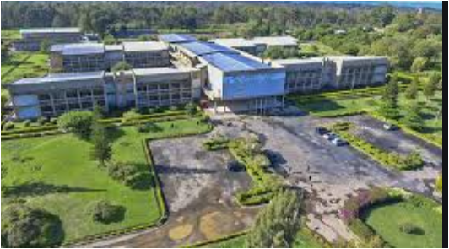

VISION;
The vision of Mbeya University of Science and Technology is to become the leading centre of excellence for knowledge, skills and applied education in Science and Technology.
MISSION;
The mission of Mbeya University of Science and Technology is to develop academically, technologically and socially competent students, staff and other stakeholders who will be responsive to the broader needs
And challenges of the society specifically by:
-Facilitating appropriate tuition, practical training and support according to the needs of students and other customers.

GRADUATION AWARDS FOR STUDENTS
-ORDINARY DIPLOMA PROGRAMMES
- Chancellor’s prize: Best Overall Finalist Student
-University Prize: Best Overall Finalist Female Student
-Note that Other Awards are to be set by the University
UNDERGRADUATE PROGRAMMES -Chancellor’s prize: Best Overall Finalist Student
-University Prize: Best Overall Finalist Female Student -Other Award to be set by the University
DEPARTMENTAL PRIZES
Other Prizes from departments may also be given to students based on criteria and award set by the departments.
OTHER PRIZES
Other Prizes from individuals or institutions may also be given to students based on criteria and award set by the donor.

MUST ORGANISATION STRUCTURE AND MANAGEMENT
Management of Mbeya University of Science and Technology (MUST)
Organization structure of Mbeya University of Science and Technology (MUST)
MANAGEMENT OF MBEYA UNIVERSITY OF SCIENCE AND TECHNOLOGY
- Vice Chancellor
Prof. Aloyce Mvuma - PhD (Dortmund) MSc. Eng. (UDSM), B.Eng. (Mysore),
- Acting Deputy Vice Chancellor Planning Finance and Administration (DVC-PFA
Dr Alexander Mtawa, PhD Mech. Eng. (CPUT, SA), Msc. Mech. Eng. (SOFIA, Bulgaria), FTC Mech. Eng. (ATC)

- Acting Deputy Vice Chancellor Academic Research and Consultancy (DVC-ARC)
Prof.Osmund Kaunde
- Principal of College of Engineering and Technology
Dr. Zacharia Katambara - PhD (WITS), MSc Eng. (UDSM) BSc Eng. (UDSM)
- Director of Human Resource Management
Mrs. Devotha Msuya - MSc.HRM (MZUMBE)
- Dean of School of Business Studies
Dr. Vicent Kipene – PhD (SUA), MBA(SUA), BSc Ed(SUA), Dip.Ed.(Monduli)
- Principal of College of Science and Education
- Director of Undergraduate Studies
- Dean of Students
Mr Augustine P. Matem - MA Ed. (UDOM), BSc Ed. (UDSM), Dip Ed. (Mkwawa)
- Chief Internal Auditor
Mr. Deusdedit Sinda - CPA (T), Diploma in accountancy (slet), ADA (IFM)
- Chief Accountant
Mr. Shwaibu Shaban - CPA (T), PGD Finance Management (IFM), ADA (IFM)
- Chief Planning Officer
Mr. Cornell Msemwa - MBA (SUA), BSc. FST (SUA)
- Director of Library Services
Mr. Novatus Luanda - MA. (UDSM), BA. (UDSM), Dip. (Nyegezi)
- Director of Postgraduate Studies, Research and Publication
- Director of MUST Consultancy Bureau (MCB)
Mr. Dua Chengula-PhD (Dortmund) MSc. Eng (UDSM) BSc. Civil (UDSM)
- Head-Center for Quality Assurance and Quality Control
Ms. Albentina Leonard, MBA-Finance &Banking (MZUMBE), BA. Ed (UDSM),
- Corporate Counsel
Advocate Saumu Mruke -LLM (Ruaha), PGD in Law (Law School of Tanzania), LLB (MZUMBE)

ORGANIZATION STRUCTURE OF MBEYA UNIVERSITY OF SCEINCE AND TECHNOLOGY
CHANCELLOR
ccccOUNCILsssssssss
VICE CHANCELLOR
HEAD OF INFORMATION, EDUCATION AND COMMUNICATION UNIT
DIRECTOR OF QUALITY ASSURANCE & QUALITY CONTROL
CHIEF INTERNAL AUDITOR
HEAD OF PROCUREMENT MANAGEMENT UNIT
HEAD OF LEGAL UNIT
DEPUTY VICE CHANCELLOR-ACADEMIC,RESEARCH AND CONSULTANCY
DEPUTY VICE CHANCELLOR-PLANNING,FINANCE AND ADMINISTRATION
PRINCIPALS/DEANS
ACADEMIC DIRECTORS
HEAD OF DEPARTMENT
ADMINISTRATIVE DIRECTORS
HEAD OF DEPARTMENT/SECTIONS
5323

TECHNICAL PART:

INTRODUCTION
This part explains more on the Network management and O&M as one among the many activities during my Industrial/Field Practical Training at Mbeya University of science and technology (MUST).

NETWPRK MANAGEMENT AND O&M
What are network management and O&M?
Network management and O&M play an important role in a communications network. It ensures that devices work properly and the communications network runs properly to provide efficient, reliable, and secure communications services.

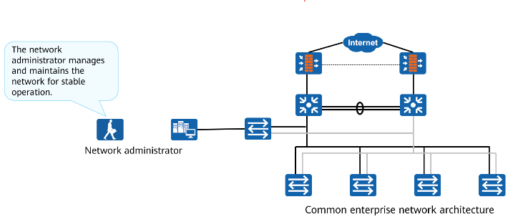
Basic Network Management Functions
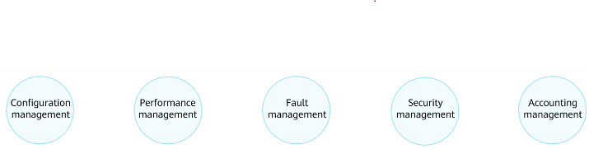
OSI defines five functional models for network management:
- Configuration management: monitors network configuration information so that network administrators can generate, query, and modify hardware and software running parameters and conditions, and configure services. Performance management manages network performance so that the network can provide reliable, continuous, and low-latency communication capabilities with as few network resources as possible.
- Fault management: ensures that the network is always available and rectifies faults as soon as possible.
- Security management protects networks and systems from unauthorized access and attacks.
- Accounting management: records the network resource usage of users, charges users and collects statistics on network resource usage.

Network Management Modes
- Traditional Network Management and O&M
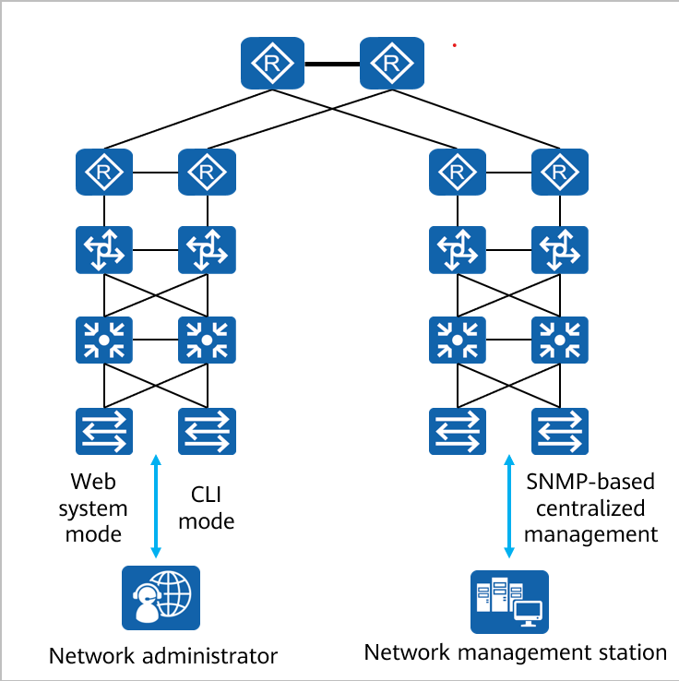
- iMaster NCE-based Network Management and O&M
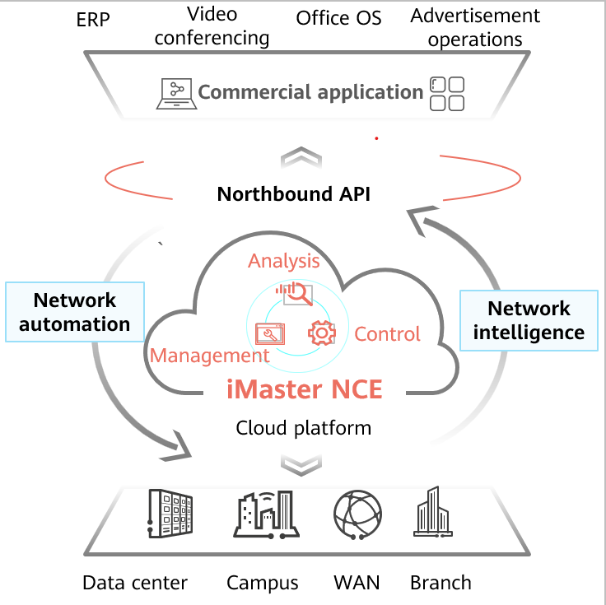

Management Through the CLI or Web System
When the network scale is small the CLI and web System are generally used for network management,
Network administrators can log in to a device through HTTPS, Telnet, or the console port to manage the device. These network management modes do not require any program or Server to be installed on the network, and the costs are low.
Network administrators must have a good master of network knowledge and vendor-specific network
configuration commands. These modes have great limitations when the network scale is large and the network topology is complex.
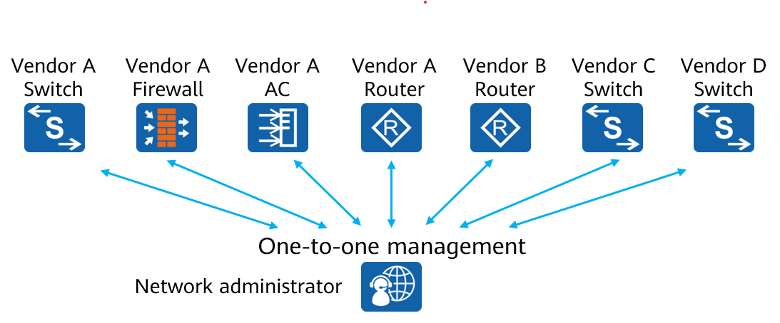

SNMP-based Centralized Management
SNMP is a standard network management protocol widely used on TCP/IP networks. It provides a method for managing NESs through a central computer that runs network management software, which is a network management station.
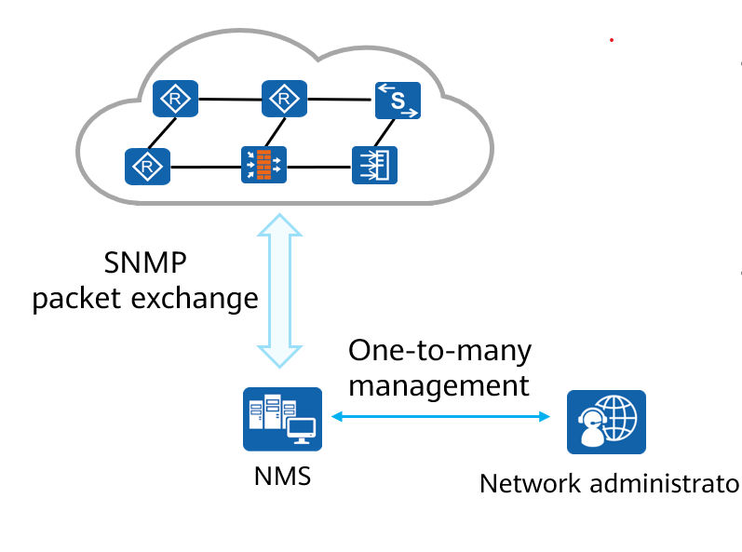
Network administrators can use the NMS to query information, modify information, and troubleshoot faults on any node on the network, improving work efficiency.
Network devices of different types and vendors are managed in a unified manner.

Typical SNMP Architecture
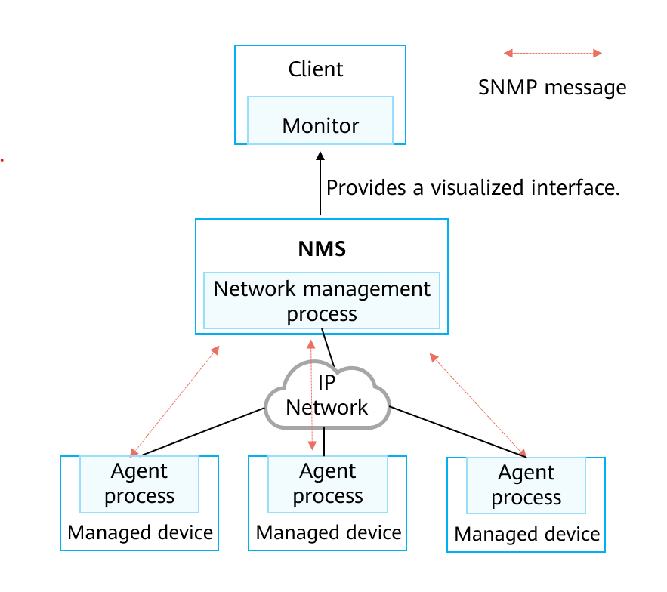
On a network where SNMP is used for network management, a network management system (NMS) functions as a network management center and runs management processes. Each managed device needs to run an agent process. The management process and agent process communicate with each other through SNMP messages. An NMS is a System that uses SNMP to manage and monitor network devices. The NMS software runs on NMS servers.

Managed devices are devices that are managed by the NMS on the network.
The agent process runs on managed devices to maintain the information data of the managed devices, respond to the request from the NMS, and report the management data to the NMS that sends the request.

SNMP Message Exchange
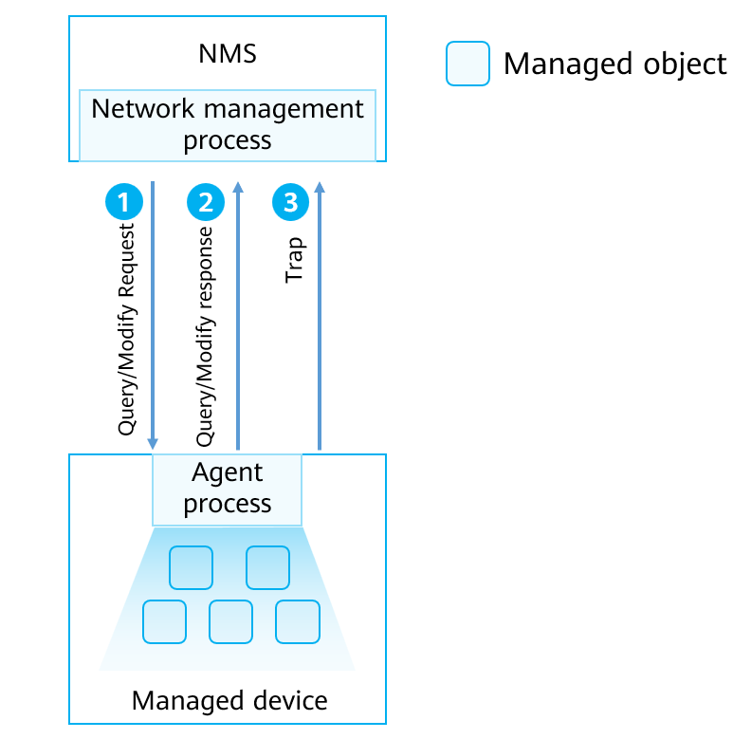

The NMS and managed devices exchange messages in the following modes:
The NMS sends a request for modifying or querying configuration information to a managed device through SNMP. The agent process running on the managed device responds to the request from the NMS.
The managed device can proactively report traps to the NMS so that the network administrator Can detect faults in a timely manner.
Managed object: Each device may contain multiple managed objects. A managed object can be a hardware component or a Set of parameters configured on the hardware or Software (Such as a routing protocol).
SNMP uses management information bases (MIBs) to describe a group of objects of a manageable entity.

MIB
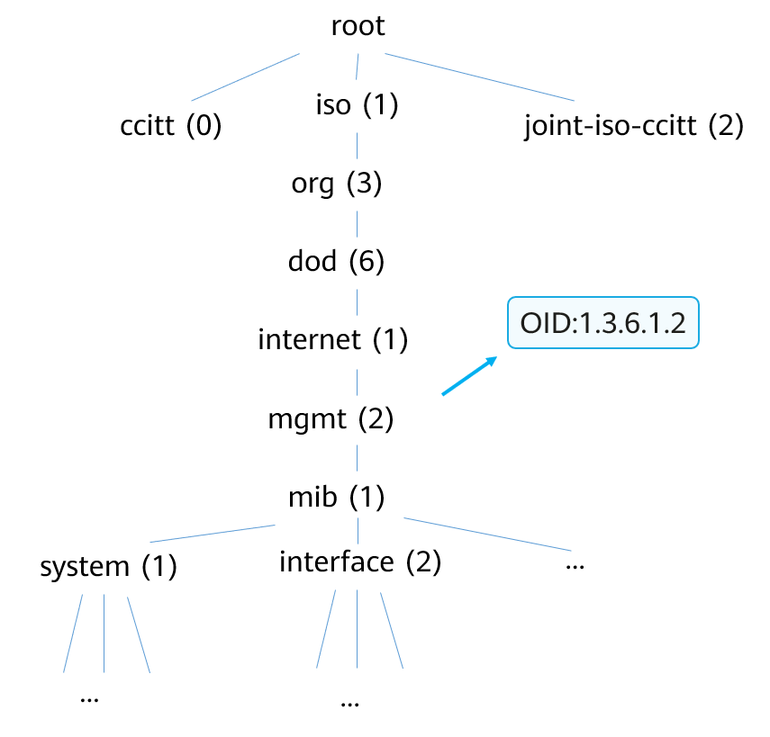
A MIB is a database containing the variables that are maintained by managed devices. (The variables can
be queried or set by the agent processes.) The MIB defines the attributes of managed devices in the
database. The object identifier (OID) of an object, Status of an object, Access permission of an object, Data types of an object
A MIB provides a Structure that contains data on all NEs that may be managed on the network. Because the data structure is similar to the tree structure, a MIB is also called an object naming tree.

Common MIB Objects
Objects used for query or modification:
OID | Object Name | Data type | Maximum Access | Description
1.3.6.1.2.1.2.1 | ifNumber | Integer | read-only | Number of network interface in the system (regardless of the current interface status)
1.3.6.1.4.1.2011.5.25.41.1.2.1.1.3 | hwlpAdEntNetMask | IpAddress | read-create | Subnet mask of an IP address

Objects used for alarm notification:
OID | Object Name | Bound Variable | Description
3.6.1.6.3.1.1.5.3 | linkDown | Iflndex  ifAdminStatus  ifOperStatus  ifDesc | It is detected that one of the communication links in the ifOperStatus object has entered the down state from another state(but not the not present state). The original state is indicated by the value of ifOperStatus.

SNMP Management Model

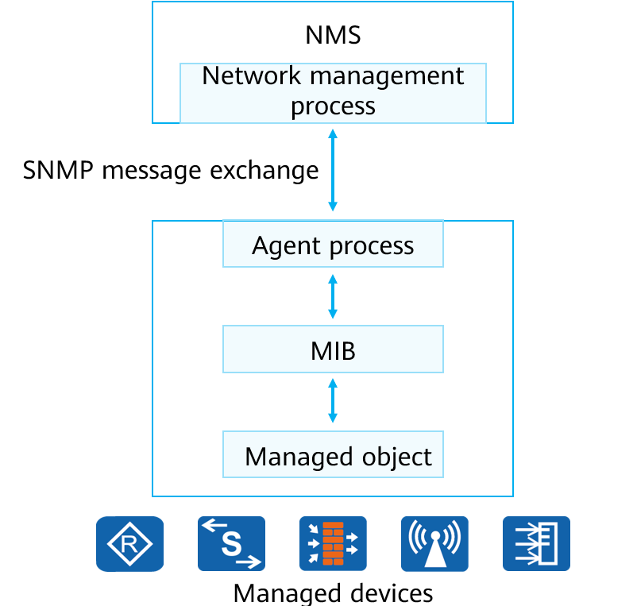
Query/Modify operation:
The NMS sends an SNMP request message to an agent process.
The agent process Searches the MIB on the device for information to be queried or modified and sends an SNMP response message to the NMS5.
Trap operation:
lf the trap triggering conditions defined for a module are met, the agent process Sends a message to notify the NMS that an event or trap has occurred on 3 managed objects. This helps network administrators promptly process network faults.

SNMPv1

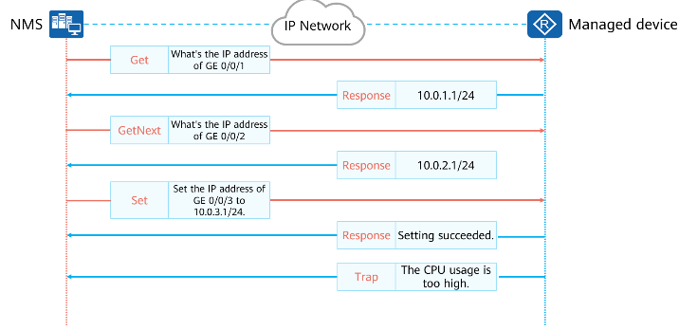
SNMPv1 defines five protocol operations.
Get-Request: The NMS9 extracts one or more parameter values from the MIB of the agent process on the managed device.
Get-Next-Request: The NMS9 obtains the next parameter value from the MIB of the agent process in lexicographical order.
Set-Request: The NMS9 sets one or more parameter values in the MIB of the agent process.
Response: The agent process returns one or more parameter values. lt is the response to the first three operations.
Trap: The agent process sends messages to the NMS9 to notify the NMS of critical

SNMPv2C

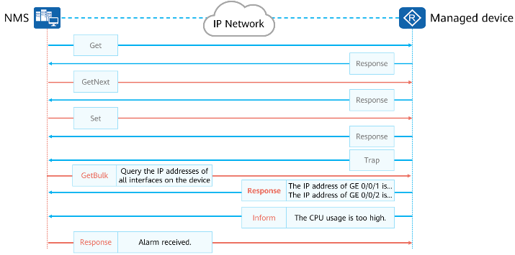
SNMPv2c supports the following operations:
GetBulk: equals to multiple GetNext operations. You can set the number of GetNext operations to be included in one GetBulk operation.
Inform: A managed device proactively sends traps to the NMS9. In contrast to the trap operation, the inform operation requires an acknowledgment. After a managed device sends an InformRequest message to the NMS9, the NMS9 returns an InformResponse message. If the managed device does not receive the acknowledgment message, it temporarily saves the trap in the Inform buffer and resends the trap until the NMS9 receives the trap or the number of.

SNMPv3
SNMPv3 has the Same working mechanism as SNMPv1 and SNMPv2c but adds header data and security parameters.
SNMPv3 messages can be authenticated and encrypted.
SNMPv3 is applicable to networks of various scales and has high security.
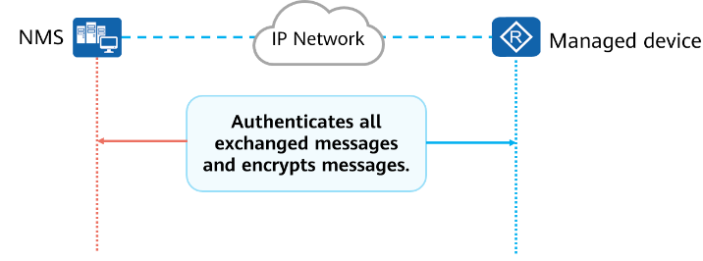
SNMPv3 supports identity authentication and encryption.
Identity authentication: A process in which the agent process (or NMS) confirms whether the received message is from an authorized NMS (or agent process) and whether the message is changed during transmission.

Encryption: The header data and security parameter fields are added to SNMPv3 messages. For example, when the management process Sends an SNMPVv3 Get- Request message carrying security parameters such as the username, key, and encryption parameters, the agent process also Uses an encrypted response message to respond to the Get-Request message. This Security encryption mechanism is especially applicable to a scenario in which data needs to be transmitted through a public network between the management process and agent process.

SNMP Summary
SNMP has the following advantages:
Simplicity SNMPis applicable to networks that require high speed and low cost because it uses a polling mechanism and provides basic network management functions. Moreover, SNMP uses UDP to exchange data and therefore is Supported by most products.
Convenience: SNMP allows management information exchange between arbitrary devices on a network So that a network administrator can query information and locate faults on any device.
SNMPv1 applies to small-scale networks where security requirements are not high or the network environment is safe and stable, such as campus networks and small-sized enterprise networks.
SNMPv2c applies to medium- and large-sized networks where security requirements are not high or the network environment is Safe, but a large volume of traffic exists and traffic congestion may occur.
SNMPv3 is the recommended version and applies to networks of various scales, especially those networks that have high-security requirements and allow only authorized administrators to manage network devices

