Lecture 6a:
1. Hardware Components
These are the physical devices needed to run an ERP system smoothly.
🔹 Types of Hardware:
- Servers:
High-performance computers that store ERP data and process transactions.
Can be:
  - On-premise: Kept in the company’s own data center.
  - Cloud-based: Hosted by companies like AWS or Microsoft Azure.
📌 Example: A big company like Nestlé uses fast servers to handle data from all its branches.
- Storage Devices:
Store huge amounts of data from ERP systems.
  - SSD (Solid State Drives): Fast and reliable.
  - Cloud Storage: Flexible, scalable, and cheaper.
📌 Example: A hospital using cloud storage for real-time access to patient data.
- Network Infrastructure:
Connects all users and departments in the company.
  - LAN: For internal office communication.
  - WAN: Connects multiple locations.
  - VPN: Provides secure remote access.
📌 Example: A global supply chain company tracks shipments using a WAN-connected ERP.

2. Software Components
These are the ERP applications and modules that manage different business areas.
🔹 Common ERP Modules:
- Finance & Accounting: Manages accounting, taxes, and budgeting.
- Human Resource Management (HRM): Handles payroll, hiring, employee performance.
- Supply Chain Management (SCM): Manages inventory, logistics, procurement.
- Customer Relationship Management (CRM): Manages sales, marketing, and customer service.
- Production & Manufacturing: Manages production planning and orders.

3. People Resources
These include the employees and IT professionals who manage and use the ERP system daily.

✅ ERP and Virtualization
💡 What is Virtualization?
Virtualization means running multiple ERP applications on a single server using cloud computing. It saves money and increases flexibility.
🔹 Two Common Types:
- Hardware Virtualization (Bare Metal):
ERP runs directly on server hardware using hypervisors (like VMware, Microsoft).
It's fast and efficient.
📌 Example: Used for mission-critical ERP systems that need speed and performance.
- Paravirtualization:
Supports multiple operating systems (OS) on one server.
Provides isolation between different ERP applications.
🔹 Vendor Strategies:
- Oracle VM: Oracle’s own virtualization software.
- SAP: Does not force customers to use a specific virtualization tool. Offers support and tweaks for whatever system they choose.

🌟 Benefits of ERP Virtualization:
- Cost Reduction: Fewer physical servers needed.
- Scalability: Easily increase system power as needed.
- Disaster Recovery: Virtual backups help continue operations after failures.
📌 Example: Microsoft Azure ERP solutions help businesses scale globally.

✅ Implementation Methodology
Implementing an ERP is a complex and resource-heavy process. That’s why choosing the right methodology is important.

🔹 Vanilla Implementation: What is it?
A vanilla implementation means installing the ERP "as is" without making custom changes.
Instead of changing the ERP system, the company changes its business processes to fit the ERP.
Why Would You Consider a Vanilla Implementation?
Several factors include considering vanilla implementation
- Business processes are standard and simple
- Company wants lower cost and faster implementation
- No expert IT team to handle system changes
- Multiple branches need a single, same system
- Want to avoid risk during updates and support
In these cases, vanilla implementation is considerable.
When Should You Consider Modifying an ERP?
- If your business have unique processes or competitive advantages.
- If you have experienced developers to manage customizations.

🔹 Benefits:
- Lower cost
- Quicker setup
- Easy to maintain and upgrade
- Follows industry best practices

✅ Third-Party Products & ERP Integration
Third-party products are extra tools that work with ERP systems. They are used to:
- Add missing features
- Improve performance
- Help the ERP do specific tasks better
📌 Example: A hospital integrates pharmacy software with SAP ERP to track drug inventory in real-time.

Lecture 6b:
🛍️ Company Overview:
GreenGrocer is an organic food supermarket chain with 250 stores, facing tough competition from Whole Foods and Trader Joe’s.
They are well-known but struggling with internal operational problems.

🚩 Main Problems GreenGrocer is Facing:
- Manual Inventory Tracking
→ Leads to overstocking perishable items and stockouts of popular products.
- Poor Supply Chain Coordination
→ Delays in deliveries, miscommunication with suppliers, and inconsistent stock availability.
- Outdated Checkout System (POS)
→ Slow billing process, long lines, and customer frustration during busy hours.
- Ineffective Loyalty Program
→ No proper data tracking = No personalized offers or insights into customer behavior.

✅ How ERP Can Solve These Issues:
1. Inventory Management Module
- Automates stock tracking
- Sends alerts when stock is low or perishable goods are about to expire
- Reduces waste and ensures shelves are always filled with in-demand items
✅ Result: Better stock control, less spoilage, more satisfied customers.

2. Supply Chain Management (SCM) Module
- Connects directly with suppliers
- Automates purchase orders and delivery tracking
- Improves communication and ensures on-time deliveries
✅ Result: Smooth stock flow and fewer delays.

3. Point of Sale (POS) Integration
- Modern POS system integrated with ERP
- Speeds up billing and updates inventory in real time
✅ Result: Faster checkout, less waiting, happier customers.

4. Customer Relationship Management (CRM) Module
- Tracks loyalty points and purchasing patterns
- Sends personalized offers and promotions
- Helps understand customer preferences
✅ Result: Better marketing and increased customer loyalty.

Lecture 7:
🌟 What is ERP Vendor Selection?
ERP vendor selection means choosing the right company (like SAP, Oracle, Microsoft) that will provide ERP software. It's one of the most important decisions because the wrong choice can cause business failure, financial loss, or waste of time.

✅ Why is ERP Vendor Selection Important?
- Ensures the ERP system matches your business needs.
- Reduces the risk of project failure.
- Supports future growth and changes (scalability).
- Offers good training, support, and follows security standards.
Example:
Welch’s (a juice company) compared SAP and Oracle, and chose Oracle because it was cheaper, easier to implement, and flexible.

🧭 Steps in Selecting an ERP Vendor
🔍 Step 1: Research and Identify Potential Vendors
- Make a list of ERP vendors that suit your industry and business type.
- Check what your competitors are using.
- Review the vendor's reputation and experience.
- Look for industry-specific ERP (e.g., SAP for manufacturing, Workday for HR).
Example:
A hospital will prefer ERP that follows health rules (like HIPAA), while a retailer wants real-time inventory.

💻 Step 2: Conduct Vendor Demonstrations and Initial Evaluations
- Shortlist ERP vendors through detailed demonstrations and system reviews.
- Ask vendors to show how their ERP works (demo).
- Check:
  - User-friendliness
  - Customization options
  - Integration with current systems
  - Security & scalability
Example:
A store will test if the ERP works well with its billing (POS) system.

🧩 Step 3: Define Business Needs
Align ERP selection with current business challenges and long-term strategy.
- Conduct a business process analysis (BPA) to define critical functions.
- Perform a fit-gap analysis to compare ERP capabilities with business needs.
- Identify customization needs and vendor capabilities.
Example:
A global company may need multi-language and multi-currency support.

📄 Step 4: Issue a Request for Proposal (RFP) or Request for Bid (RFB)
Obtain detailed vendor proposals for comparison.
- Share detailed requirements, expected outcomes and IT infrastructure details.
- Ask for information on costs, implementation time, training, and post-implementation support.
Example:
A manufacturing company may ask for ERP that supports inventory + production + IoT features.

⚖️ Step 5: Evaluate Proposals & Select Vendor
- Compare all vendors based on:
  - Functional Fit – Does the ERP meet core business requirements?
  - Technical Fit – Can the ERP integrate with current IT systems?
  - Vendor reputation – Are they reliable?
  - TCO (Total Cost of Ownership) – Is it affordable for long-term?
  - Support and training – Do they offer training and help?
Example:
SAP is great for large companies.
Microsoft Dynamics 365 is better for medium businesses because it's cheaper and integrates easily.

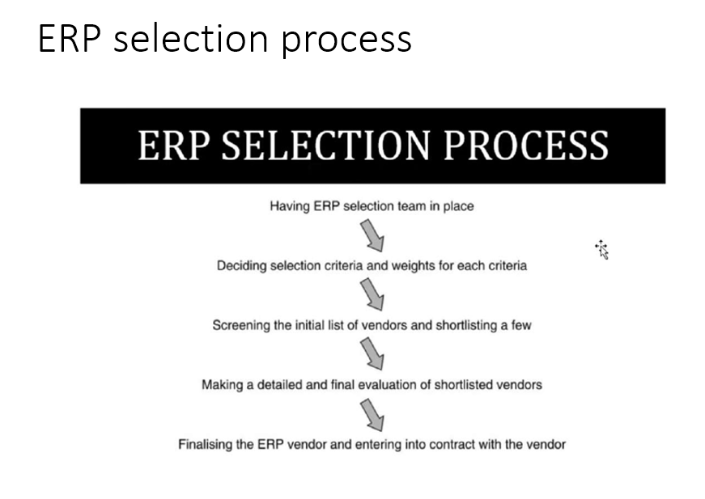

💰 Total Cost of Ownership (TCO)
Total Cost of Ownership (TCO) refers to the overall expenses associated with purchasing, implementing, and maintaining an ERP system over its lifecycle.
Direct Costs:
- Software licensing fees (one-time purchase or subscription-based).
- Hardware upgrades (servers, storage, networking).
- Implementation costs (consulting, configuration, customization).
Indirect Costs:
- Employee training costs for system adoption.
- Ongoing maintenance and vendor support fees.
- Future upgrades and integration expenses.
Example:
SAP may be cheap upfront, but maintenance is expensive.
NetSuite (cloud ERP) may be subscription-based with predictable pricing.

🎯 Matching ERP to Business Needs
1. Traditional Approach:
- Business tells what it needs.
- Vendor shows how ERP meets those needs.
2. Fit/Gap Analysis:
- Vendor maps features to your work.
- Finds missing parts → may need customization.
Example:
A construction company may need a special project accounting module, so vendor adds it.

✅ RFP (Request for Proposal) vs. RFB (Request for Bid)
- RFP (Request for Proposal):
  - Purpose: Ask vendors to propose solutions for your specific needs.
  - When to Use: For complex or custom solutions.
  - Example: If your company needs a new ERP system with custom features, you would send out an RFP asking vendors how they would build and implement it.
- RFB (Request for Bid):
  - Purpose: Request vendors to submit price quotes based on clear specifications.
  - When to Use: For standard products or services with defined requirements.
  - Example: If you’re buying office supplies or equipment, and you know exactly what you need, you’d send an RFB to get price quotes.
Key Difference: RFP focuses on solutions, RFB focuses on price.

