Virtual Systems and Services
ITL-422

Assignment 4



Student Name

Enrolment No.

Class and Section

Department of Computer Science
BAHRIA UNIVERSITY, ISLAMABAD

Assignment # 4: Case Study on Product
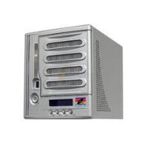
Product: Micronet MaxNAS
Explanation: ?
Working: ?
Storage: ?
Price: ?
Protocol: ?
Specifications: ?

Please note that handwritten submission is required. Also upload scanned copy on LMS.

