

Shadows of Identity: The Price of Fair Skin and Fluent English

Alishwa Rizwan, Ghania Majid, Fahad Waseem, Saboor ul Haq, Zainab Aftab
2025-GA-07, 2025-GA-09, 2025-GA-20, 2025-GA-26, 2025-GA-41

Instructor: Ms. Ramsha Khalid

Table of Contents
Introduction 2
1. Understanding the Two Dimensions of Identity 2
1.1 The Fair Skin Obsession 2
1.2 The Power of Fluent English 3
1.3 The Connection Between Skin and Speech 3
2. Data Summary and Observations 3
2.1 Overview 3
2.2 Language Fluency 4
2.3 Experiences of Skin Tone Bias 5
2.4 Sources of Influence 5
2.5 Attitude towards complexion 6
2.6 Language, Accent and Respect 6
2.7 Code-Switching and Social Pressure 7
2.8 Observations 7
3. Findings and Discussion 8
4. Conclusion and Suggestions 8

Introduction
In South Asian societies, appearance and language often carry weight far beyond their surface value. Fair skin and fluent English are widely regarded as signs of beauty, intelligence, and social prestige. These ideals, deeply rooted in colonial history and reinforced through media and education, continue to influence how individuals are perceived and valued. In Pakistan, the preference for lighter skin tones has shaped beauty standards for decades, while English fluency often functions as a marker of class and competence.
Recent studies, such as Illusions of Beauty: The Impact of Media on Color Bias and Feminine Identity in Pakistan highlight how colorism still defines social ideals of attractiveness and worth. Similarly, research on Language Preferences and Attitudes in Pakistani Higher Education reveals that English proficiency often determines one’s social acceptance and perceived intelligence. Together, these biases contribute to a silent but powerful divide within society — one that connects language and complexion to privilege, opportunity, and identity.
To better understand how these perceptions persist among the younger generation, our group conducted a survey titled “Shadows of Identity: The Price of Fair Skin and Fluent English.” Through 39 responses collected via Google Forms, this study explores how social judgments based on skin tone and language impact confidence, belonging, and self-worth among modern Pakistani youth.

1. Understanding the Two Dimensions of Identity

1.1 The Fair Skin Obsession
Fair skin has long been regarded as a symbol of beauty and privilege in South Asian societies. This belief traces back to the colonial era, when lighter skin was associated with power, superiority, and social dominance. Over time, this notion became deeply embedded in cultural values and everyday attitudes. In Pakistan, the preference for fair skin remains visible in media portrayals, advertisements, and even in casual conversations, where fair complexions are often praised as “ideal.” The beauty industry has capitalized on this bias, promoting whitening creams and fairness products that reinforce color-based hierarchies. Such perceptions have far-reaching effects on individuals, particularly young women and men who internalize these ideals and measure their self-worth against them. Colorism, in this sense, becomes more than just a social attitude—it becomes a psychological burden that shapes one’s confidence, opportunities, and sense of belonging. Despite growing awareness and criticism of these standards, the association between fair skin and social value persists in subtle yet powerful ways.

1.2 The Power of Fluent English
Language, like appearance, plays a crucial role in shaping identity and social perception. In Pakistan, English carries the legacy of colonialism and remains closely tied to education, privilege, and modernity. Those who speak fluent English are often perceived as more intelligent, confident, and respectable, while those who express themselves in Urdu or regional languages may be unfairly judged as less capable or sophisticated. This has created a linguistic divide, where fluency in English becomes not just a communication skill, but a status symbol.
The pressure to speak perfect English often leads individuals to feel anxious or inferior about their natural accents and language abilities. It also reinforces class distinctions, privileging those who have access to better education and exposure. In schools, universities, and workplaces, English is frequently prioritized over native languages, further perpetuating the belief that one’s worth is linked to linguistic ability rather than knowledge or character.

1.3 The Connection Between Skin and Speech
Although skin tone and language may appear unrelated, both serve as social markers that determine how individuals are viewed and valued. Fair skin and fluent English symbolize acceptance, success, and prestige, reflecting how society often rewards appearances and speech over authenticity and character. These intertwined standards have created an invisible hierarchy, influencing how people form identities and navigate social spaces.
Our survey, “Shadows of Identity: The Price of Fair Skin and Fluent English,” aims to explore how these two dimensions affect modern youth in Pakistan—how they shape confidence, sense of belonging, and the desire to conform. The insights drawn from the responses highlight how deeply these ideals continue to influence identity, even in a generation that aspires to move beyond them.

2. Data Summary and Observations

2.1 Overview
A total of 39 participants responded to the survey “Shadows of Identity: The Price of Fair Skin and Fluent English.” The purpose of the survey was to investigate how perceptions of skin tone and English fluency affect identity, confidence, and social acceptance in Pakistani society. Respondents included both males and females, predominantly aged 18 to 24, representing a generation deeply connected with social media and modern standards of appearance and communication.

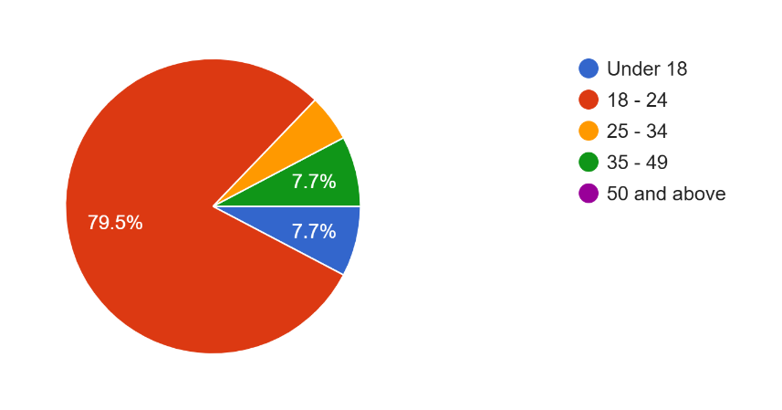

Figure 1: Distribution of Age group

2.2 Language Fluency
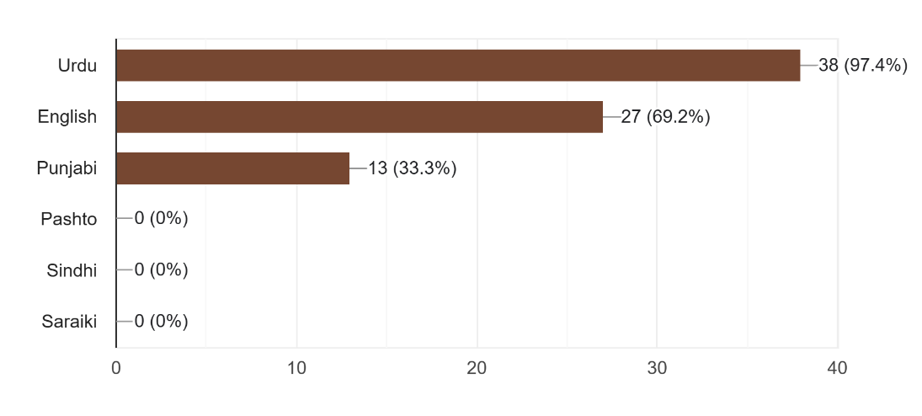
Most participants reported being fluent in Urdu and English, while a significant portion also spoke Punjabi, highlighting Pakistan’s multilingual identity. However, responses later revealed that English remains a marker of social class, especially in educational and professional settings.

Figure 2: Languages spoken by respondents

2.3 Experiences of Skin Tone Bias
When asked if they had ever felt discriminated against due to their skin tone:
- A large group (over half) indicated that they had never faced direct discrimination.
- Approximately one-third reported experiencing rare or occasional instances of discrimination.
- A small portion admitted to facing frequent discrimination.
These findings show that while overt colorism is less visible in some circles, internalized bias still exits, influencing confidence and self-image.

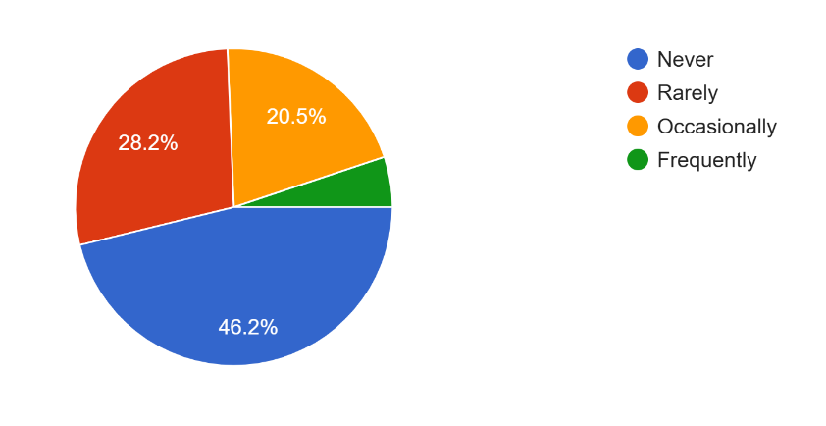
Figure 3: Frequency of Discrimination based on skin tone

2.4 Sources of Influence
When asked about who communicated the importance of skin tone during their upbringing:
- The most common influences identified were parents, extended family, and media.
- Some participants noted that the topic was never addressed in their households, highlighting a generational difference in awareness. This pattern suggests that color consciousness is often transmitted indirectly, through casual comments, cultural references, and beauty advertisements, rather than through explicit teaching.
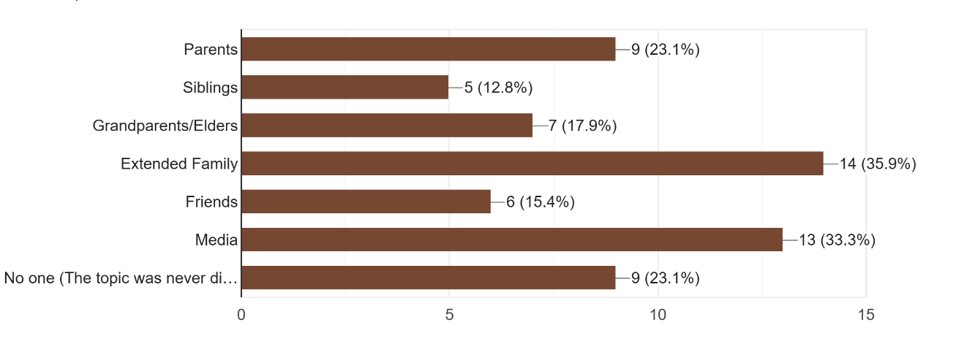
Figure 4: Who communicated the importance of skin tone during upbringing

2.5 Attitude towards complexion
When asked about their confidence and attraction:
- Many respondents expressed pride in their natural skin tone.
- However, some admitted to feeling less confident in social settings due to their complexion.
- Approximately one-third of respondents believed that fairer skin is still regarded as more attractive in society.
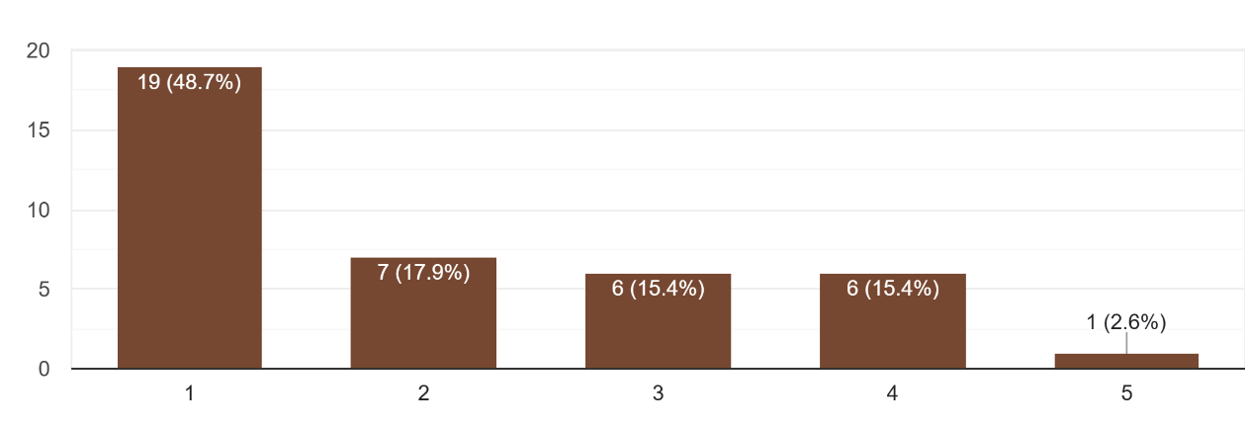
Additionally, about a quarter of those surveyed had used or considered using skin-lightening products, indicating that social pressure continues to influence behavior, even among educated youth.
Figure 5: Perceptions of confidence and Beauty linked to skin tone

2.6 Language, Accent and Respect
A significant trend emerged concerning English proficiency:
- Most respondents agreed that individuals who are fluent in English receive more respect and are often perceived as belonging to a higher social class.
- Many also reported feeling pressured to speak English in order to be taken seriously.
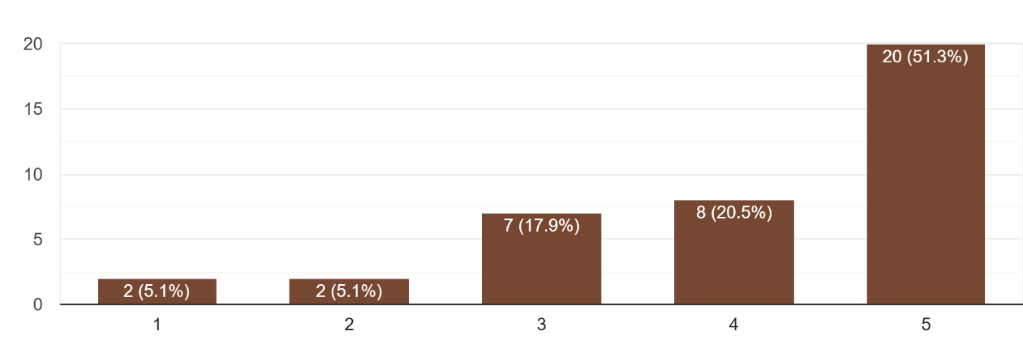
- Furthermore, the majority acknowledged that educational institutions unjustly prioritize English over local languages, which reinforces linguistic inequality.
Figure 6: Perceived social advantage of English fluency

2.7 Code-Switching and Social Pressure
When asked how frequently they switch languages or accents to fit in socially:
- Most respondents indicated that they do this sometimes or often. This behavior is especially common in schools, workplaces, and social gatherings.
It represents a form of linguistic adaptation, where individuals adjust their speech to align with social expectations, often doing so subconsciously.

2.8 Observations
Overall, the responses reveal that:
- Colorism and linguistic bias coexist, influencing both confidence and social belonging.
- The media and family environment continue to shape beauty and language ideals.
- Despite growing awareness, English fluency still acts as a gatekeeper for social acceptance in many settings.
- The younger generation shows resistance — valuing authenticity and self-acceptance more openly than before.

3. Findings and Discussion
The survey “Fair Skin and Linguistic Bias: Navigating Identity Complexes” was conducted among 39 participants of varying ages, genders, and linguistic backgrounds. Its purpose was to examine how perceptions of skin tone and language fluency influence personal and social identity in Pakistan. A majority of respondents (46%, around 18 participants) belonged to the 18–24 age group, indicating that most insights reflect the views of young adults who are socially active and more exposed to evolving beauty and language norms. Gender representation included 64% males and 36% females, ensuring that both perspectives were captured.
The linguistic diversity among respondents was notable. Urdu emerged as the dominant language (97%), followed by English (69%) and Punjabi (33%), reflecting Pakistan’s multilingual reality and the cultural hierarchies that exist within it. The data revealed that a majority of participants recognize a continuing social preference that links fair skin with attractiveness, sophistication, and privilege. Nearly two-thirds agreed that lighter skin tones are often perceived as more beautiful or successful, while only a small fraction disagreed.
Language proficiency—particularly in English—was also seen as a marker of social class and intelligence. Many participants noted that fluent English speakers are often viewed as more “educated” or “modern,” while those who speak regional languages may be unfairly considered less refined. As one respondent expressed, “People often judge you by how you speak before they even notice your abilities.” Another added, “Fair skin and fluent English together create an impression of superiority.”
These findings illustrate how colorism and linguistic elitism operate as intertwined biases that shape identity and social mobility. Both stem from deep-rooted historical and cultural patterns, continuing to influence how individuals are perceived and valued. However, many younger participants showed awareness of these prejudices and expressed a desire to move toward greater acceptance and inclusivity. This generational openness suggests a gradual cultural shift away from inherited stereotypes.
In summary, the survey highlights that appearance and language function as powerful social filters that influence how people are judged and treated. Understanding these dynamics is crucial for promoting equality, challenging outdated ideals, and redefining what it means to belong in a diverse society.

4. Conclusion and Suggestions
The findings from this study suggest that perceptions of fair skin and linguistic proficiency continue to be significant indicators of social acceptance and prestige in contemporary society. Although many respondents expressed awareness of these biases, they acknowledged that such attitudes are deeply ingrained through cultural practices, family expectations, and media representation. The survey reveals that colorism and linguistic bias coexist as dual forms of social hierarchy, reflecting an internalized value system in which external appearance and manner of speech determine perceived worth.
In conclusion, the results emphasize the need for cultural reorientation and awareness-building. Changing perceptions requires consistent efforts in education, policy, and media. Educational institutions can incorporate diversity awareness into curricula to help students understand how language and appearance influence identity. Teachers, counselors, and media practitioners should consciously use neutral and inclusive language to avoid reinforcing stereotypes. Public campaigns that highlight diverse beauty standards and linguistic pride can help reshape perceptions among young people and communities.
Moreover, the inclusion of darker skin tones and regional languages in advertisements, films, and literature would foster broader representation and equality. Encouraging multilingualism and rejecting linguistic elitism can also help bridge social divides. Civil society organizations and influencers can play a crucial role by promoting the message that confidence, intelligence, and beauty are not determined by complexion or accent but by character and competence.
Finally, it is important to sustain open discussions on colorism and linguistic bias to normalize acceptance and empathy. Awareness workshops, social media advocacy, and inclusive communication policies can reinforce positive change. As one respondent aptly summarized, “Real beauty and intelligence speak through confidence, not complexion or accent.” The journey toward equality demands not only institutional support but also individual reflection and daily practice. By valuing diversity in both appearance and expression, society can move toward a more equitable and inclusive future.

