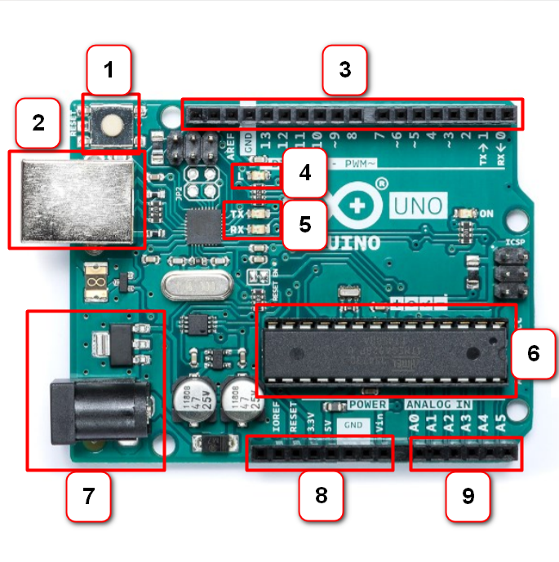

1- Reset buton;

2- USB JACK Type-B;

3- Digital pins;

4- L LEDs;

5- TX RX LEDs;

6- Microcontroler;

7- Power JVAC;

8-Power Supply;

9- Analog input pins;