
FACULTY OF TECHNOLOGY
DEPARTMENT OF INFORMATICS ENGINEERING
DESIGN, IMPLEMENTATION AND TESTING OF A LIBRARY MANAGEMENT SYSTEM WITH JAVA AND SPRING BOOT
Project
Study programme: [title of the study programme]
State code of the study programme: [code]
Field of studies: [title of the field of studies]
Author: Sabri Gür ________________ __________
(signature) (date)
Advisor: Sandeepak Bhandari ________________ __________
(signature) (date)
Klaipėda, 2026
CONTENT
List of tables and figures
Concepts
Summary
Introduction
1. Literature analysis
1.1. Requirements engineering and specification
1.2. Object-oriented analysis and UML modelling
1.3. Architecture of REST-based information systems
1.4. Security and data consistency
1.5. Software testing techniques
1.6. Summary of the literature analysis
2. Analytical part
2.1. Object and starting situation
2.2. Stakeholders
2.3. Requirements
2.4. Use case model
2.5. Business rules
2.6. Summary of the analytical part
3. Practical part
3.1. Design
3.1.1. Architecture
3.1.2. Domain model
3.1.3. Dynamic models
3.1.4. Design decisions
3.2. Implementation
3.2.1. Technology and structure
3.2.2. Business logic
3.2.3. Security, consistency and error handling
3.2.4. Demonstration of the functions
3.3. Testing
3.3.1. Test strategy
3.3.2. Black box testing
3.3.3. White box testing
3.3.4. API and non-functional tests
3.4. Verification of the requirements
3.5. Limitations
3.6. Summary of the practical part
Conclusions
List of literature and other sources of information
Annexes
Annex 1. Use case diagram
Annex 2. Class diagram of the domain model
Annex 3. Class diagram of the service layer
Annex 4. Sequence diagram of the use case Borrow Book
Annex 5. Activity diagram of the use case Borrow Book
Annex 6. Control flow graph of the method borrowBook
Annex 7. Control flow graph of the method returnBook
Annex 8. Control flow graph of the method renewLoan
Annex 9. Functional requirements
Annex 10. Non-functional requirements
Annex 11. Traceability of the functional requirements
Annex 12. REST API overview
Annex 13. Black box test cases
Annex 14. White box test cases
Annex 15. Programmer guide
Annex 16. User guide

List of tables and figures
TABLES

FIGURES

Concepts
API (Application Programming Interface) – the interface through which one program uses the functions of another program. In this work: the REST interface of the system.
REST – an architectural style for web interfaces with stateless requests, a uniform interface and resources identified by addresses.
JSON – a text format for the exchange of data between client and server.
DTO (Data Transfer Object) – an object that carries data between the layers or to the client without business logic.
JPA / ORM – Java Persistence API / object-relational mapping: the mapping of Java classes to database tables.
SDLC – software development life cycle: requirements, design, implementation, testing and maintenance.
SRS – Software Requirements Specification: the document that describes what a system must do and how well.
FR / NFR – functional requirement / non-functional requirement.
UC – use case: a description of the interaction between an actor and the system that gives a result of value.
UML – Unified Modeling Language: a standard language for the models of software systems.
RBAC – role based access control: the permissions of a user depend on the role of the user.
BCrypt – a password hashing algorithm with a salt and an adjustable cost.
Optimistic locking – a method that detects a conflicting change of the same data with a version number instead of blocking the data.
Black box testing – testing of the behavior of a program without using knowledge of its code.
White box testing – testing that is designed from the structure of the code.
Equivalence partitioning / boundary value analysis – black box techniques: the input values are divided into classes, and the values at the borders of the classes are tested.
CFG (control flow graph) – a graph of the statements (nodes) and the possible transfers of control (edges) of a method.
V(G) – cyclomatic complexity: the number of linearly independent paths of a CFG.
Loan / borrowing record – the record that a member has borrowed one copy of a book; overdue means that the due date has passed and the book is not returned.

Summary
Sabri Gür Design, Implementation and Testing of a Library Management System with Java and Spring Boot, Informatics Engineering, Faculty of Technology, Klaipėdos valstybinė kolegija | Higher Education Institution.
Research problem. Libraries that keep records on paper or in spreadsheets have incorrect stock numbers, find overdue loans late and calculate fines by hand. A reliable system that applies the library rules automatically is required.
Work object – the circulation process of a library: borrowing, returning and renewing books, reservations, overdue loans and fines.
Aim of the work – to design, implement and test a library management system as a REST API that fulfils documented functional and non-functional requirements.
Research methods: analysis of scientific literature and standards, requirements analysis, UML modelling, programming in Java with Spring Boot, black box and white box testing, performance and concurrency measurements.
Conclusions. 44 requirements (31 functional and 13 non-functional) were documented in a requirements specification and a requirements database. The system was modelled with six UML diagram types and implemented in a layered Spring Boot application with role based security. All 31 functional requirements are implemented. 111 automated tests pass, and the service layer has a code coverage of 87.6%. A search in 10,000 books takes 139 ms, and when 50 members borrow the last copy of a book at the same time, exactly one loan is created. Two non-functional requirements (availability and backup) are not met and two are met only partially.
Key words: library management system, requirements engineering, UML, Spring Boot, black box testing, white box testing.

Introduction
A library has to know at every moment which books it owns, how many copies are available, who has borrowed which copy and which loans are overdue. When this information is kept on paper or in spreadsheets, the stock numbers become incorrect, overdue loans are found late and fines are calculated by hand. A library management system solves these tasks if it applies the library rules automatically and keeps the stock consistent. The topic is also suitable for a software engineering project, because it combines data management, business rules, security and reporting. Therefore, it requires the complete software development life cycle: requirements analysis, modelling, implementation and testing.
The problem of the project is that a documented, tested and secure library circulation system, which applies the library rules automatically, is not available.
A first prototype was available at the start of the project. It contained three entities (User, Book and BorrowingRecord) and four functions: borrow, return, active loans of a user and overdue loans. It had no user roles and no login, no reservations and no fines, no input validation, only generic error messages and no working automated test. Consequently, it could not serve as a reliable system, and it did not show the application of software engineering methods.
The aim of the project is to design, implement and test a library management system as a REST API that fulfils the documented functional and non-functional requirements.
The tasks of the project:
1. To analyse the literature and the prototype and to define the requirements of the system.
2. To model the system with UML diagrams and to design a layered architecture.
3. To implement the system in Java with Spring Boot.
4. To test the system with black box and white box techniques and to verify the requirements.
The object of the project is the circulation process of a library: borrowing, returning and renewing books, reservations, overdue loans and fines.
The methods of the project: analysis of scientific literature and standards, requirements analysis, UML modelling, programming, black box and white box testing, and measurement of performance and concurrency.
The work consists of an introduction, three parts, conclusions, a list of literature and annexes. The first part analyses the literature on requirements engineering, modelling, architecture, security and testing. The second part analyses the starting situation and the requirements. The third part describes the design, the implementation, the tests and the verification of the requirements. The practical result is a working REST API with 8 controllers and 10 services, a requirements specification, a requirements database, UML models and 111 automated tests. The source code is available in the GitHub repository SabriGR/library-management-system.

1. Literature analysis

1.1. Requirements engineering and specification
Requirements describe what a system must do and which properties it must have. Sommerville (2016) distinguishes functional requirements, which describe services of the system, and non-functional requirements, which constrain the system, for example with respect to performance, security or reliability. Pressman and Maxim (2020) emphasise that requirements must be elicited from the stakeholders, negotiated, documented and validated. The international standard ISO/IEC/IEEE 29148 (2018) defines the processes and the information items of requirements engineering and lists characteristics of a good requirement, among them that it is unambiguous, singular and verifiable. For the document structure, the earlier standard IEEE Std 830 (IEEE, 1998) recommends three main parts of a software requirements specification: an introduction, an overall description and specific requirements.
Non-functional requirements can be classified with a quality model. The product quality model of ISO/IEC 25010 (ISO/IEC, 2023) groups quality in characteristics such as performance efficiency, reliability, security and maintainability. These characteristics were used in this project to classify and to formulate measurable non-functional requirements.

1.2. Object-oriented analysis and UML modelling
The Unified Modeling Language defines structure diagrams, for example the class diagram, and behavior diagrams, for example the use case, activity and state machine diagram, as well as interaction diagrams such as the sequence and communication diagram (Object Management Group, 2017). A use case diagram shows actors and use cases and allows the relationships association, include, extend and generalization. A class diagram shows classes with attributes and operations and the relationships association, aggregation, composition, generalization and dependency. Sommerville (2016) uses such models to describe the context, the interaction, the structure and the behavior of a system. Pressman and Maxim (2020) describe the use case as the central tool for requirements modelling, from which the class and the interaction models are derived. In this project, the six diagram types were used for the same system, so that the models can be checked against each other.

1.3. Architecture of REST-based information systems
Fielding (2000) defines REST as an architectural style with the constraints client-server, stateless communication, cacheability, uniform interface and layered system. Stateless requests simplify the scaling of a server, because every request contains all information that is needed to process it. Fowler (2002) describes patterns for enterprise applications. Among them are the layered structure, in which presentation, domain logic and data access are separated, the service layer, the repository and the data transfer object. The separation of the layers supports maintainability and testability, because the business logic can be tested without the web and the database layer.
Spring Boot is a widely used framework for such applications in Java. It provides an embedded web server and an automatic configuration (Spring Boot reference documentation, n. d.). Spring Data JPA generates repositories from interfaces (Spring Data JPA reference, n. d.), and Walls (2022) presents the typical structure of Spring applications with controllers, services and repositories. This structure was selected for the project.

1.4. Security and data consistency
The OWASP Top 10 list of 2021 ranks broken access control first and identification and authentication failures among the main risks of web applications (OWASP Foundation, 2021). Therefore, every function of a library system, which has different roles, must check the role of the user on the server side. For passwords, Provos and Mazières (1999) introduced the bcrypt scheme, which uses a salt and an adjustable cost, so that the hashing can be made slower when computers become faster. Spring Security supports HTTP Basic authentication, the BCrypt password encoder and method level role checks (Spring Security reference, n. d.).
Two users can try to change the same data at the same time, for example to borrow the last copy of a book. Fowler (2002) describes the pattern of the optimistic offline lock, in which a version number detects that the data was changed by another transaction. This pattern is supported in object-relational mapping tools with a version attribute (Hibernate ORM documentation, n. d.).

1.5. Software testing techniques
Myers et al. (2011) divide testing techniques into black box and white box techniques. Black box techniques derive tests from the specification. The best known are equivalence partitioning, in which the input values are divided into classes that the program should treat in the same way, and boundary value analysis, in which the values at and next to the borders of the classes are tested. Ammann and Offutt (2017) describe input space partitioning and coverage criteria on graphs. The standard ISO/IEC/IEEE 29119-4 (2021) lists specification-based techniques, such as equivalence partitioning and boundary value analysis, and structure-based techniques, such as statement and branch testing.
White box techniques derive tests from the structure of the code. McCabe (1976) defined the cyclomatic complexity of a control flow graph, which is the number of linearly independent paths:
V(G) = E − N + 2P (1)
where: V(G) – cyclomatic complexity; E – number of edges; N – number of nodes; P – number of connected components (P = 1 for one method).
Watson and McCabe (1996) propose the structured (basis path) testing, in which one test is written for each independent path. If all independent paths are executed, every statement and every branch of the method is executed as well. This technique was selected for the white box tests of the project.

1.6. Summary of the literature analysis
The analysis showed which methods are suitable for the tasks of the project. The reviewed sources are general software engineering sources and standards. Scientific publications on specific library systems were not analysed, because the focus of the work is the application of the methods. Three foundational works are older than five years (McCabe, 1976; Provos and Mazières, 1999; Fielding, 2000), but they define concepts that are still used today. Based on the analysis, the following methodology was selected:
- requirements: classification in functional and non-functional requirements, specification according to the structure of IEEE Std 830 and the characteristics of ISO/IEC/IEEE 29148;
- modelling: six UML diagram types (Object Management Group, 2017);
- architecture: layered REST API with Spring Boot, DTOs and a service layer;
- security and consistency: BCrypt, HTTP Basic, role checks on the server and optimistic locking;
- testing: equivalence partitioning and boundary value analysis, basis path testing with the cyclomatic complexity, measurement of the coverage.

2. Analytical part

2.1. Object and starting situation
The object of the project is the circulation of a library. The starting point was a prototype, which was analysed with respect to the requirements of a library. Table 1 shows the main weaknesses.
Table Weaknesses of the prototype
Area | Situation of the prototype | Consequence
Users and security | One user class, no login, no roles | Every person can borrow and return books
Data model | Entities User, Book, BorrowingRecord only | No reservations, fines, categories or configurable rules
Business rules | Fixed 14-day loan period, no loan limit | The library cannot change its rules
Error handling | Generic RuntimeException with a short text | The client cannot distinguish the errors
Configuration | Database credentials in the configuration file | A security risk and a barrier to running the project
Tests | One application context test, which could not find the application class and failed | No verification of the functions
Documentation | A short README | No requirements, models or test results

2.2. Stakeholders
The stakeholders and their needs are shown in Table 2. The Member, the Librarian and the Administrator use the system directly. The e-mail service is an external system.
Table Stakeholders and their needs
Stakeholder | Main needs
Member | Quick search, clear information about loans, due dates, fines and reservations.
Librarian | Fast and simple issue and return of books, easy management of books and members.
Administrator | Control of staff accounts and library rules, reports, security of data.
Library Management | Reliable service, low running cost, reports on library usage.
Developer | Clean architecture, easy testing and easy changes.
Email Service (external system) | Correct and complete message data from the system.

2.3. Requirements
The requirements were collected from the needs of the stakeholders and from the analysis of the prototype. They were formulated as short statements with an identifier, classified in functional and non-functional requirements and given a priority (high, medium, low). The result is 44 requirements, which are summarised in Table 3. The functional requirements belong to seven areas: account and access, catalog management, member management, circulation, reservation and notification, fine management, and administration and reports. The non-functional requirements belong to six quality characteristics: performance, security, reliability, usability, maintainability and portability. The complete lists are given in Annex 9 and Annex 10, and the requirements are described in detail in the software requirements specification, which follows the structure of IEEE Std 830.
Table Number of requirements by category and priority
Category | High | Medium | Low | Total
Functional | 12 | 16 | 3 | 31
Non-functional | 4 | 8 | 1 | 13
Total | 16 | 24 | 4 | 44

Examples of requirements: FR-013 (the system shall allow a librarian to issue a book and create a borrowing record), FR-014 (before a book is issued, the member must exist, be active and not reached the loan limit), FR-027 (the fine is the number of late days multiplied by the daily rate), NFR-001 (search results within 2 seconds for a catalog of 10,000 books) and NFR-006 (the stock of a book is never negative). All requirements are stored in an Excel database with the columns requirement identifier, name, description, category and priority, extended with the sub-category, the stakeholder, the related use case, the implementation and the verification.

2.4. Use case model
The functional requirements were realised by 26 use cases and four actors: Member, Librarian, Administrator and Email Service. The Administrator is a specialization of the Librarian. The use case diagram (see Annex 1, Fig. 8) contains all four relationships. For example, Borrow Book includes Verify Member Eligibility and Check Book Availability, Calculate Fine and Notify Reservation Availability extend Return Book, and Add Book, Update Book and Remove Book specialize Manage Books. Every functional requirement is assigned to at least one use case.

2.5. Business rules
The library rules, which the system must apply, are listed in Table 4. The values in brackets are default values, which the administrator can change.
Table Main business rules of the system
Rule | Description | Requirements
BR-01 | The loan period is 14 days. | FR-016, FR-030
BR-02 | A member can have at most 5 active loans. | FR-014, FR-030
BR-03 | A loan can be renewed once. An overdue loan or a loan of a reserved book cannot be renewed. | FR-019, FR-030
BR-05 | The fine is the number of late days multiplied by the daily rate (0.50). | FR-027, FR-030
BR-06 | A book can be reserved only when no copy is available. | FR-023
BR-07 | When a copy is returned, the first waiting member is notified by e-mail. | FR-025
BR-08 | A book can be removed only when no copy is on loan. | FR-006
BR-11 | The number of available copies is never negative and never larger than the total number of copies. | FR-018, NFR-006

2.6. Summary of the analytical part
The analysis showed that the prototype lacks roles, security, reservations, fines, configurable rules, clear errors and tests. Based on the analysis, 44 requirements and 26 use cases were defined. They are the basis for the design and the implementation in the next part.

3. Practical part

3.1. Design

3.1.1. Architecture
The system has a layered architecture (Fig. 1). A request passes the security filter, which checks the login and the role. The controller validates the request and converts the result to a DTO. The service contains the business rules and runs in a transaction. The repository reads and writes the entities through JPA. A global exception handler turns every error into a JSON answer, and an audit service writes the important changes to a log file.
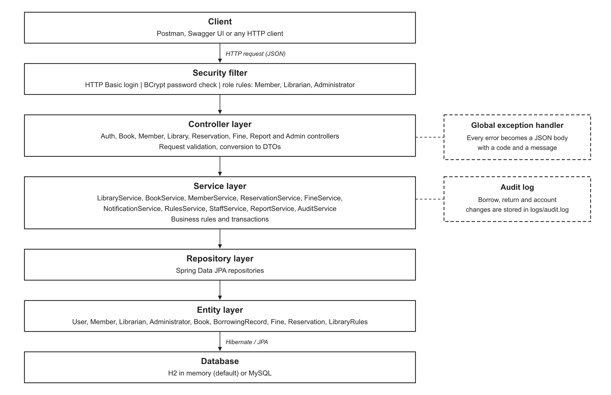
Fig. Layered architecture of the system

3.1.2. Domain model
The domain model is shown in Annex 2 (Fig. 9). The abstract class User has the subclasses Member and Librarian, and Administrator is a subclass of Librarian (generalization). A BorrowingRecord connects a Member and a Book (association). A Fine is a part of a BorrowingRecord (composition). A Reservation connects a Member and a Book and has a status. LibraryRules holds the configurable values, and the conceptual class Library aggregates books and members. The business logic is placed in services (Annex 3, Fig. 10). For example, LibraryService uses RulesService for the loan rules, FineService to create fines and ReservationService to notify waiting members.

3.1.3. Dynamic models
The use case Borrow Book was modelled with four diagrams. The sequence diagram (Annex 4, Fig. 11) shows the messages between the controller, the service and the repositories. The three alternative fragments are the error flows: member not found or inactive, loan limit reached, and book not found or not available. The communication diagram (Fig. 2) shows the same messages with numbers that express the order, and the activity diagram (Annex 5, Fig. 12) shows the workflow with the swimlanes Librarian and System.
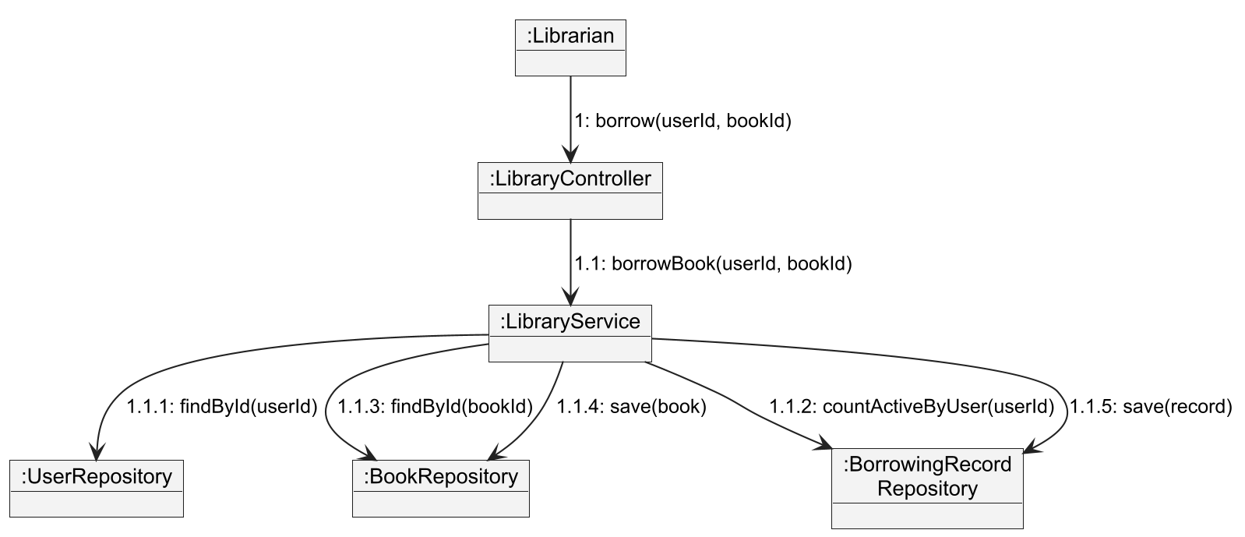
Fig. Communication diagram of the use case Borrow Book
The state diagram (Fig. 3) shows the life cycle of a borrowing record. A record is created in the state Active, it can be renewed once and stays Active, it becomes Overdue when the due date has passed, and it becomes Returned when the book is returned. In the implementation, the state Overdue is calculated from the due date and is not stored.
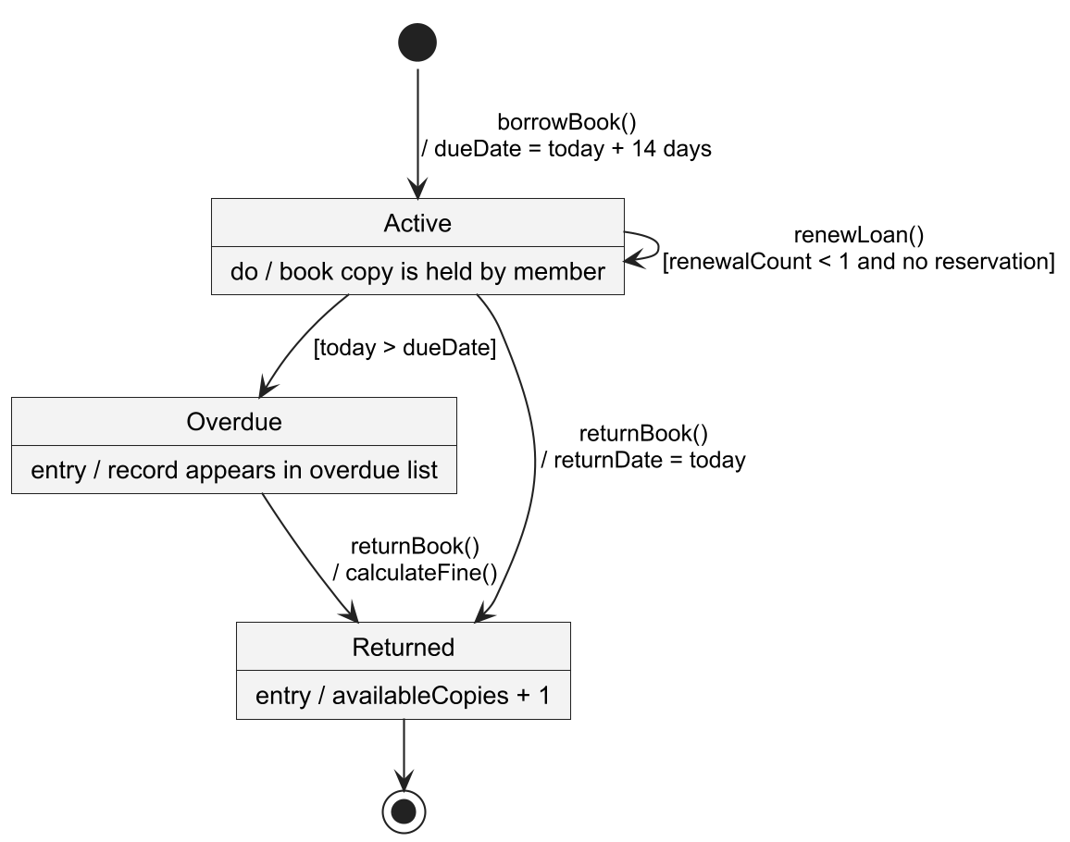
Fig. State diagram of the class BorrowingRecord

3.1.4. Design decisions
The most important design decisions and their reasons are shown in Table 5. The differences between the early class diagram and the final code are described in the software requirements specification and in the project documentation.
Table Design decisions
Decision | Reason
One table for all users (single table inheritance) | Members, librarians and administrators share most data; the role is the class of the object.
DTO classes for requests and answers | Entities are not sent to the client; the API stays stable.
Business rules in the service layer | The rules can be tested without a web server (NFR-012).
Clock as an injected bean | Tests can set a fixed date, so due dates and fines are checked exactly.
Library rules stored in the database | The administrator can change the rules without a new release (FR-030).
Soft removal of books | A removed book leaves the catalog, but the borrowing history stays correct (FR-006).
Optimistic locking and transactions | Two users cannot borrow the last copy at the same time (NFR-006).
Simulated e-mail service | The logic is complete; only the method sendEmail must be replaced to use a mail server.

3.2. Implementation

3.2.1. Technology and structure
The system was implemented with the technologies in Table 6. The source code is organised by layers (Table 7).
Table Technologies
Area | Technology
Language and framework | Java 21, Spring Boot 4, Spring Data JPA with Hibernate, Spring Security, Bean Validation
Database | H2 in memory (default) and MySQL (profile mysql)
Documentation of the API | springdoc OpenAPI (Swagger UI)
Build and tests | Maven, JUnit 5, Mockito, Spring MockMvc, JaCoCo

Table Packages of the source code
Package | Files | Content
controller | 8 | REST controllers: Auth, Book, Member, Library, Reservation, Fine, Report, Admin
service | 10 | Business logic, notifications, rules, reports and audit
repository | 8 | Spring Data JPA repositories
entity | 10 | Domain model and the reservation status
dto | 14 | Request objects with validation and response objects
exception | 4 | Business exceptions and the global exception handler
security, config | 6 | Login, security rules, OpenAPI, clock, demo data

3.2.2. Business logic
The central class is LibraryService. The method borrowBook runs the checks in the same order as the sequence and the activity diagram (Fig. 4). Only after all checks, the stock is decreased and the borrowing record with the due date is created. The method returnBook stores the return date, increases the stock, creates a fine if the book is late and notifies the first waiting member. The method renewLoan checks ownership, return state, overdue state, renewal limit and reservations. The complete API is listed in Annex 12.
An excerpt of the method borrowBook is provided in the code below:
Member member = memberRepository.findById(userId).orElse(null);
if (member == null) throw new NotFoundException("UserNotFound", ...);
if (!member.isActive()) throw new BusinessRuleException("UserInactive", ...);
LibraryRules rules = rulesService.getRules();
long activeLoans = borrowingRepository
.countByMemberIdAndReturnDateIsNull(userId);
if (activeLoans >= rules.getMaxLoansPerMember())
throw new BusinessRuleException("LoanLimitReached", ...);
Book book = bookRepository.findByIdAndRemovedFalse(bookId).orElse(null);
if (book == null) throw new NotFoundException("BookNotFound", ...);
if (!book.isAvailable())
throw new BusinessRuleException("BookNotAvailable", ...);
book.decreaseCopies();
bookRepository.save(book);
// ... create the record with dueDate = today + loanPeriodDays
Fig. Excerpt of LibraryService.borrowBook

3.2.3. Security, consistency and error handling
The login uses HTTP Basic authentication with the e-mail address and the password. The passwords are stored as BCrypt hashes, and a deactivated account cannot log in. Only the registration and the API documentation are public. The permissions of the roles are shown in Table 8 and are enforced with role checks on every controller method.
Table Roles and permitted functions
Role | Permitted functions
Member | Register, search books, reserve and cancel reservations, renew own loans, view own loans, history and fines
Librarian | All functions of book and member management, borrow, return, overdue list and reminders, fine payment, reports
Administrator | All functions of the librarian and the management of staff accounts and library rules

Borrow and return operations are transactions. The entity Book has a version field for optimistic locking, and the methods decreaseCopies and increaseCopies refuse to leave the range from zero to the total number of copies. Every error is returned as a JSON answer with a status, a code and a message, and the audit service writes every borrow, return, fine, reservation and account change to the file logs/audit.log.

3.2.4. Demonstration of the functions
The following examples show requests and answers of the running system. Fig. 5 and Fig. 6 show a successful borrow, and Fig. 7 shows the answer when no copy is available.
POST /api/library/borrow?userId=3&bookId=2
Authorization: Basic (librarian@library.com)
Fig. Request: a librarian issues a book to a member
HTTP 200
{ "id": 6, "memberId": 3, "memberName": "Sabri Gür",
"bookId": 2, "bookTitle": "Clean Code",
"borrowDate": "2026-11-11", "dueDate": "2026-11-25",
"returnDate": null, "renewalCount": 0,
"overdue": false, "fineAmount": null }
Fig. Answer: the borrowing record with the due date (today + 14 days)
HTTP 409
{ "timestamp": "2026-11-11T12:00:00Z", "status": 409,
"code": "BookNotAvailable",
"message": "No copy of 'Design Patterns' is available" }
Fig. Answer: an error with a code and a message
The values in the examples are illustrative. In total, 19 groups of endpoints were implemented (Annex 12). The installation and the use of the system are described in the programmer guide (Annex 15) and the user guide (Annex 16).

3.3. Testing

3.3.1. Test strategy
The system was tested on several levels. 111 automated tests run with one command, and all of them pass (Table 9). Black box tests were derived from the requirements, white box tests from the structure of the code, and the API tests check the complete system with the real security rules. A Postman collection with 97 requests was prepared for manual tests.
Table Test classes and results
Test class | Technique | Tests | Result
LibraryServiceBlackBoxTest | Black box: equivalence classes, boundary values | 34 | Pass
LibraryServiceWhiteBoxTest | White box: decisions and basis paths | 18 | Pass
DomainModelTest | Unit tests of the entities | 23 | Pass
SupportServicesTest | Unit tests of book, member, staff and reservation services | 16 | Pass
LibraryApiIntegrationTest | API tests with security, roles and complete flows | 16 | Pass
PerformanceAndConcurrencyTest | Measurement of NFR-001, NFR-002 and NFR-006 | 3 | Pass
Application context test | The application starts | 1 | Pass
Total |  | 111 | All pass

3.3.2. Black box testing
Black box tests check the behavior without using the code. The test data was selected with equivalence partitioning and boundary value analysis. Table 10 shows the equivalence classes of the function Borrow Book, and Table 11 shows the boundary values of the main rules. The parameterized tests execute each value of the table. The 17 black box test cases are listed in Annex 13.
Table Equivalence classes of the function Borrow Book
Input | Valid classes | Invalid classes | Tests
Member | Existing, active member | Does not exist; inactive | BB-01, 04, 05
Active loans | 0 to limit − 1 | Limit or more | BB-02, 08
Book | Exists and has a copy | Does not exist; no copy | BB-03, 06
Loan period | 14 days; configured value | – | BB-01, 07

Table Boundary value tests
Input | Values tested | Expected behavior | Test
Active loans (limit 5) | 0, 1, 4, 5, 6 | Allowed for 0, 1, 4; refused for 5, 6 | BB-02
Available copies | 0, 1, 2 | Refused for 0; stock decreases by one for 1, 2 | BB-03
Return date and due date | 3 and 1 days early, on time, 1, 2, 10 days late | Fine only from 1 day late | BB-09
Renewal and today | 3, 1, 0 days left; 1, 5 days overdue | Allowed until the due date, including today | BB-13
Renewals done (limit 1) | 0, 1, 2 | Allowed only for 0 | BB-14

3.3.3. White box testing
For the three main methods of LibraryService, the control flow graph was drawn (Annex 6, Annex 7 and Annex 8), and the cyclomatic complexity was calculated with formula (1). One test was written for each independent path. For borrowBook, the graph has 13 nodes and 17 edges, so V(G) = 17 − 13 + 2 = 6. The paths and the tests are shown in Table 12.
Table Independent paths of the method borrowBook
Path | Decisions | Result | Test
P1 | D1 true | UserNotFound | WB-B1
P2 | D1 false, D2 true | UserInactive | WB-B2
P3 | D1, D2 false, D3 true | LoanLimitReached | WB-B3
P4 | D1 to D3 false, D4 true | BookNotFound | WB-B4
P5 | D1 to D4 false, D5 true | BookNotAvailable | WB-B5
P6 | all decisions false | Loan created, stock decreased | WB-B6

The results for all three methods are summarised in Table 13. The 18 white box test cases are listed in Annex 14. For renewLoan, the compound condition of the first decision was tested with each condition separately.
Table Cyclomatic complexity and white box tests
Method | Nodes | Edges | V(G) | Tests
borrowBook | 13 | 17 | 6 | WB-B1 to WB-B6
returnBook | 10 | 12 | 4 | WB-R1 to WB-R4
renewLoan | 12 | 17 | 7 | WB-N1 to WB-N7

The code coverage was measured with JaCoCo (Table 14). The statement and branch coverage of LibraryService is 100%, and the target of NFR-012 (at least 80% of the service layer) is reached.
Table Code coverage
Scope | Instructions | Branches
LibraryService | 100% | 100%
Service layer | 87.6% | 87.1%
Whole project | 90.3% | 89.8%

3.3.4. API and non-functional tests
The API tests start the complete application with the demo data and send HTTP requests. They check the login, the role rules, registration, the catalog, borrowing and returning, the loan limit, renewals, reservations, fines, reports and administration. Three further tests measure non-functional requirements (Table 15). The tests were executed with the H2 database on one computer. The values show that the design is fast enough, but they are not a load test of a production system.
Table Results of the non-functional tests
Requirement | Test | Result
NFR-001 | Search in a catalog of 10,000 books (30 searches) | Slowest search 139 ms (limit 2000 ms)
NFR-002 | 50 users search at the same time | All answered in 59 ms
NFR-006 | 50 members borrow the last copy at the same time | 1 loan, 40 refused, 9 stopped by optimistic locking; stock 0

3.4. Verification of the requirements
All 31 functional requirements are implemented and linked to their endpoint, implementation and tests (Annex 11). Two of them (FR-010 and FR-012) are verified only manually with the Postman collection. The status of the non-functional requirements is shown in Table 16. Two requirements are not met: the availability of 99% (NFR-007) depends on the production environment and was not measured, and the automatic daily backup (NFR-008) was not implemented. NFR-009 (ease of use) and NFR-013 (portability) are only partially met, because the system has no graphical interface and was tested only on Windows with the H2 database.
Table Status of the non-functional requirements
NFR | Status | Evidence
NFR-001 | Met (tested) | Slowest search in the test: 139 ms (limit 2000 ms). PerformanceAndConcurrencyTest
NFR-002 | Met (tested) | 50 users searching at the same time finished in 59 ms. PerformanceAndConcurrencyTest
NFR-003 | Met (tested) | SupportServicesTest member_register: stored value is the hash, not the password
NFR-004 | Met (tested) | API tests unauthenticated, roleRules
NFR-005 | Met (by design) | logback-spring.xml; audit file created during the test run
NFR-006 | Met (tested) | 50 members borrow the last copy at the same time: 1 succeeds, stock is 0. DomainModelTest
NFR-007 | Not met | Out of scope. Needs a production environment and monitoring
NFR-008 | Not met | Out of scope. Listed as future work
NFR-009 | Partially met | Swagger UI test (API documentation); no usability test with real librarians
NFR-010 | Met (tested) | API tests check the error code of every error case
NFR-011 | Met (by design) | Package structure; architecture figure
NFR-012 | Met (tested) | Service layer coverage 87.6% (target 80%); LibraryService 100%
NFR-013 | Partially met | Tested on Windows with H2. MySQL profile and Linux were not tested

The comparison with other library products was not made, because the work concentrates on the verification against the own requirements. This is a limitation of the project.

3.5. Limitations
- The system has no graphical user interface; it offers a REST API and Swagger UI.
- The e-mails are simulated. The messages are written to the log and not sent.
- The availability and the automatic backup are not implemented or measured.
- The tests were executed on Windows with H2. The MySQL profile and Linux were not tested.
- HTTP Basic sends the password with every request, so the system must be used over HTTPS in a real installation.
- The lists of books, members and loans have no paging.
- The UML diagrams were created with PlantUML and a drawing script, not with a commercial CASE tool.

3.6. Summary of the practical part
The system was designed with six UML diagram types, implemented in a layered Spring Boot application and tested with 111 automated tests. All 31 functional requirements are implemented and verified. The black box and white box techniques gave a systematic test design: the cyclomatic complexity determined the number of white box tests of each method, and the boundary values revealed the borders of the business rules. The measurements confirmed the performance and the consistency of the stock. The open points are the availability, the backup and the graphical interface.

Conclusions
1. A literature and prototype analysis was performed. 44 requirements (31 functional and 13 non-functional) and 26 use cases were defined, and they were documented in a requirements specification and a requirements database. The prototype lacked roles, security, reservations, fines, clear errors and tests.
2. The system was modelled with six UML diagram types (use case, class, sequence, communication, state and activity diagram) and designed as a layered architecture with DTOs, a service layer and a global exception handler.
3. The system was implemented in Java with Spring Boot as a REST API with 8 controllers and 10 services. It has role based access with BCrypt passwords, optimistic locking for the stock and an audit log. All 31 functional requirements are implemented.
4. 111 automated tests pass. The statement and branch coverage of LibraryService is 100% and the service layer has 87.6%. A search in 10,000 books takes 139 ms, and when 50 members borrow the last copy at the same time, exactly one loan is created. Seven of the 13 non-functional requirements are verified by tests, two are met by design, two are met only partially and two are not met (availability and backup).
Recommendations:
- to develop a web or mobile client and to test its usability with librarians;
- to connect a real e-mail service, to send reminders with a scheduled job and to use HTTPS with token based authentication;
- to automate the database backup, to monitor the availability and to repeat the performance measurements on a production-like environment.

List of literature and other sources of information
1. Ammann, P. and Offutt, J. (2017). Introduction to software testing (2nd ed.). Cambridge University Press.
2. Fielding, R. T. (2000). Architectural styles and the design of network-based software architectures [Doctoral dissertation, University of California, Irvine].
3. Fowler, M. (2002). Patterns of enterprise application architecture. Addison-Wesley.
4. Hibernate ORM documentation. (n. d.). Hibernate. https://hibernate.org/orm/documentation/
5. IEEE. (1998). IEEE recommended practice for software requirements specifications (IEEE Std 830-1998). IEEE.
6. ISO/IEC. (2023). Systems and software engineering – Systems and software quality requirements and evaluation (SQuaRE) – Product quality model (ISO/IEC 25010:2023). International Organization for Standardization.
7. ISO/IEC/IEEE. (2018). Systems and software engineering – Life cycle processes – Requirements engineering (ISO/IEC/IEEE 29148:2018). International Organization for Standardization.
8. ISO/IEC/IEEE. (2021). Software and systems engineering – Software testing – Part 4: Test techniques (ISO/IEC/IEEE 29119-4:2021). International Organization for Standardization.
9. JaCoCo Java code coverage library documentation. (n. d.). EclEmma. https://www.jacoco.org/jacoco/trunk/doc/
10. JUnit 5 user guide. (n. d.). JUnit Team. https://junit.org/junit5/docs/current/user-guide/
11. McCabe, T. J. (1976). A complexity measure. IEEE Transactions on Software Engineering, SE-2(4), 308–320.
12. Myers, G. J., Sandler, C. and Badgett, T. (2011). The art of software testing (3rd ed.). Wiley.
13. Object Management Group. (2017). Unified Modeling Language (UML), version 2.5.1. https://www.omg.org/spec/UML/2.5.1/
14. OWASP Foundation. (2021). OWASP Top 10:2021. https://owasp.org/Top10/
15. Pressman, R. S. and Maxim, B. R. (2020). Software engineering: A practitioner’s approach (9th ed.). McGraw-Hill Education.
16. Provos, N. and Mazières, D. (1999). A future-adaptable password scheme. In Proceedings of the 1999 USENIX Annual Technical Conference, FREENIX Track (pp. 81–91). USENIX Association.
17. Sommerville, I. (2016). Software engineering (10th ed.). Pearson.
18. Spring Boot reference documentation. (n. d.). Broadcom. https://docs.spring.io/spring-boot/
19. Spring Data JPA reference. (n. d.). Broadcom. https://docs.spring.io/spring-data/jpa/reference/
20. Spring Security reference. (n. d.). Broadcom. https://docs.spring.io/spring-security/reference/
21. Walls, C. (2022). Spring in action (6th ed.). Manning Publications.
22. Watson, A. H. and McCabe, T. J. (1996). Structured testing: A testing methodology using the cyclomatic complexity metric (NIST Special Publication 500-235). National Institute of Standards and Technology.

Annexes

Annex 1. Use case diagram
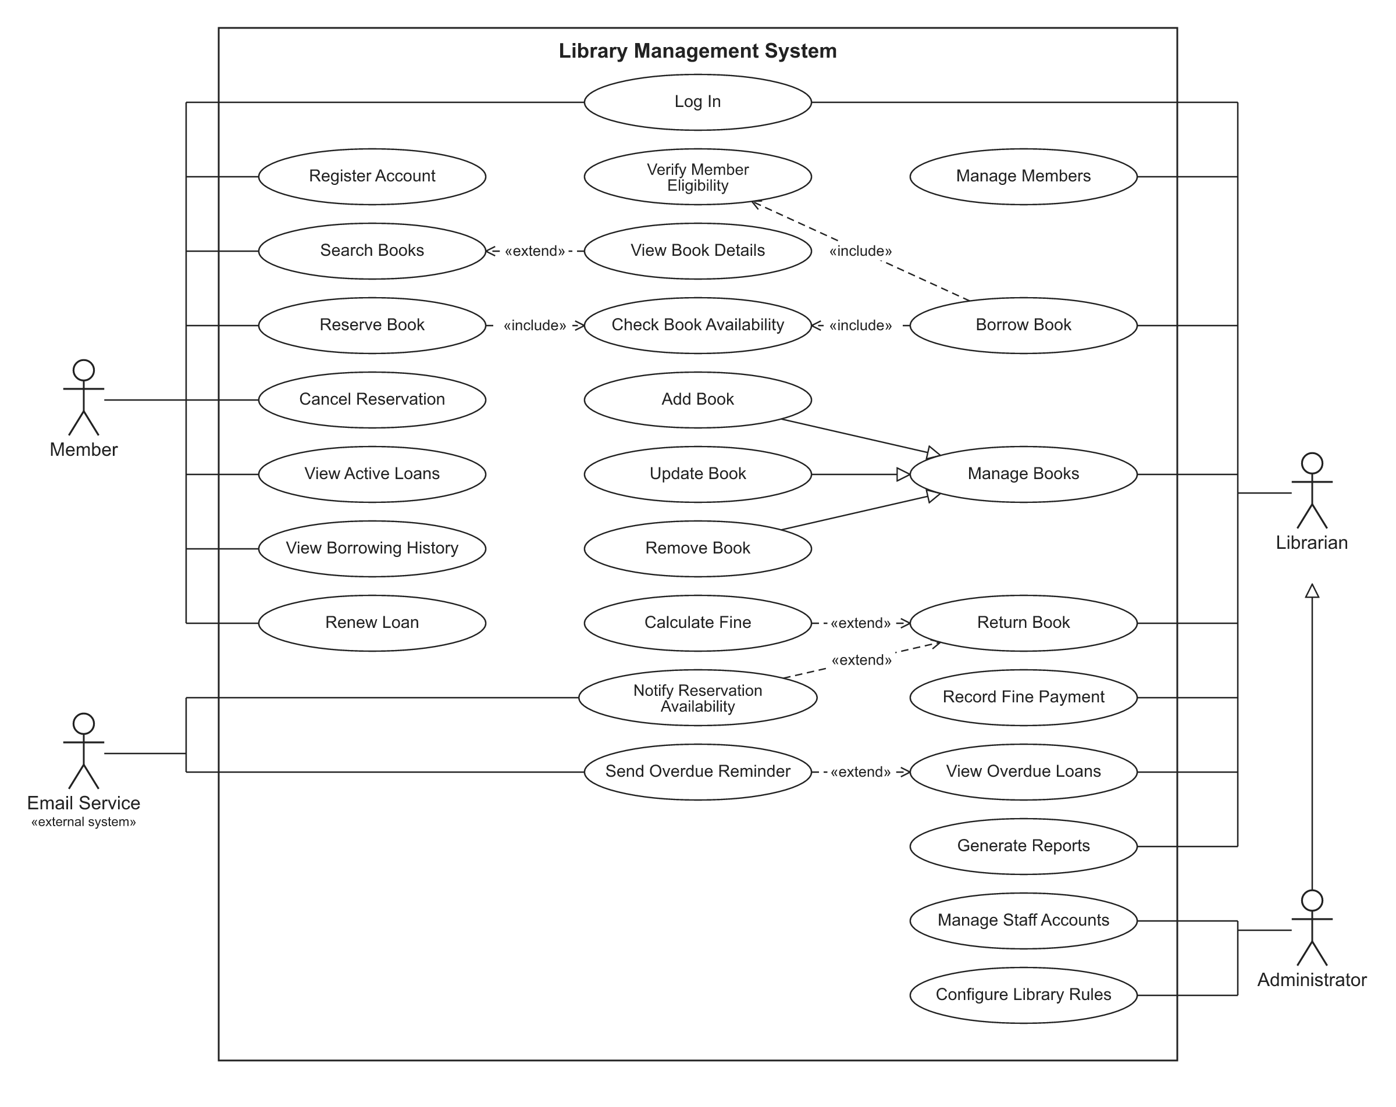
Fig. Use case diagram of the library management system

Annex 2. Class diagram of the domain model
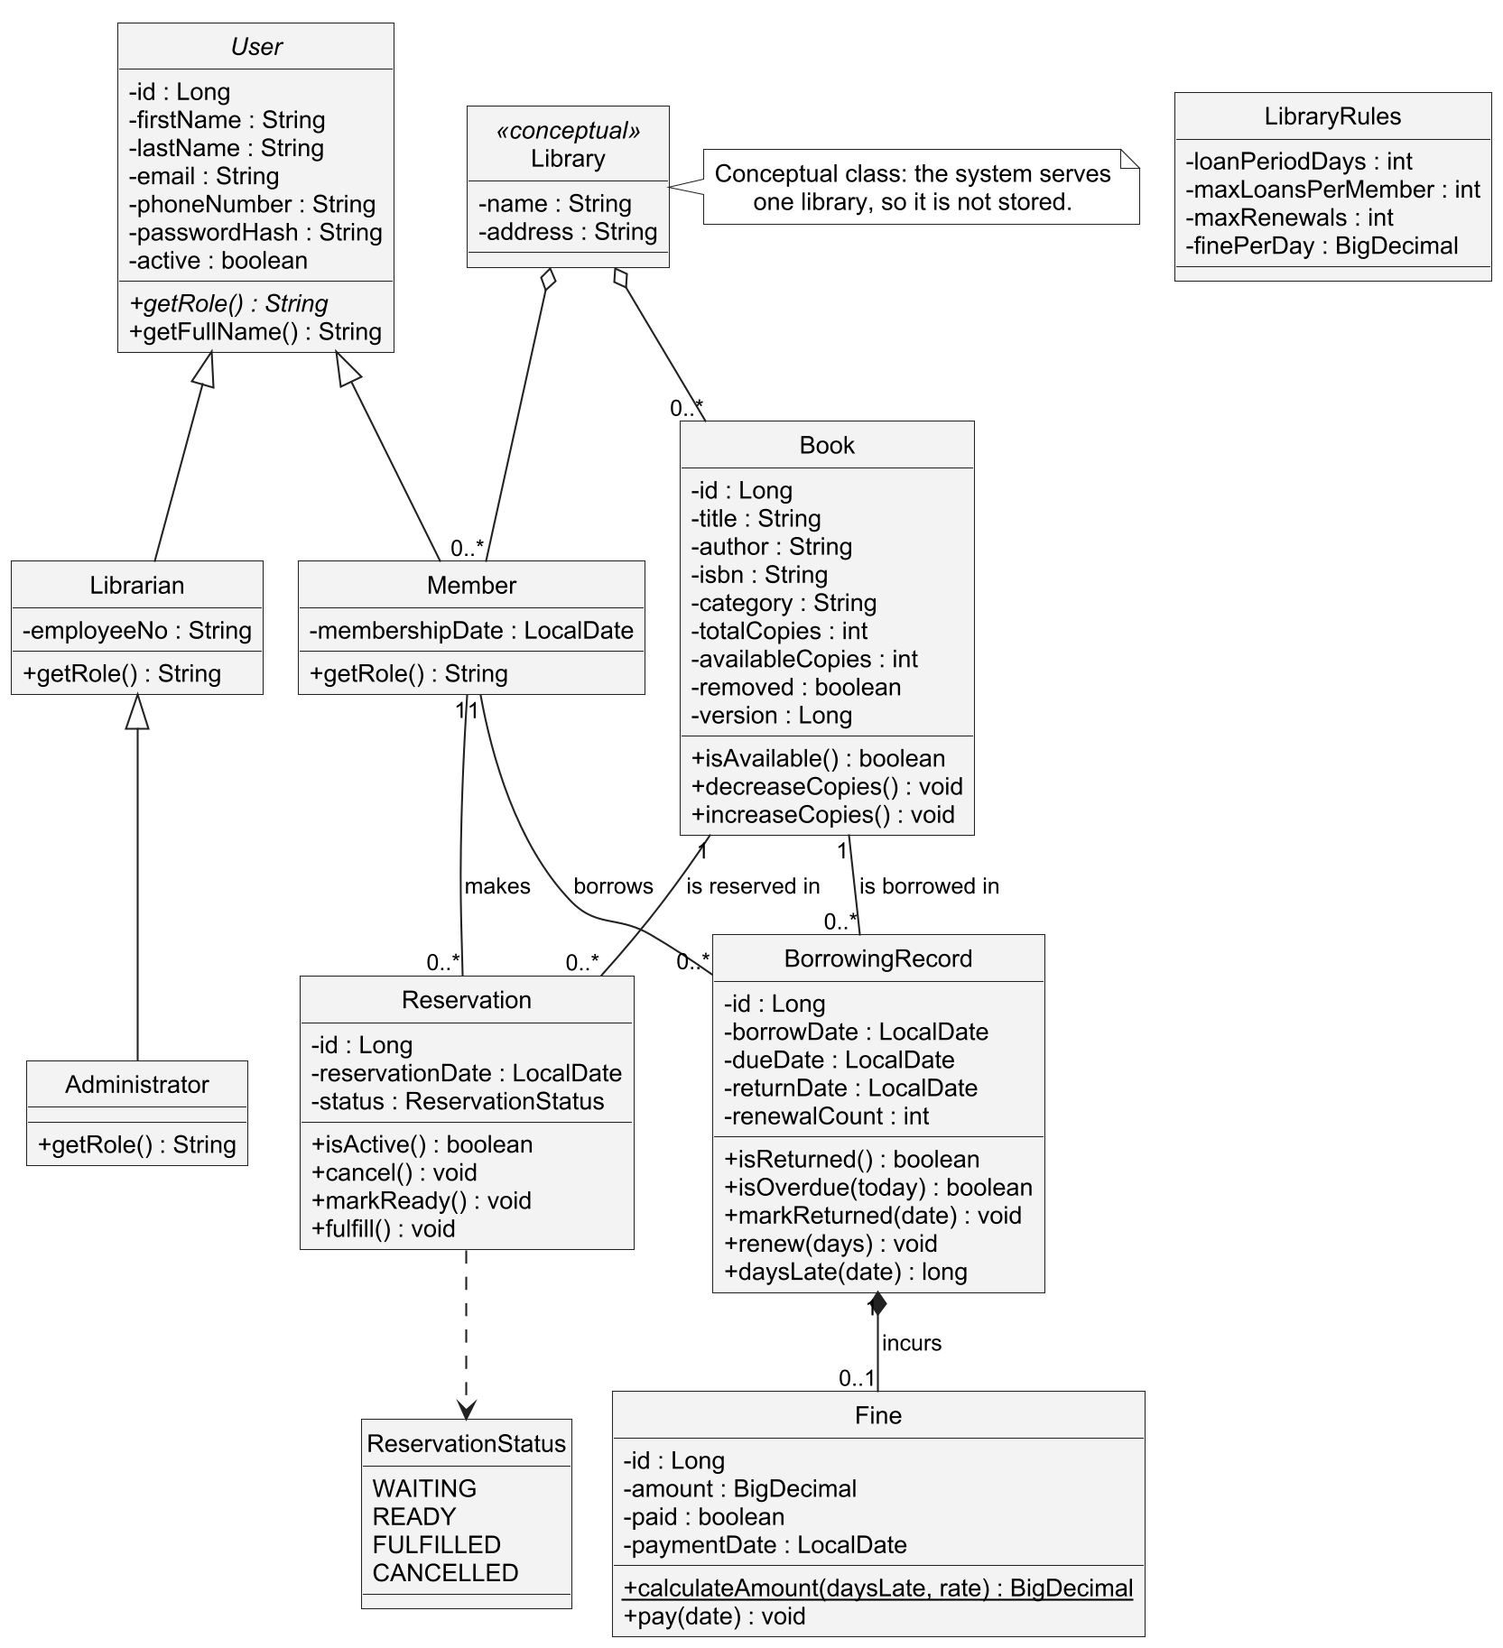
Fig. Class diagram of the domain model

Annex 3. Class diagram of the service layer
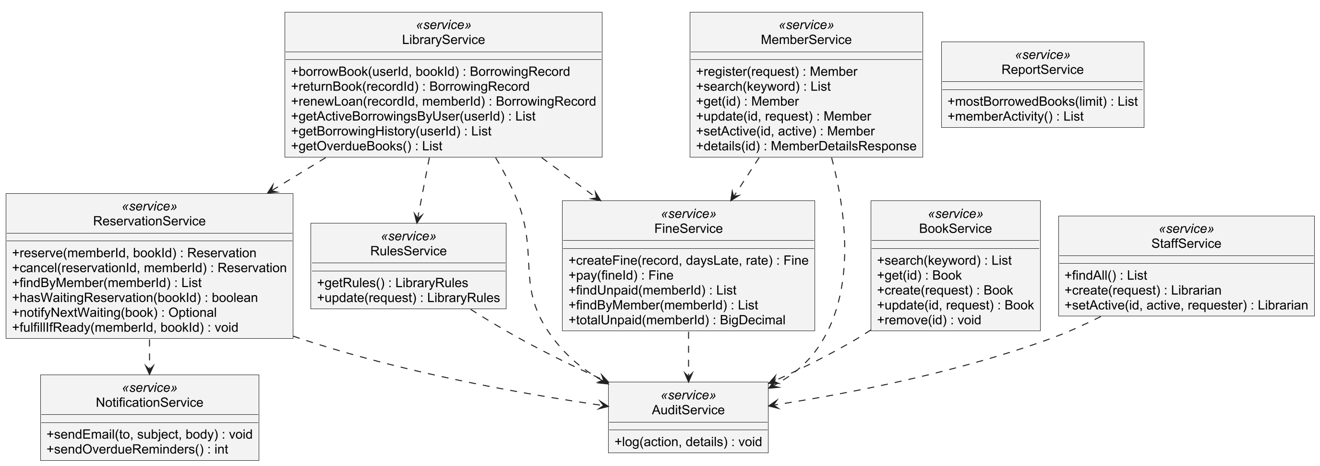
Fig. Class diagram of the service layer

Annex 4. Sequence diagram of the use case Borrow Book
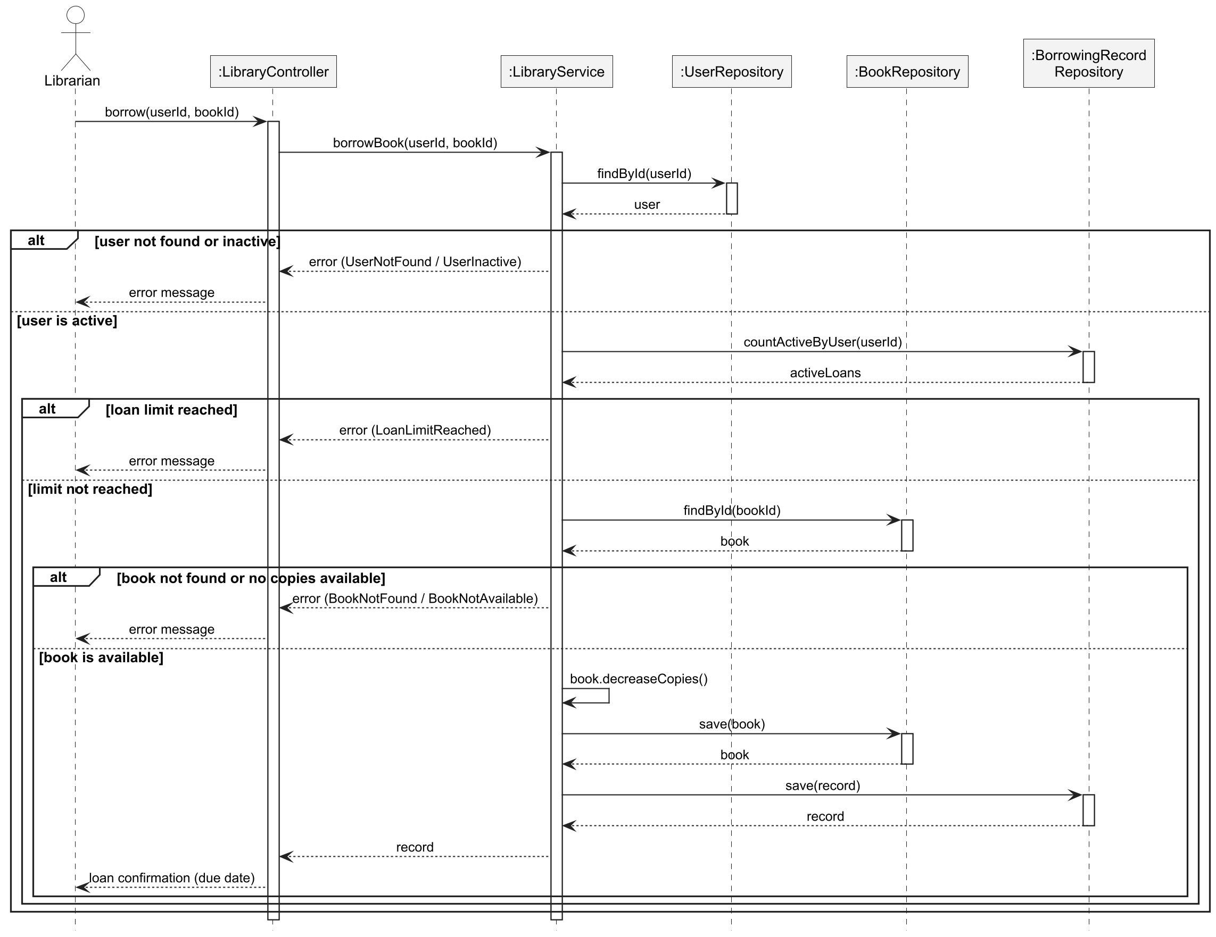
Fig. Sequence diagram of the use case Borrow Book

Annex 5. Activity diagram of the use case Borrow Book
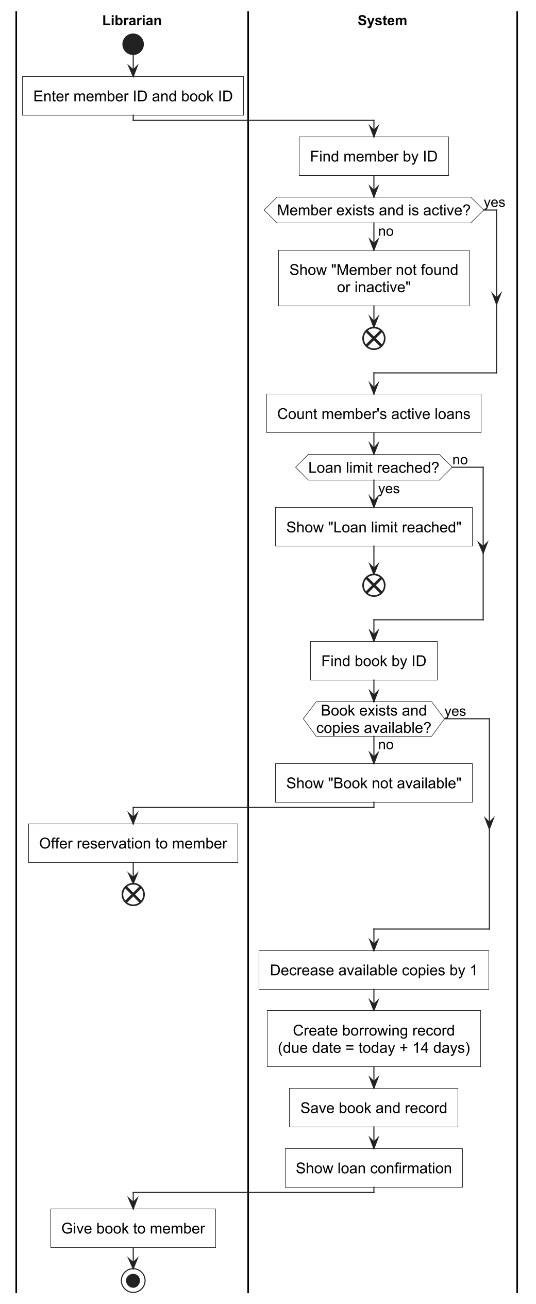
Fig. Activity diagram of the use case Borrow Book

Annex 6. Control flow graph of the method borrowBook
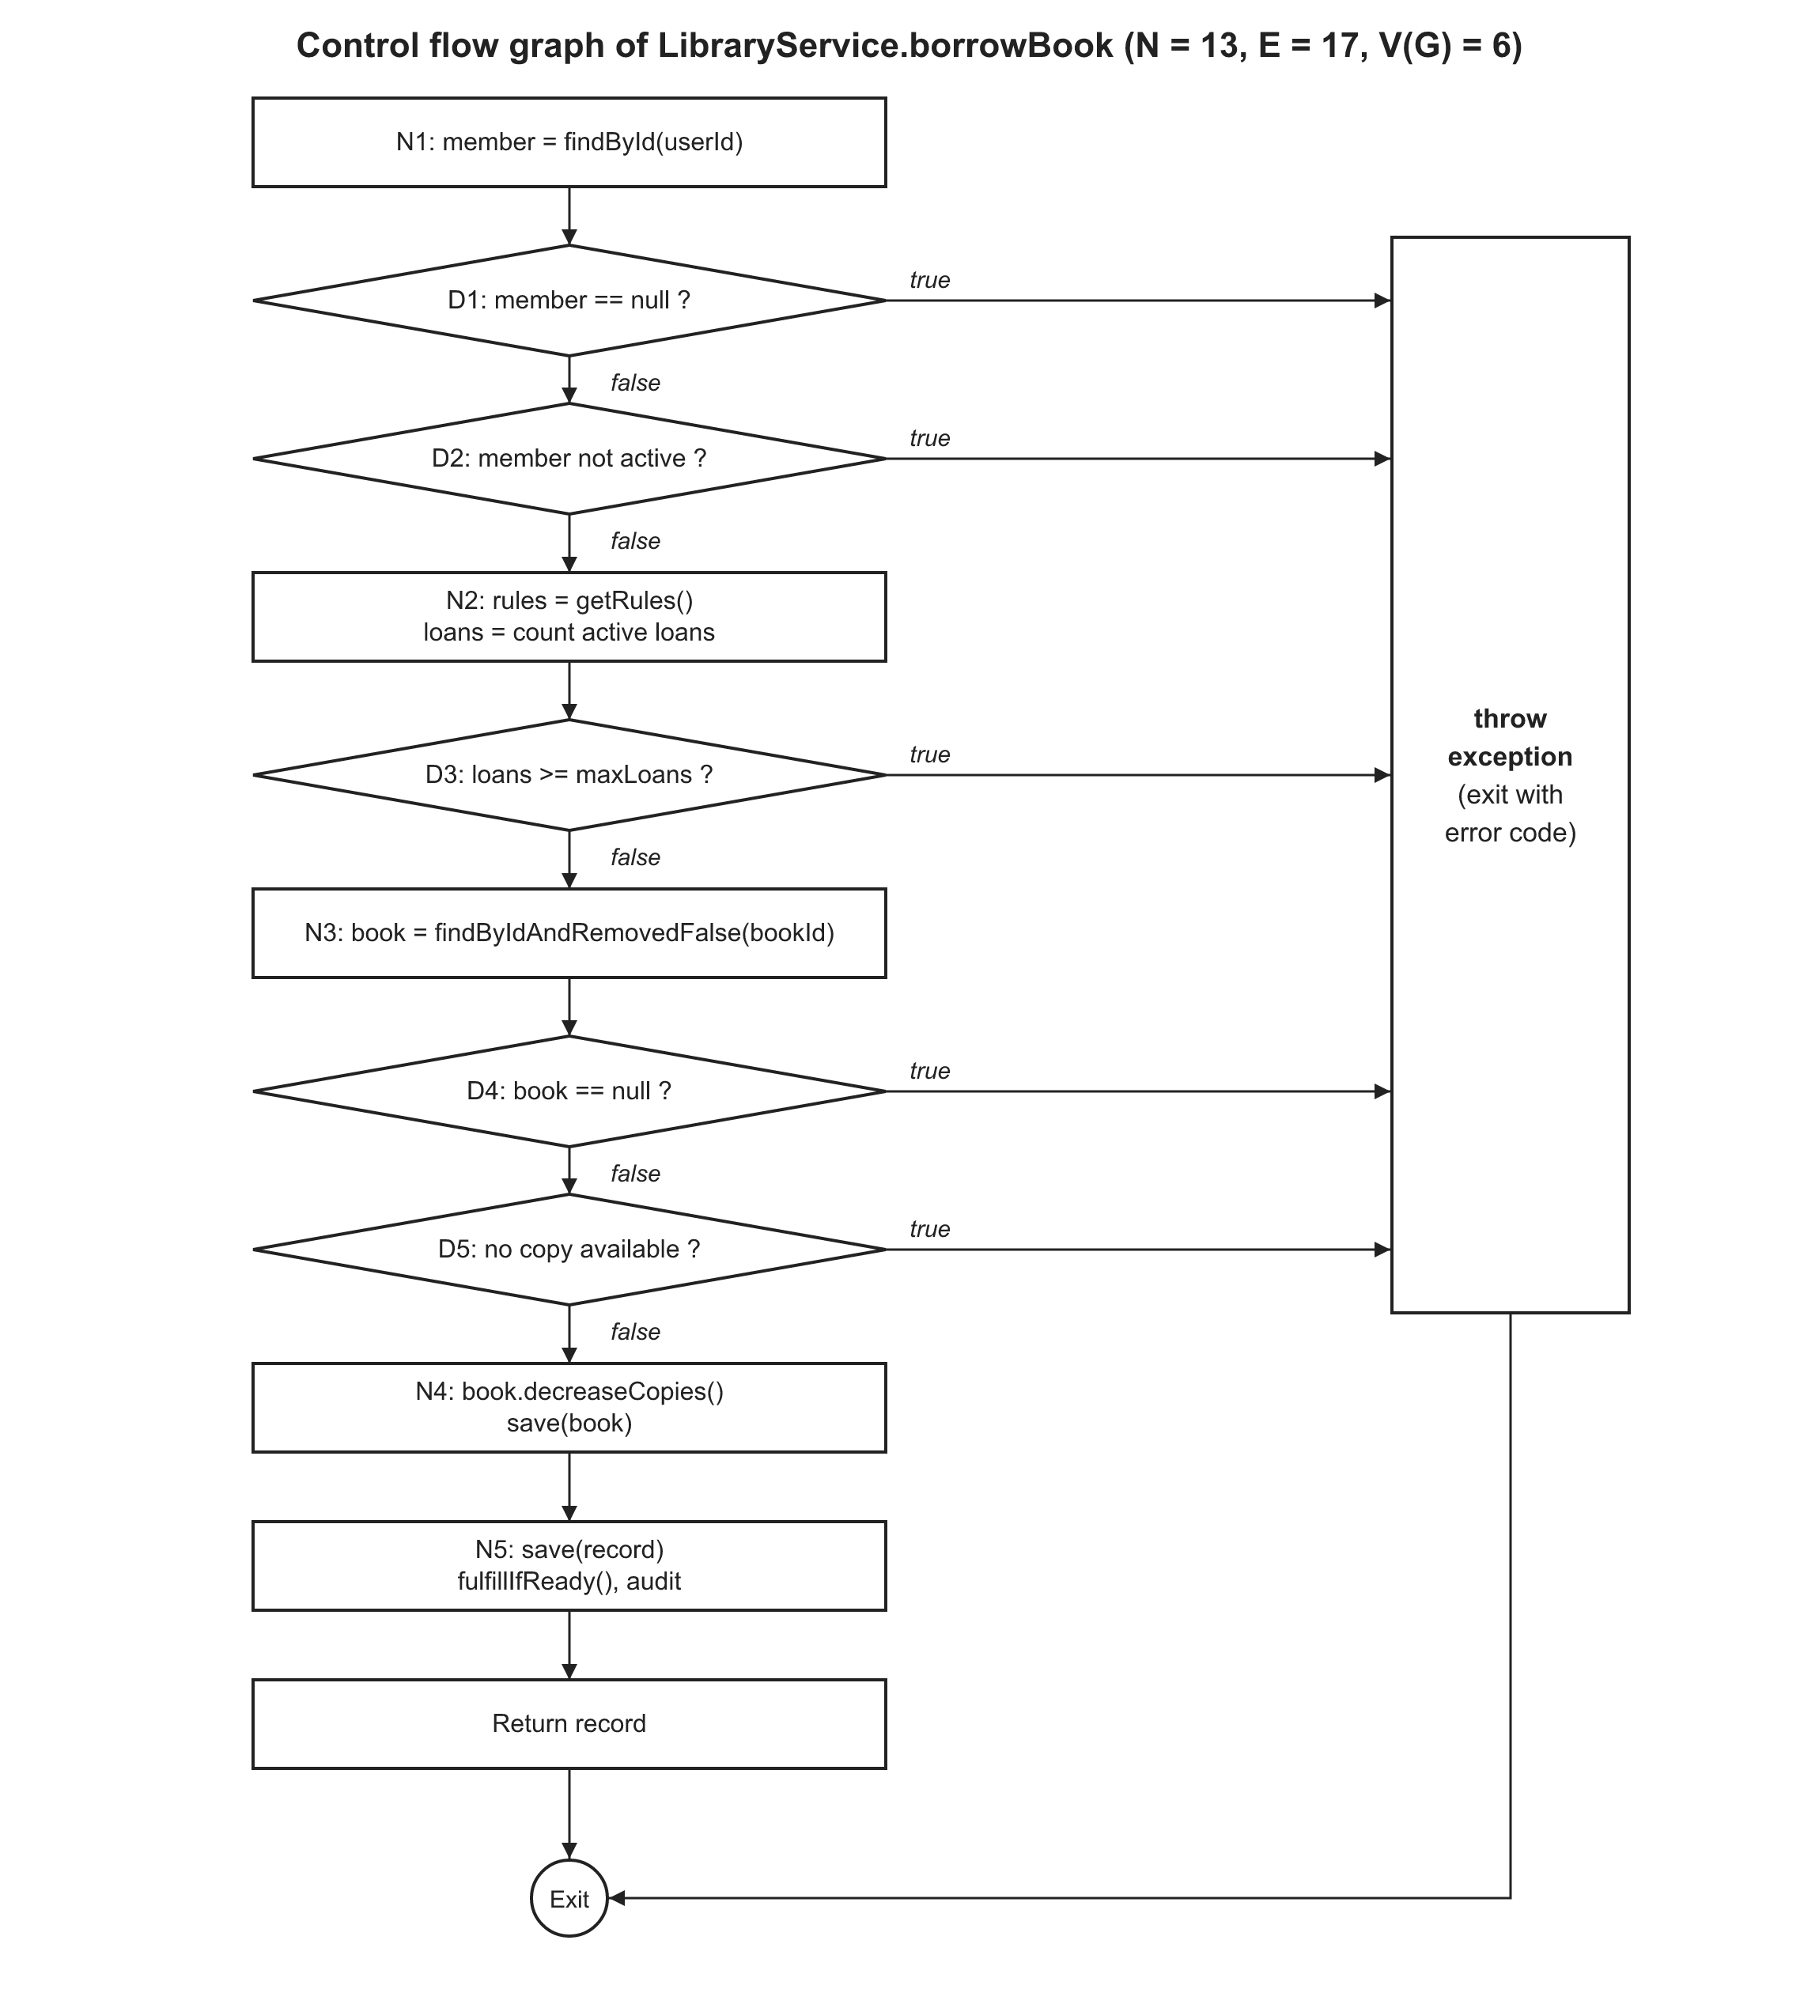
Fig. Control flow graph of LibraryService.borrowBook

Annex 7. Control flow graph of the method returnBook
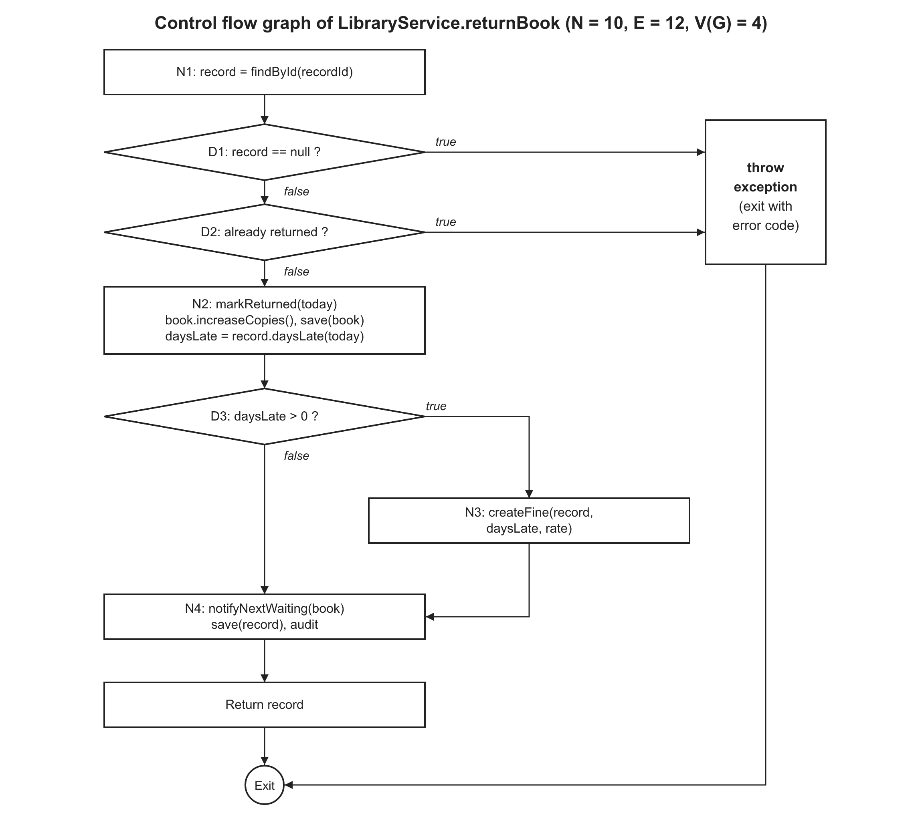
Fig. Control flow graph of LibraryService.returnBook

Annex 8. Control flow graph of the method renewLoan
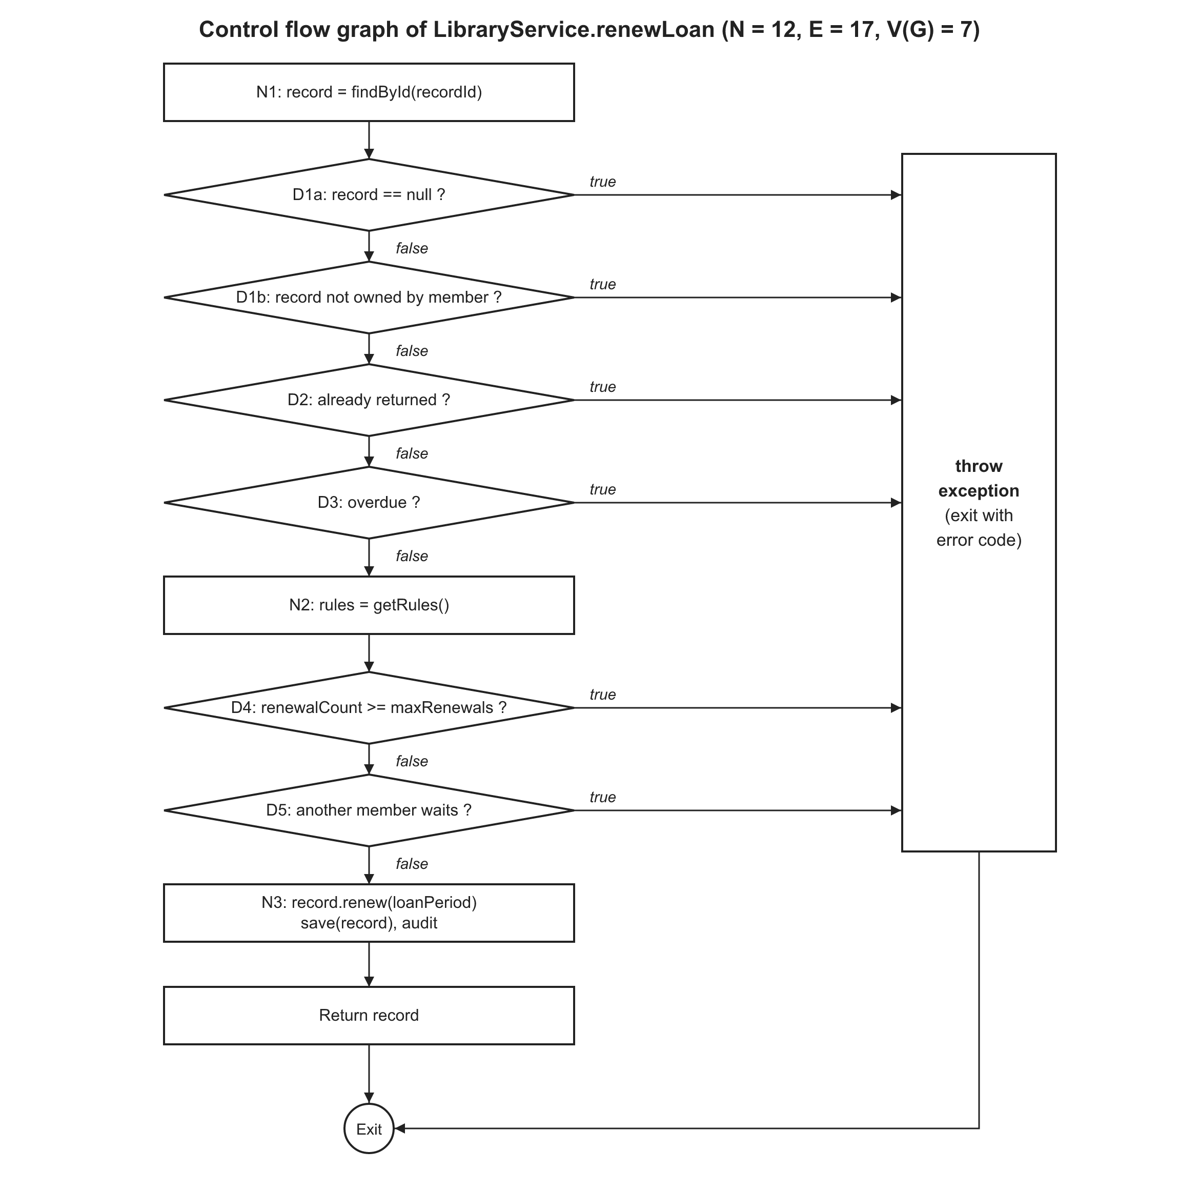
Fig. Control flow graph of LibraryService.renewLoan

Annex 9. Functional requirements
Table Functional requirements
ID | Name | Area | Priority | Use case
FR-001 | User Registration | Account and Access | High | UC-01
FR-002 | User Login | Account and Access | High | UC-02
FR-003 | Role-Based Access | Account and Access | High | UC-02
FR-004 | Add Book | Catalog Management | High | UC-11
FR-005 | Update Book | Catalog Management | Medium | UC-12
FR-006 | Remove Book | Catalog Management | Medium | UC-13
FR-007 | Search Books | Catalog Management | High | UC-03
FR-008 | View Book Details | Catalog Management | Medium | UC-04
FR-009 | Add Member | Member Management | Medium | UC-14
FR-010 | Update Member | Member Management | Medium | UC-14
FR-011 | Deactivate Member | Member Management | Medium | UC-14
FR-012 | View Member Information | Member Management | Low | UC-14
FR-013 | Borrow Book | Circulation | High | UC-15
FR-014 | Verify Member Eligibility | Circulation | High | UC-16
FR-015 | Check Book Availability | Circulation | High | UC-17
FR-016 | Set Due Date | Circulation | High | UC-15
FR-017 | Return Book | Circulation | High | UC-18
FR-018 | Update Inventory | Circulation | High | UC-15, UC-18
FR-019 | Renew Loan | Circulation | Medium | UC-09
FR-020 | View Active Loans | Circulation | Medium | UC-07
FR-021 | View Borrowing History | Circulation | Medium | UC-08
FR-022 | Track Overdue Loans | Circulation | High | UC-22
FR-023 | Reserve Book | Reservation and Notification | Medium | UC-05
FR-024 | Cancel Reservation | Reservation and Notification | Low | UC-06
FR-025 | Notify Reservation Availability | Reservation and Notification | Medium | UC-20
FR-026 | Send Overdue Reminder | Reservation and Notification | Medium | UC-23
FR-027 | Calculate Fine | Fine Management | Medium | UC-19
FR-028 | Record Fine Payment | Fine Management | Medium | UC-21
FR-029 | Manage Staff Accounts | Administration and Reports | Medium | UC-25
FR-030 | Configure Library Rules | Administration and Reports | Medium | UC-26
FR-031 | Generate Reports | Administration and Reports | Low | UC-24

Annex 10. Non-functional requirements
Table Non-functional requirements
ID | Name | Description | Priority
NFR-001 | Response Time | Search results shall be displayed within 2 seconds for at least 95% of requests when the catalog has up to 10,000 books. | High
NFR-002 | Concurrent Users | The system shall support at least 50 users working at the same time without a loss of performance. | Medium
NFR-003 | Password Protection | Passwords shall be stored only as salted hashes (for example BCrypt) and never as plain text. | High
NFR-004 | Secure Access | All functions except registration and login shall be available only to authenticated users. | High
NFR-005 | Audit Logging | The system shall log every borrow, return and account change with the user and the time. | Medium
NFR-006 | Data Integrity | Borrow and return operations shall be transactions. The number of available copies shall never become negative or greater than the total copies. | High
NFR-007 | Availability | The system shall be available at least 99% of the time during library opening hours. | Medium
NFR-008 | Data Backup | The database shall be backed up automatically every day. | Medium
NFR-009 | Ease of Use | A new librarian shall be able to issue a book after a short training of 30 minutes. | Medium
NFR-010 | Clear Error Messages | The system shall show a clear message for every validation error (for example "Book not available"). | Medium
NFR-011 | Maintainability | The software shall use a layered architecture (controller, service, repository, entity) so that each layer can be changed independently. | Medium
NFR-012 | Testability | At least 80% of the business logic (service layer) shall be covered by automated unit tests. | Medium
NFR-013 | Portability | The system shall run on Windows and Linux with Java 21 and shall support MySQL and H2 databases. | Low

Annex 11. Traceability of the functional requirements
Table Functional requirements, implementation and verification
FR | Endpoint | Implementation | Verified by
FR-001 | POST /api/auth/register | MemberService.register | SupportServicesTest (member_register, member_registerDuplicate); API test registration
FR-002 | GET /api/auth/me (HTTP Basic) | LibraryUserDetailsService, SecurityConfig | API tests login, unauthenticated
FR-003 | all endpoints (@PreAuthorize) | SecurityConfig, controllers, LibraryUserDetails | API test roleRules; DomainModelTest user_roles
FR-004 | POST /api/books | BookService.create | SupportServicesTest book_create, book_createDuplicate; API tests catalog, catalogValidation
FR-005 | PUT /api/books/{id} | BookService.update | SupportServicesTest book_updateCopiesBoundary; API test catalog
FR-006 | DELETE /api/books/{id} | BookService.remove | SupportServicesTest book_remove; API test catalog
FR-007 | GET /api/books?keyword= | BookService.search, BookRepository.search | SupportServicesTest book_searchNullKeyword; API test catalog; NFR-001 test
FR-008 | GET /api/books/{id} | BookService.get | API test catalog
FR-009 | POST /api/members | MemberService.register | SupportServicesTest member_register; Postman 4.4
FR-010 | PUT /api/members/{id} | MemberService.update | Postman 4.5 (no automated test)
FR-011 | PATCH /api/members/{id}/deactivate | MemberService.setActive | SupportServicesTest member_deactivate; API test inactiveAndUnknown
FR-012 | GET /api/members/{id} | MemberService.details | Postman 4.3 (no automated test)
FR-013 | POST /api/library/borrow | LibraryService.borrowBook | BB-01 to BB-08; WB-B1 to WB-B6; API test borrowAndReturn
FR-014 | POST /api/library/borrow | LibraryService.borrowBook (D1 to D3) | BB-02, BB-04, BB-05, BB-08; WB-B1 to WB-B3; API tests loanLimit, inactiveAndUnknown
FR-015 | POST /api/library/borrow | LibraryService.borrowBook (D4, D5) | BB-03, BB-06; WB-B4, WB-B5; API test borrowAndReturn
FR-016 | POST /api/library/borrow | LibraryService.borrowBook, RulesService | BB-01, BB-07; WB-B6
FR-017 | POST /api/library/return/{id} | LibraryService.returnBook | BB-09 to BB-11; WB-R1 to WB-R4; API test borrowAndReturn
FR-018 | borrow and return | Book.decreaseCopies, Book.increaseCopies | DomainModelTest (book_*); BB-03, BB-09; NFR-006 concurrency test
FR-019 | POST /api/library/renew/{id} | LibraryService.renewLoan | BB-12 to BB-16; WB-N1 to WB-N7; API test renewAndOwnLoans
FR-020 | GET /api/library/user/{id}/active | LibraryService.getActiveBorrowingsByUser | WB-Q1; API test renewAndOwnLoans
FR-021 | GET /api/library/user/{id}/history | LibraryService.getBorrowingHistory | WB-Q1; API test renewAndOwnLoans
FR-022 | GET /api/library/overdue | LibraryService.getOverdueBooks | BB-17; API test overdueAndFine
FR-023 | POST /api/reservations | ReservationService.reserve | SupportServicesTest reserve_*; API test reservation
FR-024 | DELETE /api/reservations/{id} | ReservationService.cancel | SupportServicesTest cancel_ownership; DomainModelTest reservation_cancel; API test reservation
FR-025 | return of a reserved book | ReservationService.notifyNextWaiting | SupportServicesTest notifyNextWaiting; API test reservation
FR-026 | POST /api/library/overdue/remind | NotificationService.sendOverdueReminders | API test overdueAndFine
FR-027 | POST /api/library/return/{id} | Fine.calculateAmount, FineService.createFine | DomainModelTest fine_amount; WB-R4; API test overdueAndFine
FR-028 | POST /api/fines/{id}/pay | FineService.pay | DomainModelTest fine_pay; API test overdueAndFine
FR-029 | /api/admin/staff | StaffService | SupportServicesTest staff_*; API test staffManagement
FR-030 | /api/admin/rules | RulesService | BB-07, BB-08; API test rules
FR-031 | /api/reports/* | ReportService | API test reports

Annex 12. REST API overview
Table Endpoints of the REST API
Method | Endpoint | Role | Description
POST | /api/auth/register | public | Create a member account
GET | /api/auth/me | any user | Login check, profile and role
GET | /api/books?keyword= | any user | Search books
GET | /api/books/{id} | any user | Book details
POST, PUT, DELETE | /api/books, /api/books/{id} | Librarian | Add, update, remove a book
GET, POST, PUT | /api/members, /api/members/{id} | Librarian | Search, view, add, update members
PATCH | /api/members/{id}/activate | deactivate | Librarian | Activate or deactivate a member
POST | /api/library/borrow?userId=&bookId= | Librarian | Borrow a book
POST | /api/library/return/{recordId} | Librarian | Return a book, creates a fine if late
POST | /api/library/renew/{recordId} | Member | Renew own loan
GET | /api/library/user/{id}/active | history | Librarian or the member | Active loans and history
GET | /api/library/overdue | Librarian | Overdue loans
POST | /api/library/overdue/remind | Librarian | Send overdue reminders
POST, DELETE, GET | /api/reservations, /{id}, /my | Member | Reserve, cancel, list reservations
GET, POST | /api/fines/unpaid, /api/fines/{id}/pay | Librarian | Unpaid fines, record a payment
GET | /api/fines/my | Member | Own fines
GET | /api/reports/most-borrowed | overdue | member-activity | Librarian | Reports
GET, POST, PATCH | /api/admin/staff, /{id}/activate | deactivate | Administrator | Staff accounts
GET, PUT | /api/admin/rules | Administrator | Library rules

Annex 13. Black box test cases
Table Black box test cases (LibraryServiceBlackBoxTest)
ID | Description | Result
BB-01 | valid member, available book: loan is created, due date = today + 14 days, copies - 1 | Pass
BB-02 | boundary values of the loan limit (limit = 5) | Pass
BB-03 | boundary values of the available copies | Pass
BB-04 | invalid partition: member does not exist | Pass
BB-05 | invalid partition: member is inactive | Pass
BB-06 | invalid partition: book does not exist | Pass
BB-07 | the loan period is configurable (FR-030): 30 days | Pass
BB-08 | the loan limit is configurable (FR-030): limit 2 | Pass
BB-09 | boundary values of the return date (due date = boundary) | Pass
BB-10 | invalid partition: record does not exist | Pass
BB-11 | invalid partition: the book was already returned | Pass
BB-12 | renew: valid loan is extended by 14 days | Pass
BB-13 | boundary values of the due date: a loan that is due today can still be renewed | Pass
BB-14 | boundary values of the renewal limit | Pass
BB-15 | renewal is refused when another member reserved the book | Pass
BB-16 | a member cannot renew the loan of another member | Pass
BB-17 | overdue query uses today's date | Pass

Annex 14. White box test cases
Table White box test cases (LibraryServiceWhiteBoxTest)
ID | Description | Result
WB-B1 | path P1: D1 true -> UserNotFound, nothing else is called | Pass
WB-B2 | path P2: D1 false, D2 true -> UserInactive | Pass
WB-B3 | path P3: D3 true -> LoanLimitReached, the book is not read | Pass
WB-B4 | path P4: D4 true -> BookNotFound | Pass
WB-B5 | path P5: D5 true -> BookNotAvailable, no record is saved | Pass
WB-B6 | path P6: all decisions false -> book and record are saved, reservation is fulfilled, audit is written | Pass
WB-R1 | path P1: D1 true -> RecordNotFound | Pass
WB-R2 | path P2: D2 true -> BookAlreadyReturned, inventory is not changed | Pass
WB-R3 | path P3: D3 false (on time) -> no fine, next reserved member is notified | Pass
WB-R4 | path P4: D3 true (late) -> fine is created with the daily rate from the rules | Pass
WB-N1 | D1 condition 1: record == null | Pass
WB-N2 | D1 condition 2: record exists but the owner is another member | Pass
WB-N3 | D2 true: returned loan cannot be renewed | Pass
WB-N4 | D3 true: overdue loan cannot be renewed | Pass
WB-N5 | D4 true: renewal limit reached | Pass
WB-N6 | D5 true: another member waits for the book | Pass
WB-N7 | all decisions false: due date moves by the loan period and the record is saved | Pass
WB-Q1 | query methods delegate to the repository | Pass

Annex 15. Programmer guide
Requirements. Java 21 (JDK), Git, and optionally MySQL 8 or newer. Apache Maven is not required, because the project contains the Maven wrapper.
1. Get the source code:
git clone https://github.com/SabriGR/library-management-system.git
cd library-management-system
2. Start the application (H2 database in memory, no set-up):
./mvnw spring-boot:run (Windows: mvnw.cmd spring-boot:run)
The API runs on http://localhost:8080. The Swagger UI is available at http://localhost:8080/swagger-ui.html. At the first start, demo data (books, members, loans, an overdue loan, a fine and a reservation) is created.
3. Use MySQL (optional):
set DB_URL=jdbc:mysql://localhost:3306/librarymanagmentsystem
set DB_USERNAME=root
set DB_PASSWORD=<password>
./mvnw spring-boot:run -Dspring-boot.run.profiles=mysql
4. Run the tests and create the coverage report:
./mvnw test
The coverage report is created in target/site/jacoco/index.html. The audit log is written to logs/audit.log.
5. Project structure. The source code is in src/main/java/com/sabrigur, organised in the packages controller, service, repository, entity, dto, exception, security and config. The tests are in src/test/java. The settings are in src/main/resources (application.properties and application-mysql.properties).
6. Extension points. A real e-mail server is connected by replacing the method NotificationService.sendEmail. The default library rules are changed in the table library_rules or with the endpoint PUT /api/admin/rules. A new business function is added as a method of a service class, with a controller method and a unit test.

Annex 16. User guide
The system is used through the Swagger UI (http://localhost:8080/swagger-ui.html) or any HTTP client such as Postman. Every request except the registration needs the login: HTTP Basic authentication with the e-mail address as user name. In Swagger UI, the button Authorize is used for this. The demo accounts are shown in the table below.
Table Demo accounts
Role | E-mail | Password
Administrator | admin@library.com | Admin123!
Librarian | librarian@library.com | Librarian123!
Member | sabri@library.com, bahri@library.com, oguzhan@library.com | Member123!

Member. A new member registers with POST /api/auth/register (first name, last name, e-mail, password of at least eight characters). The member searches books with GET /api/books?keyword=title, reserves a book that has no copy with POST /api/reservations?bookId=, renews a loan with POST /api/library/renew/{recordId} and views the own loans with GET /api/library/user/{id}/active and the own fines with GET /api/fines/my.
Librarian. The librarian issues a book with POST /api/library/borrow?userId=&bookId= and registers the return with POST /api/library/return/{recordId}. The answer of a late return contains the fine. The librarian lists the overdue loans with GET /api/library/overdue, sends reminders with POST /api/library/overdue/remind, records a payment with POST /api/fines/{id}/pay, manages books and members with the endpoints /api/books and /api/members and reads the reports under /api/reports.
Administrator. The administrator creates and deactivates staff accounts with /api/admin/staff and changes the loan period, the loan limit, the number of renewals and the fine rate with PUT /api/admin/rules.
Errors. If a request is refused, the answer contains a code and a message, for example BookNotAvailable or LoanLimitReached. The status 401 means that the login is missing or wrong, and 403 means that the role is not allowed to use the function.

