
Klaipėda State University of Applied Sciences
Software Requirements Specification
Library Management System
Version 1.0
Prepared by: Sabri Gür
Course: Software Engineering, Project Work
November 2026

Revision History
Table 1: Revision history
Version | Date | Author | Description
1.0 | 11 November 2026 | Sabri Gür | First complete version of the specification

Contents
1. Introduction
2. Overall Description
3. Specific Requirements
4. Requirements Management
Appendix A. Requirements Traceability Matrix
Appendix B. Error Codes

1. Introduction

1.1 Purpose
This document is the Software Requirements Specification (SRS) of the Library Management System (LMS). It describes what the system must do and how well it must work. It is written for the developer, the testers, the course instructor and the future maintainers of the system. It follows the structure of IEEE Std 830-1998.

1.2 Scope
The LMS is a software system that supports the daily work of a library. It manages the book catalog and the members, the borrowing and returning of books, reservations, overdue loans and fines, reports and the administration of staff accounts and library rules. The system is implemented as a REST API with Java and Spring Boot.
The main objectives of the system are:
- to replace manual records with one reliable data store;
- to make borrowing and returning fast and to keep the stock of every book correct;
- to apply the library rules (loan period, loan limit, fines) automatically;
- to give members self-service functions such as search, reservation and renewal;
- to protect the data with logins and roles.

In scope
- Catalog management, member management, circulation (borrow, return, renew), reservations, fines, e-mail notifications, reports, staff and rule administration, login and roles.

Out of scope
- A graphical user interface (the system offers a REST API and Swagger UI).
- Purchasing of books, inter-library loans, payment by card (a fine payment is only recorded), e-books.
- Sending real e-mails: the e-mail service is simulated and the messages are written to the log.

1.3 Definitions, Acronyms and Abbreviations
Table 2: Definitions
Term | Meaning
API | Application Programming Interface. Here: the REST interface of the system.
REST / JSON | Style of web interface / data format used for requests and answers.
HTTP Basic | Login method where the e-mail address and the password are sent with every request.
BCrypt | Algorithm that stores passwords as one-way hashes.
Member | A registered library user who borrows books.
Librarian | A staff member who works at the library desk.
Administrator | A senior staff member. An administrator is also a librarian.
Loan / borrowing record | The record that a member has borrowed one copy of a book.
Overdue | A loan that was not returned and whose due date is in the past.
FR / NFR | Functional requirement / non-functional requirement.
UC | Use case.
SRS | Software Requirements Specification (this document).

1.4 References
- IEEE Std 830-1998, Recommended Practice for Software Requirements Specifications.
- Object Management Group, Unified Modeling Language (UML) Specification.
- Sommerville, I. Software Engineering, 10th edition, Pearson, 2016.
- Requirements database: Requirements_Database.xlsx (delivered with this document).
- Project report, UML diagrams and the source code of the project (GitHub repository SabriGR/library-management-system).

1.5 Overview of the Document
Section 2 describes the product in general: its context, its functions, its users and its constraints. Section 3 contains the detailed requirements: interfaces, functional requirements, use cases, non-functional requirements, data and error handling. Section 4 explains how requirements are managed and verified. Appendix A links every requirement to its implementation and its tests.
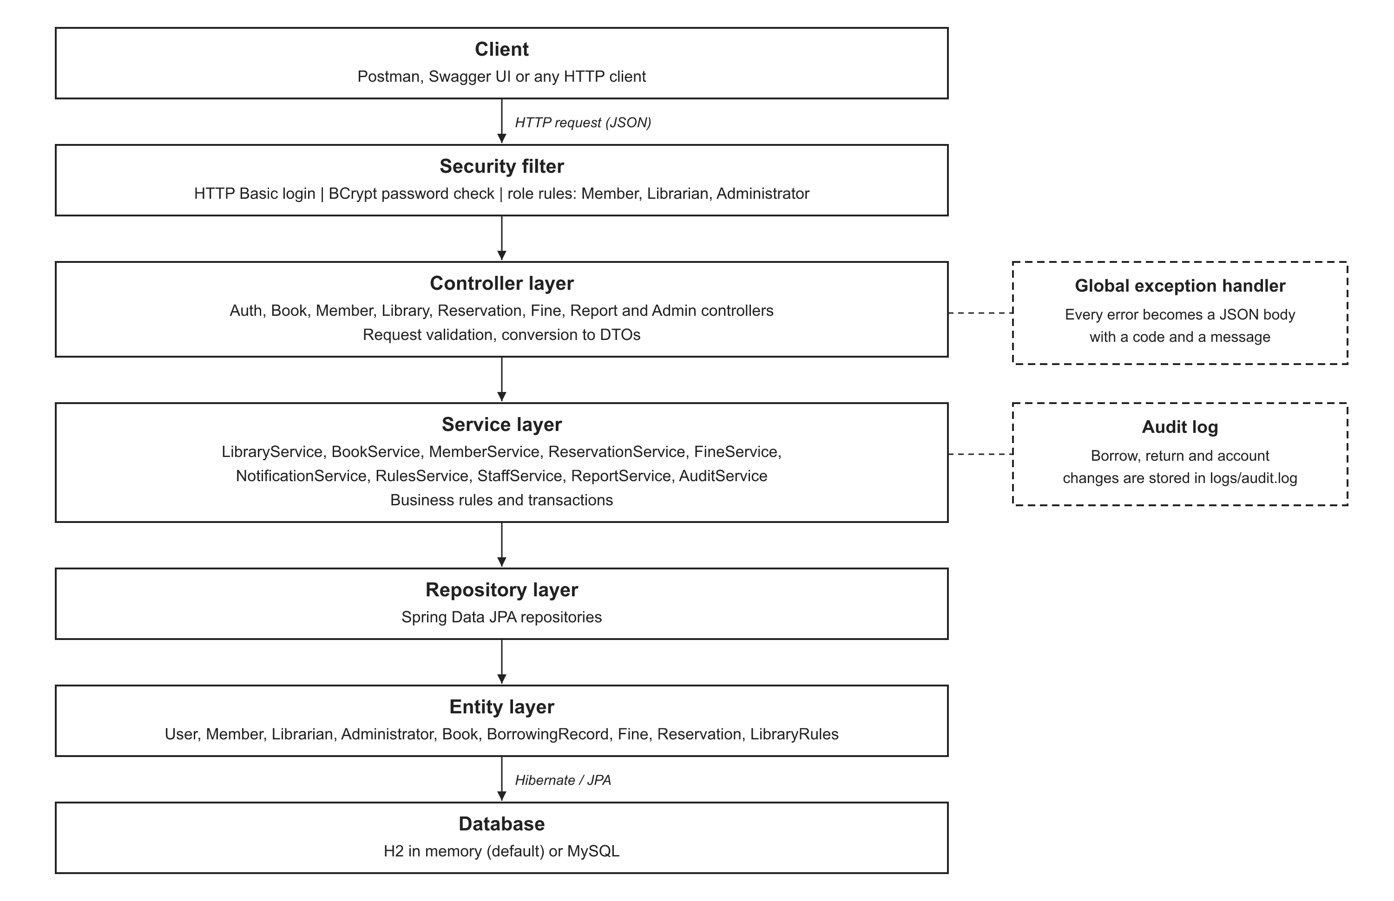
Figure 1: Architecture of the Library Management System

2. Overall Description

2.1 Product Perspective
The LMS is a new, self-contained system. It is built as a layered Java application. Clients (for example Postman, Swagger UI or a future web or mobile application) send HTTP requests with JSON data. The system checks the login and the role of the user, runs the business rules and stores the data in a relational database (H2 in memory by default, or MySQL). The only external system is an e-mail service for notifications.

2.2 Product Functions
The 31 functional requirements are grouped in 7 areas:
- Account and Access: User Registration, User Login, Role-Based Access.
- Catalog Management: Add Book, Update Book, Remove Book, Search Books, View Book Details.
- Member Management: Add Member, Update Member, Deactivate Member, View Member Information.
- Circulation: Borrow Book, Verify Member Eligibility, Check Book Availability, Set Due Date, Return Book, Update Inventory, Renew Loan, View Active Loans, View Borrowing History, Track Overdue Loans.
- Reservation and Notification: Reserve Book, Cancel Reservation, Notify Reservation Availability, Send Overdue Reminder.
- Fine Management: Calculate Fine, Record Fine Payment.
- Administration and Reports: Manage Staff Accounts, Configure Library Rules, Generate Reports.

2.3 User Classes and Characteristics
Table 3: User classes
User class | Description and privileges | Use
Member | Registered reader. Can search books, reserve, cancel a reservation, renew a loan and see his or her own loans, fines and history. | Frequent, little technical knowledge
Librarian | Staff member. Can manage books and members, issue and return books, record fine payments, send reminders and read reports. | Daily, trained
Administrator | Librarian with additional rights: manages staff accounts and the library rules. | Rare
Email Service (external system) | Delivers the e-mail messages of the system. Simulated in this version. | Automatic

2.4 Operating Environment
- Java 21 runtime on Windows or Linux.
- Database: H2 (default, in memory) or MySQL 8 or newer.
- Any HTTP client (Postman, curl, Swagger UI at /swagger-ui.html).

2.5 Design and Implementation Constraints
- Programming language and framework: Java 21, Spring Boot 4, Spring Data JPA, Spring Security.
- The system must keep the layered structure: controller, service, repository, entity (NFR-011).
- Passwords must be stored as hashes (NFR-003). All access must be authenticated (NFR-004).
- The project follows the course requirements: UML models, black box and white box testing, documentation.

2.6 Assumptions and Dependencies
- The system serves one library. There is one set of library rules for all members.
- Credentials are sent over a secure connection (HTTPS) in a real installation.
- A real e-mail server can replace the simulated e-mail service without changes in the business logic.
- Fines are only recorded. The payment itself takes place outside the system.

3. Specific Requirements

3.1 External Interface Requirements
Table 4: External interfaces
Interface | Requirement
User interface | The system offers a REST API. The API documentation and a test page are available in Swagger UI (/swagger-ui.html). There is no graphical user interface.
Data format | Requests and answers use JSON. Dates use the format yyyy-MM-dd.
Authentication | HTTP Basic with the e-mail address as user name. Only registration and the API documentation are public.
Database interface | Access through JPA (Hibernate). The default database is H2 in memory. MySQL is selected with the profile "mysql".
E-mail service | The system calls NotificationService.sendEmail(to, subject, body). The current version writes the message to the log.
Error format | Every error answer has the body {timestamp, status, code, message}. The codes are listed in Appendix B.

3.2 Functional Requirements
Priority: High = the system cannot do its main job without it; Medium = important, a work-around exists; Low = useful, can be delivered later.

3.2.1 Account and Access
Table 5: Account and Access
ID | Requirement | Description | Priority | Use case
FR-001 | User Registration | The system shall allow a new member to create an account by entering first name, last name, e-mail address, phone number and password. | High | UC-01
FR-002 | User Login | The system shall allow registered users to log in using an e-mail address and a password. | High | UC-02
FR-003 | Role-Based Access | The system shall restrict each function according to the user role (Member, Librarian, Administrator). | High | UC-02

3.2.2 Catalog Management
Table 6: Catalog Management
ID | Requirement | Description | Priority | Use case
FR-004 | Add Book | The system shall allow a librarian to add a new book with title, author, ISBN, category and number of copies. | High | UC-11
FR-005 | Update Book | The system shall allow a librarian to edit the information of an existing book. | Medium | UC-12
FR-006 | Remove Book | The system shall allow a librarian to remove a book from the catalog only if none of its copies are currently borrowed. | Medium | UC-13
FR-007 | Search Books | The system shall allow users to search books by title, author, ISBN or category. | High | UC-03
FR-008 | View Book Details | The system shall show the details of a selected book, including the number of available copies. | Medium | UC-04

3.2.3 Member Management
Table 7: Member Management
ID | Requirement | Description | Priority | Use case
FR-009 | Add Member | The system shall allow a librarian to register a new member at the library desk. | Medium | UC-14
FR-010 | Update Member | The system shall allow a librarian to edit the contact information of a member. | Medium | UC-14
FR-011 | Deactivate Member | The system shall allow a librarian to deactivate a member account. A deactivated member cannot borrow books. | Medium | UC-14
FR-012 | View Member Information | The system shall allow a librarian to view the profile, active loans and unpaid fines of a member. | Low | UC-14

3.2.4 Circulation
Table 8: Circulation
ID | Requirement | Description | Priority | Use case
FR-013 | Borrow Book | The system shall allow a librarian to issue a book to a member and create a borrowing record. | High | UC-15
FR-014 | Verify Member Eligibility | Before a book is issued, the system shall check that the member exists, is active and has not reached the loan limit. | High | UC-16
FR-015 | Check Book Availability | The system shall check that at least one copy of the requested book is available. | High | UC-17
FR-016 | Set Due Date | The system shall set the due date of every new loan to the borrow date plus the loan period (14 days by default). | High | UC-15
FR-017 | Return Book | The system shall allow a librarian to register the return of a borrowed book and store the return date. | High | UC-18
FR-018 | Update Inventory | The system shall decrease the available copies of a book when it is borrowed and increase them when it is returned. | High | UC-15, UC-18
FR-019 | Renew Loan | The system shall allow a member to renew a loan once, if the book is not reserved by another member and the loan is not overdue. | Medium | UC-09
FR-020 | View Active Loans | The system shall show a member the books that he or she currently has on loan, with due dates. | Medium | UC-07
FR-021 | View Borrowing History | The system shall show a member the list of all past loans. | Medium | UC-08
FR-022 | Track Overdue Loans | The system shall allow a librarian to list all active loans whose due date has passed. | High | UC-22

3.2.5 Reservation and Notification
Table 9: Reservation and Notification
ID | Requirement | Description | Priority | Use case
FR-023 | Reserve Book | The system shall allow a member to reserve a book when no copy is available. | Medium | UC-05
FR-024 | Cancel Reservation | The system shall allow a member to cancel his or her own reservation. | Low | UC-06
FR-025 | Notify Reservation Availability | The system shall send an e-mail to a member when a reserved book is returned and becomes available. | Medium | UC-20
FR-026 | Send Overdue Reminder | The system shall allow a librarian to send an e-mail reminder to members who have overdue loans. | Medium | UC-23

3.2.6 Fine Management
Table 10: Fine Management
ID | Requirement | Description | Priority | Use case
FR-027 | Calculate Fine | When an overdue book is returned, the system shall calculate a fine as the number of late days multiplied by the daily fine rate. | Medium | UC-19
FR-028 | Record Fine Payment | The system shall allow a librarian to mark a fine as paid and store the payment date. | Medium | UC-21

3.2.7 Administration and Reports
Table 11: Administration and Reports
ID | Requirement | Description | Priority | Use case
FR-029 | Manage Staff Accounts | The system shall allow an administrator to create, edit and deactivate librarian accounts. | Medium | UC-25
FR-030 | Configure Library Rules | The system shall allow an administrator to change the loan period, the maximum number of loans per member and the daily fine rate. | Medium | UC-26
FR-031 | Generate Reports | The system shall allow a librarian to generate reports on most borrowed books, overdue loans and member activity. | Low | UC-24

3.2.8 Business rules
The following rules apply to the functional requirements. The values in brackets are the default values.
Table 12: Business rules
ID | Rule | Related requirements
BR-01 | The default loan period is 14 days. The administrator can change it. | FR-016, FR-030
BR-02 | A member can have at most 5 active loans (default). The administrator can change the limit. | FR-014, FR-030
BR-03 | A loan can be renewed once (default). A renewal adds one loan period to the due date. | FR-019, FR-030
BR-04 | A loan that is already overdue cannot be renewed. A loan of a reserved book cannot be renewed. | FR-019
BR-05 | The fine is the number of late days multiplied by the daily fine rate (default 0.50). | FR-027, FR-030
BR-06 | A member can reserve a book only when no copy is available, and only once for the same book. | FR-023
BR-07 | When a book is returned, the first waiting member is notified by e-mail and the reservation becomes READY. | FR-025
BR-08 | A book can be removed only when no copy is on loan. Its borrowing history is kept. | FR-006
BR-09 | A deactivated member or staff account cannot log in and a deactivated member cannot borrow. | FR-011, FR-014, FR-029
BR-10 | The e-mail address of a user is unique. The ISBN of a book is unique. | FR-001, FR-004
BR-11 | The number of available copies is never negative and never larger than the total copies. | FR-018, NFR-006
BR-12 | An administrator cannot deactivate his or her own account. | FR-029

3.3 Use Cases
The use case model contains 4 actors and 26 use cases. The use case diagram is shown on the next page. The table after it describes each use case in short. The three most important use cases are specified in detail after it.
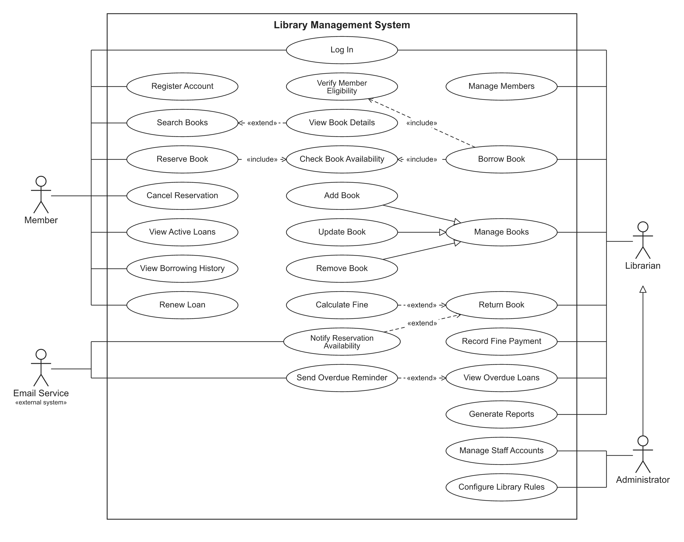
Figure 2: Use case diagram of the Library Management System
Table 13: Use cases
ID | Use case | Actor | Description
UC-01 | Register Account | Member | A new user creates a member account by entering personal data and a password.
UC-02 | Log In | Member, Librarian | A user enters e-mail and password. The system checks them and opens the functions allowed for the user role.
UC-03 | Search Books | Member | A user searches the catalog by title, author, ISBN or category and gets a list of matching books.
UC-04 | View Book Details | Member | Optional step of Search Books. The user opens one book from the result list to see its details and available copies.
UC-05 | Reserve Book | Member | A member reserves a book that has no available copy. The system checks availability first.
UC-06 | Cancel Reservation | Member | A member cancels a reservation that he or she made before.
UC-07 | View Active Loans | Member | A member sees the books currently on loan and their due dates.
UC-08 | View Borrowing History | Member | A member sees all past loans, including return dates.
UC-09 | Renew Loan | Member | A member extends the due date of a loan once, if the book is not reserved and the loan is not overdue.
UC-10 | Manage Books | Librarian | General use case for catalog maintenance. It is specialized by Add Book, Update Book and Remove Book.
UC-11 | Add Book | Librarian | A librarian adds a new book to the catalog with its number of copies.
UC-12 | Update Book | Librarian | A librarian changes the data of an existing book.
UC-13 | Remove Book | Librarian | A librarian removes a book from the catalog if no copy is on loan.
UC-14 | Manage Members | Librarian | A librarian adds, updates, views or deactivates member accounts.
UC-15 | Borrow Book | Librarian | A librarian issues a book to a member. The system verifies the member and the book, reduces the available copies and creates a borrowing record with a due date.
UC-16 | Verify Member Eligibility | (included) | Included in Borrow Book. The system checks that the member exists, is active and has not reached the loan limit.
UC-17 | Check Book Availability | (included) | Included in Borrow Book and Reserve Book. The system checks whether at least one copy is available.
UC-18 | Return Book | Librarian | A librarian registers the return of a book. The system stores the return date and increases the available copies.
UC-19 | Calculate Fine | (extends UC-18) | Extension of Return Book. It runs only when the book is returned after the due date.
UC-20 | Notify Reservation Availability | Email Service | Extension of Return Book. It runs only when another member has reserved the returned book. An e-mail is sent through the Email Service.
UC-21 | Record Fine Payment | Librarian | A librarian marks a fine as paid and stores the payment date.
UC-22 | View Overdue Loans | Librarian | A librarian lists all active loans that are past the due date.
UC-23 | Send Overdue Reminder | Email Service | Extension of View Overdue Loans. An e-mail reminder is sent to members with overdue loans.
UC-24 | Generate Reports | Librarian | A librarian creates reports about most borrowed books, overdue loans and member activity.
UC-25 | Manage Staff Accounts | Administrator | An administrator creates, edits and deactivates librarian accounts.
UC-26 | Configure Library Rules | Administrator | An administrator changes the loan period, the maximum loans per member and the fine rate.

Use case specification: UC-15 Borrow Book
Item | Description
Primary actor | Librarian
Related requirements | FR-013, FR-014, FR-015, FR-016, FR-018, NFR-006, NFR-010
Precondition | The librarian is logged in. The member and the book exist in the system.
Main flow | 1. The librarian enters the member id and the book id.  2. The system finds the member and checks that the member is active.  3. The system counts the active loans of the member and checks the loan limit.  4. The system finds the book and checks that a copy is available.  5. The system decreases the available copies by one.  6. The system creates a borrowing record with the due date (today + loan period).  7. If the member had a READY reservation for this book, it is marked as fulfilled.  8. The system saves the data and shows a loan confirmation.
Alternative flows | A1. Member not found or inactive: error UserNotFound / UserInactive.  A2. Loan limit reached: error LoanLimitReached.  A3. Book not found: error BookNotFound.  A4. No copy available: error BookNotAvailable. The librarian can offer a reservation (UC-05).
Postcondition | Success: one copy less is available and a new borrowing record exists. Failure: no data is changed.

Use case specification: UC-18 Return Book
Item | Description
Primary actor | Librarian
Related requirements | FR-017, FR-018, FR-025, FR-027
Precondition | The librarian is logged in. The borrowing record exists.
Main flow | 1. The librarian enters the record id.  2. The system checks that the book was not returned before.  3. The system stores the return date and increases the available copies.  4. If the return date is after the due date, the system calculates the fine (extension UC-19).  5. If another member is waiting for the book, the system notifies the first one by e-mail (extension UC-20).  6. The system saves the record and shows it, with the fine if there is one.
Alternative flows | A1. Record not found: error RecordNotFound.  A2. Book already returned: error BookAlreadyReturned.
Postcondition | The loan is closed, the stock is increased, a fine exists if the book was late.

Use case specification: UC-05 Reserve Book
Item | Description
Primary actor | Member
Related requirements | FR-023, FR-025
Precondition | The member is logged in and active.
Main flow | 1. The member selects a book.  2. The system checks that the book exists and that no copy is available (UC-17).  3. The system checks that the member has no active reservation for the book.  4. The system creates the reservation with the status WAITING.
Alternative flows | A1. A copy is available: error BookAvailable. The member should borrow the book.  A2. Active reservation exists: error AlreadyReserved.
Postcondition | The member waits in the queue. When a copy is returned, the first waiting member gets an e-mail and the status becomes READY.

3.4 Non-Functional Requirements

3.4.1 Performance
Table 14: Performance
ID | Requirement | Description | Priority
NFR-001 | Response Time | Search results shall be displayed within 2 seconds for at least 95% of requests when the catalog has up to 10,000 books. | High
NFR-002 | Concurrent Users | The system shall support at least 50 users working at the same time without a loss of performance. | Medium

3.4.2 Security
Table 15: Security
ID | Requirement | Description | Priority
NFR-003 | Password Protection | Passwords shall be stored only as salted hashes (for example BCrypt) and never as plain text. | High
NFR-004 | Secure Access | All functions except registration and login shall be available only to authenticated users. | High
NFR-005 | Audit Logging | The system shall log every borrow, return and account change with the user and the time. | Medium

3.4.3 Reliability
Table 16: Reliability
ID | Requirement | Description | Priority
NFR-006 | Data Integrity | Borrow and return operations shall be transactions. The number of available copies shall never become negative or greater than the total copies. | High
NFR-007 | Availability | The system shall be available at least 99% of the time during library opening hours. | Medium
NFR-008 | Data Backup | The database shall be backed up automatically every day. | Medium

3.4.4 Usability
Table 17: Usability
ID | Requirement | Description | Priority
NFR-009 | Ease of Use | A new librarian shall be able to issue a book after a short training of 30 minutes. | Medium
NFR-010 | Clear Error Messages | The system shall show a clear message for every validation error (for example "Book not available"). | Medium

3.4.5 Maintainability
Table 18: Maintainability
ID | Requirement | Description | Priority
NFR-011 | Maintainability | The software shall use a layered architecture (controller, service, repository, entity) so that each layer can be changed independently. | Medium
NFR-012 | Testability | At least 80% of the business logic (service layer) shall be covered by automated unit tests. | Medium

3.4.6 Portability
Table 19: Portability
ID | Requirement | Description | Priority
NFR-013 | Portability | The system shall run on Windows and Linux with Java 21 and shall support MySQL and H2 databases. | Low

3.5 Data Requirements
The system stores the following data. The class diagram of the domain model is shown on the next page.
Table 20: Data entities
Entity | Main attributes | Notes
User (abstract) | id, firstName, lastName, email (unique), phoneNumber, passwordHash, active | Parent of Member and Librarian. All users are stored in one table.
Member | membershipDate | Library user who borrows books.
Librarian | employeeNo | Staff member who works at the desk.
Administrator | (none) | A librarian with additional rights.
Book | id, title, author, isbn (unique), category, totalCopies, availableCopies, removed, version | The version field is used for optimistic locking.
BorrowingRecord | id, member, book, borrowDate, dueDate, returnDate, renewalCount | One loan of one book to one member.
Fine | id, borrowingRecord, amount, paid, paymentDate | Exists only for a record that was returned late.
Reservation | id, member, book, reservationDate, status | Status: WAITING, READY, FULFILLED, CANCELLED.
LibraryRules | loanPeriodDays, maxLoansPerMember, maxRenewals, finePerDay | A single row that the administrator can edit.

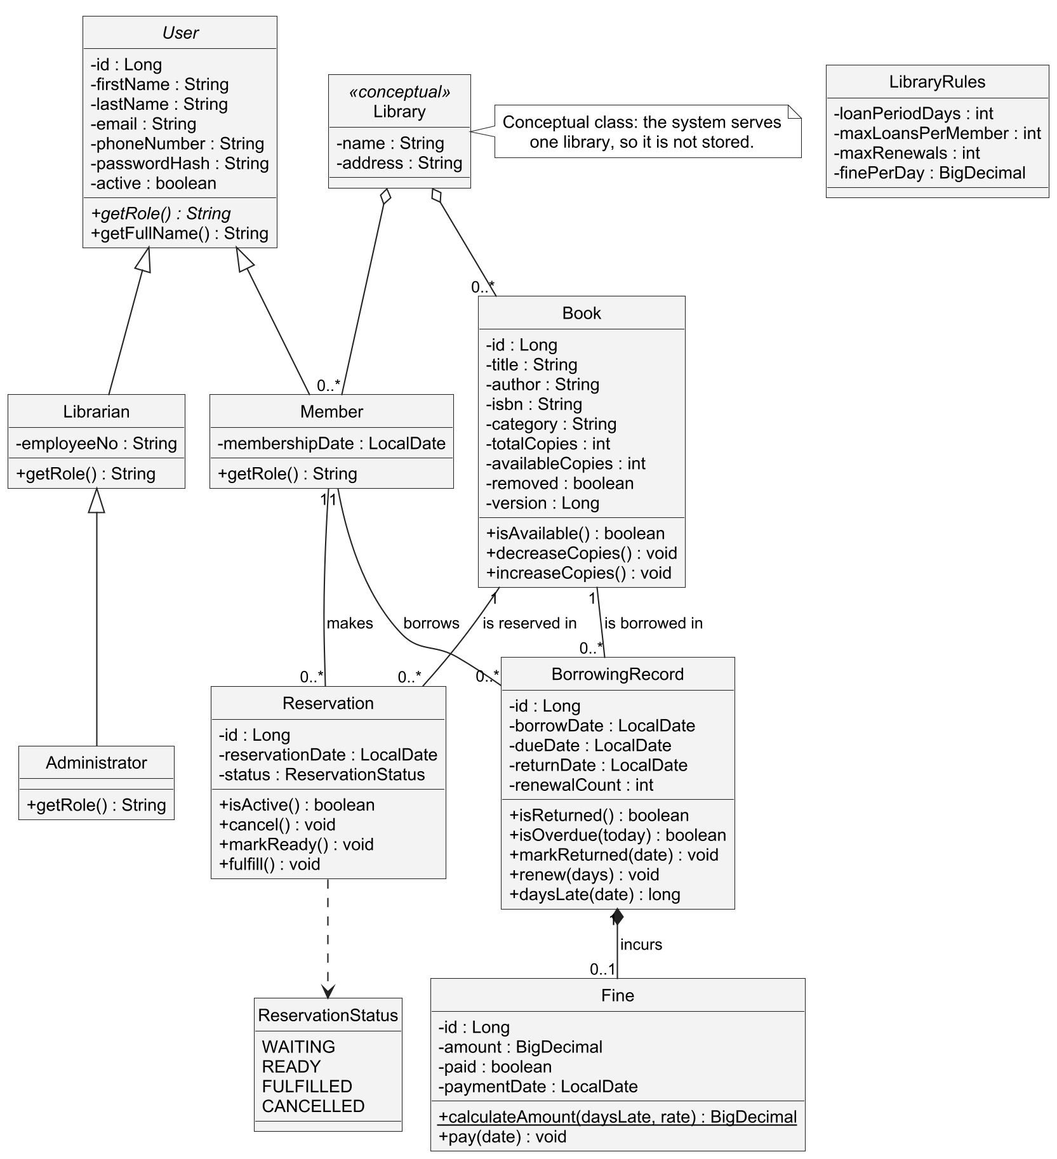
Figure 3: Class diagram of the domain model

3.6 Error Handling Requirements
The system must answer every error with a clear code and message (NFR-010). Appendix B lists all codes. Errors of login and role (401 and 403) are returned by the security layer.

3.7 Summary of Requirements
Table 21: Number of requirements by category and priority
Category | High | Medium | Low | Total
Functional | 12 | 16 | 3 | 31
Non-Functional | 4 | 8 | 1 | 13
Total | 16 | 24 | 4 | 44

4. Requirements Management

4.1 Requirements Database
All requirements are stored in the Excel workbook Requirements_Database.xlsx. Each requirement has an identifier, a name, a description, a category and a priority. The workbook also contains the sub-category, the stakeholder, the related use case, the implementation and the verification of each requirement.

4.2 Verification Methods
Table 22: Verification methods
Method | Used for | Evidence
Test (black box) | Functional rules, input limits | Unit tests derived from the requirements (equivalence partitioning, boundary values)
Test (white box) | Business logic of the service layer | Unit tests that cover all decisions and paths of the control flow graph, JaCoCo coverage report
Test (API) | Login, roles, complete flows | Integration tests with MockMvc and a Postman collection
Measurement | Performance and concurrency | Automated tests with 10,000 books and 50 users at the same time
Inspection | Architecture, security configuration | Review of the code and the package structure

4.3 Change Control
A change of a requirement is made in the requirements database first. After that, the use cases, the diagrams, the code and the tests that are linked to the requirement are updated. The traceability matrix in Appendix A shows which parts are affected.

Appendix A. Requirements Traceability Matrix
The matrix links each functional requirement to its use case, its API endpoint, its implementation and its tests. The names BB-xx and WB-xx are the black box and white box test cases of the project report.
Table 23: Functional requirements: use case, implementation and verification
FR | Use case | Endpoint | Implementation | Verified by
FR-001 | UC-01 | POST /api/auth/register | MemberService.register | SupportServicesTest (member_register, member_registerDuplicate); API test registration
FR-002 | UC-02 | GET /api/auth/me (HTTP Basic) | LibraryUserDetailsService, SecurityConfig | API tests login, unauthenticated
FR-003 | UC-02 | all endpoints (@PreAuthorize) | SecurityConfig, controllers, LibraryUserDetails | API test roleRules; DomainModelTest user_roles
FR-004 | UC-11 | POST /api/books | BookService.create | SupportServicesTest book_create, book_createDuplicate; API tests catalog, catalogValidation
FR-005 | UC-12 | PUT /api/books/{id} | BookService.update | SupportServicesTest book_updateCopiesBoundary; API test catalog
FR-006 | UC-13 | DELETE /api/books/{id} | BookService.remove | SupportServicesTest book_remove; API test catalog
FR-007 | UC-03 | GET /api/books?keyword= | BookService.search, BookRepository.search | SupportServicesTest book_searchNullKeyword; API test catalog; NFR-001 test
FR-008 | UC-04 | GET /api/books/{id} | BookService.get | API test catalog
FR-009 | UC-14 | POST /api/members | MemberService.register | SupportServicesTest member_register; Postman 4.4
FR-010 | UC-14 | PUT /api/members/{id} | MemberService.update | Postman 4.5 (no automated test)
FR-011 | UC-14 | PATCH /api/members/{id}/deactivate | MemberService.setActive | SupportServicesTest member_deactivate; API test inactiveAndUnknown
FR-012 | UC-14 | GET /api/members/{id} | MemberService.details | Postman 4.3 (no automated test)
FR-013 | UC-15 | POST /api/library/borrow | LibraryService.borrowBook | BB-01 to BB-08; WB-B1 to WB-B6; API test borrowAndReturn
FR-014 | UC-16 | POST /api/library/borrow | LibraryService.borrowBook (D1 to D3) | BB-02, BB-04, BB-05, BB-08; WB-B1 to WB-B3; API tests loanLimit, inactiveAndUnknown
FR-015 | UC-17 | POST /api/library/borrow | LibraryService.borrowBook (D4, D5) | BB-03, BB-06; WB-B4, WB-B5; API test borrowAndReturn
FR-016 | UC-15 | POST /api/library/borrow | LibraryService.borrowBook, RulesService | BB-01, BB-07; WB-B6
FR-017 | UC-18 | POST /api/library/return/{id} | LibraryService.returnBook | BB-09 to BB-11; WB-R1 to WB-R4; API test borrowAndReturn
FR-018 | UC-15, UC-18 | borrow and return | Book.decreaseCopies, Book.increaseCopies | DomainModelTest (book_*); BB-03, BB-09; NFR-006 concurrency test
FR-019 | UC-09 | POST /api/library/renew/{id} | LibraryService.renewLoan | BB-12 to BB-16; WB-N1 to WB-N7; API test renewAndOwnLoans
FR-020 | UC-07 | GET /api/library/user/{id}/active | LibraryService.getActiveBorrowingsByUser | WB-Q1; API test renewAndOwnLoans
FR-021 | UC-08 | GET /api/library/user/{id}/history | LibraryService.getBorrowingHistory | WB-Q1; API test renewAndOwnLoans
FR-022 | UC-22 | GET /api/library/overdue | LibraryService.getOverdueBooks | BB-17; API test overdueAndFine
FR-023 | UC-05 | POST /api/reservations | ReservationService.reserve | SupportServicesTest reserve_*; API test reservation
FR-024 | UC-06 | DELETE /api/reservations/{id} | ReservationService.cancel | SupportServicesTest cancel_ownership; DomainModelTest reservation_cancel; API test reservation
FR-025 | UC-20 | return of a reserved book | ReservationService.notifyNextWaiting | SupportServicesTest notifyNextWaiting; API test reservation
FR-026 | UC-23 | POST /api/library/overdue/remind | NotificationService.sendOverdueReminders | API test overdueAndFine
FR-027 | UC-19 | POST /api/library/return/{id} | Fine.calculateAmount, FineService.createFine | DomainModelTest fine_amount; WB-R4; API test overdueAndFine
FR-028 | UC-21 | POST /api/fines/{id}/pay | FineService.pay | DomainModelTest fine_pay; API test overdueAndFine
FR-029 | UC-25 | /api/admin/staff | StaffService | SupportServicesTest staff_*; API test staffManagement
FR-030 | UC-26 | /api/admin/rules | RulesService | BB-07, BB-08; API test rules
FR-031 | UC-24 | /api/reports/* | ReportService | API test reports

Non-functional requirements
Table 24: Non-functional requirements: status and evidence
NFR | Status | Solution | Evidence
NFR-001 | Met (tested) | JPQL search over title, author, ISBN and category; measured with a catalog of 10,000 books | Slowest search in the test: 139 ms (limit 2000 ms). PerformanceAndConcurrencyTest
NFR-002 | Met (tested) | Stateless API, connection pool | 50 users searching at the same time finished in 59 ms. PerformanceAndConcurrencyTest
NFR-003 | Met (tested) | BCrypt password hashes (SecurityConfig, MemberService, StaffService) | SupportServicesTest member_register: stored value is the hash, not the password
NFR-004 | Met (tested) | All endpoints except registration and API documentation need a login | API tests unauthenticated, roleRules
NFR-005 | Met (by design) | AuditService writes every borrow, return and account change to logs/audit.log (daily files, 90 days) | logback-spring.xml; audit file created during the test run
NFR-006 | Met (tested) | Transactions, optimistic locking (@Version on Book), stock rules in Book | 50 members borrow the last copy at the same time: 1 succeeds, stock is 0. DomainModelTest
NFR-007 | Not met | Depends on the deployment. It was not measured in this project | Out of scope. Needs a production environment and monitoring
NFR-008 | Not met | Not implemented. A scheduled database dump (for example mysqldump) is the recommended solution | Out of scope. Listed as future work
NFR-009 | Partially met | Simple REST calls, Swagger UI, clear error messages. There is no graphical user interface | Swagger UI test (API documentation); no usability test with real librarians
NFR-010 | Met (tested) | GlobalExceptionHandler returns a JSON body with a code and a message | API tests check the error code of every error case
NFR-011 | Met (by design) | Layered architecture: controller, service, repository, entity, DTO | Package structure; architecture figure
NFR-012 | Met (tested) | Unit tests of the service layer | Service layer coverage 87.6% (target 80%); LibraryService 100%
NFR-013 | Partially met | Java 21 with H2 (default) and MySQL (profile mysql) | Tested on Windows with H2. MySQL profile and Linux were not tested

Appendix B. Error Codes
Table 25: Error codes of the API
Code | HTTP status | Meaning
UserNotFound | 404 | The member or staff id does not exist.
BookNotFound | 404 | The book id does not exist or the book was removed.
RecordNotFound | 404 | The borrowing record does not exist (or it belongs to another member).
ReservationNotFound | 404 | The reservation does not exist (or it belongs to another member).
FineNotFound | 404 | The fine id does not exist.
UserInactive | 409 | The member account is deactivated.
LoanLimitReached | 409 | The member already has the maximum number of active loans.
BookNotAvailable | 409 | No copy of the book is available.
BookAlreadyReturned | 409 | The book of this record was already returned.
RenewalNotAllowed | 409 | The loan is overdue, already renewed, or the book is reserved.
BookAvailable | 409 | A reservation was requested for a book that has available copies.
AlreadyReserved | 409 | The member already has an active reservation for the book.
ReservationNotActive | 409 | The reservation is already cancelled or completed.
FineAlreadyPaid | 409 | The fine is already paid.
DuplicateIsbn | 409 | A book with the same ISBN exists.
InvalidCopies | 409 | The new number of copies is smaller than the number of copies on loan.
BookOnLoan | 409 | The book cannot be removed while a copy is on loan.
EmailAlreadyUsed | 409 | The e-mail address is already registered.
CannotDeactivateSelf | 409 | An administrator cannot deactivate his or her own account.
ConcurrentUpdate | 409 | The data was changed by another user at the same time. The request can be repeated.
DataConflict | 409 | The data conflicts with existing data in the database.
ValidationError | 400 | A field of the request is missing or invalid. The message lists the fields.
BadRequest | 400 | The request body is malformed or a parameter is missing.
(no code) | 401 / 403 | Missing or wrong login (401). The role is not allowed to use the function (403).

